Education Service
M22-4 – Part IV – Chapter 11 Updates
Lesson Plan
September 2016
Version 1.0

Lesson Overview
Topic | Description
Time Estimate: | 1 Hour
Purpose of the Lesson: | The purpose of this lesson is to provide VCEs with notice and training on the updated M22-4.
Prerequisite Training Requirements: | - Processing Mitigating Circumstances for Post 9/11 GI Bill Claims (TMS ID 1702616)
Target Audience: | - VCE (entry level)  - VCE (journeyman level)
Lesson References: | - M22-4 – Part IV: Chapter 11 – Enrollment Adjustments  - 38 USC 3680
Lesson Objectives: | At the conclusion of this lesson, you will be able to:  - Identify the requirements for documenting phone calls with School Certifying Officials (SCOs)  - Determine the circumstances in which to grant mitigating circumstances
What You Need: | - Ability to present PowerPoint.  - Copy of the Handout.
Post Training Requirements: | Upon completion of the classroom portion of the lesson, participants are required to complete an online lesson assessment and survey in Talent Management System (TMS).  To demonstrate successful completion of the lesson participants must pass the assessment with a score of at least 80%.  Participants must also complete the online survey to earn credit for completion of the lesson.

Instructor Notes
PowerPoint Slides | Instructor Activities
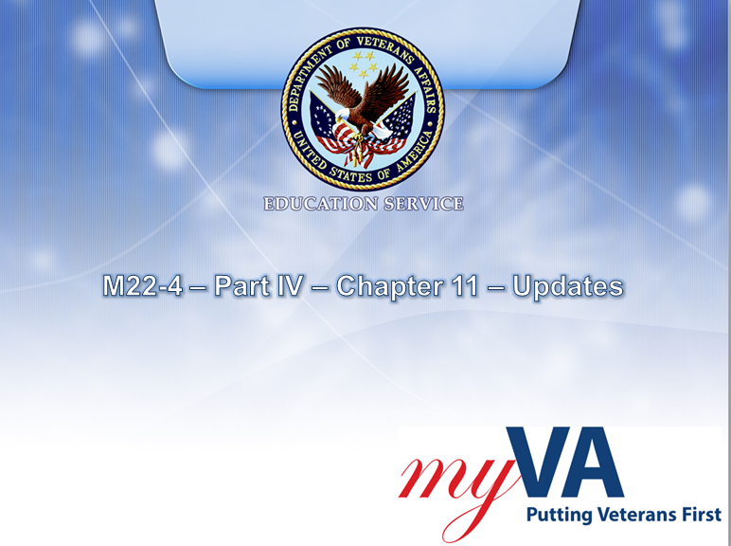 | DISPLAY slide  Introduce yourself as the instructor and introduce the lesson.
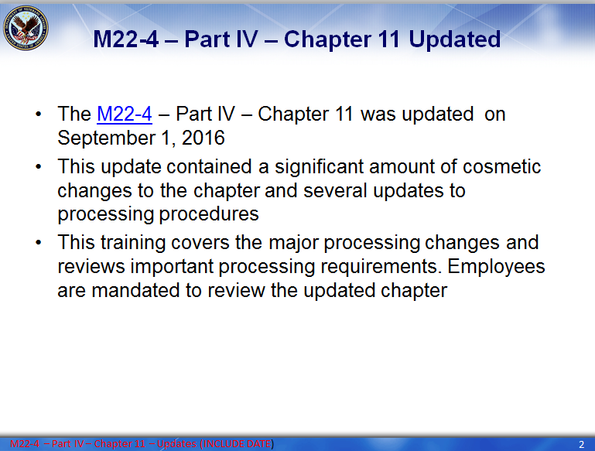 | DISPLAY slide  - Provide an overview of the lesson by discussing the key points.  - Remind trainees that they are mandated to review the updated chapter.
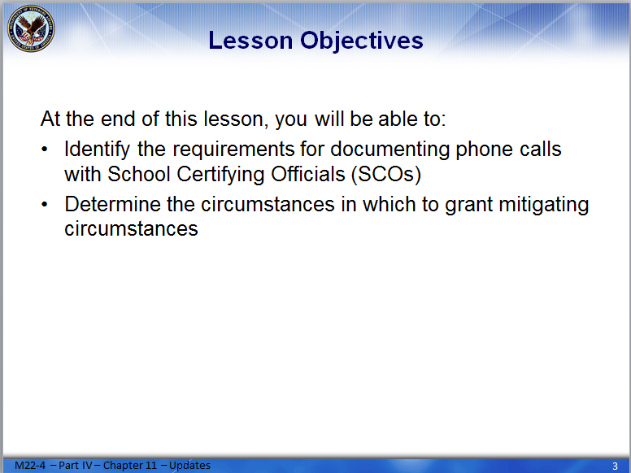 | DISPLAY slide  Review the lesson learning objectives.
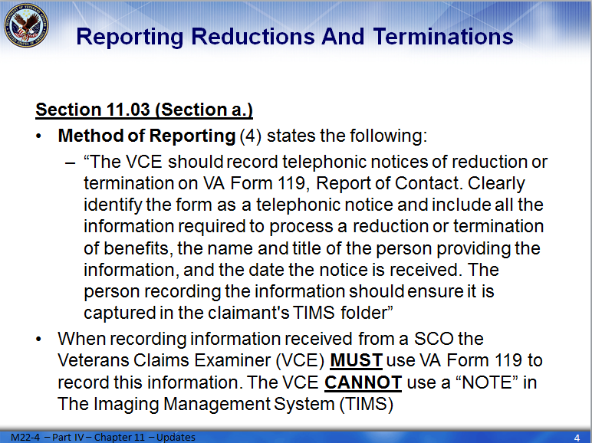 | DISPLAY slide  - Review the information with trainees.  - Reinforce that VCEs must use VA Form 119 when documenting calls with SCOs.
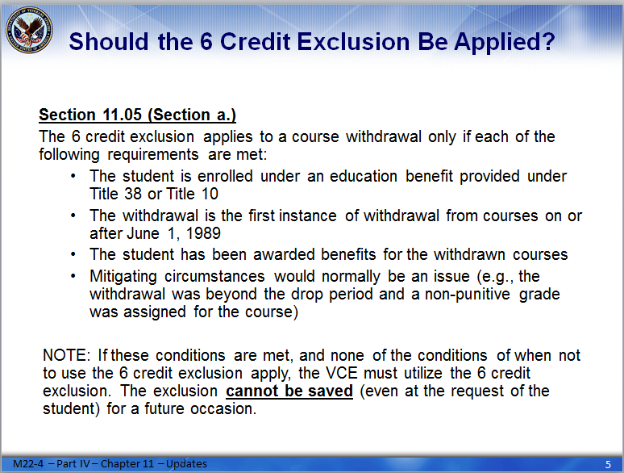 | DISPLAY slide  - Review the criteria needed to grant the 6 credit exclusion.  - Explain the note in detail:  - In order to grant the 6 credit exclusion all requirements noted on this slide must be met.  - In order to grant the 6 credit exclusion all requirements noted on the following slide must NOT be met.  - Reinforce that if both a. and b. are meet, then the 6 credit exclusion must be granted. Under no circumstances can it be “saved” for future use.
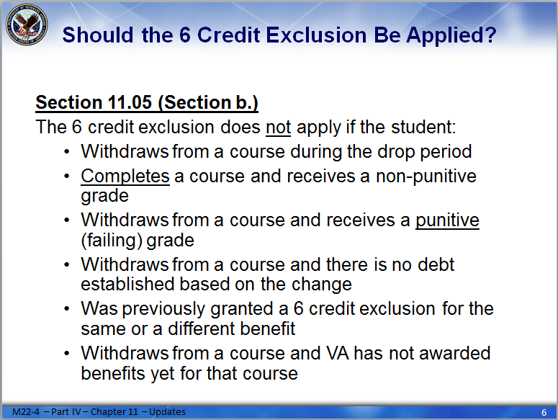 | DISPLAY slide  - Review the criterion that prevents a VCE from granting the 6 credit exclusion.  - Emphasize #4. Remind trainees that if a reduction or withdrawal does not result in any debt, they do not have to apply the 6 credit exclusion.  - ASK trainees for examples of cases they processed recently, and as a group review those situations and identify if the 6 credit exclusion should be granted.
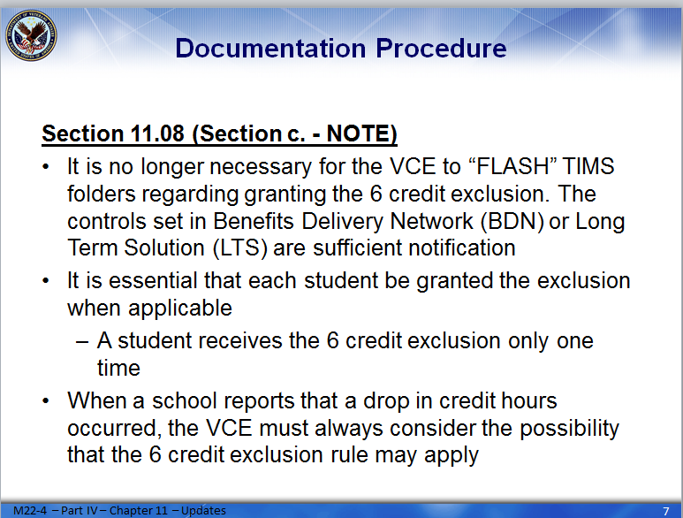 | DISPLAY slide  Review the information with trainees.
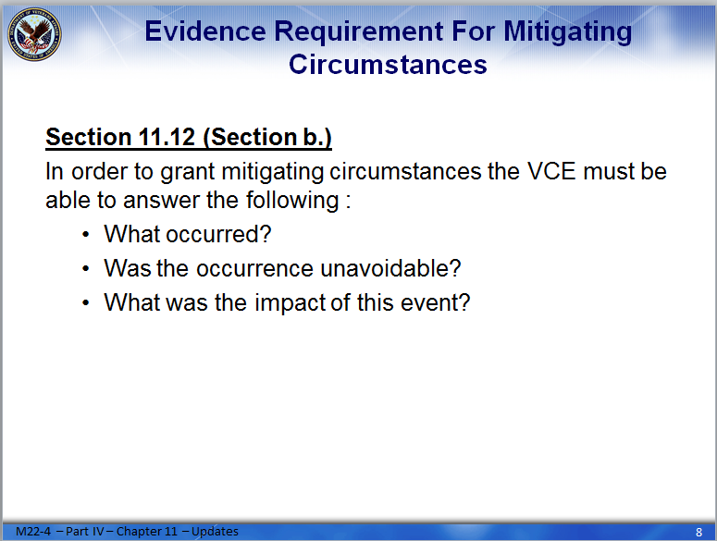 | DISPLAY slide  Emphasize these questions, and explain that VCEs must be able to answer them when processing mitigating circumstances.
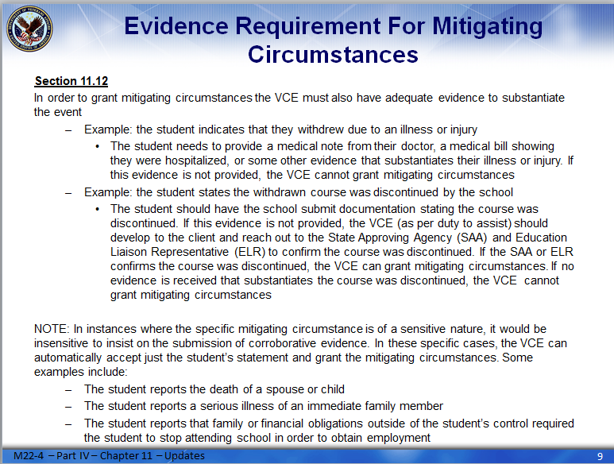 | DISPLAY slide  - Review the examples with trainees.  - Remember the clarification for presenters note:  - “If a STUDENT is reporting a serious illness – evidence is required. This evidence does not have to violate privacy concerns (i.e. VCEs do not need to develop for what illness an individual had), but evidence should show that the illness prevented the student from completing the term. If a student is reporting a serious illness of a FAMILY MEMBER – then this is considered a sensitive issue and evidence is not required.”
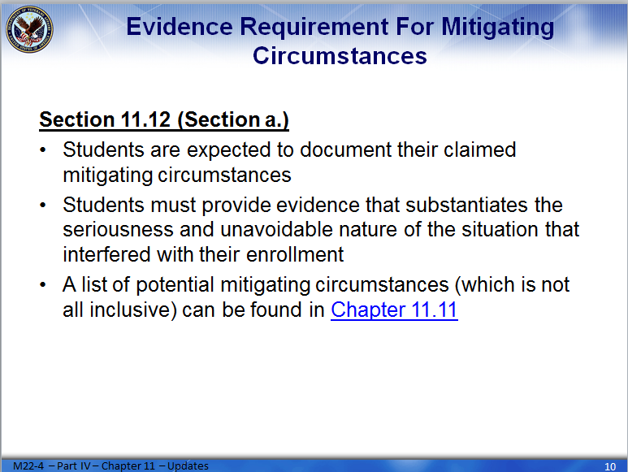 | DISPLAY slide  - Review the information with trainees.  - ASK trainees for examples of mitigating circumstances that would require evidence.  - ASK trainees for examples of mitigating circumstances that would be considered sensitive in nature and would not require evidence.
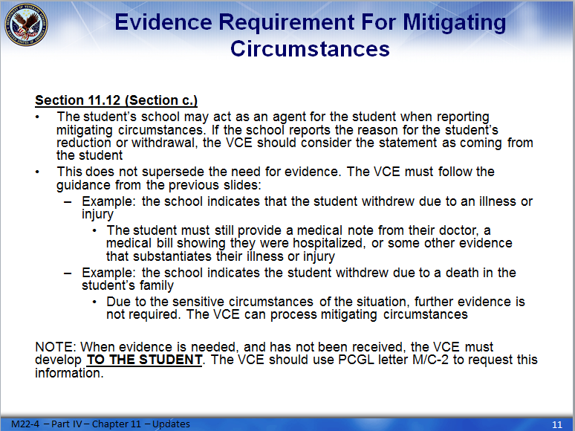 | DISPLAY slide  - Review the information with trainees.  - Emphasize that all development letters must be sent to the student, even if the school supplied the initial mitigating circumstances.  - Remind trainees of the provisions of duty to assist. (M22-4 – Part III – Chapter 3 – Subchapter 6)
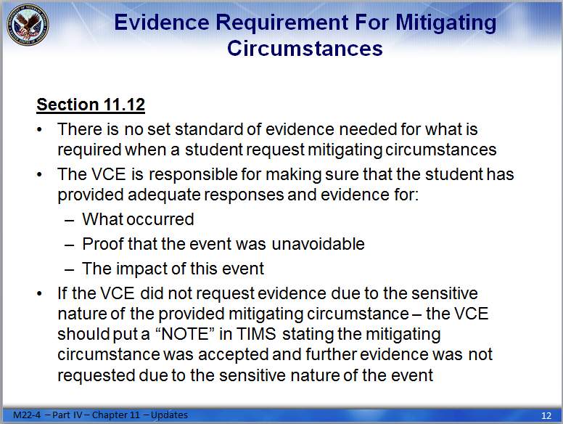 | DISPLAY slide  - Review the information with trainees.  - Emphasize the three questions that the trainees must be able to answer  - Provide the trainees with the handout. Allow them time to complete it and then review all questions and answers.
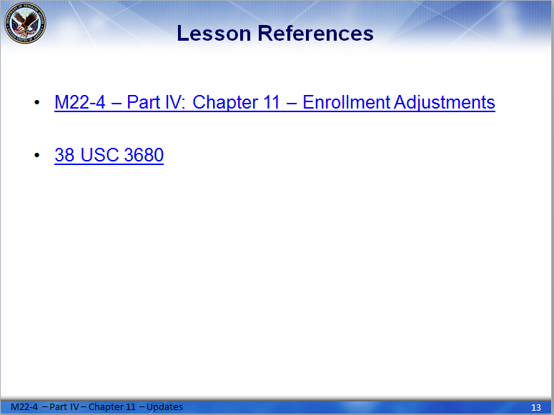 | DISPLAY slide  Review the information with trainees.
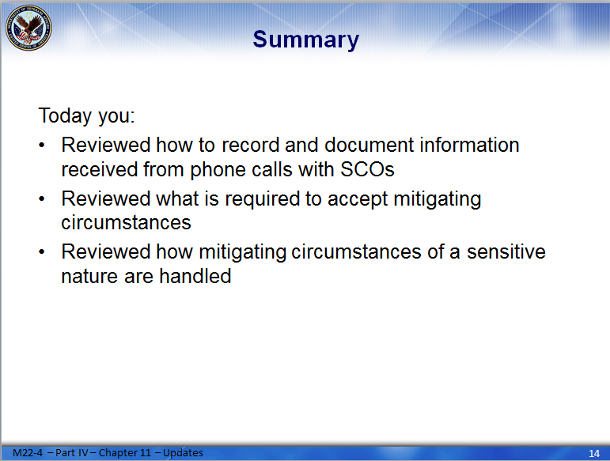 | DISPLAY slide  Review the information with trainees.
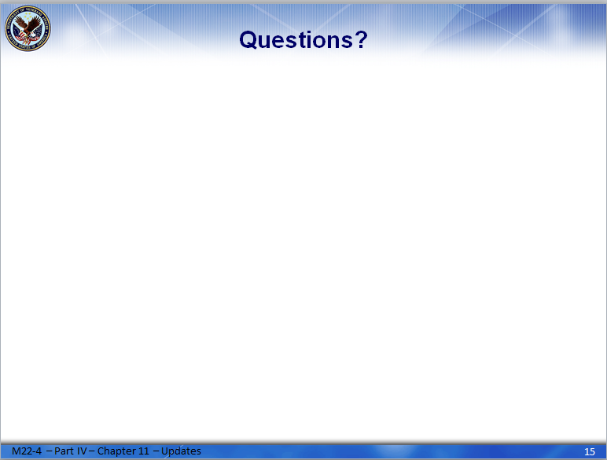 | DISPLAY slide  Ask trainees if they have any questions.
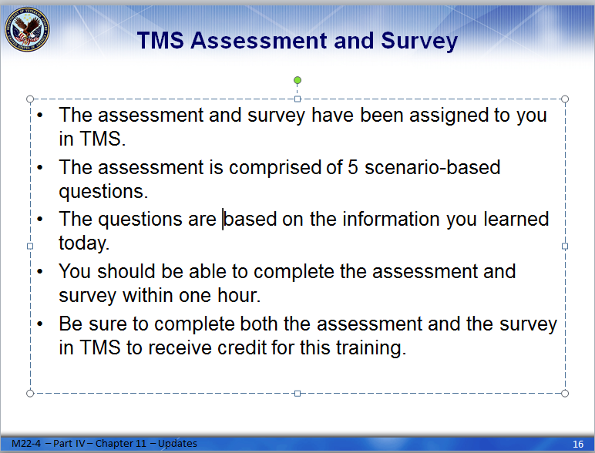 | DISPLAY slide  Provide the TMS assessment and survey information to trainees.

