VBMS Hands-on Training for VBMS Users

Trainee Handout

**Table of Contents**

Objectives 2

References 3

VBMS Introduction 4

Claims Navigation 11

Customization 15

VBMS Job Aid Filtering and sorting 16

VBMS Job aid Annotations 18

Objectives

* Understand the enrollment process
* Identify strong passwords
* Understand the layout and functionality of the various screens in VBMS
* Understand the EP Screen
* Identify when and how to annotate a document.
* Navigate Development screen.
* Understand the VBMS Development process

# References

[VBMS Intranet](http://vbaw.vba.va.gov/VBMS/Resources_Technical_Information.asp)

[VBMS SOP](http://vbaw.vba.va.gov/VBMS/Resources_Technical_Information.asp)

VBMS Introduction

**VBMS Access**

Veterans Benefit management System (VBMS)

User registration and authentication is managed by outside identity providers, such as Common Security Services (CSS), Common Security User Manager (CSUM), and Common Security Employee Manager (CSEM).

Your supervisor can register for access credentials on your behalf, either with a paper form or applying electronically in the CSEM system. Requests can be made for a single user with a single role, a single user with multiple roles, or group requests can be made for multiple users with the same user role.

After a request is submitted, allow 24 hours for access to be granted. When the registration process is complete, you and your supervisor will receive a user name and a temporary password by e-mail. For security reasons, you must change the initial password when you first log in to the VBMS application.

*Start>All Programs>VBAPPS>VBMS>VBMS*

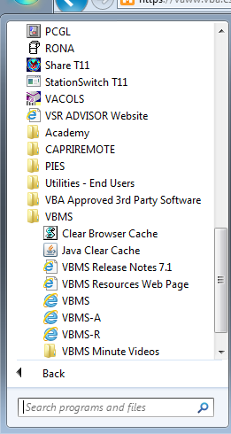

**Password**

To ensure the security of Veteran data, passwords must meet the following minimum requirements:

• Must be eight characters in length.

• Six of the characters cannot occur more than.

• Must contain three of the four following types of characters:

• Lowercase English letters (a - z).

• Uppercase English letters (A - Z).

• Numerals (0,1,2,...9).

• Special characters as follows, with no : [colon] or [SPACE]: **!**

**@ # $ % ^ & * () + { } | " < > ? ' . / [ ] \ - = ~ `**

***If you are logging in for the first time, you must change your password immediately.***

**Main Screen**

Immediately after loggin in, the system directs you to your work queue.

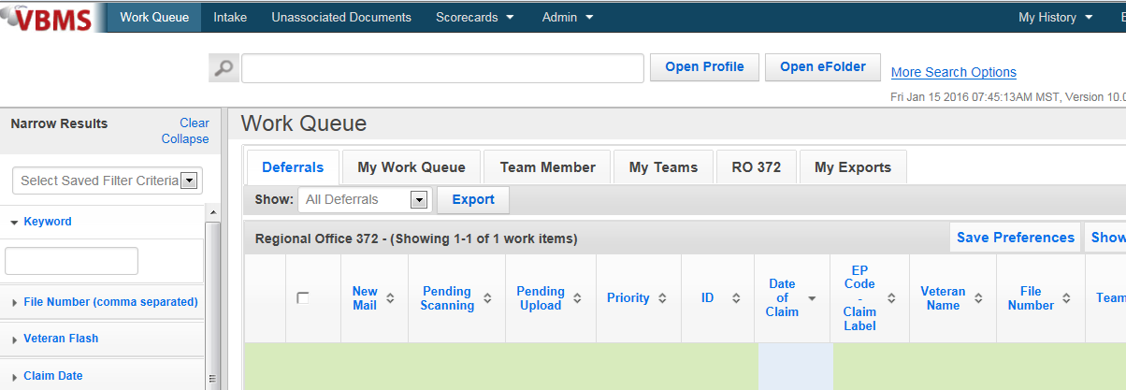

Work Queue- From the Work Queue link, users can access different table views that include general details of outstanding work items associated with VBMS claims.

Intake- From the Intake Link, users can view and manage the process of preparing hard-copy documents for shipping to an intake site.

Unassociated Documents- From the Unassociated Documents link, users can view and manage documents that are not currently associated with a specific Veteran.

**Work Queue**

The My Work Queue tab shows all work items assigned to you to complete,

including work items that are new (not worked) and work items that you have worked on, but that are not yet completed (pending).

1. At any point/ from any page you can return to this queue by clicking “Work Queue”



1. Search for any Veteran/Claim – just as you could in SHARE

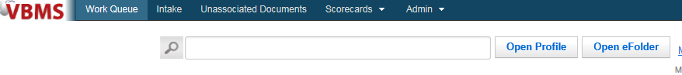

1. Use these to filter the Work Queue you are currently viewing (useful for larger queues such as the “Unassigned Queue”)



1. New Mail Indicator, Indicates there is evidence in the efolder that has not been viewed/opened

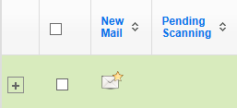

1. Click on ID, EP Code- Claim Label, Veteran Name or File Number to access folder

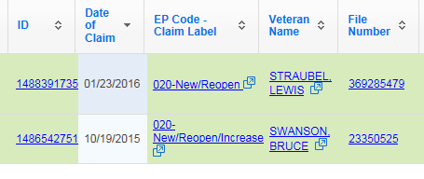

1. Flyout, This button (next to the Veteran’s name) will allow you to open the claim in a new window. Using this functionality will allow you to have multiple screens open for the Veteran at once – for example the documents tab on one screen and the development plan on another.

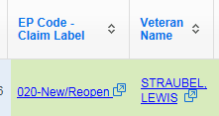

**Veteran Menu**

The Veteran Menu provides different informational views, and also provides a

link to the main Veteran Profile screen, allowing users to quickly navigate back from other views. Similar information shows in the Veteran Summary Pane; however, editing features are only available when you open the view on the main screen.

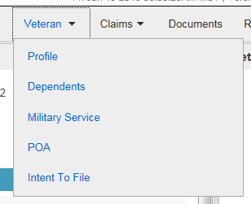

Each view provides different options from the Actions menu

**Claims Menu**

Clicking the All Claims link shows a table view of claims in any status that are

associated with the Veteran.

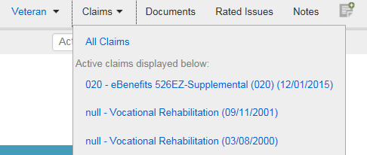

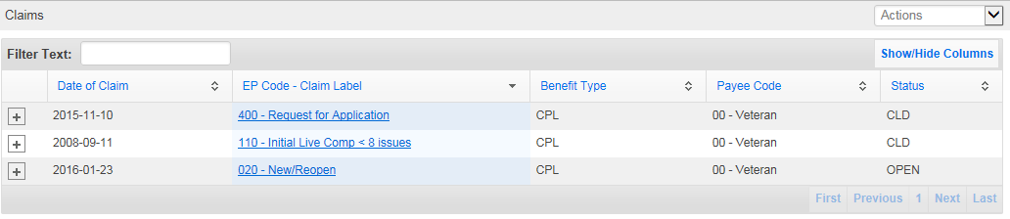**Documents Menu**

Clicking this link opens the eFolder.

The eFolder Documents tab shows general information about all the documents in the eFolder, including any bookmarks, the date the document was received, and the type and the subject of the document. As with other table views, you can drag a column to the left or right to change the order of the table, and you can further customize the view by using the Show/Hide Columns button.



Much like the work queue, the documents in the documents folder can be sorted utilizing the column headers noted below.



The Narrow Results pane and the Veteran Summary pane are both available from the eFolder.

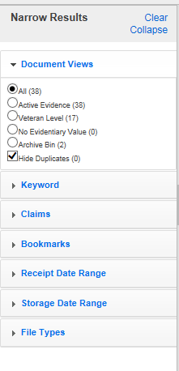

Utilizing the Narrow results pane, located on the left hand side of the documents page, allows for display of specific documents. Utilizing these functions resluts in a much shorted list of documents to review. Keyword searches will only list the documents that contain the keyword entered, good for searching for specific docuements such as 686’s, or DD214’s. Narrowing by Claims, provides a listing of documents only tagged to the claim selected. The Bookmarks pane will narrow based upon the bookmarks utilized in the file. If none are active in the documents page, this narrowing capability is still listed but is unavailable for use. The receipt date rage displays documents related to the dates entered into the fields. Storage date mimics the receipt date range function. File types selects for different formats documents can be saved in, but current functionality exists for PDF only.

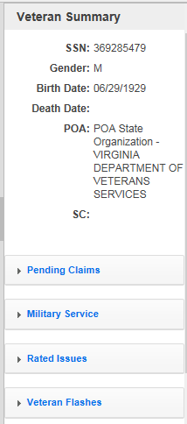

The Veteran Summary screen, located on the right side of the documents page, gives quick access to information such as Pending Claims, Military Service, Rated Issues, and Veteran Flashes.

**Actions Menu**

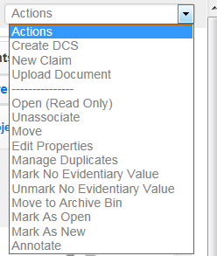

**Virtual VA**

The Virtual VA Documents tab shows documents that have been received by

Virtual VA Paperless Claim Processing. Virtual VA documents are read-only; this means the documents can be viewed, but other features, such as bookmarks and annotations, are not available. When you click a link in the Document Type column, or choose Open (Read Only) from the Actions menu, the document opens in a new window.

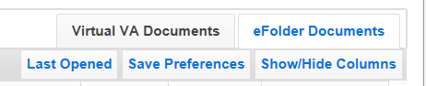

**Annotations**

To view or make annotations to an eFolder document, click the annotation icon in the Document Type column of the eFolder table view.

**To make an annotation:**

1. Click the **Add an Annotation** icon. Your cursor will change to a

selection tool.

2. Left click and drag a box on the area of the document where you want to

create an annotation.

3. Release the mouse button. The Annotation dialog appears.

4. Choose an annotation type from the list on the left. This example creates

a Note type annotation.

5. Type the annotation text in the text field provided. You can change the

color of the note by clicking the color box at the bottom of the dialog.

6. Click **OK** to close the Annotation dialog.

7. Click **Save** from the toolbar to save the annotations to the document.

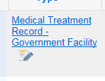



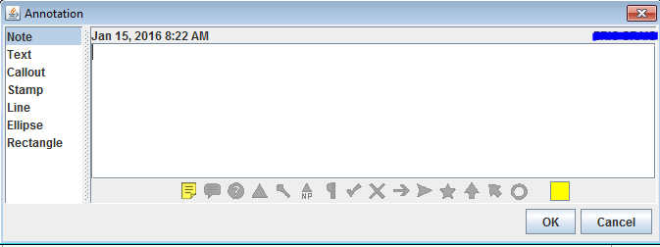

Claims Navigation

**Claim Information Bar**

Below the claim title is the *Claim Information Bar*. This shows information

regarding the claim, including a Go to Work Item link, the number of days the claim has been pending (open), the date and status of the claim, the suspense date, and the team and/or user to which the claim has been assigned.



**Button Bar**

The *Button Bar* includes buttons to Edit Claim Detail, Create DCS, Upload Document, or create a New Claim.

The Edit Claim detail button provides access to edit functions for EP and claim label, any modifier necessary, and the Date of Claim.

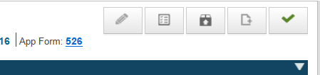

The Create DCS button, opens the Document Control Sheet. This provides the Mail Room or Intake Center the functionality to provide an electronic listing of docuemnts received and are being sent to scan.



The Upload Document button opens the window to allow the user to upload docuemts to the VBMS documents page for the veteran that are saved locally.



The Create a New Claim button provides access to the fields required to CEST a new EP.



Only when a work item is assigned to the user with the Complete Work Item button will show in the button bar.



**Development Task Bar**

The Development Plan Task Bar appears under the Claim Information bar.

Clicking the following main links will show information that can be used to complete Development Plan tasks (process a claim).

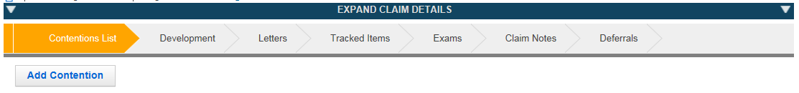

**Contentions**

Contentions are conditions or diagnoses that a Veteran “contends” are the cause of a current disability, and may qualify for benefits if directly related to a Veteran's military service. A claim can include one or more contentions.

Scanned contentions are not considered verified until a VSR views the contention, and edits the contention type and classification.

Creating Contentions

1. From the **Claim Details** screen, click the **Add Contention** button.

2. In the **Contention** field, enter a contention description. As you type, contentions that might apply will be suggested.

3. Click the **Classification** down arrow and choose a classification from the list.

• Classifying a contention is required if the Medical field is set to yes.

• If the Medical field is set to no, adding a classification is optional.

4. Click the **Date of Contention** field to select a date from the pop-up calendar. Otherwise, the contention date will default to the date of the claim. The contention date cannot be before the date of the claim.

5. The **Verified** field is automatically populated with a yes/no value once you save the contention.

• Scanned contentions will show No until a classification and type are entered.

• Manually entered contentions always show Yes.

6. Click the **Type** down arrow and choose a type from the list.

• New

• Increase

• Secondary

• Reopen

7. Click the **Medical** down arrow and select Yes or No to indicate if the contention relates to a medical issue.

**Special Issues**

If special issues apply to the contention, click the Special Issue field and select an issue from the list, or type in the field and issues will be suggested as you type.

You can add multiple special issues, but you cannot enter the same special issue to a contention more than once. As you click each special issue, they will appear in the area below the Special Issue field. Click the [X] to remove a special issue from the list.

**Development Chevron**

When you establish a claim, VBMS automatically creates four required work

items (tasks). Tasks can be comprised of one or more actions which must be completed in order to set the status of that task to complete. You can navigate to the development plan from the Claims Detail screen, or the Work Item ID screen.

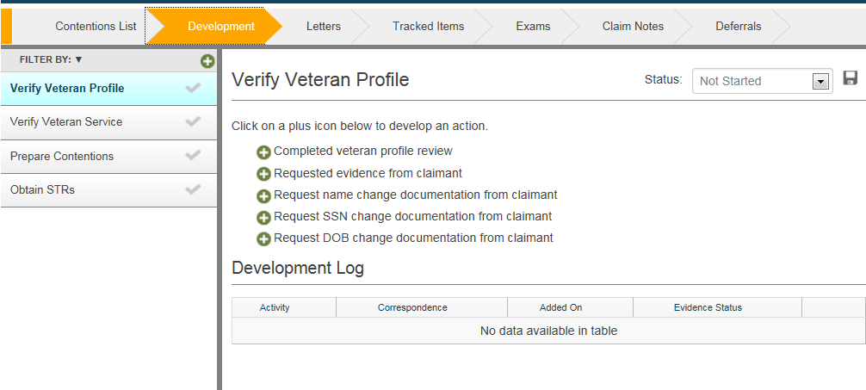

**Letter Chevron**

During claim development, you may need to create correspondence for several purposes, including:

* requesting evidence from a claimant
* requesting evidence from a private third-party
* requesting evidence from National Guard or Reserve command
* advising the claimant of the current claim status
* notifying the claimant of requests for information that were sent to a third-party
* or for third-party follow up purposes.

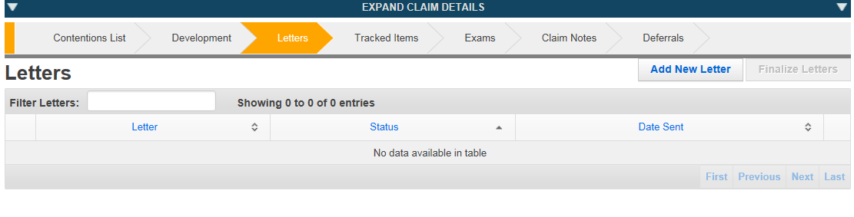

**Tracked Items**

From the Tracked Items link you can view a list of all items associated with a claim and the status of the item as it goes through the development process. Many tracked items are created and closed automatically as work items are completed, and you can also add and edit tracked items manually.

**Claim Notes**

From the Claim Notes link in the Development Plan Task Bar, you can view notes that are associated with a specific claim; this includes both temporary and permanent notes that are created by users, as well as notes that are automatically created when actions take place on the claim.

The Add Note ( ) icon is available from Veteran Profile and Claim Detail screens.

**Deferrals**

Deferrals are initiated on work items that cannot be currently completed; due to incomplete development or exams requested by the RVSR. Work items with pending deferrals cannot be marked complete until the associated deferrals are mitigated by a supervisor.

Customization

**Customizing Table Views**

At the bottom of the screen, you can modify the number of items that show in table views by clicking the Items per page arrow, and choosing a number from the list.

You can also skip to a specific page by entering a number in the Skip to Page field and clicking Go, or by using the First, Previous, Next or Last button bar.

Drag a column header to the left or right to relocate the column within the table.

**Sorting Column Headers**

Click the header of the first column you wish to sort by.

2. While holding down the **Shift** key, click the header of the second column, and so on.

3. A [1] appears next to the first chosen column, and a [2] appears next to the second chosen column, etc.

4. Click any column header to return to the default sorted view.



**Narrow Results Pane**

The Narrow Results Pane is available on the left of many main screens. It provides choices to customize the items that are listed on the main screen table view. You can open and close the pane by clicking the scroll bar.

You can expand the sections and enter criteria or make choices to indicate items you would like to show. The Clear and Collapse links at the top of the pane will clear filter selections, and collapse any sections that had been expanded.

For some views, you will need to click the Filter button to show your selections. When provided, you can save your choices with the Save button, and manage views that you have saved with the Manage button.

VBMS Job Aid Filtering and sorting

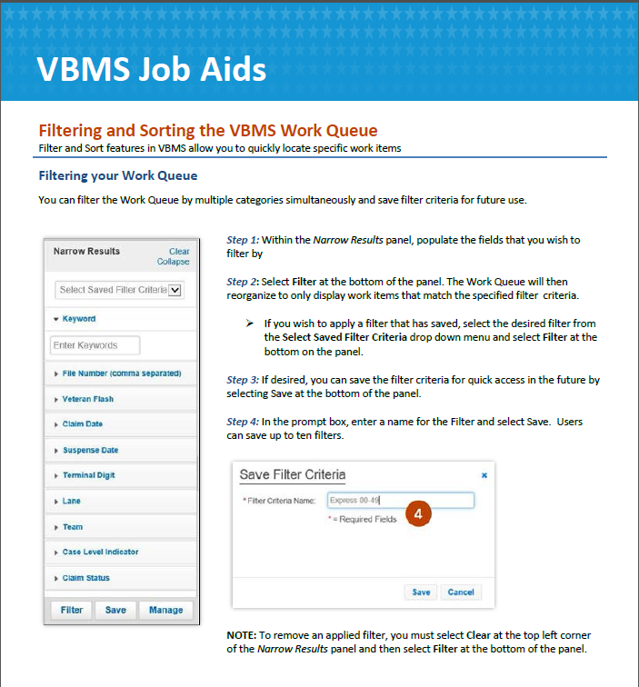

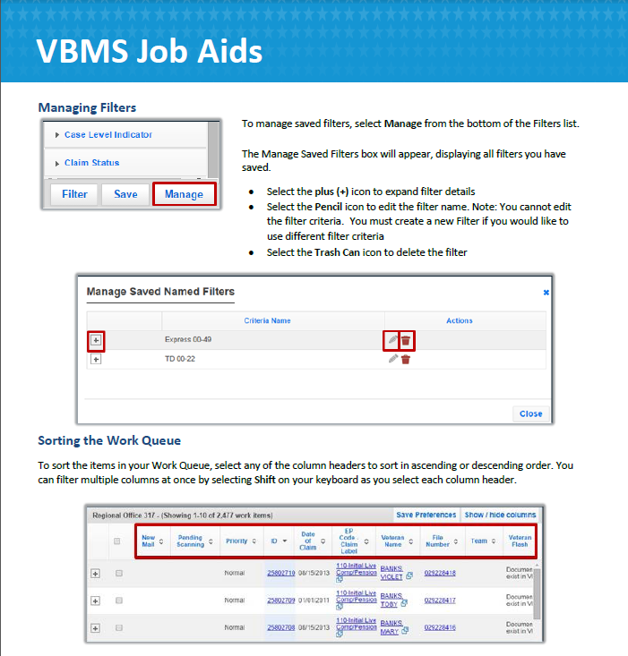

VBMS Job aid Annotations

