Hospital Adjustments

Trainee Handout

**Table of Contents**

Objectives 2

References 3

Topic 1: Hospital Adjustment Provisions 4

Topic 2: Processing Hospital Adjustments 8

Attachment A: VA Form 10-7131 13

Attachment B: VA Form 10-7132 14

Attachment C: Reduction Chart 15

Attachment D: Topic 1 Knowledge Check - Hospital Adjustment Provisions 16

Attachment E: Hospital Adjustment Due Process Letter – PCGL PP4 17

Attachment F: Hospital Adjustment Decision Notice – PCGL PP5 22

Attachment G: Topic 2 Knowledge Check - Processing Hospital Adjustments 25

Objectives

The scope of this lesson is how benefits are affected when a beneficiary is receiving Special Monthly Compensation (SMC) Aid and Attendance (A&A) and are hospitalized at VA expense.

At the end of this lesson, you should be able to:

* Describe hospital adjustment provisions
* Determine the dates of reduction and reinstatement of benefits
* Identify 38 CFR §3.552 exceptions
* Explain the requirements to process a hospital adjustment
* Demonstrate the ability to process hospital adjustments

References

All M21-1 references are found in the [Compensation Pension Knowledge Management (CPKM) portal.](https://vaww.vrm.km.va.gov/system/templates/selfservice/va_kanew/help/agent/locale/en-US/portal/554400000001034)

* [38 CFR §3.105(e)](https://www.ecfr.gov/cgi-bin/text-idx?SID=70d4a3d8262d178b211e42a0eb15d0c5&mc=true&node=se38.1.3_1105&rgn=div8), Revision of decisions, Reduction in evaluation – compensation
* [38 CFR §3.350](https://www.ecfr.gov/cgi-bin/text-idx?SID=78c220852fc58a2f609f97a379b7bc83&mc=true&node=se38.1.3_1350&rgn=div8), Special monthly compensation ratings
* [38 CFR §3.551](https://www.ecfr.gov/cgi-bin/text-idx?SID=78c220852fc58a2f609f97a379b7bc83&mc=true&node=se38.1.3_1350&rgn=div8), Reduction because of hospitalization

* [38 CFR §3.552](https://www.ecfr.gov/cgi-bin/retrieveECFR?gp=&SID=cdd688d342494ff4bb7d90fd5a8c95cd&mc=true&r=SECTION&n=se38.1.3_1552), Adjustment of allowance for aid and attendance
* [38 CFR §3.556](https://www.ecfr.gov/cgi-bin/retrieveECFR?gp=&SID=cdd688d342494ff4bb7d90fd5a8c95cd&mc=true&r=SECTION&n=se38.1.3_1556), Adjustment on discharge or release

* [M21-1 I.2.A](https://vaww.vrm.km.va.gov/system/templates/selfservice/va_kanew/help/agent/locale/en-US/portal/554400000001034/content/554400000014071/M21-1-Part-I-Chapter-2-Section-A-General-Information-on-Due-Process), General Information on Due Process
* [M21-1 I.2.B.3.c](https://vaww.vrm.km.va.gov/system/templates/selfservice/va_kanew/help/agent/locale/en-US/portal/554400000001034/content/554400000014072/M21-1-Part-I-Chapter-2-Section-B-Notice-of-Proposed-Adverse-Action#3), Special Procedures for Hospitalized Veterans
* [M21-1 III.v.6.A](https://vaww.vrm.km.va.gov/system/templates/selfservice/va_kanew/help/agent/locale/en-US/portal/554400000001034/content/554400000014259/M21-1-Part-III-Subpart-v-Chapter-6-Section-A-Information-Exchange-Between-Department-of-Veterans-Affairs-VA-Regional-Offices-ROs-and-Medical-Facilities), Information Exchange Between Department of Veterans Affairs (VA) Regional Offices (ROs) and Medical Facilities

* [M21-1 III.v.6.C](https://vaww.vrm.km.va.gov/system/templates/selfservice/va_kanew/help/agent/locale/en-US/portal/554400000001034/content/554400000014261/M21-1-Part-III-Subpart-v-Chapter-6-Section-C-Adjusting-Awards-Involving-an-Aid-and-Attendance-AA-Allowance), Adjusting Awards Involving an Aid and Attendance (A&A) Allowance
* [M21-1 IV.ii.2.H](https://vaww.vrm.km.va.gov/system/templates/selfservice/va_kanew/help/agent/locale/en-US/portal/554400000001034/content/554400000014571/M21-1-Part-IV-Subpart-ii-Chapter-2-Section-H-Special-Monthly-Compensation-SMC), Special Monthly Compensation (SMC)

* [M21-4 Appendix B.2](https://vaww.vrm.km.va.gov/system/templates/selfservice/va_kanew/help/agent/locale/en-US/portal/554400000001034/content/554400000011474/Appendix%20B.%20End%20Product%20Codes), End Products – Compensation, Pension, and Fiduciary Operations
* [VSR Assistant – Electronic Performance Support System](http://epss.vba.va.gov/vsr_assistant/index.html)

Topic 1: Hospital Adjustment Provisions

**Aid and Attendance**

Aid and Attendance (A&A) is an additional allowance that is available to Veterans as well as their spouses and parents. A&A is awarded to Veterans with mental or physical disabilities that require the regular aid and attendance of another person to perform personal functions required for everyday living.

The following are some of the criteria that a Veteran must meet to qualify for A&A:

* Inability to dress or undress
* Inability to keep clean and presentable
* Frequent need for adjustment of any special prosthetic or orthopedic appliances
* Inability to feed self through loss of coordination of upper extremities or extreme weakness
* Inability to attend to the wants of nature
* Incapacity, physical or mental, which requires care on a regular basis to protect the Veteran from hazards within the daily environment

**Hospital Adjustment Requirement**

When a Veteran becomes hospitalized at VA expense, it may be necessary to adjust the amount of Special Monthly Pension (SMP) or Special Monthly Compensation (SMC).

Two provisions governing reduction of benefits due to hospitalization:

* 38 CFR §3.551 – Veterans with no dependents, in receipt of pension, are reduced if they are provided with domiciliary or nursing home care at VA expense.
* 38 CFR §3.552 – Veterans with A&A entitlement are reduced to the Housebound (most common) or other appropriate hospitalized rate when provided care at VA expense.

This lesson is primarily focused on reductions under 38 CFR §3.552, as reductions under 38 CFR §3.551 are handled by the Pension Management Centers (PMCs).

**Notification of Hospitalization**

The hospital adjustment process begins when a VA Medical Center (VAMC) notifies a Regional Office (RO) of a change in a Veteran’s hospitalization status. There are three possible methods that a VA Medical Center (VAMC) uses for this notification:

* VA Form 10-7131, *Exchange of Beneficiary Information and Request for Administrative and Adjudicative Action* (Attachment A)
* VA Form 10-7132, *Status Change* (Attachment B)
* Electronically through the CAPRI/AMIE system
* Centralized, automated reporting informed by Veterans Health Administration (VHA) clinical data

The Veterans Benefits Administration (VBA) currently audits VHA clinical data to centrally automate timely creation and National Work Queue distribution of reports disclosing

* admissions and discharges of service-connected (SC) Veterans hospitalized in excess of 21 days, and
* hospital admissions, discharges, and re-admissions of beneficiaries in receipt of aid and attendance (A&A) or pension.

However, ROs must still use CAPRI to manually generate, *on or around the first day of each month*, the

* *Contract Nursing Home (CNH) Report of Admissions/Discharges* to ensure benefits do not require adjustment in accordance with procedures found in [M21-1, Part V, Subpart iii, 2.B](https://vaww.vrm.km.va.gov/system/templates/selfservice/va_kanew/help/agent/locale/en-US/portal/554400000001034/content/554400000014464/M21-1,-Part-V,-Subpart-iii,-Chapter-2,-Section-B---Aid-and-Attendance-(A&A)-Status-for-Beneficiaries-Who-Are-Patients-in-a-Qualified-Nursing-Home), and
* *Discharge Report* to ensure that convalescent ratings under [38 CFR §4.30](http://www.ecfr.gov/cgi-bin/text-idx?SID=c37216171a07b763c786b4d411cd7205&mc=true&node=se38.1.4_130&rgn=div8) are properly applied, if/as warranted, in accordance with procedures found in [M21-1, Part IV, Subpart ii, 2.J.4](https://vaww.vrm.km.va.gov/system/templates/selfservice/va_kanew/help/agent/locale/en-US/portal/554400000001034/content/554400000014579/M21-1,-Part-IV,-Subpart-ii,-Chapter-2,-Section-J---Compensation-Under-38-CFR-4.28,-38-CFR-4.29,-and-38-CFR-4.30-and-Other-Temporary-Total-Evaluations).

***Note***:  To access these reports, log into CAPRI, but do not attempt to locate a specific Veteran.  Instead, select

* *File* from the tool bar in the top, left-hand corner of the screen, and
* *Reports* from the drop-down box.

*Note:* Notification of hospitalization information can also come through email notification from the hospital coordinator contacts at the VAMC. Often, the VAMC will email an Excel spreadsheet to the nursing home/hospital adjustment coordinator that should be reviewed for possible adjustments.

The medical information required to adjust a Veteran’s award based on hospitalization is often available under the Clinical Documents tab in CAPRI. When medical information is unavailable in CAPRI, users must request it under the 7131 tab.

**Benefits Adjustments**

38 CFR §3.552 mandates that Veterans receiving A&A must be reduced to the Housebound or other appropriate hospitalized rate when a Veteran is provided hospital, domiciliary, or nursing home care at VA expense.

The VA determined that Veterans would not require A&A because VA-authorized medical care facilities can provide similar services.

**Reduction of Benefits**

According to 38 CFR §3.552 the following criteria must be met in order to reduce A&A SMC:

* The Veteran must receive SMC with an A&A allowance
* The Veteran must be hospitalized at VA expense
* The Veteran’s disability may not be paraplegia involving paralysis of both lower extremities together with loss of anal and bladder sphincter control, or Hansen's disease

*If A&A entitlement is established under 38 U.S.C. 1114(r)(1) or 38 U.S.C. 1114(r)(2), then A&A must be discontinued during hospitalization* ***regardless of the disability involved****.*

The Veteran receiving institutionalized care at VA expense will have his or her A&A benefits reduced to the Housebound or other appropriate hospitalized rate effective the first day of the second calendar month following admission to the hospital, domiciliary, or nursing home. (Attachment C)

*Example:* If the Veteran was admitted into a VA hospital on March 14, 2016, the reduction would be effective on May 1, 2016.

**Reinstating Benefits**

After receiving a notice of discharge from the hospital, resume the payment of benefits at the A&A rate effective the date of discharge without waiting for receipt of a hospital report.

*Example:* If a Veteran was discharged from the VA hospital on February 2, 2020, then February 2, 2020, is also the date that A&A would resume.

**Hospital Absences of 30 Days of More**

Adjust benefit payments for authorized absences from the hospital of 30 days or more as follows:

* After receiving a report showing an authorized absence of 30 days or more, amend compensation to resume payment at the full A&A rate effective the date the Veteran left the hospital, domiciliary, or nursing home.
* After receiving a report showing hospitalization resumed, reduce A&A to the Housebound or other appropriate hospitalized rate effective the date of resumption of hospitalization at VA expense.

**Readmission Following an Irregular Discharge**

An irregular discharge results when a patient:

* Is discharged
  + Against medical advice, or
  + For disciplinary reasons, or
* Fails to return from an authorized or unauthorized absence

If notice is received of a Veteran’s readmission for hospitalization

* within six months of the date of an irregular discharge, discontinue the allowance for A&A effective the date of readmission, or
* six months or more after the date of an irregular discharge, discontinue the allowance for A&A effective the first day of the second calendar month following the month of readmission.
  + *Example:* Veteran was discharged on April 3, 2019, then readmitted on December 19, 2019. Discontinue the A&A rate on February 1, 2020.

*Notes:*

* Notice of proposed adverse action procedures must be followed.
* Definition of irregular discharge is found at [M21-1 III.v.6.D.3.g.](https://vaww.vrm.km.va.gov/system/templates/selfservice/va_kanew/help/agent/locale/en-US/portal/554400000001034/content/554400000014262/M21-1-Part-III-Subpart-v-Chapter-6-Section-D-Adjusting-Compensation-When-a-Veteran-Is-Hospitalized-in-Excess-of-21-Days-or-Receives-Care-Consistent-With-38-CFR-430)

Topic 2: Processing Hospital Adjustments

**Hospital Adjustments Process**

The hospital adjustments process requires the VSR to:

1. Assess the Veteran hospitalization and claim information
2. Make adjustment decisions based on the 38 CFR §3.552 criteria
3. Perform the necessary steps in VBMS-A to complete the adjustment

**Determine the Source of A&A**

Once the hospitalization notice is received, the VSR should determine the source of A&A. The source can be either from SMC or Special Monthly Pension (SMP).

* A&A based on SMC – Screen the EP 330 to ensure it has the correct claim label.
* A&A based on SMP – Screen the EP 330 to ensure it has the correct claim label. NWQ will forward to the appropriate PMC.

**Determine if a Reduction is Necessary**

Determine if a reduction is necessary based on the following criteria:

* The Veteran must receive SMC with A&A
* The Veteran must be hospitalized at VA expense
* The Veteran’s disability may not be paraplegia involving paralysis of both lower extremities together with loss of anal and bladder sphincter control, or Hansen’s Disease

The latest Rating Codesheet in a Veteran’s eFolder will indicate if the Veteran is in receipt of A&A as well as his or her service-connected disabilities:

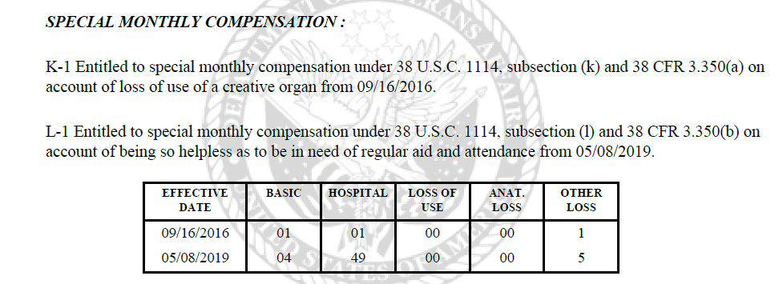

Additionally, the latest Rating Codesheet will indicate if the Veteran is in receipt of A&A at the R-1 or R-2 level, where a reduction is necessary regardless of the disabilities involved:

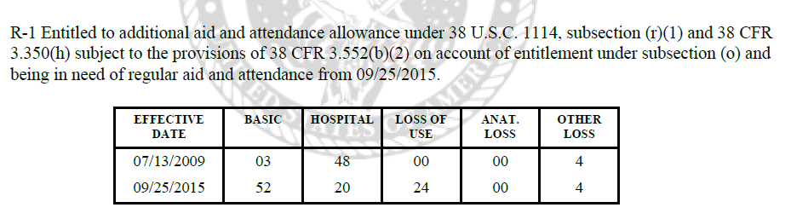

**If a Reduction is Not Necessary**

If a reduction is not necessary:

1. Clear the EP 330
2. Leave a note in VBMS that explains why no adjustment was necessary
3. Take no further action

**If a Reduction is Necessary - Notice of Proposed Adverse Action**

If the reduction is necessary:

1. Change the EP 330 to an EP 320 – *Review Due to Hospitalization* and clear the EP 320.
2. Establish an EP 600 – Hospital Adjustment
3. Prepare a notice of proposed adverse action (due process) – send one copy to the institution where the Veteran is hospitalized and another copy to the Veteran’s address of record.
4. Set suspense for 65 days.
5. When due process has expired, reduce the SMC to the Housebound or other appropriate hospitalized rate.

All notices of proposed adverse action for hospitalization must include the following statement, either at the bottom of the notice of proposed adverse action, or on an attached *VA Form 21-4138, Statement in Support of Claim*:

*I was admitted to the* ***[hospital’s name]*** *on* ***[admission date]****.*

*Please reduce my payments to the proper rate authorized by law immediately without awaiting expiration of the due process period.*

Request the Veteran sign and return the notice or form.

When either the 65-day due process period has expired or the Veteran has requested action, reduce the compensation to the Housebound or other appropriate hospitalized rate immediately.

*Note:* See Attachment E: Due Process Letter – PCGL PP4, for an example letter.

**VBMS-A Steps for Reduction**

From the **Record Decisions** screen, click on the **Institutionalizations** tab:

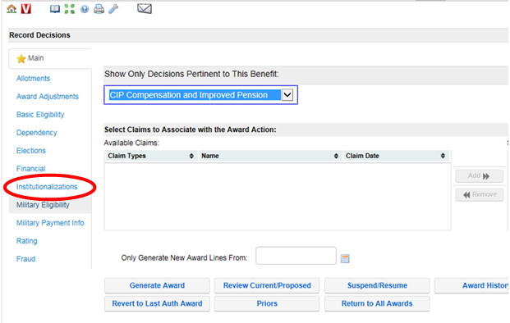

The first screen displayed is the Institutionalizations screen where information regarding the type, location, and date of institutionalization can be recorded.

1. Click **Add**
2. Select the **Institution Type/Event**
3. For VA hospitalizations, select the **State** in which the Veteran is hospitalized
4. Select the **VHA Facility**
5. The **Institution** name will be system populated for VHA admission
6. Enter the **From** and **To** dates as necessary
7. Click **Accept** to update the screen
8. Click **Adjust** to open the second screen where the details regarding the decision to adjust benefits are recorded

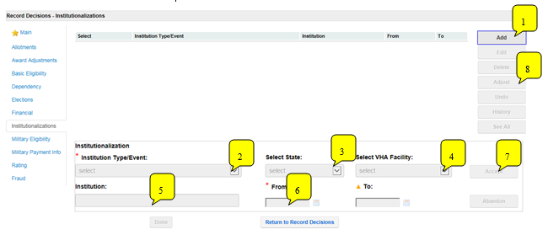

Upon selection of the Adjust button, the second Institutionalization Adjustments Screen will display. This screen is where the type of adjustment is recorded.

1. Note that the details of the institutionalization are shown in the upper part of the screen.
2. Click **Add**
3. Select the **Adjustment Type**
4. The **From** and **To** dates will be system populated based on the begin date and end date of the institutionalization and the adjustment type recorded; verify accuracy
5. Click **Accept** to update the screen
6. Select **Done** to save the decision and close the Institutionalization Adjustments screen (then click Done on the Institutionalizations screen to return to Record Decisions)

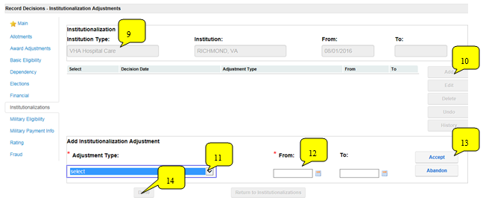

**Send Final Notice**

Complete the final notice to inform the Veteran that compensation has been reduced to the Housebound or other appropriate hospitalized rate.

* Be sure to include the new rates as well as the effective dates in the notification letter
* Check Capri to see if the Veteran remains hospitalized
  + If the Veteran has not yet been discharged, request that the Veteran notify the VA upon discharge so A&A benefits can be reinstated
* Include applicable laws and regulations for compensation hospital adjustments: e.g. 38 CFRs §3.105(e), §3.350, §3.552, and §3.556

*Note:* See Attachment F: Hospital Adjustment Decision Notice – PCGL PP5, for an example letter.

**VSR Assistant – Electronic Performance Support System (EPSS)**

The VSR Assistant Electronic Performance Support System (EPSS) is a tool that is available to aid in reinforcement as well as just-in-time training of complex claims processes. The advantages of using the EPSS are:

* Reduces level of complexity of multi-step claims
* Provides performance support information as a VSR performs a task
* Provides decision support that enables a VSR to identify the action that is appropriate for a particular set of conditions
* Includes calendars and calculators to assist in certain determinations

*Note:* Always verify information within the VSR Assistant with the M21-1, Adjudication Procedures Manual, and M21-4 Manual, as it is constantly being updated.

Attachment A: VA Form 10-7131

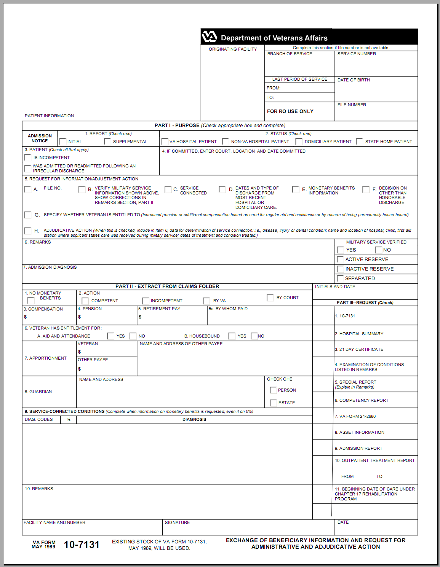

Attachment B: VA Form 10-7132

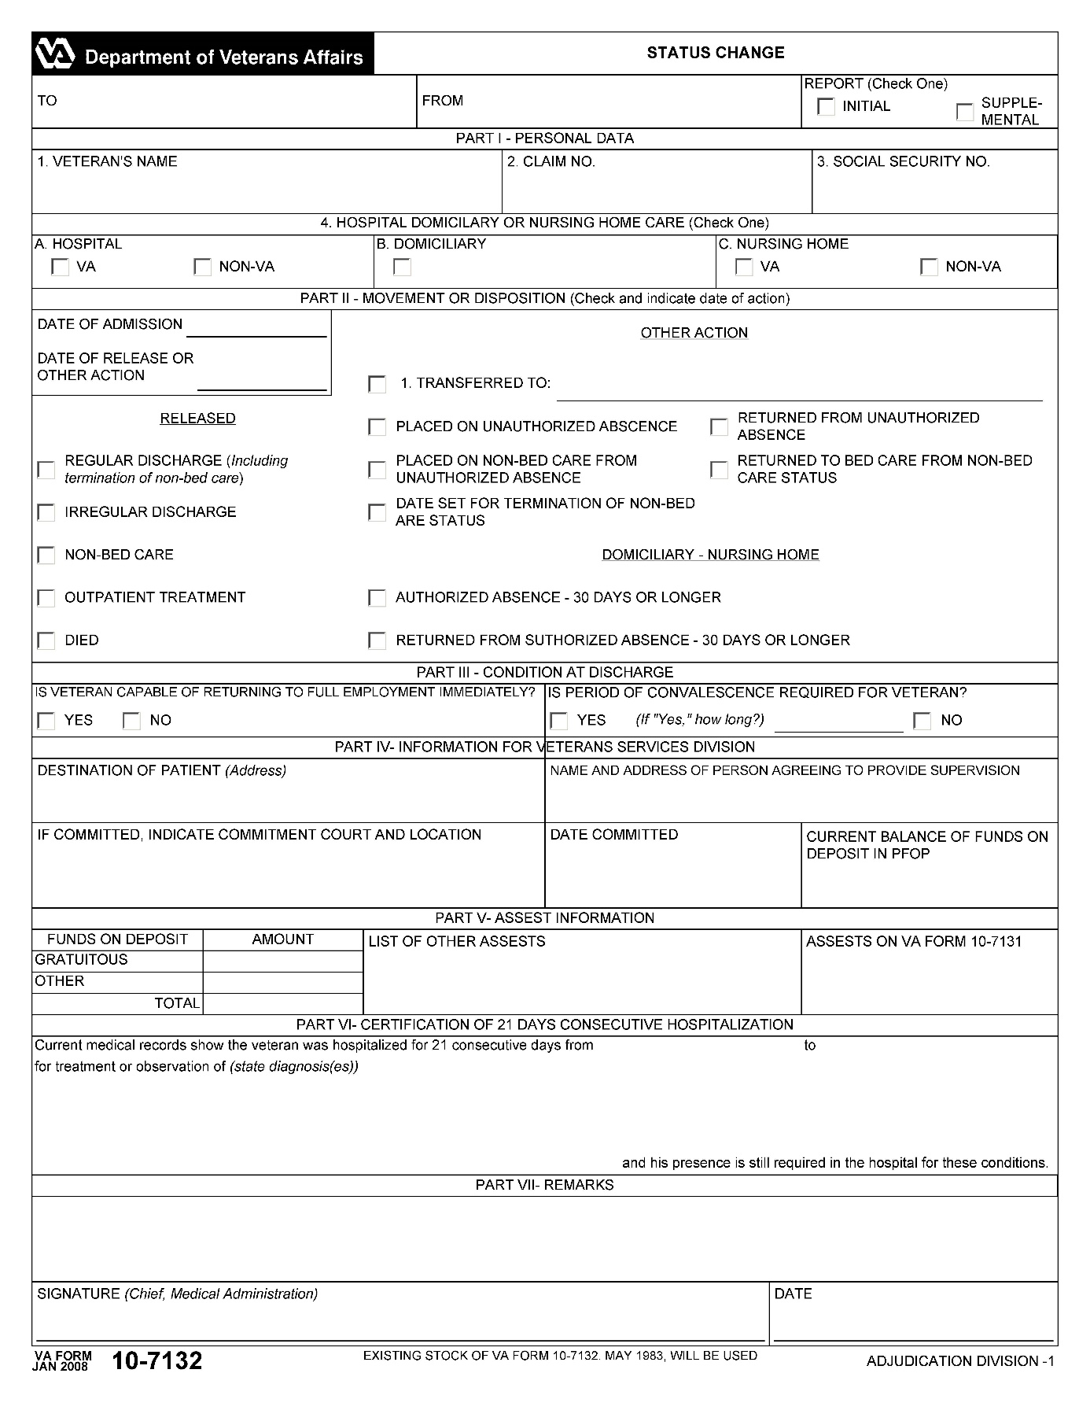

Attachment C: Reduction Chart

|  |  |
| --- | --- |
| **Reduction Chart**  ***38 CFR §3.552 A/A Reduction*** | |
| **Month Admitted** | **Month Reduced** |
| Jan | Mar |
| Feb | Apr |
| Mar | May |
| Apr | Jun |
| May | Jul |
| Jun | Aug |
| Jul | Sep |
| Aug | Oct |
| Sep | Nov |
| Oct | Dec |
| Nov | Jan |
| Dec | Feb |

Attachment D: Topic 1 Knowledge Check - Hospital Adjustment Provisions

Instructions: Take about five minutes to answer the following questions.

1. A Veteran is in receipt of SMC A&A and was hospitalized (initial hospitalization) at VA expense from 2/1/2019 until 9/9/2019.
2. What is the date of reduction of SMC from A&A to the Housebound or other appropriate hospitalized rate?
3. What is the date A&A will resume?
4. If the Veteran suffered from Hansen’s disease, would the reduction of benefits occur? Explain your answer.
5. What are the four sources of notification from the VAMC that a Veteran has been hospitalized?

Attachment E: Hospital Adjustment Due Process Letter – PCGL PP4

The sample letter below was generated using PCGL with additional changes. Be sure to always proofread and check the letter for formatting prior to release to the Veteran.

Directions for PCGL

1. On the Environment and Configuration screen:
   1. BDN Data Availability Mode: choose VETSNET Data
   2. Selection of Letter Type – CENTAL: choose C and P
   3. Click OK
2. PCGL Letter Type Selection Menu: choose PP4 Pre: Hosp – Reduce A/A - All
3. Ensure that the following verbiage and enclosures, including the additional notice to the Veteran, is correct

**IMPORTANT -- reply needed within 60 days**

Dear Mr./Ms. Veteran,

Our VA Medical Center in CITY told us you were admitted for treatment on DATE OF ADMISSION (spell out date).

**What We Propose to Do**

We plan to reduce the special monthly aid and attendance allowance, included in your payments, to the housebound rate because this care continued more than one full calendar month. The laws allowing payment of the special monthly amount you receive require this action.

This adjustment will result in an overpayment of benefits which have been paid to you. If the proposed action is implemented, you will be notified of the exact amount of the overpayment and given repayment information.

We propose to reduce your monthly benefit payments effective the first day of the second month following your admission date, as follows:

|  |  |  |  |
| --- | --- | --- | --- |
| **Old Monthly**  **Entitlement Amount** | **New Monthly**  **Entitlement** | **Payment Change Date** | **Reason for Change** |
| $X,XXX.XX | $X,XXX.XX | Date of Reduction | Special Monthly Compensation Adjustment |
| X,XXX.XX | X,XXX.XX | Date of Release | Special Monthly Compensation Adjustment |

We won't do anything to reduce your benefits for 60 days unless you ask us to reduce them now.

We're giving you this time so that you can show us why we shouldn't reduce your compensation back to {enter date reduction will take place}.

**This action may create an overpayment**

**When and Where to Send the Information or Evidence**

If you want us to take immediate action to reduce your payments to the proper rate as authorized by law, please complete each item that applies to you on the enclosed VA Form 21-4138, *Statement in Support of Claim*. Please return the form ***right away.*** If we don't hear from you within 60 days, we must reduce your payments from{enter date reduction will take place}.

Please note that the quickest, easiest, and most secure way to submit any documents to us is via the eBenefits website. Just visit www.eBenefits.va.gov to register. Please also refer to the ‘What is eBenefits?’ section of this letter for more information.

You can also send what we need to the appropriate address listed on the attached *Where to Send Your Written Correspondence* chart.

**How Submitting Evidence May Affect Payments**

Your payments will continue at the present rate for 60 days following the date of this notice so that you may, if you wish, submit evidence to show that the proposed action should not be taken. You may submit evidence in person, through the mail or through your accredited representative.

If you wait more than 60 days to submit evidence, we will carefully consider whatever you submit, but the adjustment of benefits described above will already have gone into effect and your adjusted benefits will continue while we review the additional evidence.

Please mail or fax all responses to the appropriate address listed on the attached *Where to Send Your Written Correspondence* chart.

**How to Minimize a Potential Overpayment**

You should be aware that if you continue to accept payments at the present rate for the next

60 days and we then determine to make the proposed adjustment, you will have to repay all or a part of the benefits you have received during the 60 days. You may minimize this potential overpayment by sending us a written statement asking that, beginning with your next check, we reduce your payments while we review your case. If you make this request and, at the end of 60 days, our review shows that you should have received the higher rate, we will restore the full rate from the date on which it was reduced.

**How to Obtain a Personal Hearing**

If you desire a personal hearing to present evidence or argument on any point in your claim, notify this office and we will arrange a time and place for the hearing. If you want, you may bring witnesses and their testimony will be entered in the record. VA will furnish the hearing room and provide hearing officials. VA cannot pay for any other expenses of the hearing since a personal hearing is held only on your request.

If, within 30 days from the date of this notice, VA receives your hearing request, we will continue payments at the present rate until we have held the hearing and reviewed the testimony. Continuing to receive the current rate of payment until a hearing is conducted could result in the creation of an overpayment, which you must repay. If you request a hearing but wish to minimize any overpayment which could result, you should submit a statement asking that we reduce or suspend your benefits beginning with your next check.

You may request a hearing after 30 days; however, we may continue with our proposed action.

**How to Obtain Representation**

An accredited representative of a Veterans' organization or other service organization recognized by the Secretary of Veterans Affairs may represent you, without charge. An accredited agent or attorney may also represent you. However, an accredited agent or attorney may only charge you for services performed in support of your decision review, either a notice of disagreement, supplemental claim, or higher-level review. If you desire representation, let us know and we will send you the necessary forms. If you have already designated a representative, no further action is required on your part.

**What is eBenefits?**

eBenefits provides electronic self-service resources to Service members, Veterans, and their families. Use of these resources often helps us serve you faster! Through the eBenefits website you can:

* Submit claims for benefits and/or upload documents directly to VA
* Request to add or change your dependents
* Update your contact and direct deposit information and view payment history
* Request a Veterans Service Officer to represent you
* Track the status of your claim or appeal
* Obtain verification of military service, civil service preference, or VA benefits
* And much more!

Enrolling in eBenefits is easy. Just visit www.eBenefits.va.gov for more information. If you submit a claim in the future, consider filing through eBenefits. Filing electronically, especially if you participate in our fully developed claim program, may result in a faster decision than if you submit your claim through the mail.

**If You Have Questions or Need Assistance**

If you have any questions or need assistance with this claim, you may contact us by telephone, email, or letter.

|  |  |
| --- | --- |
| **If you** | **Here is what to do.** |
| Telephone | Call us at 1‑800‑827‑1000. If you use a Telecommunications Device for the Deaf (TDD), the Federal number is 711. |
| Use the Internet | Send electronic inquiries through the Internet at https://iris.custhelp.va.gov. |
| Write | VA now uses a centralized mail system. For all written communications, put your full name and VA file number on the letter. Please mail or fax all written correspondence to the appropriate address listed on the attached Where to Send Your Written Correspondence chart, below |

In all cases, be sure to refer to your VA file number XXXXXXXXX.

If you are looking for general information about benefits and eligibility, you should visit our web site at https://www.va.gov, or search the Frequently Asked Questions (FAQs) at https://iris.custhelp.va.gov.

We sent a copy of this letter to your representative, {POA}, because you appointed them as your representative. If you have questions or need assistance, you can also contact them.

We look forward to resolving this issue in a fair and timely manner.

Sincerely Yours,

RO Director

VA Regional Office

Enclosure(s): Where to Send Written Correspondence

VA Form 21-0790

VA Form 21-4138

cc: {POA}

{Place the following statement at the bottom of the notice of proposed adverse action **or** on an attached *VA Form 21-4138*, *Statement in Support of Claim*.}:

Name____________________________ VA File # _______________________

I was admitted to the _________________________________ VA Medical Center (VAMC) on

______________________ (date).

Please take action without awaiting expiration of the due process period to reduce my payments to the proper rate authorized by law.

_________________________________ __________________________

*Signature*  *Date*

Attachment F: Hospital Adjustment Decision Notice – PCGL PP5

Dear Mr./Ms. Veteran:

Our VA Medical Center in {City of VAMC} confirms they admitted you for treatment on {Date of Admission}, and said you are still there/were released on {Date of Release}.

In our letter of {Date of Due Process Letter} we told you that the law requires us to reduce your Compensation benefit after one full calendar month of treatment at VA expense. We have taken final action in accordance with that proposal.

We have restored your aid and attendance allowance on {Date of Release}, the date of your release from the VA Medical Center.

OR

We will restore your aid and attendance allowance beginning the date of release. Please notify us when you have been released from the hospital.

**Applicable laws and regulations:** 38 CFR 3.105(e), 38 CFR 3.350, 38 CFR 3.552, and 38 CFR 3.556

|  |  |  |  |  |  |
| --- | --- | --- | --- | --- | --- |
| ***Note:*** On the letter closing logic screen select **002t** for payment chart or **002tw** for payment chart with withholding. | | | | | |
| **Total VA Benefit** | **Amount Withheld** | **Amount Paid** | **Effective Date** | **Reason for Change** |
| $X,XXX.XX | $XXX.XX | $X,XXX.XX | Date of Reduction | Special Monthly Compensation Adjustment |
| $X,XXX.XX | $XXX.XX | $X,XXX.XX | Date of Release [if applicable] | Special Monthly Compensation Adjustment |

**What You Owe**

We've reviewed evidence in your case and found that we've overpaid your benefits. A separate initial proposal letter will tell you more about the overpayment. VA's Debt Management Center will also send you a letter explaining how much you've been overpaid, as well as how to repay this debt. We know managing a new debt can be difficult, but we'd like to work with you on some options that can help. We encourage you to visit www.mymoney.gov and www.consumer.gov for helpful financial information.

**What You Should Do If You Disagree with Our Decision**

If you do not agree with this decision, you have one year from the date of this letter to select a review option to preserve your earliest effective benefit date. The review options and their proper applications are as follows, for a(n):

* **Supplemental Claim**, complete **VA Form 20-0995***, Decision Review Request: Supplemental Claim*.
* **Higher-Level Review**, complete **VA Form 20-0996***, Decision Review Request: Higher-Level Review*.
* **Appeal to the Board**, complete **VA Form 10182***, Decision Review Request: Board Appeal (Notice of Disagreement)*.

Please see the enclosed VA Form 20-0998, *Your Rights to Seek Further Review of Our Decision*. It explains your options for an additional review. You may obtain any of the required application by down loading them from www.va.gov/vaforms/ or by contacting us. You can also learn more about the disagreement process at www.va.gov/decision-reviews. If you would like to obtain or access evidence used in making this decision, please contact us as noted below. Some evidence may be obtained by signing in at www.va.gov.

**What Is eBenefits?**

eBenefits provides electronic resources in a self-service environment to Service members, Veterans, and their families. Use of these resources often helps us serve you faster! Through the eBenefits website you can:

* Submit claims for benefits and/or upload documents directly to the VA
* Request to add or change your dependents
* Update your contact and direct deposit information and view payment history
* Request a Veterans Service Officer to represent you
* Track the status of your claim or appeal
* Obtain verification of your military service, civil service preference, or VA benefits
* And much more!

Enrolling in eBenefits is easy. Just visit www.eBenefits.va.gov for more information. If you submit a claim in the future, consider filing through eBenefits. Filing electronically, especially if you participate in our fully developed claim program, may result in faster decision than if you submit your claim through the mail.

**If You Have Questions or Need Assistance**

If you have any questions, you may contact us by telephone, e-mail, or letter.

|  |  |
| --- | --- |
| **If you** | **Here is what to do.** |
| Telephone | Call us at 1‑800‑827‑1000. If you use a Telecommunications Device for the Deaf (TDD), the Federal number is 711. |
| Use the Internet | Send electronic inquiries through the Internet at https://iris.custhelp.va.gov. |
| Write | VA now uses a centralized mail system. For all written communications, put your full name and VA file number on the letter. Please mail or fax all written correspondence to the appropriate address listed on the attached Where to Send Your Written Correspondence chart, below. |

In all cases, be sure to refer to your VA file number XXX XX XXXX.

If you are looking for general information about benefits and eligibility, you should visit our website at https://www.va. custhelp.gov, or search the Frequently Asked Questions (FAQs) at https://iris.va.gov.

We sent a copy of this letter to your representative, {POA}, whom you can also contact if you have questions or need assistance.

Sincerely yours,

RO Director

VA Regional Office

Enclosure(s): Where to Send Your Written Correspondence

VA Form 20-0998

cc: {POA}

Attachment G: Topic 2 Knowledge Check - Processing Hospital Adjustments

Instructions: Take about five minutes to answer the following questions.

1. If it is determined that a hospitalized Veteran should have their benefits reduced to the Housebound or other appropriate hospitalized rate, which EP is established for the due process letter and finalization of the claim?
2. If a Veteran is hospitalized, how many copies of the notice of proposed adverse action should we send? Where should the notice(s) be sent?
3. What should be added to the final notice when the Veteran has not yet been discharged from the hospital?