Pension and fiduciary service

PMC VSR Advanced Core Course

Phase 5: Stages of a Claim  
Part 1: Determine Eligibility

Lesson 14: Determine Dependency Eligibility: Helpless Child

Trainee Guide

October 28, 2016

Version 1.0

Determine Dependency Eligibility: Helpless Child

Lesson Overview

| Topic | Description |
| --- | --- |
| Time Estimate: | 2 hours |
| Purpose of the Lesson: | This lesson is part of the entry-level curriculum, Core Course for PMC VSRs. The purpose of this lesson is to prepare PMC VSRs to determine if a claimant meets the eligibility requirements of a helpless child of a Veteran. |
| Prerequisite Training Requirements: | Prior to taking the Determine Dependency Eligibility: Helpless Child lesson, you must complete PMC VSR Core Course Phases 1–4, and Phase 5, Part 1, lessons 1–13. (Refer to the **Master Course Map** learning aid for a list of lessons.) |
| Target Audience: | This lesson is for entry level PMC VSRs. |
| Lesson References: | * **Master Course Map** learning aid * Compensation and Pension Knowledge Management (CPKM) * 38 CFR 3.315(a) (Child Over 18 Years) * 38 CFR 3.356 (Conditions Which Determine Permanent Incapacity for Self-Support) * 38 CFR 3.57 (Child) * M21-1 III.iii.5.F (Establishing a Child’s Age and Relationship) * M21-1 III.iii.5.G (Establishing a Biological Child, Adopted Child, or Step, as a Veteran’s Child for Department of Veterans Affairs (VA) Purposes) * M21-1 III.iii.7 (A Child’s Permanent Incapacity for Self-Support) |
| Technical Competencies: | * Program Benefits and Eligibility (PMC VSR) * Processing Claims (PMC VSR) * VBA Applications (PMC VSR) |
| Knowledge Check: | Phase 5: Stages of a Claim, Part 1(b): Determine Basic Eligibility Knowledge Check |
| Lesson Objectives: | * Determine dependency eligibility for a helpless child of a Veteran.   + Define helpless child for VA purposes.   + Determine dependency eligibility requirements for a helpless child of a Veteran.   + Determine whether claim is ready to rate for helpless child.   + Determine what to develop for a helpless child of a Veteran. |
| What You Need: | * Trainee guide * **Master Course Map** learning aid * **Dependency Eligibility Requirements** job aid in the VSR assistant * Access to VBA Intranet * Access to CPKM |

| PowerPoint Slides | Notes | |
| --- | --- | --- |
| Lesson 14: Determine Dependency Eligibility: Helpless Child |  | |
| You Are Here  Vertical flowchart with two columns showing the parts of Phase 5 highlighting Phase 5 Part 1 and a branch from Phase 5 Part 1 showing its subparts. In the left column, starting from the top, the phases are: Phase 5 Part 1, Determine Eligibility; Phase 5 Part 2, Process a Claim; Phase 5 Part 3, Promulgate Non-rating or rating Decision; Phase 5 Part 4, Prepare Decision Notice; and Phase 5 Part 5, Award Adjustment.  The highlighted Phase 5 Part 1 branches to the right column of the flowchart showing its subparts and highlighting Part 1b. From the top, the subparts are: Phase 5 Part 1a, Initial Screening and Establish a Claim Phase 5 Part 1b, Basic Eligibility; Phase 5 Part 1c, Income Eligibility; and Phase 5 Part 1d, Beyond Basic Eligibility and Ready to Rate. |  | |
| Why It Matters!  Determining Basic Eligibility   * Administrative Decisions * Establish Veteran Status * Determine if Veteran Meets Presumptive Criteria for Permanent and Total Disability * Determine Dependency Eligibility: Spouse * Determine Dependency Eligibility: Child * **Determine Dependency Eligibility: Helpless Child** * Determine Dependency Eligibility: Parent |  | |
| Ice Breaker Activity  **Title: DEMO Icon - Description: DEMO Icon**   * **What is the age of the child/children?** * **What is the relationship to the Veteran?** * **Does the form indicate that the child is helpless?** * **What other important information can you derive from this form?** |  | |
| Technical Competencies   * Program Benefits and Eligibility (PMC VSR) * Processing Claims (PMC VSR) * VBA Applications (PMC VSR) |  | |
| Lesson Objectives  Determine dependency eligibility for a helpless child of a Veteran.   * Define helpless child for VA purposes. * Determine dependency eligibility requirements for a helpless child of a Veteran. * Determine whether claim is ready to rate for helpless child. * Determine what to develop for a helpless child of a Veteran. |  | |
| Knowledge Check  Vertical flowchart showing the four subparts of Phase 5 Part 1 of the PMC VSR course with the corresponding Knowledge Checks. Phase 5 Part 1b Knowledge Check is highlighted. From the top, the subparts are: Phase 5 Part 1a, Initial Screening and Establish a Claim (CEST); Phase 5 Part 1b, Basic Eligibility; Phase 5 Part 1c, Income Eligibility; and Phase 5 Part 1d, Beyond Basic Eligibility and Ready to Rate. |  |
| **Relationship and Dependency**  Whiteboard with hand writing. Relationship: Can the individual be recognized by VA as the Veteran’s child?  Dependency: If VA establishes that an individual is the child of a Veteran, VA assumes the child is financially dependent on the Veteran. |  |

Whiteboard with hand writing. Relationship: Can the individual be recognized by VA as the Veteran’s child? 
Dependency: If VA establishes that an individual is the child of a Veteran, VA assumes the child is financially dependent on the Veteran. 


| PowerPoint Slides | Notes | |
| --- | --- | --- |
| **What Is a Helpless Child for VA Purposes?**  **A helpless child is a Veteran’s child who is permanently incapable of self-support** through his/her own efforts due to physical or mental disabilities. |  |
| **What Is a Helpless Child for VA Purposes? Answers**   * A helpless child has to be ***rated*** by the rating team and requires evidence to support the permanent incapacity for self-support * A helpless child must be shown to be permanently incapable of self-support by reason of mental or physical defect at the date of attaining the age of 18 years |  |
| Age Requirement for Helpless Child  What is the age requirement for a helpless child? |  |
| Age Requirement for Helpless Child Answers  What is the age requirement for a helpless child? |  |
| Dependency Eligibility—Helpless Child  What are the dependency eligibility requirements for a child that also apply to a helpless child? |  |
| Dependency Eligibility—Helpless Child Answers  What are the dependency eligibility requirements for a child that also apply to a helpless child? |  |
| Dependency Eligibility—Helpless Child Example  **Example:** Cindy Chapps is 20 years old and her mother is applying for DIC benefits. Cindy submitted VA Form 21-534EZ to show she was the Veteran’s stepchild at the time of the Veteran’s death. On section IV of VA Form 21-534EZ, a check indicates that Cindy is seriously disabled. Evidence of record shows Cindy was already established as a dependent on the Veteran’s award at the time of his death.   * What dependency eligibility requirements for a child may apply to this helpless child example? * **Where on the** VA Form 21-534EZ **would indicate the child is helpless?** |  |
| Dependency Eligibility—Helpless Child Example Answers   * What dependency eligibility requirements for a child may apply to this helpless child example? * **What item on the** VA Form 21-534EZ **would indicate the child is helpless?** |  |
| Dependency Eligibility—Helpless Child Demonstration  DEMO Icon   * VA Form 21-534EZ (Application for DIC, Death Pension, and/or Accrued Benefits) section IV, item 28H, Seriously Disabled * VA Form 21-686c (Declaration of Status of Dependents) section III, item 14H, Seriously Disabled * VA Form 21p-0519C-1 (Improved Pension Eligibility Verification Report) item 1E, block 3, Disabled Child |  |
| Dependency Check   * It is important to make sure that **all** the evidence regarding dependency information is included with the claim. * If evidence is missing then develop for dependency related claim information. |  |
| ****Proof of Permanent Incapacity for Self-support****  **What are some example documents that may provide proof of permanent incapacity for self-support?** |  |
| Proof of Permanent Incapacity for Self-support Answers  **What are some documents that may provide proof of permanent incapacity for self-support?** |  |
| Facts Based on Personal Observation   * Statements from witnesses who have:   + Knowledge of the facts   + Observed the child’s condition as of 18 * Statements must conclude with:   + Name and signature of person making the statement   + Certification: "*I hereby certify that the information I have given above is true and correct to the best of my knowledge and belief*." |  |
| Facts Based on Personal Observation Answers  **Describe witnesses who could have knowledge of facts and could have observed the helpless child’s condition.** |  |
| ****Evidence Examples****  DEMO Icon |  |
| Is Helpless Child Information Complete?  **Example**: **VA received a pension application on VA Form 21-534EZ from a 40-year-old surviving child who claims he is incapable of self-support. The surviving child meets all the requirements to receive pension benefits. He submitted his birth certificate, which establishes him as the Veteran's child. The surviving child lists that he is living in an institution and submits medical evidence from his doctor, who indicates he has been incapable of self-support since he was under 18. The doctor also submits supporting medical evidence.**   * Is the helpless child information complete for the type of claim requested? |  |
| Is Helpless Child Information Complete Answers  Is the helpless child information complete for the claim requested? |  |
| Group Activity—Practice Exercise   * Instructions:   + Divide into groups of three.   + Review Claim 2, 3, and 4.   + Use the **Dependency Eligibility Requirements job aid** to determine if the helpless child meets the dependency eligibility requirements.   + Mark your answers based on the questions asked on the checklist.   + Provide the rationale for your decisions. * Time allowed: 10–15 minutes |  |

Group Activity: Practice Exercise

| Dependency Eligibility: Helpless Child **Checklist** | **Yes** | **No** |
| --- | --- | --- |
| * *Is the child identified on the VA Form as disabled?* |  |  |
| * *Is the child married?* |  |  |
| * *Is the child the Veteran’s biological, step, or adopted child?*   If yes, list _____________________________ |  |  |
| * *Has supporting evidence been provided?* |  |  |
| * *Is the child information complete?* |  |  |

| PowerPoint Slides | Notes | |
| --- | --- | --- |
| Group Activity—Practice Exercise Answers  Dependency eligibility: helpless chlid checklist |  |
| Ready to Rate for Helpless Child   * Is there evidence of prior designation of helpless child under Veteran or Survivors award? * Is the medical evidence of record sufficient for the child to be rated? * Is the claim for Veterans Pension, Survivors Pension, or DIC? |  |
| Helpless Child Prior Designation  SHARE Screen showing the column where the helpless child would be indicated. |  |

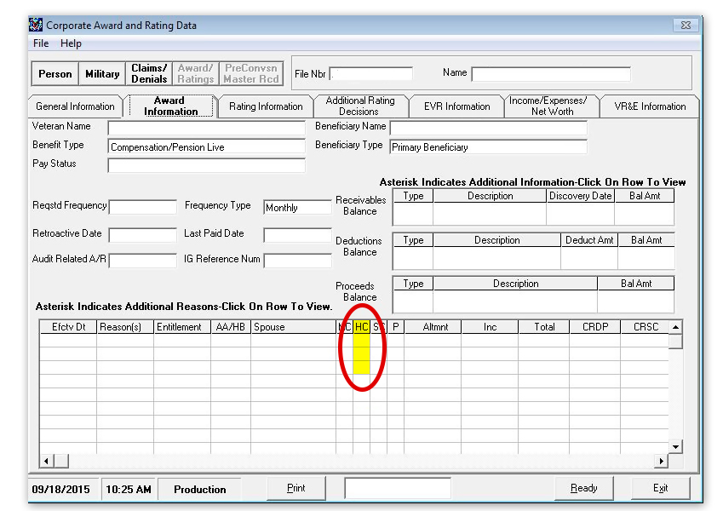

| PowerPoint Slides | Notes | |
| --- | --- | --- |
| Sufficient Medical Evidence   * What are some examples of sufficient evidence? (Hint: discussed early in lesson) * What are some examples of insufficient evidence? |  |
| Sufficient Medical Evidence Answers   * What are some examples of sufficient evidence? (Hint: discussed early in lesson) * What are some examples of insufficient evidence? |  |
| Sufficient Medical Evidence Missing  **If the medical evidence is missing then go to develop for missing or additional evidence.** |  |
| Helpless Child Veterans Pension  **A helpless child is a dependent for the purpose of determining monthly payments for the Veteran’s pension award**. |  |
| Helpless Child Survivors Pension  **Additional allowance is payable for a child permanently incapable of self-support if the surviving spouse is receiving Survivors Pension.** |  |
| Helpless Child DIC  **A helpless child will be on a separate award in his or her own right even if the surviving spouse has custody of the child and is receiving DIC benefits.** |  |
| Is Claim Ready to Rate?   * Is the **Veteran’s or Survivors Pension claim ready to rate?** * **Is the DIC claim ready to rate?** |  |
| Is Claim Ready to Rate? Answers   * Is the **Veteran’s or Survivors Pension claim ready to rate?** * **Is the DIC claim ready to rate?** |  |
| Ready to Rate Demonstration  DEMO Icon |  |
| **Questions?**  This icon prompts you to ask trainees a discussion question or to ask trainees if they have any questions before proceeding with instruction. |  |
| **Lesson Summary**   * How is helpless child dependency determined? * What are the eligibility requirements for a helpless child? * How do you determine if the helpless child claim is ready to rate? |  |
| **What’s Next**  Phase 5 Part 1, Lesson 15: Establish Parental Relationship for DIC |  |