Pyramiding
Instructor Lesson Plan
Time Required: 0.5 Hours

Table of Contents

Lesson Description 2
Pyramiding 4
Topic: Pyramiding 5

Lesson Description
The information below provides the instructor with an overview of the lesson and the materials that are required to effectively present this instruction.
TMS # | 4189213
Prerequisites | Trainees should have completed the Challenge IWT portion of their training prior to taking this basic refresher.
target audience | The target audience for Pyramiding is entry level RVSRs in their residency portion of their training.
Time Required | 0.5 hour
Materials/  TRAINING AIDS | Lesson materials:  - Pyramiding PowerPoint Presentation
Training Area/Tools | The following are required to ensure the trainees are able to meet the lesson objectives:  - Classroom or private area suitable for participatory discussions  - Seating, writing materials, and writing surfaces for trainee note taking and participation  - Handouts, which include a practical exercise  - Large writing surface (easel pad, chalkboard, dry erase board, overhead projector, etc.) with appropriate writing materials  - Computer with PowerPoint software to present the lesson material
Pre-Planning | - Become familiar with all training materials by reading the Instructor Lesson Plan while simultaneously reviewing the corresponding PowerPoint slides. This will provide you the opportunity to see the connection between the Lesson Plan and the slides, which will allow for a more structured presentation during the training session.  - Become familiar with the content of the trainee handouts and their association to the Lesson Plan.  - Practice is the best guarantee of providing a quality presentation. At a minimum, do a complete walkthrough of the presentation to practice coordination between this Lesson Plan, the trainee handouts, and the PowerPoint slides and ensure your timing is on track with the length of the lesson.  - Ensure that there are copies of all handouts before the training session.  - When required, reserve the training room.  - Arrange for equipment such as flip charts, an overhead projector, and any other equipment (as needed).  - Talk to people in your office who are most familiar with this topic to collect experiences that you can include as examples in the lesson.  - This lesson plan belongs to you. Feel free to highlight headings, key phrases, or other information to help the instruction flow smoothly. Feel free to add any notes or information that you need in the margins.
Training Day | - Arrive as early as possible to ensure access to the facility and computers.  - Become familiar with the location of restrooms and other facilities that the trainees will require.  - Test the computer and projector to ensure they are working properly.  - Before class begins, open the PowerPoint presentation to the first slide. This will help to ensure the presentation is functioning properly.  - Make sure that a whiteboard or flip chart and the associated markers are available.  - The instructor completes a roll call attendance sheet or provides a sign-in sheet to the students. The attendance records are forwarded to the Regional Office Training Managers.

Pyramiding
INSTRUCTOR INTRODUCTION |  | Complete the following:  - Introduce yourself  - Orient learners to the facilities  - Ensure that all learners have the required handouts
time required |  | 0.5 hours
Purpose of Lesson  Explain the following: |  | This “refresher” lesson is intended to provide a review the considerations for pyramiding. It is an effective complement to the lesson on Rating Schedule 4.1-4.31, which is taught in week two.
Lesson Objectives  Discuss the following:  Slide 2 | Given the available references, the trainee will be able to identify the regulations and manual references associated with pyramiding to properly evaluate a rating with 98 % accuracy.
Motivation
STAR Error code(s) | C2
References  Slide 3-4 | Explain where these references are located in the workplace.  All M21-1 references are found in the Live Manual Website.  - 38 CFR§4.14 - Avoidance of Pyramiding  - 38 CFR§4.55 - Principles of Combined Ratings for Muscle Injuries  - 38 CFR§4.96 - Special Provisions Regarding Evaluation of Respiratory Conditions  - 38 CFR 4.97 Respiratory System  - 38 CFR§4.113 - Coexisting Abdominal Conditions  - M21-1, Part III, Subpart iv, 4.A - Musculoskeletal Conditions  - M21-1, Part III, Subpart iv, 4.D.1 - Respiratory Conditions  - M21-1, Part III, Subpart iv 6.C Completing the Rating Decision Narrative  - Decision Assessment Document (DAD), Esteban v. Brown, No. 92-693 - Pyramiding

Topic: Pyramiding
38 CFR 4.14  Slide 5 | EXPLAIN this is the regulation as written.  ASK the trainees what this means.  The evaluation of the same disability under various diagnoses is to be avoided. Disability from injuries to the muscles, nerves, and joints of an extremity may overlap to a great extent, so that special rules are included in the appropriate bodily system for their evaluation.  Both the use of manifestations not resulting from service-connected disease or injury in establishing the service-connected evaluation and the evaluation of the same manifestation under different diagnoses are to be avoided.
Esteban v. Brown  Slide 6 | EXPLAIN that separate evaluation would not be pyramiding if the symptoms indicate distinct functional impairments.  EMPHASIZE that the evaluation builder is programmed to assist with many of these evaluations (ie. skin/scars).  EXPLAIN that we must always be careful to use a symptom only once to avoid pyramiding.
Points to Consider  Slide 7 | EXPLAIN that we should review the evidence of record for objective symptoms.
Points to Consider  Slide 8 | EXPLAIN that using each symptom only once, the most accurate diagnostic code or codes are selected to evaluate the disability.
Points to Consider  Slide 9 | EMPHASIZE that it is important to be aware that the symptomology/manifestations of a disability may overlap diagnostic codes.
Points to Consider  Slide 10 | EMPHASIZE that we need to consider if there are any prohibitions against having separate disabilities with overlapping symptoms, as outlined in our regulations.
Examples  Slide 11 | REVIEW the examples shown with the trainees, showing the rating criteria if necessary.  - Painful Scars vs. Scar Measurements  - Limited Motion of the Spine vs. Radiculopathy  - Residuals Of TBI vs. Headaches, Ptsd, Tinnitus
Remember  Slide 12 | - EXPLAIN to the trainees that some body systems address the issue of pyramiding within the regulation. For example respiratory – 4.96 and digestive – 4.114 (examples of which are on the next slide).

Rating Schedule  Slide 13 | REVIEW the special provisions with the trainees.  §4.96 Special provisions regarding evaluation of respiratory conditions.  (a) Rating coexisting respiratory conditions. Ratings under diagnostic codes 6600 through 6817 and 6822 through 6847 will not be combined with each other. Where there is lung or pleural involvement, ratings under diagnostic codes 6819 and 6820 will not be combined with each other or with diagnostic codes 6600 through 6817 or 6822 through 6847. A single rating will be assigned under the diagnostic code which reflects the predominant disability with elevation to the next higher evaluation where the severity of the overall disability warrants such elevation. However, in cases protected by the provisions of Pub. L. 90-493, the graduated ratings of 50 and 30 percent for inactive tuberculosis will not be elevated.  §4.114 Schedule of ratings—digestive system.  Ratings under diagnostic codes 7301 to 7329, inclusive, 7331, 7342, and 7345 to 7348 inclusive will not be combined with each other. A single evaluation will be assigned under the diagnostic code which reflects the predominant disability picture, with elevation to the next higher evaluation where the severity of the overall disability warrants such elevation.
VBMS-R Conflicts Tab  Slide 14-16 | EXPLAIN to the trainees that should we inadvertently create a conflict in VBMS-R, the Conflicts tab is programmed to assist us with resolving those problems.  Instructor Note: Be prepared to discuss each of the slides (14-16) and what they represent within VBMS-R. If possible, provide a demonstration if needed of how to use the Conflicts tab. The example in the slides refers to GERD and IBS from the IWT e-case.  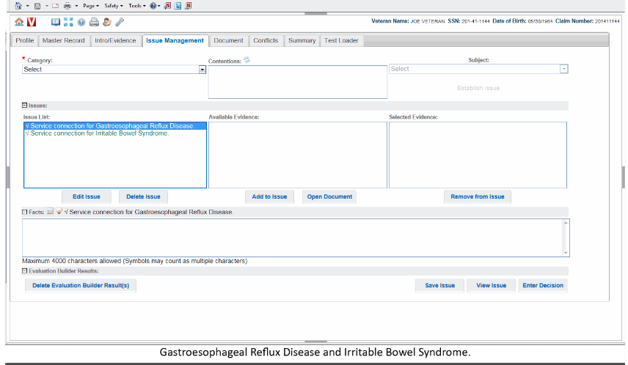
 | 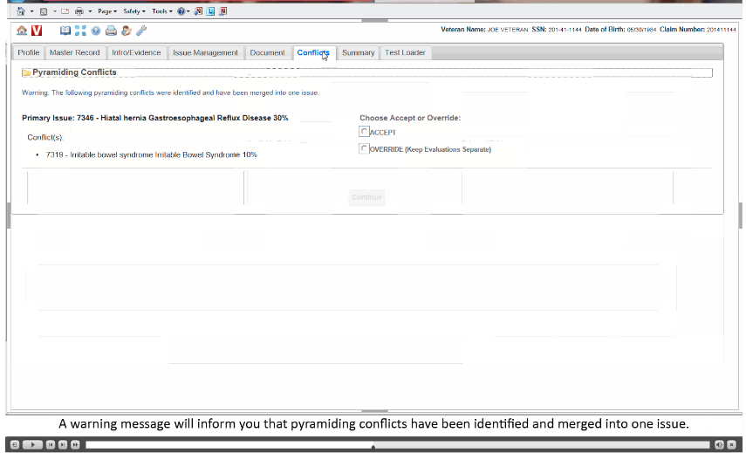
 | 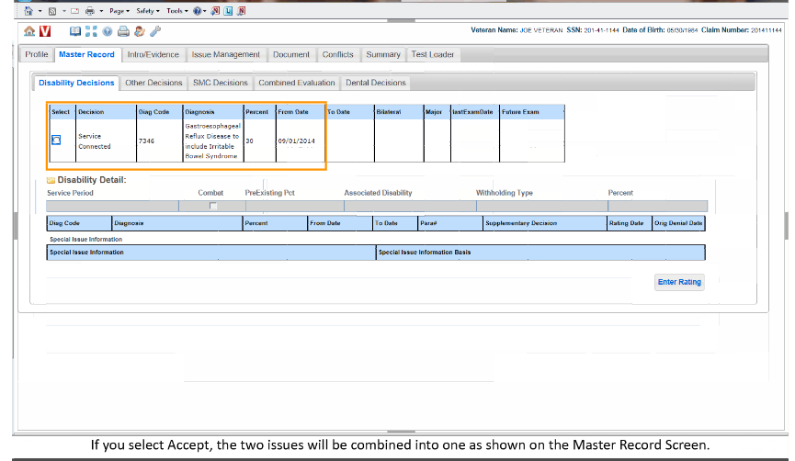
Questions  Slide 18 | ASK the trainees if they have any questions concerning the course of instruction. Answer questions as needed and conclude the class.

