Education Service
eBenefits
Lesson Plan
March, 2016
Version 1.0

Lesson Overview
Topic | Description
Time Estimate:
Purpose of the Lesson: | Today’s training will discuss the purpose of eBenefits, the services it provides, how to register for access, and what to do if technical issues arise.  The PowerPoint also serves as a visual guide that VA employees may use to assist claimants in navigating through various portions of the program.
Prerequisite Training Requirements: | None.
Target Audience: | ECCT
Lesson References: | - https://www.ebenefits.va.gov/  - eBenefits Help Desk Reference Guide, Release 3.3 – December 2011  - eBenefits for the Call Center Representative and Public Contact, TMS VA #3864696, 11/6/13  - Fraud/Privacy Violation Guidelines – Reportable Incidents, Procedural Guidance, FAQs, and Suggested Scripts
Lesson Objectives: | At the conclusion of this lesson, you will be able to:  - Recall characteristics and features of the eBenefits portal  - Differentiate between methods of obtaining Basic vs. Premium level eBenefits account access  - Recognize location of content within the eBenefits portal  - Recall education-specific features of eBenefits  - Identify actions when users report fraud and/or technical issues pertaining to eBenefits.
What You Need: | [Describe/list anything the instructor needs to successfully present the lesson including copies of handouts, equipment, case materials, answer keys, etc.]
Post Training Requirements: | Upon completion of the classroom portion of the lesson, participants are required to complete an online lesson assessment and survey in Talent Management System (TMS).  To demonstrate successful completion of the lesson participants must pass the assessment with a score of at least 80%.  Participants must also complete the online survey to earn credit for completion of the lesson.

Instructor Notes
[Insert overview and summary of the lesson.]
[Note: Insert slide text in the left-hand column. If the slide has a chart or graphic, copy and paste that image into the cell. Use the right column for instructor notes, tips, and scripting as necessary.]
PowerPoint Slides | Instructor Activities
eBenefits | DISPLAY slide  INTRODUCE yourself as the instructor and introduce the lesson.
Overview of Today’s Training  The eBenefits portal is a joint VA and DoD effort that allows users to update personal information, apply for benefits, view benefit payment history, check the status of a pending claim, and access official military personnel records.  As a VCE, you may receive general or education-specific inquiries about the system; therefore you should have a basic understanding of its features and how users may interact with it. | DISPLAY slide  PROVIDE an overview of the lesson by discussing the topics or key points of instruction.
Overview of Today’s Training, Cont.  Today’s training will discuss the purpose of eBenefits, the services it provides, how to register for access, and what to do if technical issues arise.  This PowerPoint also serves as a visual guide that VA employees may use to assist claimants in navigating through various portions of the portal. | DISPLAY slide
Icebreaker Activity  - Has anyone heard of eBenefits?  - What do you know about eBenefits, or what have you heard about it? | DISPLAY slide  [start lesson with a motivating statement, ice breaker, or knowledge check to gauge familiarity with the subject]
Lesson Objectives  At the conclusion of this lesson, you will be able to:  - Recall characteristics and features of the eBenefits portal  - Differentiate between methods of obtaining Basic vs. Premium level eBenefits account access  - Recognize location of content within the eBenefits portal  - Recall education-specific features of eBenefits  - Identify actions when users report fraud and/or technical issues pertaining to eBenefits | DISPLAY slide  Review the lesson learning objectives.
History and Features of eBenefits | DISPLAY slide  [Add rows and copy/paste Slide info above as needed.  Provide instructor guidance/notes]
History  - eBenefits (www.ebenefits.va.gov) is a joint VA/DoD Web portal that provides self-service capabilities to Veterans, Servicemembers, and their dependents and caregivers  - Development of eBenefits began in March of 2007 at the recommendation of the President’s Commission on Care for America’s Returning Wounded Warriors (Dole/Shalala)  - Veterans Online Application (VONAPP) is a website linked to eBenefits that allows Veterans to apply for benefits online by completing and sending an application electronically | DISPLAY slide  [Add rows and copy/paste Slide info above as needed.  Provide instructor guidance/notes]
Features of eBenefits  - Secure, personalized online access to numerous VA and DoD applications and services  - Links to other sites containing information about military and Veteran benefits and services  - 24/7 access to information, records, and services from VA and DoD  - Faster way for Servicemembers, Veterans, and their eligible dependents (age 18 and over) to access and submit information  - Complete career lifecycle access to personnel and other records | DISPLAY slide  [Add rows and copy/paste Slide info above as needed.  Provide instructor guidance/notes]
Features of eBenefits, Cont.  - Access and download VA and DoD documents (to include DD214)  - Edit personal information (to include address and Electronic Funds Transfer (EFT) changes)  - Apply for benefits  - Review benefit claims and appeal status  - Check Post-9/11 GI Bill status  - Transfer Post-9/11 GI Bill benefits  - Verify enrollment for Ch30, 1606, or 1607  - Search for employment  - Order medical equipment | DISPLAY slide  [Add rows and copy/paste Slide info above as needed.  Provide instructor guidance/notes]
Enrolling in eBenefits | DISPLAY slide  [Add rows and copy/paste Slide info above as needed.  Provide instructor guidance/notes]
eBenefits Account Options  Two types or levels of access exist for the eBenefits portal:  - Basic eBenefits (DS Logon Level 1) account  - Does not allow access to Personally-Identifiable Information (PII)  - Allows limited access to self-service features  - Premium eBenefits (DS Logon Level 2) account  - Includes access to individual’s PII  - Allows full access to all self-service features | DISPLAY slide  [Add rows and copy/paste Slide info above as needed.  Provide instructor guidance/notes]
Basic vs. Premium Account | DISPLAY slide  [Add rows and copy/paste Slide info above as needed.  Provide instructor guidance/notes]
Obtaining a Basic Account  - In order to obtain a Basic account, the user must be registered in Defense Enrollment Eligibility Reporting System (DEERS)  - Once registered in DEERS, the user may obtain a Basic eBenefits account by either:  - Online self-registration  - In-person registration at a VA Regional Office or TRICARE center | DISPLAY slide  [Add rows and copy/paste Slide info above as needed.  Provide instructor guidance/notes]
Basic Account Online Registration  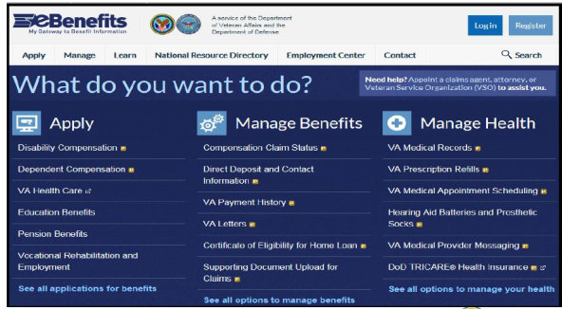  To register for a Basic eBenefits account online, select “Register” from the homepage. | DISPLAY slide  [Add rows and copy/paste Slide info above as needed.  Provide instructor guidance/notes]
Basic Account Registration Page  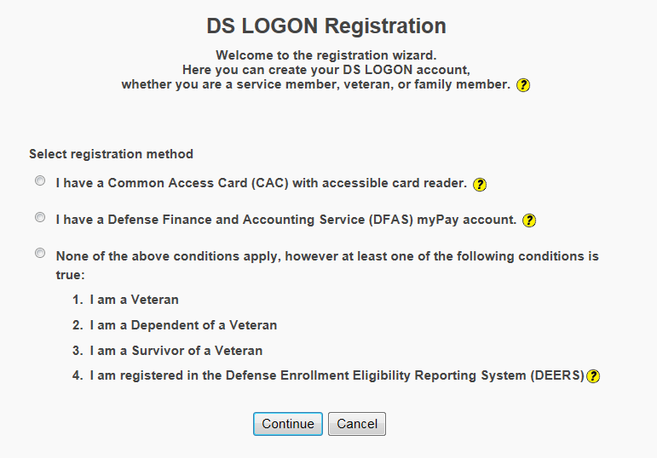  Select the appropriate registration method and then select “Continue”. | DISPLAY slide  [Add rows and copy/paste Slide info above as needed.  Provide instructor guidance/notes]
Basic Account Personal Information  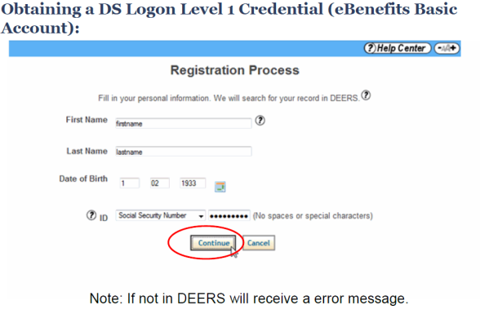  User should enter their personal information and select “Continue”. If the user is not registered in DEERS, they will receive an error message. | DISPLAY slide  [Add rows and copy/paste Slide info above as needed.  Provide instructor guidance/notes]
Basic Account Password  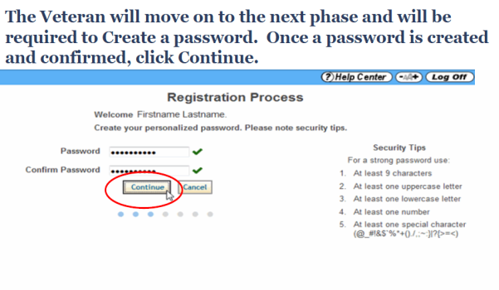  User should create and confirm a password; then, select “Continue”. | DISPLAY slide  [Add rows and copy/paste Slide info above as needed.  Provide instructor guidance/notes]
Basic Account Challenge Questions  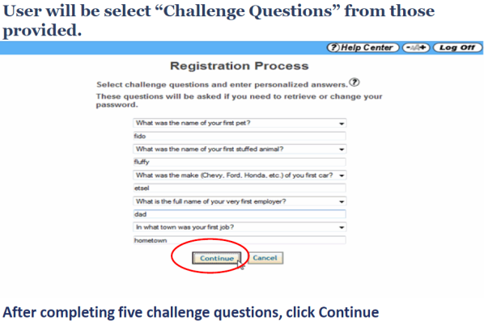  User should select and respond to five challenge questions. Then, select “Continue”. | DISPLAY slide  [Add rows and copy/paste Slide info above as needed.  Provide instructor guidance/notes]
Basic Account Personal Image  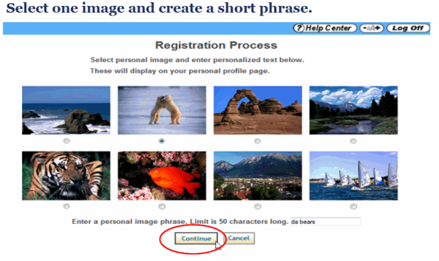  User should select a personal image and enter a personal image phrase. Select “Continue”. | DISPLAY slide  [Add rows and copy/paste Slide info above as needed.  Provide instructor guidance/notes]
Basic Account Username Assigned  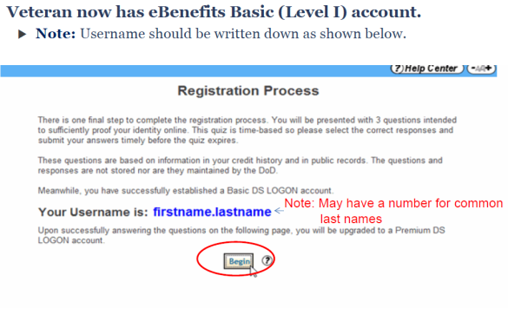  A username will be provided. If needed, user should keep a copy for future reference. User should select “Begin” to continue with the Premium Account registration process. | DISPLAY slide  [Add rows and copy/paste Slide info above as needed.  Provide instructor guidance/notes]
Obtaining a Premium Account  - Before obtaining a Premium account, user must have a Basic eBenefits account  - Once users have a Basic level account, there are three ways to obtain a Premium eBenefits account:  - Online, self-service proofing  - Phone proofing  - In-person proofing at a VA Regional Office | DISPLAY slide  [Add rows and copy/paste Slide info above as needed.  Provide instructor guidance/notes]
Premium Account Online Proofing  In order to upgrade to a Premium account online:  - Users should login to eBenefits (www.ebenefits.va.gov) with their Basic account login  - And select “Upgrade to a Premium Account” | DISPLAY slide  [Add rows and copy/paste Slide info above as needed.  Provide instructor guidance/notes]
Upgrade Method  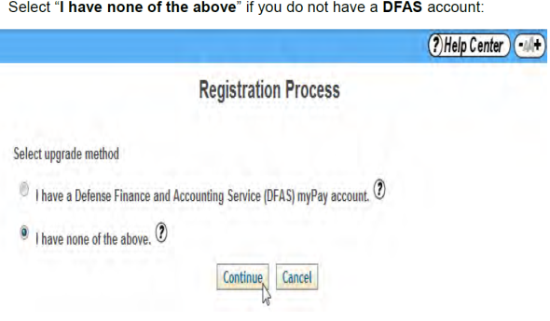  User should select the appropriate upgrade method option and select “Continue”. | DISPLAY slide  [Add rows and copy/paste Slide info above as needed.  Provide instructor guidance/notes]
Premium Account Proofing Instructions  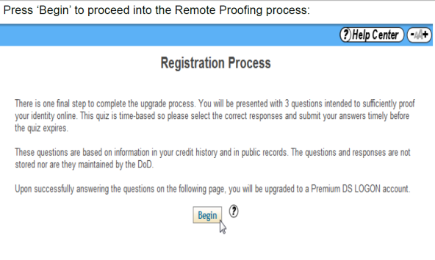  User should select “Begin” to proceed with the remote proofing process. | DISPLAY slide  [Add rows and copy/paste Slide info above as needed.  Provide instructor guidance/notes]
Premium Account Consent Page  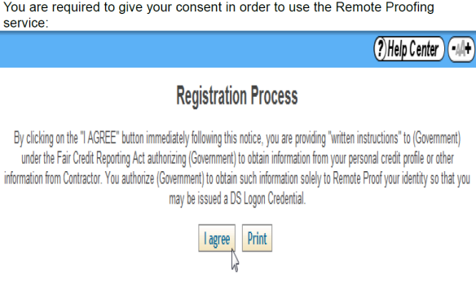  User should select “I agree” to provide consent to use the remote proofing service. | DISPLAY slide  [Add rows and copy/paste Slide info above as needed.  Provide instructor guidance/notes]
Premium Account Personal Information  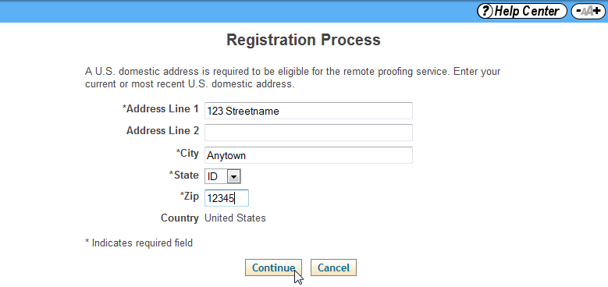  User should enter their address and select “Continue”. | DISPLAY slide  [Add rows and copy/paste Slide info above as needed.  Provide instructor guidance/notes]
Premium Account Proofing Questions  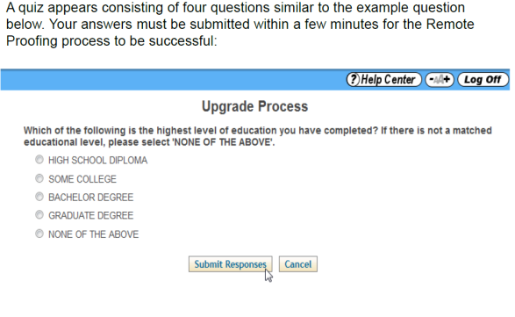  A quiz appears consisting of three applicant-specific questions. User’s answers must be submitted within a few minutes for the remote proofing process to be successful. | DISPLAY slide  [Add rows and copy/paste Slide info above as needed.  Provide instructor guidance/notes]
Premium Account Proofing Questions, Cont.  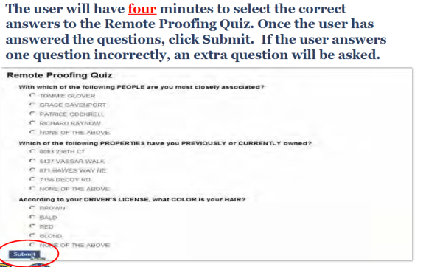  The user will have four minutes to select the correct answers to the quiz. Once the questions have been answered, they should select “Submit”. If the user answers one question incorrectly, an extra question will be asked. | DISPLAY slide  [Add rows and copy/paste Slide info above as needed.  Provide instructor guidance/notes]
Premium Account Confirmation  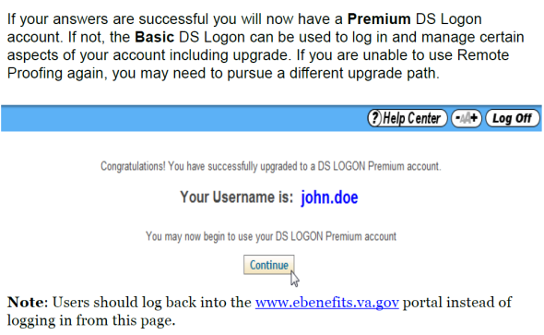  If the answers are successful, the user will receive confirmation of a Premium account. If they are unable to use remote proofing, they may need to pursue a different upgrade path.  Users should log back into the eBenefits portal instead of logging in from this page. | DISPLAY slide  [Add rows and copy/paste Slide info above as needed.  Provide instructor guidance/notes]
Premium Account Phone Proofing  - Users must be receiving VBA payments by direct deposit  - This service is not available for dependents  - Dial 1-800-827-1000, options 1, 7, and 0  - ECC Phone Agents may transfer the call by dialing *6, then 150  - Users must have available:  - Date of birth  - Primary ID (driver’s license, Military ID, or passport)  - Secondary ID (birth certificate or social security card)  - Bank account number  - The exact dollar amount of their most recent VA payment | DISPLAY slide  [Add rows and copy/paste Slide info above as needed.  Provide instructor guidance/notes]
Premium Account In-Person Proofing  - Users may go to the nearest VA Regional Office or TRICARE Service Center  - Provide a Federal or State-issued picture ID (such as Driver’s License, Military ID, or Passport)  - Provide a Federal or State-issued non-picture ID (such as Social Security Card, Voter Registration, or Birth Certificate)  Note: Creating a Premium account by visiting a RO without having a Basic account first will require the Veteran to receive an activation code from DoD within 6-12 days at their mailing address on record. | DISPLAY slide  [Add rows and copy/paste Slide info above as needed.  Provide instructor guidance/notes]
Comprehension Check  - What methods are available to apply for a Basic level eBenefits account?  - What methods are available to upgrade to a Premium level eBenefits account?  - Which account level is needed to apply for VA benefits? | DISPLAY slide  [Add rows and copy/paste Slide info above as needed.  Provide instructor guidance/notes]
Navigating the eBenefits Portal | DISPLAY slide  [Add rows and copy/paste Slide info above as needed.  Provide instructor guidance/notes]
eBenefits Home Page  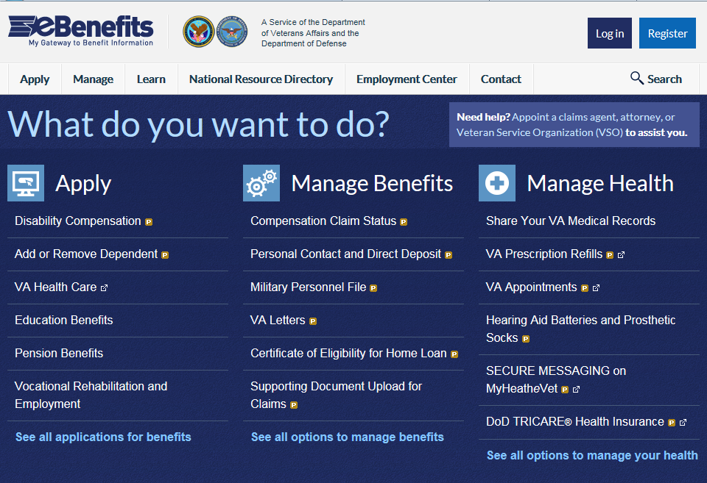 | DISPLAY slide  [Add rows and copy/paste Slide info above as needed.  Provide instructor guidance/notes]
eBenefits Home Page Tabs  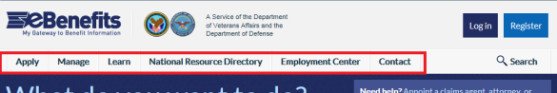  - Apply  - Manage  - Learn  - National Resource Directory  - Employment Center  - Contact | DISPLAY slide  [Add rows and copy/paste Slide info above as needed.  Provide instructor guidance/notes]
Apply for Benefits  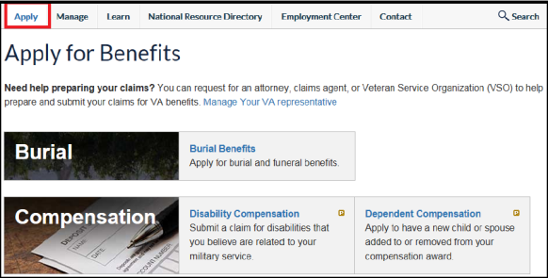  To apply for benefits, user should select the “Apply” tab. Then, select the hyperlink that corresponds to the type of benefit they wish to apply for. | DISPLAY slide  [Add rows and copy/paste Slide info above as needed.  Provide instructor guidance/notes]
Apply for Benefits, Cont.  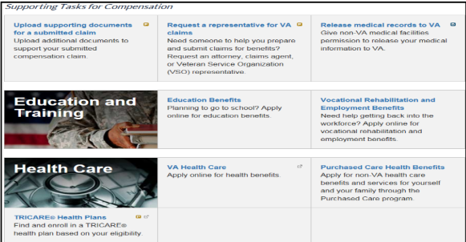  Users may apply for burial, compensation, education and training, health care, housing, insurance, or pension benefits through eBenefits. | DISPLAY slide  [Add rows and copy/paste Slide info above as needed.  Provide instructor guidance/notes]
Manage Your Benefits  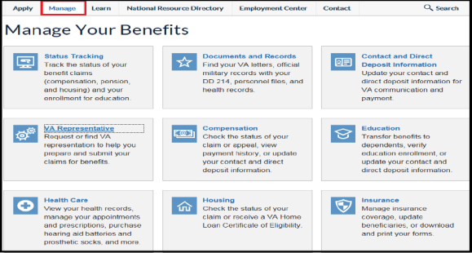  From the “Manage Your Benefits” tab users may track the status of their compensation and pension claim, order certain medical supplies, request copies of military documents, transfer education benefits, and update insurance beneficiaries. | DISPLAY slide  [Add rows and copy/paste Slide info above as needed.  Provide instructor guidance/notes]
Obtaining VA Letters  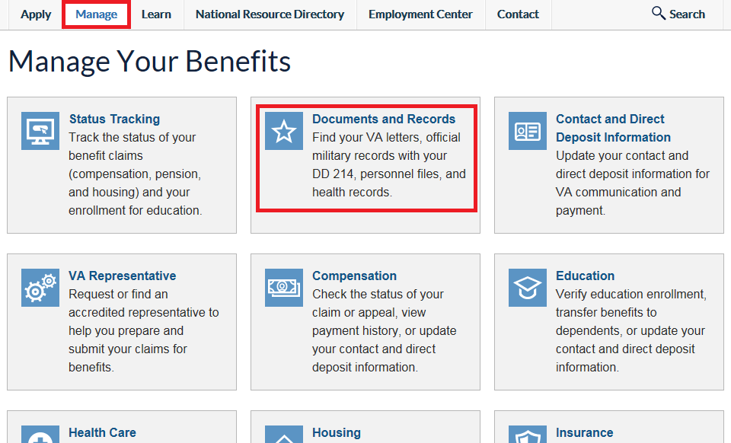  To request copies of official military documents, the user must first select the “Manage” tab, then select “Documents and Records”. | DISPLAY slide  [Add rows and copy/paste Slide info above as needed.  Provide instructor guidance/notes]
Obtaining VA Letters, Cont.  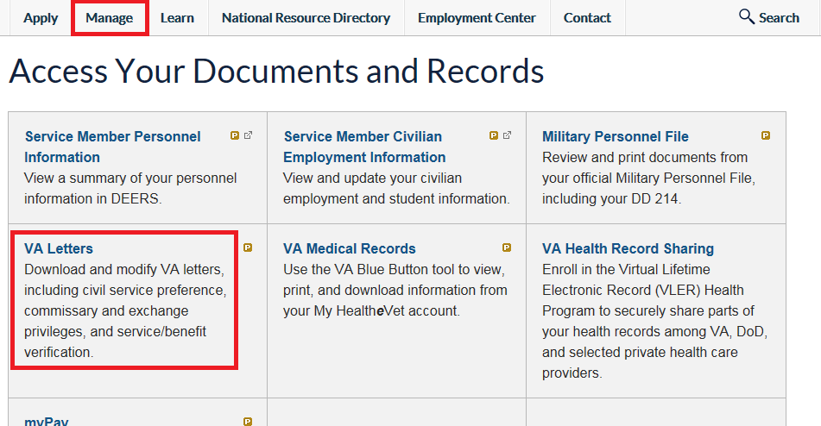  The “Access Your Documents and Records” page shows several types of documents that may be requested. The user should select “VA Letters”. | DISPLAY slide  [Add rows and copy/paste Slide info above as needed.  Provide instructor guidance/notes]
Obtaining VA Letters, Cont.  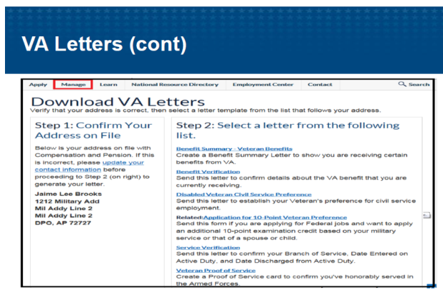  From the “Download VA Letters” page, users will need to further specify the type of letter needed by selecting the appropriate hyperlink. | DISPLAY slide  [Add rows and copy/paste Slide info above as needed.  Provide instructor guidance/notes]
Finding a VA Representative  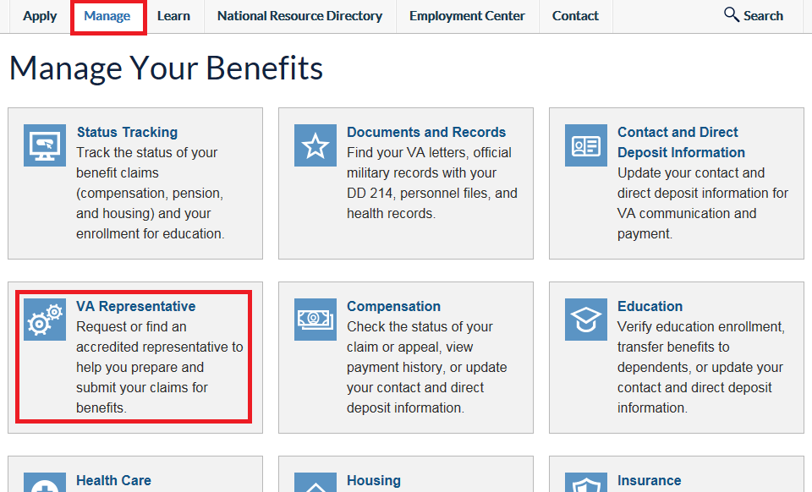  Users may also request or find VA representation by selecting the “VA Representative” link from the “Manage” tab. | DISPLAY slide  [Add rows and copy/paste Slide info above as needed.  Provide instructor guidance/notes]
Learn Page  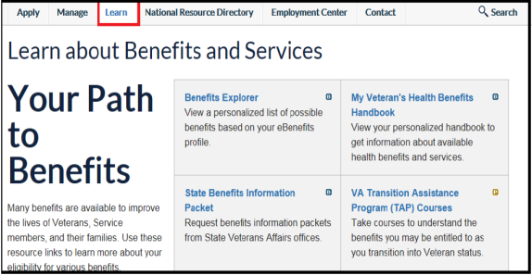  From the “Learn” tab, users may select and explore the various links to find resources that are available to them. | DISPLAY slide  [Add rows and copy/paste Slide info above as needed.  Provide instructor guidance/notes]
National Resource Directory  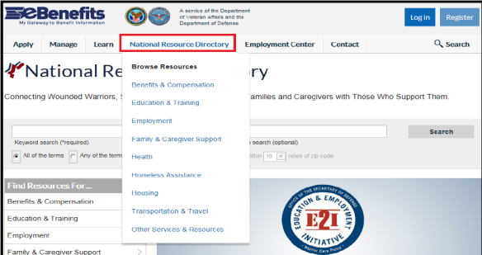  From the “National Resource Directory” tab drop-down menu, users may find resources in their specific geographic area. Users should select the hyperlink for the type of resources they are searching for to find additional information. | DISPLAY slide  [Add rows and copy/paste Slide info above as needed.  Provide instructor guidance/notes]
National Resource Directory, Cont.  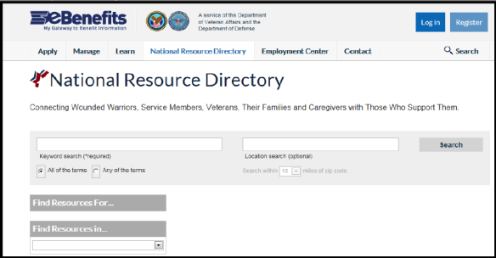  Users may also enter a keyword for the type of assistance they need from the “National Resource Directory” page. Then, enter the location and select “Search”. A list of topic-specific local resources will be displayed. | DISPLAY slide  [Add rows and copy/paste Slide info above as needed.  Provide instructor guidance/notes]
Employment Center Page  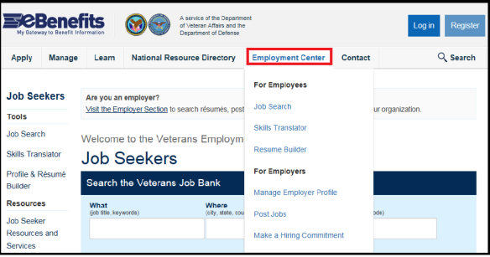  The “Employment Center” tab provides options such as searching for jobs, translating military skills into similar civilian occupations, and building resumes. | DISPLAY slide  [Add rows and copy/paste Slide info above as needed.  Provide instructor guidance/notes]
Contact Page  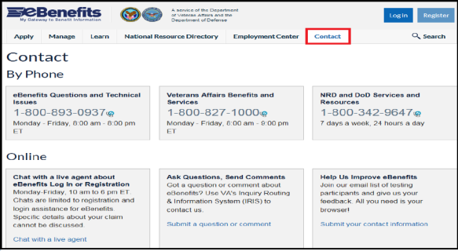  The “Contact” tab provides various means of interacting with VA. Users may contact the VA by phone, email, or chat. | DISPLAY slide  [Add rows and copy/paste Slide info above as needed.  Provide instructor guidance/notes]
Contact Page, Cont.  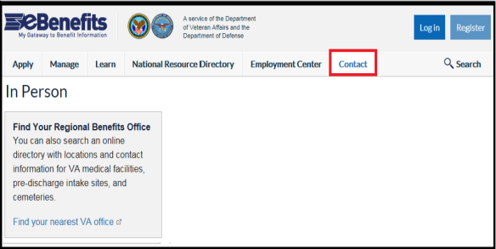  The “Contact” tab also provides a list of nearest VA facilities. | DISPLAY slide  [Add rows and copy/paste Slide info above as needed.  Provide instructor guidance/notes]
Comprehension Check  - What types of benefits may be applied for on the eBenefits site?  - What are the main tabs available on the eBenefits site? | DISPLAY slide  [Add rows and copy/paste Slide info above as needed.  Provide instructor guidance/notes]
Education-Related eBenefits Features | DISPLAY slide  [Add rows and copy/paste Slide info above as needed.  Provide instructor guidance/notes]
Education Related Features  - Apply for benefits  - Enroll in direct deposit  - Change address  - Review Post 9/11 GI Bill enrollment status  - Check remaining benefits and delimiting date  - Transfer Post-9/11 GI Bill entitlement  - Web Automated and Verification of Enrollment (WAVE) for Ch30, 1606, and 1607 | DISPLAY slide  [Add rows and copy/paste Slide info above as needed.  Provide instructor guidance/notes]
Applying for Benefits  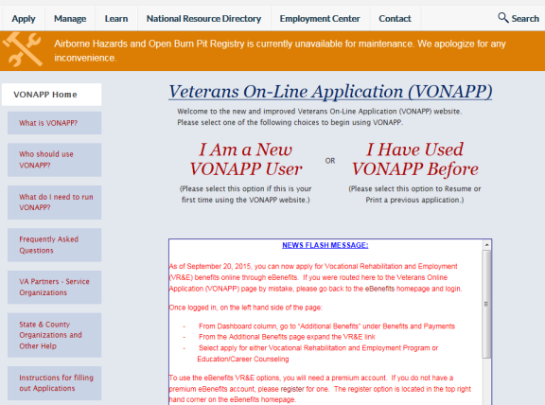  From the “Apply” tab, the user may select “Education”, to be directed to the VONAPP portal where they can apply for a variety of VA Education benefits. If they are a new VONAPP user, they will first have to set up a VONAPP account. | DISPLAY slide  [Add rows and copy/paste Slide info above as needed.  Provide instructor guidance/notes]
Address or Direct Deposit Changes  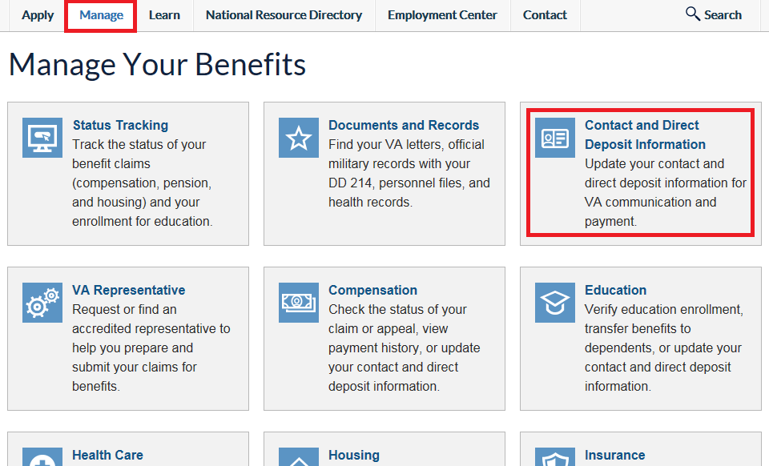  In order for a user to change their address or EFT information, the user should select the “Contact and Direct Deposit Information” link from the “Manage” tab. | DISPLAY slide  [Add rows and copy/paste Slide info above as needed.  Provide instructor guidance/notes]
Address or Direct Deposit Changes, Cont.  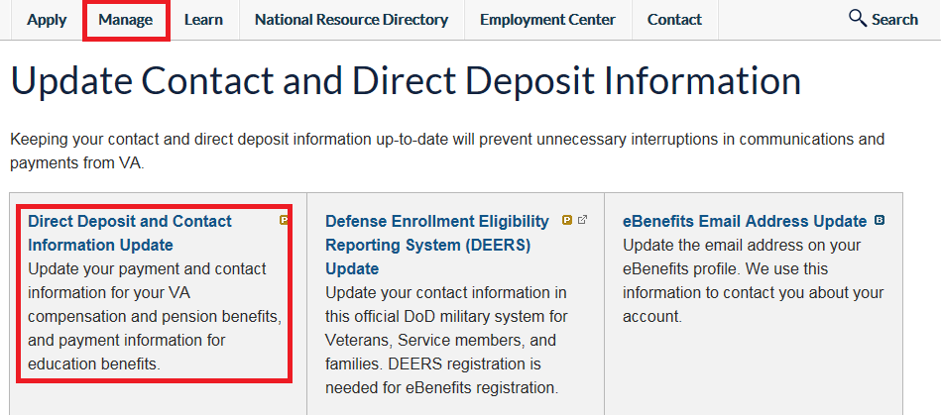  Select “Direct Deposit and Contact Information Update”. | DISPLAY slide  [Add rows and copy/paste Slide info above as needed.  Provide instructor guidance/notes]
Address or Direct Deposit Changes, Cont.  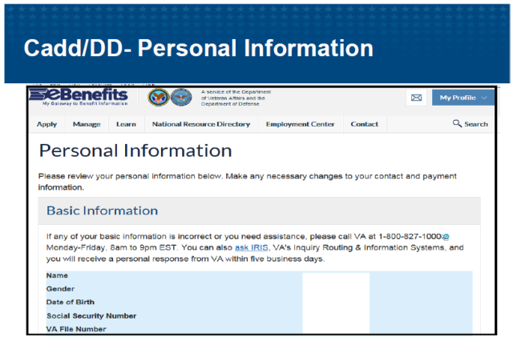  The “Personal Information” page will display and show their personal information that is already on file. From there the user may edit their direct deposit and/or address. | DISPLAY slide  [Add rows and copy/paste Slide info above as needed.  Provide instructor guidance/notes]
Direct Deposit Changes  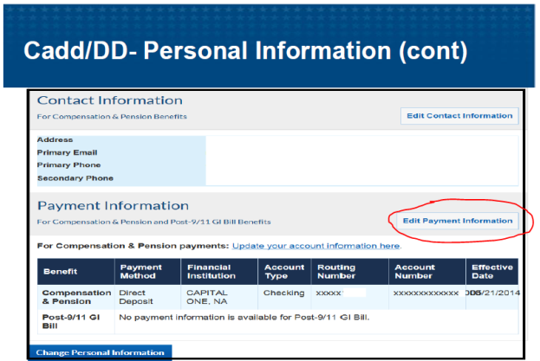  To edit direct deposit information, the user should select “Edit Payment Information” and submit the updated information. | DISPLAY slide  [Add rows and copy/paste Slide info above as needed.  Provide instructor guidance/notes]
Address Changes  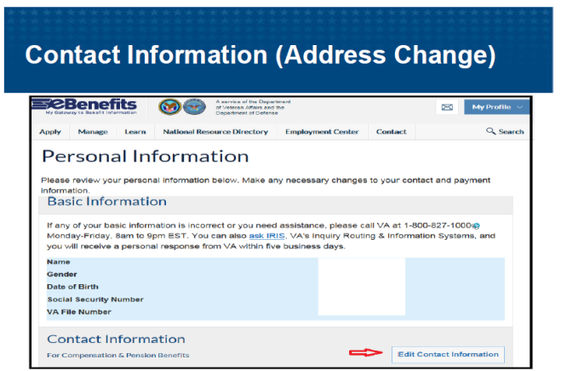  To edit an address, the user should select “Edit Contact Information”. | DISPLAY slide  [Add rows and copy/paste Slide info above as needed.  Provide instructor guidance/notes]
Address Changes, Cont.  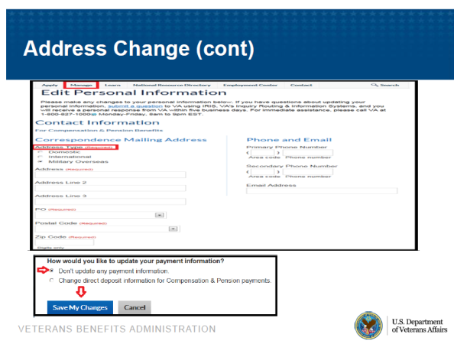  The user will then update address information as necessary, then select “Save My Changes”.  NOTE: Address changes completed in eBenefits will have a 22 transaction code in BDN, but no NOTE in the TIMS file. | DISPLAY slide  [Add rows and copy/paste Slide info above as needed.  Provide instructor guidance/notes]
Managing Education Benefits  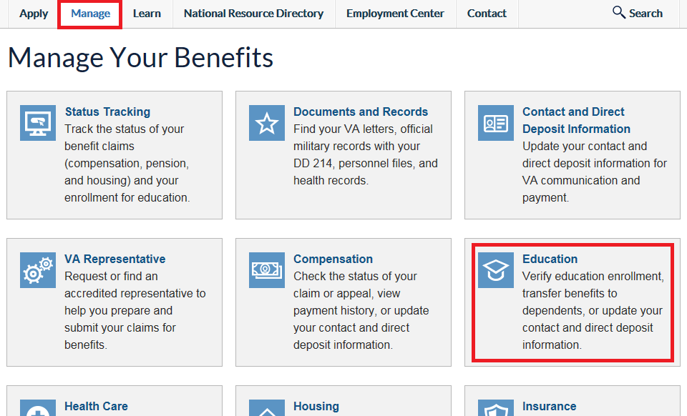  The “Manage Your Education Benefits” page, accessible from the “Manage” tab, provides access to a variety of education benefit specific features and information. | DISPLAY slide  [Add rows and copy/paste Slide info above as needed.  Provide instructor guidance/notes]
Checking VA Education Payments  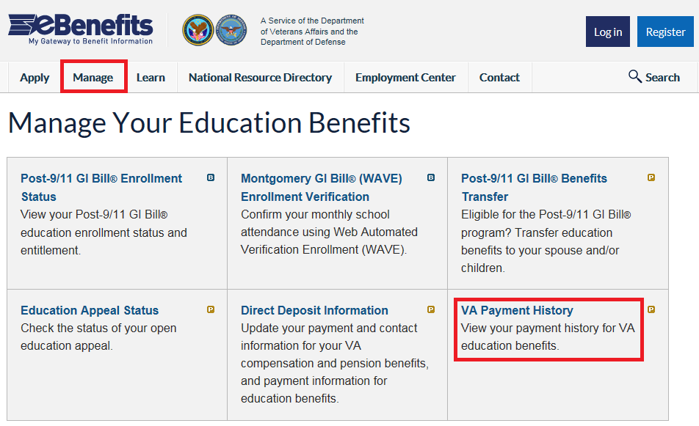  User should select the “VA Payment History” link to review their education benefit payment history. | DISPLAY slide  [Add rows and copy/paste Slide info above as needed.  Provide instructor guidance/notes]
Checking VA Education Payments, Cont.  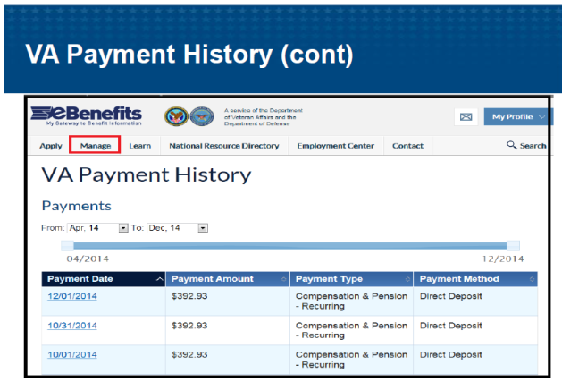  User should select the time period for which they would like to view past payments. | DISPLAY slide  [Add rows and copy/paste Slide info above as needed.  Provide instructor guidance/notes]
Post 9/11 GI Bill Enrollment Status  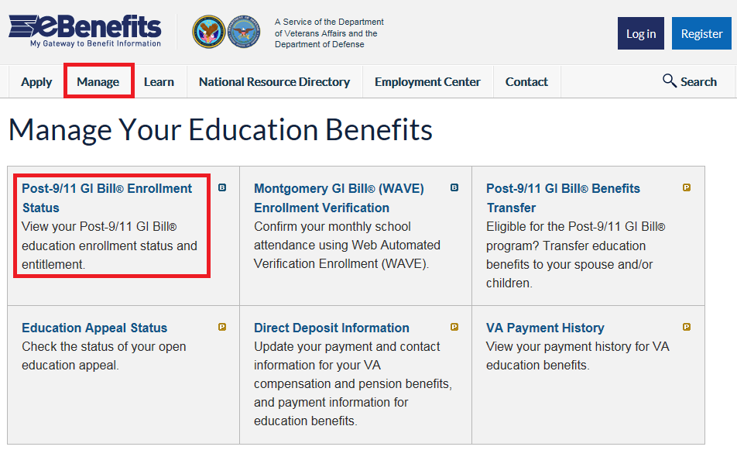  User should select the “Post-9/11 GI Bill Enrollment Status” link to review benefit status.  Note: Enrollment status for other education benefits is currently not available. | DISPLAY slide  [Add rows and copy/paste Slide info above as needed.  Provide instructor guidance/notes]
Remaining Benefits and Delimiting Date  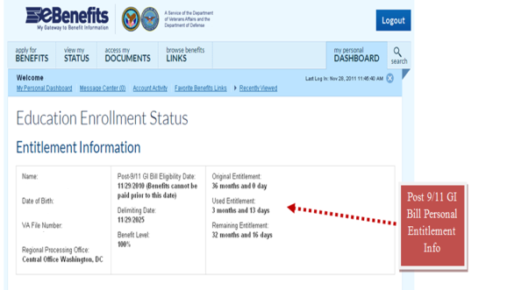  Under “Entitlement Information” the user may view their school enrollment information, delimiting date, and the amount of entitlement used and remaining. | DISPLAY slide  [Add rows and copy/paste Slide info above as needed.  Provide instructor guidance/notes]
Transferring Post-9/11 GI Bill Benefits  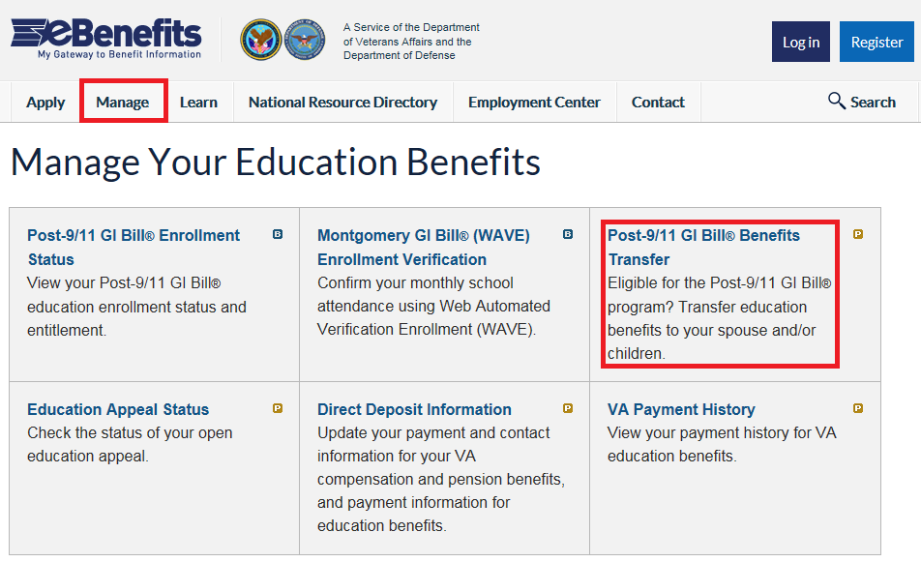  User may select the “Post-9/11 GI Bill Benefits Transfer” link to transfer education benefit(s) to their dependent(s). | DISPLAY slide  [Add rows and copy/paste Slide info above as needed.  Provide instructor guidance/notes]
WAVE  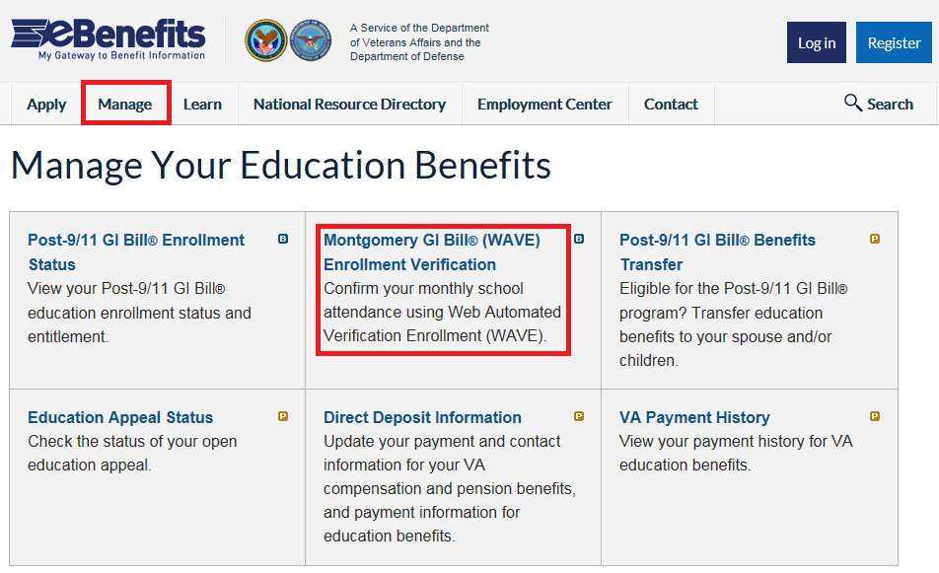  Students using Ch30, Ch1606, Ch1607 may access WAVE to certify their attendance electronically, rather than calling the Education Call Center. | DISPLAY slide  [Add rows and copy/paste Slide info above as needed.  Provide instructor guidance/notes]
Comprehension Check  - What are some education-related features available within eBenefits?  - Which education benefit displays enrollment status on eBenefits? | DISPLAY slide  [Add rows and copy/paste Slide info above as needed.  Provide instructor guidance/notes]
Fraud and Technical Issues | DISPLAY slide  [Add rows and copy/paste Slide info above as needed.  Provide instructor guidance/notes]
Fraud Issues  - eBenefits users have occasionally reported that their personal information (address, EFT) has been changed in the eBenefits system without their consent  - In these instances, VA Education employees must:  - Advise the user to contact their local police department and file a report  - Correct any address or EFT information as needed  - Complete a payment tracer for any missing payment  - Complete a VA Form 119, Report of Contact, and email (via encrypted email) to their supervisor  **Please refer to the Fraud/Privacy Violation Guidelines – Reportable Incidents, Procedural Guidance, FAQs, and Suggested Scripts for specific reporting instructions | DISPLAY slide  [Add rows and copy/paste Slide info above as needed.  Provide instructor guidance/notes]
Technical Issues  Transfer callers who are experiencing technical issues with the eBenefits portal to 1-800-983-0937.  Do not transfer for:  - Navigational help  - Help with applying for Education Benefits  - Problems with the VONAPP website  - Problems with the GI Bill website  - Phone proofing | DISPLAY slide  [Add rows and copy/paste Slide info above as needed.  Provide instructor guidance/notes]
Comprehension Check  - Which actions should you complete if a customer suspects fraud on their eBenefits account?  - True or False: You should transfer individuals who are having difficulty with the VONAPP site to the technical helpdesk. | DISPLAY slide  [Add rows and copy/paste Slide info above as needed.  Provide instructor guidance/notes]
Summary  - eBenefits is a self-service portal that offers services and access to VA and DoD programs and information  - Veterans and dependents may obtain a Basic or Premium account  - The site contains six tabs which categorize services by function: Apply, Manage, Learn, National Resource Directory, Employment Center, and Contact  - Education specific functions include the ability to apply for education benefits, manage EFT and address information, check Post-9/11 GI Bill enrollment/benefit status, transfer benefits, and certify enrollment  - A dedicated phone line is available for technical help with the site | DISPLAY slide  REVIEW the key points of the lesson.
Summary, Cont.  You have completed the eBenefits lesson. You should now be able to:  - Recall characteristics and features of the eBenefits portal  - Differentiate between methods of obtaining Basic vs. Premium level eBenefits account access  - Recognize location of content within the eBenefits portal  - Recall education-specific features of eBenefits  - Identify actions when users report fraud and/or technical issues pertaining to eBenefits | DISPLAY slide  REVIEW the lesson learning objectives.
Questions  What questions do you have about today’s training? | DISPLAY slide  ASK students what questions they have about the lesson.
References  - eBenefits portal  - eBenefits Help Desk Reference Guide, Release 3.3 – December 2011  - eBenefits for the Call Center Representative and Public Contact, TMS VA #3864696, 11/6/13  - Fraud/Privacy Violation Guidelines – Reportable Incidents, Procedural Guidance, FAQs, and Suggested Scripts | DISPLAY slide  REVIEW the lesson references.
TMS Assessment and Survey  - The assessment and survey have been assigned to you in TMS  - The assessment is comprised of multiple choice questions  - The questions are based on the information presented throughout the lesson  - The assessment should take approximately 30 minutes  - Be sure to complete both the assessment and the survey in TMS to receive credit for this training | DISPLAY slide  PROVIDE an overview of the process of completing the post lesson online assessment and survey.

