Auditory Disorders
Instructor Lesson Plan
Time Required: 1.5 Hours

Table of Contents

Lesson Description 2
Introduction to Auditory Disorders 4
Topic 2: Hearing Loss 7
Topic 3: Tinnitus 10
Practical Exercise 11

Lesson Description
The information below provides the instructor with an overview of the lesson and the materials that are required to effectively present this instruction.
TMS # | 4186156
Prerequisites | None
target audience | The target audience for Auditory Disorders is RVSR’s in IWT.
Time Required | 1.5 hours
Materials/  TRAINING AIDS | Lesson materials:  - Auditory Disorders PowerPoint Presentation  - Auditory Disorders Trainee Handouts  - Auditory Disorders Excercises
Training Area/Tools | The following are required to ensure the trainees are able to meet the lesson objectives:  - Classroom or private area suitable for participatory discussions  - Seating, writing materials, and writing surfaces for trainee note taking and participation  - Handouts, which include a practical exercise  - Large writing surface (easel pad, chalkboard, dry erase board, overhead projector, etc.) with appropriate writing materials  - Computer with PowerPoint software to present the lesson material  Trainees require access to the following tools:  - Auditory Disorders PowerPoint Presentation  - Auditory Disorders Trainee Handouts  - Auditory Disorders Excercises
Pre-Planning | - Become familiar with all training materials by reading the Instructor Lesson Plan while simultaneously reviewing the corresponding PowerPoint slides. This will provide you the opportunity to see the connection between the Lesson Plan and the slides, which will allow for a more structured presentation during the training session.  - Become familiar with the content of the trainee handouts and their association to the Lesson Plan.  - Practice is the best guarantee of providing a quality presentation. At a minimum, do a complete walkthrough of the presentation to practice coordination between this Lesson Plan, the trainee handouts, and the PowerPoint slides and ensure your timing is on track with the length of the lesson.  - Ensure that there are copies of all handouts before the training session.  - When required, reserve the training room.  - Arrange for equipment such as flip charts, an overhead projector, and any other equipment (as needed).  - Talk to people in your office who are most familiar with this topic to collect experiences that you can include as examples in the lesson.  - This lesson plan belongs to you. Feel free to highlight headings, key phrases, or other information to help the instruction flow smoothly. Feel free to add any notes or information that you need in the margins.
Training Day | - Arrive as early as possible to ensure access to the facility and computers.  - Become familiar with the location of restrooms and other facilities that the trainees will require.  - Test the computer and projector to ensure they are working properly.  - Before class begins, open the PowerPoint presentation to the first slide. This will help to ensure the presentation is functioning properly.  - Make sure that a whiteboard or flip chart and the associated markers are available.  - The instructor completes a roll call attendance sheet or provides a sign-in sheet to the students. The attendance records are forwarded to the Regional Office Training Managers.

Introduction to Auditory Disorders
INSTRUCTOR INTRODUCTION |  | Complete the following:  - Introduce yourself  - Orient learners to the facilities  - Ensure that all learners have the required handouts
time required |  | 1.5 hours
Purpose of Lesson  Explain the following: |  | This lesson is intended to cover the rating schedule for auditory conditions, with emphasis on proper rating consideration and evaluation of hearing loss and tinnitus.  This lesson will contain discussions, exercises and an E-case
Lesson Objectives  Discuss the following:  Slide 2 | Upon conclusion of the lesson, and provided available references, trainees will be able to prepare a rating decision targeting auditory disabilities with 98% accuracy.
Motivation | Listen closely to the sounds around you. The ticking of a clock, the sound of rain on the windows, or the sound of a clicking pen. Veterans with hearing loss and/or tinnitus have difficulties with hearing certain sounds between 500 and 4000 htz, or even at higher frequencies. Our rating decisions can mean the difference between receiving treatment (hearing aids) for their service connected hearing loss, or not.
STAR Error code(s) | A2; C2
References  Slide 3 | All M21-1 references are found in the Live Manual Website.  - 38 CFR 3.159 Department of Veterans Affairs Assistance in Developing Claims  - 38 CFR 3.309 Disease Subject to Presumptive Service Connection  - 38 CFR 3.350 Special Monthly Compensation Ratings  - 38 CFR 3.383(a)(3) Paired Organs and Extremities  - 38 CFR 3.385 Disability Due to Impaired Hearing  - 38 CFR 4.85 Evaluation of Hearing Impairment  - 38 CFR 4.86 Exceptional Patterns of Hearing Impairment  - 38 CFR 4.87 Schedule of Ratings - Ear  - 38 CFR 4.87a Schedule of Ratings - Other Sense Organs  - M21-1 Part III, Subpart iv, 4.B Conditions of the Organs of Special Sense, Hearing Impairment  - M21-1 Part III, Subpart iv, 4.G Definition: Other Organic Diseases of the Nervous System

Overview of the Ear  Slide 4 | EXPLAIN that the ear is a fundamental sensory organ that serves dual functions to regulate balance and enable reception and translation of sound stimuli. Explain that the external and middle ear conduct sound, while the inner ear receives it and controls its transmission to the cranial nerves and brain.
Auditory System Highlights  Slide 5 | EXPLAIN that hearing loss and tinnitus represents the conditions that will be rated most often, but that vestibular conditions and disequilibria are also covered within its provisions. Emphasize that peripheral vestibular conditions and Meniere’s will be for overview purposes as they are a fraction of the auditory cases that require rating action.
Peripheral Vestibular Disorder (DC 6204)  Slide 6 | EXPLAIN that the name associated with this code is a generalized label and will ordinarily be further differentiated as a clinical diagnosis of either vertigo or labyrinthitis. In either case, however, the diagnosis must be one that is clinically verified in order to allow favorable rating action, and subjective symptoms alone may not be recognized as deserving of an award under this code (see NOTE).  ILLUSTRATE that the “Ear Disease” DBQ actually consolidates vestibular dysfunction and Meniere’s symptoms into one section, and that only symptoms of vertigo and staggering are particularly germane to consideration under DC 6204. Point out that the Evaluation Builder entry for this condition is fairly straight-forward and simple: A selection of dizziness generates a 10-percent evaluation, while staggering will prompt an award of the 30 percent.  EMPHASIZE that vertigo is probably most commonly encountered as a TBI residual and, per M21-1 III.iv.4.G.2.h, may not be separately evaluated as anything other than a subjective symptom under DC 8045 unless so diagnosed as vertigo during service.
Meniere’s Syndrome  Slide 7 | EXPLAIN that Meniere’s syndrome is a somewhat rare condition that isn’t encountered remarkably often, and that in order to consider an evaluation under DC 6205, we must have definitive medical evidence of a clinical diagnosis of Meniere’s, and not merely subjectively related vertigo paired with hearing loss and tinnitus.  Point out that the rating schedule allows for evaluation of Meniere’s using DC 6205 OR on the combination of component hearing impairment, tinnitus, and vertigo, but not both. Also observe that the same common DBQ (“Ear Disease”) is used to assess both Meniere’s and vestibular conditions, and that symptoms attendant upon one, the other, or both are located within Section III.  Point out also the notes associated with the Evaluation Builder and the Rating Schedule.  Also explain that the Evaluation Builder for Meniere’s disease will assign an evaluation under DC 6205, but that, depending on the facts of the case, independent evaluations under DCs 6100, 6260, and/or 6204 may better advantage the Veteran and would need to be entered as independent issues in the Evaluation Builder to generate the correct decisional text and diagnostic codes.

Topic 2: Hearing Loss
Introduction | We will now be shifting our attention to this system’s most significant and commonly encountered disability, hearing loss. Our instruction will include the hearing loss rating rubrics per 38 CFR 4.85; the Hearing Loss & Tinnitus DBQ; special considerations specific to hearing loss; and data entry in the Hearing Loss Calculator environment.

Slide 8
Proper Hearing Loss Development and Our Duty to Examine  Slide 9 | EXPLAIN that it is of crucial importance that we as RVSRs remain ever mindful of the unique developmental and examination requirements inherent to hearing loss claims in order to ensure that our legal duty to assist has been fulfilled in every case that is certified as “ready for decision”.  STRESS that the threshold for requesting an audiological examination is extremely low – more so, even, than with a general reading of McClendon and for conventional claims adjudication. Authentication of current, persistent symptoms may be accomplished via lay testimony, as Veterans are regarded as competent to speak to subjectively appreciable conditions such as hearing impairment. Veterans’ contentions of or allusions to service-related causation are also regarded as credible and plausible, and are to be routinely accepted as sufficient to referral for examination.  The construction of a qualifying in-service event may assume a number of forms in hearing loss claims. STRs may show an in-service manifestation of hearing loss or diminution of auditory thresholds, either of which would certainly be accepted as proof of a hearing-related in-service event. But a combat decoration or performance of an occupational specialty consistent with moderately or highly probable noise exposure is also grounds for validating the existence of an in-service event on which a grant of service connection may be predicated.  REFER to M21-1 III.iv.4.B.3.d and the Duty Military Occupational Specialty (MOS) Noise Exposure Listing, which is hyperlinked within the CPKM, and briefly explain the layout of the MOS Excel document and its division by service branch and enlisted/commissioned status.  Trainees should also be advised that, as per VSCM Conference Call dated May 2012, even Veterans with low-probability MOSs may be accorded a VA examination for hearing loss and/or tinnitus, provided they supplement their claims with lay testimony concerning a declaration of in-service noise exposure, and such testimony is otherwise reasonably consistent with the facts and circumstances of service.
38 CFR 3.385 – Disability Due to Impaired Hearing  Slide 10 | EXPLAIN that in order for a Veteran to be awarded service connection, current hearing loss, even if clinically diagnosed as such by an audiological professional, must meet the audiometric and/or speech discrimination requirements of 3.385.  DISPLAY the following graphic onto a Whiteboard and ask that trainees identify whether audiometric findings as shown constitute 3.385-compliant, VA-purpose hearing loss.  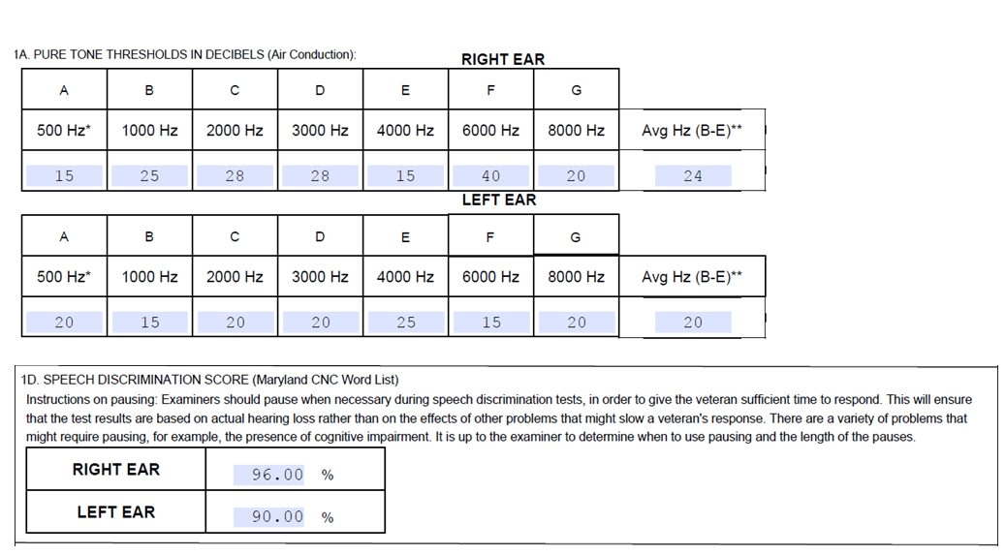  (Answer: The left does, and the right does not.)
Hearing Loss (DC 6100)  Slide 11 | EXPLAIN that the schedule for rating hearing loss comprises a series of tables that plot intersections of impairment to puretone threshold averages and percentages of speech discrimination. Stress that the puretone threshold average represents the mean of decibel losses recorded at frequencies of 1000-4000 Hertz, but that 500 (although a part of 3.385) 6000, and 8000 Hertz, though routinely documented on examination, bear no import on evaluation assignment.
Hearing Loss: The DBQ  Slide 12 | DISPLAY excerpts from the audiological DBQ (or the complete DBQ) and call to trainees attentions that the primary points of focus upon reviewing such exams are the audiometric frequency readings, the Maryland CNC-derived speech discrimination scores, and the embedded etiology opinion request.  EMPHASIZE footnote points, including the requirement that this specialty exam be carried out by a state-licensed audiologist; that Maryland CNC speech discrimination testing be conducted; and that hearing loss be assessed without the use of hearing aids.
Special Considerations Re: Hearing Loss  Slide 13 | EXPLAIN that sensorineural hearing loss (vice conductive, the less common variety) constitutes an “organic disease of the nervous system” and is subject to a one-year presumption of service connection under 38 CFR 3.309(a).  Also remind trainees that a finding of bilateral deafness entitles a Veteran to a single SMC-K, and that 38 CFR 3.350(a)(5) defines “deafness” in the context of hearing loss that’s been granted the maximum schedular evaluation under DC 6100.
Special Considerations Cont’d: Exceptional Patterns  Slide 14 | EXPLAIN that 38 CFR 4.85 also contains Table VIA, which can be used to evaluate a Veteran’s hearing loss on the basis of puretone threshold averages alone if such consideration would yield a higher evaluation that conventional consideration under Table VI and when plotted on Table VII. Potential application of Table VIA is authorized when there exist “exceptional patterns of hearing impairment” consistent with 38 CFR 4.86(a) or (b), or when an examiner concludes that speech discrimination testing is not advisable for medical or cognitive reasons.
The Hearing Loss Calculator  Slide 15 | EXPLAIN that the Hearing Loss Calculator, which is accessible via the Rating Job Aids page and embedded as a hyperlink within the trainee PDF version of the PPT presentation, will be used to generate both grants and denials of service connection for hearing loss in an effort to facilitate the eventual transition into the VBMS-R environment. However, a claim for increase currently directs us to the legacy evaluation builder and its abbreviated format.  INITIATE sharing of screens and demonstrate data entry in each of the specifically labeled fields. Model entry of both a grant on the basis of in-service noise exposure, and a denial on the basis of audiometric findings that do not rise to the levels specified under 38 CFR 3.385.

Topic 3: Tinnitus
Introduction | Tinnitus is a frequently claimed disability that involves subjective perception of ringing in one or both ears, and in some instances, due to certain medical conditions, odjectively.
Tinnitus  Slide 16 | Stress to trainees that tinnitus will essentially have to present recurrently before it’s ascribed a clinical diagnosis, and that 38 CFR 4.87 provides a lone 10-percent evaluation – no more or less – for tinnitus perceived unilaterally or bilaterally. In the rare event that tinnitus is objectively perceptible, DC 6260 is not for utilization, and consideration must be lent to the underlying etiology behind the symptom.  EMPHASIZE that the Tinnitus section of the audiological DBQ essentially consists of one pertinent question concerning whether or not the Veteran attests to current symptoms, as well as an etiology opinion, wherein the attending audiologist can attribute the tinnitus to hearing loss or to military noise exposure.
Special Considerations re: Tinnitus  Slide 17 | EXPLAIN the following four special considerations that frequently apply to rating tinnitus:  - Tinnitus is a chronic disability subject to a one-year presumption of service connection under 38 CFR 3.309(a). (See M21-1 IV.ii.2.B.2.b; Fountain v McDonald)  - A claim for hearing loss that ultimately yields a diagnosis of (unclaimed) tinnitus should be “sympathetically read” as inclusive of both contentions, provided favorable medical opinions exist for both (M21-1.III.iv.4.B).  - Tinnitus that is opined to be secondary or related to service-connected hearing loss should still be granted and coded service connection on a direct/incurred (vs. secondary) basis (M21-1.III.iv.4.B).  - If service treatment records mention a complaint of tinnitus and the Veteran claims tinnitus and has current complaints of tinnitus, a medical opinion regarding possible causation is not required. Service connection can be established without an opinion about the specific cause of the tinnitus because it began in service (TL 10-02).

Practical Exercise
Questions/  EXERCISE | Entertain any questions trainees may present and offer any clarification that may be requested.  Then refer trainees to their review exercises and allow fifteen minutes for independent completion.  Ask if there are any questions about the information presented in the exercise, or additional questions concerning the material.

Slide 18

