(VSR VIP Pre-D) Telephone Development

Trainee Handout

**Table of Contents**

Objectives 5

References 6

Topic 1: Telephone Development 7

Attachment A: VA Form 27-0820, Report of Contact 12

Attachment B: VA Form 21-0845, Authorization to Disclose Personal Information to a Third Party 13

Practical Exercise 15

Objectives

* List appropriate situations for telephone development
* Describe the telephone development requirements and contact procedures
* Identify the procedures to complete VA Form 27-0820, *Report of General Information*
* Recognize the purpose of VA Form 21-0845, *Authorization to Disclose Personal Information to a Third Party*
* Summarize how to manage difficult telephone calls
* Review Telephone Courtesy Tips

References

* [38 CFR 3.217(b) Submission of statements or information affecting entitlement to benefits](http://www.ecfr.gov/cgi-bin/text-idx?SID=c841080008e357c12ba48d519985c2c5&node=se38.1.3_1217&rgn=div8)
* [M21-1 Part III*,* Subpart ii, 3.C*,* System Updates](https://vaww.vrm.km.va.gov/system/templates/selfservice/va_kanew/help/agent/locale/en-US/portal/554400000001034/content/554400000014125/M21-1-Part-III-Subpart-ii-Chapter-3-Section-C-System-Updates)
* [M21-1, Part III, Subpart iii, 1. B, Evidence Requested from the Claimant](https://vaww.vrm.km.va.gov/system/templates/selfservice/va_kanew/help/agent/locale/en-US/portal/554400000001034/content/554400000014152/M21-1-Part-III-Subpart-iii-Chapter-1-Section-B-Evidence-Requested-From-the-Claimant)
* [M21-1, Part III, Subpart iii, 1. C, Requesting Evidence from Federal Record Custodians](https://vaww.vrm.km.va.gov/system/templates/selfservice/va_kanew/help/agent/locale/en-US/portal/554400000001034/content/554400000014156/M21-1-Part-III-Subpart-iii-Chapter-1-Section-C-Requesting-Evidence-From-Federal-Record-Custodians)
* [M21-1, Part III, Subpart iii, 5.A, General Information on Relationship and Dependency](https://vaww.vrm.km.va.gov/system/templates/selfservice/va_kanew/help/agent/locale/en-US/portal/554400000001034/content/554400000015798/M21-1-Part-III-Subpart-iii-Chapter-5-Section-A-General-Information-on-Relationship-and-Dependency)
* M27-1 Part I, 3. [Telephone](http://www.benefits.va.gov/WARMS/M27_1.asp) Interviews
* [M27-1 Part I, 5. 6. Development Claims using Telephone, E-Mail, and Facsimile](http://www.benefits.va.gov/WARMS/M27_1.asp)
* [M27-1 Part I, 5. 8. Using VA Form 27-0820 (Series)](http://www.benefits.va.gov/WARMS/M27_1.asp)

Topic 1: Telephone Development

**Appropriate Situations for Telephone Development**

VSRs can use a telephone contact to solicit or verify essential information. This method is recommended when only a few pieces of information or evidence are required and can easily be obtained by telephone.

Understanding the types of evidence that may be obtained by telephone is important. A list of issues suitable for this method of development is available in M21-1 III.iii.1.B.1.d., *Claims Development by E-mail, Fax and Telephone;* M21-I, III.iii.5.A.1.f, *Issues to Consider When Determining Whether Dependency and/or a Familial Relationship Exists and M27-1, I.3.h, Types of Information Suitable for Telephone Development.*

Evidence suitable for telephone development includes:

* Clarification of claimed conditions
* Names and address of physicians or medical facilities
* Medical evidence
* Social Security numbers (SSNs)
* Award/denial letters for certain benefits, such as Social Security disability benefits
* Mailing address and direct deposit information
* Employment information
* Clarification of income-related issues and medical expenses.
* Dependency information
* Whether the Veteran has service treatment, personnel, or other records to provide

**38 CFR 3.217(b) Contact Requirements**

When conducting a telephone contact, appropriate procedures must be followed.

38 CFR 3.217(b), Submission of statements or information affecting entitlement to benefits states:

VA may take action affecting entitlement to benefits based on oral or written information or statements provided to VA by a beneficiary or his or her fiduciary. However, VA may not take action based on oral information or statements unless the VA employee receiving the information meets the following conditions:”

During the conversation in which the information or statement is provided, the VA employee must:

* Identify yourself as a VA employee who is authorized to receive the information or statement and state the purpose of the call;
* Verify the identity of the provider as either the beneficiary or his or her fiduciary by obtaining specific information about the beneficiary. This information needs to be verified from the beneficiary's VA records, such as Social Security number (SSN), date of birth, branch of military service, dates of military service, or other information; and
* Inform the provider that the information or statement will be used for the purpose of calculating benefit amounts.”

**Documenting Telephone Contact**

Completely document all information received during the call on VA Form 27-0820 (Series), *Report of General Information*, or the equivalent, such as the *Informal Conference Report for Decision Review Officers (DROs) for action*.

When documenting telephone calls on VA Form 27-0820 (Series), keep in mind that:

* beneficiaries are ***not*** required to advise VA in writing of
* changes in income or net worth, or
* changes in dependency status, such as loss of a dependent due to death, divorce, or annulment of a marriage.
* If the caller has a Power of Attorney (POA), ensure the POA information is noted on VA Form 27-0820
* Send a copy of the completed form to the beneficiary’s power of attorney, if applicable
* Enter an appropriate note in VBMS CORE that a copy of the completed form was sent to the POA, if applicable
* Upload the VA Form 27-0820 to the e-folder in VBMS CORE

**Required Information on VA Form 27-0820**

When using VA Form 27-0820, the following items must be documented:

* Specific information or statement provided
* Date the information or statement was provided
* Identity of the provider
* Steps taken to verify the identity of the provider as being either the beneficiary or his or her fiduciary
* Verification that employee informed the provider that the information would be used for the purpose of calculating benefits, and
* Clear identification of the employee executing the VA Form 27-0820 including a signature that meets the requirements described in M21-1, Part III, Subpart ii, 1.C.2.e

Additional Information:

* Information required to properly document the call is not included on the VA Form 27-0820 and filed in the claims file; no action can be taken on the evidence received. If due process is required, then a letter must be sent. Also, if the file is not properly documented a development letter must be sent.
* Beneficiary has a power of attorney (POA), a copy of VA Form 27-0820, *Report of General Information*, must be sent to his or her representative.
* Information received by telephone results in award or denial action, the notification letter should reference the information received by telephone and include the date of telephone contact and the name of the person who provided the information.

Specific guidelines about documentation requirements when using VA Form 27-0820 can be found in 38 CFR 3.217(b) and M27-1, Part I.5. 8.

Available Versions of VA Form 27-0820

Following the telephone contact, the VSR must document the beneficiary’s VA records using VA Form 27-0820, Report of General Information. The following is a list of the available versions of VA Form 27-0820:

* VA Form 27-0820: *Report of General Information*
* VA Form 27-0820a: *Report of First Notice of Death*
* VA Form 27-0820b: *Report of Nursing Home or Assistant Living Information*
* VA Form 27-0820c: *Report of Defense Finance & Accounting Service (DFAS)*
* VA Form 27-0820d: *Report of Non-Receipt of payment*
* VA Form 27-0820e: *Report of Incarceration*
* VA Form 27-0820f: *Report of Month of Death*

**Target Your Telephone Development**

The Compensation Service encourages stations to incorporate telephone development into their individual workload management plans.

This process can bring many claims closer to resolution. Wherever possible, the VSRs should use telephone development on information such as:

* Military Treatment Facilities
* Contact the claimant to retrieve missing information on a claim or form.

The timeliness of claims processing decreases dramatically with constant use of telephone development.

**Unsuccessful Telephone Contact**

If the claimant cannot be reached by telephone, employees may leave a message for a claimant as voicemail or with a third party. However, the message must not include any information that is protected by the Privacy Act. The employee should simply leave VA’s toll-free number (1-800-827-1000) and ask for a return call. After doing so, the employee must immediately enter a detailed note in VBMS CORE regarding the information or evidence he/she is seeking, so the national call center can respond to any returned call.

Unsuccessful attempts must be documented in the “notes” section in VBMS CORE. Include the following:

* Name of the individual/facility attempting to contact
* Specific evidence required

Compensation Service no longer requires completion of VA Form 27-0820 to document unsuccessful attempts to make telephone contact. Nevertheless, the employee who made the attempt is still responsible for documenting the action in VBMS CORE notes.

**Third Party Authorization**

VA Form 21-0845, *Authorization to Disclose Personal Information to a Third Party*

Allows National Call Centers (NCCs) and Regional Office to release specified information normally protected under privacy provisions to family members or other designated persons who are not POAs, Agents, or Fiduciaries

The VA Form 21-0845:

* Informs incompetent beneficiaries (including those with supervised direct pay) they cannot submit without their fiduciary’s signature. If incompetent beneficiaries submit the form, a letter explaining that VA cannot accept the form unless his or her fiduciary signs it needs to be sent. The fiduciary is also responsible for revoking the authorization.
* Requires the beneficiary/claimant to determine whether the designated individual has access to limited or unlimited information (e.g., the status of claims, benefit information, payment history, payment rate, debt owed VA, or any other information specified by the authorizer).
* Allows designated individuals to provide certain information to VA (e.g., such as changes in address or direct deposit accounts). Designated persons must correctly answer a security question chosen by the claimant or beneficiary to confirm their authorization.
* Beneficiaries may revoke third party authorization over the telephone. In addition, only one form may be valid at a time. If a new form is received, revoke the prior authorization.
* May only have one designated person or organization

Verifying third-party Authorization

If someone claims to have third-party authorization:

* Verify authorization
* Solicit their identity and ask the security question.
* If the caller responds correctly, proceed with the standard protocol to identify the beneficiary or claimant.
* If the individual does not know the answer to the security question, inform him/her that he/she does not have the proper authorization. If the individual persists, refer him/her to the beneficiary/claimant.
* Review the authorization carefully.

Note what type of information is permitted for release and the expiration date of the authorization, if any.

How to approach difficult telephone calls

Most phone conversations with beneficiaries and fiduciaries are cordial and polite. However, there are rare occasions when the caller is angry, threatening, or abusive.

VBA does not expect its employees to tolerate or listen to abusive language or behavior on the part of its callers. Before terminating a call, inform the caller:

* “I want to help you.”
* “I’m asking that you please stop using foul language.”
* “If you do not stop, I will need to disconnect the call.”

If the caller refuses to stop and continues using abusive or foul language, inform the caller the call will be terminated and to please call back when they are ready to discuss the situation more calmly.

Note: Never respond in anger towards the caller. Often after taking a long silent pause, the caller may refrain from using foul language. (M27-1, I.3.8, a.)

Steps on Handling Suicidal Calls

Take all suicidal threats seriously. Remain calm and listen carefully to the caller.

The primary goals when dealing with a suicidal caller are to keep the caller alive, keep the caller from any further injury, and get the caller in contact with a trained crisis center.

Follow the steps below if you encounter a suicidal caller:

* Never place a suicidal caller on hold
* Get the attention of someone who can alert a supervisor
* If the caller agrees, transfer them to the Veterans Crisis Line: 1-800-273-8255
* If the caller does not agree, the supervisor will seek second-party assistance
* Continue the call until the crisis is managed and under control.

Note- The internal warm transfer number for the suicide hotline is (585) 393-7938. The VA Suicide Hotline can be reached at 1-800-273 TALK (8255).

The following web site includes a state-by-state listing of suicide prevention organizations: [www.suicidehotlines.com](http://www.suicidehotlines.com)

Courtesy Tips – Speaking Voice

Good customer service is a direct by-product of how courteous we are to our callers. By using a proactive approach and emphasis in the following areas, we can ensure we provide professional, consistent, and meaningful customer service to our callers. These areas include:

* Your speaking voice
* Your active listening skills
* Acknowledging your caller’s feelings, and
* Use of effective customer service techniques

How you use your voice is more critical over the telephone because the caller is not able to use visual communication tools to gauge your level of involvement in the conversation. As such, you must be able to project your customer service attitude through your voice.

Use the following five methods to improve your speaking voice:

* Speak in low tones
* Articulate
* Match the other person’s rate of speech (take note that you are not speaking at a rate too fast for your caller to comprehend)
* Control volume (do not allow your voice to indicate disturbance), if your caller begins to speak in a louder tone in reference to their frustration – attempt to lower you volume since the caller will often lower the volume of their voice to match the volume of the conversation
* Use voice inflections (changing the pitch of your voice to create enthusiasm or concern)

Courtesy Tips – Listening Skills

Active listening skills are just as important as your speaking skills, if not more so. The ability to listen to your caller is of paramount importance to allow you to properly assess the purpose of the call and what the caller expects from you.

Use the following seven methods to improve your listening skills:

* Visualize what you are hearing (not what you are going to do later)
* Take notes on the important parts of the conversation
* Do not interrupt or cut off the caller (however, it may be necessary to utilize call control techniques to resolve a rambling call)
* Listen for feelings (is the caller anxious, argumentative, or distressed?)
* Acknowledge what the caller is saying (best way to accomplish this is to paraphrase the caller or use an empathetic statement)
* Ask questions (this will help you understand and will show you are engaged in the process
* Concentrate (the most fundamental skill in effective listening)

**Courtesy Tips – Acknowledging the Caller’s Feelings**

One of the most important aspects of ***world-class service*** is to show your caller that you are sympathetic or understanding of their situation and feelings. By using the four methods below, your caller will recognize that you are “hearing” them and want to be of service.

These methods are:

* Showing empathy
* Asking questions
* Giving feedback
* Summarizing the problem or issue
* Common manners such as please, thank you, and you’re welcome

**Courtesy Tips – Acknowledging the Caller’s Feelings**

The final area to address in ensuring our callers receive the courteous service they deserve is the use of **effective customer service techniques**. These seven techniques, called “The 7 C’s,” are provided below:

* Caring – **Care about the VA**. Show loyalty (do not tell a caller that someone else made a mistake). **Care about the customer**. Do not view a phone call as an interruption of your job. View it as your job – it is, you know. **Care about yourself**. Be careful of stress and burnout. Know the signs and learn how to deal with them.
* Confident – Be confident in your *ability to handle your interactions*. If you do not know the answer, advise your caller that you “will be happy to research the information for them.” Be confident of your technical knowledge. As you use your technical skills, it will become second nature to you. ***Remember:*** no *one person* will have the ability to answer all the questions that may be asked, but you will be provided with the tools and training to be successful in your position.
* Considerate – Be considerate *of the customer*. If the customer is upset, do not gloss over it. Acknowledge the customer’s feelings and attempt to address his/her concerns.
* Committed – Go *the extra step*. Make appropriate referrals. Do not just tell customers they have the wrong department or agency. Help them to reach the department or agency they need.
* Creative - Be *resourceful*. There will be many days when you will repeatedly get the same questions repeatedly (***Example***: “I didn’t get my check on the first!”) Take it as a challenge to be *innovative* with your answers and don’t allow the repeated questions to cause you to provide those later callers with a lower level of customer service.
* Controlled - Do not lose it! No matter how angry a customer gets, you must *always maintain control.* Always remember: It isn’t you the customer is angry with – it’s the situation.
* Contagious - ***Remember***: *What goes around comes around*. If you challenge the customer, it will often create more anger and cause you to lose control of your call.

Attachment A: VA Form 27-0820, Report of Contact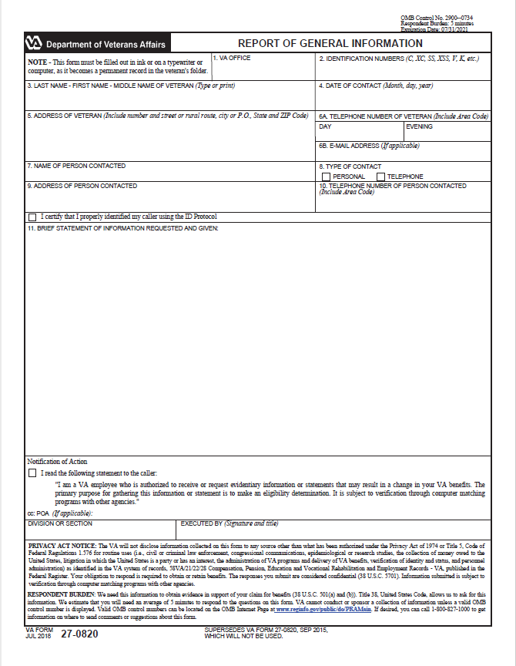

Attachment B: VA Form 21-0845, Authorization to Disclose Personal Information to a Third Party

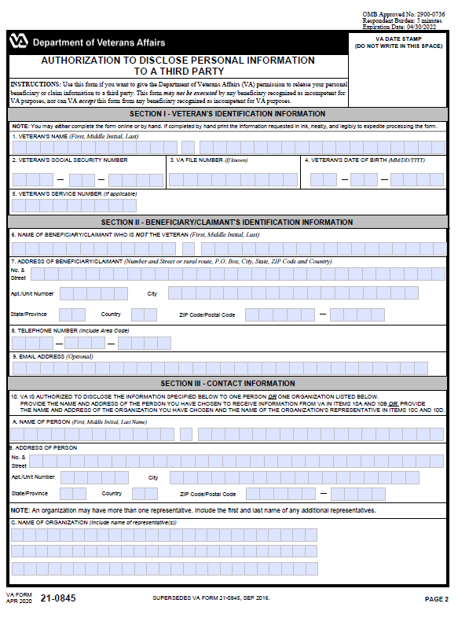

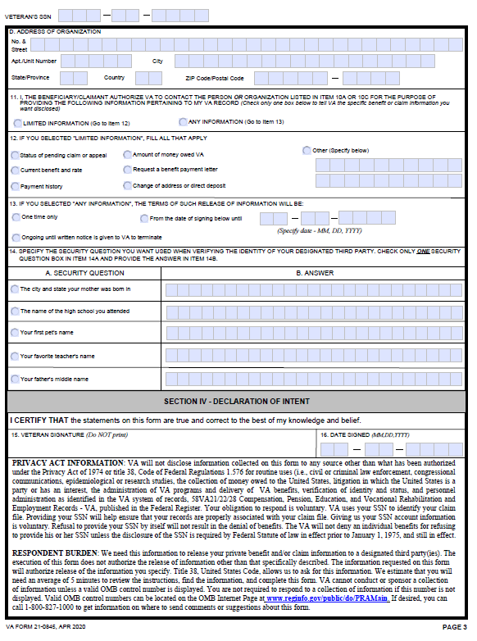

Practical Exercise

Please complete the following review questions. You may use your reference material.

1. List at least four types of information suitable for telephone development.
2. When doing telephone development, what types of information can be used to verify the identity of the Veteran or contact?
3. What form is used to document a successful telephone contact with the claimant?
4. What form must be in the claims folder in order to release personal information to a third party? Describe the purpose.
5. Name the 7 Cs in effective customer service techniques.