DPRIS and PIES

Trainee Handout

**Table of Contents**

Objectives 2

References 3

Topic 1: DPRIS 4

Topic 2: PIES 12

Practical Exercise 15

Objectives

* Identify the purpose and functionality of the Defense Personnel Records Information Retrieval System (DPRIS) Web organization and Personnel Information Exchange System (PIES)
* Identify what records are available through DPRIS and PIES
* Demonstrate how to create a request and navigate the functions within DPRIS and PIES

References

* [M21-1, Part III, Subpart iii.2.A](https://vaww.vrm.km.va.gov/system/templates/selfservice/va_kanew/help/agent/locale/en-US/portal/554400000001034/content/554400000014154/M21-1-Part-III-Subpart-iii-Chapter-2-Section-A-General-Information-on-Service-Records) , General Information on Service Records
* [M21-1, Part III, Subpart iii.2.D](https://vaww.vrm.km.va.gov/system/templates/selfservice/va_kanew/help/agent/locale/en-US/portal/554400000001034/content/554400000014158/M21-1-Part-III-Subpart-iii-Chapter-2-Section-D-Requesting-Information-and-Records-Through-the-Personnel-Information-Exchange-System-PIES), Requesting Information and Records Through the Personnel Information Exchange System (PIES)
* [DPRIS Site User Guide](https://auth.dpris.dod.mil/downloads/dpris_user_guide.pdf)
* [PIES User Guide](http://vbaw.vba.va.gov/bl/21/publicat/Users/Pies/PIESparticipantguide.docx)

All M21-1 references are found in the [Live Manual Website](https://vaww.compensation.pension.km.va.gov/)

Topic 1: DPRIS

**DPRIS Overview**

The Defense Personnel Records Information Retrieval System (DPRIS) Website provides authorized users with access to digital electronic images to Official Military Personnel Files (OMPF). DPRIS is now the primary internet portal supporting external electronic access by authorized government agencies to any of the military services’ digital OMPF repositories. In the past, information from these records was typically provided via hardcopy, with requests for information and responses to such requests mailed through the U.S. Postal Service. Regardless of the form in which the information is obtained, all users are required by law to safeguard the information contained in the OMPF, as directed by the Privacy Act of 1974 and HIPPA.

**DPRIS Advantages**

Some advantages of DPRIS include:

* Allows access to OMPF images contained in each services’ repositories
* On average, images are received in less than 48 hours
* Many images are received within minutes
* Provides a standard index of all images contained in each of the services’ OMPF Systems
* Includes a Follow-up Message capability
* Single-source repository for all branches

**VA-Services Interface without DPRIS**

Without DPRIS, submitting a request to a service’s image repository would be much more cumbersome. If you needed images from the Army’s image repository, for example, you would have to log into the repository, submit the request, and then log out. At some point later on, you would have to go back to see if the request for images has been processed, and if so, download the images. You would have to do this for each military service’s repository (Army, Navy, Air Force, or Marines). Therefore, you would have to maintain several separate logons.

In addition, if one of the Services needed to change some of the programming for their record system, VA would possibly need to change their programming to ensure users would have continued access. VA would have to do this every time a military service changed the programming to their personnel records system. This would result in delays in retrieving images from these repositories, which is not an efficient way to conduct business. This is why the Office of the Under Secretary of Defense, Personnel and Readiness Management, sponsored the creation of DPRIS.

**VA-Services Interface with DPRIS**

By having DPRIS, you will only need to maintain one login in order to submit requests. When you submit the request, DPRIS will route the request to the correct image repository. When the image is available for viewing, DPRIS will advise you via email.

**VSR Roles and Responsibilities**

As a DPRIS user, there are several roles and responsibilities associated with this assigned duty:

* Initiate requests for military personnel records information Upload records into the Veteran’s electronic folder or print and associate with the claims folder
* Communicate with local managers, DPRIS Web staff via User Assistance Forms, and Central Office to solve problems.
* Initiate and manage secure follow-up messages
* Access DPRIS Web Information, Help Website Modules, and submit automated User Requests Assistance Forms

**Using DPRIS**

The normal means of entry to the website is through its home page at <https://www.dpris.dod.mil>, which includes a public area open to all Internet users. Type in the website address in your browser and hit enter. The DPRIS homepage will be displayed. It is recommended that this website address be added to your Favorites list.

The Agency Identification Code (AIC) will be provided to you prior to attempting registration into DPRIS. This Agency Identification Code (AIC) is specific to a regional office. It will not change, and everyone that works at that regional office will use that regional office’s identification code.

For selecting a manager, select your direct supervisor or coach. Now that the correct DPRIS manager has been selected, DPRIS automatically populates the fields for name, phone number, e-mail address, the full agency name, and the office code or symbol, if one was entered. These fields are read-only, and cannot be changed by the user when entering information on the registration form. Now that the form has been completed, you just need to click on submit.

**Personnel Records Available Through DPRIS**

Not every Veteran’s OMPF is available through DPRIS. There are specific dates associated with each branch of service as to when each branch of service began retaining Veterans’ OMPFS into their imaging system.

The Veteran’s OMPF should be available through DPRIS if his/her service obligation ended on or after the following dates:

Army: October 1, 1994*

Navy: January 1, 1995

Marine Corps: January 1, 1999

Air Force: October 1, 2004

There are no Coast Guard records currently available in DPRIS.

*Note: Army Discharge and Retirement date shown in the DPRIS User Guide under DPRIS Help tab incorrectly shows October 1, 2002.

For Army service obligations that ended between October 1, 1994, and September 30, 2002, user should make the DPRIS request as indicated per [M21-1, Part III, Subpart iii, 2.I.4.a](M21-1-Part-III-Subpart-iii-Chapter-2-Section-I-Control-and-Follow-Up-of-Requests-for-Service-Records). If a negative response is given, user should make a request through NPRC, per [M21-1, Part III, Subpart iii, 2.B.5.b](https://vaww.vrm.km.va.gov/system/templates/selfservice/va_kanew/help/agent/locale/en-US/portal/554400000001034/content/554400000014155/M21-1-Part-III-Subpart-iii-Chapter-2-Section-B-Migration-of-Service-Records-and-the-Procedures-for-Obtaining-Them#5).

**National Guard and Reserves Service**

When determining if the OMPF records are available through DPRIS Web, you must take Reserves and National Guard duty into consideration as well. The easiest way to think about this is the word obligation. It does not matter if the person served on Active Duty, Reserves, National Guard, or in all three. It is when there is no further obligation that matters.

**Document Indexing Scheme**

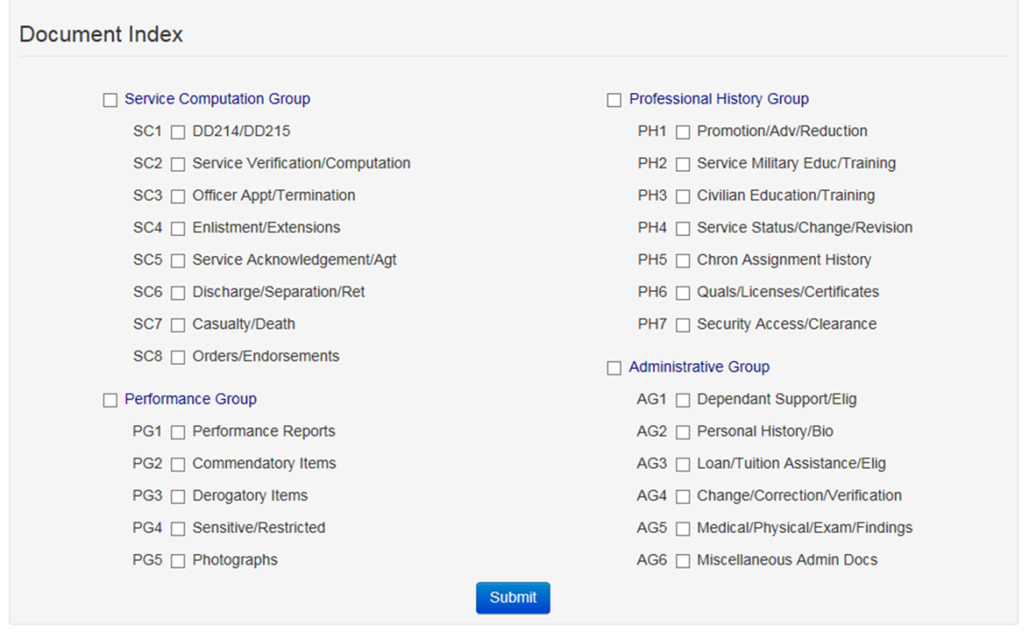

Each of the military services manages their OMPF digital records systems differently. Rather than requiring users to learn each indexing system, DPRIS has developed a standard index. Each document within the four military services’ OMPF systems has been mapped to the DPRIS standard indexing scheme. It shows the four major functional document groupings.

**DPRIS Groups and Subgroups**

All documents in the digital OMPF inventory can intuitively be assigned to one of the following three major functional groupings:

* Service Computation: Documents that record service entry and discharge, length of service, service agreements, appointments, commissions, statements of cumulative service, and other similar time specific data.
* Performance: Documents that record a service member’s performance including evaluations, fitness reports, effectiveness reports, commendatory or derogatory items, and other performance-specific data.
* Professional History: Documents that record promotions, education, training, chronological listing of assignments, qualifications and similar historical data
* Administrative: Documents that record administrative actions or personal information regarding dependents, tuition assistance, medical and dental reports, insurance, and other miscellaneous administrative data.
* The *Consolidated OMPF Document Mapping Report* published July 24, 1998 assigned each of the individual document types contained in the military services’ digital OMPF systems to one or more of the DPRIS Standard Index subgroups. Building on this, DPRIS can support standard requests and retrieval of OMPF document images from any of the four OMPF systems, by another military service or authorized agency, using a single functional methodology.

**Using DPRIS**

Log-in using your User ID and Password

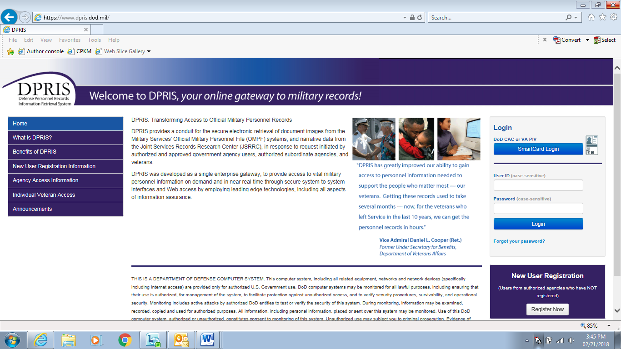

Create Request: Link to the Create Request Form, where you can create a new query for information from a digital OMPF record maintained by one of the military services or submit a request to JSRRC.

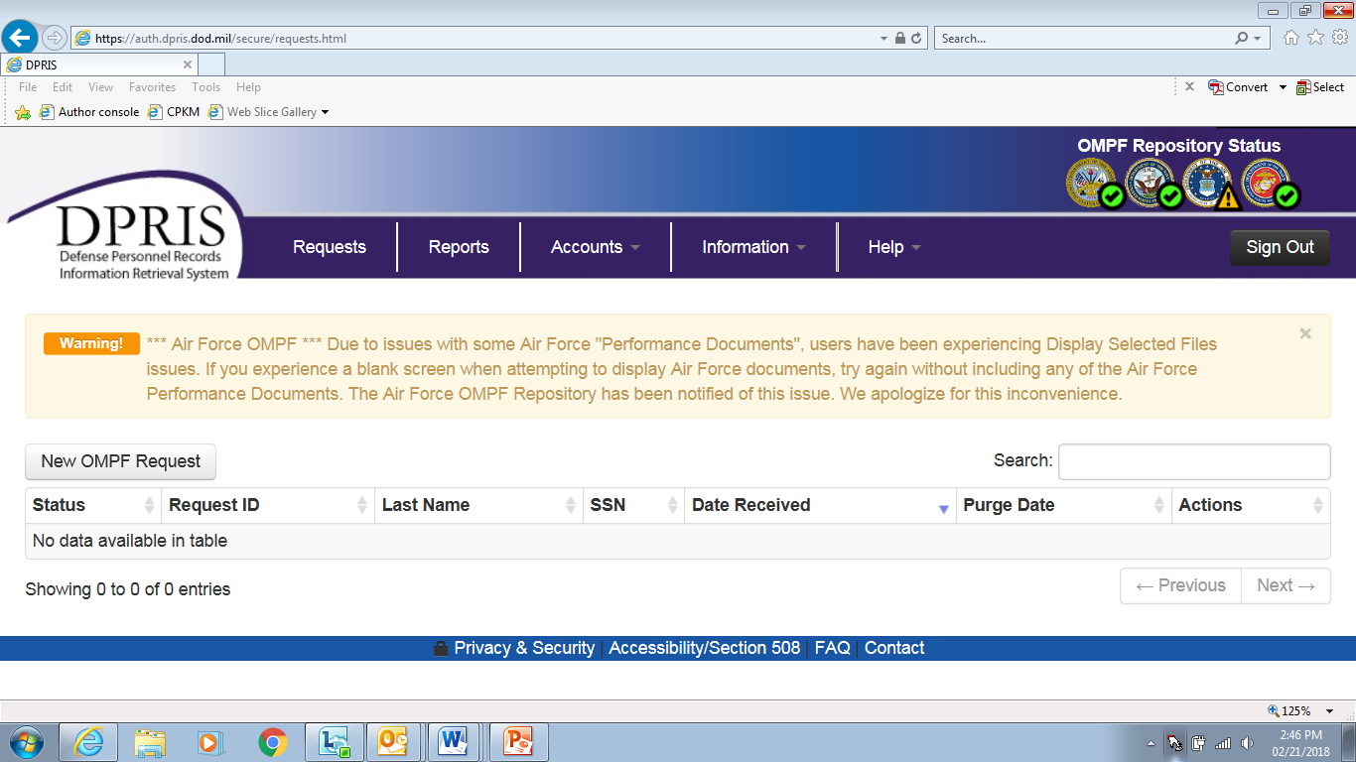

When the Create Request link is selected, the page shown below is displayed. When the OMPF Request link on this page is selected, the OMPF Request Form is displayed as shown on the following page. The OMPF repositories will vary, based upon the authorization approved for the agency. For example, if an agency is only authorized to submit requests to the Navy and Army repositories, only the checkboxes for the Navy and Army would be displayed on this form. The Air Force and Marine Corp checkboxes would not be visible on the form. The Document Index codes that are displayed will also vary, based upon the access level approved for the user. To create an OMPF request, you need to complete the form and click the *Submit* button.

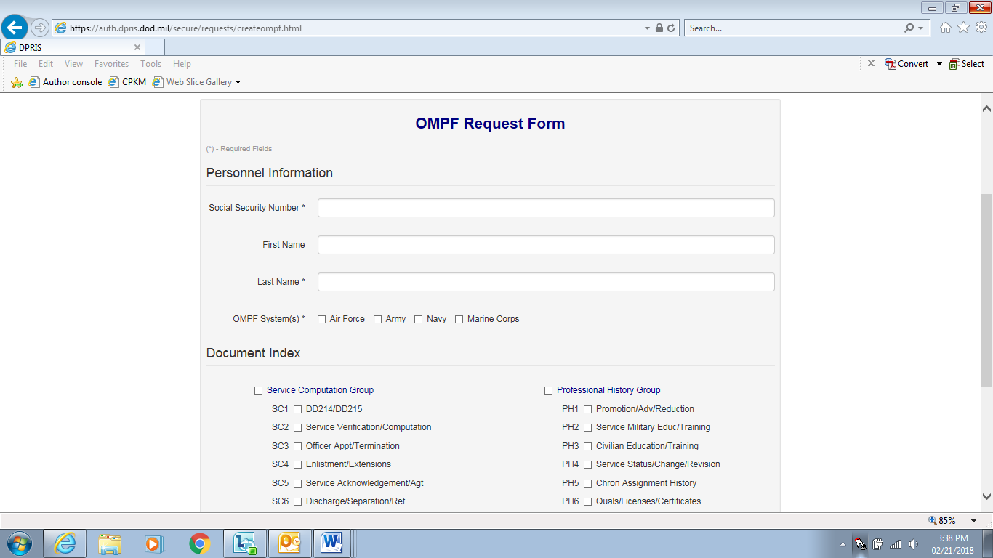

Your authorization level is pre-established by your manager during the registration process. This process determines the types of documents (i.e., groups and subgroups of the DPRIS Standard Index) that will be visible to you on the OMPF Request Form and that can be used in a request to the military service OMPF repositories. For example, a user viewing the screen in Figure 3-9 is only authorized to request document images associated with the DPRIS Service Computation Group and some of the subgroups from the DPRIS Professional History Group.



Responses: Link to the Responses via a list of your requests for which responses have been received from one or more of the military service OMPF systems or from JSRRC. This is the default page that opens after a successful user login. It is often useful to return to this screen from other pages within the secure area of the Website via this link.

Request ID: This column lists Request IDs that have received a response from an OMPF repository or JSRRC. If multiple requests are displayed, they are initially sorted by the Request ID. However, multiple requests can be sorted in a different order by clicking on the arrow in either the Social Security Number (SSN) or Date column headings.

SSN: Lists the SSNs associated with each of your active requests.

Date Received: This column lists the date and time each set of images was received by DPRIS from the OMPF repository, or information was received from JSRRC.

Purge Days Left: This column displays the number of days remaining before the responses will be purged from the DPRIS system. After a requested response is purged, non-image data pertaining to the request remains available via the Reports option, but the response is no longer displayed on the Responses page.

Extend Purge Date: This link allows you to extend the purge date for a request.

The DPRIS Help Desk can be contacted from most of the DPRIS pages by clicking on the Help link located on the bar near the top of each page. After clicking the link, you are taken to the Help area of the Website.

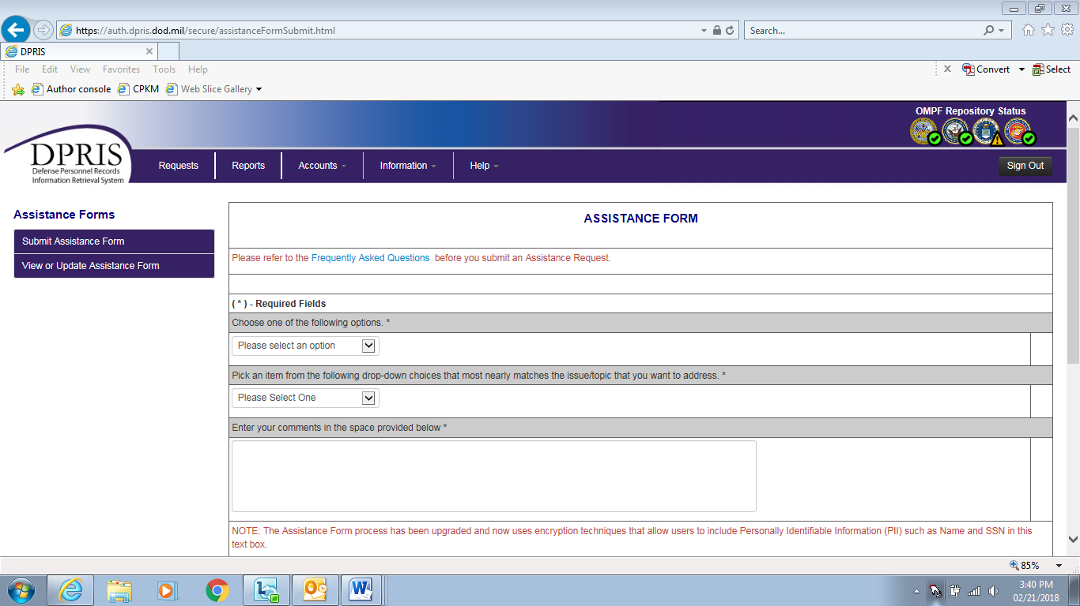

The Assistance Form link will take you to the DPRIS Assistance Form. The Frequently Asked Questions link will provide you with regularly asked questions and answers concerning DPRIS. The Help On Images link provides you with information concerning documents available in the Services’ OMPF systems. The Downloads links give you the capability to download the most recent versions of the DPRIS site Users Guide, DPRIS Training Curriculum, and the MS PowerPoint slides used in conjunction with the training curriculum.

To communicate with the DPRIS Help Desk, you would initially click on the Assistance Form option. A screen will be displayed containing the Assistance Form. This form is designed both for routine DPRIS users and for managers and systems administrators. It allows you to:

Submit suggestions to improve the DPRIS user interface and functional design.

Report deficiencies and problems encountered with the performance of DPRIS.

Request technical or operational assistance.

You are required to select options in the top sections of the form to specify the general nature and urgency of the communication.

Topic 2: PIES

**PIES Overview**

Personnel Information Exchange System

System the VA uses in order to request service records from the National Personnel Records Center (NPRC) in order to develop a Veteran’s claim.

**STRs the NPRC Houses**

|  |  |
| --- | --- |
| **If the Veteran last served in the…** | **and service ended prior to…** |
| Army | October 16, 1992 |
| Navy | January 31, 1994 |
| Air Force | May 1, 1994, if separated from active duty  June 1, 1994 if separated from  National Guard or Reserves |
| Marine Corps | May 1, 1994 |
| Coast Guard | May 1, 1998 |

These dates can be found in [M21-1, Part III, Subpart iii, 2.A.3.d](https://vaww.vrm.km.va.gov/system/templates/selfservice/va_kanew/help/agent/locale/en-US/portal/554400000001034/content/554400000014154/M21-1-Part-III-Subpart-iii-Chapter-2-Section-A-General-Information-on-Service-Records#3)**.**

**Personnel Records the NPRC Houses**

The OMPF should be available through PIES if their service obligation ended before:

* Army: October 1, 1994
* Navy: January 1, 1995
* Marine Corps: January 1, 1999
* Air Force: October 1, 2004

**PIES Inputs**

If this is the first request, once the file number is entered, click “Submit to PIES.”

If this is not the first request, click “Submit to BIRLS.” The Veteran’s Identification Data (VID) is transferred to PIES.

Input the Date of Claim and EP.

Once entered, click on the curved black arrow.

Input your request (PIES O50).

Ensure all information is correct.

Click on yellow rectangle to submit the request.

Once back at the Home Screen, click “Search Existing,” type in the file number, and click “Submit to PIES.”

Double-click the request and upload to the e-folder.

NOTE: Please use the PIES USERs guide for further instructions.

**Using PIES**

***DO***

* Check for the status of your request on the Branch of Service tabs, particularly if the overall status is complete, but there are no responses
* Make sure that you have a complete organizational assignment *(down to the company level)* when requesting sick or morning reports
* Check PIES Help whenever you are not sure of the dates when morning reports are available or the branches of service that maintain them
* Check PIES Help for the time frames when clinical records are available
* Check for redundancy in your requests, particularly if you have selected more than 5 request items
* Update BIRLS, making sure that all fields contain valid data BEFORE making a PIES request

***DON’T***

* Use PIES for requesting service medical records located at the VA RMC (376 or 375)
* Repeat your request by using request code O99
* Mix requests for finance information with requests for service or medical information
* Address requests for service or medical records yourself, unless you have confirmation of where they are
* Request sick or morning reports for a time frame longer than 3 months
* Allege clinical treatment for a period in excess of one year, unless the patient was actually hospitalized that long
* Allege overlapping dates of service in the periods of service grids
* Compose a request (O99) when a programmed request item already exists
* Enter the duty status as “Active”, unless the “Veteran” is currently on active duty in the branch of service about which you are inquiring

**DPRIS to PIES Cross Reference Guide**

The DPRIS to PIES Cross Reference Guide can be found on the Compensation Service Intranet Site under Procedures titled “PIES/DPRIS”.

Practical Exercise

1. Name two of the Groups on the Document Indexing Scheme in DPRIS.
2. Logistics Group and Administration Group
3. Military History Group and Professional History Group
4. Service Computation Group and Performance Group
5. Name one example of a document received through DPRIS.
6. DD-214
7. VA Form 21-22
8. CAPRI Progress Notes
9. Where can we find the DPRIS to PIES Cross-reference Guide?
10. Under the “Hey VA” logon each day in the office
11. On the Compensation Service Intranet page under Procedures – PIES/DPRIS
12. On VA PULSE
13. For a VBMS claim, which PIES code do you use for a claim for PTSD?
14. O19
15. O18
16. O43
17. O50
18. When requesting STRs from the NPRC, which branch of service requires a discharge date before 10/16/1992?
19. Army
20. Navy
21. Air Force
22. Marine Corps
23. What type of records is primarily requested through DPRIS?
24. Medical
25. Finance
26. Personnel
27. Recreational
28. DPRIS provides authorized users access to digital electronic images of each military branch except for the ____________________.
29. Army
30. Navy
31. Air Force
32. Coast Guard
33. Marine Corps