

Payment Tracers
Lesson Plan

January, 2016 – Version 1.0

Payment Tracers (2 hours)

Lesson Overview
TMS # | 4180876
Purpose of the Lesson: | The purpose of this lesson is to provide Veterans Claims Examiner Non-Technical Agents (commonly referred to as “phone techs”) in the Education Call Center with the knowledge needed to properly perform a payment tracer for benefits issued by check or electronic funds transfer (EFT).
Prerequisite Training Requirements: | Agents should be familiar with:  - Performing updates in BDN (i.e. Address and EFT Account changes)  - Adding notes in TIMS
Target Audience: | This lesson is intended for the Veterans Claims Examiner Non-Technical Agents in the Education Call Center.
Lesson References: | The following references support the lesson content:  - VBA Financial Procedures Guide  - Veterans Benefits Administration, MP-4, Part IV  - Non-Receipt of Payment Participant Guide Quality Client Services (27)  - FMS Form 3858  - FMS Form 1133  - ECC Index Documents:  - Finance Escalation Request Form  - Check Tracer Procedures  - Check Tracer Script
Lesson Objectives: | At the conclusion of this lesson, the Veterans Claims Examiner Non-Technical Agents will be able to:  - Using available references, identify what factors should be evaluated prior to performing a payment tracer, with 80% accuracy on the assessment.  - Using available references, identify the procedures for requesting a 1st, 2nd, and 3rd payment tracer, with 80% accuracy on the assessment.  - Using available references, identify Finance issues that require escalation, with 80% accuracy on the assessment.  - Using available references, identify what happens after a payment tracer is performed, with 80% accuracy on the assessment.

Instructor Notes
This lesson covers how to properly perform a payment tracer, as well as what to check prior to initiating a payment tracer. There are opportunities for comprehension checks throughout the lesson. In addition, when appropriate, the lesson contains practical exercises that provide Veterans Claims Examiner Non-Technical Agents with the opportunity to practice the knowledge and skills presented in the lesson for deeper understanding.
Prior to training, the instructor will need to compile:
- A list of file numbers for students to review in BDN, SHARE, TIMS and LTS
  - To allow for various payment scenario discussions, ensure that the files include: Payments, Returned Payments, Debts
- Sample data for students to use to complete a Finance Escalation Request Form

PowerPoint Slides | Instructor Activities
Payment Tracers | DISPLAY slide 1  “Payment Tracers”  INTRODUCE yourself as the instructor and introduce any fellow instructors.  INTRODUCE the lesson.
Overview of Today’s Training | DISPLAY slide 2  “Overview of Today’s Training”  PROVIDE an overview of the day’s schedule.  EXPLAIN that students will be learning how to properly perform a payment tracer for benefits issued by check or electronic funds transfer (EFT).  DISCUSS how the subject fits into the lesson purpose, goals, and importance.
Student Introductions (Optional) | If required, ASK students to introduce themselves.
Lesson Objectives  At the end of this lesson, you will be able to:  - Identify what factors should be evaluated prior to performing a payment tracer  - Identify the procedures for requesting a 1st, 2nd, and 3rd payment tracer  - Identify Finance issues that require escalation  - Identify what happens after a payment tracer is performed | DISPLAY slide 3  “Lesson Objectives”  REVIEW the lesson objectives and assure students they will have opportunities to practice what they learn.  EMPHASIZE that the post-lesson assessment will align with the content and these objectives.
Payment Tracer - Defined  A Payment Tracer is a transaction used to determine if a payment has been deposited, cashed, or has not been negotiated. | DISPLAY slide 4  “Payment Tracer - Defined”  DEFINE payment tracer.  PROCEED to the next further discuss.
Steps to Initiate a Payment Tracer  Payment tracers can be requested for payments made by:  - Direct Deposit (EFT)  - Check  STEPS  - Students and/or School Officials may contact VA to report non-receipt of payment and request a payment tracer.  - The VA employee submits the request to the VA Finance department.  - Finance performs the tracer and notifies the claimant of the results and any next steps. | DISPLAY slide 5  “Steps to Initiate a Payment Tracer”  EXPLAIN that payment tracers can be requested for both EFT and check payments.  REVIEW the steps that occur for a payment tracer.  INFORM students that you will be discussing steps throughout the class.
Requesting a Payment Tracer - Considerations  Check the following BEFORE requesting a payment tracer:  - Has the payment been issued?  - Was the payment sent to the correct location?  - Was the payment included with other payments?  - Was the payment applied to a debt?  - Was the payment returned? | DISPLAY slide 6  “Requesting a Payment Tracer - Considerations”  EMPHASIZE that there are certain things that an agent should check BEFORE he/she requests a payment tracer.  REVIEW the 5 items listed.  PROCEED to the next slide to begin a more detailed discussion of each one.
1. Has the Payment Been Issued?  - Once a payment has been sent by VA, it will be displayed in the following places:  - BDN M22 Screen  - SHARE | DISPLAY slide 7  “1. Has the Payment Been Issued?”  EXPLAIN that once a payment is sent by the VA, it will show in both BDN and SHARE.  PROCEED to the next slide to show screenshots of both BDN and SHARE.
1. Has the Payment Been Issued? – BDN and SHARE  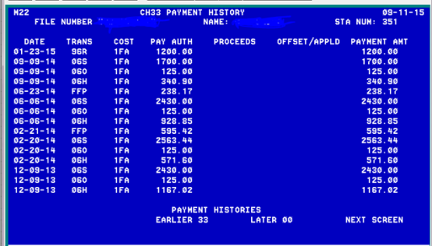 | DISPLAY slide 8  “1. Has the Payment Been Issued?”  SHOW the BDN screenshot and point out the payment amount and date.  MENTION that Ch35 payments will not show on this screen.  SHOW the SHARE screenshot.  TELL the students that in order to see the date the payment was actually sent by Treasury, they must check the SHARE screen.
2. Was the Payment Sent to the Correct Location?  Verify the student’s:  - Address  - EFT Account (routing number and account number)  Correct if necessary using the established procedures. | DISPLAY slide 9  “2. Was the Payment Sent to the Correct Location?”  EXPLAIN that agents should verify that the payment was sent to the correct location by verifying the student’s address (for check payments) or EFT Account (for electronic payments).  REMIND students that they should use the established procedures for updating when necessary.
3. Was the Payment Included With Other Payments?  Compare the expected payment amount with the actual payment amount:  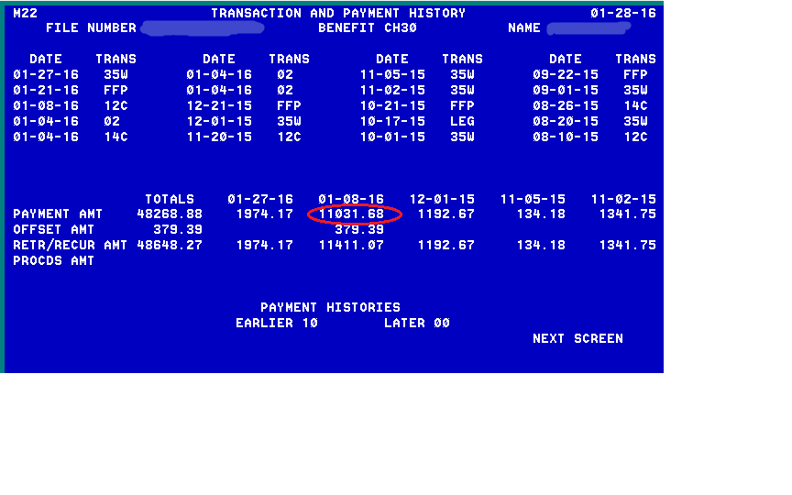 | DISPLAY slide 10  “3. Was the Payment Included With Other Payments?”  EXPLAIN that next agents should check to see if the expected payment was included with another payment.  SHOW the BDN M22 screenshot and point out the appropriate fields. Note that this is a Ch30 Master Record and that the payment on 1-8-16 is well over the Full Time Chapter 30 rate. Therefore, it includes multiple payments.
4. Was the Payment Applied to a Debt?  Check to see if the payment was applied to a debt:  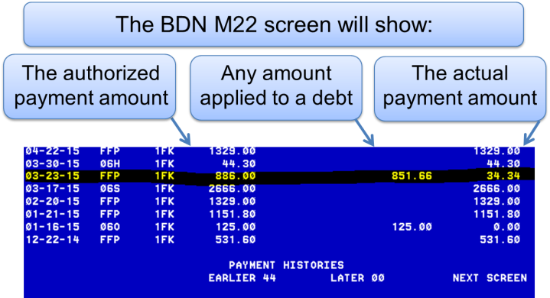 | DISPLAY slide 11  “4. Was the Payment Applied to a Debt?”  EXPLAIN that agents can also use the BDN M22 screen to see if the payment was applied to a debt.  SHOW the BDN M22 screenshot and point out the appropriate fields.
4. Was the Payment Applied to a Debt? (Continued)  Check to see if the payment was applied to a debt:  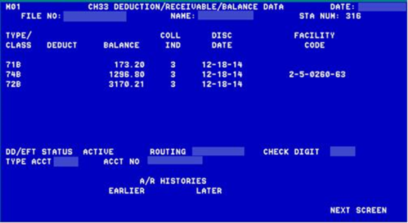 | DISPLAY slide 12  “4. Was the Payment Applied to a Debt? (Continued)”  EXPLAIN that agents can also use the M01 screen to see if the payment was applied to a debt.  SHOW the M01 screenshot and point out the appropriate fields.
5. Was the Payment Returned?  - Check BDN and SHARE to see if the payment was returned.  - BDN Screen M23 (Code 21R or 21S)  - BDN Screen M21 (proceeds)  - SHARE (bottom of screen)  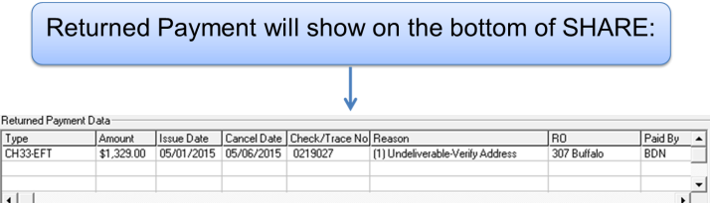 | DISPLAY slide 13  “5. Was the Payment Returned?”  EXPLAIN that lastly, agents should check to see if the payment was returned.  MENTION the locations in BDN and SHARE where they can find this information.  SHOW the SHARE screenshot and point out the appropriate fields.  INFORM students that performing a CADD will often release a returned payment.
Requesting a Payment Tracer  - Wait at least 10 business days from the date a check was issued in SHARE before requesting a tracer.  - If the claimant reports that a check was lost or stolen, you may complete a payment tracer the same day.  - Wait at least 5 business days from the date of the EFT transaction in SHARE before requesting a tracer. | DISPLAY slide 14  “Requesting a Payment Tracer”  INFORM students of the waiting periods for requesting a payment tracer.  POINT OUT the exception for lost or stolen checks.
Payments Over a Year Old  - Treasury typically does not trace payments over one year old.  - Do not perform payment tracer requests for payments over a year old.  - Advise the claimant to report non-receipt of payment to their postal service, local law enforcement, or DA’s office if needed.  - Only in the instance of theft/fraud may a payment be traced after one year.  - The claimant should send a written request to their RPO and include a copy of the report issued by local law enforcement. | DISPLAY slide 15  “Payments Over a Year Old”  INFORM students that Treasury typically doesn’t trace payments that are over one year old.  EMPHASIZE that agents should not escalate payment tracer requests for payments over a year old.  DISCUSS how to handle a situation where a claimant is inquiring about a payment that is over a year old.
Comprehension Check  Questions:  - What 5 things should you check prior to requesting a Payment Tracer?  - Who actually performs the Payment Tracer? | DISPLAY slide 16  “Comprehension Check”  ASK the students the comprehension check questions.  ALLOW multiple students to answer aloud.  Response 1:  - Has the payment been issued?  - Was the payment sent to the correct location?  - Was the payment included with other payments?  - Was the payment applied to a debt?  - Was the payment returned?  Response 2:  VA Finance
Group Activity  Practical Application  Claimant Inquiries: Payment Scenarios based on information in BDN, SHARE, TIMS, and LTS. | DISPLAY slide 17  “Group Activity”  INFORM students that you will now spend some time looking at actual files and discussing how to handle claimant inquiries about payments.  DISPLAY your computer screen so that students can see you access BDN, SHARE, TIMS, and LTS.  ACCESS the pre-determined file numbers in each system.  FACILITATE a discussion regarding various payment scenarios, being sure to include: recent payments, returned payments and debts.
Payment Tracer - 1st, 2nd, and 3rd Requests  The procedures for requesting a payment tracer differ depending on whether it is a 1st, 2nd or 3rd request. | DISPLAY slide 18  “Payment Tracer - 1st, 2nd, and 3rd Requests”  TELL students the procedures for requesting a payment tracer differ depending on whether it is a 1st, 2nd or 3rd request.  PROCEED to the next slide to begin the discussion on procedures.
Payment Tracer - 1st Request Procedures  1st Request:  - Use the Check Tracer Button on the ECC Index  - Complete the email template  - Email to Finance  - Capture a copy of the sent email into TIMS  - Label captured email in TIMS as “Tracer Request” | DISPLAY slide 19  “Payment Tracer – 1st Request Procedures”  REVIEW the procedures for a 1st Request Payment Tracer.  DEMONSTRATE where to locate the Check Tracer Button.  REMIND students how to capture items into TIMS.  PROCEED to the next slide to show a copy of the email template.
Payment Tracer Email Template  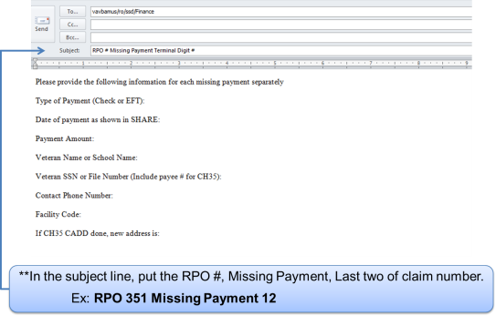 | DISPLAY slide 20  “Payment Tracer Email Template”  DISCUSS how to properly complete the Payment Tracer Email for a 1st Request.  PROCEED to the next slide to discuss 2nd Request procedures (which also utilize the Payment Tracer Email).  PROVIDE the student with an example specific to your RPO.
Payment Tracer – 2nd Request Procedures  2nd Request:  - Wait at least 10 business days from 1st Request  - Follow procedures from the 1st Request  - Include “2nd Tracer Request” in subject line of email  - Label captured email in TIMS as “2nd Tracer Request” | DISPLAY slide 21  “Payment Tracer – 2nd Request Procedures”  REVIEW the steps for requesting a 2nd Request Payment Tracer.  EMPHASIZE that they must wait at least 10 business days from 1st Request before performing a 2nd Request.  PROCEED to the next slide to discuss how to handle a 3rd Request.
Payment Tracer- 3rd Request Procedures  3rd Request:  - Wait at least 10 business days from the 2nd Request  - Escalate the call  - If escalation line is closed:  - Complete the Finance Escalation Request Form (located in “Job Aids” on the ECC Index)  - Give the Form to your coach  - Place a Note in TIMS that “3rd Request for payment tracer sent to coach on mm-dd-yy” | DISPLAY slide 22  “Payment Tracer – 3rd Request Procedures”  TELL students that if there is no response from Finance, (at least 10 business days from 2nd Request), they should escalate the call.  REVIEW the procedure for a 3rd Request.  REMIND students how to place a note in TIMS.  PROCEED to the next slide to discuss additional Finance issues that require escalation.
Additional Finance Issues  Requiring Escalation  Escalate these calls (or complete a Finance Escalation Request Form if the escalation line is closed):  - 3rd Payment Tracer Request  - Requests to release/reissue payments showing at the bottom of SHARE or in proceeds (after CADD failed to release)  - Requests to release/reissue a returned payment for Chapter 35  - Direct communication with Finance is needed  Note: DO NOT complete a VA Form 119 for these issues. | DISPLAY slide 23  “Additional Finance Issues  Requiring Escalation”  INFORM students that in addition to a 3rd Request, there are other Finance issues that require escalation.  DISCUSS the issues/items listed.  EMPHASIZE that agents should not complete a Form 119 for these issues.  PROCEED to the next slide show a screenshot of the Finance Escalation Request Form Template.
Finance Escalation Request Form Template  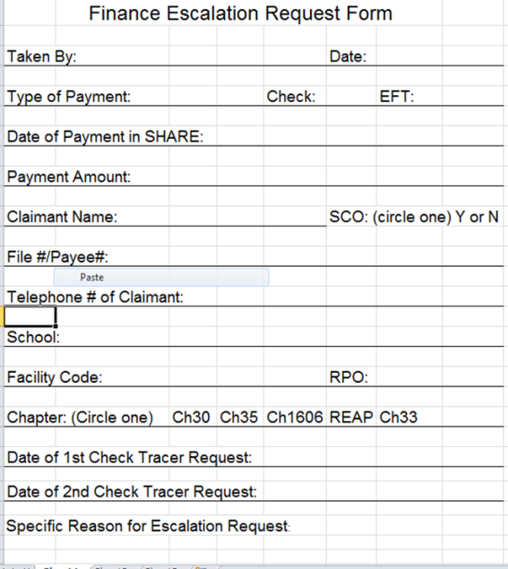 | DISPLAY slide 24  “Finance Escalation Request Form Template”  This slide is specific to the Muskogee Call Center.  REVIEW the parts of Finance Escalation Request Form Template.  DISCUSS how to properly complete the Form.  DEMONSTRATE how to access the Form.  PROCEED to the next slide to begin an activity that will allow students to practice locating and completing the Finance Escalation Request Form.
Individual Activity  Completing a Payment Tracer and a Finance Escalation Request Form:  - Locate the Tracer Button on the ECC Index.  - Complete a payment tracer using the information provided.  - Locate the Finance Escalation Request Form on the ECC Index.  - Complete a Finance Escalation Request Form using the information provided. | DISPLAY slide 25  “Individual Activity”  REVIEW the activity instructions with the students.  PROVIDE students the pre-compiled information needed to complete the Payment Tracer and Finance Escalation Request Form.  DEBRIEF the activity after students have completed 1 to 3 Payment Tracers and Escalation Forms.  ENSURE that students are comfortable completing the Payment Tracers and Escalation Forms before moving on.
What Happens After  the Payment is Traced?  After a payment tracer has been requested, claimants should allow at least 2-4 weeks for the U.S. Treasury to contact them. | DISPLAY slide 26  “What Happens After  the Payment is Traced?”  INFORM students that the U.S. Treasury may take 2-4 weeks to contact a claimant after a payment tracer has been requested.  PROCEED to the next slide to discuss additional details of what happens after a payment tracer has been requested.
What Happens After  the Check is Traced?  - Checks:  - If the check has not been cashed, Treasury will send the claimant a courtesy replacement check.  - If the claimant later finds the original check, he/she should mail one of the checks back to VA.  - If both checks are cashed, a debt will be established against the claimant. | DISPLAY slide 27  “What Happens After  the Check is Traced?”  INFORM students that what happens after a check is traced depends on whether or not the check has been cashed.  DISCUSS what happens after a payment tracer if the check has not been cashed.  PROCEED to the next slide to discuss what happens if the check has been cashed.
What Happens After  the Check is Traced? (Continued)  Checks:  - If the check has been cashed, Treasury will send the claimant a fraud package (FMS 3858).  - The package will contain:  - A photocopy of the front and back of the cashed check  - Signature sample form  - Fraud claim form (FMS 1133)  - The claimant must complete the claim form and return the package to the U.S. Treasury.  - Treasury will notify the claimant regarding the outcome and send a replacement check if applicable. | DISPLAY slide 28  “What Happens After  the Check is Traced?” (Continued)  DISCUSS what happens after a payment tracer if the check has been cashed.  PROCEED to the next slide to discuss what happens after an EFT payment tracer has been requested.
What Happens After  the EFT is Traced?  EFT Payments:  - Finance and Treasury will work together to determine:  - If the payment was deposited or not  - The account into which the payment was deposited  - Depending upon information received from the claimant’s bank, Treasury will:  - Determine if a payment needs to be made  - Notify the claimant of the findings | DISPLAY slide 29  “What Happens After  the EFT is Traced?”  DISCUSS what happens after an EFT payment tracer.  ENSURE that students understand the process before moving on to the Comprehension Check.
Comprehension Check  Questions:  - How long should a claimant allow for the U.S. Treasury to contact them after a payment tracer has been requested?  - If a student reduces their hours enrolled by withdrawing from fewer than all classes and mitigating circumstances are received and approved, payments would be reduced effective when? | DISPLAY slide 30  “Comprehension Check”  ASK the students the comprehension check questions.  Response 1:  At least 2-4 weeks.  Response 2:  Treasury will send the claimant a fraud package (FMS 3858).
Lesson References  - VBA Financial Procedures Guide  - Veterans Benefits Administration, MP-4, Part IV  - Non-Receipt of Payment Participant Guide Quality Client Services (27)  - FMS Form 3858  - FMS Form 1133  - ECC Index Documents:  - Finance Escalation Request Form  - Check Tracer Procedures  - Check Tracer Script | DISPLAY slide 31  “Lesson References”  IDENTIFY where students can find any important VA and non-VA lesson references and job aids.
Summary  You have completed this lesson. You should be able to:  - Identify what factors should be evaluated prior to performing a payment tracer  - Identify the procedures for requesting a 1st, 2nd, and 3rd payment tracer  - Identify Finance issues that require escalation  - Identify what happens after a payment tracer is performed | DISPLAY slide 32  “Summary”  REVIEW the information in the day’s lesson.
Questions?  What questions do you have? | DISPLAY slide 33  “Questions?”  ASK students what questions they have about the day’s lesson.  RESPOND to all questions before tasking students to complete the assessment.
TMS Assessment and Survey  - The assessment and survey have been assigned to you in TMS  - The assessment is comprised of multiple choice questions  - The questions are based on the information presented in this lesson  - The assessment should take you approximately 30 minutes  - Be sure to complete both the assessment and the survey in TMS to receive credit for this training | DISPLAY slide 34  “TMS Assessment and Survey”  CONFIRM that the students know how to access the assessment and survey in TMS.  EXPLAIN that the assessment is TMS# “{_____}” and will cover what they learned in class today.  REMIND them that they must complete both the assessment and the survey in order to receive credit in TMS for their training.  TELL students that the survey provides them an opportunity to improve the training and that their feedback is welcome.

