Service Records

Excercise

**Table of Contents**

Practical Exercise 2

Practical Exercise

Directions: Translate each of the three service treatment record samples given. Put the SOAP information in the blanks provided at the bottom by the corresponding letter. In addition, write out the abbreviations and acronyms you find in the text. We will go over the answers together.

1. Please “translate” SOAP, abbreviations & acronyms on the left side.

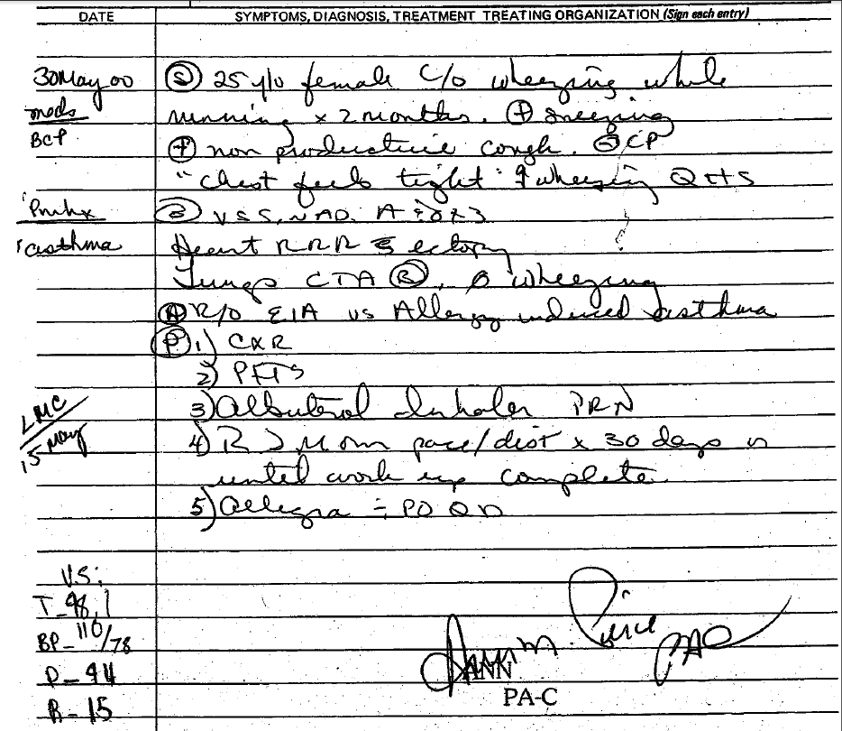

S:___________________________________________________________________________________________________________________________________O:__________________________________________________________________________________________________________________________________A:__________________________________________________________________________________________________________________________________P:___________________________________________________________________________________________________________________________________Left:________________________________________________________________________________________________________________________________

1. Please “translate” SOAP.

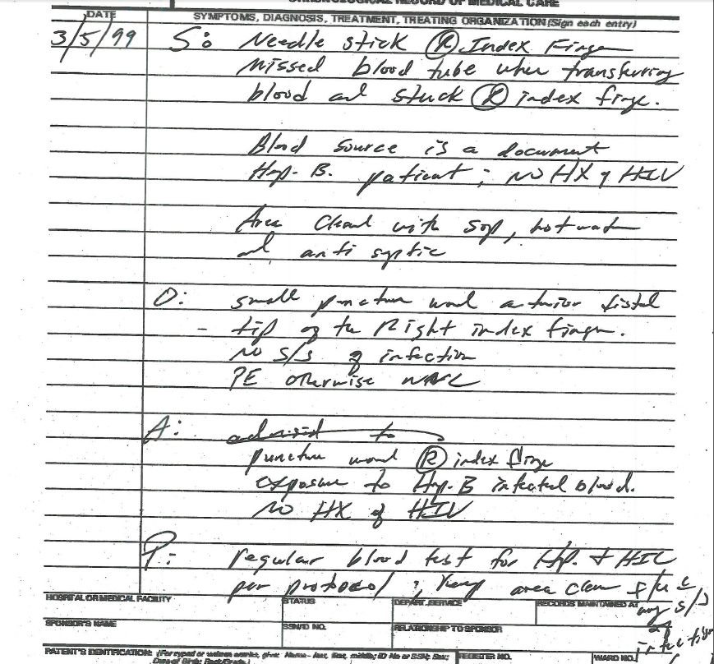

S:___________________________________________________________________________________________________________________________________O:__________________________________________________________________________________________________________________________________A:__________________________________________________________________________________________________________________________________P:___________________________________________________________________________________________________________________________________

1. Please “translate” SOAP.

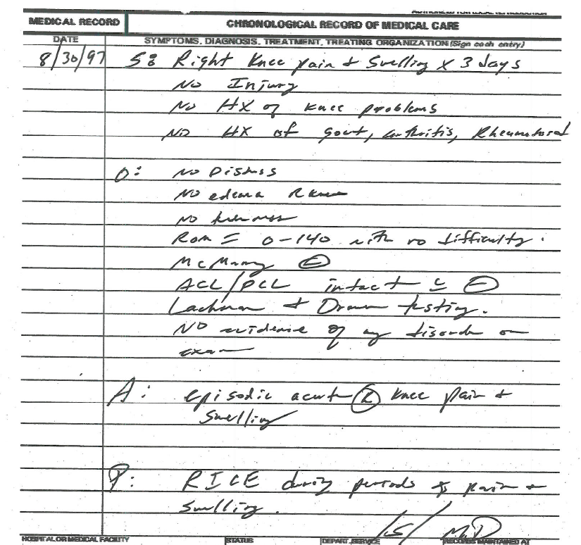

S:___________________________________________________________________________________________________________________________________O:__________________________________________________________________________________________________________________________________A:__________________________________________________________________________________________________________________________________P:___________________________________________________________________________________________________________________________________