Mental Disorders (RVSR IWT)
Instructor Lesson Plan
Time Required: 2.5 Hours

Table of Contents

Lesson Description 2
Introduction to Mental Disorders (RVSR IWT) 4
Topic 1: Posttraumatic Stress Disorder (PTSD) 5
Topic 2: Rating Mental Disorders 12
Topic 3: Competency and Other Considerations 19

Lesson Description
The information below provides the instructor with an overview of the lesson and the materials that are required to effectively present this instruction.
TMS # | 4178966
Prerequisites | Not applicable
target audience | The target audience for Mental Disorders (RVSR IWT) is RVSR Challenge trainees.  Although this lesson is targeted to teach the RVSR Challenge trainees, it may be taught to other VA personnel as mandatory or refresher type training.
Time Required | 2.5 hours
Materials/  TRAINING AIDS | Lesson materials:  - Mental Disorders (RVSR IWT) PowerPoint Presentation  - Mental Disorders (RVSR IWT) References Job Aid
Training Area/Tools | The following are required to ensure the trainees are able to meet the lesson objectives:  - Classroom or private area suitable for participatory discussions  - Seating, writing materials, and writing surfaces for trainee note taking and participation  - Handouts, which include a practical exercise  - Large writing surface (easel pad, chalkboard, dry erase board, overhead projector, etc.) with appropriate writing materials  - Computer with PowerPoint software to present the lesson material  Trainees require access to the following tools:  - VA TMS to complete the assessment
Pre-Planning | - Become familiar with all training materials by reading the Instructor Lesson Plan while simultaneously reviewing the corresponding PowerPoint slides. This will provide you the opportunity to see the connection between the Lesson Plan and the slides, which will allow for a more structured presentation during the training session.  - Become familiar with the content of the trainee handouts and their association to the Lesson Plan.  - Practice is the best guarantee of providing a quality presentation. At a minimum, do a complete walkthrough of the presentation to practice coordination between this Lesson Plan, the trainee handouts, and the PowerPoint slides and ensure your timing is on track with the length of the lesson.  - Ensure that there are copies of all handouts before the training session.  - When required, reserve the training room.  - Arrange for equipment such as flip charts, an overhead projector, and any other equipment (as needed).  - Talk to people in your office who are most familiar with this topic to collect experiences that you can include as examples in the lesson.  - This lesson plan belongs to you. Feel free to highlight headings, key phrases, or other information to help the instruction flow smoothly. Feel free to add any notes or information that you need in the margins.
Training Day | - Arrive as early as possible to ensure access to the facility and computers.  - Become familiar with the location of restrooms and other facilities that the trainees will require.  - Test the computer and projector to ensure they are working properly.  - Before class begins, open the PowerPoint presentation to the first slide. This will help to ensure the presentation is functioning properly.  - Make sure that a whiteboard or flip chart and the associated markers are available.  - The instructor completes a roll call attendance sheet or provides a sign-in sheet to the students. The attendance records are forwarded to the Regional Office Training Managers.

 | Introduction to Mental Disorders (RVSR IWT)
 | INSTRUCTOR INTRODUCTION |  | Complete the following:  - Introduce yourself  - Orient learners to the facilities  - Ensure that all learners have the required handouts
 | time required |  | 0.25 hours
 | Purpose of Lesson  Explain the following: |  | This lesson is intended to introduce RVSR Challenge trainees to the principles of service connection and evaluation of psychiatric and mental conditions. Particular focus is placed on posttraumatic stress disorder (PTSD).
 | Lesson Objectives  Discuss the following:  Slide 2 | Upon the completion of this less and given all available references, RVSR trainees will be able to accomplish the following with:  - grant, deny, and/or evaluate PTSD and other mental disorders  - address 38 U.S.C 1702  - address competency and incompetency
 | Explain the following: | Each learning objective is covered in the associated topic. At the conclusion of the lesson, the learning objectives will be reviewed.  The primary focus of this lesson is PTSD since that will most likely be the most commonly encountered mental condition. But also, because almost all mental conditions are evaluated based on the exact same criteria. So if you understand how to evaluate PTSD, you will also know how to evaluate most other mental conditions.
 | STAR Error code(s) | A1, A2, B1, B2, C1, C2, E2
 | References  Slide 3 | Explain where these references are located in the workplace.  All M21-1 references are found in the Live Manual Website.  - M21-1, Part III, Subpart iv, 4, H, Mental Disorders  - M21-1, Part IV, Subpart ii, 1, D, Claims for Service Connection for Posttraumatic Stress Disorder  - M21-1, Part III, Subpart iv, 3, D, Examination Reports  - M21-1, Part III, Subpart iv, 8, A, Evaluating Competency  - M21-1, Part III, Subpart iv, 6, C, Completing the Rating Decision Narrative  - M21-1, Part IX, Subpart ii, 2, 5, Rating for Service Connection for Psychosis Under 38 U.S.C. 1702

Topic 1: Posttraumatic Stress Disorder (PTSD)
Introduction |  | This topic will introduce trainees to the regulations that define posttraumatic stress disorder (PTSD) and to become familiar with the requirements for granting service connection for PTSD.
Time Required |  | 0.75 hours
OBJECTIVES/  Teaching Points |  | Topic objectives:  - Understand the regulations that define posttraumatic stress disorder (PTSD)  - Learn the different considerations for stressor verification  - Learn the requirements for granting service connection for PTSD
Posttraumatic Stress Disorder (PTSD) Defined  Slide 4 |  | A disorder in which an overwhelming traumatic event is re-experienced, causing intense fear, helplessness, horror, and avoidance of stimuli associated with the trauma.  The development of symptoms usually occurs after a psychologically traumatic event (stressor) that the person experienced, witnessed, or was confronted with that involved actual or threatened death or serious injury, or a threat to the physical integrity of themselves or others. Such as:  - Combat exposure  - Child sexual or physical abuse  - Terrorist attack  - Sexual/physical assault  - Serious accident  - Natural disaster  Discuss: The following credentialed mental health professionals are qualified to perform initial C&P mental disorder examinations:  - board-certified or board-eligible psychiatrists  - licensed doctorate-level psychologists, or  - the following other mental health professionals, under the close supervision of a board-certified or board-eligible psychiatrist or licensed doctorate-level psychologist:  - doctorate-level mental health providers  - psychiatry residents, and  - clinical or counseling psychologists completing a one-year internship or residency.  Important: For a claim for posttraumatic stress disorder (PTSD) based upon a stressor related to the Veteran’s fear of hostile military or terrorist activity, 38 CFR 3.304(f)(3) directs that the examination must be conducted by a VA psychiatrist or psychologist, or a psychiatrist or psychologist with whom VA has contracted. (M21-1 III.iv.3.D.2.h.)  Review examinations or examinations in claims for increased evaluations of service-connected (SC) mental disorders may be conducted by those listed above, or other mental health professional under the close supervision of a board-certified or board-eligible psychiatrist or licensed doctorate-level psychologist, including  - licensed clinical social workers  - nurse practitioners  - clinical nurse specialists, and  - physician assistants.  (M21-1 III.iv.3.D.2.i.)
PTSD Eligibility Criteria  Slide 5 |  | Service connection for PTSD associated with an in-service stressor requires  - credible supporting evidence that the claimed in-service stressor actually occurred  - medical evidence diagnosing the condition  - a link, established by medical evidence, between current symptomatology and the claimed in-service stressor.  Discuss: To establish service connection for PTSD based on an in-service stressor, the relationship between stressor and symptoms must be  - specifically addressed in the DBQ, and  - supported by documentation (we will cover specifically what documentation is needed in which circumstances throughout the lesson.)  STRESS: 38 CFR 3.304(f) ONLY applies to PTSD, not other mental conditions such as anxiety disorder or major depressive disorder.
Categories and Types of PTSD Claims  Slide 6 |  | There are five regulatory categories with special liberalizing considerations for establishing occurrence of the claimed stressor:  - Section 3.304(f)(1) In-service diagnosis of PTSD  - Section 3.304(f)(2) Combat related  - Section 3.304(f)(3) Fear of hostile military or terrorist activity related  - Section 3.304(f)(4) Former prisoner-of-war related  - Section 3.304(f)(5) Personal assault/MST related  Explain: We will discuss the different considerations for each one.
In-service diagnosis of PTSD  Slide 7 |  | When PTSD is properly diagnosed in service, the Veteran’s testimony alone may establish that the claimed in-service stressor occurred, as long as the claimed stressor is  - related to the Veteran’s service, and  - consistent with the circumstances, conditions, or hardships of that service.  Discuss: If a Veteran is sound on enlistment and develops delayed or late-onset PTSD in service related to a pre-service stressor, the claim may be granted under 38 U.S.C. 1110, which contains the general criteria for establishing service connection for a chronic disability.  The existence of a pre-service stressor does not rebut the presumption of soundness under 38 U.S.C. 1111.  There is no statutory or regulatory requirement for credible supporting evidence of a pre-service stressor.  (M21-1 III.iv.4.H.2.d & e)
Combat Related  Slide 8 |  | Engaging in combat with the enemy means personal participation in events constituting an actual fight or encounter with a military foe or hostile unit or instrumentality.  When the Veteran engaged in combat, the Veteran’s testimony alone may establish that the claimed in-service stressor occurred, as long as the claimed stressor is  - related to the Veteran’s service, and  - consistent with the circumstances, conditions, or hardships of that service.  Discuss: The stressor(s) that the Veteran reports must be combat related if we are using combat as the basis of the grant. E.g. if a Veteran goes to the VA examination and discusses personal trauma related stressors, we would then have to determine if we are able to grant on a personal trauma basis, but we cannot grant based on the fact they have verified combat service.
Individual Decorations as Evidence of Combat Participation  Slide 9 |  | 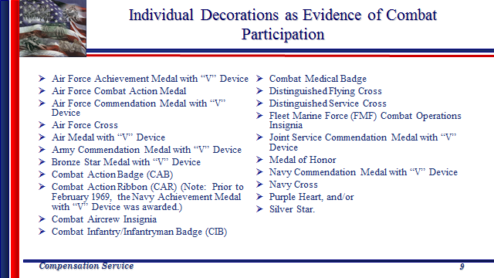  Discuss: Consider the receipt of any of these individual decorations as evidence of personal participation in combat. Receipt of one of the decorations cited above is not the only acceptable evidence of engagement in combat.
Fear of Hostile Military or Terrorist Activity  Slide 10 |  | Fear of hostile military or terrorist activity means  - the Veteran experienced, witnessed, or was confronted with an event or circumstance that involved  - actual or threatened death or serious injury, or  - a threat to the physical integrity of the Veteran or others, and  - the Veteran’s response to the event or circumstances involved a psychological or psycho-physiological state of fear, helplessness, or horror.  - Examples of exposure to hostile military or terrorist activity include presence at events involving  - actual or potential improvised explosive device (IED)  - vehicle-embedded explosive devices  - incoming artillery, rocket, or mortar fire  - small arms fire, including suspected sniper fire, or  - attack upon friendly aircraft.  Important: 38 CFR 3.304(f)(3), “fear-based” applies only to the development of PTSD after service in an area with risks from hostile military or terrorist activity.  An examination should be ordered if there is evidence of a PTSD diagnosis or symptoms, and the Veteran’s DD Form 214, Certificate of Release or Discharge From Active Duty, or other service records, shows service in an area of potential hostile military or terrorist activity. No stressor statement or development for 0781 is necessary. The examiner will solicit the stressor information at the examination.  (M21-1 III.iv.4.H.3.d.)
Establishing a Stressor Related to the Fear of Hostile Military or Terrorist Activity  Slide 11 |  | The Veteran’s DD Form 214, Certificate of Release or Discharge From Active Duty, or other service records, shows service in an area of potential hostile military or terrorist activity.  The receipt of military awards such as, but not limited to,  - the Vietnam Service or Campaign Medal,  - Kuwait Liberation Medal,  - Iraq Campaign Medal, and  - Afghanistan Campaign Medal  is generally considered evidence of service in an area of potential hostile military or terrorist activity.  Important: The receipt of service medals such as the National Defense, Armed Forces, and Global War on Terrorism (GWOT) Service Medals does not indicate service in locations that involve exposure to hostile military or terrorist activity, because these are general medals that do not denote service in a particular area or campaign.  Also Consider: Special pay for a member of the uniformed service in any month in which he was entitled to basic pay and in which he:  - Was subject to hostile fire or explosion of hostile mines  - Was on duty in an area in which he was in imminent danger of being exposed to hostile fire or explosion of hostile mines, etc.  - Was killed, injured or wounded by hostile fire, explosion of a hostile mine or any other hostile action  - Was on duty in a foreign area in which he was subject to the threat of physical harm of imminent danger on the basis of civil insurrection, civil war, terrorism or wartime conditions  Combat Pay/Imminent Pay - based on the chance that an individual may come into contact with hostile forces. (based on geographical location).  Hazardous duty pay - based on MOS and duty position assignment
Former POW  Slide 12 |  | When the Veteran a Former Prisoner of War (FPOW), the Veteran’s testimony alone may establish that the claimed in-service stressor occurred, as long as the claimed stressor is  - related to that prisoner-of-war experience, and  - consistent with the circumstances, conditions, or hardships of that service.  Explain: The term former prisoner of war means a person who, while serving in the active military, naval or air service, was forcibly detained or interned in the line of duty by an enemy or foreign government, the agents of either, or a hostile force. (38 CFR 3.1(y))  Each regional office (RO) must designate at least one member of its rating activity to be specifically responsible for handling claims filed by former prisoners of war (FPOWs).  Note: The rating activity must exercise the utmost care and compassion in deciding FPOW claims.  (M21-1 IV.ii.2.E)
Personal Assault/Trauma  Slide 13 |  | Personal trauma, for the purpose of VA disability compensation claims based on PTSD, refers broadly to stressor events involving harm perpetrated by a person who is not considered part of an enemy force.  Examples: Assault, battery, robbery, mugging, stalking, harassment.  Military sexual trauma is a subset of personal trauma and refers to sexual harassment, sexual assault, or rape that occurs in a military setting.  Discuss: Because a personal trauma is an extremely personal and sensitive issue, many incidents of personal trauma are not officially reported, and the victims of this type of in-service trauma may find it difficult to produce evidence to support the occurrence of the stressor.
Alternative Evidence of In-Service Personal Trauma  Slide 14 |  | Sources of such evidence may include  - A rape crisis center or center for domestic abuse  - A counseling facility or health clinic  - Family members or roommates  - A faculty member  - Civilian police reports  - Medical reports from civilian physicians or caregivers who treated the Veteran immediately following the incident or sometime later  - A chaplain or clergy  - Fellow service members , and  - Personal diaries or journals  Explain: If STRs and service personnel records contain no explicit documentation that personal trauma, including in-service sexual assault, occurred, review of the records submitted by the Veteran in response to a request for information may identify alternative sources of evidence that can help establish an in-service stressful incident.
Secondary and Behavioral Changes (Markers)  Slide 15 |  | Secondary and behavioral change evidence of trauma may include  - Increased use or abuse of leave without an apparent reason  - Episodes of depression, panic attacks, or anxiety without identifiable reasons  - Visits to a medical or counseling clinic or dispensary without a specific diagnosis or specific ailment  - Use of, or increased interest in, pregnancy tests or tests for sexually-transmitted diseases around the time of the incident  - Sudden requests that the Veteran’s military occupational series or duty assignment be changed without other justification  Discuss: Do not deny a PTSD claim that is based on in-service personal trauma without first advising the Veteran that secondary evidence from sources other than STRs, such as evidence of behavioral changes, may constitute credible supporting evidence of the stressor.
Interpretation of Secondary Evidence of Personal Trauma  Slide 16 |  | Secondary or behavior change evidence needs interpretation by a clinician  Submit evidence received for a medical opinion  If the examiner offers a credible assessment that the evidence of record is consistent with the occurrence of the claimed assault, that opinion can constitute credible supporting evidence  Discuss: The medical opinion should ask whether the credible factual evidence of behavior changes demonstrated by the Veteran is consistent with the expected reaction or adjustment of a person who has been subjected to an assault.  The opinion constitutes credible supporting evidence that the claimed in-service stressor occurred.
When In-Service Stressor Corroboration is Needed  Slide 17 |  | Examples of claimed stressors that must be corroborated are  - A plane crash caused by severe weather  - A severe motor vehicle accident  - A personal assault  - Witnessing the death, injury, or threat to the physical being of another person caused by something other than hostile military or terrorist activity, and  - Actual or threatened death or serious injury, or other threat to one’s physical being, caused by something other than hostile military or terrorist activity.  Explain: In order to verify the event took place in service, review all available records to include personnel records, pay records, military occupation evidence (MOS), hazard pay records, STRs, military performance reports, receipt of Combat/Imminent Danger/Hostile Fire Pay, unit and organizational histories, daily staff journals, operational reports-lessons learned (ORLLs), after action reports (AARs), radio logs, deck logs, and ship histories, muster rolls, command chronologies and war diaries, and monthly summaries and morning reports.  Also consider buddy statements, contemporaneous letters and diaries, newspaper archives, and information from Veterans Benefits Administration (VBA)-sanctioned web sites, which may be accessed through the PTSD Rating Job Aid website.  (M21-1 III.iv.4.H.3.g&h)
Making a Decision in a PTSD Claim |  | DEMONSTRATION  Demonstrate and review the “If/Then” table for M2-1.III.iv.4.H.6.i. Making a Decision in a PTSD Claim

Topic 2: Rating Mental Disorders
Introduction |  |  |  | This topic will introduce the trainees to the requirements for granting service connection for mental disorders, and how to properly evaluate with primary focus on the General Rating Formula for Mental Disorders. It addresses temporary 100 percent considerations, as well as diagnostic considerations.
Time Required |  |  |  | 0.75 hours
OBJECTIVES/  Teaching Points |  |  |  | Topic objectives:  - Learn how to grant service connection for mental disorders.  - Learn how to properly evaluation mental disorders based on the General Rating Formula for Mental Disorders.  - Learn the differences, and appropriate application, of the Rating Formula for Eating Disorders.
General Information on Mental Disorders  Slide 18 |  |  |  | A claim for a particular mental disorder should be read as a claim for any mental disability that may be reasonably defined by  - the description of the claim  - the symptoms that the claimant describes  - the information and evidence that the claimant submits, and  - any other information and evidence obtained  Example: Veteran claims anxiety, and upon examination is diagnosed with posttraumatic stress disorder (PTSD).  Discuss: When reviewing a claim for service connection based on a mental disorder  - do not limit consideration only to a particular mental disorder diagnosis identified by the claimant;  - do sympathetically read the claim as including any chronic acquired mental disorder consistent with the analysis above.  STRESS: If additional development is needed to address an alternative diagnosis in the evidentiary record, ensure that this is completed before making a decision
Diagnosis of mental disorders  Slide 19 |  |  |  | Under the DSM-5, PTSD is included in the chapter Trauma- and Stressor-Related Disorders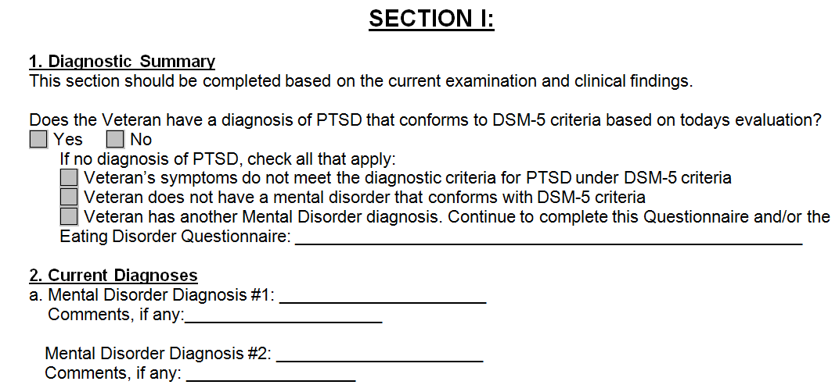  A change in diagnosis of a psychiatric condition  - A progression  - A correction of an error in the prior diagnosis, or  - A development of a new and separate condition  Explain: In the United States the Diagnostic and Statistical Manual of Mental Disorders (DSM) serves as a universal authority for psychiatric diagnosis. In May 2013 the American Psychiatric Association (ASA) released the Fifth Edition. DSM-5 no longer uses the GAF score. (A Global Assessment of Functioning (GAF) score is a number between 0 and 100 representing an assessment of an individual’s overall level of psychological, social, and occupational functioning.)  The removal of the GAF score in the DSM does not change the application of the Rating Schedule. When assigning an evaluation based on psychological assessments made under prior versions of the DSM do not base the disability evaluation solely or primarily on the GAF score.  Important: A PTSD examination based on fear of hostile military or terrorist activity that links a diagnosis of PTSD to the claimed, uncorroborated event (such as a rocket or mortar attack) rather than to “fear” should not be treated as insufficient on that basis. Fear (or helplessness or horror) refers to the reaction to the threat or stressor as required under prior versions of the DSM-4. The requirement of a reaction to the stressor was removed in DSM-5.  Discuss: If the diagnosis only changed because of the changes between DSM IV and 5, that does not require clarification. If the diagnosis, or change in diagnosis is not clear from the available records, a determination by an examiner is required.
Evaluating a Disability Diagnosed as Both a Physical and Mental Disorder  Slide 20 |  |  |  | Avoid assigning separate evaluations for SC disabilities based on the same manifestations as this constitutes pyramiding. To warrant separate evaluations, symptoms considered must be distinct and not overlap.  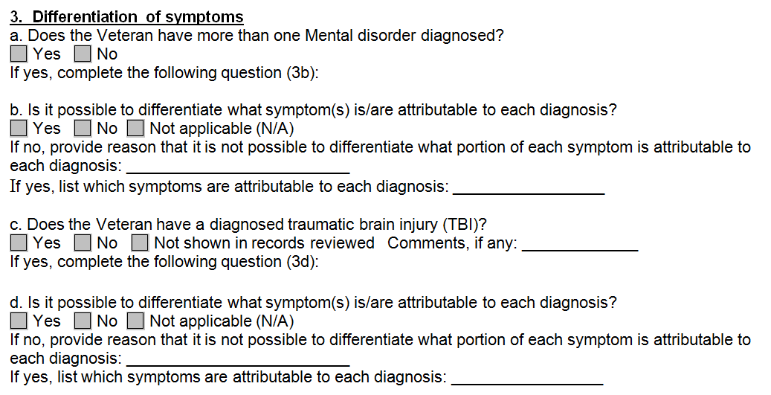  Example: PTSD and TBI may not be assigned separate evaluations based on shared symptoms such as social interaction, judgement, or orientation as this represents rating the same manifestations twice.
Intellectual disability (intellectual developmental disorder) and Personality Disorders  Slide 21 |  |  |  | Intellectual disability (intellectual developmental disorder) and personality disorders are not diseases or injuries for compensation purposes.  Exceptions:  - aggravation, or  - secondary to a service-connected psychomotor epilepsy.  Discuss: The exceptions noted will likely be extremely rare.  (38 CFR 4.127, 4.9, 4.122)
Mental Disorders Due to Traumatic Stress  Slide 22 |  |  |  | When a mental disorder that develops in service as a result of a highly stressful event is severe enough to bring about the Veteran's release from active military service, the evaluation cannot be less than 50 percent.  Schedule an examination within the six month period following the Veteran's discharge to determine whether a change in evaluation is warranted.  Discuss: Consider whether the Veteran’s condition is stable or not. If the Veteran has an unstable disability at the time of separation, consider application of a 50 or 100 percent under 38. CFR 4.28. If the condition is stable, establishing a schedular 50 or above per 38 CFR 4.129 is appropriate.  (M21-1 IV.ii.2.J.1.l.)
100%- Total Occupational and Social Impairment  Slide 23 |  |  |  | 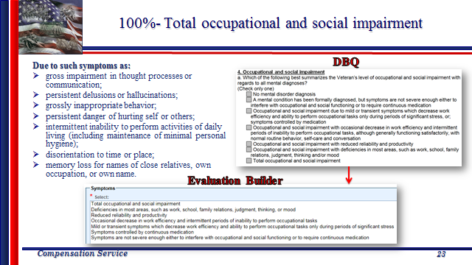  Discuss: Consider ALL evidence of record, not just the DBQ results. Always look at CAPRI and any private or lay evidence submitted with the claim. Your evaluation builder selections should reflect everything shown in the record. NOT just what is checked on the DBQ.  Always start at the top, and see if you can grant the 100 percent, and then work your way down. If you can grant the 100, you are good to go and have to look no further. If you start at the bottom and work your way up, it might take you longer as you will be going through every single evaluation to determine which is most appropriate.
70%- Deficiencies in Most Areas, Such as Work, School, Family Relations, Judgment, Thinking, or Mood  Slide 24 |  |  |  | 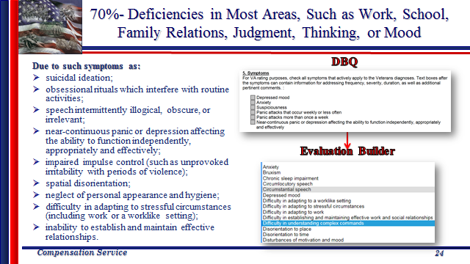  Discuss: Mental disorder evaluations generated by the Evaluation Builder are a suggestion and may be adjusted either one step higher or lower upon consideration of the evidence in its entirety. (M21-1 III.iv.6.C.5.c.) This should only be done if you have evidence to support it. Clearly identify and discuss the reason for the elevation or reduction.  STRESS: The evidence must be clear that the lower evaluation is more appropriate for this case. CAUTION is advised for choosing to assign a lower evaluation than what the evaluation builder generates.
50%- Reduced Reliability and Productivity  Slide 25 |  |  |  | 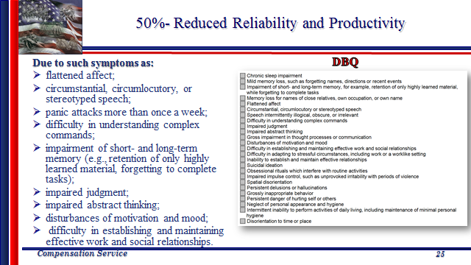  Discuss: Remember, when the decision maker concludes that the facts equally (or approximately equally) support two levels of evaluation such that each is as likely as not warranted, the higher evaluation will be awarded. Consider, any one of the alternative criteria will support entitlement to the level of evaluation.  38 CFR 4.7 provides that where there is a question upon review of the evidence as to which of two evaluations shall be assigned, the higher evaluation will be assigned if the disability picture more nearly approximates the criteria required for that rating. Otherwise, the lower rating will be assigned. This means that the preponderance of the evidence should support the level of evaluation chosen.
30%- Occasional Decrease in Work Efficiency and Intermittent Periods of Inability to Perform Occupational Tasks  Slide 26 |  |  |  | 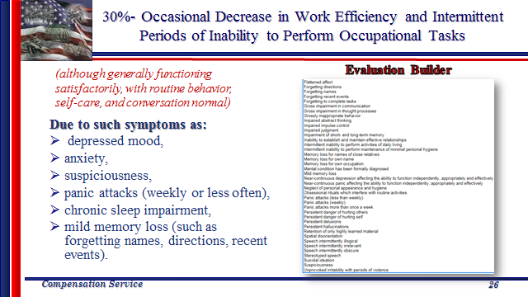  Note: The order that the symptoms line up in the evaluation builder is not identical to the order of the DBQ.
10% and 0%  Slide 27 |  |  |  | 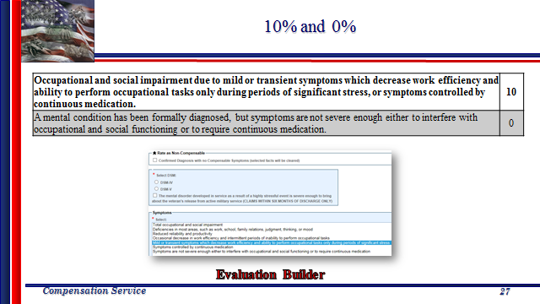  Reiterate: Consider ALL evidence of record. Noncompensable and 10 percent evaluations for mental conditions are not very common. There usually is enough evidence in the symptomatology and the impact on social and/or occupational functioning that a higher evaluation can be justified.
Anorexia & Bulimia  Slide 28 |  |  |  | 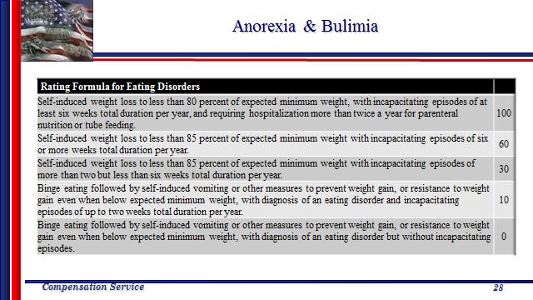  Discuss: Anorexia and Bulimia do not follow the General Formula for Rating Mental Disorders, as there is separate rating criteria specifically provided for eating disorders.
Convalescence Ratings Following Extended Hospitalization  Slide 29 |  |  |  | If a mental disorder has been assigned a total evaluation due to a continuous period of hospitalization lasting six months or more, continue the total evaluation and schedule a mandatory examination six months after the Veteran is discharged or released to nonbed care.  A change in evaluation based on that or any subsequent examination shall be subject to the provisions of §3.105(e) of this chapter.  Discuss: The total evaluation for continuous hospitalization discussed here is based on 38 CFR 4.29. 4.29 is granted provided a total, 100-percent rating cannot be assigned under other provisions of the rating schedule, providing a temporary 100-percent evaluation for periods of hospitalization in excess of 21 days for medical treatment of an SC disability, or a disability requiring hospitalization in excess of 21 days for medical treatment for which compensation is payable under either 38 U.S.C. 1151 or 38 U.S.C. 1160.  Note: Competency must be addressed when assigning a temporary 100-percent evaluation for a mental disorder under 38 CFR 4.29. This is addressed by use of glossary text provided by VA_COMPETENT within the narrative of the evaluation determination. (NOT as a separate contention.) (This will be discussed in more detail shortly!)  (38 CFR 4.128)
Evidence of Improvement  Slide 30 |  |  |  | Do not make drastic reductions in evaluations in ratings for psychiatric disorders if a reduction to an intermediate rate is more in agreement with the degree of disability  Observe the general policy of gradually reducing the evaluation to afford the Veteran all possible opportunities for adjustment.  STRESS: This applies to psychiatric disorders only.  Discuss: This is an instance where using the option to select one level higher of an evaluation in the calculator would come into play.  Example: If the Veteran is currently 70% and the current evaluation is showing as 30%, elevate to the 50% to prevent a drastic change. Most likely a future examination will be appropriate to reevalute if the reduction to 30% is still appropriate.  (M21-1 III.iv.4.H.1.e.)  Note: Always keep in mind temporary or episodic improvement is common with mental illness. e.g., manic depressive or other psychotic reaction. When evaluating a mental disorder, the rating agency shall consider the frequency, severity, and duration of psychiatric symptoms, the length of remissions, and the veteran's capacity for adjustment during periods of remission. The rating agency shall assign an evaluation based on all the evidence of record that bears on occupational and social impairment rather than solely on the examiner's assessment of the level of disability at the moment of the examination. (38 CFR 4.126)

Topic 3: Competency and Other Considerations
Introduction |  | This topic will introduce trainees to additional considerations for rating mental conditions. Learning when (and how) to address 1702 and competency, as well as special considerations of presumption, substance abuse, SMC and CH35.
Time Required |  | 0.75 hours
OBJECTIVES/  Teaching Points |  | Topic objectives:  - Identify what qualifies as psychosis for 38 CFR 3.309 consideration  - Learn when/how to address the issue of competency and incompetency  - Learn when/how to address eligibility to 38 U.S.C 1702  - Learn when/how substance abuse can and cannot be considered.
Psychosis  Slide 31 |  |  |  | For the purpose of presumptive service connection, a psychosis is any of the following disorders:  - Brief Psychotic Disorder,  - Delusional Disorder,  - Psychotic Disorder Due to Another Medical Condition,  - Other Specified Schizophrenia Spectrum and Other Psychotic Disorder,  - Schizoaffective Disorder,  - Schizophrenia,  - Schizophreniform Disorder, and  - Substance/Medication-Induced Psychotic Disorder .  Discuss: Consider service connection on a presumptive basis for psychosis manifested to a compensable level within one year of discharge from service.  38 CFR 3.384, M21-1 III.iv.4.H.1.g., M2-1 IV.ii.2.B.2.a  Ask: A Veteran with honorable service, released from active duty on January 12, 2016, files a VA Form 21-526EZ claiming SC for PTSD received on July 15, 2016. The evidence shows diagnosis of schizophrenia which would warrant a 30% evaluation on March 17, 2016, and no evidence of a diagnosis of PTSD. DD-214 shows receipt of Purple Heart, STRs are negative for any mental conditions.  Based solely on the facts provided:  Can we grant SC for anything? Yes  If so, what? schizophrenia (claimed as PTSD) 38 CFR 3.309(a)  If so, what would the effective date be, and why? March 17, 2016, date entitlement arose since the claim was received within one year of separation from service. 38 CFR 3.400(2)(ii)  RECOMMENDATION: Create polls before the start of the class, assure them that their selection is anonymous, that helps generate more participation. It also gives everyone the opportunity to answer, where other methods may result in some of the faster folks answering every time, which doesn’t allow those that need a bit more time the opportunity to ever answer.
Psychosis  Slide 32 |  |  |  | 38 U.S.C. 1702 provides that SC is presumed for VA treatment purposes for  - Psychoses based on wartime service, or  - Any mental condition based on Gulf War service  developed within  - two years after the date of separation (under other than dishonorable conditions) from such service, and  - two years after the end of the war period  Emphasize: This is for treatment purposes only. This should only be addressed if requested by VHA, or if you are able to GRANT the benefit. Do NOT raise the issue to deny. If you are granting SC for a mental condition, you do not need to consider or address 1702, as the Veteran will be afforded treatment based on the mental condition being service connected.  Explain: To address 1702 in VBMS-R, select Category: Compensation, Subject: *type in diagnosed disability*, click Establish Issue, click on the contention in the Issue List, click Enter Decision, select Disability Decision Information-manual entry, under Decision select Active Psychosis/GW Mental, under Decision Basis SC For Treatment Only (or NSC-1702 if denying). (You will also need to input the appropriate diagnostic code, but that is it.)
Mentally Competent Person  Slide 33 |  |  |  | A mentally incompetent person is one who, because of injury or disease, lacks the mental capacity to manage his or her own affairs, including disbursement of funds without limitation.  In the absence of clear and convincing evidence to the contrary, presume that a person is competent.  The evidence must leave no doubt as to the beneficiary’s incompetency.  Discuss:  If the evidence suggests but does not clearly and convincingly show that the person is incapable of managing the VA benefit payment without limitation  Then do not develop, do not propose incompetency, and state in the narrative of the rating decision issue that there was no clear and convincing evidence of incompetency.  If the evidence clearly and convincingly shows that the person is incapable of managing the VA benefit payment without limitation  Then propose incompetency.  To propose, or make a final determination of, incompetency in VBMS-R, select Category: Other, Subject: Competency.  Note: Definition copied verbatim from 38 CFR §3.353(a).
Mental Condition is Evaluated as Totally Disabling  Slide 34 |  |  |  | Competency must be addressed in cases where a mental condition is evaluated as totally disabling. This includes  - a schedular 100 percent evaluation,  - when individual employability (IU) is awarded on the basis of a single mental health disability, and  - when assigning a temporary total evaluation for a mental disorder under 38 CFR 4.29.  ADL Glossary: VA_COMPETENT  Discuss: The mere existence of a mental condition with a total evaluation does not automatically correlate to a Veteran’s inability to manage his/her benefits, but many of the symptoms warranting a total disability evaluation could render the Veteran unable to manage benefits.  Carefully consider the facts in these cases to determine whether the regulatory standard warrants a proposal of incompetency. When the evidence shows the Veteran is competent, address the competency determination as part of the narrative within the mental condition issue. (M21-1 III.iv.8.A.2.a)
Rating Actions  Slide 35 |  |  |  | 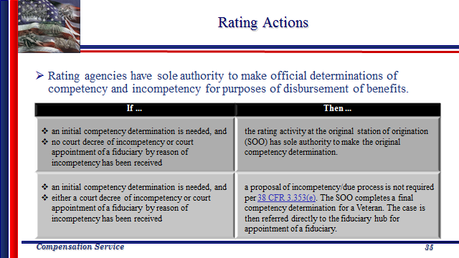  Discuss: Judicial findings of a court with respect to competency of a Veteran are not binding on the rating activity. However, if a Veteran is declared by a court to be incompetent, develop all necessary evidence for a rating determination.  If an initial competency determination is needed, and either a court decree of incompetency or court appointment of a fiduciary by reason of incompetency has been received, then a proposal of incompetency/due process is not required per 38 CFR 3.353(e).  38 CFR §3.353(b)(1)
Additional Considerations  Slide 36 |  |  |  | Substance abuse as a primary disability is not a basis for granting entitlement to or increasing compensation or Veterans Pension under the laws administered by the Department of Veterans Affairs (VA).  Establish service connection on a secondary basis for any diseases or disabilities resulting from alcohol abuse, if alcoholism is determined to be secondary to a service connected disability.  Always consider entitlement to SMCs and CH35.  Discuss: Although drug and alcohol abuse cannot be service connected as a primary condition, even if diagnosed as such, alcohol abuse may be considered a symptom of an SC disability. E.g. posttraumatic stress disorder with alcoholism. The doctor must make this link upon examination. Do not just lump alcoholism in with mental conditions because you see that they have it. Include it with the diagnosis IF the examiner related it to the SC condition. Do not address it otherwise, unless the Veteran has explicitly claimed it.  (M21- 1 IV.ii.2.K.2.)  “If/Then” table located M21-1.III.v.1.D.4.h to determine if service connection can be granted on a secondary basis  If you are granting 100%, or IU, and no routine future examination- grant CH35!  If you have a 100%, and other disabilities that are either a single 60 or combined 60%, grant SMC S- statutory housebound.  If you have a single 100 percent, consider A&A or factual housebound- if the evidence shows existence/need of either of these, grant the greatest benefit.
Questions?  Slide 38 |  |  |  | 

