Claims Based on Exposure to Environmental Hazards in Iraq, Afghanistan, and Djibouti
(After Classroom Training - VSR & RVSR)

Instructor Lesson Plan
Time Required: 2 Hours

Table of Contents

Lesson Description 2
Claims Based on Exposure to Environmental Hazards in Iraq, Afghanistan, and Djibouti 4
Topic 1: Locations of Specific Environmental Hazards 5
Topic 2: Developing Environmental Hazard Claims 8
Lesson Review, Assessment, and Wrap-up 18

Lesson Description
The information below provides the instructor with an overview of the lesson and the materials that are required to effectively present this instruction.
TMS # | 4178422
Prerequisites | Prior to this lesson, the Veteran Service Representatives (VSRs), Rating Veteran Service Representatives (RVSRs), Decision Review Officers (DROs), and Quality Review Specialists (QRSs) should have completed Challenge training.
target audience | The target audience for Claims Based on Exposure to Environmental Hazards in Iraq, Afghanistan, and Djibouti (Post Challenge VSR & RVSR) is for VSRs and RVSRs who have completed Challenge training, DROs, and QRSs. Although in most instances the VSR will be undertaking the necessary development actions, an RVSR/DRO must also know what information is required before they can appropriately decide a claim. The A/RQRSs must also know this information in order to properly review claims for quality.
Time Required | 2 hours
Materials/  TRAINING AIDS | Lesson materials:  - Claims Based on Exposure to Environmental Hazards in Iraq, Afghanistan, and Djibouti PowerPoint Presentation
Training Area/Tools | The following are required to ensure the trainees are able to meet the lesson objectives:  - Classroom or private area suitable for participatory discussions  - Seating, writing materials, and writing surfaces for trainee note taking and participation  - Handouts, which include a practical exercise  - Large writing surface (easel pad, chalkboard, dry erase board, overhead projector, etc.) with appropriate writing materials  - Computer with PowerPoint software to present the lesson material  Trainees require access to the following tools:  - VA TMS to complete the assessment  - Compensation Service Intranet: Rating Job Aids  - Internet acces for Compensation Pension Knowledge Management (CPKM)  - Internet acces for Electronic Code of Federal Regulations
Pre-Planning | - Become familiar with all training materials by reading the Instructor Lesson Plan while simultaneously reviewing the corresponding PowerPoint slides. This will provide you the opportunity to see the connection between the Lesson Plan and the slides, which will allow for a more structured presentation during the training session.  - Become familiar with the content of the trainee handouts and their association to the Lesson Plan.  - Practice is the best guarantee of providing a quality presentation. At a minimum, do a complete walkthrough of the presentation to practice coordination between this Lesson Plan, the trainee handouts, and the PowerPoint slides and ensure your timing is on track with the length of the lesson.  - Ensure that there are copies of all handouts before the training session.  - When required, reserve the training room.  - Arrange for equipment such as flip charts, an overhead projector, and any other equipment (as needed).  - Talk to people in your office who are most familiar with this topic to collect experiences that you can include as examples in the lesson.  - This lesson plan belongs to you. Feel free to highlight headings, key phrases, or other information to help the instruction flow smoothly. Feel free to add any notes or information that you need in the margins.
Training Day | - Arrive as early as possible to ensure access to the facility and computers.  - Become familiar with the location of restrooms and other facilities that the trainees will require.  - Test the computer and projector to ensure they are working properly.  - Before class begins, open the PowerPoint presentation to the first slide. This will help to ensure the presentation is functioning properly.  - Make sure that a whiteboard or flip chart and the associated markers are available.  - The instructor completes a roll call attendance sheet or provides a sign-in sheet to the students. The attendance records are forwarded to the Regional Office Training Managers.

 |  | Claims Based on Exposure to Environmental Hazards in Iraq, Afghanistan, and Djibouti
 |  | INSTRUCTOR INTRODUCTION |  | Complete the following:  - Introduce yourself  - Orient learners to the facilities  - Ensure that all learners have the required handouts
 |  | time required |  | 0.25 hours
 |  | Purpose of Lesson  Slide 2 |  | This lesson is designed to provide the VSR, RVSR, DRO, or QRS with a comprehensive understanding of developing claims for disabilities resulting from exposure to specific environmental hazards in the Gulf War.
 |  | Lesson Objectives  Slide 3 |  | In order to accomplish the purpose of this lesson, the VSR, RVSR, DRO, or QRS will be required to accomplish the following lesson objectives.  The VSR, RVSR, DRO, or QRS will be able to:  - Recognize the four Environmental Hazard exposure scenarios related to service in Iraq, Afghanistan, and Djibouti  - Identify long term health effects of exposure scenario  - Identify eligibility criteria for each exposure scenario  - Develop claims for any necessary evidence for compensation related to Environment Hazard exposure  - Recognize when to order an exam and medical opinion for conditions related to Environmental Hazard exposure
 |  |  |  | Stress that the topic is claims for specific Gulf War environmental hazards, which is NOT the same as claims for undiagnosed illness (or other claims) under §3.317, and are NOT limited to the Southwest Asia theater of operations defined in §3.317(e)(2).
 |  | Motivation |  | Gaining knowledge in this area will improve your quality, your office’s quality, and most importantly; ensure the accuracy of decisions made in regards to service connection for claims for disabilities resulting from exposure to specific environmental hazards in the Gulf War. Proper development prevents unneccesary delay in claims which may result from over, or under development. This not only impacts the timeliness in which a Veteran receives a decision, and potentially payment, but it also is a quality error.
 |  | STAR Error code(s) |  | Task 1, 2, 3, 4, 5 and 11:
 |  | References  Slide 4 |  | All M21-1 references are found in the Live Manual Website.  - M21-1, Part IV, Subpart ii.1.I .5, Developing Claims Based on Exposure to Other Specific Environmental Hazards  - M21-1, Part IV, Subpart ii.2.C.5, SC for Disabilities Resulting From Exposure to Other Specific Environmental Hazards  - Fact Sheet: Burn Pits in Iraq, Afghanistan, and the Horn of Africa  - Fact Sheet: Particulate Matter throughout Iraq and Afghanistan, and Djibouti  - Fact Sheet: Qarmat Ali Water Treatment Plant in Basrah, Iraq  - Fact Sheet: Sulfur Fire at the Mishraq State Sulfur Mine Near Mosul, Iraq

Topic 1: Locations of Specific
Environmental Hazards Exposure
 | Introduction |  |  | This topic will provide an overview on the types, and locations, of specific environmental hazards that a Veteran may have been exposed to in the Gulf War.
 | Time Required |  |  | 0.5 hours
 | OBJECTIVES/  Teaching Points |  |  | Topic objectives and teaching points to support the topic objectives:  - Define locations and types of environmental hazards
 | Locations of Specific  Environmental Hazards |  |  | Explain that the focus of this lesson will be on specific environmental hazards from the Gulf War. (Not ALL specific enivornmental hazards, such as Camp Lejeune and Atsugi.)
 | Environmental Hazards Exposure Scenarios  Slide 5 |  |  | DoD has identified a number of specific environmental hazards at military installations in Iraq, Afghanistan, and elsewhere that could present health risks. These hazards include  - large burn pits throughout Iraq, Afghanistan, and Djibouti on the Horn of Africa  - particulate matter in Iraq, Afghanistan, and Djibouti on the Horn of Africa  - a large sulfur fire at Mishraq State Sulphur Mine near Mosul, Iraq  - hexavalent chromium exposure at the Qarmat Ali Water Treatment Plant at Basrah, Iraq  Explain that when we get claims based on environmental hazard, our first question needs to be whether the Veteran served in an area that would have exposed them to environmental hazards.
 | Burn Pits  Slide 7 |  |  | In Iraq, Afghanistan, and Djibouti on the Horn of Africa from approximately 2001 to the present, the U.S. military has utilized large burn pits to dispose of waste at every location wherein the military has positioned a forward operating base (FOB).  Explain The burned waste products include, but are not limited to: plastics, metal/aluminum cans, rubber, chemicals (such as, paints, solvents), petroleum and lubricant products, munitions and other unexploded ordnance, wood waste, medical and human waste, and incomplete combustion by-products. Jet fuel (JP-8) is used as the accelerant. The pits do not effectively burn the volume of waste generated, and smoke from the burn pit blows over bases and into living areas.  Explain exposure to burn pits can effect the respiratory system, skin, eyes, liver, kidneys, central nervous system, cardiovascular system, reproductive system, peripheral nervous system, and GI tract.  Explain when considering total potential exposure, considerartion is given to the synergistic affect of all combined toxins, primarily through inhalation and dermal exposure, but also through ingestion.
 | Particulate Matter  Slide 8 |  |  | The particulate matter levels in Southwest Asia and Djibouti on the Horn of Africa are naturally higher and may present a health risk to service members.  Particulate matter is made up of a number of components to include  - acids (such as nitrates and sulfates)  - organic chemicals  - metals, and  - soil or dust particles.  Explain that most studies relate PM exposure to respiratory (lungs) and cardiopulmonary (heart) which may cause serious health effects.
 | Sulfur Fire  Slide 9 |  |  | On June 24, 2003, a fire ignited at the Mishraq State Sulfur Mine Plant in Northern Iraq. The fire burned for approximately 3 weeks. Other areas found to be affected included  Qayyarah Airfield West (Camp Q West), which is 25 km to the south and is a major military supply airstrip as well as the primary area of deployment for the 101st Airborne Division, and the area approximately 50 km to the north up to the Mosul Airfield area.  Explain potential health effects include symptoms of unexplained shortness of breath on exertion, but may have normal chest X-rays and inconclusive findings on pulmonary function testing which could be indicative of a diagnosis of constrictive bronchiolitis, which is very uncommon. Due to some similarities, symptoms of constrictive bronchiolitis may be attributed to asthma or chronic obstructive pulmonary disease (COPD), which is why the examiner is informed (via Fact Sheet) and encouraged to consider requesting tests for bronchiolitis.
 | Qarmat Ali Water Treatment Plant  Slide 10 |  |  | If a Veteran served in an Army NG unit located in Indiana, West Virginia, South Carolina, or Oregon between April and September 2003, DoD has confirmed that the Veterans served at the Qarmat Ali Water Treatment Plant in Basrah, Iraq. Therefore, exposure can be conceded for these personnel.  Explain Chromium VI can cause immediate irritation of the eyes, nose, sinuses, lungs, and skin. The results at the time showed some abnormalities in individuals, such as complaints of eye, nose, throat and/or lung irritation, or abnormal pulmonary function, kidney, or liver tests.
What is a burn pit?
A waste disposal process used by the US military to dispose various waste during the Gulf War.
2. Particulate matter is a combination of?
extremely small particles and liquid droplets.
3. Other areas found to be affected by the Mishraq State Sulfur Mine Fire include?
Qayyarah Airfield West, arear north of the Mosul Airfield
4. What National Guard units were assigned to guard workers at the Qarmat Ali Water Treatment Plant?
Indiana, West Virginia, South Carolina or Oregon

Knowledge Check

Slide 11 - 14

Topic 2: Developing Environmental Hazard Claims
 | Introduction |  |  | This topic will outline specific development procedures and requirements.
 | Time Required |  |  | 1 hour
 | OBJECTIVES/  Teaching Points |  |  | Topic objectives and teaching points to support the topic objectives:  - Outline necessary development actions and considerations.
 | Developing Environmental Hazard Claims |  |  | Explain that development for claims based on specific GW environmental hazards is similar to that for claims based on 3.317, but not identical.
 | Long Term Effects of Exposure  Slide 16  Eligibility Requirements  Slide 17 |  |  | 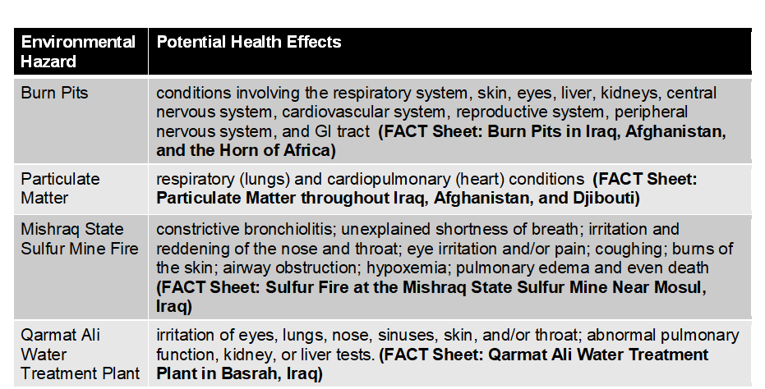  Review with the trainees the potential health effects of the environmental hazard.  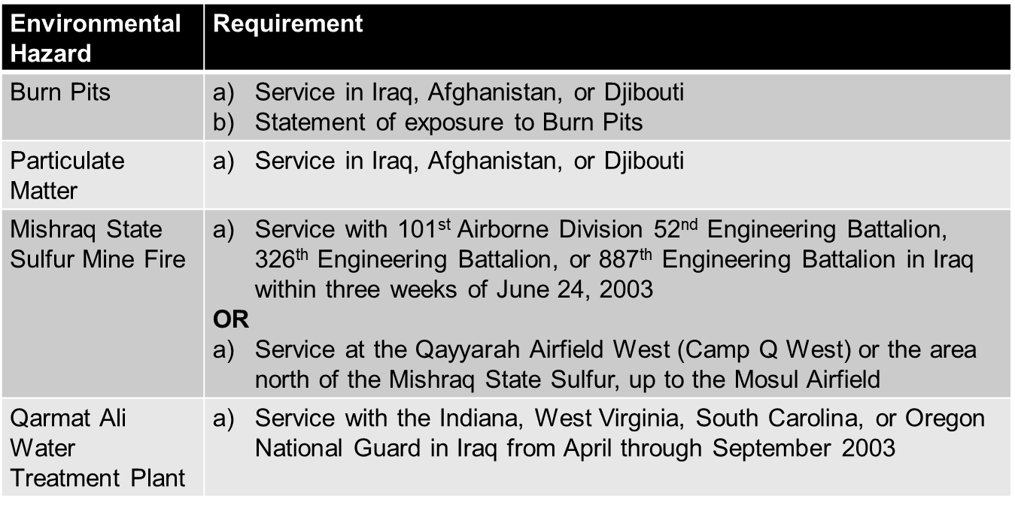  Explain that there is no specific list of conditions that can/are considered to be due to exposure to these specific environmental hazards. Basically you treat these claims like any other claim for service connection, with your event in service being the exposure. You will need an exam and medical opinion if  - there is competent lay or medical evidence of a current diagnosed disability or persistent or recurrent symptoms of disability,  - the evidence establishes that the Veteran served in a qualifying location, and  - the evidence indicates that the claimed disability or symptoms may be associated with the established event, injury, or disease in service (This element is VERY relaxed. If the Veteran is claiming it due to exposure, more often than not you will need the medical opinion.)
 | Claim Based Solely on Exposure to Environmental Hazards  Slide 18 |  |  | A claim is not substantially complete if a Veteran alleges exposure to environmental hazards during service, but does not identify the medical condition or symptom for which service connection (SC) is claimed.  In cases such as these  - inform the Veteran that he/she must identify a specific disability, since exposure in and of itself is not a disability, and  - ask the Veteran to identify the disability(ies) that resulted from exposure to environmental hazards during service.  If exposure is the only claimed condition:  - Change the EP to a 400 – Incomplete Application  - Clear the EP 400 after the letter is sent  Important: Whenever possible, telephone the Veteran to obtain the information needed to substantiate the claim. Do not establish a pending EP until the Veteran has identified a disability that has resulted from exposure to the environmental hazard. Do not process the claim as a denial. (There is NO rating jurisdiction without a disability identified!) M21-1 Part I, Subpart 1.B.1.g.-h.
 | Developing Environmental  Hazard Claims  Slide 19 |  |  | - If the claimed exposure is not established by the evidence of record, send the Veteran a Custom 5103 notice.  - Ask the claimant to provide at least some general information about the exposure event.  - Develop for STRs and any VA and/or private medical records that are noted by the claimant.  - Verify dates of military service and obtain military personnel records as per normal procedures.  Note: Send a follow-up letter or telephone the Veteran if he/she fails to provide sufficient information regarding exposure and/or disability claimed because of such exposure. M21-1 Part I, Subpart 1.B.1.g.-h..  Do not routinely develop to the Veteran without first reviewing the claims folder.  If evidence of exposure cannot be established, develop to the Veteran using a Supplemental Development Letter.  If you are sending a development letter to the Veteran, provide the Veteran with information about the GW Information Center and the GW Registry Exam.
 | Special Issue Indicators  Slide 20  Knowledge Check  Slide 21 -22  Developing Environmental Hazard Claims:  Veteran  Slide 23  Developing for  Federal and Non-Federal Records  Slide 24 |  |  | - Environmental Hazard in Gulf War  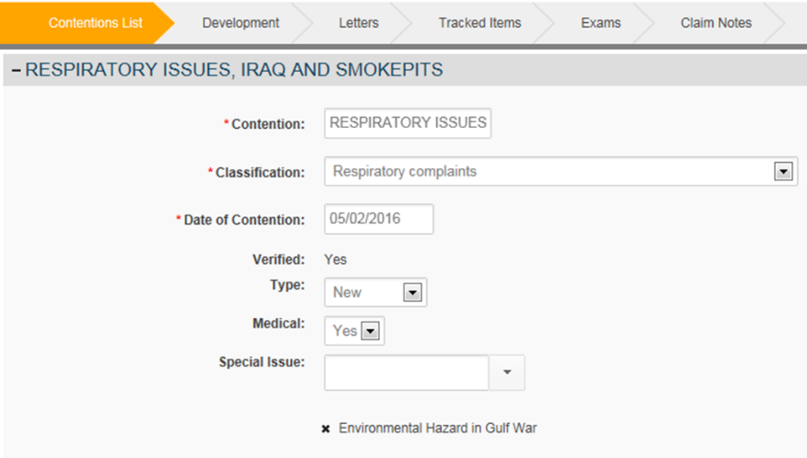  - Is an Environmental Hazard claim substantially complete if the Veteran does not identify a medical condition or symptom?  No. The Veteran must specify the medical condition or symptom for which service connection is claimed.  - What special issue is required for claimed conditions related to Environmental Hazards?  Environmental Hazard in Gulf War  Discuss the type of development paragraphs below located in VBMS.  VBMS Development paragraphs for Environmental Hazard Claims  - GW – Earliest manifestations/evid of illness (This is no longer required. This information is solicited in the VA Form 21-526EZ located on page 4 in the Evidence Tables under Disability Service Connection.)  - GW – evidence of SW Asia service needed Used if the Veteran has not provided information about his/her exposure.*  - GW – notice – information center (toll-free helpline) Include this paragraph if sending the Veteran a development letter.  - GW – registry exam? Include this paragraph if sending the Veteran a development letter.  - GW – tell us specific disability from GW Used if the Veteran does not specify an actual condition.  If you need specific information (i.e., Burn Pit statement or service in Mosul), draft a custom paragraph asking for specifics about the Veteran’s exposure.  ** Phone development is acceptable.  In addition to service treatment records (STRs), request  - clinical records, if the Veteran furnishes information on the application about specific inpatient treatment, and  - service personnel records, if the dates of service in Southwest Asia during the Gulf War period that began on August 2, 1990, are not already of record.  Note: Concurrently request clinical records, service personnel records, and STRs, if all are needed.
 | Exposure at the Qarmat Ali Water Treatment Plant  Slide 25  VHA Persian Gulf Health Registry Examinations  Slide 26  Knowledge Check  Slide 27-28  Review of Evidence to Establish Exposure to Environmental Hazards  Slide 29 |  |  | DoD has provided VA with a list of those who served at the Qarmat Ali Water Treatment Plant in Basrah, Iraq.  - If the Veteran is claiming exposure at Qarmat Ali Water Treatment Plant and service can’t verified via the DoD list, assign the Compensation Service Review – Environmental Hazards Verification special issue, create the Compensation Service Case Review tracked item and add a note to the efolder stating the claim is referred to Compensation Service for verification.  See M21-1 IV.ii.1.I.5.f., Verifying Service at the Qarmat Ali Water Treatment Plant, for additional detail.  In all cases when the Veteran has been examined as part of the Veterans Heath Administration (VHA) Persian Gulf Health Registry, ensure those results have been obtained.  Important: Check the box in the GULF WAR REGISTRY PERMIT field (in VBMS) when claimants indicate they were included in the Veterans Heath Administration (VHA) Persian Gulf Health Registry. If you are unsure whether the Veteran had one, there is a pick in VBMS (Special Issues: GW-registry exam?) providing language asking the Veteran. (Do not send a development letter solely for this information, this is merely something you should add to your letter if you have to develop for other necessary information.)  - When developing to a Veteran who has not provided information about his/her exposure, what VBMS paragraph must be added to the letter?  GW – Evidence of SW Asia service needed  - A list of those who served at Qarmat Ali Water Treatment Plant is available. How would you verify service for a Veteran whose unit os not on the DoD list?  Assign the Compensation Service Review – Environmental Hazards Verification special issue, create Compensation Service Review tracked item and add note to eFolder stating claim referred to Compensation Service for verification.  Thoroughly review military personnel records and service treatment records (STRs) (to include the Post-Deployment Health Assessment (PDHA) and Discharge Examination) for evidence that corroborates the Veteran’s statement of exposure.  Important: Look at the DD214, personnel records, and STRs for service in the location(s) for which the Veteran may have been exposed.  Consider the Iraq Campaign Medal, Kuwait Liberation Medal, or The Afghanistan Campaign Medal as verification of service in the specified location for the award.  Southwest Asia Service Medal- Review, DD Form 214 and/or personnel records to ensure that this medal was not awarded solely for service in Israel, Egypt, Turkey, Syria, or Jordan (including the airspace above and the territorial waters) from January 17, 199,1 through November 30, 1995.  Global War on Terrorism Service/Expeditionary Medal does NOT verify service in any of these locations. You must locate evidence on the DD214 or in the personnel records/STRs for specific location based on the environmental hazard exposure claimed.
Military service records will not verify all incidents of exposure, it is important to consider alternate evidence in establishing whether the Veteran participated in or was affected by an in-service environmental hazard exposure incident, such as
- personal statements
- buddy statements
- unit histories
- news articles, and
- other lay evidence.
Important: Competent lay evidence means any evidence not requiring that the proponent have specialized education, training, or experience. Lay evidence is competent if it is provided by a person who has knowledge of facts or circumstances and conveys matters that can be observed and described by a lay person. M21-1 Part III, Subpart iv.5.A.2.c
 | Conceding Exposure  Slide 30 |  |  | Concede exposure to the claimed environmental hazard if the evidence of records shows the Veteran meets the eligibility requirements for each exposure scenario. Consider lay statements provided by the Veteran and/or others in verifying exposure if the information is consistent with the facts, places, and circumstances of the Veteran’s service.  The Veteran does not need to explicitly claim an environmental hazard.  Example: A Veteran’s lay statement of burn pit exposure, together with evidence verifying that the Veteran served in Iraq, Afghanistan, or Djibouti, generally will be sufficient to establish the occurrence of such exposure.  Important: As a matter of policy, VA decision makers should accept evidence at face value (credible) unless called into question by other evidence of record or sound medical or legal principles. M21-1, III. iv.5.A.2.b
Knowledge Check  Slide 31-32  Developing Environmental Hazard Claims: Exams/Opinions  Slide 33 |  |  | - Reviewing evidence is an important part of claims development. What alternate evidence may be used to confirm an in-service environmental hazard exposure event?  Personal statements, buddy statements, unit histories, news articles and other lay evidence.  - Can the DD 214 be used to concede exposure to an Environmental Hazard?  Yes. The DD 214 may show the Veteran served in an area where Environmental Hazards were at issue.  An examination is necessary in environmental hazard claims when there is  - competent lay or medical evidence of a disease or chronic signs or symptoms of a disease) and  - qualifying service (as previously described).  Important:  - The threshold for requiring an examination is low. (It is lower than the normal standard.)  Important: A claimant’s own statement, covering in sufficient detail a condition that is within his/her ability to describe, such as his/her own symptoms, may to that extent constitute evidence. The claimant is often the most qualified source to describe the circumstances of the disabling effects of the disease or injury. M21-1, III.iv.5.A.6.c.
 | Developing Environmental Hazard Claims:  Exams/Opinions cont.  Slide 34 |  |  | When an examination/opinion is necessary  - Request appropriate examination based on applicable body system(s).  - Advise the examiner of the nature of the claimed environmental hazard and the location and timeframe of exposure.  - Upload all applicable fact sheets to VBMS.  - Forward the claims folder to the examiner and ask him/her to  - review the medical and other evidence in the claims folder, including the Fact Sheets or other documents, and  - provide an opinion, and rationale for the opinion, as to the likelihood that the Veteran’s claimed disability is related to the hazardous environmental exposure.  Important: Do not order a Gulf War General Medical examination for this type of claim, unless there is also potential entitlement under 38 CFR 3.317. (i.e. Veteran served in Iraq and is claiming shortness of breathe. This could be due to burn pits, particulate matter, or considered under 3.317.)
 | Developing Environmental Hazard Claims: Exam Request Builder (ERB) Exams/Opinions  Slide 35 |  |  | 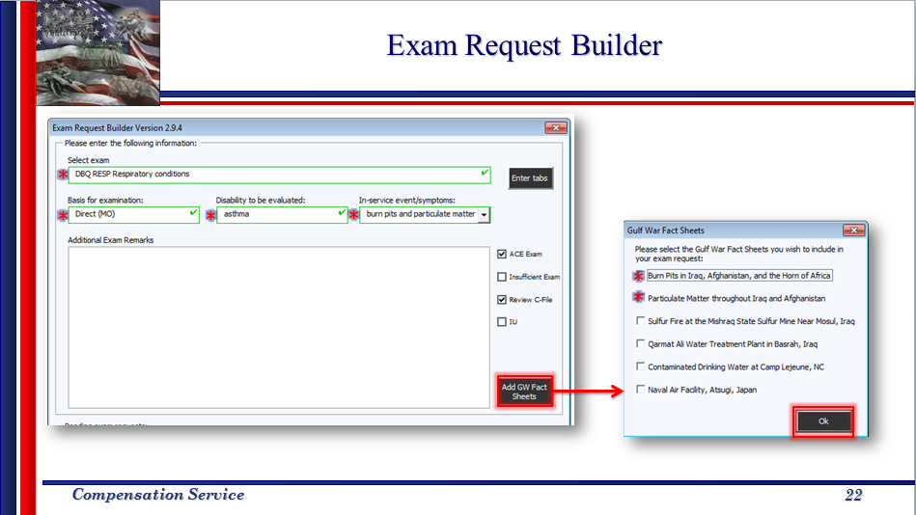
 | Exam Management Exam (EMS) Requests  Slide 36 |  |  | 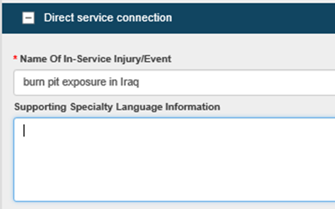  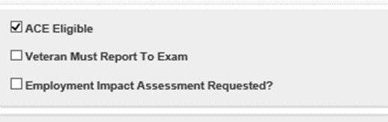  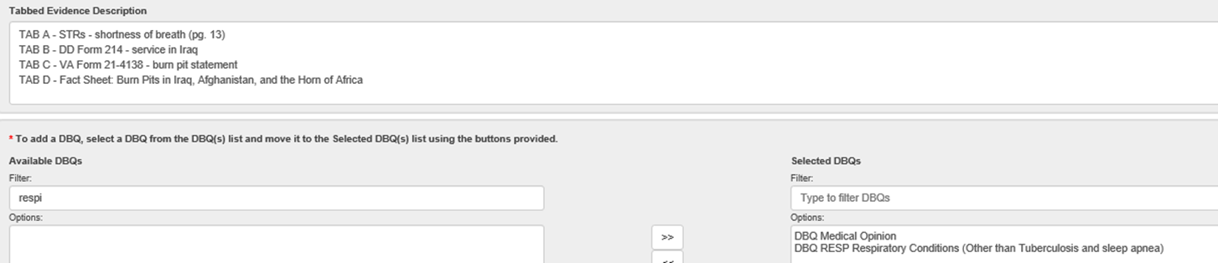  - If you are not ordering a Gulf War or regular General Medical Examination, you can utilize the ACE process.  You must upload and annotate the applicable Environment Hazard Fact Sheet(s) to VBMS. (Facts sheets located within the ERB Exam)
 | Knowledge Check  Slide 37  Questions  Slide 39 |  |  | When requesting an exam for conditions related to exposure to Environmental Hazards, what additional information must be provided to the examiner?  The Environmental Hazard Fact Sheet(s)
 | Lesson Review, Assessment, and Wrap-up
 | Introduction  Discuss the following: |  |  | The Claims Based on Exposure to Environmental Hazards in Iraq, Afghanistan, and Djibouti (Post Challenge VSR & RVSR) lesson is complete.  Review each lesson objective and ask the trainees for any questions or comments.
 | Time Required |  |  | 0.25 hours
 | Lesson Objectives |  |  | You have completed the Claims Based on Exposure to Environmental Hazards in Iraq, Afghanistan, and Djibouti (Post Challenge VSR & RVSR) lesson.  The trainee should be able to:  - Recognize the four Environmental Hazard exposure scenarios related to service in Iraq, Afghanistan, and Djibouti  - Identify long term health effects of exposure scenario  - Identify eligibility criteria for each exposure scenario  - Develop claims for any necessary evidence for compensation related to Environment Hazard exposure  - Recognize when to order an exam and medical opinion for conditions related to Environmental Hazard exposure

