Systematic Analysis of Operations (SAO)
Instructor Lesson Plan
Time Required: 1.5 Hour

Table of Contents

Systematic Analysis of Operations (SAO) 2
Purpose of SAOs 3
Who is Responsible for the SAO? 3
The Depth of the Analysis 4
SAO Elements 6
Areas Covered by an SAO 13
Scheduling for SAOs 14

 | Systematic Analysis of Operations (SAO)
 | INSTRUCTOR INTRODUCTION | Complete the following:  - Introduce yourself  - Orient learners to the facilities  - Ensure that all learners have the required handouts
 | time required | 1.5 hour
 | Purpose of Lesson  Explain the following: | This lesson is intended to engage the participants in the discussion and exchange of ideas on how to properly develop a Systematic Analysis of Operations (SAO) and recognition of the positive change that can be created within their Regional Office or area of supervision as a result of a thorough review.
 | Lesson Objectives  slide 2 | Lesson Objectives for Systematic Analysis of Operations (SAO)  - Know the purpose of an SAO  - Know the SAO Schedule  - Know the format of an SAO  - Know the elements of an SAO  - Handling recommendations and Completion of an SAO
References  slide 3  Take this opportunity to show the participants where they can locate the information referenced on the slide for later review. |  |  | References for this lesson include the following:  - M21-4, Chapter 5 (for most current list)  - February 2014 Compensation Service Bulleting  - VBA Letter 20-09-17  *Please note that SAO information is subject to change
Purpose of SAOs  Slide 4  An SAO is a formal analysis of an organizational element or an operational function of the VSC and PMC.  A researched and well-written SAO is a valuable management tool. It provides an organized means for reviewing operations to identify existing or potential problems and proposing corrective actions.  This self-audit technique, when applied conscientiously, is a positive guide for operational improvement.  Slide 5-6  The analyst’s job is to determine why problems exist. The depth of the analysis must be sufficient so that problems or potential problem areas are clearly explained.  This may be obtained with the use of a “5 Whys Analysis”  Note: The following is an example of the “5 Whys” a light-hearted explanation is provided as to why an individual received a speeding ticket. Towards the end, it was noted the failure to replace the batteries in the clock started the process. To resolve and prevent this issue from occurring again, a countermeasure was set up to ensure the batteries are checked and replaced at certain intervals to ensure the clock will always work properly. |  |  | Purpose of SAOs  SAOs are a self-audit technique and are to be uses as a positive guide for operational improvement. An SAO should assist with the following:  - Monitor progress toward established goals and objectives  - Identify problems or out-of-line situations and recommend corrective actions  - Assess areas of vulnerability  - Determine effectiveness  - Identify opportunities for improvement  - Verify that records and reports accurately and properly reflect actual operations and results  - Evaluate compliance with manuals, regulations and other directive material  - Document a history of operational performance  Remember the primary goal of the analysis is to systematically review activities and identify potential areas of improvement.  Who is Responsible for the SAO?  The VSCM and PMCM are responsible for the ongoing analysis of VSC and PMC operations, to include SAOs required by this chapter as well as those required by station policy.  Please also note, the participation in the SAO process does not have to be limited to supervisory personnel. VSCMs and PMCMs may delegate responsibility to other division personnel who are sufficiently experienced in VSC/PMC operations and who display analytical ability. Sharing or rotating the responsibility for SAOs may also be useful in providing a fresh look at a situation.  * Depending on your RO, a Coach or Assistant Coach may be assigned an SAO to complete each fiscal year.  The Depth of the Analysis  As an analyst, you are to determine why problems exist. The depth of the analysis must be sufficient so that problems or potential problem areas are clearly explained. One may use a question asking technique, such as “The 5 Whys” to determine the root cause of a problem.  The “5 Whys” is a simple and effective tool used to get to the root cause of a problem. Subjective in its approach, it relies on the analysis of the problem to come upon an agreed upon conclusion as to what the root causes are to the problems at hand.  The “5 Whys” are set around asking “why” to a problem, getting the answer and then asking why again and again until you come up with the real root cause of the problem.  Note: “The 5 Whys” is not necessarily about asking questions five times, you ask “why” as many times as you need in order to get to the real cause of a problem.  As illustrated in the following example, asking a series of why, enables you to get to the root cause of the problem. It is worth noting that most root causes are due to a lack of a robust system or process, or that there is no process in the first place.  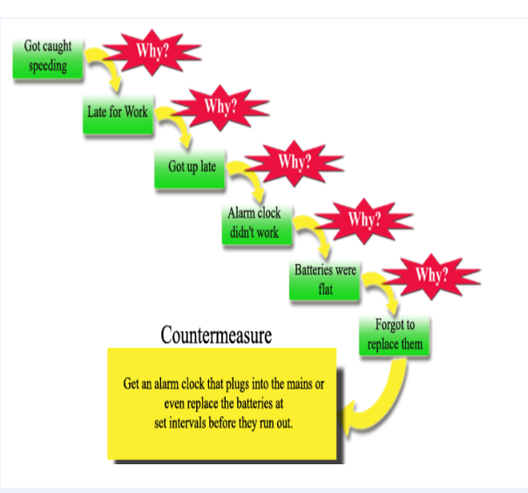
Slide 7  Slide 8  SAO Elements  Slide 9  The Findings section will include a summary of the results of the review along with a comparison of prior review findings.  The list of all subtopics for the subject area are included in M21-4, 5.04.  The conclusion section will contain an evaluation of the area under review, compare findings with established program requirements or guidelines and specify any deficiency. References used in making determination will also be included.  Slide 10  This documentation is part of the originating SAO and must be discussed as part of the next scheduled SAO  Recommendations and Improvements  Slide 11  SAO Recommendations:  Review the following tracking template with the participants…  Slide 12  SAO Recommendation Template  Actual address to the link:  http:\vbaw.vba.va.gov\bl\21\calendar\agenda\FY14\0214.docx  Slide 13  SAO Format  If possible, provide copies of your station’s SAO for the participants to review and discuss.  Slide 14  When discussing, take a moment to review 1-2 of the stated areas so an understanding may be gained as to what information is required to complete specific SAO. |  |  | In the example provided, reasoning was provided as to why an individual received a speeding ticket. Towards the end, it was noted the failure to replace the batteries in the clock started the process. To resolve and prevent this issue from occurring again, a countermeasure was set up to ensure the batteries are checked and replaced at certain intervals to ensure the clock will always work properly.  Avoid common shortcomings when using “The 5 Whys”.  - Tendency for investigations to stop at symptoms rather than going on to the lover-level root causes.  - Don’t stop at only a description of the process  - Continue questioning until you reach the root cause of the symptoms – a process that is not working well or that does not yet exist.  - Tendency to isolate a single root cause, when each question could elicit many different root causes.  - Refer to collected data to verify the probability of a relationship between the answers (s) and the current “why” question before proceeding to the next “why”.  Data Collection Strategies  When collecting your data for your SAO report, you may use a combination of methods:  - Sample size  - Use random and/or judgment sampling, that relates to the specific needs of a targeted analysis and that is appropriate for the type of data being collected  - State the size of the sample used, as well as population size when applicable and describe the results.  - Example: A sample size of 40 locally generated supplemental development letters to the Veteran, with a date range of January 2014 to March 2014, were reviewed. Fifteen out of the 40 letters reviewed were missing required technical information, for a total error rate of 37.5 percent.  - Reports and Sample Pulls  - VOR, Director’s Dashboards, Correspondence, PA&I Reports, etc.  - Electronic systems to include VOR, VBMS, VVA, COVERS, VACOLS, MAP-D, Share, etc.  - Additional Techniques  - Interviews, Questionnaires, etc.  SAOs should ensure effective and efficient benefit delivery by addressing, at a minimum:  - Identification of any problems and /or potential problem areas  - Recommendations/suggestions for corrective action  Note: Each analysis must identify any problem and/or potential problem areas drawn from assumptions and predictions based on the facts and findings. All assumptions and predictions must be explained and supported with rationale clearly outlined.  Policy, procedure and requirements contained in all VBA directives may be utilized as evaluation criteria.  SAO Elements  There are 6 elements that are required to provide a complete SAO report:  - Scope of Review  - Facts and Findings  - Analysis  - Conclusion  - Previous Reviews/Actions and  - Recommended Improvement Actions  Scope of Review  The scope of the SAO details the basis for the review. The objectives of the scope are to be as specific as possible. Systematic analyses will encompass all elements of the VSC and PMC activities. The time allotted to the review will depend on the size, scope, and complexity of the activity under study.  SAOs should be performed at least annually and must cover all areas described in paragraph 5.06. (Control Action Logs)  Note: Electronic systems to include VOR, VBMS, VVA, COVERS, VACOLS, MAP-D, Share, and FBS can provide data to use in the analysis.  Facts and Findings  A summarization of the data reviewed is presented in the facts and findings section.  - Relevant findings should be identified.  - Keep factual points relevant to the scope, to include areas for current review and findings of prior review.  - List all subtopics for the subject area being discussed and outline specific conclusions for each subtopic.  - Numbers and data should be displayed in an easy to read format (i.e., charts, graphs, etc.).  Analysis  The goal of the analysis is to systematically review an activity and look for potential areas of improvement. When problems are identified, the analyst’s job is to determine why they exist.  SAOs should ensure effective and efficient benefit delivery. The analysis section will provide  - meaning to the findings  - compare data, and  - discuss trends.  Important: Each analysis must identify any problem and/or potential problem areas drawn from assumptions and predictions based on the facts and findings. All assumptions and predictions must be explained and supported with rationale  Conclusion  The conclusion of the SAO will provide a discussion about the areas that need to be improved.  - All conclusions should be supported by the facts and analysis presented.  - Identify areas of improvement by assessing the conditions/situations and any determined causes.  - Be sure that the basis for the conclusion is clearly outlined.  Previous Reviews and Actions  Prior action items and/or recommendations from the last report should be restated. A description of when and how the recommendation was completed should be provided.  If the prior recommendation could not be completed, an explanation of possible mitigating circumstances that prevented the completion should be included. Prior recommendations that have not been completed should be continued as a current actionable item into the next SAO until completed.  The maintenance of a Control Log will assists with tracking the progress and completion of SAO action items.  The tracker should include:  - the action items  - the names of individuals responsible for completing the actions, and  - the targeted due dates as well as actual completion dates.  Control Action Logs should be maintained for review as part of the associated SAO for historical purposes. Documentation of the actual corrections and the establishment of a tracker with actual completion dates will help in monitoring compliance.  Recommended Improvement Actions  When problems or areas of improvement are identified by an SAO, the report should include recommended actions to remedy the problem or to implement processing improvements. Note that your SAO recommendations must be justified by the findings and the analysis. Additionally, your findings and analysis must be supported by your attached data.  - When providing recommended actions, be specific in terms of what is expected, who (by position) is responsible for the action item, and when it is to be accomplished.  - State the action to be completed  - State the date the action is to be completed  - State the party responsible for completing the action  - Identify criteria of evaluation  - When specific recommendations are made, ensure the procedures to complete the recommended actions are included. The proposed plans for corrective action as well as the time frame necessary for completion should be included.  - All SAO recommendations will be tacked in the same way general SAOs are tracked and maintained. The summarized recommendations will be flashed filed in the corresponding SAO until completion.  Example of an SAO Tracker…  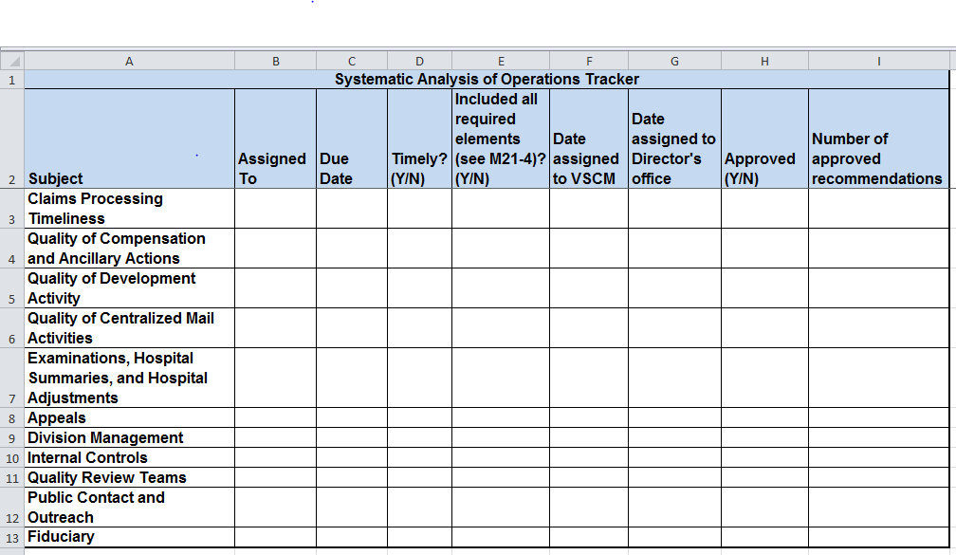  ** A copy of the SAO tracker for future use may be obtained on the C&P Best Practices web page:  http://vbacodmoint1.vba.va.gov/bl/21/sitevisit/docs/best_practice.htm  Tips to keep in mind when formulating your recommendations for inclusion in the SAO report.  - Avoid phrasing a recommendation in this way:  “Continue doing process X.”  - Instead, phrase in this way:  Process X should be continued until reevaluation is completed on specific date to determine if criteria Y is met.”  - Avoid phrasing a recommendation in this way:  “Follow up analysis should be conducted in a timely manner.”  - Instead, phrase in this way:  “Follow up analysis, in the form of a random sample of X number of Ys, should be completed by specific date to see if criteria X is sufficient to meet the requirements of Document Y. Otherwise, an action plan should be implemented addressing criteria X no later than specific date.”  - Avoid phrasing a recommendation in this way:  “Conduct additional training on topic X.”  - Instead, phrase in this way:  “Conduct X number of training sessions on topic Y to be completed no later than specific date.  Note: The VSCM/PMCM or designee will be responsible for disseminating each completed SAO to ensure that recommendations are appropriately assigned for implementation.  The Compensation Service Program Operations Team has found that many Systematic Analysis of Operations (SAOs) fail to include appropriate and measurable recommendations. Recommendations in SAOs help make even good areas better, as there is always room for improvement.  Management should follow-up on recommended items and be sure to merge the findings in the updated SAO.  As explained in the February 2014 Compensation Services Bulletin under Common Findings, a Recommendations Template is available for use… (Comp Service Bulletin February 2014)  SAO Format  As required for all VBA Correspondence, please ensure that your document is formatted with the use of the following:  - Arial font  - 12-point and  - One inch margins on all sides  When writing your SAO, remember:  - You are conveying information to another person or party in the most clear and effective manner possible.  - Document design and layout of the information are also very important components of technical writing. Your graphs and charts must be easy to read and understand.  Good technical writing is concise, focused, easy to understand, and free of errors  Sample of an SAO report…  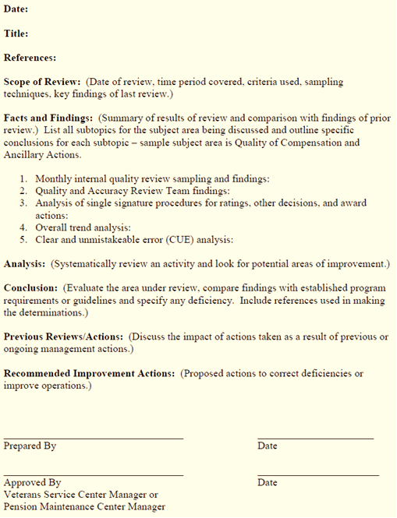  Sample of an SAO Review and Validation Sheet…  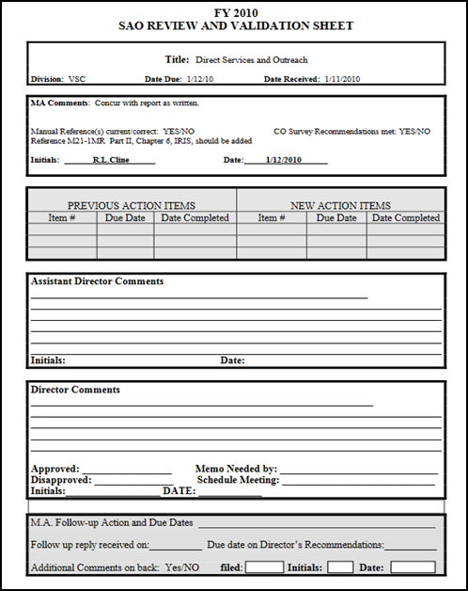  Once your SAO report is completed and submitted, the SAO Review and Validation Sheet will be attached and use to provide comments on the report. Please note that comments may consist of requests for additional data to support your recommendations and/or questions about the information provided.  Areas Covered by an SAO  SAOs should be performed at least annually and must cover all aspects of claims processing, including quality, timeliness, and related factors.  Division management may expand the areas of consideration to ensure a thorough analysis; however, the areas for review listed below indicate the minimum areas to be included.  - Claims Processing Timeliness  - Quality of Compensation and Ancillary Actions  - Quality of Development Activity  - Quality of Centralized Mail Activities (updated 9/25/14 – formally: Control Actions)  - Examinations, Hospital Summaries, and Hospital Adjustments  - Appeals  - Division management  - Internal Controls  - Quality Review Teams (Added 9/25/14)  - Fiduciary  - Public Contact and Outreach (updated 9/25/14 – formally: Direct Services)  **The areas covered and required elements for each SAO are subject to change. See M21-4, Chapter 5.04 for the most current list.
Slide 15 |  |  | Scheduling for SAOs  The VSCM/PMCM is responsible for preparing the SAO schedule annually.  - The schedule should be approved before October 1 of the fiscal year in which the SAOs are to be completed.  - The schedule must show the position title of the person responsible for the report and the month due.  - The schedule should include a tracker of the dates the completed SAOs were submitted.  As it may be necessary to analyze certain segments of an area of review more frequently than scheduled, SAOs may be prepared more frequently than schedule to determine trends, obtain facts for special reports, or determine quality in specified areas.  Example:  If hospital adjustment processing was determined to be a problem, then hospital adjustments should be analyzed more frequently until the situation is resolved. Retain the findings on such interim studies in the division administrative files and reference these studies in the next regularly scheduled SAO on the topic.
Slide 16
  Lesson Review, Assessment, and Wrap-up
  The Systematic Analysis of Operations (SAO) lesson is complete.
  Review each lesson objective and ask the trainees for any questions or comments.
  15 minutes
  You have completed the Systematic Analysis of Operations (SAO) lesson.
  The trainee should be able to provide information on the following:
  - The purpose of an SAO
  - The SAO Schedule
  - The format of an SAO
  - The elements of an SAO
  - The proper handling of recommendations and completion of an SAO
  Inform the trainees that they must complete the Level 1 assessment, located in the VA TMS, to receive credit for the lesson

