Systematic Analysis of Operations (SAO)

Trainee Handout

**Table of Contents**

Objectives 2

References 3

Purpose of SAOs 4

Who is Responsible for the SAO? 4

The Depth of the Analysis 5

SAO Elements 7

SAO Format 11

Areas Covered by an SAO 14

Scheduling for SAOs 15

Lesson Review, Assessment, and Wrap-up 15

# Objectives

Lesson Objectives for Systematic Analysis of Operations (SAO)

* Know the purpose of an SAO
* Know the SAO Schedule
* Know the format of an SAO
* Know the elements of an SAO
* Handling Recommendations and Completion of an SAO

# References

* M21-4, Chapter 5 (for most current list)
* February 2014 Compensation Service Bulleting
* VBA Letter 20-09-17

*Please note that SAO information is subject to change

# Purpose of SAOs

SAOs are a self-audit technique and are to be uses as a positive guide for operational improvement. An SAO should assist with the following:

* Monitor progress toward established goals and objectives
* Identify problems or out-of-line situations and recommend corrective actions
* Assess areas of vulnerability
* Determine effectiveness
* Identify opportunities for improvement
* Verify that records and reports accurately and properly reflect actual operations and results
* Evaluate compliance with manuals, regulations and other directive material
* Document a history of operational performance

Remember the primary goal of the analysis is to systematically review activities and identify potential areas of improvement.

# Who is Responsible for the SAO?

The VSCM and PMCM are responsible for the ongoing analysis of VSC and PMC operations, to include SAOs required by this chapter as well as those required by station policy.

Please also note, the participation in the SAO process does not have to be limited to supervisory personnel. VSCMs and PMCMs may delegate responsibility to other division personnel who are sufficiently experienced in VSC/PMC operations and who display analytical ability. Sharing or rotating the responsibility for SAOs may also be useful in providing a fresh look at a situation.

*\* Depending on your RO, a Coach or Assistant Coach may be assigned an SAO to complete each fiscal year.*

# The Depth of the Analysis

As an analyst, you are to determine why problems exist. The depth of the analysis must be sufficient so that problems or potential problem areas are clearly explained. One may use a question asking technique, such as “The 5 Whys” to determine the root cause of a problem.

The “5 Whys” is a simple and effective tool used to get to the root cause of a problem. Subjective in its approach, it relies on the analysis of the problem to come upon an agreed upon conclusion as to what the root causes are to the problems at hand.

The “5 Whys” are set around asking “why” to a problem, getting the answer and then asking why again and again until you come up with the real root cause of the problem.

Note: “The 5 Whys” is not necessarily about asking questions five times, you ask “why” as many times as you need in order to get to the real cause of a problem.

As illustrated in the following example, asking a series of why, enables you to get to the root cause of the problem. It is worth noting that most root causes are due to a lack of a robust system or process, or that there is no process in the first place.

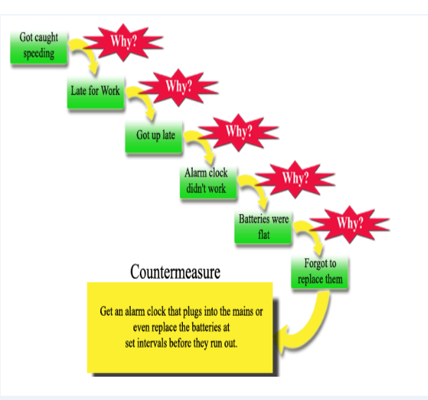

In the example provided, reasoning was provided as to why an individual received a speeding ticket. Towards the end, it was noted the failure to replace the batteries in the clock started the process. To resolve and prevent this issue from occurring again, a countermeasure was set up to ensure the batteries are checked and replaced at certain intervals to ensure the clock will always work properly.

Avoid common shortcomings when using “The 5 Whys”.

* Tendency for investigations to stop at symptoms rather than going on to the lover-level root causes.
* Don’t stop at only a description of the process
* Continue questioning until you reach the root cause of the symptoms – a process that is not working well or that does not yet exist.
* Tendency to isolate a single root cause, when each question could elicit many different root causes.
* Refer to collected data to verify the probability of a relationship between the answers (s) and the current “why” question before proceeding to the next “why”.

**Data Collection Strategies**

When collecting your data for your SAO report, you may use a combination of methods:

* Sample size
* Use random and/or judgment sampling, that relates to the specific needs of a targeted analysis and that is appropriate for the type of data being collected
* State the size of the sample used, as well as population size when applicable and escribe the results:
* Example: A sample size of 40 locally generated supplemental development letters to the Veteran, with a date range of January 2014 to March 2014, were reviewed. Fifteen out of the 40 letters reviewed were missing required technical information, for a total error rate of 37.5 percent.
* Reports and Sample Pulls
* VOR, Director’s Dashboards, Correspondence, PA&I Reports, etc.
* Electronic systems to include VOR, VBMS, VVA, COVERS, VACOLS, MAP-D, Share, etc.
* Additional Techniques
* Interviews, Questionnaires, etc.

SAOs should ensure effective and efficient benefit delivery by addressing, at a minimum:

* Identification of any problems and /or potential problem areas
* Recommendations/suggestions for corrective action

Note: Each analysis must identify any problem and/or potential problem areas drawn from assumptions and predictions based on the facts and findings. All assumptions and predictions must be explained and supported with rationale clearly outlined.

Policy, procedure and requirements contained in all VBA directives may be utilized as evaluation criteria.

# SAO Elements

There are 6 elements that are required to provide a complete SAO report:

* Scope of Review
* Facts and Findings
* Analysis
* Conclusion
* Previous Reviews/Actions and
* Recommended Improvement Actions

**Scope of Review**

The scope of the SAO details the basis for the review. The objectives of the scope are to be as specific as possible. Systematic analyses will encompass all elements of the VSC and PMC activities. The time allotted to the review will depend on the size, scope, and complexity of the activity under study.

SAOs should be performed at least annually and must cover all areas described in paragraph [5.06](https://vaww.compensation.pension.km.va.gov/system/templates/selfservice/va_ka/#506). *(Control Action Logs)*

*Note*: Electronic systems to include VOR, VBMS, VVA, COVERS, VACOLS, MAP-D, Share, and FBS can provide data to use in the analysis.

**Facts and Findings**

A summarization of the data reviewed is presented in the facts and findings section.

* Relevant findings should be identified.
* Keep factual points relevant to the scope, to include areas for current review and findings of prior review.
* List all subtopics for the subject area being discussed and outline specific conclusions for each subtopic.
* Numbers and data should be displayed in an easy to read format (i.e., charts, graphs, etc.).

**Analysis**

The goal of the analysis is to systematically review an activity and look for potential areas of improvement. When problems are identified, the analyst’s job is to determine why they exist.

SAOs should ensure effective and efficient benefit delivery. The analysis section will provide

* meaning to the findings
* compare data, and
* discuss trends.

***Important***: Each analysis must identify any problem and/or potential problem areas drawn from assumptions and predictions based on the facts and findings. All assumptions and predictions must be explained and supported with rationale

**Conclusion**

The conclusion of the SAO will provide a discussion about the areas that need to be improved.

* All conclusions should be supported by the facts and analysis presented.
* Identify areas of improvement by assessing the conditions/situations and any determined causes.
* Be sure that the basis for the conclusion is clearly outlined.

**Previous Reviews and Actions**

Prior action items and/or recommendations from the last report should be restated. A description of when and how the recommendation was completed should be provided.

If the prior recommendation could not be completed, an explanation of possible mitigating circumstances that prevented the completion should be included. Prior recommendations that have not been completed should be continued as a current actionable item into the next SAO until completed.

The maintenance of a Control Log will assists with tracking the progress and completion of SAO action items.

The tracker should include:

* the action items
* the names of individuals responsible for completing the actions, and
* the targeted due dates as well as actual completion dates.

Control Action Logs should be maintained for review as part of the associated SAO for historical purposes. Documentation of the actual corrections and the establishment of a tracker with actual completion dates will help in monitoring compliance.

**Recommended Improvement Actions**

When problems or areas of improvement are identified by an SAO, the report should include recommended actions to remedy the problem or to implement processing improvements. Note that your SAO recommendations must be justified by the findings and the analysis. Additionally, your findings and analysis must be supported by your attached data.

* When providing recommended actions, be specific in terms of what is expected, who (by position) is responsible for the action item, and when it is to be accomplished.
  + State the **action** to be completed
  + State the **date** the action is to be completed
  + State the **party** responsible for completing the action
  + Identify **criteria of evaluation**
* When specific recommendations are made, ensure the procedures to complete the recommended actions are included. The proposed plans for corrective action as well as the time frame necessary for completion should be included.
* All SAO recommendations will be tacked in the same way general SAOs are tracked and maintained. The summarized recommendations will be flashed filed in the corresponding SAO until completion.

Example of an SAO Tracker…

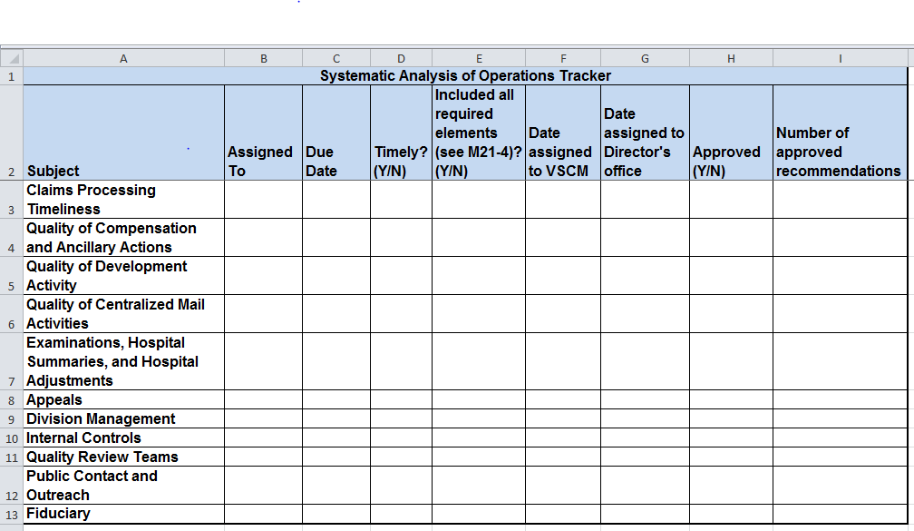

** A copy of the SAO tracker for future use may be obtained on the C&P Best Practices web page:

<http://vbacodmoint1.vba.va.gov/bl/21/sitevisit/docs/best_practice.htm>

Tips to keep in mind when formulating your recommendations for inclusion in the SAO report.

* **Avoid phrasing a recommendation in this way:**

“Continue doing *process X*.”

* **Instead, phrase in this way:**

*Process X* should be continued until reevaluation is completed on *specific date* to determine if *criteria Y* is met.”

* **Avoid phrasing a recommendation in this way:**

“*Follow up analysis* should be conducted in a *timely manner*.”

* **Instead, phrase in this way:**

“*Follow up analysis, in the form of a random sample of X number of Ys,* should be completed by *specific date* to see if *criteria X* is sufficient to meet the requirements of *Document Y*. Otherwise, *an action plan* should be implemented addressing *criteria X* no later than *specific date*.”

* **Avoid phrasing a recommendation in this way:**

“Conduct *additional training* on *topic X*.”

* **Instead, phrase in this way:**

“Conduct *X number of training sessions* on *topic Y* to be completed no later than *specific date*.

*Note*: The VSCM/PMCM or designee will be responsible for disseminating each completed SAO to ensure that recommendations are appropriately assigned for implementation.

The Compensation Service Program Operations Team has found that many Systematic Analysis of Operations (SAOs) fail to include appropriate and measurable recommendations. Recommendations in SAOs help make even good areas better, as there is always room for improvement.

Management should follow-up on recommended items and be sure to merge the findings in the updated SAO.

As explained in the February 2014 Compensation Services Bulletin under Common Findings, a Recommendations Template is available for use… ([Comp Service Bulletin February 2014](http://vbaw.vba.va.gov/bl/21/calendar/agenda/FY14/0214.docx))

# SAO Format

As required for all VBA Correspondence, please ensure that your document is formatted with the use of the following:

* Arial font
* 12-point and
* One inch margins on all sides

When writing your SAO, remember:

* You are conveying information to another person or party in the most clear and effective manner possible.
* Document design and layout of the information are also very important components of technical writing. Your graphs and charts must be easy to read and understand.

Sample of an SAO report…

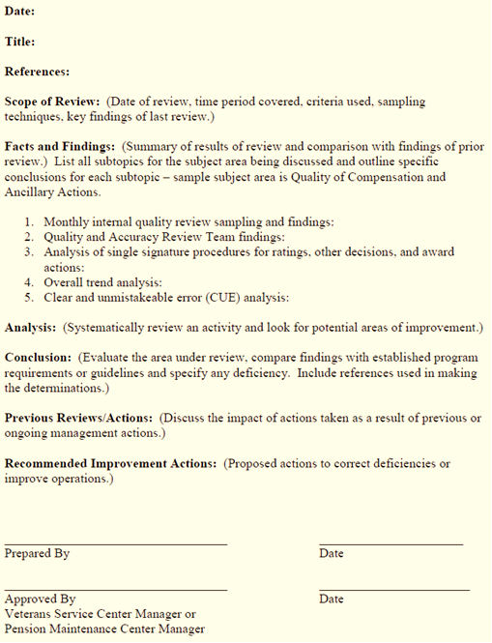

Sample of an SAO Review and Validation Sheet…

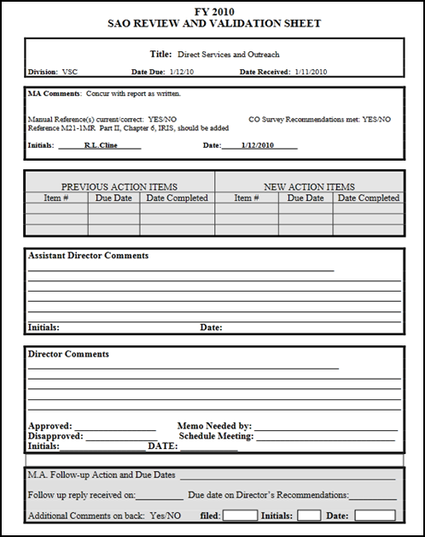

Once your SAO report is completed and submitted, the SAO Review and Validation Sheet will be attached and use to provide comments on the report. Please note that comments may consist of requests for additional data to support your recommendations and/or questions about the information provided.

# Areas Covered by an SAO

SAOs should be performed at least annually and must cover all aspects of claims processing, including quality, timeliness, and related factors.

Division management may expand the areas of consideration to ensure a thorough analysis; however, the areas for review listed below indicate the minimum areas to be included.

* + Claims Processing Timeliness
  + Quality of Compensation and Ancillary Actions
  + Quality of Development Activity
  + Quality of Centralized Mail Activities *(updated 9/25/14 – formally: Control Actions)*
  + Examinations, Hospital Summaries, and Hospital Adjustments
  + Appeals
  + Division management
  + Internal Controls
  + Quality Review Teams *(Added 9/25/14)*
  + Fiduciary
  + Public Contact and Outreach *(updated 9/25/14 – formally: Direct Services)*

**The areas covered and required elements for each SAO are subject to change. See [M21-4, Chapter 5.04](http://vbaw.vba.va.gov/bl/21/publicat/Manuals/M214/index.htm) for the most current list.

# Scheduling for SAOs

The VSCM/PMCM is responsible for preparing the SAO schedule annually.

* The schedule should be approved before October 1 of the fiscal year in which the SAOs are to be completed.
* The schedule must show the position title of the person responsible for the report and the month due.
* The schedule should include a tracker of the dates the completed SAOs were submitted.

As it may be necessary to analyze certain segments of an area of review more frequently than scheduled, SAOs may be prepared more frequently than schedule to determine trends, obtain facts for special reports, or determine quality in specified areas.

Example:

If hospital adjustment processing was determined to be a problem, then hospital adjustments should be analyzed more frequently until the situation is resolved. Retain the findings on such interim studies in the division administrative files and reference these studies in the next regularly scheduled SAO on the topic.

# Lesson Review, Assessment, and Wrap-up

The Systematic Analysis of Operations (SAO) lesson is complete. Review each lesson objectives and ask additional questions you may have about the information presented.

Upon completion of this lesson, you should be able to provide information on the following:

* The purpose of an SAO
* The SAO Schedule
* The format of an SAO
* The elements of an SAO
* The proper handling of recommendations and completion of an SAO