COVERS User Guide

Table Of Contents

What's New This Release 1

Getting Started 5

Overview 5

Functions 6

Basic Functions 6

Advanced Functions 6

System Interactions 7

Starting and Exiting Covers 8

To start the COVERS application 8

To exit the COVERS application 9

To configure your scanner device 9

Using Help 10

Context Sensitive Help 11

Using Keyboard Shortcuts 12

The COVERS Desktop 15

Using the Toolbar 15

Common Functions 15

The Main Menu 15

Windows Conventions 16

Printing the Current Screen 17

To print the current contents of the screen 17

Security 18

BIRLS (BICO/COBI) Processing 19

CSS and COVERS Functional Interface 20

Password Information 23

Password Requirements 23

Common Security Application Logon Password 24

Changing Your Password 25

To change your COVERS password 25

Password Reset 27

Logon Screen "INFO" Button 28

Logging on at a Different Work Station 29

Administrative Information 31

Security Administrator Capabilities 31

Sensitive and Access Level 32

Diagnostic Code Suppression 34

Linking Procedures for BDN 35

General Information 35

Naming Conventions 37

Administering a Jurisdictional Station 37

User ID Naming for Jurisdictional Stations 38

User ID Naming for VSO and Contractors 39

Selecting a Facility Job Title for Contractors 40

Additional Information 41

Changing the User Location 41

Special Locations 41

Acting as a Service Organization 43

Acting as a Service Organization 43

To stop acting as a Service Organization 43

Interaction with other VA systems 44

RO Options 45

Consolidate Locations 47

To consolidate records in the Locations Table 47

Classes of COVERS Users 48

COVERS Configuration File (COVERS.INI) 50

Troubleshooting 52

Working With Folders 53

Overview 53

General Notes 53

Receive Folder 55

Folder Inquiries 56

Folder Access Restrictions 56

Receiving Folders At Your Location 57

Receiving Folders At Your Location 57

To Receive Folders at Your Location 57

If COVERS could not locate your folder 58

Special note for location LFN processing 59

For SO or Acting SO Users - A Note on POA Processing 59

If BIRLS is down 59

The Quick Print Function 59

A Note on Folder Consolidation 59

Display Folder Data Window 61

Display Folder Data buttons 61

Search Folder 63

To request the folder you are viewing 63

Transfer View 64

To switch to the Transfer view 64

Interpreting Transfer Information 64

History View 65

To switch to the History view 65

Understanding the History View 65

History View Status Codes 65

Search View 66

To switch to the Search view 66

Understanding the Search View 66

Search Type and Priority Codes 66

Corp/BDN 67

Folder Maintenance Operations 69

Folder Maintenance Operations 69

Add Volume 70

Adding A Volume To A Large Folder 71

To Add a Volume to a Large Folder (from COVERS Main Menu) 71

To Add a Volume to a Large Folder (from the Display Folder Data - Folder Data tab screen) 71

Change Folder 72

If COVERS could not locate your folder... 72

Delete Folder 74

Deleting A Folder From COVERS 75

Folder Inquiries 77

Single Inquiry 77

Performing A Single Inquiry 78

To perform a Single Inquiry 78

Name/SSN Inquiry 79

Folder Requests and Mail Searches 81

Overview 81

Folder Requests and Mail Searches 82

Mark For Mail 83

Mark Folder For Mail 84

Request 85

Request A Folder 86

Change/Delete 87

Delete Search For A Single Folder 88

Delete Search For A Specific Criteria 89

Delete Mail Search In Bulk 90

Re-assign Search 91

If COVERS could not locate your folder... 92

Folder Access Restrictions 93

BIRLS Functions 95

BIRLS Functions 95

Location Inquiry 96

Loc Correction 97

Generating and Printing Folder Labels 99

Generating and Printing Folder Labels 99

Generate Labels 100

Generating Labels 101

Print Labels 102

Printing Labels 103

Using QK Print 104

Transferring Folders 105

Transferring Folders 105

Track a Folder Transfer 106

Request Transfer 107

Acknowledging a Transfer Request Response 108

Transferring a Folder to Another RO 109

Station of Jurisdiction (SOJ) 111

Transfer Out 112

Create Transfer Slip 113

Print Transfer Slips 114

Receive 115

Receiving Multi-Volume Temporary Transfers 116

Expected Return Date 117

Initiating a Temporary Transfer of a Folder 118

Permanent Transfer of a Folder 120

Creating Temporary Claims Folders 122

Send TTO Back 123

Surprise Receive 124

Deleting Temporary Claims Folders 125

Update Transfer 126

Delete Transfer 127

Barcode Reader 129

Using and Maintaining the Barcode Reader 129

Configuring Your Scanner Device 131

Tips for Using the Wand 132

Tips for Using the Scanner Gun 133

Brokered Work 135

Brokered Work 135

Brokering Work To A Different Station 136

CVR Extract 137

Performing CVR Extract 138

Tables 139

Tables 139

Browsing a COVERS Table 140

Edit the contents of a COVERS Table 141

Add Code to COVERS Table 142

Delete Code From COVERS Table 143

Reports 145

Reports 145

Report Sequence 146

Search List by Search Location 147

Select A Report 150

Search List by Priority Code 152

Search List by Folder Location 155

Search List by Terminal Digit 158

Folder Statistics Report 161

Temporary Transfers Report 163

Permanent Transfer Report 165

Folder Aging for a Location Report 167

Special Codes Statistics Report 169

Multi-Volume Folders - Terminal Digit Sequence 171

Unauthorized SO Holdings 173

Folder Search Review 174

Multi-Volume Folders - Folder Number Sequence 176

Validation Tables Report 177

Facility Codes Table Report 178

Location Code Table Report 179

Priority Code Table Report 180

Organization Code Table Report 181

Special Code Table Report 182

Brokered Work Report 183

Utilities 185

COVERS Administrative Functions 185

Utilities 189

Utility Menu 190

Table Maintenance 191

Folder Retirement/Relocation 193

Extract FNL/LNF 194

Delete FNL/LNF 196

Consolidating Locations 197

Refreshing Codes 198

Messages 199

Messages 199

Info/Error Messages 200

To read and dispose of Info/Error Messages 200

Unauthorized Holdings 201

Folder Requests Your Station 202

Folder Requests Responses 203

Responding To A Folder Request Response 204

COVERS Messages 205

Code Tables 223

Facility Codes Tables 223

Location Codes Tables 224

Organization Codes Tables 226

Priority Codes Table 227

Refresh Code From COVERS Table 229

Special Codes Table 230

Locations @ 101 231

Screen Descriptions 233

COVERS Main Menu screen 233

Set RO User Options screen 235

Folder Data screen 236

History screen 238

Search screen 240

Transfer screen 242

Corp/BDN screen 244

Folders 245

Receive screen 245

Single Inquiry screen 246

Name/SSN Inquiry screen 248

Add Volume screen 249

Change screen 251

Delete screen 253

Folder Inquiry 254

Search 255

Multiple Folder Inquiry 255

Delete Search screen 256

Mark Folder For Mail screen 257

Request screen 257

Change/Delete screen 257

Delete Search For A Single Folder screen 257

Delete Search For A Specific Criteria screen 257

Delete Mail Search In Bulk screen 257

Re-Assign Search screen 257

Search List by Priority Code screen 257

Search List by Folder Location screen 257

Search List by Search Location screen 257

Search List by Terminal Digit screen 257

Folder Search Review screen 257

Labels 257

Generate Labels screen 257

Print Labels screen 257

Transfers 257

Request Transfer screen 257

Transfer Out screen 257

Print Xfrs Slip screen 257

Temporary Transfer screen 257

Permanent Transfer screen 257

Delete Transfer Request screen 257

Create Temp Folder screen 257

Mass Temporary Transfer Folders screen 257

Delete Transfer screen 257

Delete Temp Folder screen 257

Update Transfer screen 257

BIRLS 257

Location Inquiry screen 257

Loc Correction screen 257

Miscellaneous 257

Reports screen 257

Utilities screen 257

CVR Extract screen 257

Report Options-Folder Aging screen 257

Report Options-Special Codes screen 257

Table Reports Selection screen 257

Table Maintenance screen 257

Consolidate Locations screen 257

Folder Retirement/Relocation screen 257

Act As Service Organization screen 257

Change User Location screen 257

Messages 257

Info/Error Messages screen 257

Unauthorized Holdings screen 257

Folder Request Your Sta screen 257

Folder Request Responses screen 257

Field Descriptions 257

Field Descriptions 257

Definitions 257

Definitions 257

Glossary 257

Index 257

# What's New This Release

**COVERS V6.3 Release Notes**

**System Enhancements**

**Receive**

* During Receive function, the Sensitive Folder message has been enhanced to state whether or not the veteran is employed at the receiving station.    Previously, only “This Folder Is a Sensitive Folder” would display when the folder was received.

**Brokered Work**

* COVERS has been enhanced so that if there are multiple file numbers in the Transfer Folder grid and a particular number is selected, when Qkprint is selected, the barcode will print the particular file number selected.
* The Brokered Work Indicator on the Transfer Tab should update the Station of Jurisdiction (SOJ) correctly.
* Brokered Work will now print on the Transfer Slip on a case that has been brokered out.

**Transfer**

* The horizontal space on the ‘Mass Temporary Transfer’ button has been made wider so that all the text will fit in that space.
* The station receiving a permanent transfer should be able to create a temporary folder and the station that is waiting to receive the permanent transfer should be able to create a temporary folder.
* Mass Temporary Transfer – The COV250 message was modified to expand the message:  “COV250 – Both CLAIM and TEMP Folders Exist In Your Database. Before transferring, you should determine whether consolidation of the CLAIM and Temp folders is appropriate.  Do you want to continue with the transfer?”
* The Transfer Request Message:  “COV287 – This Folder was requested for Perm Trsfr by Station ###” has been added back.
* When a folder is temporarily transferred to a station, the user may issue a Mail Search – Mark for Mail; however, after the user has issued the mail search, the user may not issue an ‘Other Search’.  If the user attempts to issue an ‘Other Search’, the user will receive an error message.  The user may select ‘OK’ and continue using COVERS, but they will not be able to issue an ‘Other Search’.

**Single Inquiry**

* The ‘Not at Your Station’ message has been corrected so that it should always display correctly.
* COVERS should only display the Rebuilt message when an Inquiry is first performed on the claim.  This message should also be shown in Share/COVERS Inquiry.
* Single Inquiry BDN/PIF portion will populate and display with claims created in Share.

**SOJ**

* COVERS has been modified so that if the Temporary SOJ is equal to the permanent SOJ, at Receive, the Temporary SOJ will be deleted on a permanent transfer in (PTI).
* Pension Maintenance Center (PMC) users should not be able to generate PTO actions in COVERS.  As of the installation of this release, the user who sends a folder to Philadelphia, Milwaukee or St Paul will have to distinguish whether he/she is sending the folder to a regional office (VARO) or PMC.  If the user selects PMC, the permanent transfer out will be systemically changed to a temporary transfer.

**508 Compliance**

* In compliance with 508 Federal regulations, the Name/SSN screen has been modified for use by visually impaired employees.   This functionality is only available with special device usage.

**Hot Keys**

* Previously the same ‘Hot Key’ was used for the “HELP” function and “History Tab”.  With this release, the History Tab hot key will be CTRL + H and the Help function hot key will be ALT + H.
* The Hot Keys on Single Inquiry (Display Folder, History, Search, Corp/BDN) screens.  Once focus is set, users will not only be able to access screens using CTRL + F (Folder Data), CTRL + H (History), CTRL + S (Search) and CTRL + C (Corp/BDN), but they will be able to use the arrow keys to change tabs.  Focus can be set by tabbing to each screen tab.

**Miscellaneous**

* The COV226 message has been enhanced to state:  “Volume ## is not in COVERS.  There are ## Volumes for this folder.”
* The Act So button will be enabled on Request.
* In this release, CH31 claims are created from Share for the first time.          COVERS BDN/PIF will display newly created CH31 claims.

# Getting Started

## Overview

COVERS (Control of Veterans Records System) is a Microsoft Windows-based Client/Server application using barcode technology to support RO (Regional Office) and RMC (Record Management Center) folder activities, including requests, mail, search, and external transfers.

The primary function of COVERS is tracking the location of folders within, and between offices.  Covers tracks the file number, name, power of attorney, and current location of each folder.  The effective functioning of COVERS requires that the database accurately reflect the actual current physical location of the folder.

COVERS was designed as a 'receipt-based' system.  This means that the COVERS database is updated each time a folder is received at a location.  For example, if a folder is moved from the 'Files' location to the 'Adjudication' location, Adjudication will issue a COVERS 'Receive' transaction as soon as possible to update the database.  Although the basic design of COVERS is a receipt-based system, the user is encouraged to cover files to their next destination.

## Functions

### Basic Functions

The following is a list of the basic functions provided by COVERS:

* Online access to the current location of any folder.
* The ability to request a folder located at the RO.
* A history of folder movement.
* Online alerts for folder requests, mail or messages directed to the user.

### Advanced Functions

The following is a list of the advanced functions provided by COVERS.  These functions are available based on the access granted:

* Determination of a claim number based on name or social security number.
* Cancellation of folder requests.
* Temporary transfer of folders, eliminating the need to prepare written transfer documents, or maintain manual control systems.
* Permanent transfer of folders, eliminating the need to prepare written transfer documents and advising requesters that the folder has been transferred.
* Custom lists of search mail and folders requests.  These lists are sequenced in claim number order and provide the current location of the folder.
* Various lists helpful to managers and supervisors, including an 'Aging List', which lists the folder at a specific location grouped by the length of time at that location.

**Note for SO Users:**  Limited access to COVERS functions is granted to Service Organization users.  SO users are allowed to inquire about, request and receive folders for which appropriate Power of Attorney is maintained.

## System Interactions

It is vitally important that COVERS be updated as soon as possible after folders are physically received, because the location code will remain inaccurate until a receive transaction is completed.  This may cause other users to receive inaccurate information from COVERS, causing unnecessary delays in related activities and ultimately delaying service to veterans.

## Starting and Exiting Covers

To exit the COVERS application

To configure your scanner device

In order to use COVERS, you must have a valid LAN User ID.  Depending on local procedures, the COVERS Program Administrator, System Administrator or Security Officer will add privileges from supervisors made through CSS.  A default location code and access privileges will be assigned to each user based on the supervisor's request.

CSS Security uses the LAN User ID to validate the user against the CSS Security Database.  When a user attempts to start COVERS, the users LAN ID is validated against defined COVERS User IDs.  Once COVERS has located the user's LAN ID among the list of valid User IDs, the user must enter the password associated with that User ID.

### To start the COVERS application

1. Log on to the PC using your network User ID and password.
2. From the **Start** button, select the COVERS icon located under the *VBAPPS* folder.  The *VBA Common Security Services-User Authentication* logon screen will appear.

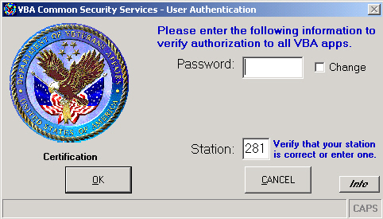

1. Enter your logon password.  For more information on passwords, see Password Requirements.
2. Select the **OK** button.  The COVERS Main Menu will appear.  If you have entered an incorrect password, a warning message will appear.  For more information and the password requirements, see Common Security Application Logon Password.

To prevent such a security violation, you should contact you Security Administrator to reset your password.  For more information, see Password Reset.

### To exit the COVERS application

1. Select the **Exit** button from the toolbar.  For more information on the toolbar, see The COVERS Desktop.

### To configure your scanner device

* If you have a scanning device for use with barcode labels, you need to insure that your scanner is configured for use with COVERS.  This may be performed before starting COVERS, or immediately after starting COVERS.  Your scanner will not operate properly under COVERS until this step has been performed.
* If you are using an Intermec scanner, there will be a special barcode attached to you PC.  You will be required to scan this special label to configure your scanner.  If this process works correctly, you will hear one beep, followed by four beeps to indicated that the configuration process worked correctly.  If you do not hear this particular beep sequence, or do not have a special barcode attached to your PC, see your system administrator.
* If you are using a BX100 scanner, then you should have been given a sheet of barcodes that you must scan in order to configure the scanner.  Contact your administrator to obtain this special sheet of barcodes.

## Using Help

Online Help includes step-by-step procedures to guide the user through the application function list.  Descriptions for all windows provide an overview to assist with COVERS functionality.

Use the *Contents* tab to access Help topics through the Table of Contents.

Use the *Index* tab to search for information using keywords.

Search for information using the *Find* tab to perform full-text searches.

Utilize the "Keep the Help on top" Help functions.  The keep a displayed topic visible while working in COVERS:

* From the Help menu bar, select the **Options** button
* Select the **Keep on top** button
* Select the **On Top** button

Select any open window behind the Help to continue working.  Online Help remains on top of the other windows currently open on the desktop.

## Context Sensitive Help

Many portions of COVERS are *Context Sensitive*.  Context Sensitive Help allows the user to obtain help on specific fields without using the Help menu.

To use Context Sensitive Help on any COVERS screen, place the insertion point on the object and press **F1.**

**For example:**

Press F1 when the cursor is in the *File Number* field.  This will show the help topic related to File Number.

The context-sensitive parts are:

* All data fields on any screen
* Error messages

## Using Keyboard Shortcuts

|  |  |  |
| --- | --- | --- |
| **Menu Name** | **Window Name** | **Shortcut** |
| Folders-Receive | COVERS-Enter Folder Identification (Receive Folder) | Alt + R |
| Folders-  Single Inquiry | COVERS-Enter Folder Identification (Inquiry Single Folder) | Alt + I |
| Folders-Name/SSN Inq | COVERS-Name/SSN Inquiry | Alt + m |
| Folders-  Add Volume | COVERS-Enter Folder Identification (Inquire Single Folder) | Alt + V |
| Folders-  Change | COVERS-Enter Folder Identification (Inquiry Single Folder) | Alt + C |
| Folders-  Delete | COVERS-Enter Folder Identification (Inquiry Single Folder) | Alt + D |
| Folders-Single Inquiry-  Folder Data | COVERS-Display Folder Data | Ctrl + F |
| Folders-Single Inquiry-History | COVERS-Display Folder Data | Ctrl + H |
| Folders-Single Inquiry-Search | COVERS-Display Folder Data | Ctrl + S |
| Folders-Single Inquiry-Transfer(s) | COVERS-Display Folder Data | Ctrl + T |
| Folders-Single Inquiry-Corporate/BDN | COVERS-Display Folder Data | Ctrl + C |
| Search-Mark For Mail | COVERS-Enter Folder Identification (Mark Folder for Mail) | Alt + k |
| Search-  Request | COVERS-Enter Folder Identification (Request Folder) | Alt + q |
| Search-  Change/Delete | COVERS-Change/Delete Search | Alt + / |
| BIRLS-  Location Inquiry | COVERS-BIRLS Inquiry | Alt + L |
| BIRLS-  Loc Correction | COVERS-Enter Folder Identification (Inquiry Single Folder) | Alt + o |
| Labels-  Generate Labels | COVERS-Enter Folder Identification (Generate an Additional Label) | Alt + b |
| Labels-  Print Labels | COVERS-Print Labels | Alt + P |
| Transfers- Request Transfer | COVERS-Enter Folder Identification (Inquiry Single Folder) | Alt + n |
| Transfer-  Transfer Out | COVERS-Enter Folder Identification (Transfer Folder) | Alt + T |
| Transfer-  Print Xfr Slips | COVERS-Print Transfer Slips | Alt + S |
| Miscellaneous-Utilities | COVERS-Utilities Menu | Alt + U |
| Miscellaneous-Utilities- Tables | COVERS-Utility Menu | Alt +T |
| Miscellaneous-Utilities- Reports | COVERS-Utility Menu | Alt + R |
| Miscellaneous-Utilities - Maintenance | COVERS-Utility Menu | Alt + e |
| Miscellaneous-Utilities - RO Options | COVERS-Utility Menu | Alt + O |
| Messages-  Info/Error Messages | COVERS-Info/Error Messages | Alt + 1 |
| Messages-  UnAuthorized Holdings | COVERS-Unauthorized Holdings | Alt + 2 |
| Messages-  Folder Requests Your Sta | COVERS-Folder Requests Your Sta | Alt + 3 |
| Messages-  Folder Request Responses | COVERS-Folder Request Responses | Alt + 4 |
| Help | COVERS-Main Menu | Alt + H |
| Act SO | COVERS-Main Menu | Alt + A |
| Chg Loc | COVERS-Main Menu | Alt + g |
| QK Print | COVERS-Main Menu | Alt + Q |
| Location Correction | COVERS-Main Menu | Alt + o |
| Clear | COVERS-Main Menu | Alt + l |
| Prev Screen | COVERS-Main Menu | Alt + c |
| Delete Search For A Single Folder | COVERS Change/Delete Search | Alt + F |
| Delete Search For Specific Criteria | COVERS Change/Delete Search | Alt + C |
| Delete Mail Search In Bulk | COVERS Change/Delete Search | Alt + B |
| Re-assign Search | COVERS Change/Delete Search | Alt + R |
| Mass Temporary Transfer | COVERS-Enter Folder Identification | Alt + R |
| Process Data | COVERS-CVR Extract Report Query | Alt + r |
| Copy to Clipboard | COVERS-CVR Extract Report Query | Alt +b |
| Clear Data Above | COVERS-CVR Extract Report Query | Alt +l |
| Extract FNL/LNF | COVERS-Maintenance | Alt + E |
| Delete FNL/LNF | COVERS-Maintenance | Alt + D |
| Retirement/Relocation | COVERS-Maintenance | Alt - R |
| Clear Folder Location Count | COVERS-Enter Folder Identification (Receive Folder) | Alt + u |
| Exit | COVERS-Main Menu | Alt + X |

## The COVERS Desktop

### Using the Toolbar

The COVERS toolbar is located at the bottom of the desktop.  It provides information on the current status of COVERS, and gives quick access to a number of common functions.

**Note:**  Although the toolbar is always visible, some toolbar functions may not be available at certain times.  COVERS will temporarily disable a function if it does not apply in the current context, or if you are not authorized to use it.

### Common Functions

There are a number of buttons that appear in numerous places in COVERS, and they always perform the same action.  The following table summarizes the actions associated with the most common of these recurring functions.

|  |  |
| --- | --- |
| **Button** | **Function** |
| OK | Initiate the action for the screen using the data entered |
| Prev Screen | Cancel current action and return to previous screen |
| Main Menu | Cancel current action and return to main menu |
| Cancel | Cancel current action and return to underlying screen (for pop-up dialogs) |
| Clear | Erase any data entered on the screen and reset values to defaults, if applicable |
| Double-Click | Used only in grids.  COVERS accepts a double-click in a grid as an ENTER |

### The Main Menu

The Main Menu is the starting point for all COVERS subsystems.

**Main Menu screen**

## Windows Conventions

COVERS follows most Windows interface conventions.  For more information on using Windows application, see *Microsoft Windows User's Guide* Chapter 4, "Windows Basics."  In this document, the work "select" is used to mean any of the following, which are equivalent:

* Clicking on a button or other control using the mouse
* Pressing ENTER (rather than clicking with the mouse) when the control is highlighted.  In most dialogs, the **OK** button is highlighted by default.
* Moving the *focus* (the highlighted control) by pressing the TAB key, then pressing ENTER.  For example, rather than clicking on the **Prev Screen** button, you can press the TAB key until the button is highlighted, the press ENTER to select it.
* Pressing the *Accelerator Key* associated with a control.  The accelerator key is activated by pressing and holding the ALT key, then pressing the key indicated by an underlined letter in the control's name.  For instance, you may Exit from COVERS by pressing ALT+x (note that the x on the **Exit** button is underlined.)

## Printing the Current Screen

If you wish to print the current contents of your screen, Windows provides a straightforward general method.

### To print the current contents of the screen

1. Press the PRINT SCRN on your keyboard.  On most keyboards, this key is located just to the right of the F12 key.
2. Open a new document in Microsoft Word (or WordPerfect, or any other word processing programs that allows graphics) or the Windows Paintbrush application.
3. Select Paste from the *Edit* menu.  The screen shot will appear.
4. Select Print from the *File* menu to print your screen shot.

## Security

Security in CSS provides a method for determining who may access COVERS and restricting what operations a COVERS user is allowed to perform.  A COVERS user needs a valid COVERS User ID and password to log onto COVERS.  Once established as a valid COVERS user, there are 38 operations that may be individually enabled or disabled for a user by a user basis.  In addition each user has an access level that restricts the users ability to view sensitive records.

## BIRLS (BICO/COBI) Processing

**BICO - BIRLS to COVERS**

BICO (BIRLS to COVERS) processing happens whenever the TARGET BDN system has either a CLAIM or NOD folder established for a veteran in the BIRLS application.  When this occurs, a message is sent to COVERS so that COVERS can create a record for this veteran.  COVERS will also generate folder barcode labels for this new folder.

In addition, other BIRLS transactions cause notification to COVERS.  When a BIRLS application changes the name, Social Security Number (SSN), or Power of Attorney (POA) code for an existing folder, COVERS is notified and makes a proper notification to its records.  A BIRLS consolidation of two veteran records also sends notification to COVERS, and COVERS will delete the cancelled record and update the retained record as appropriate.  Finally, if an existing CLAIM or NOD folder is deleted, a message is sent to COVERS and the appropriate record will be deleted from the COVERS system.  In all cases, barcode labels are generated as needed.

**COBI - COVERS to BIRLS**

COBI (COVERS to BIRLS) processing happens whenever COVERS makes folder changes that require a BIRLS update.  There are only two situation where this occurs.

First, whenever a permanent transfer is made, a message is sent to BIRLS to inform BIRLS of the new RO location for the folder.  Temporary transfers do not generate any COBI processing.

The second COVERS action that forces COBI processing is on COVERS location corrections.  These unusual events, when a COVERS user overrides the current folder location and enters a new corrected location, sends a message informing BIRLS of the location correction.

BIRLS applications, as well as Compensation and Pension (C & P), update their folders on all COBI transactions.

## CSS and COVERS Functional Interface

There are 38 COVERS application operations that may be individually enabled or disabled for each user in CSS:

* Maintain Tables
* Generate Labels
* Delete Folder
* Add/Change Folder
* Transfer Folder
* Print Labels
* Location Inquiry
* Location Correction
* Transfer Folder Request
* Mark Folder for Mail
* Maintenance Functions
* Change Search Location
* BCIO/TRANS Authority
* Delete Search for A Folder
* Del Search For Special Criteria
* Delete Mail Searches in Bulk
* Delete Mail Search in Bulk
* Generic Delete Mail Search
* Generic Delete Request
* Quick Print
* Search Lists Report
* Folder Search Review
* Folder Statistics
* Validation Tables
* Transfers Report
* Multi-Volume Folder Stats
* Unauthorized SO Holdings
* Special Codes Statistics
* Folder Aging For A Location
* Create Transfer Slips
* CVR Extract
* Mass Temporary Transfer
* Station Of Jurisdiction
* Update Transfer
* Delete Transfer
* Brokered Work
* Corporate/BDN Inquiry
* Location At 101
* Single Inquiry Only

In addition to specifying access to these operations, a User Profile indicates a user's access level.  A user's access level establishes which sensitive file folders the user may view.  The access level must be greater than or equal to the sensitive file record access level for that user to view the folder.  In most cases, a COVERS user will have the same access level in COVERS that was allowed in BDN and BIRLS 3270.

Additional information in the User Profile includes a user's personal information (SSN, Job, Title), default location and default organization.

# Password Information

## Password Requirements

The Department of Veterans Affairs (VA) has mandated the use of strong passwords on all VA computer systems.  Common Security "strong" passwords are case sensitive, mandatory eight characters in length, and contain three of the following four types of characters:

* Upper case letters
* Lower case letters
* Numbers
* Special characters (e.g., "#", "\", or "$")

**Note:**  Passwords will not be displayed.  They will be displayed as asterisks (*).

## Common Security Application Logon Password

* Application Passwords must be eight characters in length.
* No blank spaces allowed within the password.
* The Default (start-up) password is the *User ID* found in the CSS security record.
* The application CSS password expires every 90 days.
* Reminders will appear indicating that the application password will expire beginning five days before the actual expiration date.  The last reminder will appear on the date the password actually expires.
* When entering a new application password, the previous three passwords cannot be reused.  Passwords may be changed at any time by selecting the "Change" checkbox next to the Password field.  Follow the logon screen prompts for entering a new password.
* After five unsuccessful attempts to logon, the system will block any further attempts.  The VBA CSS automatically records these failures and considers it a security violation.  Contact the CSS Security Administrator to request a password reset.  The CSS Security Administrator has the option of resetting the password, or unlocking the current password.
* When attempting to logon and the password attempt fails, check the User ID and password.  This may prevent the user from being locked out from excessive attempt.  Try re-entering the User ID.
* To prevent a security violation, contact the CSS Security Administrator to reset the password.

When logging in for the first time, or when the password has been reset, an eight character User ID password is required.

## Changing Your Password

CSS allows users to change their passwords and should be complete periodically to ensure the account remains secure.

Application passwords expire every **90** days.  Reminders are sent beginning 5 days prior to the expiration.  The final reminder will be the date the password actually expires.

The following situations will prompt a change to the user password:

* When the CSS security record is first established
* More than five attempts to logon
* The password has expired (every ninety days in normal)
* Ninety days of non-use

### To change your COVERS password

1. Logon to the PC using the usual network user ID and password.
2. From the **Start** button, select the COVERS icon from the *VBAPPS* folder.  The VBA Common Security logon screen will appear.

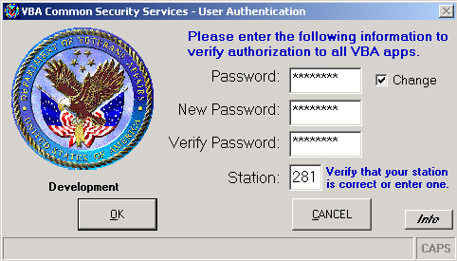

1. Enter your old logon password.  The characters will be displayed as asterisks (*).
2. Select the check box labeled '*Change'.*
3. Tab down tothe *New Password* field and enter a new password.  The characters will be displayed as asterisks (*).
4. Tab down to the *Verify Password* field and enter the new password again, verifying the new password.
5. Select the **OK** button to continue password change and logon process, or **CANCEL** to exit the process.
6. When the password has been successfully changed, a message will appear stating "*Password change has been completed."*  Select the **OK** button.

## Password Reset

When the password ha been reset, a prompt will appear to enter a new eight character password.  To initiate a change of password, enter the default password.  The default password is the first eight characters of the Network Logon Name or User ID assigned to the CSS record, e.g. 281GJOHN.

Change the default password when prompted by the system, or for Web application, immediately after entering the default password and station number.  After entering a password that is due to expire, the following message will be displayed: "*Your password has expired, please enter a new password".*

At any time, changing the password may be accomplished by selecting the "Change" checkbox.  Enter a new password.  Verify the password by re-entering it.

1. Type the old password first.  Failure to do so will prompt the message *"You must enter a Password"*. Enter a new password.

**Note:**  To stop the logon process, press the **CANCEL** button.  This will default to the Windows operating system.

1. To continue processing, press the **OK** button.

**Note:**  FOR SECURITY REASONS, PLEASE DO NOT USE YOUR LAN PASSWORD.  The application password is not related to the LAN.  The password is not re-connecting to Windows.  Windows is already active.  Using the LAN password increases the security risk to the database system.

## Logon Screen "INFO" Button

The **Info** button helps the IRM personnel troubleshoot a problem with the CSS logon.  The computer name indicates the computer assigned to the station.

Attempts to access an application that does not match the information on this screen will result in one of the following messages:

* *"Invalid Password at Change to Station"*
* *"You do not have authority to run the Requested Application.  See the Appropriate Application Program Administrator"*
* *"Invalid User ID at the Change to Station.  Access is terminated.  An attempt will be made to initialize to previous station.  Please notify your system administrator."*

Check with the IRM official for further instructions.

## Logging on at a Different Work Station

For LAN applications within the VBA, CSS security requires that the workstation LAN User ID match the LAN User ID entered in the security access record.  An "*Invalid Password*" error message will result when entering a password that does not match the current duty station logon.  Ensure the logon screen has the correct duty station.

# Administrative Information

## Security Administrator Capabilities

The Security Administrator functions are:

* Establish and maintain the basic Application User security record.
* Assign sensitive record access levels to Application Users.
* Assign POA codes to VSO Users.
* Restrict access to POA codes for VSO representatives.
* Set default passwords and Lock/Unlock User account.
* Assign application (and a default role) to Users.  Roles define the functions an Application User may perform.  All applications using CSS are automatically associated to a default or generic role called User.
* List and delete Applications Users.
* Monitor Users on the system.
* Maintain the veteran sensitive record lock file on the Corporate/NumaQ and the BDN Regional Data Processing Center's (RDPC) via CSUM.

## Sensitive and Access Level

|  |  |  |  |
| --- | --- | --- | --- |
| **Level**  **of Sensitivity** | **VA Records, including Employee, Veterans or Beneficiaries** | **Level**  **of**  **Access** | **Authorized**  **Employees** |
| **0** |  | **0** | All employees not authorized access to sensitive file records |
| **1** |  | **1** |  |
| **2** | Other - local determination | **2** |  |
| **3** |  | **3** |  |
| **4** | Relatives of VA employees | **4** |  |
| **5** | Work-study employees at VARO, VRO&IC, VAM&ROC, VAMC, and VADPC with BDN terminals | **5** |  |
| **6** | VSO representative, employees cooperating in public and private agencies engaged in presentation of claims to VA, Governors, Lieutenant Governors, Attorney Generals of States or Commonwealths, locally prominent persons and officials, VHA Medical Centers employees, and Regional Council | **6** | At the discretion of the station director, access to this level will be limited by a strict need-to-know basis according to the minimum number of employees required to process the workload |
| **7** | VBA Employees | **7** | Service Center Directors, Assistant Service Center Directors, Team Leaders, all of the Division Chiefs, supervisory personnel, Security Officers and alternated, accredited VSO representative |
| **8** | VA Senior Executive Service, GS-16/17 and higher, Directors and Assistant Directors, District Counsel, Division Chiefs or equivalent, and persons of national prominence | **8** | RO Directors and Assistant Directors, Service Center Directors and Assistant Service Center Directors |
| **9** | President and Vice President of the U.S., Members of cabinets, U.S. Senators and members of Congress, U.S. Supreme Court Justices, Secretary of Veteran Affairs, Deputy Secretary of Veteran Affairs, Under Secretaries, Deputy Under Secretaries, VA department Directors and Deputies | **9** | Under Secretary for Benefits, Deputy Under Secretary for Benefits, Directors of C&P and Education Services, VBA Security Officers, Director and Assistant Directors or ROs having jurisdiction of the records with a level of sensitivity equal to nine |

## Diagnostic Code Suppression

|  |  |  |
| --- | --- | --- |
| **BDN** | **Meaning** | **CSS** |
| Diag Suppress | For a VA file number, diagnostic code descriptions are hidden.  These codes cannot be seen on the screen. | Suppress Diagnostics checkbox (User Information) |
| Diagnostic | For VA or Non-VA employees, Diag Codes are displayed on the screen.  Description field is blank. | Suppress Diag Legends checkbox (Sensitive File Tab) |

**Note:**  When the diagnostic suppression checkbox is selected, the code descriptions will not appear on any of the code screens.  Some codes may also be suppressed due to the nature of the diagnosis.

# Linking Procedures for BDN

## General Information

When the VA hires an employee with veteran status, a sensitive record is created.  The sensitive file in Corporate and BDN must be updated with new information when the CSS/BDN Security Administrator is notified of a hiring.  Complete item number four on Terminal Access Request VA Form 20-8824 by entering the VA File Number.

# Naming Conventions

## Administering a Jurisdictional Station

Jurisdictional Stations are VA Stations identified by a three-digit station number.  Stations are placed under a RO for security access control through CSUM.  Examples of Jurisdictional Stations are Medical Centers (VHA), the National Cemetery Administration (NCA), and the Officer of Inspector General (OIG).

CSUM security records for Jurisdictional Station employees should be kept separate from the security records of the RO employees.  The User Listing ('Home or Jurisdictional Station' combo box) displays the Jurisdictional Station assigned to the RO.  If a Jurisdictional Station is missing or assigned to the incorrect RO, please submit a help ticket through the ITC Help Desk.

## User ID Naming for Jurisdictional Stations

**Caution:**  The User ID provided on the VA Form 20-8824, item 2, may cause confusion.  The LAN User ID is identified at VHA or NCA, and not the RO.  When assigning a User in CSUM, VHA or NCA employees requesting access to IBBA should use the following standard naming convention.

* **First three characters** - the three letters of the User ID identifies the employees' VA organization, e.g. VHA, NCA, OIG, OGC, etc.
* **Fourth character** - the first letter of the first name
* **Fifth through eighth character** - first four letters of the last name, e.g. Johnson=JOHN.  For last names four characters or less, enter the entire last name, or backfill with numbers until the last name equals four characters, e.g. Ray=RAY1.

## User ID Naming for VSO and Contractors

Users without a VA station number, such as VSO employees and contractors, should be added under the RO number.

**VSO Personnel**

For VSO personnel, the first three characters of the User ID should be "VSO".  Do not use the specific name of the VSO as the leading identifier.  The VSO indicator provides this information.

**Contractors**

For contractors, the first three characters of the User ID is an abbreviation of the company's name, e.g. Titan System Incorporated = TSI.  If the company's name is "PSI" = "PSI".

## Selecting a Facility Job Title for Contractors

When a Facility Job Title for an employee outside the RO that is not listed in CSUM, select a generic job title for Cemetery, Medical or other Non-VA Users.

* NCS Global User
* Non-VA Global User
* VHA Global User

For Contractors hired as programmers, use the job title 'Contractor-Programmer'.  CSUM will prompt the Administrator to enter the expected end for the contractor.

If the CSUM user is a VBA employee, request a correct job title be added to CSUM.  Contract a VBA representative.

# Additional Information

## Changing the User Location

The User Location is the mechanism COVERS uses to track the origin and target of folder transactions.  In some cases, changing the location setting on a workstation may be desired.  For example, using the COVERS User ID to log on in another division, the user will need to tell COVERS that this is not the usual location.

**Note:**  When selecting a location other than the default location, the indicator in the toolbar that displays the current location will be highlighted in a special color.

1. Select the **Chg Loc** button on the COVERS toolbar.  The Change User Location screen will appear.  If **Chg Loc** is grayed out, this function is not available because (1) **Chg Loc** is not allowed from the current screen, or (2) the user is a SO and is not allowed to change the location.
2. Select the desired location from the pull-down menu.
3. Select the **OK** button to continue and return to the **Main Menu**, or **Cancel** to quit and return to the Main Menu.

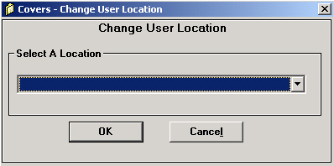

### 

### Special Locations

There are a number of special locations that are defined at all ROs.

|  |  |
| --- | --- |
| **Location** | **Function** |
| TRANS | Processes all transfer requests for this RO.  Info/Error Messages and Transfer Requests Your Sta are the only function available at this location.  Authorized users (those with BICO/TRANS permitted in user profile, or PA or SC users, may choose this location only from the Main Menu |
| BICO | Process all BIRLS to COVERS requests for this RO.  Info/Error Messages is the only function available at this location.  Authorized users (those with BICO/TRANS permitted in user profile, or PA or SC users may choose this location only from the Main Menu.  The BICO location will received all Info/Error Messages relating to BIRLS to COVERS transaction. |
| LNF | [Label-No Folder] Receives folders that are to be designated as LNF.  Info/Error Messages is the only other functions available at this location.  Authorized users may choose this location only from the Receive screen. |
| FILES | Represents the physical room or rooms where the file bank is located. |

The special location TRANS, BICO and LNF are assigned an organization of "system"; the special location FILES has an organization of "files".

## Acting as a Service Organization

COVERS allows non-SO users to act as a Service Organization (SO) for the following functions: Receive, Single Inquiry, Folder Request, or Delete Search for single folder.  This may occur in cases where the SO in question does not have immediate access to COVERS workstations.

**Note:**  While acting as a Service Organization, all functions other than those mentioned above will be temporarily disabled.

### Acting as a Service Organization

1. Select the Folders **Receive,** **Single Inquiry**, or **Change/Delete** button on the COVERS Main Menu.  This function is only available within these functions.
2. Select **Act SO** on the COVERS toolbar.  The Act As Service Organization screen will appear.  If this function is unavailable, the user is not authorized to use it.
3. Select the desired SO from the pull-down menu.
4. Select the **OK** button, or **Cancel** to continue and return to the previous screen.

### To stop acting as a Service Organization

Change the location to a non-SO location.  See the section titled Changing the User Location.  The user will return to normal COVERS operating mode.

## Interaction with other VA systems

COVERS shares folder information with BIRLS and WAFPS.  When a folder is added to BIRLS or certain information is updated, a transaction is sent to COVERS to ensure that folder information remains consistent across systems.  Likewise, when folders are retired from BIRLS via WAFPS, COVERS is updated via an automatically update location information in BIRLS.

## RO Options

COVERS provides a convenient way for authorized users (Security Officers) to change these values.  The RO options are stored in the COVERS.INI file.  System administrators have the options of editing the file directly.  It is recommended to use the RO Options screen to minimize the chance for error.  The RO Options screen is accessed from the Utilities menu.

**RO Options screen**

**Note:**  Network traffic and load will determine what is the appropriate setting for an RO.

The following settings apply:

**Folder Types:**

The valid COVERS folder types are displayed here.  The only valid folder types are 'NOD' and 'CLAIM'.  As additional folder types are handled by COVERS, they will be displayed here.

**Msg Interval:**

The number of minutes between message retrievals.  This field determines the length of time between message inquiries to the server.  The valid values for the field are 3 to 60.  The default value is 10.

**XfrSlip TD Sequence:**  If this check box is selected, transfer slips print in terminal digit (within file number) order.  The valid selections are Yes and No, and the Default is set to Yes.  When this option is selected, the XferSlip Entry Sequence option is set to No.

**XfrSlip Entry Sequence:**

If this check box is selected, transfer slips print in data entry order.  The valid selections are Yes and No; and the default is set to No.  When this option is selected, the XfrSlip TD Sequence option is set to No.

**Create XfrSlip Print For POA:**

When this is selected, an additional Transfer slip is printed for a folder with Power of Attorney.  The valid selections are Yes and No; and the default is set to No.

**Number XfrSlip to Create:**

Create specified number of Transfer slips.  The valid range is 1-5, and the default is set to 2.  This option determines how many transfer slips are generated.  After they are generated, this is the number that will print, not including the POA slip.

**Paths:**

These are the director paths for the COVERS files that reside on the LAN, in case they need to be changed from the standard paths.  To change file paths for database, reports and error logs, use the file and directory windows to easily navigate and select drives and directories.  Select the **Change** button to choose the new drive and directory.

**Search Settings:**

This option allows for an extended search of all COVERS locations for a folder during a Transfer Request operation.  An extended search occurs when a folder is not found at the location specified by BIRLS.  During an extended search, all ROs will be polled to determine the location of the folder.  If the folder is at your own RO, the Inquiry never gets to BIRLS.  This is a background task that will allow the user to continue processing; the user will be notified via message processing of the search results.  This is a network intensive option and should not be used except for very short periods of time, and under very restricted use.  The valid selections are Yes and No, and the Default is set to No.

**Number of Days After Which Queues Labels Are Deleted**  This specified that number of days after which labels have been printed are deleted from the database.  The valid range is 1-9 and the default is 1.

**Number of Labels to Print:**

This specifies the number of labels to print when a label is requested.  The valid range is 1-5, and the default is set to 2.

**Number of Days After Which Transfer Slips Are Deleted:**

This specifies the number of days after which Transfer Slips that have been printed are deleted from the database.  The valid range is 1-9, and the default is set to 4.

**Unauthorized Holding Location:**

This specifies the location where messages will be delivered if a folder is received at a location that a user is not authorized to view.

## Consolidate Locations

The Consolidation function allows you to combine several locations into a single existing location.  Use this function if, for example, a new file cabinet replaces two old cabinets that were formerly separate location.  By consolidating the old locations into a single location, you are telling COVERS that all the files associated with the two old locations are now located in one place.  Search locations are also updated by the consolidation process.

**Note:**  Only the System Administrator should execute this operation.  All other users should log off the system before performing this operation.

### To consolidate records in the Locations Table

1. Browse the Location Codes Table.
2. Select Consolidate.  The Consolidate Location Codes window will appear.

**Note:**The Consolidate command is available only when the Location Codes Table is browsed.  A warning will appear telling you that this function should be performed when no other users are on the system.  This is to ensure that user folder operations are not in progress while the consolidation is being performed.

1. Select a 'To' location.
2. Select up to six 'From' locations you wish to consolidate in the 'From' box.  Since the 'From' locations will no longer exist after the consolidation update has completed, COVERS will search through all user accounts to insure that no user refers to one of these locations as its default location.  If COVERS, determines that any are in fact a default location for any user, the default location and organization code will be updated to reflect the new consolidated location.
3. Select **OK** to consolidate the records, or select the **Previous Screen** or **Main Menu** to cancel.

## Classes of COVERS Users

There are four classes of COVERS users.

**Note:**  All users can request folders, receive folders and perform single inquiries.  You can not restrict these three functions; even users with no checkbox selections will have the ability to perform these functions.

**Security Officer Users**

Security Officer users have complete authority over all aspects of security.  Security Officers can add and delete users, issue user profile change requests, and approve/modify/deny any profile change request.  Security Officers can view the entire user list.  Security Officers are the only users allowed to access the sensitive file, and are the only users permitted to specify access levels for users greater than zero.  Only Security Officers may view security violation.

**Program Administrator Users**

Program Administrator users are similar to Security Officers with one major exception: a Program Administrator may not change a user's access level or access the sensitive file.  What a Program Administrator can do is add and delete users, issue user profile change requests, and approve/modify/deny any profile change request.  Program Administrators can view the entire user list.

**Normal Users**

These users may not request or authorize any user profile changes of access to the sensitive file.  The rest of normal COVERS user's access to application functional list is determined based on the selections made in the user profile when it was set up by his supervisor, the Program Administrator or the Security Officer.  If a COVERS function is not available to a normal COVERS user, then his user profile did not specify that the user has access to that capability.  A user's access level establishes which sensitive file folder the user may view, the level must be greater than or equal to, the sensitive file record access level for the user to view the folder.  In most cases, a COVERS user will have the same access level in COVERS that was allowed BDN and BIRLS 3270.  Changes to the user profile can be requested by the user's supervisor.  Changes to the access level must be requested by a COVERS Security Officer.

**COVERS Service Organization Users**

Service Organizations are allowed restricted access to COVERS.  They may perform only the following functions using COVERS:

* Request folder
* Receive folder
* Inquire folder location
* Delete folder request

COVERS SO users have no ability to request any reports or other system capabilities.

## COVERS Configuration File (COVERS.INI)

COVERS has a configuration file, COVERS.INI, that contains many important system parameters.  It is a standard, ascii text file.  This file should be changed only by system administrators.  The parameters contained in the file, and their default values, are shown below:

|  |  |  |
| --- | --- | --- |
| **Parameter Name** | **Default Value** | **Description** |
| DemoMode | 0 | Indicates if COVERS is in Demo Mode:  0-No  1=Yes.  For use in ROs; this field should always be set to 0. |
| Folder Types | CLAIM, NOD, TEMP | Valid COVERS folder types.  Do not change the values in this field |
| DatabasePath | g:\covers\database\ | The database path of the COVERS databases. |
| ReportPath | g:\covers\repots\ | The database path of the COVERS Local Reports. |
| SearchROs | N | Indicates whether or not extended searches of all COVERS databases are allowed to located a COVERS record:  Y=Yes  N=No.  This will be determined by system and network performance. |
| MsgInterval | 10 | Indicates how often a transaction will be sent from each workstation to determine if a messages are available.  The number indicated the how many minutes elapse between transactions.  This may be used to tune network traffic. |
| TDSequence | 1 | Indicates if transfer slips will be printed in Terminal Digit sequence: 1=Yes  0=No. |
| EntrySequence | 0 | Print Transfer Slips in the order in which they were created: 1=Yes  0=No |
| Print3rdXferSlip | 0 | Automatically Print an extra Transfer slip for folders with POA: 1=Yes  0=No |
| DoubleLabels | 2 | A misnomer, this parameter actually indicates the number of label to print.  Valid entries are from 1 to 5. |
| VBRig | 1 | Determines if error trapping is turned on: 1=Yes  0=No.  This options should be turned on at all times. |
| ErrLog | f:\tux\ulog | Sets the path for logging any errors trapped by error handling. |
| DeleteDays | 1 | Indicates the number of days for automatic deletion of printed labels. |
| NumbersXferSlips | 2 | The number of transfer slips to generate. |
| XferDeleteDays | 4 | The number of days for automatic deletion of printed transfer slips. |
| UnauthLocation | FILES | This specifies the location where messages will be delivered if a folder is received at a location that a user is not authorized to view. |
| EmailAddress | <Blank> | The email address specified by the Program Administrator for all Outstanding Mail Search emails to be sent to. |

## Troubleshooting

Contact the Philadelphia Help Desk for assistance with this application.

|  |  |
| --- | --- |
| **Problem** | **Explanation** |
| I can't find the COVERS icon in the Windows Program Manager. | COVERS may not have been properly installed.  Check with your local COVERS administrator. |
| My User ID doesn't work. | Your User ID may not have any assigned privileges.  If your User ID does not work, see your local COVERS administrator. |
| When I select **OK**, I get a message stating "Invalid File Number." | You have not entered a file number.  If you wish to exit this screen, select the **Main Menu** or **Prev Screen** button. |
| BIRLS was not updated when I received a folder. | BIRLS is down temporarily; do a Location Correction later. |
| Transfer slips are not printing. | Check to see if the slips were selected.  If the slips never appear on the printer, check with your System Administrator to ensure that the printer setup is correct. |
| Label is not scanning. | The label may not be flat.  Ensure that the label is not curved or folded.  If the problem persists, the label may be defective.  Print a new label.  If the newly-generated label fails to scan properly, there may be a problem with the barcode configuration.  Contact your COVERS System Administrator. |
| Label is read properly but there is not ENTER keystroke. | There may be a problem with the barcode configuration or the scanning hardware.  Contact your COVERS System Administrator. |
| I get a BIRLS System Error when trying a Location Inquiry. | BIRLS is down temporarily.  Try again later. |
| COVERS Error Trap #3049. | Your database has been corrupted.  Show your System Administrator a screen print.  The database must be repaired using Microsoft Access. |

# Working With Folders

## Overview

The purpose of COVERS is to track the location of folders within VA Regional Offices (RO).  COVERS will search for a particular folder at a site and, if desired, request the folder be sent to a specific location.

The Folders panel in the COVERS Main Menu window displays seven options for operation related to folders at the users site.

|  |  |
| --- | --- |
| **Function** | **Description** |
| Receive | Inform COVERS that you have received a folder at your location from another location within your RO, or that you have received a temporary transfer. |
| Single Inquiry | Find a particular folder if you know the file number. |
| Name/SSN Inquiry | Find a particular folder or group of folders using a name and/or Social Security number, but do not know the file number. |
| Add Volume | Inform COVERS that you have added a new volume to a folder that has grown too large. |
| Change | Inform COVERS that you have changed a folder's special code or restricted data specification. |
| Delete | Tell COVERS to remove a folder from the tracking system. |

### General Notes

The **Quick Print** button on the toolbar will be enabled during the Single Inquiry, Receive and Name/SSN Inquiry, to allow users to quickly print a single label.

For the RMC only, the **Quick Print** button will be available after the *Transfer Out* function.

When scanning labels, you must take care to insure that the cursor is located in the file number field before scanning.  If you move the cursor to another field by pressing the *TAB* key or clicking, and then you scan the label, the results are unpredictable.  **Make sure that cursor is in the file number field before scanning labels**.

If you are scanning a label on an NOD folder and the label you are scanning does not say NOD, the label will scan as a CLAIM folder.  Create an NOD label for this folder as soon as possible using the **Quick Print** or **Generate Labels** button.  Meanwhile, to use the existing label, enter the folder type (NOD) first, then click back into the file number field (as discussed above), and then scan the folder.

If you are scanning a label for a CLAIM volume 2, 3 or 4, and you get an invalid volume, you are probably scanning labels from the old WANG COVERS system.  These volume 2-4 labels will not work with the new COVERS system, and new labels must be created using the *Quick Print* or *Generate Labels* functions.

The following categories apply to this topic:

Receive Folder

Single Inquiry

Name/SSN Inquiry

Add Volume

Change Folder

Delete Folder

Mark Folder For Mail

Request

Loc Correction

Generate Labels

Transfer Out

## Receive Folder

The most common use of COVERS will be Receive Folder.  The Receive function is used only for folders that have arrived at the users location from other locations inside, as well as outside the RO.  When receiving a folder that has been transferred in (from another RO on a permanent transfer), the Receive function from the COVERS Main Menu will be used.

Because COVERS relies on these receive transactions to track the location of folders, it is vitally important use the Receive function is used immediately when receiving a folder.  Otherwise, other users may be given incorrect information.  For help on receiving folders, see Receiving Folders At Your Location.

## Folder Inquiries

COVERS allows you to perform two kinds of inquiries on folders at your site, depending on the type of information you already have.  If you know the file number of the folder you are looking for, you can use the Single Inquiry function to find that particular folder.  If you do not know the file number but you do know the name or Social Security number, you can find all matching folders using Name/SSN Inquiry, then select the inquiry needed.

**Note:**  In most cases you will know the name and/or Social Security number for the folder being inquired, but you should always use *Single Inquiry* if possible.  This is because COVERS can locate a folder much quicker if the file number is known.  This reserves limited system resources.

### Folder Access Restrictions

COVERS enforces two types of access restrictions that may prevent you from retrieving information on a folder:

* Service Organization (SO) users must have power or attorney (POA) recorded in COVERS for a folder in order to retrieve information through a folder inquiry.  If an SO user does not have POA *or* if the folder has multiple POAs, the inquiry will be denied.  These will be logged in the unauthorized messages.
* Some folders are marked as *Sensitive* and have an associated access restriction level from zero to nine, with nine being the highest level of sensitivity.  COVERS users are assigned an access level, also from zero to nine; this is how COVERS determines whether or not you may access a sensitive folder.  If the access level is lower than the sensitivity level of the folder in question, the inquiry may be denied.

# Receiving Folders At Your Location

## Receiving Folders At Your Location

If COVER could not locate your folder

Special note for location LFN processing

For SO or Acting SO Users - A Note on POA Processing

If BIRLS is down

The Quick Print Function

A Note on Folder Consolidation

### To Receive Folders at Your Location

1. Verify that the location is set correctly.  For information on changing the location, see the section titled Change User Location.
2. From the Main Menu, select the Folders **Receive** button.  The *Enter Folder Identification (Receive Folder)* window will appear.
3. Enter the file number for the folder being searched, or scan the label on the folder.  If scanning, remember that the cursor must be in the file number field before scanning.  If scanning, skip to step 7.
4. Select the folder type.  Folder type will default to 'CLAIM' if left blank.
5. Select the volume number.  Folders will default to '1', if left blank.
6. If you do not wish to display the Search/Sensitive Message that is associated with a record, select the '*Do Not Display Search/Sensitive Message'* checkbox.
7. Select **OK** to continue the Process, **Clear** to clear the current entry on the screen, or **Main Menu** to cancel the process and return to the Main Menu.
8. A grid will be displayed showing the number of files that have been received by the users location.

**Note:**  If the **OK** button is selected, on of the following scenarios will occur:

* **Scenario 1**:  Click **OK.**  COVERS Message dialog box will appear.  On a COVERS folder found message, click **Yes** to receive the folder.  Click on **OK** (To continue Receive Folder process), a COVERS message will be displayed in the Message Area.
* **Scenario 2**:  Click **OK.**  COVERS Message dialog box will appear.  On a COVERS folder found message, click **No** to NOT receive the folder, a COVERS message will be displayed in the Message Area.
* **Scenario 3**:  Click **OK.**  COVERS Message dialog box will appear.  On a COVERS folder NOT found message, click **Yes** to re-inquire COVERS with a different folder type.
* **Scenario 4**:  Click **OK.**  COVERS Message dialog box will appear.  On a COVERS folder NOT found message, click **No** to receive the folder.  Click **Yes** to Add The Folder From BIRLS.  Click **OK** (To continue Receive Folder process), a COVERS message will be displayed in the Message Area.
* **Scenario 5**:  Click **OK.**  COVERS Message dialog box will appear.  On a COVERS folder NOT found message, click **No** to continue.  A second COVERS Message dialog box will appear.  Click **No**  to Add The Folder From BIRLS, a COVERS message will be displayed in the Message Area.

**Note:**  COVERS will be updated to reflect the location of the folder.  If the folder could not be located, COVERS will provide a brief message.  If there are outstanding searches for the folders, COVERS will provide a message.  The user may continue to receive folders on this screen without returning to the Main Menu.  When finished, select the **Main Menu** button.

### If COVERS could not locate your folder

If COVERS could not locate your folder, there are several possible reasons, each with its own resolution procedure.

* **If you are trying to receive volume 2-99 of a multi-volume folder**
* If COVERS knows about this folder, you will be given the option of adding the next volume and registering it at your location.
* If COVERS *does not* know this folder, it will assume that you have made an error.  You must receive volume 1 first and then the processing below will take place.
* **If you are trying to receive a single-volume folder *or* volume 1 of a multi-volume folder**
* Ensure that you have entered the current folder number.
* You may have incorrectly specified the folder type.  If this is the case, you may re-try the inquiry with a different folder type.
* If the information you have entered is correct and COVERS cannot locate the folder, you can attempt to add the folder from BIRLS.  If the folder is found in BIRLS, both BIRLS and COVERS will be updated to reflect the folder's location.  If BIRLS cannot locate the folder, this indicates that there is no electronic record of the folder, which generates an error.
* **If the file number you are using is a cancelled file number**
* You will receive a message telling you what the new file number is.  The folder will not be added or received.
* **If the file number you are using is a duplicate file number**
* You will receive a message telling you what the other file number/SSN is.  The folder will not be added or received.

### Special note for location LFN processing

If you receive a transferred folder (TTO, TTI, PTO, or PTI) as location LNF, you will get a message to change to another location and receive again.

### For SO or Acting SO Users - A Note on POA Processing

If you are an SO or Acting SO user and you receive a folder you are not authorized to hold, a folder with restricted data, or a folder with multiple POAs, a number of errors are generated.  In such situations it is usually necessary to return the folder to the precious location.

* You will receive an error message indicating that this is an unauthorized holding.
* The previous location on this folder will be notified that the current location is not authorized to hold this folder.  At the previous location, the **Unauthorized Holdings** button on the Main Menu will be enabled.  Messages will be deleted when the folder is received back into a location authorized to have the folder, or when COVERS shows that POA has been given to the SO.
* If the folder you are receiving that has not yet been received into your office (COVERS still shows this folder as a pending transfer), then the unauthorized message will go to the FILES location at your office.

### If BIRLS is down

If BIRLS is down during a receive that generates an update to BIRLS, you will receive the message "COV081 System Error."  In such a situation, COVERS knows the correct location of the folder, but BIRLS does not.  It will be necessary to perform a BIRLS Location Correction when BIRLS comes back online.

### The Quick Print Function

The **QK Print** button (located on the toolbar at the bottom of the screen) allows you to print a label for last folder received.

* **To print a label for the folder you just received**
* Select **QK Print** from the Toolbar at the bottom of the screen.

### A Note on Folder Consolidation

If you receive an off-site folder that was misplaced or forgotten, there is a chance that a rebuilt folder was created in BIRLS, resulting in two folders with the same number.  In addition, it is sometimes discovered that a single person has two files with different numbers.  In either case, the multiple folders need to be consolidated into a single folder.

*COVERS does not have a facility for consolidating folders.*  If you find that you need to perform a folder consolidation, you must use BIRLS.

## Display Folder Data Window

The Display Folder Data window displays the results of an inquiry.  This window will allow the user to view folder information and request that the record be sent the station.  From this window, you may view information on the folder and, if desired, request that the folder be sent to your location.  There are five **views** available to view the folder data, history, search, transfer, and Corp/BDN information for the folder.  The Display Folder Data window initially shows Folder Data information.

The Display Folder Data window contains five general information panels, which present basic information about the folder.

* The *Folder Description* tab displays identifying information about the folder, including file number, name and Social Security number.
* The *Folder Location* panel displays the current location of the folder and the date and time it was received, or the facility code, if the folder has been transferred but has not been received in a location.  Temporary transfers will display the station the folder is transferred to (if the user is the transferring station), or from (if the user is the receiving station).  For the receiving station, the location and date/time of receipt will appear on a Temporary transfer.  Permanent transfers will show only the station the folder is transferred to (if the transferring station) or from (if the receiving station).
* The *Search* panel displays the types of active searches for this folder.  The keyword Main indicates that there is a mail search active; Other indicates that there is a non-mail search active; and None indicates that there are no active searches.  For more information on searches and mail, see Folder Requests and Mail Searches
* The *Request Data* panel displays the station requesting the folder (if any).
* The *Message Area* panel displays COVERS messages.

### Display Folder Data buttons

The following buttons may or may not appear on the User's Authority and the Current Folder Type and location

**Folder Data Tab**

* **Update** - This button will allow the user to change the special code and restricted data on a folder.
* **Delete** - This button will allow the user to delete the folder.
* **Add Volume** - This button will allow the user to add the next volume for the claim folder only.
* **Create Temp Folder** - This button will allow the user to create a temporary folder.
* **Correct the COVERS Name, SSN & POA from BIRLS** - This button will allow the user to correct the COVERS Name, SSN and POA from BIRLS.

**Search Tab**

* **Add Request** - This button will appear after the user clicks the **Search Request** button on the bottom of the screen.  The user has the option of adding the priority code before adding the search.
* **Cancel** - This button will cancel the add of the search request.

## Search Folder

On the Display Folder Data screen, you may select the **Request Folder** button to request that the folder be sent to your location.

### To request the folder you are viewing

1. Select the **Request Folder** button on the Search Folder window.
2. If your RO does not have any priority codes established, the request will be issued.  Otherwise, the following tab will appear on top of the other tab of the Display Folder Data window, and COVERS will allow you to specify a priority code.  Select a priority if you do want your search to have a priority.
3. Select the **Add Request** button to initiate the request.

## Transfer View

The Transfer view displays information on the transfer status of this folder.  Information includes type of transfer (temporary or permanent), reason for transfer, transfer date, date expected back (if temporary transfer), and adjudication pending (if permanent transfer).

### To switch to the Transfer view

1. Select the **Transfer(s)** tab.
2. If this button is disabled, no transfer information is available or transfer data is already displayed.

### Interpreting Transfer Information

The BIRLS Information section contains the permanent location data on the folder being viewed.  The Current Folder Location section displays the current location of the folder being viewed.  If the folder is temporarily transferred, the information will be displayed in the folder transfer information area.  If the folder is still in-transit, it will be displayed to the right of the folder transfer information area (in red lettering).

## History View

The History view displays information on all internal location where this folder has been and all prior transfers of the folder.

### To switch to the History view

1. Click on **History** tab.
2. If this button is disabled, no history information is available.  If the button is titled "Hide History", you are already in the History view.

### Understanding the History View

The History view lists all prior transfers, the last 10 internal locations where the current folder has been, as well as the date the folder was received.  In some cases, a status code is included.  The locations are sorted from most current to oldest.

### History View Status Codes

Records in the History view may include one of the following status codes.

**This code means:**

N = Folder is registered to a location that doesn't have a POA.

R = Folder is registered to a SO location and contains restricted information.

M = Folder is registered to a SO location and has multiple POAs.

## Search View

The Search view displays information on all active searches for this folder.

### To switch to the Search view

1. Click on **Search** tab.
2. If this button is disabled, there are no searches.  If this button is titled "Hide Search", you are already in the Search view.

### Understanding the Search View

For more information on searches and mail, see Folder requests and Mail Searches.

The Search view lists all location where a search has been issued for the current folder, as well as the date, type and priority of the search.  The searches are sorted by search date, from most current to oldest.

### Search Type and Priority Codes

Search types fall into two categories; *M* (mail searches) and *O* (other searches).  Priority codes are determined locally and may differ from one RO to another.

**Note:**  Priority applies only to '*O'* searches.

## Corp/BDN

The Corp/BDN tab will display the BDN/PIF, Corporate Claim and Corporate Award information for veteran's folder.

To view the detailed information on a particular record:

1. Double-click on the payee type.  The record details will be displayed.
2. Select the **Back** button to return to the list of available records.

# Folder Maintenance Operations

## Folder Maintenance Operations

Sometimes you may need to do more than just receive a folder at your location.  Once you have it, you may find that it has grown too large and needs to have a volume appended, may need to change the information associated with the folder, or may need to remove the folder from COVERS altogether.  This section discusses each of these folders maintenance activities.

## Add Volume

In some cases, a folder may contain too many documents to be handled efficiently.  In these cases, it is often desirable to add an additional volume.  The 'Add Volume' function notifies COVERS of an addition.

For additional help, see Adding A Volume To A Folder

## Adding A Volume To A Large Folder

**Note:**  Volumes may not be added to transferred folders, but a volume may be added if the folder is not in COVERS.

### To Add a Volume to a Large Folder (from COVERS Main Menu)

1. Select the Folder **Add Volume** button on the COVERS Main Menu.  The *Enter Folder Identification (Inquire Single Folder)* window will appear.
2. Enter the file number for the folder being changed, or scan the label on the folder.  If scanning, remember that the cursor must be in the file number field.  If scanning, skip to step 4.
3. Select the **OK** button to continue the process, **Clear** button to clear the current entry, or **Main Menu** button to cancel the process and return to the Main Menu.
4. Display Folder Data window will appear.  Proceed with the following process: **To add Volume to a large Folder (from Display Folder Data-Folder Data tab**.

### To Add a Volume to a Large Folder (from the Display Folder Data - Folder Data tab screen)

1. If the volume requires a special code, select the code from the pull down menu.  If the folder contains restricted information, check the Restricted Data option.  Local procedures will determine whether either of these options is appropriate.
2. Select the **Add Volume** (COVERS will automatically assign the next available volume number), or **Main Menu** to cancel the operation.
3. A message box will be displayed indicating the volume has been added.
4. A label for the new volume may be printed.

## Change Folder

COVERS allows limited manipulation of folder data.  Authorized users may change the Special Code and/or Restricted Data values for folders.

**To Inform COVERS of a Change in a Folder**

1. Select the Folders **Change** on the COVERS Main Menu.  The Enter Folder Identification (Inquire Single Folder) window will appear.
2. Enter the file number for the folder being changed or scan the label on the folder.  If scanning, remember that the cursor must be in the file number field.  If scanning, skip to step 6.
3. Select the folder type.  This will default to 'CLAIM' if left blank.
4. Select the volume number.  This will default to '1' if left blank.
5. Select the **OK** button to continue the process, **Clear** button to clear the current entry, or **Main Menu** button to cancel the process and return to the Main Menu.
6. If the folder was located, the Display Folder Data window will appear.
7. Make changes to folder data as needed.  Select the **Update** button to complete the changes, **Prev Screen** button to return to the previous screen, or **Main Menu** button to return to the Main Menu.

### If COVERS could not locate your folder...

If COVERS could not locate your folder, there are several possible reasons, each with its own resolution procedure.

**If you are trying to change volume 2-99 of a multi-volume folder**

* If COVERS knows about this folder, COVERS will change the ADD function so that you can add the next volume and register it at your location
* If COVERS *does not* know this folder, it will assume that you have made an error.  You must change volume 1 first and then the processing below will take place.

**If you are trying to change a single-volume folder *or* volume 1 of a multi-volume folder**

* Ensure that you have entered the current folder number
* You may have incorrectly specified the folder type.  If this is the case, you may re-try the inquiry with a different folder type.
* If the information you have entered is correct and COVERS cannot located the folder from BIRLS.  If the folder is found in BIRLS, both BIRLS and COVERS will be updated to reflect the folders location.  If BIRLS cannot locate the folder, this indicates that there is no electronic record for the folder, which generates an error.

**If the file number you are using is a cancelled file number**

* You will receive a message telling you what the new file number is.  The folder will not be added or received.

**If the file number you are using is a duplicate file number**

* You will receive a message telling you what the other file number/SSN is.  The folder will not be added or received.

**Note:**  Before adding a folder from BIRLS, be sure that you have entered the correct file number.  A mistyped file number may accidentally identify a valid folder in BIRLS, which would cause an incorrect location update.

## Delete Folder

In some cases, it may be necessary to delete a folder from COVERS.

**Note:**  There is not an Undo command and a deleted folder may not be reinstated through COVERS.

For additional help, see Deleting A Folder from COVERS.

## Deleting A Folder From COVERS

**Note:**  A folder may not be deleted if it has been requested for transfer, or already been transferred.

**Note:**  You may not delete volume one of a claim folder if BIRLS shows that it is currently at your station.  If you delete an NOD folder, the NOD folder will be deleted from BIRLS, if BIRLS shows a CLAIM and NOD folder at the same location.

**To Remove a Folder from COVERS**

1. Select the Folder **Delete** button on the COVERS Main Menu.  The *Enter Folder Identification* (Inquire Single Folder) window will appear.
2. Enter the file number for the folder being deleted, or scan the label on the folder.  If scanning, remember that the cursor must be in the file number field.  If scanning, skip to step 6.
3. Select the folder type.  This will default to 'CLAIM' if left blank.
4. Select the volume number.  This will default to '1' if left blank.
5. Select the **OK** button to continue the process, **Clear** button to clear the current entry, or **Main Menu** button to cancel the process and return to the Main Menu.

**Note:**  If the file was not found, COVERS will display a brief error message and return to the Enter Folder Data screen.

1. When the folder is located, a folder must be selected from the 'Current Folder Location' grid.  Once a folder is selected, the **Delete** button will become visible.
2. Select the **Delete** button.  COVERS will ask to confirm deletion of the folder.
3. Select the **Yes** button to remove the folder, select **Prev Screen** to the search results, or **Main Menu** button to cancel.

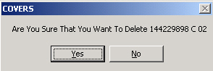

1. COVERS requires that folder volumes be deleted sequentially from highest to lowest.  If the last volume is not being deleted, COVERS will inform the user that earlier volumes must also be deleted, and will allow you to specify a lower bound for volumes to be deleted on the Select Volumes screen.

**Note:**  Volume 1 of a CLAIM folder may not be deleted if BIRLS shows that it is currently at the users station.  If a NOD folder is deleted, the NOD folder will be deleted from BIRLS when a CLAIM and NOD folder are shown at the same location.

# Folder Inquiries

## Single Inquiry

The Single Inquiry function allows the user to find a folder using the folder's file number.  If the file number is not known, but the name and/or Social Security number are, the folder may be located by using the Name/SSN Inquiry function.  For instruction on how to perform a single inquiry, see Performing A Single Inquiry.

## Performing A Single Inquiry

**Note:**On the Single Inquiry screen, if the folder has been Temporary Transferred Out (TTO) to your site, then you can use the **Send TTO Back** button to return the folder back to the site that sent it to your station.  This functionality can also be done from the **Transfer Out** button on the Main Menu.

**Note:**  If a folder has been rebuilt, a message indicating "Rebuilt Folder" will be displayed.

### To perform a Single Inquiry

1. Select the Folders **Single Inquiry** button on the COVERS Main Menu.  The *Enter Folder Identification (Inquire Single Folder)* dialog will appear.
2. Enter the file number, or scan the label on the folder.  If scanning, remember that the cursor must be in the file number field before scanning.  If scanning, skip to step 6.
3. Select the folder type.  This will default to CLAIM if left blank.
4. Select the volume number.  This will default to 1 if left blank.
5. Select the **OK** button (to continue Inquire Single Folder process), **Clear** button (clears current entry), or **Main Menu** button (to cancel Inquire Single Folder process and return to the COVERS Main Menu).
6. If COVERS is able to locate the folder, the Display Folder Data window will appear (see Display Folder Data).

If the file cannot be located, COVERS will display a brief message explaining that the search failed.  If the file number is valid, but the file does not exist in COVERS, the user will be able to perform a BIRLS Location Inquiry to look for the folder at other sites.

## Name/SSN Inquiry

The Name/SSN Inquiry function allows the user to search for a folder if the name and/or Social Security number are known, but do not know the file number.  COVERS will construct a list of all matching folders, and folder may be searched from the list.  If the file number is known, use the Single Inquiry function.

To performing a Name/SSN Inquiry

1. Select the Folders **Name/SSN Inq** button on the COVERS Main Menu.  The Folder Inquiry window will appear.
2. Select the INQUIRY TYPE.  Search by Name or by SSN.
3. Enter the search criteria.  Partial names are allowed; the last name is usually sufficient, although with common names, the resulting list may be very long.
4. Select the **OK** button to initiate the inquiry, or the **Main Menu** to cancel the inquiry and return to the Main Menu.
5. COVERS will display the search results.

* If COVERS is able to locate only a single matching folder, the Display Folder Data window will appear.
* If no matching folders can be located, COVERS will display a brief message explaining the search failed.
* If more than one match is found, COVERS will present a list of matching folders.  Select the folder and click the **OK** button.  The Display Folder Data window will appear.  The folder list contains a limited number of records (current limit is about 150 records).
* If more records are currently available, select the **Next** button to retrieve the next group of records .

**Note:**  If a folder is sensitive, an alert will be displayed at the bottom of the screen indicating "This folder is a Sensitive Folder."

1. Select the **Prev Screen** button on the Display Folder Data window to return to the list of search results.  Select another record to examine.
2. Select the **Prev Screen** button to perform another Name/SSN Inquiry, or **Main Menu** button to return to the Main Menu.

# Folder Requests and Mail Searches

## Overview

**Note:**  These functions apply to folders within your RO that are not at your location.

Users may issue search requests for a folder from the current User Location order to attach mail ("M" search request), or for other reasons such as claim processing ("O" search request).  By selecting Request on the Main Menu, the user may issue "O" search requests; by selecting Mark Folder for Mail on the Main Menu, the user may issue "M" search requests.  Both types of search requests are recorded and maintained in the COVERS database.  Mail search requests remain on the database until manually deleted by a user.  Folder search requests may be deleted manually by a user, but they are also deleted dynamically by the system when the folder being searched for is received at the location that issued the "O" search request.  Manual deletion of search requests may be done by a single search request or in bulk.

Some processes refer to "B" searches.  This is not a search type maintained in the database, but rather a way for the user to indicate that some processing is to be done for folders which have both "M" and "O" searches issued by the same location.

A unique search for a folder is defined by search location and search type.  Duplication search requests are not stored on the database.  If a process attempts to create a search for a folder, and a search of the same type issued from the same location exists for the folder, the current search it not issued.

Access to the Request Folder process is available to all users, however SO users must have POA authority for a folder in order to request it.  SO users are denied access to all other folder search activities except that they may delete their own folder search request.  All other users are granted access to all search processing unless explicitly denied through CSS.

If the folder you are looking for is not at your location, you may wish to have it brought to you, or you may wish to associate mail with a folder that you do not have.  For these situations, COVERS provides the following functions:

* Mark for Mail
* Request
* Change/Delete

## Folder Requests and Mail Searches

**Note:**  Each RO will have its own procedures for responding to folder and mail searches.  In most cases, there will be clerks who will user a Search List report to physically locate folders which have associated searches.

Mark For Mail:  Use this function to inform COVERS that there is mail to attached to a folder.  When the folder is received at any location, the recipient will be notified that there is associated action, mail via Info/Error Messages on the Main Menu.

Request:  Use this function to request that a folder be sent to the user's location.

Change/Delete:  Use these functions to delete or reassign searches.

## Mark For Mail

Use this function to inform COVERS that there is mail to attach to a folder.  If a folder marked for mail is received, the user will be notified that there is action mail for the folder.  Use local office procedures to associate the mail with the folder Mark Folder For Mail.

## Mark Folder For Mail

Use this function to inform COVERS that there is mail to attach to a folder.  If you receive a folder marked for mail, you will be notified that there is action mail for that folder.  Use local office procedures to associate the mail with the folder.

**Note:**  Because COVERS does not actually associate mail with a folder, the user who attaches the mail must delete the corresponding mail search from COVERS using the Search **Change/Delete** function.  COVERS allows folders to be marked as needing mail to be attached.

**To mark a folder for mail**

1. Select the **Search Mark For Mail** button on the COVERS Main Menu.  The *Enter Folder Identification* (Mark Folder For Mail) window will appear.
2. Enter the file number for the folder, or scan the label on the folder.  If scanning, remember that the cursor must be in the file number field.  If scanning, skip to step 6.
3. Select the folder type.  This will default to 'CLAIM' if left blank.
4. Select the volume number, if applicable.  This will default to '1' if left blank.
5. Select the **OK** button to continue the process, **Clear** button to clear the current entry, or **Main Menu** button to cancel the process and return to the Main Menu.
6. COVERS will initiate the mail search (search type "M").  If the mail search cannot be established, one of the following problems may have occurred:

* The folder may already be at the location.
* The folder may be PTO; mail searches are not allowed.
* There may already be a search from this location.
* If the user is a SO, access to this function is not allowed.

## Request

Use this function to request a folder be sent to the user's location.  If a folder with a folder search is received, the user will be notified that a request has been made.

This process establishes a search request for a folder indicating that the user requires the physical folder for reasons other than for attaching mail.  The Enter Folder Identification screen is displayed and the user enters a folder number and an option priority.  Data entered on the screen is validated, and if no errors are found, a folder search request ("O") is issued for the folder from the current user location and is recorded on the database.  Various messages may be displayed about the status of the folder as it relates to search request establishment.

All users have access to this process, however, a SO user may not issue a search request for a folder for which they do not have POA authority.

**Folder Access Restrictions**

COVERS enforces a type of access restriction that may prevent the user from retrieving information on a folder.

* Service Organization (SO) users must have power of attorney (POA) recorded in COVERS for a folder in order to retrieve information through a folder inquiry.  If an SO user does not have a POA, if the folder has multiple POAs, or the folder contains restricted data, the inquiry will be denied.  These will be logged in the unauthorized messages.

This function is also available from the Display Folder Data screen for the Inquiry functions.  See Request A Folder

## Request A Folder

**To request that a folder be sent to your location**

1. Select the Search **Request** button on the COVERS Main Menu.  The Enter Folder Identification (Request Folder) window will appear.
2. Enter the file number for the folder.
3. Select the folder type.  This will default to 'CLAIM' if left blank.
4. Select the volume number.  This will default to '1' if left blank.
5. Select a priority code if desired.  If your RO has not assigned any priority codes, this field will not be available.
6. Select the **OK** button to continue the process, **Clear** button to clear the current entry, or **Main Menu** button to cancel the process and return to the Main Menu.
7. COVERS will initiate the folder search (search type "O").  If the search request was rejected, one of the following problems may have occurred:

* The folder may already be at the users location.
* The user may have already issued a search request for this folder.
* You do not have POA for the folder.
* The folder contains restricted material.
* The folder has multiple POAs.
* The folder may be PTO; folder searches are not allowed.

## Change/Delete

The Change/Delete Search screen is the entry point to all processes that involve deleting or reassigning search requests.  When this screen is displayed, all processes that the user may not access are grayed out.  From this screen, the user selects the process desired, and the appropriate command is performed.

Authorized non-SO users have access to these functions.  Authorized SO users have access only to the "Delete Search for a Single Folder" function and may only delete their own searches.

**To get to the Change/Delete Search menu**

* Select the Search **Change/Delete** from the COVERS Main Menu.  The following functions apply:

Delete Search For A Single Folder

Delete Search For A Specific Criteria

Delete Mail Search In Bulk

Re-assign Search

## Delete Search For A Single Folder

This function allows the user to cancel a search for a single folder.  To cancel a set of searches matching a specific set of criteria, use the Delete Search For A Specific Criteria function.

This process allows users to delete mail and/or folder search requests for a particular folder.  Users are granted access to this process by the Delete Search for Single Folder indicator in CSS under Application Operations.  Access to this process enables non-SO users to delete mail and folder search requests issued from the current User Location.  SO users may delete mail or folder search requests issued from other locations, and is granted only to non-SO users by the Generic Delete Mail/Request Search for Single Search indicators in CSS under Application Operations.

**To delete a request for a single folder**

1. Select the **Delete Search For A Single Folder** on the CHANGE/DELETE SEARCH menu.  The Enter Folder Identification (Delete Search for a Single Folder) window will appear.
2. Enter the file number for the folder, or scan the label on the folder.  If scanning, remember that the cursor must be in the file number field.  If scanning, skip to step 6.
3. Select the folder type.  This will default to 'CLAIM' if left blank.
4. Select the volume number.  This will default to '1' if left blank.
5. Select the **OK** button to continue the process, **Clear** button to clear the current entry, or **Main Menu** button to return to the Main Menu.
6. If COVERS was unable to locate the file, there are no searches for the file, or there are no searches the user is authorized to delete, COVERS will display a brief error message.  Otherwise, the user will be presented with a list of all active searches for which delete authority is available.
7. Select the search or searches to be deleted.  Use CONTROL+CLICK or SHIFT+CLICK to select a collection of searches.  Select the **Clear** button to clear the selections.  Select the **Delete** **All Searches** button to delete all listed searches.
8. Select the **OK** button to continue the process, **Clear** button to clear the current entry, or **Main Menu** button to return to the Main Menu.
9. The user may also delete a request for a single folder from the Single Inquiry Screen.
10. Select the **Single Inquiry** button.  Type or scan in the file number.  A search message will be displayed if there is a search for the file.  The Folder Data screen will display.
11. Select the Search tab.
12. Select the **Delete Search** button.

## Delete Search For A Specific Criteria

This function allows the user to cancel a set of searches matching specific criteria.  To cancel a search for a single folder, use the Delete Search For A Single Folder function.

Non-SO users are granted access to this function through CSS.

**To delete a request for a set of folders matching specific criteria**

1. Select the **Delete Search For Specific Criteria** button on the Change/Delete Search menu.  The Specify Search Criteria (Delete Search for Specified Criteria) window will appear.

**Note:**  Sets of default values are shown in several of the option fields.  These defaults are for selecting all searches for all dates.  If the user does not wish to further specify the search criteria, skip to step 6.  Notice that the default values for the folder locations and search locations are "ALL".  The default TD range is 00-99 (all TDs) and the default for search dates is blank (indicating that there are no restrictions; therefore, all dates are used).  In addition, both "M" and "O" search types are indicated.

**Note:**  If the user selects the **OK** button without changing any default values, all searches will be deleted!

1. To limit the criteria to specific search locations, select a search location from the pull-down menu.  Locations that cannot issue searched will not be shown in the selection box.  This includes the location BICO, TRANS and LNF.
2. Select TD range if default range is not correct.
3. Specify search date range if desired.  Date format is MM/DD/YYYY.  The user may select the **Clear Dates** button to clear any date range entered to correct errors.
4. Select search types if the default is not correct.  At least one search type must be selected.
5. Select the **OK** button to submit the request, **Prev Screen** to return to the previous screen, or **Main Menu** to return to the Main Menu.
6. COVERS will issue a request to locate and delete all search requests meeting the selected criteria.  The request will be processes after hours.  COVERS will notify the user of the results via Info/Error Messages on the Main Menu.

**NOTE:**  If selecting the OK button without changing any default values, all searches will be deleted!

## Delete Mail Search In Bulk

This function allows the user to cancel a number of mail searches issued by a location in a single batch.

Non-SO users are granted access to this function by the 'Delete Mail Search In Bulk' indicator in CSS under Application Operations.

**To delete mail searched in bulk**

1. Select the **Delete Mail Search In Bulk** button on the Change/Delete Search menu.  The *Delete Main Search In Bulk* window will appear.
2. Enter or scan the file number for the folder.
3. Select the folder type.  This will default to 'CLAIM' if left blank.
4. Select the volume number.  This will default to '1' if left blank.
5. Select the **Enter** button to add this folder to the deletion list.
6. Repeat steps 2-4 until the list is complete.  Up to forty folders may be selected.  Select the **Clear** button to clear all entries from the deletion list or clear a single entry by double-clicking the entry.  This does not delete the mail search; it simply clears the entry or entries.
7. Select the **Delete** button to delete mail searches for all folders on the list, **Cancel** button to return to the previous screen, or **Main Menu** to cancel and return to the Main Menu.
8. A completion message will be received for each folder.

## Re-assign Search

This function allows the user to reassign searches from one location to another.  For example, if a clerk is absent for a period of time, it may be necessary to shift the clerk's outstanding searches to another location for completion.

Non-SO users are granted access to this function by the 'Del Search For Special Cr' indicator in CSS under Application function.

**To re-assign Search**

1. Select the **Re-assign Search** buttonon the Change/Delete Search menu.  The *Re-Assign Search* window will appear.
2. Select a 'From' location from the pull-down menu.  Up to four 'From' locations may be selected for re-assignment.  Double-click on a 'From' location in the 'Search Reassignment' panel to remove it.
3. Select a single 'To' location for the re-assignment.
4. Both the 'From' and 'To' locations will only include locations that may issue searches.  This does not include BICO, TRANS and LNF.
5. Select the **OK** button to issue a request for the re-assignment, **Cancel** to return to the previous screen, or **Main Menu** return to the Main Menu.
6. COVERS will submit a background job that will execute after normal working hours.  Results notification will be received via Info/Error Messages in the Main Menu.

## If COVERS could not locate your folder...

If COVERS could not locate the folders, one of the following issues may have occurred:

**Trying to receive volume 2-99 of a multi-volume folder**

* If COVERS knows about this folder, the option of adding the next volume and registering it at your location will be available.
* If COVERS *does not* know this folder, an error is assumed.  Receipt of volume 1 must occur and then the processing will take place.

**Trying to receive a single-volume folder or volume 1 of a multi-volume folder**

* Ensure the current folder number is entered.
* The folder type may have been incorrectly specified.  If so, retry the inquiry with a different folder type.
* If the information entered is correct and COVERS cannot locate the folder, attempt to add the folder from BIRLS.  If the folder is found in BIRLS, both BIRLS and COVERS will be updated to reflect the folder's location.  If BIRLS cannot locate the folder, this indicates that there is no electronic record of the folder, which will generate an error.

**If the file number is a canceled file number**

* A message indicating the new file number will be received.  The folder will not be added or received.

**If the file number is a duplicate file number**

* A message indicating the other file number/SSN will be received.  The folder will not be added or received.

**Note:**  Before adding a folder from BIRLS, be sure that the correct file number was entered.  A mistyped file number may accidentally identify a valid folder in BIRLS, which would cause an incorrect location update.

## Folder Access Restrictions

If COVERS could not locate your folder, you will receive a message that the folder could not be found.

* Ensure that you have entered the current folder number.
* You may have incorrectly specified the folder type.  If this is the case, you may re-try the inquiry with the correct file number, folder type and volume.

COVERS enforces two types of access restrictions that may prevent you from retrieving information on a folder.

* Service Organizations (SO) users must have power of attorney (POA) recorded in COVERS for a folder in order to retrieve information through a folder inquiry.  If an SO user does not have POA, *or* if the folder has multiple POAs, the inquiry will be denied.
* Some folder are marked as *Sensitive* and have an associated access restriction level from zero to nine, with nine being the highest level of sensitivity.  COVERS users are assigned an access level, also from zero to nine.  This is how COVERS determines whether or not you may access a sensitive folder.  If your access level is lower than the sensitivity level of the folder in question, your inquiry will be denied.

# BIRLS Functions

## BIRLS Functions

COVERS allows limited access to BIRLS as follows:

Location Inquiry:  Use this function to access information on the location of folders listed in BIRLS.

Loc Correction:  Use this function to notify BIRLS that a folder's location must be updated.  Perform this operation only if the COVERS location is known to be correct.

## Location Inquiry

**To perform a BIRLS folder inquiry**

1. Select the **Location Inquiry** button on the COVERS Main Menu.  The *LOCATION INQUIRY* window will appear.
2. Enter the file number or SSN for the folder.  If the file number entered is a canceled file number, a message will be displayed indicating what the retained file number is.  This file number will be required to issue the request.
3. Select the **OK** button to continue, or **Main Menu** button to cancel and return to the Main Menu.  If matching folders were found in BIRLS, COVERS will display the locations in the BIRLS folders panel.  If no matching folders were found, COVERS will display a brief message indicating why.
4. Return to step 2 to perform an additional inquiry, select **Prev Screen** to return to the previous screen or **Main Menu** to return to the Main Menu.

**Note:**  The Location Inquiry will be displayed automatically if a Single Inquiry fails and the user asks COVERS to submit a BIRLS Inquiry.

1. You may return to step 2 if you wish to perform an additional inquiry, or select the **Main Menu** or **Prev Screen** button to exit.

## Loc Correction

**To perform a Location correction (from the Main Menu screen)**

1. Select the BIRLS **Loc Correction** button on the COVERS Main Menu.  The *Enter Folder Identification (Location Correction)* window will appear.

**Note:**The Station of Jurisdiction (SOJ) will be updated to reflect the new station.

1. Enter the file number for the folder, or scan the label on the folder.  If scanning, the cursor must be in the file number field.  If scanning, skip to step 5.
2. Select the folder type.  This will default to 'CLAIM' if left blank.
3. The folder volume will default to '1'; BIRLS does not track volumes.

**Note:** When a location correction is performed and there is pending work, the user will received a message Stating "All pending claims at {RO} will be transferred to your station."

1. Select the **OK** button to continue, **Clear** to clear current entry, **Prev Screen** to return to the previous screen, or **Main Menu** to return to the Main Menu.

* If COVERS is able to locate the folder at the user's station, it will update BIRLS to reflect the RO as the file's actual location.  Following the BIRLS update, the record will also be updated in BDN via subsequent batch processing.
* If the file cannot be located, COVERS will display a brief message explaining why the search failed and indicate that BIRLS was not updated.
* If BIRLS located the file at the user's COVERS station, a message indicating that the BIRLS location is correct and does not require updating will be received.  BIRLS transfer data (in transit date, transfer to station, etc.) will not be blanked out.

**To perform a Location Correction (from the Display Folder Data screen)**

1. Select **BIRLS Location Correction**.

* If COVERS is able to locate the folder at the user's station, it will update BIRLS to reflect the RO as the file's actual location.  Following the BIRLS update, the record will also be updated in BDN via subsequent batch processing.
* If the file cannot be located, COVERS will display a brief message explaining why the search failed, and indicate that BIRLS was not updated.
* If BIRLS locates the file at the user's COVERS station, a message indicating that the BIRLS location is correct and does not require updating will be received.  BIRLS transfer data (in transit date, transfer to station, etc.) will not be blanked out.

# Generating and Printing Folder Labels

## Generating and Printing Folder Labels

One of the most convenient features of COVERS is its ability to read folder labels using a barcode reader, such as a light wand or scanner gun.  The utility to print the labels is built right into COVERS.

All of the COVERS screens titled "Enter Folder Identification" allow you to enter folder numbers using a barcode reader attached to your computer.  Using the barcode reader will make it easier to process folders in COVERS by automating the entry of folder numbers.

COVERS allows the generation of labels whenever folders are added, when changes occur that affect the content of the label, or when specifically requested by the user.

**Note:**  SO users are not allowed access to this function.

Covers provides two ways to generate folder labels:

* Qk Print:  This function is available on the Toolbar after you receive a folder, transfer in a folder, or add a volume to a folder.  This function allows you to print a single label quickly and easily, at the time when you are most likely to need one, and is the most commonly used.
* Queued Printing:  The Generate Labels and Print Labels functions allow the printing of multiple labels in batch, and also allows generation of single labels.

Generate Labels

Print Labels

## Generate Labels

Use this function to queue as many labels as desired.  COVERS will generate the label and keep them in the queue for later printing.  For help on how to generate labels, see Generating Labels

**Note:**  BICO transactions (i.e., BIRLS actions that cause automatic updates in COVERS) will in some cases generate new labels automatically.

## Generating Labels

**To generate folder labels**

1. Select the Labels **General Labels** button on the Covers Main Menu.  The *Enter Folder Identification (Generate an Additional Label)* window will appear.
2. Enter the file number for the label to create, or scan the label on the folder.  (Only scan a label if attempting to duplicate the label).  If scanning, the cursor must be in the file number field.  If scanning, skip to step 6.
3. Select the folder type.  This will default to 'CLAIM' if left blank.
4. Select the volume number.  This will default to '1' if left blank.
5. Select the **OK** button to continue, **Clear** button to clear the current entry or **Main Menu** button to return to the Main Menu.
6. If COVERS is able to locate the folder, the label will be generated.  The user may continue to generate additional labels and then use the Print Labels function to print all queued labels.

## Print Labels

Use this function to print any or all queued labels on your barcode printer.  For help on how to print or generate labels, see Printing Labels

**Note:**  BICO transactions (i.e., BIRLS actions that cause automatic updates in COVERS) will in some cases generate new labels automatically.

## Printing Labels

**To print folder labels**

1. Select the **Print Labels** button from the COVERS Main Menu.  The *Label Print* window will appear.
2. Several things occur in the background when using the Label Print screen.  First, all labels older than the deletion criteria are removed from the system.  Second, BICO transactions that have generated labels (TARGET updates, for example) will be automatically retrieved into COVERS.
3. Choose the label source and select COVERS to print labels generated using the Generating Labels function.
4. Select BIRLS to print labels that have been queued automatically from BICO transactions.
5. Select print options:

* *Print All Pending Labels:*  Print all COVERS or BIRLS labels in the queue that have never been printed.  There may be a brief pause while COVERS checks and retrieves labels from BIRLS.
* *Print All Pending From Current Location*:  Print labels generated from the current user location (not available for BIRLS labels).  A special header and trailer label will be generated that indicates the location selected.
* *Print Selected Labels*:  All labels (printed and un-printed) will appear in the box titles "Selected Labels to Print".  Click on label record to select it, SHIFT+CLICK to select a range of records, or CTRL+CLICK to select a discontinuous collection of records.  To un-select a specific record, CTRL+CLICK the record.

1. Select the **OK** button to print the chosen option, or **Main Menu** to return to the Main Menu.  BIRLS/COVERS labels will be printed by file number with TD sequence.
2. COVERS will notify the user of how labels were sent to the printer.  If labels were not printed successfully, select **Print Selected Labels** and continue with step 8 below.
3. Select **Print Selected Labels** button.  Select the label records to re-print from a list of records for first time printing requests.

**Note**:  Each time the print options are changed, COVERS will automatically determine if there are any records that match the criteria selected.  If none exist, a notification message will be received.

## Using QK Print

The simplest way to manage labels is to generate one each time you add a claim volume, receive a folder, or transfer in a folder with a missing or damaged label.  To do this, you can use the QK Print function, which is available on the Toolbar immediately after receiving a folder, transferring in a folder, or adding a volume to a folder.

**To use QK Print**

1. Select the **QK Print** button from the Toolbar.

Covers will print a label for the folder just received, transferred in, or the volume just added.  If the **QK Print** button is unavailable and you need a label, use the Queued Label functions:  Generate Labels and Print Labels.

# Transferring Folders

## Transferring Folders

The transfer process involves three steps:

* Any RO issues a folder transfer request for the desired folder (for additional help, see Request Transfer function.)
* The sending RO performs a Transfer Out function and ships the folder to the requesting RO.
* The receiving RO performs a Receive Folder function after the folder arrives.

There are two types of folder transfers supported by COVERS.  A ***permanent*** transfer is used when a folder is moving from one RO to another and will remain at the receiving RO until requested again.  A ***temporary*** transfer is used when a folder is moving from one RO to another facility, but will be returned to the original facility, and due back by a user specified date.  Temporary transfers are not initiated by a transfer request.

COVERS allows the creation of a Temporary Claim Folder.  The user may create a Temporary Claim Folder when the Original Claim folder is temporary transferred to another station/facility.  The Temporary Claim Folder may only be tracked at the station having permanent jurisdiction.

The following functions apply in this section:

Request Transfer

Transfer Out

Print Transfer Slips

## Track a Folder Transfer

Folders may be tracked through a Folder Transfer.  The following explanation is a scenario of the tracking process:

You are in the Jackson RO and need a folder for Mr. Green.  Not knowing the folder number, you use Mr. Green's SSN to find his folder with a Location Inquiry.  Looking at the *Location Inquiry* screen, you see that the folder is in Chicago.  To request a permanent transfer, you use the 'Transfer Request' by going through the *Single Inquiry* function and are notified that the request has been issued.

Meanwhile, in Chicago, the clerk at the transfer desk receives a message that there is a transfer request.  The clerk respond to the COVERS transfer request by using the 'Transfer Out' function and puts the folder in the mail.  COVERS supplies transfer slips to affix to the folder.  Or, the clerk may deny the transfer request.

When the folder arrives a few days later, the Jackson RO will receive it by using the 'Receive' function off-site folder option.  COVERS records the transfer information so that anyone viewing folder information will know that the folder is not in Jackson.

## Request Transfer

Requesting a folder involves three steps:

1. Identify the folder needed using *Location Inquiry*.
2. Request the transfer.  All transfer requests are for permanent transfers.  A COVERS transfer request may not be issued for a temporary transfer.  Temporary transfer requests will be made informally by RO personnel directly via telephone or email.  Consult the RO supplement for more information.
3. Receive the folder when it arrives, or acknowledge the transfer refusal, if the transfer was refused.

**To request a folder transfer**

1. Select the Transfers **Request Transfer** button from the COVERS Main Menu.  The *Enter Folder Identification (Inquire Single Folder)* window will appear.
2. Enter the file number for the file to transfer.  If the file number entered is a canceled file number, a message will be displayed stating what the retained file number is.  This number will be used to issue the request.
3. Select the **OK** button to continue, **Clear** to clear the current entry, or **Main Menu** to return to the Main Menu.
4. If the folder was located, the *Display Folder Data* window will appear.  COVERS will display information on this folder from BIRLS (located under the BIRLS Information heading).
5. Select the **Transfer Request** button to submit the transfer request, **Prev Screen** to return to the previous screen, or **Main Menu** to return to the Main Menu.
6. A COVERS message will be displayed, advising that the request has been sent to the station with the file jurisdiction.  Select the **OK** button.
7. Select the **Prev Screen** to return to the previous screen, **Main Menu** to return to the Main Menu, or **Exit** to exit COVERS.

**Note:**  If you have mistakenly requested a folder, you now have the opportunity to delete your erroneous request by simply pressing the **Delete Request** button.

## Acknowledging a Transfer Request Response

When the transfer clerk receives your request, they will normally proceed with the transfer.  If the transfer is refused, COVERS will send you a message indicating that the requested transfer has been refused and a reason for the refusal.  You must manually delete this COVERS message.

COVERS will notify you of the message with a chime and a yellow indicator light on the **Folder Request Responses** button in the Message panel of the Main Menu.

**To respond to a Transfer Request Refusal**

1. You must be the location that issues the request to see the request response.
2. From the Main Menu, select the **Folder Request Responses** button.  The Folder Request Responses window will appear.  If this option is unavailable, you have no folder request responses waiting.
3. Select any or all responses to be deleted.
4. Select the **Delete** button to remove the responses, or select **Prev Screen** to cancel.
5. Responses are shown in groups of 20.  Use the **Previous/Next** buttons to request the previous/next group of messages.  Use the scroll bars to move within a group of messages.

## Transferring a Folder to Another RO

* If the transfer is due to a COVERS transfer request, you will want to read the request using the Folder Requests Your Station function.
* Determine whether to refuse or comply with the transfer request.
* To refuse the request, refer to "Responding to a Transfer Request".
* To comply with the transfer request, perform the following steps:

1. Issue a local search for the folder to determine at which location the folder resides.  This step may not be necessary.

**Note:**  It may be necessary to receive the folder at your location to perform a local transfer.

1. After locating the folder, use the Transfer Out function to notify COVERS of the transfer.  Print out transfer slips as required at your RO.
2. Mail the folder

**Responding to a Transfer Request**

COVERS will notify you of transfer requests with a chime and a yellow indicator light on the **Folder Requests Your Sta** button in the Messages panel of the Main Menu.  Only the TRANS location will receive such requests.

1. Change to the TRANS location.  Only a PA or SC user, or a user with BICO/TRANS authority, can do this.
2. From the Main Menu, select the **Folder Requests Your Sta** button.  The Folder Request window will appear.  If this option is unavailable, you do not have folder request responses waiting.
3. The normal action will be to issue a permanent transfer of the requested folders and ship the folders to the requesting ROs.  In this case, there is no need to perform any explicit action on the folder request message (COVERS handles it automatically when the transferred folder is received at the requesting station).  If all transfer requests are to be honored, then skip to the next section on "Initiating a Permanent Transfer Request."
4. If any of the transfer requests must be denied, then select folder for disposition.  Folders that have been requested from another station appear in the right list box.  These requests are displayed in the file number within TD sequence.  Six hundred requests are returned to the screen at one time.  To see the next group of 600, use the **Next** button.  (For RMC, the requests are in file number within double TD sequence).  You must indicate a disposition.  You may select several requests at a time.
5. Select the **Submit** button.  All folder request responses for selected requests will be sent to the requester.

## Station of Jurisdiction (SOJ)

**Permanent Jurisdiction Requirements**

1. A permanent jurisdictional change in COVERS shall update the SOJ in COVERS in Corporate, Share, MAPS, Vetsnet Award, and FAS.
2. A permanent jurisdictional change in COVERS shall update the SOJ in Corporate, Share, MAPD, Vetsnet Award, and FAS when one of the following occurs:

* On a Permanent Transfer Out (PTO), but only when the claim folder is received in at the "new" Regional Office. (Transaction 23 is generated and sent to BIRLS)
* When a BIRLS station location update is performed.
* A Permanent Transfer In (PTI) is performed in COVERS by the RO that requested the permanent transfer of the folder.
* When there is no pending transfer and a folder is "Surprise Received" in through COVERS by a Regional Office.

1. Surprise Receives performed by Non-RO locations shall not update the permanent SOJ in Corporate, BIRLS, pending claims in BDN/SHARE, MAPD, FAS or Vetsnet Award.
2. When BIRLS and COVERS show different Stations of Jurisdiction, the SOJ will not be updated.
3. All pending claims established at the old SOJ will be update with the new SOJ.
4. Pending claims established at another station other than the old SOJ will not be affected.

**Temporary Station of Jurisdiction**

1. Temporary Station of Jurisdiction (SOJ) will be changed when a folder is received into a station via Brokered Work Temp Transfer.
2. When a folder is transferred back to the original transferring station, the SOJ will be changed back to reflect that station, if it is Brokered Work.

## Transfer Out

Transferring a folder involves these steps:

1. If the transfer is due to a COVERS transfer request, read the request using the 'Folders Requests Your Sta' function.
2. Determine whether to refuse or comply with the transfer request.
3. To refuse the request, refer to Folder Requests Your Station.
4. To comply with the transfer request, complete the following steps:

* Issue a local search for the folder to determine at which location the folder resides.  (This step may not be necessary.)
* After locating the folder and receiving it at the location (if it was necessary to perform a local transfer), use the Transfer Out function to notify COVERS of the transfer.
* Print out transfer slips as required at the RO.
* Mail the folder.

## Create Transfer Slip

Select the 'Yes' or 'No' option to create transfer slips.  This option will automatically default to 'Yes'.

To change this option to 'No' permanently, the System Administrator must log into CSS.

## Print Transfer Slips

**Printing Transfer Slips**

When the user is ready to print transfer slips, return to Main Menu.

1. Select the **Print Xfer Slips** button.  This function will only print slips that the user has generated.

**Note:**  There are two types of slips (Permanent and Temporary).  Temporary transfer slips will print before permanent transfer slips.

**Note:**  The number of transfer slips that print depends on the number of copies specified in the RO Options screen.  In addition, the office may have specified creating an extra slip for folders with POA.

There are several print options:

* **Print all pending**: This option will allow printing of all un-printed Transfer Slips the user has generated.
* **Print selected**: This option will allow reprinting Transfer Slips.  Depending on the parameter set for XferDeleteDays in the covers.ini, the transfer slip may not be available.

1. Choose the types of slips to print: Permanent or Temporary.
2. Choose the printing option: Print All Pending or Print Selected.
3. Select the **OK** button.  A message box will appear stating, "Printing Records".  When the printing is complete, the specified slips will be on the designate printer.

**Note:**  If all of the specified slips did not print correctly, use the Print Selected option.

**Re-printing Transfer Slips**

1. Select the 'Print Selected' button.
2. Choose the Transfer Slips to be reprinted and select the **OK** button.  Slips will be printed in the order that they were selected.

## Receive

**Receiving Folders From Other RO's**

The Receive function is used for folders that have been transferred in from another RO on a permanent transfer.  For folders that have been sent to your location from another location inside your RO, use the Receive function from the Main Menu.

Because COVERS relies on these transactions to track the location of folders, it is vitally important that the Receive function is used immediately when transferring in a folder.  Otherwise, other users may be given incorrect information.

**To Receive Folders at Your Location**

1. Select the **Receive** button from the COVERS Main Menu.  The *Enter Folder Identification (Receive)* dialog will appear.
2. Select the folder type.  This will default to 'CLAIM' if left blank.
3. Enter the file number, or scan the label on the folder.  If scanning, the cursor must be in the file number field.  If scanning, skip to step 6.
4. Select the volume number.  This will default to '1' if left bank.
5. Select the **OK** button.
6. COVERS will be updated to reflect the location of the folder.  If the folder could not be located, COVERS will provide a brief message explaining the reason.
7. If the folder is not in COVERS, the user will be asked to add the folder from BIRLS.

**To Receive Multi-Volume Folders**

When receiving multi-volume folders arriving as a permanent transfer, Receive must be completed on each folder volume separately.  For example, if the user transfers in a claim folder that contains four separate volumes (volumes 1-4), each folder must be received.  Once all volumes have been received into the office, the individual volumes may be sent to different locations within the office.

## Receiving Multi-Volume Temporary Transfers

**To receive Multi-Volume Temporary Transfers at your location**

When receiving multi-volume folders that arrive as a Temporary transfer, each folder volume must be received separately.  For example, when receiving a claim folder that contains four separate volumes (volume 1-4), follow the instructions Receiving Folders At Your Location, one for each volume.  Once all volumes have been received into the office, the individual volumes may be sent to different locations within the office.

## Expected Return Date

Expected Return Date is available only when doing a Temporary Transfer.  This date is eight characters and is **required**.  It must be entered in the format mm/dd/ccyy, and must be greater than the current date but less than 2 years.

## Initiating a Temporary Transfer of a Folder

**To initiate a Temporary Transfer of a Folder**

**Note:**  COVERS requires a NOD folder to be consolidated with the Claim folder before it can be transferred out or received.  If a NOD and Claim folder both exist, COVERS requires the folders to be consolidated before it can be transferred out.

1. Select the Transfers **Transfer Out** button on COVERS Main Menu.  Then *Enter Folder Identification (Transfer Folder)* dialog will appear.
2. Enter the file number, or scan the label on the folder.  If scanning, skip to step 4.
3. Select the folder type.  This will default to 'CLAIM' if left blank.

**Note:**  The volume does not need to be entered, as all volumes will be transferred.

1. Select Temporary transfer type.
2. Select **OK** to continue, **Clear** to clear the current entry, or **Main Menu** to return to the Main Menu.  If COVERS is able to locate the folder, it will display the Transfer Folder (Temporary) dialog.
3. Specify Routing information, Expected Return Date, and Remarks (if desired).
4. Specify Expected Return Date.  This field is required.
5. Select an RO or another facility from the Transfer To list.  If the desired facility is not on the list, select :999: and then hand correct the transfer slip after it is printed.
6. Specify whether to Create a Transfer Slip.  It will default to "Yes".
7. If the folder is to be Brokered Work, select the check box.
8. Select the **OK** button to initiate the transfer.  Now follow standard office procedures for mailing the file to its final destination.

**Note:** If the folder is transferred as a 'Brokered Work Transfer', the transfer slip will be marked as 'Brokered Work'.

* Temporary Station of Jurisdiction (SOJ) will be changed when a folder is received into a station via Brokered Work Temp Transfer.
* When a folder is transferred back to the original transferring station, the SOJ will be changed back to reflect that station, if it is Brokered Work.

**If COVERS could not locate your folder...**

If COVERS could not locate your folder, there are several possible reasons, each with its own resolution procedure.

* Ensure the current folder number is entered.
* The folder type may have been incorrectly specified.  If this is the case, retry the inquiry with a different folder type.
* If the information entered is correct and COVERS cannot locate the folder, attempt to add the folder from BIRLS.  If the folder is found in BIRLS, both BIRLS and COVERS will be updated to reflect the folder's location.  If BIRLS cannot locate the folder, this indicates that there is no electronic record of the folder, which generates an error.

**Note:**  Before adding a folder from BIRLS, be sure the correct file number was entered.  A mistyped file number may accidentally identify a valid folder in BIRLS, which would cause an incorrect location update.

## Permanent Transfer of a Folder

Generally, a folder transfer will be made in response to a transfer request.

**Note:**  When a station permanently transferred out (PTO) a folder, they will no longer be able to create a Temp folder.

**To initiate a permanent transfer of a folder**

1. Select the **Transfer Out** button under Transfers on COVERS Main Menu.  The Enter Folder Identification (Transfer Folder) dialog will appear.
2. Enter the file number for the folder you are transferring, or scan the label on the folder.  If you use the scanner, skip to step 4.
3. Select the folder type.  This will default to 'CLAIM' if left blank.
4. Note that the volume number does not need to be entered as all volumes will be transferred.
5. Select Permanent transfer type.
6. Select the **OK** button to continue, **Clear** (Clears current entry), or **Main Menu** (Return to the Main Menu).  If COVERS is able to locate the folder, it will display the Transfer Folder (Permanent) dialog.
7. Specify Routing information, Adjudication pending and Remarks if desired.
8. Select an RO or the RMC from the Transfer To list.  If the folder is being transferred to a PMC, the user must select either PMC or VARO.
9. Specify whether to Create a Transfer Slip.  It will default to "YES".  If the RO does not require the transfer slips to be created, this options may be changed in CSUM under "Application" operations.
10. Specify Print Pending and Current Transfer Slip if you wish to print the current transfer record in addition to the one you are creating.
11. Select the **OK** button to initiate the transfer.  Now, follow standard office procedures for mailing the file to its final destination.
12. The Station of Jurisdiction will be changed to reflect the new station when the receiving station received the folder in.

**If COVERS could not locate your folder...**

If COVERS could not locate your folder, there are several possible reasons, each with its own resolution procedure.

* Ensure that you have entered the current folder number.
* You may have incorrectly specified the folder type.  If this is the case, you may retry the inquiry with a different folder type.
* If the information you have entered is correct and COVERS cannot locate the folder, you can attempt to add the folder from BIRLS.  If the folder is found in BIRLS, both BIRLS and COVERS will be updated to reflect the folder's location.  If BIRLS cannot locate the folder, this indicates that there is no electronic record of the folder, which generates an error.

**Note:**  Before adding a folder from BIRLS, be sure that you have entered the correct file number.  A mistyped file number may accidentally identify a valid folder in BIRLS, which would cause an incorrect location update.

## Creating Temporary Claims Folders

**Note:**  If a permanent transfer request exists in COVERS, only the parent station and the requesting station may create a temp folder.

To create a Temporary Claims Folder:

1. Select the **Single Inquiry** button from the Main Menu.  Then *Enter Folder Identification (Transfer Folder)* dialog will appear.
2. Enter the file number, or scan the label on the folder.  If scanning, skip to step 4.
3. Select the folder type.  This will default to 'CLAIM' if left blank.
4. The folder data screen will be displayed.  Select the **Create Temp Folder** button.  The message display area displays the message, "Temporary Folder has been added."  The folder location area will display the location of both the Original and Temporary folders.

**Note:**  When the folder is received by either the parent station or the requesting station, a message will be displayed stating, "COV250  Both CLAIM And TEMP Folders Exist In Your Database; You Should Determine Whether To Manually Consolidation of the CLAIM And TEMP Folders Is Appropriate."

## Send TTO Back

The TTO Back function allows the user to send the Temporary Transfer Out (TTO) back to the original transferring station.

If a folder is TTOd using code 999 - Offsite TTO, upon return of the folder, COVERS will reflect the actual station number if available.

To send a TTO back:

1. Select the **Single Inquiry** button from the Main Menu.  Then *Enter Folder Identification (Transfer Folder)* dialog will appear.
2. Enter the file number, or scan the label on the folder.  If scanning, skip to step 4.
3. Select the folder type.  This will default to 'CLAIM' if left blank.

**Note:**  The volume does not need to be entered, as all volumes will be transferred.

1. The folder data screen will be displayed.  Select the **Send TTO Back** button.  A message will be displayed stating that the transfer was successful.  The folder location area will display the location of both the Original and Temporary folders.

## Surprise Receive

**Permanent Transfer Surprise Receive**

A Surprise Receive occurs when the receiving station unexpectedly receives a folder and there are no Temp Transfers.  This may be due to a folder accidentally being shipped with other folders, or the folder was sent to the wrong station.

When a Surprise Receive is performed on a folder that has a Permanent Transfer request outstanding and there are pending claims, the user at the receiving station will receive a message stating, "There is a permanent transfer request for this folder by {RO}.  All pending work at {RO/Station} will be updated with your Station of Jurisdiction.  Transfer folder out to requesting station."

If a station has requested a permanent transfer of a folder, and the folder is "Surprise Received" by another station, the requesting station will receive a message stating, "Your station requested a permanent transfer of this folder from {Station #}.  However, {RO/Station #} received this folder on {date}. Pending work from {RO/Station #} was transferred to that station."

When the folder is checked in as a Surprise Receive, all outstanding transfer requests are terminated.  The station that initiated the original transfer request must complete another transfer request for the folder.

Station of Jurisdiction for any outstanding claims will be changed to reflect the surprise receive location.  The claims will not be canceled; they will be relocated.

**Note:**  Surprise Receives can be performed at Non-RO locations, but the SOJ will not be updated to reflect the new location.

**Temporary Transfer Surprise Receive**

A Surprise Receive occurs when the receiving station unexpectedly receives a folder and a Temp Transfer exists.  This may be due to a folder accidentally being shipped with other folders, or the folder was sent to the wrong station.  When the folder is scanned in, it will appear as a "Temp Trnsfr created - Surprise Receive" Receive" in the Remarks field and the folder will be Temporary Transferred to your site.  If the folder was Brokered Out to the previous site, the folder will be now be "Brokered Out" to the Surprise Receive site.

## Deleting Temporary Claims Folders

**To delete a Temporary Claims Folder**

**Note:**  When only one folder is selected for transfer, the **Delete Temp Folder** button will not be available.

1. Select the **Single Inquiry** button from the Main Menu.  The folder data screen will be displayed.
2. Click on the *Search* tab.  Under the 'Current Folder Location' field, select the Temp Folder to delete.
3. Select the **Delete Temp Folder** button.

## Update Transfer

**To update a Transfer**

1. Select the **Single Inquiry** button from the Main Menu.
2. Enter the File Number, Folder Type and Volume.  The folder data screen will be displayed.
3. Under the 'Current Folder Location' field, select the folder with the location to be updated.
4. Select the **Update** button.  A message will be displayed stating that the update was successful.

## Delete Transfer

**To delete a Transfer**

1. Select the **Single Inquiry** button from the Main Menu.  The folder data screen will be displayed.
2. Select the *Transfer* tab.  Select the record of the transfer to be deleted.
3. Edit the information for the records and select the **Delete Transfer** button.
4. The transfer request for the selected record will be deleted.

# Barcode Reader

## Using and Maintaining the Barcode Reader

**Using Information Entered via the Barcode Reader**

COVERS folder label barcodes contain the following pieces of information:

1. The file number
2. The folder volume number
3. An *ENTER* keystroke

The result is when you enter information using a barcode, all elements are entered *just as if you had keyed them.*  For example, if you are scanning in a Claim folder and the cursor is in the file number field on the *Enter Folder Identification* dialog, scanning the folder label will read in the file number, volume, and press the *Enter* key for you, automatically selecting the highlighted button (usually the **OK** button).

On some screens, there are fields for additional information.  In such cases, you must select a command manually because the *ENTER* keystroke from the label will not select a command for you.  Note the following:

* On the Add a CLAIM Volume screen, you must select the **OK** button manually because there are additional fields for Special Code and Restricted Data.
* On the Search Request screen, you must select the **OK** button manually because there is an additional field for Priority Code, if your office has priority codes defined.
* On the Delete Mail Search in Bulk screen, the **ENTER** button is selected; this screen does not have an **OK** button.

Note that this can be problematic if the cursor is in the wrong field, or the focus has been moved (by pressing the TAB key or clicking on a control using the mouse), so that the highlighted button is not the correct one.  If you find that scanning is not working properly, back out to the Main Menu and try the operation again.

When scanning labels, you must take care to insure that the cursor is located in the file number field before scanning.  If you move the cursor to another field by pressing the *TAB* key, or clicking and then scan the label, the results are unpredictable.

If you are scanning a label on an NOD folder but the label does not say "NOD", the label will scan as a CLAIM folder.  Create a NOD label for this folder as soon as possible using QK Print or Generate Labels.  Meanwhile, to use the existing label, enter the folder type (NOD) first, then click in the file number field and scan the folder.

## Configuring Your Scanner Device

If you have a scanning device for use with barcode labels, there will be a COVERS barcode affixed to your PC to configure the scanner for use with COVERS.  Scan this barcode to properly configure your scanning device.  This may be performed before starting or immediately after starting COVERS.  Your scanner will not operate properly under COVERS until this step has been performed.

## Tips for Using the Wand

You may find the following tips helpful when using the wand.

* Hold the wand as if you were holding a pencil.
* Place the tip of the wand in contact with the label while scanning.
* You may scan left to right *or* right to left.
* You must scan the entire label with the wand moving at a relatively constant speed; if you start slow and end fast, the label may not be read properly.  Also, if you miss part of the label, the read will fail.
* Moving the wand slowly *does not* increase readability; as long as the want is moving at a constant speed, it can read labels very quickly.
* Scanning a label is an all-or-nothing operation.  If the wand reads anything at all, it will read the entire label without error.  You do not need to worry about the wands making mistakes.

## Tips for Using the Scanner Gun

You may find the following tips helpful in using the scanner gun.

* Make sure the label being scanned with the scanner gun is flat; the scanner gun cannot read curved or folded labels.
* Depending on the width of the label, you may need to adjust the distance between the label and the scanner gun.  The proper distance for reading COVERS labels is generally 5-7 inches between the label and the scanner gun.
* Scanning a label is an all-or-nothing operation.  If the wand reads anything at all, it will read the entire label without error.  You do not need to worry about the wands making mistakes.

**Note:**  The scanner gun will not read if it is too close to the label.

# Brokered Work

## Brokered Work

The Brokering Utility function was developed to assist with the process of preparing veteran's claims files for brokering.  Required system updates are processed using a COVERS wand or gun (preferred method) rather than manual keystrokes.  The new function is designed to process a temporary transfer in COVERS and process the CDEV command in BDN, which inputs the desired DISP code (Claim Location field in SHARE PIF).

The Brokered Work function has two embedded reports:

1. A manifest for each box of files.
2. A listing of files for each Veterans Service Organization (VSO).

A brokered work report may be generated that displays all folders transferred via the Brokered Work transaction.

This function allows the user to export the file data to a pre-formatted Microsoft Excel spreadsheet.  This spreadsheet can be used as a Master Record of sent cases and may help to ensure all files are returned.

The data elements captured via the utility and transferred to the Excel spreadsheet are:

* Item # (counts the number of claims sent, not volumes)
* Receiving Station
* Claim Number
* Terminal Digit
* Volumes (provides the number of volumes being transferred for each claim)
* Veteran's Name
* End Product Code (if multiple EPs, provides data regarding the first EP listed in the selection screen)
* Date of Claim
* Age of Claim
* POA
* Shipment Date
* Box Number
* "CDEV" - validated the CDEV command has processed

For additional information, see Initiating a Temporary Folder Transfer

## Brokering Work To A Different Station

**To broker work to a different station**

**Note:**  The Brokered Work indicator may be selected when attempting a single or Mass Temporary Transfer.

**Note:**  Upon Brokered Work Temporary Transfer in COVERS, the Brokered Work station will gain temporary jurisdiction of the claim until the folder is returned in COVER to the permanent Station of Jurisdiction.  While the folder is on Brokered Work Temporary Transfer, both the Brokered Work site and the permanent Station of Jurisdiction will be able to process the claim and edit the Benefit Claim Status in MAPD.

**Note:**A folder can be brokered out to a station using the TTO or Mass Temporary Transfer functions.

1. Select the Transfers **Transfer Out** button from the COVERS Main Menu.
2. The *Enter Folder Identification (Transfer Folder)* window will appear.
3. Enter the file number for the file to transfer.  If the requested folder is TTOd, a message will be displayed, a message will be displayed stating "*Folder is currently TTOd; Folder Not Transferred.*"

or

1. Select the **Mass Temporary Transfer Work** button.  A new screen will appear and enter the file number, 'Route To', 'Expected Return Date', 'Transferred To', and any remarks.
2. Select the 'Yes' radio button and the 'Print  Pending and Current Transfer Slip' checkbox to print all required Transfer slips.
3. Check the 'Brokered Work' checkbox if the folder is being brokered out.

**Note:**  All stations within the transfer chain will have the ability to update the Brokered Work indicator via the **Update Transfer** button on the Transfer tab of the *Single Inquiry* screen.

1. Select the **OK** button to continue, **Clear** to clear the current entry, **Prev Screen** or **Main Menu** to return to the Main Menu.

## CVR Extract

The CVR Extract function utilizes the PC's clipboard to move data between COVERS and an Excel spreadsheet.  Required system updates are processed using a COVERS wand or gun (preferred method) rather than manual keystrokes.  The new function is designed to capture data from the Single Inquiry screen in COVERS.  The data from the Single Inquiry will only include the last folder information.  The data is then processed through an OCR filter to convert from graphic to text data.  The user may then choose to place the extracted data into a grid.  Once the function has processed the list of claim numbers, the user copies the data to the clipboard.  The relevant data is then pasted into the Excel spreadsheet.

## Performing CVR Extract

1. Select the Miscellaneous **CVR Extract** button from the COVERS Main Menu.
2. The *CVR Extract Report Query* window will appear.
3. Enter the file number(s) of the records you wish to extract.
4. Select the **Process Data** button.
5. Select the **Copy to Clipboard** button.
6. Select the **Start Excel** button to paste the information into the appropriate format.
7. Select the **Clear** button to clear the current entry, or **Main Menu** to return to the Main Menu.

# Tables

## Tables

Use this function to maintain COVERS database tables.

The Table Maintenance function allows the user to add, edit, and/or delete records in the table.

**Note:**  Depending on the security authorization and the table in question, table editing commands may be unavailable for some or all tables.

Browsing a COVERS Table

Edit the contents of a COVERS Table

Add Code to COVERS Table

Delete Code From COVERS Table

COVERS has a number of RO specific tables:

Facility Codes Tables

Location Codes Tables

Organization Codes Tables

Priority Codes Table

Special Codes Table

Locations @ 101

## Browsing a COVERS Table

**To browse a COVERS table**

1. Select *Tables* from the Utilities Menu.
2. Select the desired table from the pull-down list.

## Edit the contents of a COVERS Table

**To edit the contents of a COVERS table**

1. Select the Miscellaneous **Utilities** button from the COVERS Main Menu.
2. Select the **Table** button and choose the record from the pull down menu.
3. Chose a record to edit and select the **Edit** button.  The editing window for the selected table will appear.  If the Edit command is unavailable, the user is not authorized to perform this function, or the Edit function is not supported for the currently selected table.
4. Edit the contents of each field as desired.  Only fields appropriate for the table will be shown.
5. Select **OK** to add the code, or **Cancel** to quit without adding the code.

## Add Code to COVERS Table

**To add a code**

1. Select the Miscellaneous **Utilities** button from the COVERS Main Menu.
2. Select the **Table** button and choose the record from the pull down menu.
3. Select the **Add** button.  The editing window for the selected table will appear.  If the Add command is unavailable, the user is not authorized to perform this function, or that the Add function is not supported for the currently selected table.
4. Edit the contents of each field as desired.  Only fields appropriate for the table will be shown.
5. Select **OK** to add the code, or **Cancel** to quit without adding the code.

## Delete Code From COVERS Table

**To delete a record**

1. Select the Miscellaneous **Utilities** button from the COVERS Main Menu.
2. Select the **Table** button and choose the record from the pull down menu.
3. Select the **Delete** button to remove the record from the table.  The editing window for the selected table will appear.  If the Delete command is unavailable, the user is not authorized to perform this function, or the Delete function is not supported for the currently selected table.
4. COVERS will ask to verify the selected item for deletion.  Select the **Confirm Delete** button to confirm the deletion or **Cance**l to cancel the deletion.
5. Deletes may not happen immediately on the server machine.  The user may not be able to add in a code with same value until the following day.

# Reports

## Reports

COVERS provides twenty-three reports to help authorized users track various aspects of system usage.  Reports are available from the Utilities menu.

**To generate a COVERS Report**

1. Select the **Reports** button or the **Utilities** button from the COVERS Main Menu.
2. If utilizing the Utilities Menu, select the **Reports** button.  The *Reports Selection* menu will appear.
3. Request a report by clicking on the name of the report and selecting the **OK** button, or by double-clicking on the name of the report.

**Note:**

* For some reports, COVERS immediately issues the report request.  For others, the user will be asked to enter more information before the request for the report is issued.
* The Folder Search Review report is a screen display rather than a printed report; it displays as soon as the data is available.
* For all printed reports, except the Validation Tables Reports, once the report is requested, a message will be received stating the report has been requested and will be emailed after 6:00PM Central Time, or that no searched satisfied the screen criteria.
* The Validation Tables Report will print as soon as it is requested.

The following COVERS reports are available from the Reports selection screen:

Search List by Search Location

Search List by Priority Code

Search List by Folder Location

Search List by Terminal Digit

Folder Statistics Report

Temporary Transfers Report

Permanent Transfer Report

Folder Aging for a Location Report

Special Codes Statistics Report

Multi-Volume Folders - Terminal Digit Sequence

Multi-Volume Folders - Folder Number Sequence

Unauthorized SO Holdings Report

Folder Search Review

Validation Tables Report

## Report Sequence

This option is available when printing either a Permanent Transfer or Temporary Transfer Report.

**For Permanent Transfer:**

Report Sequence has two options: Folder Number and Terminal Digit.

* If selecting Folder Number, the sequence will be file number, folder type and volume with page breaks for each station to which folders are PTOd.
* If selecting Terminal Digit, the sequence will be terminal digit with page breaks for each station to which folders are PTOd.  For an RMC user, the report sequence will be file number, folder type, and volume within double terminal digit (last four characters of file number) with two-folder transfer requests per page, one on each half of the page.

**For Temporary Transfer:**

Report Sequence has two options: Folder Number and Terminal Digit.

* If selecting Folder Number, the report sequence will be file number, folder type and volume, with page breaks for each station to which folders are TTOd.
* If selecting Terminal Digit, the report sequence will be terminal digit, with page breaks for each station to which folders are TTOs.

## Search List by Search Location

This report will provide the user with a listing of folders on search sequences by search location.

If the **OK** button is selected without making any changes on the screen, the shown default criteria will be used and all folders searched with a priority will be in the report.

If all searches in the report is not desired, change data in any or all of the selection criteria, and only searches that meet all screen criteria and defaults will be in the report.

**To Specify Selection Criteria**

1. Folder Location(s) - If you use this criterion, only searches for folders in the specified locations will be in the report provided other screen criteria and defaults are also met.

* Click the down arrow.
* Select up to six locations.
* Selected locations will display in the box below the Folder Location(s) box.
* If you choose the default locations of "ALL", the folders in all locations will be included in the report.
* To de-select a selected location, double click on the selected location.
* If you do not specify a location, the folder location defaults to "ALL".
* Once folder locations appear in the list, system locations BICO and TRANS will not be displayed.

1. Search Location(s) - If you use this criterion, only searched issued from the specified locations will be in the report, provided other screen criteria and defaults are also met.

* Click the down arrow.
* Select up to six locations.
* Selected locations will display in the box below the Search Location(s) box.
* If you choose the default locations of "ALL", the folders in all locations will be included in the report.
* To de-select a selected location, double-click the selected locations.
* If you do not specify any locations, folder location defaults to "ALL".
* Once folder locations appear in the list, system locations LNF, BICO and TRANS will not be displayed.

1. TD Range - If you use this criterion, only searches for folders whose terminal digits fall within the specified range will be in the report provided other screen criteria and defaults are also met.

* Enter numbers in From and To by keying, or using the spin button
* Valid values for From and To are "00" - "99".
* The number entered in From must be less than or equal to the number entered.

1. Search Dates - If you use this criterion, only searches issued during the specified date range will be in the report, provided other screen criteria and defaults are also met.

* Enter dates in From and To in the format mm/dd/ccyy, including leading zeros for one-character months and days.
* Valid dates are required - for example, 04/31/2005 is invalid because April has only 30 days.
* The date entered in From must be less than or equal to the date entered in To.
* The year entered in From must be greater than or equal to 1985.
* The date entered in To must be less than or equal to today's date.
* If you do not enter any search dates, search date will not be used as a criteria for the report.

1. Search Type(s) - If you use this criterion, only searches of the specified type(s) will be in the report, provided other screen criteria and defaults are also met

* Click any or all of the search types
* If you click 'M', mail searches will be in the report.
* If you click 'O', folder searches will be in the report.
* If you click 'B', searches will be in the report if there is both an 'M' and an 'O' search for the same folder from the same location.
* You must pick at least one search type.

1. Priority Code - If you use this criterion, only folder searches with the specified priority code will be in the report, provided other screen criteria and defaults are also met.

* Click the down arrow.
* Select a priority.
* If you select 'ALL' the priority code is not used in the selection criteria, as all searches with priority codes, as well as searches without a priority code, are included.
* To de-select a priority, click the down arrow and select 'None'.  If you do not specify a priority code, priority code defaults to 'ALL'.

1. TTO Option

* If you click Yes, only searches for temporarily transferred folders will be in the report provided other screen criteria are also met.
* If you click 'No', transfer status will not be used as a criteria for the report.

1. Once you have entered all selection criteria, select the **OK** button.  You will get a message stating that the report has been requested.
2. At this point, you can request another report, return to the Main Menu by selecting the **Main Menu** button, or return to the Reports Selection screen by selecting the **Prev Screen** button.

When the report is complete, a red light indicator will appear on the tool bar, indicating that there is a message to view on the Main Menu.  This message will state that the report is complete or that no searches satisfied the screen criteria.

The report will consist of all folder searches that satisfied all screen criteria and default.  The selection criteria used in generating the report will print at the top of each page.  Each search location will begin on a new page and the report for each search location will be sorted in ascending sequence by terminal digit, file number, folder type, and volume.  Folders located in the file room will print in a separate report at the end of the main report.

Sensitive records will not be in the main body of the report; instead, the name of the sensitive veteran will be in a listing of sensitive records at the beginning of the report.

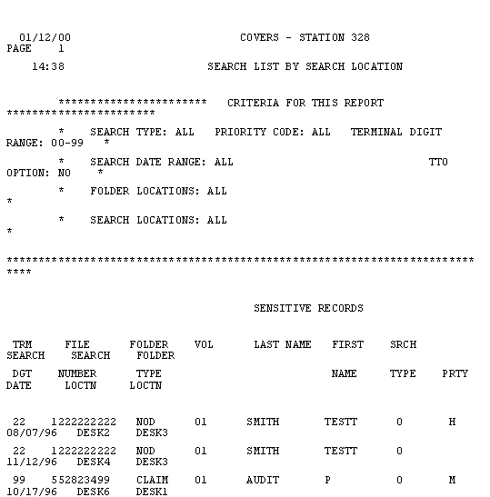

## Select A Report

This category is available with options for Permanent Transfer and Temporary Transfer .

**For Permanent Transfer, the following options apply:**

In Transit To Another Station:  The report will show all folders that are currently PTOs to another RO from the user's station.  There will be page breaks for each station to which folders are PTO'd.

Pending Receipt At This Station:  The report will show all folders that are currently PTId to the location from another RO.  There will be page breaks for each station that has transferred folders to the user's station.  When 'Requested By This Station' is selected, the report shows all folders that the user's station has requested.  There will be page breaks for each station with requested folders transfers.

Requested by Other Stations-All:  The report will show all folders other ROs have requested from the user's facility.  There will be page breaks for each station that has requested a folder from the user's facility.

Requested by Other Stations-New:  The report will show new folders (from the date selected) other ROs have requested from the user's facility.  There will be page breaks for each station that has requested a folder from the user's facility.

Requested by This Station:  The report will show all folders that the user's station has requested from other facilities.  There will be page breaks for each station that the user's stations has requested a folder.

Folder Request Responses:  The report will show responses from other ROs to transfer requests the user's station has made.  There will be page breaks for each station for which there are responses.  The possible responses are Charged Out To, Forward the Claim To, and No Record.  All are denials for the folder request.

Outstanding Folder Request by Other Stations:  This report option is only available for RMC users.  This report will show folders other ROs have outstanding requests from the user's facility.  This report will be printed after 6:00 PM central time.

**For Temporary Transfer, the following options apply:**

All TTO Folders:  The report will show all folders which are currently TTO'd to another facility from the user's station.

Overdue Folders:  The report will show all folders currently TTOs to another facility from the user's station that are overdue to be returned.

TTO Folders Due back By:  The report will show all folders currently TTOd to another facility from the user's station that are due back by a specific date.  When the user selects 'TTO Folders Due Back By', a box will appear on the screen to enter the specific date.  Use the mm/dd/yyyy format.

## Search List by Priority Code

This report will provide the user with a listing of folders on search sequences by priority code.

If the **OK** button is selected without making any changes on the screen, the shown default criteria will be used and all folders searched with a priority will be in the report.

To prevent all folders searched with priority from being displayed in the report, change data in the selection criteria and only folder searches with a priority that meet all screen criteria and defaults will be displayed.

**To Specify Selection Criteria**

1. Folder Location(s) - If you use this criterion, only searches for folders in the specified locations will be in the report provided other screen criteria and defaults are also met.

* Click the down arrow.
* Select up to six locations.
* Selected locations will display in the box below the Folder Location(s) box.
* If you choose the default locations of "ALL", the folders in all locations will be included in the report.
* To de-select a selected location, double click on the selected location.
* If you do not specify a location, the folder location defaults to "ALL".
* Once folder locations appear in the list, system locations BICO and TRANS will not be displayed.

1. Search Location(s) - If you use this criterion, only searched issued from the specified locations will be in the report, provided other screen criteria and defaults are also met.

* Click the down arrow.
* Select up to six locations.
* Selected locations will display in the box below the Search Location(s) box.
* If you choose the default locations of "ALL", the folders in all locations will be included in the report.
* To de-select a selected location, double-click the selected locations.
* If you do not specify any locations, folder location defaults to "ALL".
* Once folder locations appear in the list, system locations LNF, BICO and TRANS will not be displayed.

1. TD Range - If you use this criterion, only searches for folders whose terminal digits fall within the specified range will be in the report provided other screen criteria and defaults are also met.

* Enter numbers in From and To by keying, or using the spin button
* Valid values for From and To are "00" - "99".
* The number entered in From must be less than or equal to the number entered.

1. Search Dates - If you use this criterion, only searches issued during the specified date range will be in the report, provided other screen criteria and defaults are also met.

* Enter dates in From and To in the format mm/dd/ccyy, including leading zeros for one-character months and days.
* Valid dates are required - for example, 04/31/2005 is invalid because April has only 30 days.
* The date entered in From must be less than or equal to the date entered in To.
* The year entered in From must be greater than or equal to 1985.
* The date entered in To must be less than or equal to today's date.
* If you do not enter any search dates, search date will not be used as a criteria for the report.

1. Search Type(s) - If you use this criterion, only searches of the specified type(s) will be in the report, provided other screen criteria and defaults are also met

* Click any or all of the search types
* If you click 'M', mail searches will be in the report.
* If you click 'O', folder searches will be in the report.
* If you click 'B', searches will be in the report if there is both an 'M' and an 'O' search for the same folder from the same location.
* You must pick at least one search type.

1. Priority Code - If you use this criterion, only folder searches with the specified priority code will be in the report, provided other screen criteria and defaults are also met.

* Click the down arrow.
* Select a priority.
* If you select 'ALL' the priority code is not used in the selection criteria, as all searches with priority codes, as well as searches without a priority code, are included.
* To de-select a priority, click the down arrow and select 'None'.  If you do not specify a priority code, priority code defaults to 'ALL'.

1. TTO Option

* If you click Yes, only searches for temporarily transferred folders will be in the report provided other screen criteria are also met.
* If you click 'No', transfer status will not be used as a criteria for the report.

1. Once you have entered all selection criteria, select the **OK** button.  You will get a message stating that the report has been requested.
2. At this point, you can request another report, return to the Main Menu by selecting the **Main Menu** button, or return to the Reports Selection screen by selecting the **Prev Screen** button.

When the report is complete, a red light indicator will appear on the tool bar, indicating that there is a message to view on the Main Menu.  This message will state that the report is complete, or that no searches satisfied the screen criteria.

The report will consist of all folder searches that satisfied all screen criteria and default.  The selection criteria used in generating the report will print at the top of each page.  Each search location will begin on a new page, and the report for each search location will be sorted in ascending sequence by terminal digit, file number, folder type, and volume.  Folders located in the file room will print in a separate report at the end of the main report.

Sensitive records will not be in the main body of the report; instead, the name of the sensitive veteran will be in a listing of sensitive records at the beginning of the report.

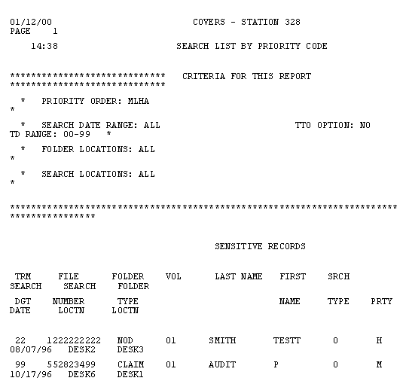

## Search List by Folder Location

This report will provide the user with a listing of folders on search sequenced by folder location.

If the **OK** button is selected without making any changes on the screen, the shown default criteria will be used and all searches will be in the report.

If all searches in the report are not desired, change data in any or all of the seven selection criteria and only searches that meet all screen criteria and defaults will be in the report.

**To Specify Selection Criteria**

1. Folder Location(s) - If you use this criterion, only searches for folders in the specified locations will be in the report provided other screen criteria and defaults are also met.

* Click the down arrow.
* Select up to six locations.
* Selected locations will display in the box below the Folder Location(s) box.
* If you choose the default locations of "ALL", the folders in all locations will be included in the report.
* To de-select a selected location, double click on the selected location.
* If you do not specify a location, the folder location defaults to "ALL".
* Once folder locations appear in the list, system locations BICO and TRANS will not be displayed.

1. Search Location(s) - If you use this criterion, only searched issued from the specified locations will be in the report, provided other screen criteria and defaults are also met.

* Click the down arrow.
* Select up to six locations.
* Selected locations will display in the box below the Search Location(s) box.
* If you choose the default locations of "ALL", the folders in all locations will be included in the report.
* To de-select a selected location, double-click the selected locations.
* If you do not specify any locations, folder location defaults to "ALL".
* Once folder locations appear in the list, system locations LNF, BICO and TRANS will not be displayed.

1. TD Range - If you use this criterion, only searches for folders whose terminal digits fall within the specified range will be in the report provided other screen criteria and defaults are also met.

* Enter numbers in From and To by keying, or using the spin button
* Valid values for From and To are "00" - "99".
* The number entered in From must be less than or equal to the number entered.

1. Search Dates - If you use this criterion, only searches issued during the specified date range will be in the report, provided other screen criteria and defaults are also met.

* Enter dates in From and To in the format mm/dd/ccyy, including leading zeros for one-character months and days.
* Valid dates are required - for example, 04/31/2005 is invalid because April has only 30 days.
* The date entered in From must be less than or equal to the date entered in To.
* The year entered in From must be greater than or equal to 1985.
* The date entered in To must be less than or equal to today's date.
* If you do not enter any search dates, search date will not be used as a criteria for the report.

1. Search Type(s) - If you use this criterion, only searches of the specified type(s) will be in the report, provided other screen criteria and defaults are also met

* Click any or all of the search types
* If you click 'M', mail searches will be in the report.
* If you click 'O', folder searches will be in the report.
* If you click 'B', searches will be in the report if there is both an 'M' and an 'O' search for the same folder from the same location.
* You must pick at least one search type.

1. Priority Code - If you use this criterion, only folder searches with the specified priority code will be in the report, provided other screen criteria and defaults are also met.

* Click the down arrow.
* Select a priority.
* If you select 'ALL' the priority code is not used in the selection criteria, as all searches with priority codes, as well as searches without a priority code, are included.
* To de-select a priority, click the down arrow and select 'None'.  If you do not specify a priority code, priority code defaults to 'ALL'.

1. TTO Option

* If you click Yes, only searches for temporarily transferred folders will be in the report provided other screen criteria are also met.
* If you click 'No', transfer status will not be used as a criteria for the report.

1. Once you have entered all selection criteria, select the **OK** button.  You will get a message stating that the report has been requested.
2. At this point, you can request another report, return to the Main Menu by selecting the **Main Menu** button, or return to the Reports Selection screen by selecting the **Prev Screen** button.

When the report is complete, a red light indicator will appear on the tool bar, indicating that there is a message to view on the Main Menu.  This message will state that the report is complete or that no searches satisfied the screen criteria.

The report will consist of all folder searches that satisfied all screen criteria and default.  The selection criteria used in generating the report will print at the top of each page.  Each search location will begin on a new page and the report for each search location will be sorted in ascending sequence by terminal digit, file number, folder type, and volume.  Folders located in the file room will print in a separate report at the end of the main report.

Sensitive records will not be in the main body of the report; instead, the name of the sensitive veteran will be in a listing of sensitive records at the beginning of the report.

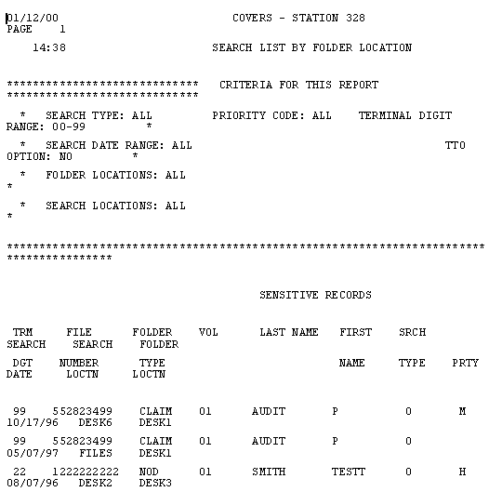

## Search List by Terminal Digit

This report will provide the user with a listing of folders on search sequences by priority code.

If the **OK** button us selected without making any changes on the screen, the shown default criteria will be used and all folders searched with a priority will be in the report.

If all searches in the report are not desired, change data in any or all of the seven selection criteria and only searches that meet all screen criteria and defaults will be in the report.

**To Specify Selection Criteria**

1. Folder Location(s) - If you use this criterion, only searches for folders in the specified locations will be in the report provided other screen criteria and defaults are also met.

* Click the down arrow.
* Select up to six locations.
* Selected locations will display in the box below the Folder Location(s) box.
* If you choose the default locations of "ALL", the folders in all locations will be included in the report.
* To de-select a selected location, double click on the selected location.
* If you do not specify a location, the folder location defaults to "ALL".
* Once folder locations appear in the list, system locations BICO and TRANS will not be displayed.

1. Search Location(s) - If you use this criterion, only searched issued from the specified locations will be in the report, provided other screen criteria and defaults are also met.

* Click the down arrow.
* Select up to six locations.
* Selected locations will display in the box below the Search Location(s) box.
* If you choose the default locations of "ALL", the folders in all locations will be included in the report.
* To de-select a selected location, double-click the selected locations.
* If you do not specify any locations, folder location defaults to "ALL".
* Once folder locations appear in the list, system locations LNF, BICO and TRANS will not be displayed.

1. TD Range - If you use this criterion, only searches for folders whose terminal digits fall within the specified range will be in the report provided other screen criteria and defaults are also met.

* Enter numbers in From and To by keying, or using the spin button
* Valid values for From and To are "00" - "99".
* The number entered in From must be less than or equal to the number entered.

1. Search Dates - If you use this criterion, only searches issued during the specified date range will be in the report, provided other screen criteria and defaults are also met.

* Enter dates in From and To in the format mm/dd/ccyy, including leading zeros for one-character months and days.
* Valid dates are required - for example, 04/31/2005 is invalid because April has only 30 days.
* The date entered in From must be less than or equal to the date entered in To.
* The year entered in From must be greater than or equal to 1985.
* The date entered in To must be less than or equal to today's date.
* If you do not enter any search dates, search date will not be used as a criteria for the report.

1. Search Type(s) - If you use this criterion, only searches of the specified type(s) will be in the report, provided other screen criteria and defaults are also met

* Click any or all of the search types
* If you click 'M', mail searches will be in the report.
* If you click 'O', folder searches will be in the report.
* If you click 'B', searches will be in the report if there is both an 'M' and an 'O' search for the same folder from the same location.
* You must pick at least one search type.

1. Priority Code - If you use this criterion, only folder searches with the specified priority code will be in the report, provided other screen criteria and defaults are also met.

* Click the down arrow.
* Select a priority.
* If you select 'ALL' the priority code is not used in the selection criteria, as all searches with priority codes, as well as searches without a priority code, are included.
* To de-select a priority, click the down arrow and select 'None'.  If you do not specify a priority code, priority code defaults to 'ALL'.

1. TTO Option

* If you click Yes, only searches for temporarily transferred folders will be in the report provided other screen criteria are also met.
* If you click 'No', transfer status will not be used as a criteria for the report.

1. Once you have entered all selection criteria, select the **OK** button.  You will get a message stating that the report has been requested.
2. At this point, you can request another report, return to the Main Menu by selecting the **Main Menu** button, or return to the Reports Selection screen by selecting the **Prev Screen** button.

When the report is complete, a red light indicator will appear on the tool bar, indicating that there is a message to view on the Main Menu.  This message will state that the report is complete or that no searches satisfied the screen criteria.

The report will consist of all folder searches that satisfied all screen criteria and default.  The selection criteria used in generating the report will print at the top of each page.  Each search location will begin on a new page and the report for each search location will be sorted in ascending sequence by terminal digit, file number, folder type, and volume.  Folders located in the file room will print in a separate report at the end of the main report.

Sensitive records will not be in the main body of the report; instead, the name of the sensitive veteran will be in a listing of sensitive records at the beginning of the report.

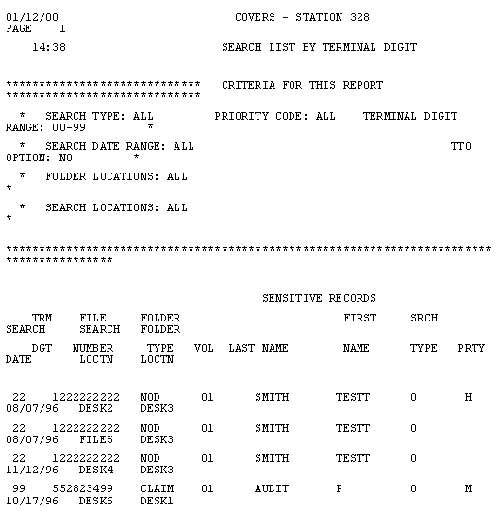

## Folder Statistics Report

This report will generate counts of folders at each ROs locations; counts by facility of folders that are PTO or TTO, and a total of all folders for the user's RO.  The report is sequenced in ascending order by the location of the folder.

When requesting a Folder Statistics Report, additional data will not be required.  When the report is complete, a message will be displayed stating *"COV307 Folder Statistics Report Requested;  This Reports Will Be Emailed After 6:00pm Central Time Tonight"*.

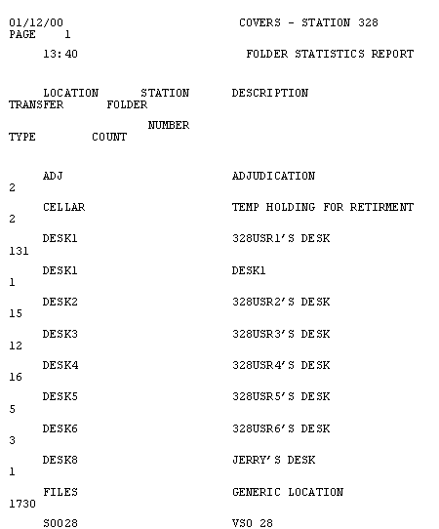

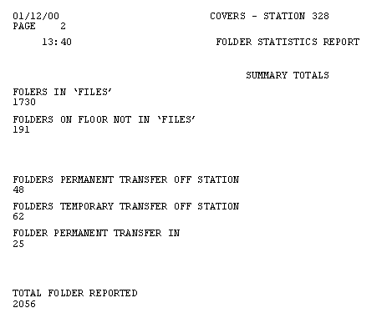

## Temporary Transfers Report

This report will provide the user with a listing of all folders that are Temporarily Transferred Out.

If the **OK** button is selected without making any changes on the screen, the shown default criteria will be used and all Temporary Transfers Off-Station (TTO) will be in the report.  The report will be sequenced by file number, folder type and volume with a page break for each station to which folders are TTOd.

The following paragraphs explain the meaning of the various options on this screen.

Report Sequence has two options: *Folder Number and Terminal Digit.*  If the Folder Number is selected, the report sequence will be file number, folder type and volume, with page breaks for each station to which folders are TTOd.  If the Terminal Digit is selected, the report sequence will be terminal digit, with page breaks for each station to which folders are TTOd.

Select A Report allows the user to choose the type of report.   If 'All TTO Folders' is selected, the report will show all folders which are currently TTOd to another facility from the users station.  If 'Overdue Folders' is selected, the report will show all folders currently TTOd to another facility from the users station that are overdue and being returned.  If 'TTO Folders Due Back By' is selected, the report will show all folders currently TTOd to another facility from the users station that are due back by a specific date.  When 'TTO Folders Due back By' is selected, a box will appear on the screen allowing a specific date to be entered.  Use mm/dd/yyyy format.  The date must be later than 01/01/1989.

Once the Report Sequence and Report Type have been chosen, select the **OK** button to request the report.  When the report is complete, a message will be displayed stating*"COV307 Folder Statistics Report Requested;  This Reports Will Be Emailed After 6:00pm Central Time Tonight"***.**The user will be returned to the Reports Selection screen.

When the report is ready, a red light indicator will appear on the tool bar, indicating that there is a message to view on the Main Menu.  This message states that the report is complete or that no searches satisfied the screen criteria.

Sensitive records will not be in the main body of the report; instead, the name of the sensitive veterans will be in a listing of sensitive records at the beginning of each report.

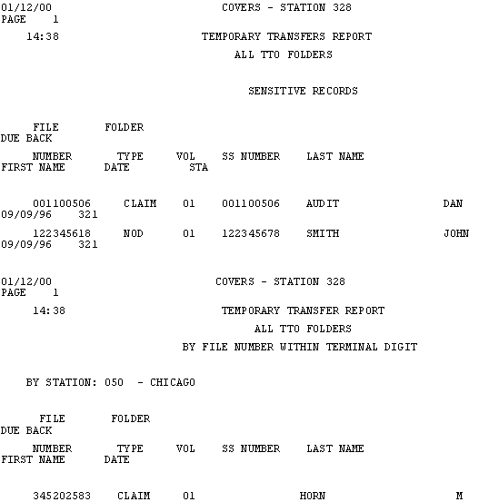

## Permanent Transfer Report

If the **OK** button is selected without making any changes on the screen, the shown default criteria will be used and all Permanent Transfers to the station will be in the report.  The report will be sequenced by file number, folder type and volume.

The following paragraphs explain the meaning of the various options on this screen.

Report Sequence has two options: *Folder Number and Terminal Digit*.  If Folder Number is selected, the report sequence will be file number, folder type and volume.  Page breaks depend on the type of report.  If Terminal Digit is selected, the report sequence will be terminal digit.  Page breaks depend on the type of report.  For a RMC user, the only Report Sequence option available is terminal digit.  The report sequence will be file number, folder type and volume within double terminal digit (last four characters of file number) with two-folder transfer request per page, one on each half of the page.

Select A Report allows the user to choose the type of report.  If 'In-Transit' is selected, the report will show all folders, which are currently PTOd to another RO from the user's station.  There will be page breaks for each station to which folders are PTOd.  If 'Pending' is selected, the report will show all folders currently PTId to the users location from another RO.  There will be page breaks for each station that has transferred folders.  If 'Requested By This Station' is selected, the report will show all folders the station has requested.  There will be page breaks for each station that the user has requested folder transfers from.  If 'Requested By Other Stations' is selected, the report shows all folders, which your station has requested.  There will be page breaks for each station that has requested a folder from your facility.  If 'Folder Request Responses' is selected, the report will show responses from other RO's to transfer requests the users station has made.  There will be page beaks for each station for which there are responses.  The possible responses are 'Charged Out To', 'Forward the Claim To' and 'No Record'.  All are denials of the folder request.

For RMC users only, there is also an 'Outstanding Folder Requests by Other Stations' report.  This report will show all folders from other ROs which are currently requested and outstanding.  This report will be printed after 6 PM central time.

Once the Report Sequence and Report Type have been chosen, select the **OK** button to request the report.  You will receive a message stating that the report has been requested and will be returned to the Reports Selection screen.

When the report is ready, a red light indicator will appear on the tool bar, indicating that there is a message to view on the Main Menu.  This message will state that the report is complete or that no searches satisfied the screen criteria.  See Info/Error Messages for more details.

Sensitive records will not be in the main body of the report; instead, the name of the sensitive veterans will be in a listing of sensitive records at the beginning of each report.

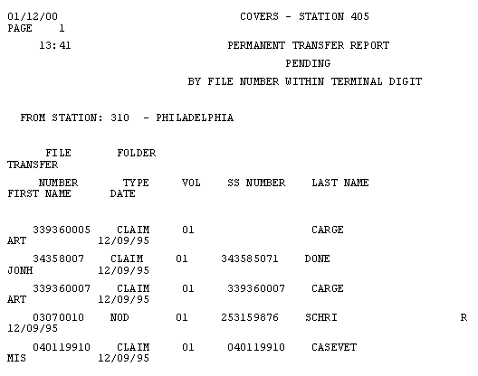

## Folder Aging for a Location Report

This report will consist of all folders that have been in the specified location for the specified number of days.  The report for each aging duration will be sorted in ascending sequence by terminal digit, file number, folder type, and volume.  For each duration, there will be a total of the number of folders for that duration.

Sensitive records will not be in the main body of the report; instead, the name of the sensitive veteran will be in a listing of sensitive records at the beginning of the report.

**To Specify Selection Criteria**

1. Select a location:

* Click the down arrow
* Select a location (a location must be chosen)

1. Select an aging duration:

* The default shown may be accepted
* The pre-specified durations may be selected.  If a pre-specified duration is selected, any entry in the "Other" duration will be cleared.
* "Other" may be selected and any entries in the pre-specified durations will be cleared.  Enter a day range; valid values are 1-999; days may not be left blank if "Other" is selected.

1. Once the aging duration is entered, select the **OK** button.
2. A message stating the report has been requested will be displayed.
3. At this point, another report may be requested.  If another report is not desired, return to the Main Menu by selecting the **Main Menu** button, or return to the Reports Selection screen by select the **Prev Screen** button.

When the report is complete, a message will be displayed stating *"COV307 Folder Statistics Report Requested;  This Reports Will Be Emailed After 6:00pm Central Time Tonight"*.

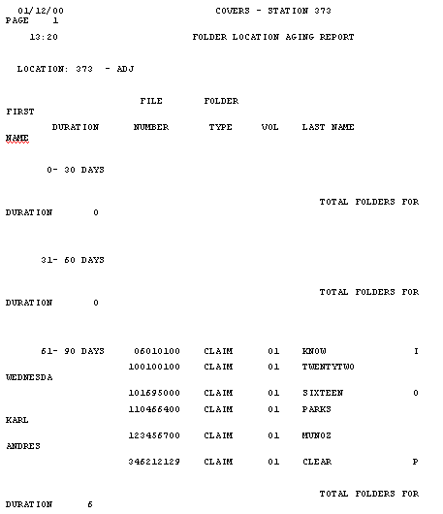

## Special Codes Statistics Report

The report will consist of all folders that satisfied all screen criteria.  Each special code will begin on a new page and the report for each special code will be sorted in ascending sequence by terminal digit, file number, folder type, and volume.

Sensitive records will not be in the main body of the report; instead, the name of the sensitive veteran will be in a listing of sensitive records at the beginning of the report.

**To Specify Selection Criteria**

1. Data must be entered in the option fields.
2. Special Codes

* For all special codes, select 'All Special Codes'.
* For specific special codes, select the down arrow.  Up to five codes may be selected.
* To de-select a special code, click on the selected special code.
* At least one special code must be selected.
* Only folders with the special codes will be in the report provided the folder's terminal digits fall within the range specified below.
* Select a location (required).

1. TD Range

* Enter numbers in From and To by keying or using the spin button.
* Valid values for From and To are "00" - "99"; spaces are not allowed.
* The number entered in From must be less than or equal to the number entered in To.
* Only folders with terminal digits that fall within the specified range, will be in the report provided the folder has one of the special codes specified above.

1. Once all selection criteria is entered, select the **OK** button.
2. A message will be displayed stating that the report has been requested.
3. At this point, another report may be requested.  Return to the Main Menu by selecting the **Main Menu** button, or return to the Reports Selection screen by selecting the **Prev Screen** button.

When the report is complete, a message will be displayed stating *"COV307 Folder Statistics Report Requested;  This Reports Will Be Emailed After 6:00pm Central Time Tonight"*.

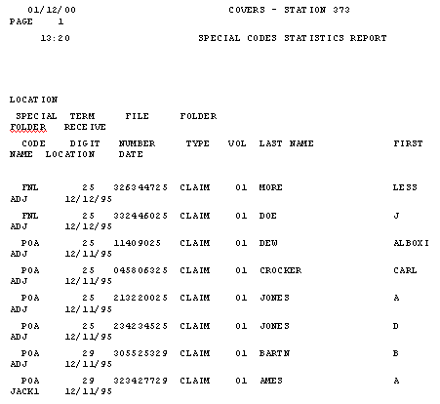

## Multi-Volume Folders - Terminal Digit Sequence

When requesting Multi-Volume Folders - Folder Number Sequence, the user will not be asked to enter additional data.  A message stating that the report has been requested will be displayed.  When the report is ready, a red light indicator will appear on the tool bar, indicating that there is a message to view on the Main Menu.  This message will state that the report is complete.

This report will show all CLAIM folders that have more than one volume.  The report is sequenced in ascending order by terminal digit, file number, folder type, and volume, or by the file number, folder type, and volume, depending on which report was requested.

Sensitive records will not be in the main body of the report; instead the name of the sensitive veteran will be in a listing of sensitive records at the beginning of the report.

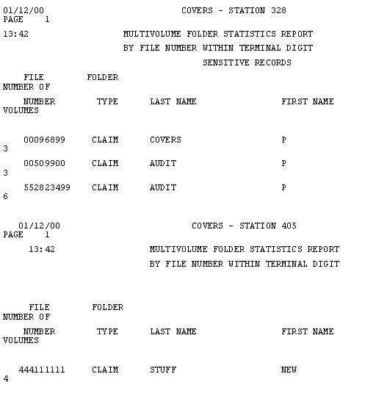

## Unauthorized SO Holdings

If you request Unauthorized SO Holdings Reports, you will not be asked to enter additional data.  You will receive a message telling you the report has been requested.  When the report is ready, a red light indicator will appear on the tool bar indicating there us a message for you to view on the Main Menu.  The message will tell you that the report is complete or that no searches satisfied the screen criteria.

This report will show all folders that are registered to an SO location not authorized to have the folder for any of the following reasons:

* The SO does not have power of attorney for the folder
* The folder contains restricted material
* The folder has a special code "POA" meaning there are multiple POAs for the folder

The report is sequences in ascending order by SO location, terminal digit, file number, folder type, and volume.

Sensitive records will not be in the main body of the report; instead, the name of the sensitive veteran will be in a  listing of sensitive records at the beginning of the report.

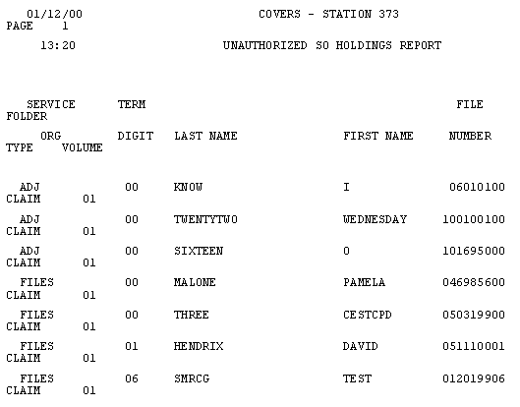

## Folder Search Review

If you select **OK** without making any changes on the screen, the shown default criteria will be used and all folders searched with a priority will be in the report.  If you select **Prev Screen**, you will return to the report selection screen.

If you do not want all searches in the report, change data in any or all of the selection criteria and only searches that meet all screen criteria and defaults will be in the report.

**To Specify Selection Criteria**

1. Folder Location(s) - Not available
2. Search Location(s) - If you use this criterion, only searched issued from the specified locations will be in the report, provided other screen criteria and defaults are also met.

* Click the down arrow.
* Select up to six locations.
* Selected locations will display in the box below the Search Location(s) box.
* If you choose the default locations of "ALL", the folders in all locations will be included in the report.
* To de-select a selected location, double-click the selected locations.
* If you do not specify any locations, folder location defaults to "ALL".
* Once folder locations appear in the list, system locations LNF, BICO and TRANS will not be displayed.

1. TD Range - If you use this criterion, only searches for folders whose terminal digits fall within the specified range will be in the report provided other screen criteria and defaults are also met.

* Enter numbers in From and To by keying, or using the spin button
* Valid values for From and To are "00" - "99".
* The number entered in From must be less than or equal to the number entered.

1. Search Dates - If you use this criterion, only searches issued during the specified date range will be in the report, provided other screen criteria and defaults are also met.

* Enter dates in From and To in the format mm/dd/ccyy, including leading zeros for one-character months and days.
* Valid dates are required - for example, 04/31/2005 is invalid because April has only 30 days.
* The date entered in From must be less than or equal to the date entered in To.
* The year entered in From must be greater than or equal to 1985.
* The date entered in To must be less than or equal to today's date.
* If you do not enter any search dates, search date will not be used as a criteria for the report.

1. Search Type(s) - If you use this criterion, only searches of the specified type(s) will be in the report, provided other screen criteria and defaults are also met

* Click any or all of the search types
* If you click 'M', mail searches will be in the report.
* If you click 'O', folder searches will be in the report.
* If you click 'B', searches will be in the report if there is both an 'M' and an 'O' search for the same folder from the same location.
* You must pick at least one search type.

1. Priority Code - Not available
2. TTO Option - Not available
3. Once you have entered all selection criteria, select the **OK** button.

Searches that satisfy all screen criteria and defaults will display on the following screen sorted in ascending sequence by terminal digit, file number, folder type, and volume.  Searches are displayed in groups of approximately 100.

You may scroll through the data using the horizontal and vertical scroll bars.

You may ask for the next group of records by selecting the **Next** button; Next is not available if you are already on the first group of records.

You may ask for the previous group of records by selecting the **Previous** button; Previous is not available if you are already on the last group of records.

When you are finished looking at the data, you can request another report, return to the Main Menu by clicking on the **Main Menu** button, or return to the Reports Selection screen by clicking on **Prev** Screen.

When the report is complete, a message will be displayed stating *"COV307 Folder Statistics Report Requested;  This Reports Will Be Emailed After 6:00pm Central Time Tonight"*.

## Multi-Volume Folders - Folder Number Sequence

When requesting Multi-Volume Folders - Terminal Digit Sequence, the user will not be asked to enter additional data.  A message stating that the report has been requested will be displayed.  When the report is ready, a red light indicator will appear on the tool bar, indicating that there is a message to view on the Main Menu.  This message will state that the report is complete.

This report will show all CLAIM folders that have more than one volume.  The report is sequenced in ascending order by terminal digit, file number, folder type, and volume, or by the file number, folder type, and volume, depending on which report was requested.

Sensitive records will not be in the main body of the report; instead the name of the sensitive veteran will be in a listing of sensitive records at the beginning of the report.

## Validation Tables Report

A report is requested by highlighting the name of the report and selecting the **OK** button, or by double-clicking on the name of the report.  COVERS immediately issues the report request.

The following reports are available from the Table Reports Selection:

Facility Code Table Report

Location Codes Table Report

Organization Codes Table Report

Priority Codes Table Report

Special Codes Table Report

## Facility Codes Table Report

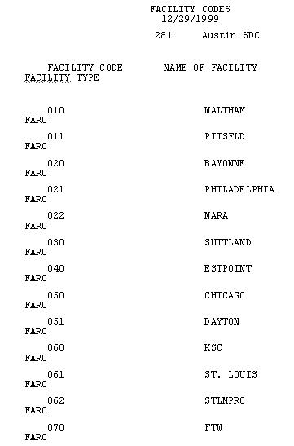

## Location Code Table Report

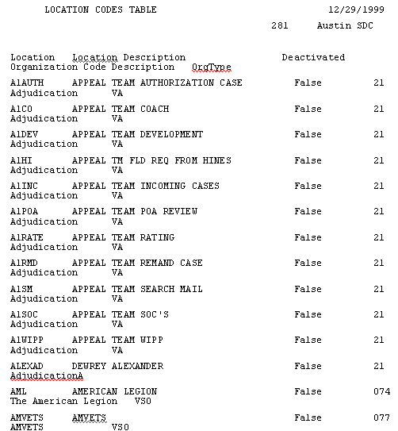

## Priority Code Table Report



## Organization Code Table Report

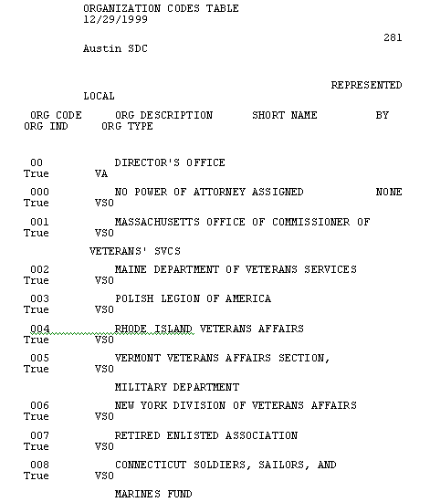

## Special Code Table Report

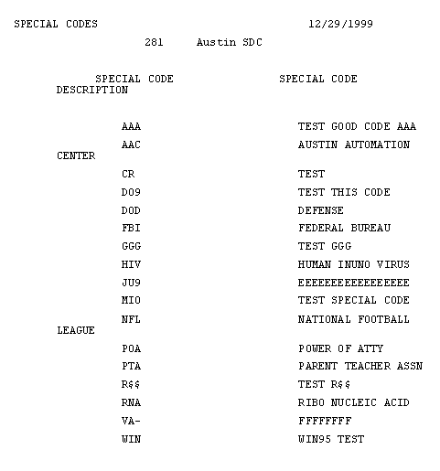

## Brokered Work Report

The Brokered Work Report utilizes the PC's clipboard to move data between COVERS and an Excel spreadsheet.  The new function is designed to capture data regarding the locations of folders that have been brokered out for work to other locations. The .csv file displays the details as to where the TTOd folders are physically located.  The data will include the file number, terminal digit, folder type, volume cd, SSN, last name, first name, expected return date, destination station, destination station name, from station, from station name, and transfer date.  The data is then processed through an OCR filter to convert from graphic to text data.  The user may then choose to place the extracted data into a grid.  Once the function has processed the list of claim numbers, the user copies the data to the clipboard.  The relevant data is then pasted into the Excel spreadsheet.

# Utilities

## COVERS Administrative Functions

COVERS provides four maintenance utilities that are available to authorized users.  These functions are available from the COVERS Utilities Menu.

When setting up COVERS for the first time, COVERS must be customized for the Regional Office (RO).  Specific information that must be defined before COVERS can be used is:

* The internal locations for the RO (these must also be associated with an organization)
* The representation of service organizations within the RO
* Priority codes for the RO
* Any special codes that are used to classify folders in that RO
* COVERS user accounts

**Note:**  The Security Officer will set up accounts for administrators and supervisors, and will assign security/lock file access levels for all users.  A user cannot access COVERS until they have been added to CSS, and has been granted COVERS and appropriate application operations.

The following table shows the correlation's between the user profile functions that may be individually enabled and disabled in CSS and the COVERS processes that they control.

|  |  |  |  |
| --- | --- | --- | --- |
| **Function** | **Enables Button** | **On Screen** | **Allows User to** |
| Maintain Tables | Tables | Utility | Update local code tables |
| Generate Labels | Generate Labels | Main Menu | Send labels to label queue |
| Delete Folder | Delete | Main Menu | Delete an NOD folder or a volume of a multi-volume CLAIM folder |
| Add/Change Folder | Add Volume Change | Main Menu | Add a volume to a CLAIM folder and to update special code or the restricted data indication on a folder |
| Transfer Folders | Transfer Out | Main Menu | Transfer folders to another facility |
| Print Labels | Print Labels | Main Menu | Print previously queued labels |
| Location Inquiry | Location Inquiry | Main Menu | Inquire BIRLS for the folder |
| Location Correction | Location Correction | Main Menu | Correct the BIRLS location of the folder |
| Transfer Folder Request | Request Transfer | Main Menu | Send a request for the folder to another facility |
| Mark Folder for Mail | Mark For Mail | Main Menu | Establish a local mail search for a folder |
| Maintenance Functions | Maintenance | Utility | Perform COVERS retirement/relocation and FNL/LNF processing |
| Change Search Location | Change/Delete | Main Menu | Perform process that change or delete local searches |
| BICO/TRANS Authority | n/a | n/a | Select BICO or TRANS as the user location |
| Delete Search For Special Criteria | Change/Delete | Main Menu | Delete all searches that have certain criteria specified by the user |
|  | Delete Search For Specific Criteria | Change/Delete Search | NOTE: This function has caused problems.  It will delete all searches if no additional criteria is specified. |
|  |  |  | This function should be limited to program administrators only. |
| Delete Search for a Folder | Delete Search For Single Folder | Change/Delete Search | Delete user's mail and folder search for a specified folder |
| Delete Mail Search In Bulk | Change/Delete | Main Menu | Delete all mail searches for a list of folder specified by the user |
|  | Delete Mail Search In Bulk | Change/Delete Search |  |
| Re-assign Search | Change/Delete | Main Menu | Reassign search from one location to another |
|  | Delete Search For Single Folder | Change/Delete Search |  |
| Generic Delete Request | Change/Delete | Main Menu | Delete any folder search for a specified folder (allows user to delete other user's search) |
|  | Delete Search For Single Folder | Change/Delete Search |  |
| Quick Print | Quick Print | Enter Folder Identification | Immediately print a label for the folder the user just received, transferred in, added a volume for |
| Search Lists | Utilities | Main Menu | Request Search List by Search Location, Search List by Priority |
|  | Reports | Utilities | Code, and Search List by Folder Location and Search List by Terminal Digit reports |
| Folder Search Review | Reports | Utilities | Request Folder Search Review online report |
| Folder Statistics | Reports | Utilities | Request Folder Statistics report |
| Validation Tables | Reports | Utilities | Request reports for local code tables |
| Transfers | Reports | Utilities | Request Temporary Transfer report or Permanent Transfers report |
| Multi-Volume Folder Statistics | Reports | Utilities | Request Multi-Volumes Folder Statistics - Terminal Digit Sequence and Multi-Volume Folder Statistic - Folder Number Sequence report |
| Unauthorized SO Holding | Reports | Utilities | Request Unauthorized SO Holdings report |
| Special Codes Statistics | Reports | Utilities | Request Special Codes Statistics report |
| Folder Aging for a Location | Reports | Utilities | Request Folder Aging for a Location report |
| Create Transfer Slip | Transfer Out | Main Menu | Request Transfer Slips to be created |
|  | Transfer Folder |  |  |
| Brokered Work | Transfer Folder | Enter Folder Identification | Allows the folder to be brokered out to another location for work |
| CVR Extract | CVR Extract | Main Menu | Create an Excel report from a Single Inquiry |
| Station of Jurisdiction |  |  |  |
| Update Transfer | Update | Folder Data | Update a transfer request for a folder |
| Delete Transfer | Delete Transfer | Folder Data | Delete a transfer request for a folder |
| Location at 101 |  | Table Maintenance | Select a specific location at Station 101 for folder transfer |

## Utilities

COVERS provides seven maintenance utilities that are available to authorized users.  these functions provide the capability of editing RO-specific tables, generating reports and managing user security.

## Utility Menu

**To get to the Utilities Menu**

1. Select the **Utilities** button from the Covers Main Menu.

From this menu, the following utilities are available.  Depending on your security authorization, some or all of these functions may be unavailable.

Tables  Use this function to maintain COVERS database tables.  The section titled "Table Maintenance" describes the use of this function.

Reports  Use this function to access COVERS reports.

Maintenance  Use these functions to maintain FNL/LNF and retirement/relocation information.

RO Options  These functions establish a variety of RO parameters.

## Table Maintenance

The Table maintenance function allows you to add, edit, and/or delete records in a table.  Note that depending on your security authorization and the table in questions, table editing commands may be unavailable for some or all tables.

The most basic table maintenance function is browsing - looking at the contents of the COVERS table.

**To browse a COVERS table**

1. Select the **Tables** button from the Utilities Menu.
2. Select the desired table from the pull-down list.

COVERS has a number of RO-specific tables which store information such as location codes and priority codes.

**To add a code**

1. Select the table to which you wish to add a new code.
2. Select the **Add** button.  The editing window for the selected table will appear.  If the Add command is unavailable, this means that you are not authorized to perform this function, or that the Add function is not supported for the currently selected table.
3. Edit the contents of each field as desired.  Only fields appropriate for the table will be shown.
4. Select the **OK** button to add the code, or **Cancel** to quit without adding the code.

**To edit a record**

1. Select the **Table** button and choose the record from the pull down menu.
2. Select the **Edit** button.  The editing window for the selected table will appear.  If the Edit command is unavailable, the user is not authorized to perform this function, or that the Edit function is not supported for the currently selected table.
3. Edit the contents of each field as desired. Not all fields are allowed to be modified, these fields will be grayed out.  Value for these fields will be visible, but no changes may be made.  If changes to these non-editable fields need to be made, the code must be deleted and re-entered with the desired changes.
4. Select the **OK** button to continue the change, or **Cancel** to discard the changes.

**To delete a record**

1. Browse the table and select the record you wish to delete.
2. Select the **Delete** button to remove the record from the table.  If the Delete command is unavailable, this means that you are not authorized to perform this function, or that the Delete function is not supported for the currently selected table.
3. COVERS will ask to verify that you wish to delete the selected item.  Select the **Confirm Delete** button to confirm the deletion, or select the **Cancel** button to cancel the deletion.
4. Deletes may not happen immediately on the server machine.  You might not be able to add in a code with the same value until the following day.

Location Codes Table

Priority Codes Table

Organization Codes Table

Facility Codes Table

Special Codes Table

## Folder Retirement/Relocation

**To get to the Maintenance Menu**

* Select Maintenance from the COVERS Utilities Menu

This option allows folders retired or relocated in BIRLS by WAFPS processing to be deleted accordingly in COVER.  Selecting this option allows the user to specify the type of retirement/relocation processing desired.

This function uses the same WAFPS file that is uploaded to BIRLS for retirement/relocation processing.  The file name is VABxxR.XCR, where "xx" is the last two digits of the Regional Office (RO).

## Extract FNL/LNF

Folder No Label (FNL) and Label No Folder (LNF) Procedures

**Folder No Label**

1. Locate the folder in BIRLS.
2. Contact the BIRLS station to notify the users of the new location of the folder.
3. If the folder is an LNF at the BIRLS station:

* Inform the station to destroy the label
* Receive the folder at the user's station - this will update all systems
* Print a new label

1. If the folder is not an LNF at the BIRLS station, this indicates that there are two folders and consolidation actions are required.
2. Do not receive the folder without contacting the BIRLS station to avoid missing the duplicate folder situation described above.

**Label No folder**

1. Hold label until contacted by the LNF station
2. For unresolved LNFs:

* Find out where BIRLS shows the folder as being located at
* Contact the BIRLS station to verify possession of the folder

If the BIRLS station has the folder, dispose of the label and direct the BIRLS station to print a new label.

If the BIRLS station does not have the folder, hold the label and at a specified time (to be determined by C&P), circularization will be done.

**To keep track of FNL/LNF on the database**

**FNL Folders**

To designate a folder as FNL, use the change COVERS folder data function to update the special code to FNL.  To remove the FNL designation, update the special code to spaces.  A special codes statistics report may be requested.

**LNF Folders**

The user must be location LNF to designate a folder as 'LNF'.  Perform a normal receive function once the users has established the location as LNF.

**Note:**  To remove LNF designation, receive the folder into a location other than LNF.  If scanning as LNF and the folder is PTO, PTI, TTO, or TTI, a message will be received to change locations and try again.

## Delete FNL/LNF

**To keep track of FNL/LNF on the database**

**FNL Folders**

To designate a folder as FNL, use the change COVERS folder data function to update the special code to FNL.  To remove the FNL designation, update the special code to spaces.  The special codes statistics report may be requested.

**LNF Folders**

The user must be location LNF to designate a folder as LNF.  Perform a normal receive function once the location has been established as LNF.

**Note:** To remove LNF designation, receive the folder into a location other than LNF.  If scanning as LNF and the folder is PTO, PTI, TTO, TTI, a message will be received to change location and try again.

## Consolidating Locations

The Consolidating function allows you to combine several locations into a single existing location.  Use this function if, for example, a new file cabinet replaces two old cabinets that were formerly separate locations.  By consolidating the old locations into a single location, you are telling COVERS that all the files associated with the two old locations are now located in one place.  Search locations are also updated by the consolidation process.

**Note:**  Only the System Administrator should execute this operation.  All other users should log off the system before performing this operation.

**To consolidate records in the Locations Table**

1. Browse the Location Table.
2. Select the **Consolidate** button.  The Consolidate Location Codes window will appear.  The Consolidate command is available only when the Locations table is browsed. A warning will appear telling you that this function should be performed when no other users are on the system to ensure that user folder operations are not in progress while the consolidation is being performed.
3. Select a To location.
4. Select up to six From locations you wish to consolidate in the From box.  Since the From locations will no longer exist after the consolidation update has been completed, COVERS will search through all user accounts to insure that no user refers to one of these locations as the default location.  If COVERS determines that any are in fact a default location for any user, the default location and organization code will be updated to reflect the new consolidated location.
5. Select the **OK** button to consolidate the records, or select the **Prev screen** or **Main Menu** buttons.

## Refreshing Codes

This process initiates a download of data from Oracle into local Access database tables, and should only be performed when the Oracle Org table is updated, or in case of irreparable damage to the Access database tables (Special Codes, Priority Codes, Location Codes).  Any information which exists only in the Access Tables, such as the ranking code in the Priority Codes table, will need to be re-entered.

**Note:**Only the System Administrator should execute this operation.  All other users should log off the system before performing this operation.

**To refresh the contents of a table**

1. Browse the table you wish to refresh.
2. Select the **Refresh** command.

# Messages

## Messages

COVERS has a generalized mechanism for sending a message to a user.  Info/Error Messages are generated when a user requests a report.  They will tell the user where the report was printed, or if there was an error creating the report.

COVERS delivers messages to users for a number of reasons.  When a message arrives, COVERS will alert you with a chime and a light indicator.  The appropriate message button will become activated.  If there are no messages, the message button will be grayed out.

**Note:**  In the message text, characters between < > show text that is filled in at runtime; text separated by / shows text that varies at runtime.

Info/Error Messages

Unauthorized Holdings

Folder Requests Your Station

Folder Request Responses

## Info/Error Messages

COVERS has a generalized mechanism for sending a message to a user.  Info/Error Messages are generated when a user requests a report.  The messages will inform the user where the report was printed, or if there was an error creating the report.  If an Info/Error message is available, the Info/Error Messages light will be illuminated and the Info/Error Messages button will become active.  If no messages are available, the Info/Error Messages button will be grayed out.

### To read and dispose of Info/Error Messages

1. From the Main Menu, select the **Info/Error messages** button.  If no messages are displayed, the command will be unavailable.
2. COVERS will display a list containing all Info/Error Messages.  Scroll through the list as needed.
3. To delete messages after reading, select the messages to delete.  Select a collection of messages with CTRL+CLICK or SHIFT+CLICK.
4. Select the **Delete** button.

**or**

1. To delete all messages at once, select the **Delete All** button.
2. Up to 20 at a time may be received.  Use the **Previous**/**Next** buttons to request the previous/next group of 20 messages.  Use the vertical scroll bar to scroll through the 20 messages in the box.
3. Select the **Cancel** button to return to the Main Menu.

## Unauthorized Holdings

These messages will be available when there is a yellow light on the tool bar.  These messages indicate that an SO received a folder which they do not have a POA.

1. From the Main Menu, select the **Unauthorized Holdings** button.  If no messages are displayed, the command will be unavailable.
2. COVERS will display a list containing all Unauthorized Holdings.  Scroll through the list as needed.

## Folder Requests Your Station

COVERS will notify you of transfer requests with a chime and a yellow indicator light in the Messages panel of the Main Menu.  Only the TRANS location will receive such requests.

**To respond to a transfer request**

1. Change to the TRANS location.  Only a user with BICO/TRANS authority can perform this function.
2. From the Main Menu, select the **Folder Requests Your Sta** button.  The *Folder Request Your Station* request window will appear.  If this option is unavailable, you have no folder request responses waiting.
3. Double-click the folders that are for disposition.  These folders will be moved to the *Selected Folders for Disposition* grid.
4. If the folder file number is not displayed in the *Folders Available For Disposition* grid, select the **Find** button.
5. A box will be displayed.  Enter the *File Number* and select the **OK** button.  Any additional folders will be displayed if located.
6. To print the screen, select the **Print Screen** button.
7. Select the **Submit** button.
8. The normal action will be to issue a permanent transfer of the requested folders and ship the folders to the requesting ROs.  In this case, there is no need to perform any explicit action on the folder request message (COVERS handles it automatically when the transferred folder is received at the requesting station).  If all transfer requests are to be honored, skip to the section on Permanent Folder Transfer.
9. If any of the transfer requests must be denied, then select records for disposition.  Folders that have been requested from another station appear in the top list box.  The requests are displayed in file number within TD sequence; 600 requests are returned to the screen at one time.  To see the next group of 600, use the **Next** button.  You must indicate a disposition and move the request into the lower box.  You may select several requests at a time.
10. Select **OK**.  A folder request response for selected requests will be sent to the requester.

## Folder Requests Responses

When the transfer clerk receives your request, they will normally proceed with the transfer.  If the transfer is refused, COVERS will send you a message indicating that the requested transfer has been refused and a reason for the refusal.  You must manually delete this COVERS message.

COVERS will notify you of the message with a chime and a yellow indicator light on the Folder Request Responses button in the Messages Panel on the COVERS Main Menu.

Responding To A Folder Request Response

## Responding To A Folder Request Response

1. To view a request response, the user must be at the location that issued the request .
2. From the Main Menu, select the Folder **Request** **Responses** button.  The *Folder Request Responses* window will appear.  If this option is unavailable, there are no folder request responses waiting.
3. Select any or all responses to be deleted.
4. Select the **Delete** button to remove the responses, or select the **Prev Screen** button to cancel.
5. Responses are shown in groups of twenty.  Use the **Previous**/**Next** buttons to request the previous/next group of messages.  Use the scroll bars to move within a group of messages.

## COVERS Messages

|  |  |
| --- | --- |
| **Message Code** | **Message Text** |
| COV000000 | Location For 101 has been deleted |
| COV000002 | This location code already exists |
| COV000002 | There has been a problem deleting Location at 101 |
| COV001 | Invalid Facility Code |
| COV002 | Field Is Full |
| COV003 | Invalid Default Logon Location |
| COV004 | First Record Is Invalid |
| COV005 | Last Record Is Invalid |
| COV006 | Invalid Volume |
| COV007 | Invalid File Number |
| COV008 | Invalid Folder Type |
| COV009 | The first initial of first name is required for Name Search |
| COV009 | Invalid First Or Last Name |
| COV010 | Invalid SSN |
| COV011 | Invalid Org Code |
| COV012 | Folder Charged Out -- Unavailable For Transfer |
| COV013 | Duplicate Load records |
| COV014 | More than 100 Duplicate Load Records; Processing Is Aborted |
| COV015 | Invalid COVERS Userid; Access To COVERS Id Denied |
| COV016 | Invalid Location Code |
| COV017 | You Do Not Have POA For This Folder |
| COV017 | This Location Does Not Have POA For This Folder |
| COV018 | Error in checking record |
| COV018 | No record found, can add |
| COV018 | Record Already Exists |
| COV019 | Do You Want To Change <nnn> To <mmm>?  (where nnn and mmm = from/to priority or special code) |
| COV020 | Invalid User Name |
| COV021 | Invalid User Id |
| COV022 | Record Not Found |
| COV023 | You Must Update A Location Code Using The Consolidate Location Codes Process; Do You Want To Add This Location Code And Deactivate The Other? |
| COV025 | Invalid Location Description |
| COV026 | This Folder Has More Than One POA Code; Please Follow Local Procedures |
| COV027 | Invalid SO Code |
| COV028 | Take This Folder To Adjudication |
| COV029 | Request/Inquiry Denied |
| COV030 | Please Follow Local Procedures |
| COV031 | Invalid Special Code Description |
| COV032 | No Remote Printer ID's Returned. Prints will be directed to your COVERS default printer. |
| COV032 | Printer ID Retrieval Processing Failed |
| COV032 | Report Processing Not Initiated |
| COV033 | Invalid Priority Code |
| COV034 | Invalid Priority Code Description |
| COV036 | You Do Not Have Security Clearance To Access This Record |
| COV037 | Folder Transferred And May Not Be <Updated/Added> |
| COV038 | Volume <#> Of This Folder Contains Restricted material; Please Follow Local Procedures |
| COV038 | This Folder Contains Restricted Material; Please Follow Local Procedures for Restricted Records |
| COV038 | This Folder Contains Restricted Material; Please Follow Local Procedures |
| COV039 | There are Folder At This Location; Location Code Not Deleted |
| COV040 | There Is A Transfer Status For This Folder; Folder Not Deleted |
| COV041 | You May Select Only 6 Locations; You May De-Select By Double Clicking On A Previously Selected Location |
| COV042 | You May Select Only 5 Locations; You May De-Select By Double Clicking On A Previously Selected Special Code |
| COV043 | Invalid Transfer Code |
| COV044 | You May Not Process Additional Volumes Until Volume 1 Has Been Added; Please Try later |
| COV045 | Please Return Folder |
| COV046 | Invalid Special Case Code |
| COV047 | You Did Not Change Any Data |
| COV048 | Other Volumes Are Transferred.  This Could Be A Problem; Please Research |
| COV049 | Folder Already Exists |
| COV050 | Invalid Folder Type Character |
| COV 051 | NOD does not exist for this folder |
| COV051 | Folder Not Found In COVERS |
| COV052 | Label Already Exists |
| COV053 | This Folder Has <xx> Volumes; You Must Delete Volumes In Sequence |
| COV056 | Invalid Date Or Date Range; Date Must Be Entered As MM/DD/CCYY; You Must Enter Leading Zeroes For 1-Digit Month And Date And No Part Of The Date Can Be Left As Spaces |
| COV057 | The Folder You Are Requesting Was Not Found At Any COVERS Station; Please Circularize The Folder |
| COV058 | Rebuilt Folders -- Review For Possible Consolidation |
| COV059 | Specified Labels Not Found |
| COV060 | Invalid TD Or TD Range |
| COV061 | Invalid Criteria For Inquiry |
| COV062 | Record Already Exists At Your Station -- Possible Rebuilt Folder Action Required -- Check Birls |
| COV063 | Forward The Claim To <xx  xx> (xx...xx = text provided by user) |
| COV064 | There are No Folders That Satisfy The Entered Criteria |
| COV065 | Invalid Priority Code |
| COV066 | Folder Is PTO; No Search Issued |
| COV067 | Folder Is Already Registered To This Location; No Search Issued |
| COV068 | You Have Already Issued A Folder Search For This Folder; No Search Issued |
| COV069 | You Have Already Issued A Mail and Folder Search For This Folder; No Search Issued |
| COV070 | You Have Already Issued A Mail Search For This Folder; No Search Issued |
| COV071 | Rebuilt Folders Exists -- Contact the RMC |
| COV071 | Rebuilt Folder Exists -- Contact The RPC |
| COV072 | Invalid Location |
| COV073 | There Are No Search To Which You Have Access |
| COV074 | There Are No Search That Satisfy The Criteria |
| COV075 | There Are No Searches Issued By Location <nnnnnn> |
| COV076 | Cleanup Processing Complete |
| COV078 | This Folder Is Not In COVERS; Do You Want To Send An Inquiry To BIRLS? |
| COV079 | File Number Is Required |
| COV079 | The Expected Return Date Is Required |
| COV079 | Transfer To Station Is required |
| COV079 | You Must Enter Data In This Field |
| COV080 | Location at 100 Is Required |
| COV080 | Too Many Records Returned |
| COV081 | An Error Has Occurred Retrieving The BIRLS Record.  Either BIRLS IS Down Or This Is A Bad Record On BIRLS |
| COV081 | BIRLS System Error. BIRLS Was Not Updated |
| COV081 | BIRLS System Error |
| COV082 | There Are No Unprinted Transfer Slips For Your Userid |
| COV083 | Folder Is Currently PTO; Folder Not Transferred |
| COV084 | Folder Is Currently TTO; Folder Not Transferred |
| COV085 | Invalid RO Number |
| COV086 | May Not Be An RO |
| COV087 | This Folder Has Been Consolidated With <file number> <folder type>, But The Deleted Folder Is not At Your Site; Please Research |
| COV088 | TTO'd Folder Is Being Changed To A Permanent Transfer |
| COV089 | BIRLS Shows Folder Is At Your Station Or Is Not At An RO Or 376; Folder May Not Be Requested |
| COV090 | Select Searched To Be Deleted or Delete All Search; Then Press OK |
| COV090 | Select Searched To Be Deleted; Then Press OK |
| COV091 | You Did Not Select Any Searched For Deletion |
| COV092 | Folder Currently In Use; Folder Information Not Updated; Try Update Later |
| COV093 | You May Not Transfer This Folder Until You Receive It |
| COV094 | User Id <999999999> At Your Station Has Already Requested This Folder; Request Denied |
| COV095 | Folder Added From BIRLS; You May Transfer The Folder Now |
| COV096 | BIRLS Shows Folder Is Already At Your Station; BIRLS Not Updated |
| COV097 | COVERS Communications Not Available; Try 'COVERS Restart' On Main Menu |
| COV098 | BIRLS Folder Not Present In COVERS |
| COV099 | COVERS Folder Not Present In BIRLS |
| COV100 | BIRLS and COVERS SSN, NAME, Or POA/SO Code Do Not Agree |
| COV101 | Invalid Retirement/Reconciliation Processing Type |
| COV102 | Specified AFPS File Not Found |
| COV103 | AFPS Processing Type Entered On The Screen Does Not Agree With The Header In The AFPS File; Processing Aborted |
| COV104 | This Is Not Your Station's AFPS File; Processing Aborted |
| COV105 | Status Code Not 1-6 |
| COV106 | COVERS Folder Is Not A Claim Folder |
| COV107 | COVERS Folder Is Not A NOD Folder |
| COV108 | AFPS Shows No Record |
| COV109 | Invalid Transaction Type |
| COV110 | Folder/Payee Invalid For <xxx> Processing |
| COV111 | Only Vol. 1 Folders May Be Designated As An 'FNL' |
| COV112 | Folder May Not Be Designated As Both An 'FNL' And An 'LNF' |
| COV113 | Folder Does Not Exist In COVERS |
| COV113 | Folder Does Not Exist In COVERS  Do You Want To Re-Inquire COVERS With A Different Folder Type?  If So, Select 'Yes', Then Change Folder Type; Otherwise, Select 'No' |
| COV114 | Invalid RO Location |
| COV115 | The file number you entered is not the file number in BIRLS.  Please receive under the correct file number. |
| COV116 | BIRLS Is Attempting To Delete A Folder That Is Not Found At This Location |
| COV117 | During Folder Consolidation; The Retained Folder Is In-transit; Please Research |
| COV118 | During Folder Consolidation; The Cancelled Folder Is In-transit; Please Research |
| COV119 | COVERS Identified Your Station As The Recipient Of A Folder In-transit From <nnn> And  BIRLS Shows That The Folder Is Being Added; The COVERS Folder At Your Site Was Updated |
| COV120 | Deleted Client Not Found In COVERS |
| COV121 | COVERS Identified Your Station As The Owner Of A Folder That Is Being Added From BIRLS And COVERS Shows That The Folder Already Exists; The COVERS Folder Was Updated |
| COV122 | Outstanding Processing For This Code; Try Tomorrow |
| COV123 | You Did Not Select A Record For Inquiry |
| COV124 | BIRLS And COVERS Have Identified Your Station As The Owner Of A Folder That Has |
| COV125 | BIRLS Has Identified Your Station As The Owner Of A Folder That Has An In-transit Indication In BIRLS, And COVERS Does Not Show The Folder As In-transit |
| COV126 | COVER Has Identified Your Station As The Owner Of A Folder That Has An In-transit Indication In BIRLS, And COVERS Does Not Show A Transfer Pending |
| COV127 | COVERS And BIRLS Show A Folder In-transit To Different Location; The Folder Was Transferred To The COVERS Destination |
| COV128 | AFPS File Already Exists |
| COV129 | No Matching Record In BIRLS |
| COV129 | No Matching Record In COVERS or BIRLS; Folder Must Be Established Through BIRLS Processing |
| COV129 | No Matching Record In BIRLS; Folder Must Be Established Through BIRLS Processing |
| COV130 | This Folder Was TTO To You - You May Not <Transfer/Delete> It |
| COV131 | All pending CLAIMS at <nnn> will be transferred to your station |
| COV131 | All pending claims at <RO #> will be transferred to your station. |
| COV132 | This Folder Does Not Exist In COVERS; You May Only Add Vol 2-99 Of Existing CLAIM Folders; You May Need To Establish A Folder in BIRLS |
| COV133 | Folder Not And Must Be Circularized |
| COV134 | Folder Not Available |
| COV135 | BIRLS Identified Your Station As the Owner Of A Folder In-transit From <nnn>; COVERS Verified That A Pending Record Should Exist At Your Site, But It Does Not |
| COV136 | COVERS Identified Your Station As the Recipient Of A Folder In-transit From <nnn>; COVERS Verified That A Pending Record Should Exist At Your Site, But It Does Not |
| COV137 | Claim Number Not Equal To User's Claim Number |
| COV138 | User Not Found |
| COV139 | BIRLS Does Not Agree With Entered Data |
| COV140 | Please enter Aging Duration |
| COV140 | Invalid Aging Duration |
| COV140 | Invalid Day Range |
| COV141 | BIRLS Identified Your Station As The Owner Of A Folder That Does Not Exist At Your Site; The Folder Was Added |
| COV142 | BIRLS and COVERS Identified Your Station As the Recipient Of A Folder In-transit From <nnn>; COVERS Verified That A Pending Record Should Exist At Your Site, But It Does Not |
| COV143 | This Volume is not in COVERS. Do you want to add the new Volume?  If So, Select 'Yes', Then Provide Additional Data (Folder Type, Special Code, Restricted Data) If Different Than Shown; Otherwise, Select 'No'. After Responding To This Message, Click On The OK Button At The Bottom |
| COV143 | This Folder Has <nn.> Volumes; Please Provide Data For Adding Next Volume |
| COV144 | Email Message Sent |
| COV145 | This Folder Has <nn> Volumes; Please Provide Data For Adding Next Volume; Once The Folder Has Been Added, Transfer The Folder |
| COV146 | At Least One User Is Designated As An SO User But The Org Being Assigned To The User Is NOT An SO; You Must Update SO User Status Using The Security Function |
| COV147 | At Lease One User Is being Changed To An SO User; You Must Use The Security Function To Remove SO User Status |
| COV148 | Invalid Month; Valid Values Are 01-12 |
| COV149 | Invalid Day; Valid Values Are 01-31 |
| COV150 | Invalid Year; Valid Values Are 1989-9999; Century Optional |
| COV151 | You Did Not Enter Century; Current Century Is Being Substituted |
| COV152 | COVERS Has File Number <999999999> For SSN <999999999>; BIRLS Has File Number <999999999> For The Same SSN; Contact The Help Desk To Resolve The Problem |
| COV153 | Refresh Failure - Contact System Administrator |
| COV201 | Table Load complete |
| COV202 | Folder Load Complete |
| COV203 | Record Added |
| COV204 | Record Not Added |
| COV205 | Select YES to Confirm change |
| COV206 | Record Not Changed |
| COV207 | Record Changed |
| COV208 | Press Confirm To Delete |
| COV209 | Record Not Deleted |
| COV210 | Record Deleted |
| COV211 | Location Codes not Consolidated - Refresh Table |
| COV212 | Location Codes Consolidated |
| COV213 | Both CLAIM and NOD Folders Exist In Your Database; You Must manually Consolidate The NOD Into the CLAIM And Then Delete The NOD |
| COV214 | Search not Issued |
| COV215 | Added Volume <nn> <folder id> |
| COV216 | Folder Changed <folder id> |
| COV217 | Folder Not Changed ,Folder if> |
| COV218 | Folder Deleted <folder id> |
| COV219 | Folder Not Deleted <folder id> |
| COV220 | Searches Deleted |
| COV221 | Searches Not Deleted |
| COV222 | Labels Generated |
| COV222222 | Failure printing Transfer Slip |
| COV223 | Volume Not Added |
| COV224 | Folder Transfer Requested By Station nnn |
| COV225 | No Labels Printed |
| COV226 | Mark For Mail Request Was Deleted |
| COV226 | Mark For Mail Request Was Issued |
| COV226 | Requested Mail Search Was Issued |
| COV226 | Label Print Completed |
| COV227 | Requested Folder Search Was Issued; But This Folder Is TTO |
| COV228 | Requested Folder Search Was Deleted |
| COV228 | Requested Folder Search Was Issued |
| COV229 | Requested Mail Search Was Issued |
| COV230 | Search Requests That Satisfy Criteria Were Deleted |
| COV231 | Deletion Was Successful |
| COV232 | No Search Found For This Folder |
| COV233 | No Mail Search Requested Found |
| COV234 | Delete Successful; There Is Mail Search From Another Location |
| COV235 | No Mail Search Request Found For User Location; Main Search Request From Another Location Exists |
| COV236 | This Folder Should Not Be At This Location. Please Retrieve This Folder |
| COV237 | BIRLS Shows This Folder Is Located At Your Station; You May NOT Deleted Volume 1; If You Requested Deletion Of Other Volumes, They Were Deleted |
| COV238 | Folder Not Transferred |
| COV239 | There Is Mail Search For This Folder |
| COV239 | There Is Mail Search For Volume <#> Of This Folder |
| COV239 | There Is Mail Search For This Folder; Do You Want To Continue Transfer Processing?>  (**Note**: The second part of the message is present only during transfer processing) |
| COV240 | There Is A Folder Search For This Folder From These Location <(xxxxxx), (xxxxxx), (xxxxxxx)> <;Do You Want To Continue Transfer Processing?>  (**Note**: The second part of the message is present only during transfer processing; xxxxxx occurrences show location and priority of the three most recent folder searches for this folder) |
| COV240 | Do You Want To Continue Transfer Processing? |
| COV240 | There Is A Folder Search For Volume <#> Of This Folder From These Location |
| COV240 | There Is A Folder Search For This Folder From These Locations |
| COV241 | Folder Was PTO'd To Station <nnn> |
| COV242 | Folder Was TTO'd To Station <nnn> |
| COV243 | Folder Received |
| COV244 | Folder Transferred |
| COV244 | Folder Received At This Location And Transferred |
| COV245 | You Issued A Folder Search For This Folder; Do You Want To Continue Transfer Processing? |
| COV246 | Transfer Slips Sent To Printer |
| COV247 | Search List Report Sent To Printer |
| COV248 | Folder Statistics Report Sent To Printer |
| COV249 | Delete Search Processing Initiated |
| COV250 | Permanent/Temporary Transfers Report Sent To Printer |
| COV250 | Both CLAIM And TEMP Folders Exist In Your Database; Before Transferring, You Should Determine Whether Consolidation of the CLAIM And Temp Folders Is Appropriate |
| COV250 | Both CLAIM And TEMP Folders Exist In Your Database; You Must Manually Consolidate the TEMP Into The CLAIM And Then Delete The TEMP. |
| COV250 | Both CLAIM And TEMP Folders Exist In Your Database; You Should Determine Whether Consolidation of the CLAIM And Temp Folders Is Appropriate |
| COV251 | Aging Report Sent To Printer |
| COV252 | Multivolume Report Sent To Printer |
| COV253 | Unauthorized SO Holdings Report Sent To Printer |
| COV254 | Special Codes Statistics Report Sent To Printer |
| COV255 | Table Report Sent To Printer |
| COV256 | FNL/LNF Extract Complete |
| COV257 | FNL/LNF Cleanup Complete |
| COV258 | Report Processing Initiated |
| COV259 | nnnnnn Folders Were Deleted |
| COV260 | Folder Not Added |
| COV260 | Volume Not Added |
| COV260 | Folder Not Received |
| COV261 | Labels Not Generated |
| COV261 | Labels Not Received |
| COV262 | You can only create a temporary folder through the Inquiry button off the Main Menu |
| COV262 | You Tried To Enter An Invalid Date; It Was Changed To A Valid Date; Verified That The Corrected Date Is Acceptable |
| COV263 | Your Mail Search Was Issued; But This Folder Is TTO |
| COV264 | xxxxx Report Requested |
| COV265 | You Issues Mail Search For Volume <#> Of This Folder |
| COV265 | You Issued Mail Search For This Folder |
| COV266 | Volume ### is not is Covers. There is only ### Volume for this Folder. |
| COV266 | Search List Processing Initiated |
| COV267 | If There Are Searches For This Location, They Will Be Deleted; You May Want To Reassign Search Or Print A Search List Before Deleting The Location; Continue With Location Delete? |
| COV268 | Search List Report Sent To Printer |
| COV269 | Search Deleted |
| COV270 | No Search Locations Changed |
| COV271 | BIRLS To COVERS Transaction Report Sent To Printer |
| COV272 | Transfer In Report Sent To Printer |
| COV273 | Select YES To Confirm Consolidation |
| COV274 | Confirm This Action By Selecting 'Confirm' Or Cancel by Selecting 'Prev Screen' |
| COV275 | nnn Labels have been Sent To Printer |
| COV276 | Did All Labels Print Successfully?  If You Respond NO, You May Re-Print All Or A Selected Portion Of The Labels You Requested |
| COV277 | Printer Labels Were Not Deleted |
| COV278 | BIRLS Was Not Updated |
| COV278 | COVERS Was Not Updated |
| COV279 | BIRLS Was Updated To Reflect Actual Location Of Folder |
| COV279 | COVERS Name, SSN, and POA Were Updated Using BIRLS Data |
| COV280 | Please Try Transfer Processing Later |
| COV281 | Please Add The Folder Later |
| COV282 | This Folder is still in TTO status at the following sites: From Station <sta #> To Station <sta #> |
| COV282 | This Folder Was TTO'd From Station <nnn> |
| COV283 | This Folder Was PTO'd From Station <nnn> |
| COV284 | You Must Enter A Date That Is Greater Than Today And Less Than 2 Years From Now. |
| COV286 | Folder Already Requested By Station nnn; Do You Want To Continue Transfer Processing? |
| COV287 | This Folder Was Requested For Permanent Transfer By Station <sta>.  All pending work at <sta> will be updated with your Station of Jurisdiction. If needed, transfer folder out to requesting station. |
| COV287 | This Folder Was Requested For Permanent Transfer By Station <nnn> |
| COV288 | Transfer Request Has been deleted. |
| COV288 | Transfer Request Issued To Station <nnn> |
| COV289 | Your station requested a permanent transfer of folder <file number> from <sta>. However, <sta> received this folder on <date>. Pending work from <sta> was transferred to that station. |
| COV290 | A BIRLS Location Correction occurred from station <sta #> on the file number <file #>.  All Pending work from <sta> was transferred to station. |
| COV291 | Enter Folder Type, Special Code, And Restricted Data If Different Than Shown |
| COV292 | Folder Was Not Present But Was Added <folder id> |
| COV294 | Do You Want To Add The Folder From BIRLS? |
| COV294 | Do You Want To Add The Folder From BIRLS? Id So, Select 'Yes', The Provide Additional Data (Folder Type, Special Code, Restricted Data). If Different Than Shown; Otherwise, Select 'No'. After Responding To This Message, Click On The OK Button At The Bottom Of The Screen To Continue The Process. |
| COV294 | Do You Want To Add The Folder From BIRLS?  If So, Select 'Yes', Then Provide Additional Data (Folder Type, Special Code, Restricted Data)  If Different than Shown; Otherwise, Select "No" |
| COV295 | Search Review Processes Initiated |
| COV297 | Delete Search Now? |
| COV298 | There Is A Problem With The Location You Are Using; Change To Another Location And Try Again; If The Folder Still Will Not Process, See Your System Administrator |
| COV299 | No Locations Can Be Consolidated Into The Above Location |
| COV300 | You May Select Only 5 Special Codes At A Time |
| COV300 | You May Select Only 6 Locations At A Time |
| COV300 | You May Select Only 4 Locations At A Time |
| COV301 | Please Select A Location To Consolidate Into |
| COV302 | Please Select 1 To 6 Locations To Be Consolidated - then Click On OK |
| COV304 | Volume <##>Has Been Added |
| COV304 | Volume 1 Has Been Received. This Folder Has <#> Volumes; Do You Want To Receive The Remaining <#> Volume(s)? |
| COV304 | There Are <#> Volumes For This Folder. All Volumes Will Be Transferred. Do You Want To Continue Transfer Processing? |
| COV304 | This Folder Has <nn> Volumes; All Volumes Will Be Transferred; Do You Want To Continue The Transfers? |
| COV305 | Do You Want To Print Transfer Slips Now? |
| COV306 | Report Processing Initiated And Will Take A Few Minutes To Complete |
| COV307 | This Report Will Be Emailed After 6:00pm Central Time Tonight |
| COV307 | You Will Be Notified When Processing Has Finished via Info/Error Messages On The Main Menu |
| COV307 | This Report Will Be Printed After 6:00pm Central Time Tonight. You Will Be Notified When Processing Has Finished via Info/Error Messages On The Main Menu |
| COV307 | FNL/LNF Extract Requested; You Will Be Notified When Processing Has Finished via Info/Error Messages On The Main Menu |
| COV307 | <process name> Requested; You Will Be Notified When Processing Is Finished via Info/Error Messages on The Main Menu |
| COV308 | This is a SAMPLE of 360 records from a range of terminal digits that meet your criteria.  There are more records available but a maximum of  360 will be returned per search; Please refine your criteria and resubmit to see additional records |
| COV309 | Invalid Search Type Selection |
| COV310 | No Record Found |
| COV311 | Are You Sure You Want to Delete All Records? |
| COV312 | There Are No Locations Assigned To This Station and processing can not continue |
| COV313 | Invalid COVERS Password; Access To COVERS Is Denied. |
| COV314 | COVERS Is Already Running! |
| COV315 | Unable To Obtain COVERS Userid; Access to COVERS Is Denied |
| COV316 | The WIN.INI file does not exist on the LAN.  Please install on <xxx> and restart."  <xxx> is path name |
| COV317 | The LMUSER.INI file does not exist on the LAN.  Please install on <xxx> and restart.  <xxx> is path name |
| COV318 | The COVERS.INI file does not exist on the LAN. Please install on <nnn>. |
| COV318 | The COVERS.INI file does not exist on the LAN.  Please install on <xxx> and restart.  <xxx> is path name.  COVERS will Terminate now. |
| COV319 | ERROR <xxx> Reading Data File <xxxxxx>  <xxx> is the error code; <xxxxxxx> is the file name |
| COV320 | Error xxx - xxxxxxxx Printing Report  <xxx> is the error code; <xxxxxxxx> is the error description |
| COV321 | The Current Default Printer may be used to support Barcode printing.  Please verify and Select another type of printer is the Barcode printer is the default printer.  If you need assistance, please contact your System Administrator |
| COV322 | The Current Default Printer does not seem to support Barcode printing.  Please Select a "Generic/Text Only" type printer.  If you need assistance, please contract you system administrator. |
| COV323 | Would you like to launch Printer Setup Program? |
| COV324 | The Current Default Printer is used for Barcode printing.  You Must Select a "Laser" type printer.  If you need assistance, please contact you system administrator. |
| COV325 | Unexpected Error: Can not located record |
| COV326 | All fields are required |
| COV327 | Users Assigned To This Location - Location Code not Deleted |
| COV328 | Update Failure: |
| COV329 | Warning: Org Code not located |
| COV330 | All users should be off the system to execute this Function |
| COV331 | Select A record. |
| COV332 | This is a Rebuilt folder |
| COV332 | This is a Rebuilt folder |
| COV333 | Permission Denied: You may only edit VSO types |
| COV334 | Code and Description Required |
| COV335 | Code already exists |
| COV336 | Rank already exists or is invalid |
| COV337 | Code cannot be added until tomorrow |
| COV338 | Entry in new file number only allowed on Change function |
| COV339 | You must enter a Surname on Add function |
| COV340 | You must enter a Suspense Date on Add function |
| COV341 | You must do an inquiry prior to Change or Delete processing |
| COV342 | Attempt to enter invalid data in Suspense date! |
| COV343 | Update Complete! |
| COV344 | The first group of records is already being displayed |
| COV345 | You have not selected any records to delete! |
| COV346 | All record have been selected to delete |
| COV347 | Select a maximum of 5 codes |
| COV348 | You must select a function other than N/A! |
| COV349 | Invalid UserID.  The first 3 characters must be a valid station number! |
| COV350 | User ID Not Found.  Changing Function to Add! |
| COV351 | User ID Not Found.  Verify User Id entry! |
| COV352 | User ID Found. Changing Function to Change! |
| COV353 | No History Available! |
| COV354 | No Processing Type Selected! |
| COV355 | Labels are currently being printer by another user.  Please try again later |
| COV356 | Database is currently being printer by another user.  Please try again later. |
| COV357 | No Birls Labels to retrieve! |
| COV358 | Retrieval of Birls Labels Complete! |
| COV359 | Folder Information Must Be Selected Prior To A Transfer Request! |
| COV360 | Only a CLAIM or NOD is valid for Transfer request processing! |
| COV361 | Transfer Valid for Non-SO User(s) Only. |
| COV362 | ERROR <xxx xxxxxxxxx> Selecting Drive. |
| COV363 | Last Record Already Being Displayed! |
| COV364 | First Record Already Being Displayed! |
| COV365 | Delete Request Complete! |
| COV366 | Last name, first name, Organization, and access level are required fields! |
| COV367 | There Are No Records On The Database! |
| COV368 | Unexpected Visual Basic Error: Description.  COVERS will terminate now. |
| COV369 | Location Codes Processing Compete |
| COV370 | FNL/LNF Extract Complete |
| COV371 | FNL/LNF Cleanup Complete |
| COV372 | FNL/LNF AFPS File Already Exists |
| COV373 | No FNL/LNF Were Found - AFPS File Not Created |
| COV374 | First Header Problem Is AFPS File |
| COV375 | Second Header Problem In AFPS File |
| COV376 | <nnnnnn> Folders Were Deleted |
| COV377 | AFPS Processing Unsuccessful |
| COV378 | Search Request Processing Complete |
| COV379 | Search Request Processing Unsuccessful |
| COV380 | BIRLS Showed The Folder In-transit From <xxx> to <yyy> But COVERS Did Not Find The Folder At <yyy>; The Folder Was Updated At <yyy> |
| COV381 | As Location LNF, You Are Receiving A Folder That Is Transferred Or Requested for transfer; Please Changed Your Location And Receive The Folder Again |
| COV382 | Invalid level Number! |
| COV383 | Duplicate entry. |
| COV384 | The entry count(40) is at maximum! |
| COV385 | Deletions NOT EQUAL Returned Messages. |
| COV386 | TO Information Missing! |
| COV387 | You may only select one type of disposition! |
| COV388 | You must select a Location! |
| COV389 | Home Location may not appear in Consolidate Locations |
| COV390 | A COVERS database path is invalid or a COVERS database is missing.  Please notify your COVERS Program Administrator.  Processing is terminated. |
| COV391 | COVERS Communication Not Available; Try 'COVERS Restart' When Main Menu is displayed. |
| COV392 | Not enough memory to execute COVERS.  Please close other application and try again. |
| COV393 | User Record Not Available for Delete. |
| COV394 | WSENV File Missing. Please Notify you Administrator.  Processing is terminated. |
| COV395 | Report <rrrrrr> Has Been Printed On The <pppppp> Printer |
| COV396 | Your Requested Printer <pppppp> And The RO Default Printer Are Offline; Report <rrrrrr> Will Remain On The Queue For One Day; Contact Your System Administrator |
| COV397 | COVERS Communications not available |
| COV398 | An Outstanding Request Already Exists For This UserID.  Please Process The Outstanding Request Or Try Again Later |
| COV399 | You May Not Process Your Own Security Record |
| COV400 | You must process the selected records before choosing NEXT or PREVIOUS |
| COV401 | You have a Printer that is used to support Barcode printing but it is not currently connected.  You must reconnect the printer.  If you need assistance, please contact your system administrator.  COVERS will terminate now. |
| COV402 | A Barcode printer is assigned to you terminal but it is not connected.  Label printing will not be available.  Please see your System Administrator is you need assistance |
| COV403 | A Generic / Text Only printer is assigned to LPT1 and is assumed to be a Barcode printer.  The Barcode printer can not use lpt1.  Please use the Control panel to correct the situation |
| COV404 | The Access database has been corrupted.  Please contact your System Administrator |
| COV405 | The Station of Jurisdiction will be changed on the following databases: Corporate, COVERS, BIRLS, and BDN. |
| COV406 | The record being processed is currently in use by another user.  The current processing is being terminated.  Please try again later |
| COV407 | Can not delete location because folder still exist at the location |
| COV408 | Terminal digit range may only span 10 terminal digits |
| COV409 | You must select Permanent or Temporary |
| COV410 | Unexpected Error Processing BIRLS Labels - Inform System Administrator |
| COV411 | No Labels Exists For The Selected Criteria |
| COV412 | (during Add from BIRLS, the message reads:)  BIRLS Shows This Is A Cancelled File Number.  The Retained File Number Is <999999999>; If You Wish To See The Location Of The Retained File Number, Do A Location Inquiry Using The Retained File Number  (during Location Inquiry, the message reads:)  BIRLS Shows This Is A Cancelled File Number.  The Retained File Number Is <999999999> And The Folder Is At Stations <nnn>;Enter Retained File Number To Re-Inquire  (during Transfer Request, the message reads:)  BIRLS Shows This Is A Cancelled File Number; The Retained File Number Is <999999999>; And The Folder Is At Station <nnn>; Enter Retained File Number To Continue The Transfer Request |
| COV413 | You must enter a new password |
| COV414 | Password is protected or your LAN User ID.  Please chose another password |
| COV415 | Date Can Not Be A Future Date |
| COV416 | You Did Not Change Default Criteria; All Searched Will Be Deleted Using This Criteria; Do You Want To Continue? |
| COV417 | The File Number Requested Already Exists Under Selected Folder For Disposition |
| COV418 | You Must Submit The Selected Folders For Disposition Before Adding Another Folder For Disposition |
| COV419 | There Are Folder Selected For Disposition.  Do You Wish To Process the Folders At This Time? |
| COV420 | Invalid Printer Selection |
| COV421 | There Are No Printed Transfer Slips To Display |
| COV422 | There Are No Unprinted Transfer Slips to Display |
| COV423 | No Print Selection Made |
| COV424 | The Folders Current Location Is Not At Your Station |
| COV430 | Transfer From can not equal Transfer To |
| COV431 | You must enter a Transfer From location |
| COV432 | Transfer From station must be numeric |
| COV432 | Transfer To station must be numeric |
| COV433 | <sta> is not a valid station |
| COV434 | You must enter a Transfer To location |
| COVRA051 | Folder Not At Your Station |
| COVT01 | Not All Volumes Are Located At Your Station |
| COV INQ286 | Unexpected return code. Contact Help Desk. |
|  | Folder current location is not at your station |
|  | Location Code Description must be entered |
|  | No Temporary Transfer |
|  | No Temporary Transfer Found |
|  | Not All Volumes Are Located At Your Station |
|  | Please Receive The Following Volumes Before Transferring The Folder |
|  | Reassign Search From These Locations must be selected first |
|  | Send Back Date has been updated and Location has been modified |
|  | Send Back Date not successfully sent |
|  | The Folder You Are Trying To Receive Into COVERS From BIRLS Does Not Exist In BIRLS |
|  | The Transfer From <sta> To <sta> has not been deleted |
|  | There are <#> volumes for this folder. COVERS will update all volumes. Do you want to continue the update? |
|  | Would you like to change the 'Transfer To' Station? |
|  | You are transferring to station 999 but according to the text entered in the Remarks text field, it appears you may be transferring to 101. Use station 101 for transfers to VACO, BVA, or General Counsel |
|  | You may not enter over 99 volumes |

# Code Tables

## Facility Codes Tables

This table lists all VA stations.  COVERS cannot update this table.  If something happens to this table, the PA must reload the table provided at the time of installation.

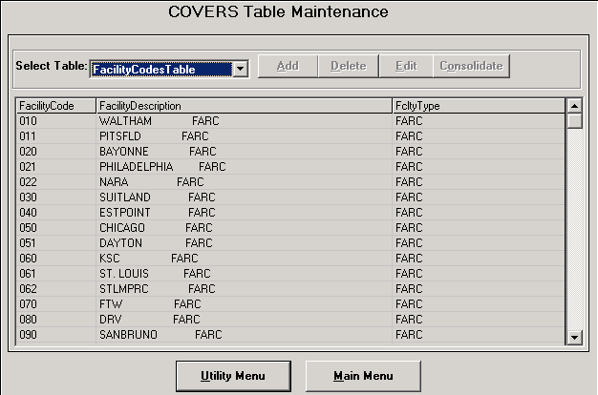

Facility Code Table Report

## Location Codes Tables

This table lists all codes that represent places where folders may be received.  All distinct locations where folders are to be tracked within the RO must be entered here.  Tracking of requests and folders is performed to the location and not to the UserID of the person making a request or receiving a folder.  The granularity of tracking will be reflected in the number of locations defined in the locations table.

The following rules apply when working with location codes:

* The location code may be 1 to 6 characters (no special characters are allowed)
* The description fields may be 1 to 30 characters and both are **required** fields.  An organization code must be selected.
* When editing an existing location code, only the description field may be modified.
* To change the location or organization code, the location code must be deleted and re-entered with the changes.
* If location codes become corrupted, the location codes may be refreshed using a copy from the server (Oracle) database.

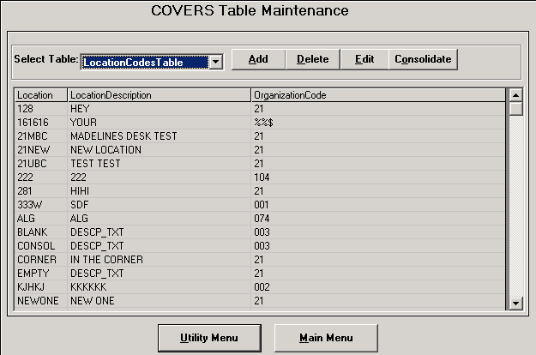

**What you need to know before deleting location codes**

**Note:**  Only the System Administrator should execute this operation.  All of the users should log off the system before performing this operation.

Before deleting a location code, you must consider the impact on your system.  Folders may be registered at this location; users may have the location indicated as a default location.  In either of these cases, it is unwise to delete the location code.  In fact, the COVERS system will not allow you to do so.

To prepare for the removal of a location code, create a folder statistics report to see if any folders are registered to the location.  If so, you need to receive the folders into a different location, or perform a location consolidation.  Also, review all system users and determine if any users have this location code as their indicated default location.  If so, change the default locations to a different location.

Location Code Table Report

## Organization Codes Tables

This table is used to enumerate the organizations within the VA.  In addition, it is used to show which service organizations represent the interest of other service organizations for that RO.

The following rules apply when working with organization codes:

* Organization codes may not be added or deleted; a different application (not COVERS) will do this.
* Only the "Represented By" field may be updated.  Updates to the "Represented By" field may take several hours before becoming effective.
* If the local copy of the organization code becomes damaged or corrupted, refresh the codes from the server (Oracle) database.

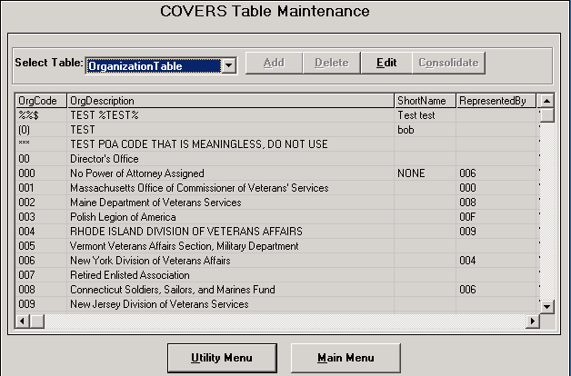

Organization Code Table Report

## Priority Codes Table

This table lists all codes used to enable a person making a request to identify the urgency for a folder.  When a priority code is entered, a number is assigned to the priority.  This number is used in sorting priorities.  When a request for a folder is issued, the priority for that search may be supplied.  The higher the number associated with the priority assigned to the request, the more urgent that request is assumed to be; legal values are in the range from 1 to 99.

**Note:**  Refresh of priority code table resets all priority codes to the same priority (s0). PROGRAM ADMINISTRATORS ARE STRONGLY URGED TO MAINTAIN PRIORITY VALUES USING THE EDIT FUNCTION, and not to use the refresh function.

The following rules apply when working with priority codes:

* The priority code is a single character, (a-z) and is **required**.  The description field is 1 to 30 characters and is **required**.
* The ranking code is a value from 1 to 99 and is **required**; no duplicate rankings are permitted.
* Only the description field and ranking code field may be edited.
* To change the priority code, delete the code and re-enter the code with the changes.

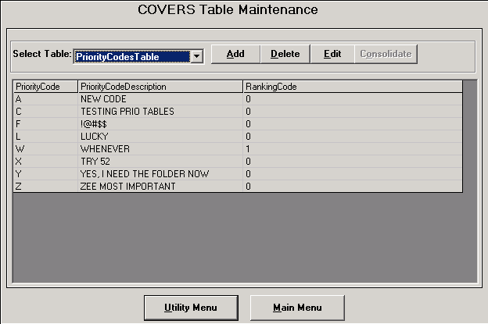

Priority Code Table Report

## Refresh Code From COVERS Table

This process initiates a download of data from Oracle into local Access database tables, and should be performed when the Oracle Org table is updated, or in case of irreparable damage to the Access database (Special Codes, Priority Codes, Location Codes).

**Note:**  Only the System Administrator should execute this operation.  All other users should log off the system before performing this operation

**To refresh the contents of a table**

1. Browse the table you wish to refresh.
2. Select the Refresh command.

## Special Codes Table

This table lists all codes that are used to associate a folder and to perform statistics on folder.  The use of these codes is entirely Regional Office dependent.  Potential uses for these codes include demographic studies, RO work flow studies and associating related folders for any reason.  Currently, each folder may be assigned only one special code.

The following rules apply when working with special codes:

* The special code is one to three characters, valid characters are a-z or 0-9, and is **required**.
* The description field is 1 to 30 characters and is **required**.
* Only the description field may be edited.
* To change a special code, delete the code and re-enter the changes.

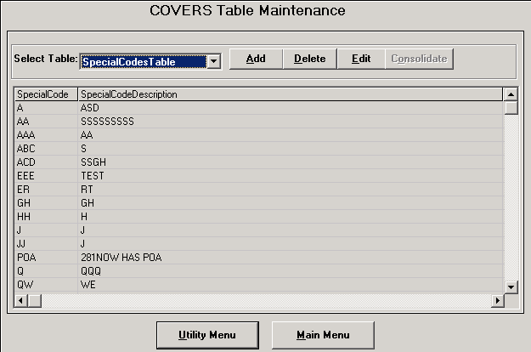

Special Code Table Report

## Locations @ 101

This table lists all the location codes that are used to identify folder locations at Station 101.  The use of these codes are only available when the user is at Station 101.  The codes identify the physical location of a folder while at Station 101.

The following rules apply when working with special codes:

* The special code is 1 to 6 characters, valid characters are a-z or 0-9, and is **required**.

# Screen Descriptions

## COVERS Main Menu screen

The COVERS Main Menu allows the user access to all COVERS screens.  The command buttons are divided into sections: *Folders, Search, Labels, Transfers, BIRLS, Miscellaneous, and Messages.*

The following command buttons are located in each section:

**Folders**

Receive

Single Inquiry

Name/SSN Inq

Add Volume

Change

Delete

**Search**

Mark For Mail

Request

Change/Delete

**Labels**

Generate Labels

Print Labels

**Transfers**

Request Transfer

Transfer Out

Print Xfr Slips

**BIRLS**

Location Inquiry

Loc Correction

**Miscellaneous**

Reports

Utilities

CVR Extract

**Messages**

Info/Error Messages

UnAuthorized Holdings

Folder Requests Your Sta

Folder Request Responses

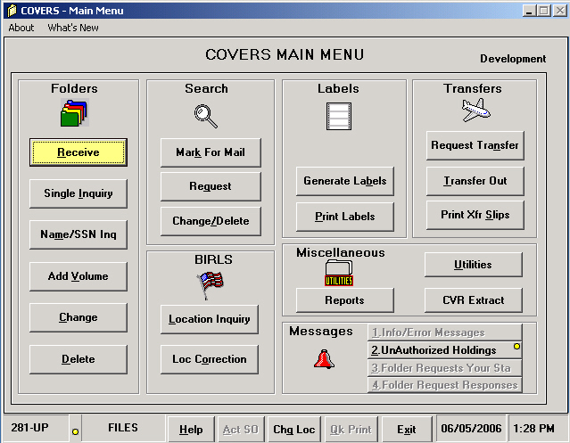

## Set RO User Options screen

The Set RO User Options screen is used to allow the Security Officers at each Regional Office (RO) to establish the preferred settings for a user.  These settings can only be changed by a designated Security Officer.

The fields on the Set RO User Option screen are as follows:

* Folder Types - CLAIM, NOD, TEMP
* General Settings - Msg Interval, Phone Pfx/Code, XfrSlip TD Sequence, XfrSlip Entry Sequence, Create XferSlip for POA, Number XferSlips to Create
* Paths - Database Path, Report Path, Error Path
* Search Settings - Search ROs
* Other Settings - Number of days after which queued labels are deleted, Number of Labels to Print, Number of days to view Transfer Slips, Unauthorized Holdings Location

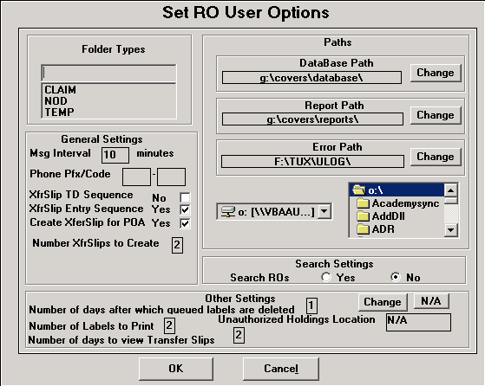

## Folder Data screen

**Screen Shot**

The Folder Data screen displays information for a specified folder including the veteran information, current folder location and BIRLS information.

All fields on the Folder Data screen are protected from user entry.  Folder information can be updated and deleted using the buttons at the bottom of the screen.  Volumes can be added by using the **Add Volume** button at the bottom of the screen.

**Note:**  The Folder Data screen will display different command buttons depending on the command used to access the screen.

The Folder Data screen contains the following fields:

* **File Number**
* **Folder Type**
* **Volume**
* **Last**
* **First**
* **Suffix**
* **Middle**
* **SSN**
* **POA**
* **Received At**
* **Confirmed At**
* **Special Code**
* **Restricted Data**
* **Type**
* **Vol**
* **Sta**
* **Loc**
* **Trans**
* **Spcl**
* **Code**
* **Restricted Data**
* **Org**
* **Received Date**
* **Confirm Date**
* **Created by User ID**
* **Last Updated by User ID**
* **Message Area**

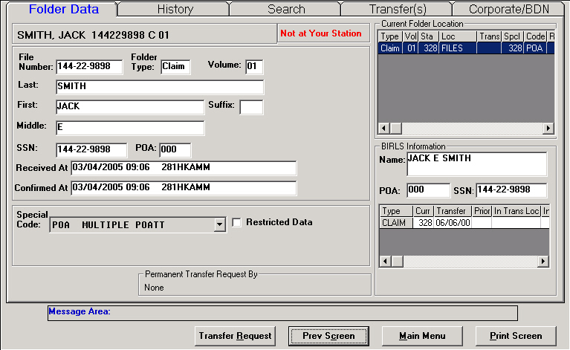

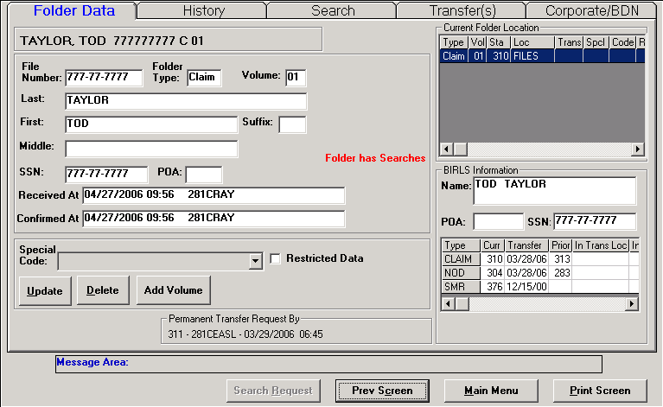

## History screen

**Screen Shot**

The History screen displays the folder location history for a specified folder including current folder location and BIRLS information.

All fields on the History screen are protected from user entry.  History information is recorded each time a folder is transferred in or out of a location, including within and out of a station.

The History screen contains the following fields:

* **Station**
* **Location**
* **Status**
* **Date/Time In**
* **Date/Time Out**
* **User ID**
* **Type**
* **Vol**
* **Trans**
* **Spcl**
* **Code**
* **Restricted Data**
* **Org**
* **Received Date**
* **Confirm Date**
* **Created by User ID**
* **Last Updated by User ID**
* **Permanent Transfer Request By**
* **Message Area**

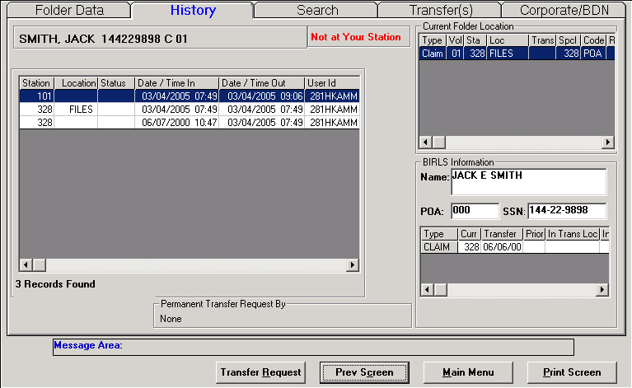

## Search screen

**Screen Shot**

The Search screen displays all searches for a specified folder.

All fields on the Search screen are protected from user entry.  Search information is recorded each time a search is initiated for a folder.

The Search screen contains the following fields:

* **Station**
* **Location**
* **Org**
* **Date**
* **Type**
* **Priority**
* **User ID**
* **Comment**
* **Vol**
* **Trans**
* **Spcl**
* **Code**
* **Restricted Data**
* **Org**
* **Received Date**
* **Confirm Date**
* **Created by User ID**
* **Last Updated by User ID**
* **Permanent Transfer Request By**
* **Message Area**

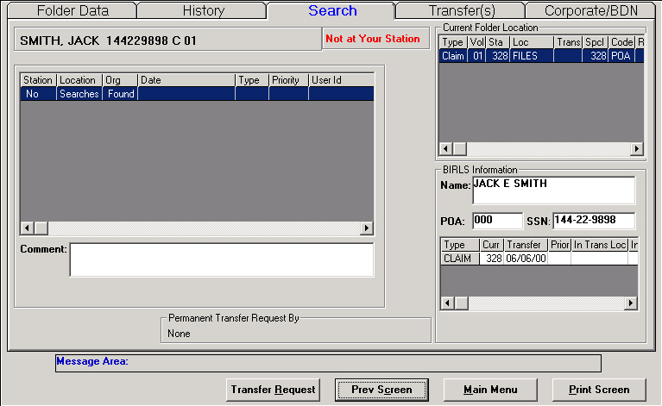

## Transfer screen

The Transfer screen will allow the user to transfer a folder between stations.  The user will be allowed to select the folder to be transferred.

Folder transfers can be updated and transfer slips printed using the **Print Transfer Slip** and **Update Transfer** buttons .

The Transfer screen contains the following fields:

* **Transfer From**
* **Transfer To**
* **Type of Transfer**
* **Transfer Date**
* **Remarks**
* **Route To**
* **Expected Back By**
* **Send Back Date**
* **Adjudication Pending**
* **Brokered Work**
* **Type**
* **Vol**
* **Station**
* **Location**
* **Trans**
* **Spcl**
* **Code**
* **Restricted Data**
* **Org**
* **Received Date**
* **Confirm Date**
* **Created by User ID**
* **Last Updated by User ID**

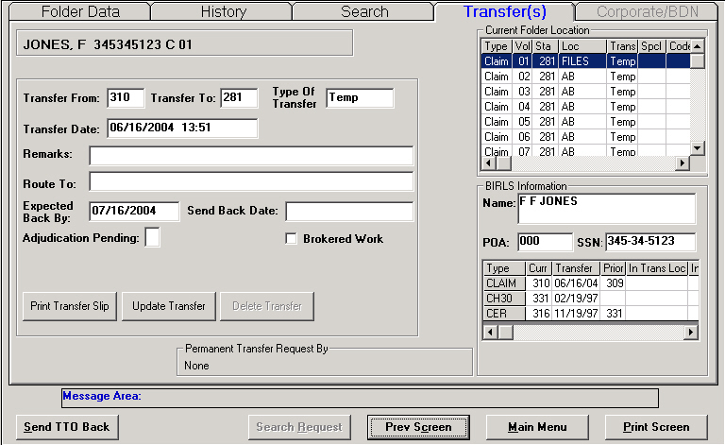

## Corp/BDN screen

The Corp/BDN screen displays BDN/PIF, Corporate Claim and Corporate Award information for a specified folder.

All fields on the Folder Data screen are protected from user entry.  Folder information can be updated and deleted using SHARE and BDN functions.

The Corp/BDN screen contains the following fields:

* **Payee**
* **Benefit Type**
* **Claim Type**
* **Claim Received Date**
* **Ptcpnt Vet Name**
* **Ptcpnt Claimant Name**
* **PGM Type Code**
* **Benefit Claim Type Code**
* **Payee Type Code**
* **Status Type Code**
* **Change Date**
* **Location**

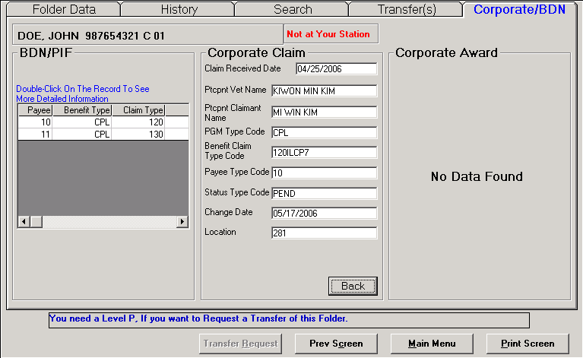

## Folders

### Receive screen

The Receive screen is used to enter the folder information to receive a folder that has arrived at the users location from other locations inside, as well as outside the Regional Office (RO).

The Receive screen is displayed after the COVERS Main Menu screen and contains the following fields:

* **File Number**
* **Folder Type**
* **Volume**
* **Clear Folder Location Count**
* **Message Area**
* **Do Not Display Search/Sensitive Message**

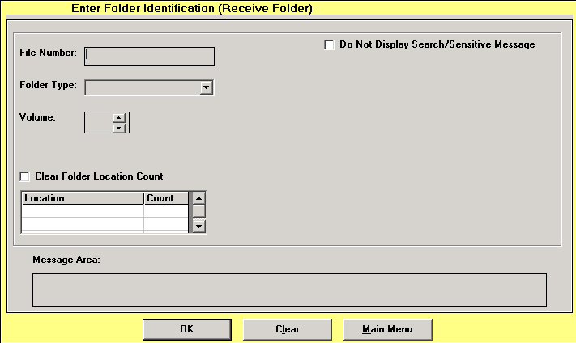

### Single Inquiry screen

The Single Inquiry screen will allow the user to inquiry on a specified folder.

The Search screen contains the following fields:

* **File Number**
* **Folder Type**
* **Volume**
* **Message Area**

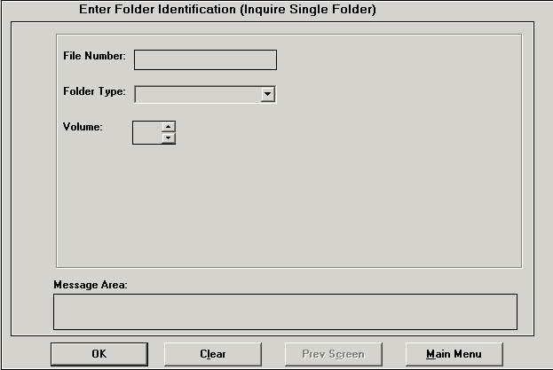

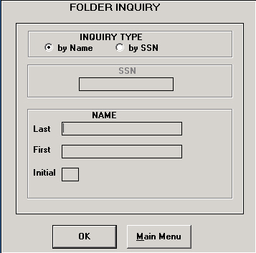

### Name/SSN Inquiry screen

The Name/SSN Inquiry screen will allow the user to inquiry on a specified name or SSN.

The Name/SSN Inquiry screen contains the following fields:

* **SSN**
* **Last Name**
* **First Name**
* **Middle Initial**



### Add Volume screen

**Screen Shot**

The Add Volume screen will allow the user to add a volume to a veteran folder.

The Add Volume screen contains the following fields:

* **File Number**
* **Folder Type**
* **Volume**
* **Last**
* **First**
* **Suffix**
* **Middle**
* **SSN**
* **POA**
* **Received At**
* **Confirmed At**
* **Special Code**
* **Restricted Data**
* **Type**
* **Vol**
* **Sta**
* **Loc**
* **Trans**
* **Spcl**
* **Code**
* **Restricted Data**
* **Org**
* **Received Date**
* **Confirm Date**
* **Created by User ID**
* **Last Updated by User ID**
* **Message Area**



### Change screen

The Change screen allows the user to change information on the Transfer screen.

The Change screen contains the following fields:

* **Transfer From**
* **Transfer To**
* **Type of Transfer**
* **Transfer Date**
* **Remarks**
* **Route To**
* **Expected Back By**
* **Send Back Date**
* **Adjudication Pending**
* **Brokered Work**
* **Type**
* **Vol**
* **Station**
* **Location**
* **Trans**
* **Spcl**
* **Code**
* **Restricted Data**
* **Org**
* **Received Date**
* **Confirm Date**
* **Created by User ID**
* **Last Updated by User ID**



### Delete screen

The Delete screen allows the user to delete a specified folder.



### Folder Inquiry

The Folder Inquiry screen allows the user to determine the inquiry type for a folder.



## Search

### Multiple Folder Inquiry

The Multiple Folder Inquiry screen displays all of the inquiries for folders at a specified location.

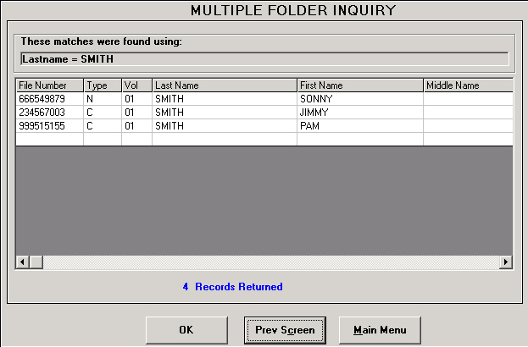

### Delete Search screen

**Screen Shot**

The Delete Search screen will allow the user to delete a folder search.  The user will be allowed to select the folder search to be deleted.

All fields on the Search screen are protected from user entry.  A **Delete Search** button is located below the *Comments* field.

The Search screen contains the following fields:

* **Station**
* **Location**
* **Org**
* **Date**
* **Type**
* **Priority**
* **User ID**
* **Comment**
* **Vol**
* **Trans**
* **Spcl**
* **Code**
* **Restricted Data**
* **Org**
* **Received Date**
* **Confirm Date**
* **Created by User ID**
* **Last Updated by User ID**
* **Permanent Transfer Request By**
* **Message Area**

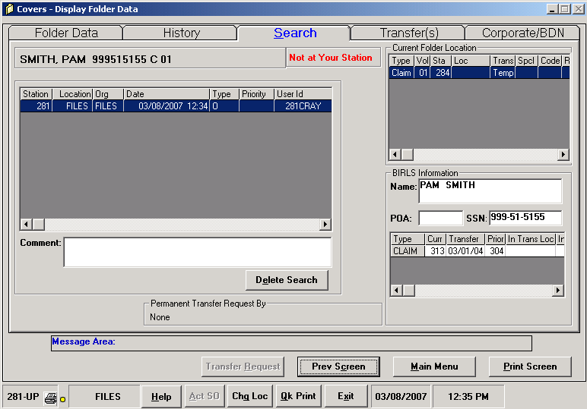

### Mark Folder For Mail screen

The Mark Folder For Mail screen is used to inform COVERS that there is action mail to attach to a folder.

The Receive screen is displayed after the COVERS Main Menu screen and contains the following fields:

* **File Number**
* **Folder Type**
* **Volume**
* **Comment**
* **Message Area**

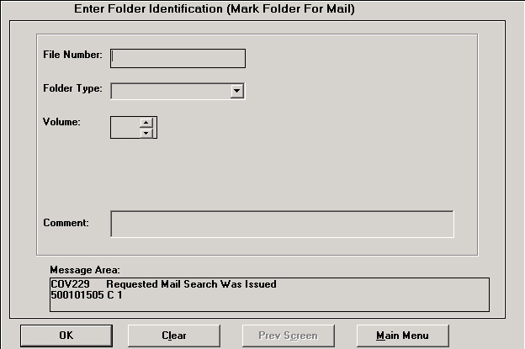

### Request screen

The Request screen will allow the user to request a specified folder.

The Request screen contains the following fields:

* **File Number**
* **Folder Type**
* **Volume**
* **Priority**
* **Comment**
* **Message Area**

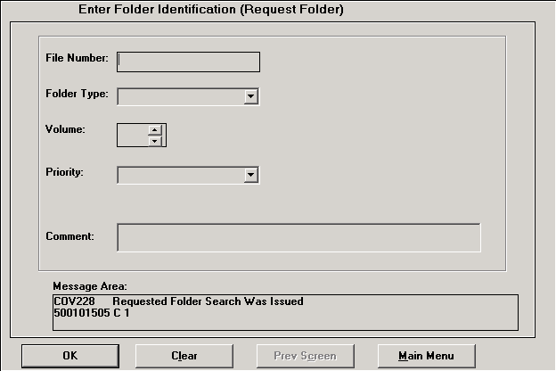

### Change/Delete screen

The Change/Delete screen contains command buttons to allows the user to access all change and delete searches for folders.

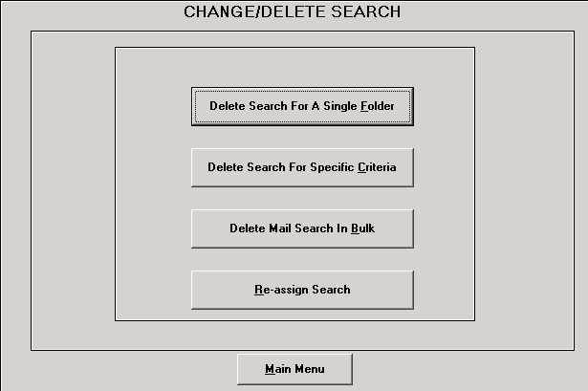

### Delete Search For A Single Folder screen

The Delete Search For A Single Folder screen will allow the user to delete a search for a specified folder.

If more than one search is located for a folder, a grid will be displayed with all of the outstanding searches.

The Delete Search For A Single Folder screen contains the following fields:

* **File Number**
* **Folder Type**
* **Volume**
* **Message Area**
* **Location**
* **Date**
* **Type**
* **Priority**
* **Delete All Searches**

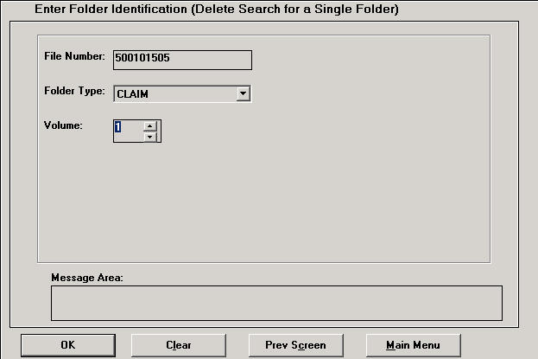

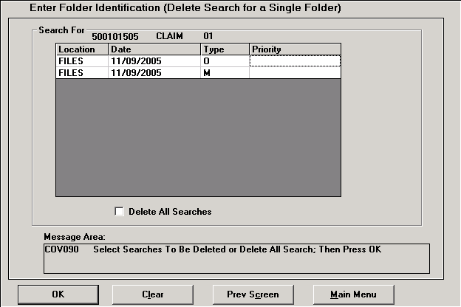

### Delete Search For A Specific Criteria screen

The Delete Search For A Specific Criteria screen allows the user to specify report search criteria for folders.

The Delete Search For A Specific Criteria screen contains the following fields:

* **Folder Locations**
* **Search Locations**
* **TD Range**
* **Search Date**
* **Search Type(s)**
* **Priority Code**
* **TTO Option**

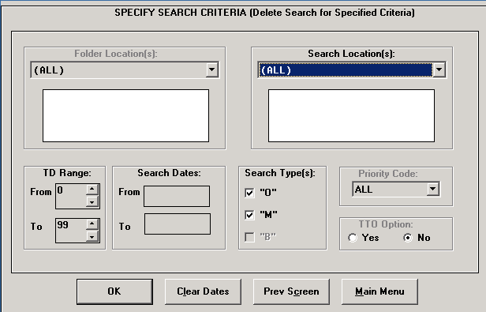

### Delete Mail Search In Bulk screen

The Delete Mail Search In Bulk screen will allow the user to delete searches in bulk for a specified folder.

The Delete Mail Search In Bulk screen contains the following fields:

* **File Number**
* **Folder Type**
* **Volume**
* **Return Status Message**

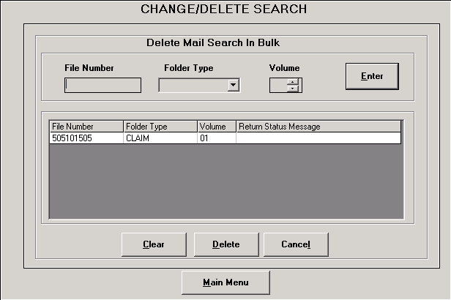

### Re-Assign Search screen

The Re-Assign Search screen will allow the user to reassign folder searches between locations.  The *Search Reassignments* grid will display all of the reassignments for the specified folder.

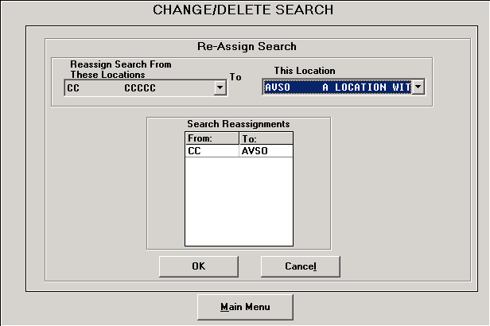

### Search List by Priority Code screen

The Search List by Priority Code screen allows the user to produce a report using the Priority Codes.

The Search List by Priority Code screen contains the following fields:

* **Folder Locations**
* **Search Locations**
* **TD Range**
* **Search Date**
* **Search Type(s)**
* **Priority Code**
* **TTO Option**

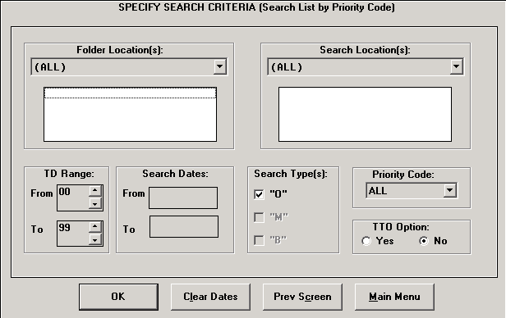

### Search List by Folder Location screen

The Search List by Folder Location screen allows the user to produce a report using the Folder Locations.

The Search List by Folder Location screen contains the following fields:

* **Folder Locations**
* **Search Locations**
* **TD Range**
* **Search Date**
* **Search Type(s)**
* **Priority Code**
* **TTO Option**

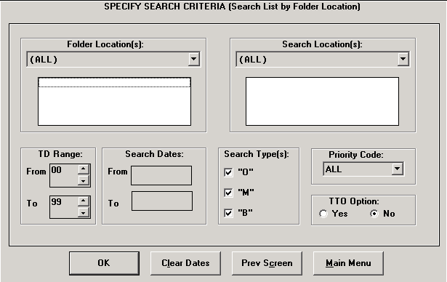

### Search List by Search Location screen

The Search List by Search Location screen allows the user to produce a report searching by locations.

The Search List by Search Location screen contains the following fields:

* **Folder Locations**
* **Search Locations**
* **TD Range**
* **Search Date**
* **Search Type(s)**
* **Priority Code**
* **TTO Option**

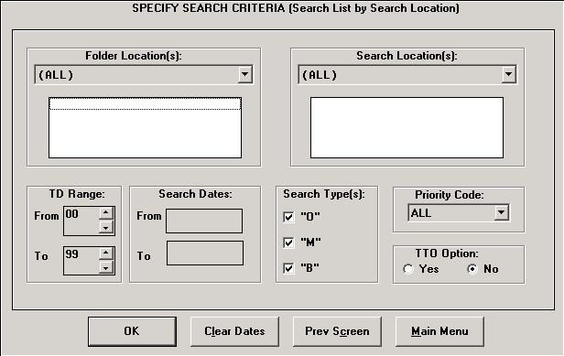

### Search List by Terminal Digit screen

The Search List by Terminal Digit screen allows the user to produce a report using the Terminal Digits.

The Search List by Terminal Digit screen contains the following fields:

* **Folder Locations**
* **Search Locations**
* **TD Range**
* **Search Date**
* **Search Type(s)**
* **Priority Code**
* **TTO Option**

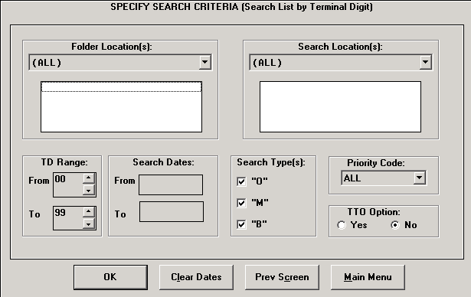

### Folder Search Review screen

**Screen Shot - Search Criteria**

**Screen Shot - Folder Review**

The Folder Search Review screen allows the user to produce a report for a folder search review.

The Folder Search Review screen contains the following fields:

* **Folder Locations**
* **Search Locations**
* **TD Range**
* **Search Date**
* **Search Type(s)**
* **Priority Code**
* **TTO Option**
* **TD**
* **File Number**
* **Type**
* **Vol**
* **Issued By**
* **Priority**
* **Search Date**

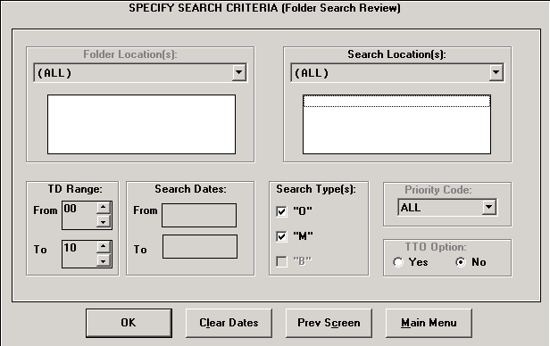

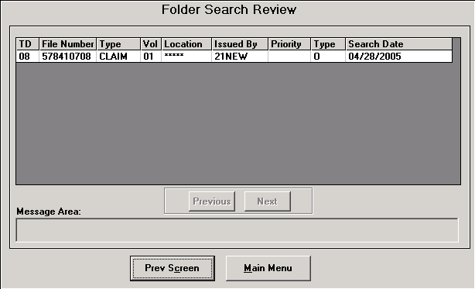

## Labels

### Generate Labels screen

The Generate Labels screen allows the user to generate an additional labels for a folder.

The Generate Labels screen contains the following fields:

* **File Number**
* **Folder Type**
* **Volume**

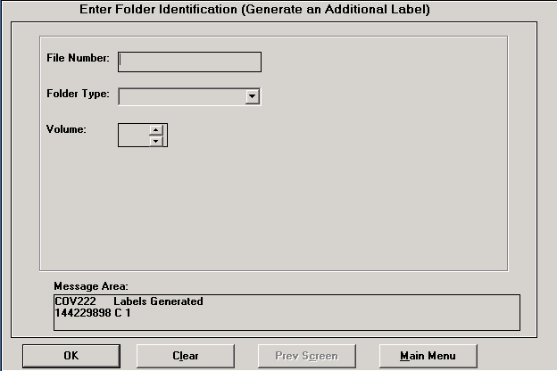

### Print Labels screen

The Print Labels screen allows the user to print labels for a folder.  Label can be printed using one of three options: Print All Pending Labels, Print All Pending From Current Location, or Print Selected Labels.

The Print Labels screen contains the following fields:

* **Label Source**
* **Print Options**
* **File Number**
* **Folder Type**
* **Volume**
* **Name**
* **Loc**
* **Print Date**

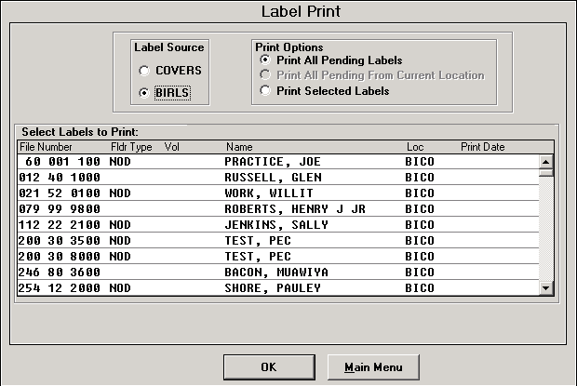

## Transfers

### Request Transfer screen

The Request Transfer screen is used to request a transfer of a folder from one station to another.  There are four types of transfers: Permanent, Temporary, Send TTO Back, and Mass Temporary Transfer.

On the Folder Data screen, the **Transfer Request** button will appear at the bottom of the screen.

The Request Transfer screen contains the following fields:

* **File Number**
* **Folder Type**
* **Vol**
* **Message Area**

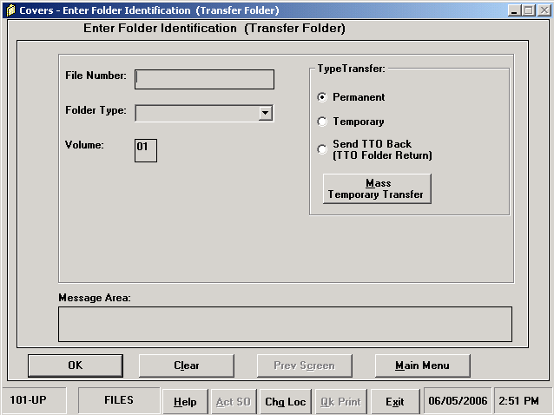



### Transfer Out screen

The Transfer Folder screen is used to transfer a folder from one station to another.  There are four types of transfers: Permanent, Temporary, Send TTO Back, and Mass Temporary Transfer.

The Transfer Folder screen contains the following fields:

* **File Number**
* **Folder Type**
* **Vol**
* **Message Area**



### Print Xfrs Slip screen

The Print Xfrs Slip screen is used to print a transfer slip for a folder.

The Print Xfrs screen contains the following fields:

* **File Number**
* **Transfer To**
* **Print Date**
* **P/T**

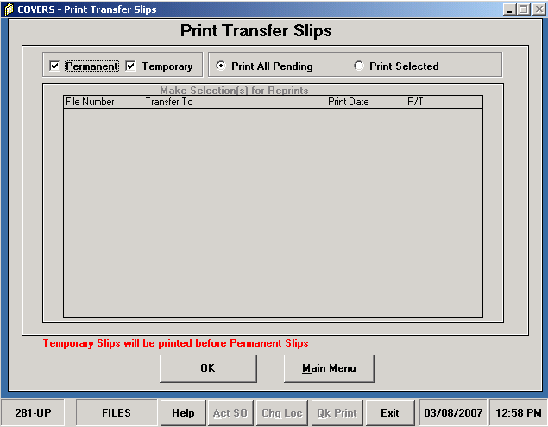

### Temporary Transfer screen

The Temporary Transfer screen is used to transfer a folder to a new station temporarily.  A transfer slip can also be created.

The Temporary Transfer screen contains the following fields:

* **File Number**
* **Folder Type**
* **Volume**
* **Name**
* **Route To**
* **Expected Return Date**
* **Transfer To**
* **Remarks**
* **Create Transfer Slip**
* **Brokered Work**
* **Message Area**

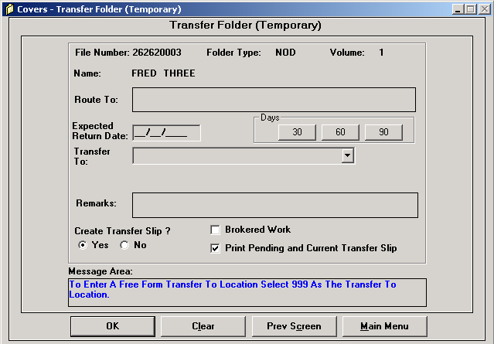

### Permanent Transfer screen

The Permanent Transfer screen is used to transfer a folder to a new station permanently.  A transfer slip can also be created.

The Permanent Transfer screen contains the following fields:

* **File Number**
* **Folder Type**
* **Volume**
* **Name**
* **Route To**
* **Adjudication Pending**
* **Transfer To**
* **Remarks**
* **Create Transfer Slip**
* **Message Area**



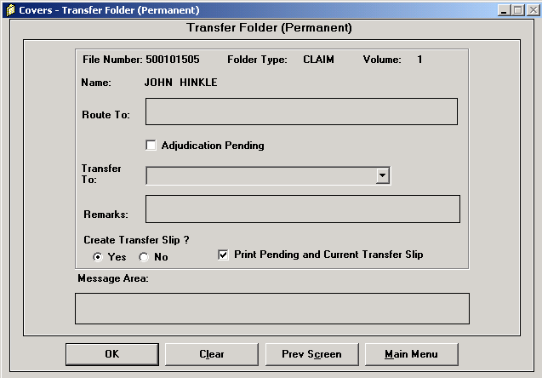

### Delete Transfer Request screen

**Screen Shot**

The Delete Transfer Request screen will allow the user to delete a folder transfer request.  The user will be allowed to select the transfer request to be deleted.

All fields on the Search screen are protected from user entry.  A **Delete Request** button is located in the 'Permanent Transfer Request By' field.

The Search screen contains the following fields:

* **Station**
* **Location**
* **Org**
* **Date**
* **Type**
* **Priority**
* **User ID**
* **Comment**
* **Vol**
* **Trans**
* **Spcl**
* **Code**
* **Restricted Data**
* **Org**
* **Received Date**
* **Confirm Date**
* **Created by User ID**
* **Last Updated by User ID**
* **Permanent Transfer Request By**
* **Message Area**

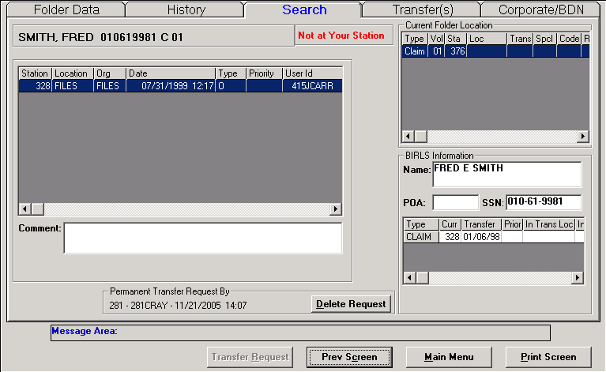

### Create Temp Folder screen

**Screen Shot**

The Create Temp Folder screen displays allows the user to create a temporary folder for a veteran.

All fields on the Create Temp Folder screen are protected from user entry.

The Create Temp Folder screen contains the following fields:

* **File Number**
* **Folder Type**
* **Volume**
* **Last**
* **First**
* **Suffix**
* **Middle**
* **SSN**
* **POA**
* **Received At**
* **Confirmed At**
* **Special Code**
* **Restricted Data**
* **Type**
* **Vol**
* **Sta**
* **Loc**
* **Trans**
* **Spcl**
* **Code**
* **Restricted Data**
* **Org**
* **Received Date**
* **Confirm Date**
* **Created by User ID**
* **Last Updated by User ID**
* **Message Area**

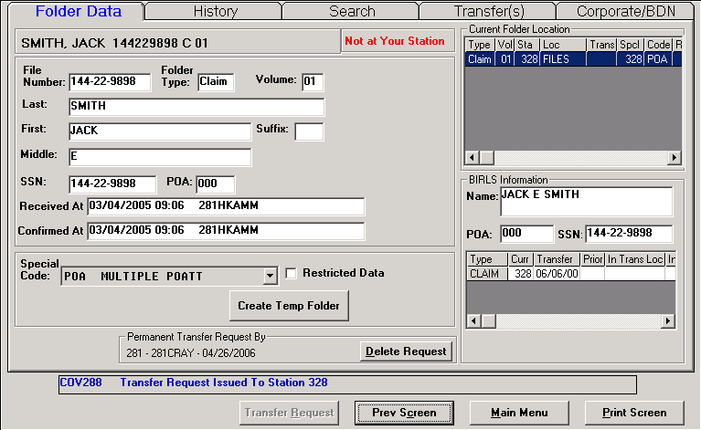

### Mass Temporary Transfer Folders screen

The Mass Temporary Transfer Folders screen is used to transfer a large number of folders from one station to another.

The Mass Temporary Transfer Folders screen contains the following fields:

* **File Number**
* **Folder Type**
* **Transferred Folders**
* **Route To**
* **Expected Return Date**
* **Transfer To**
* **Remarks**
* **Create Transfer Slip**
* **Brokered Work**
* **Print Pending and Current Transfer Slip**

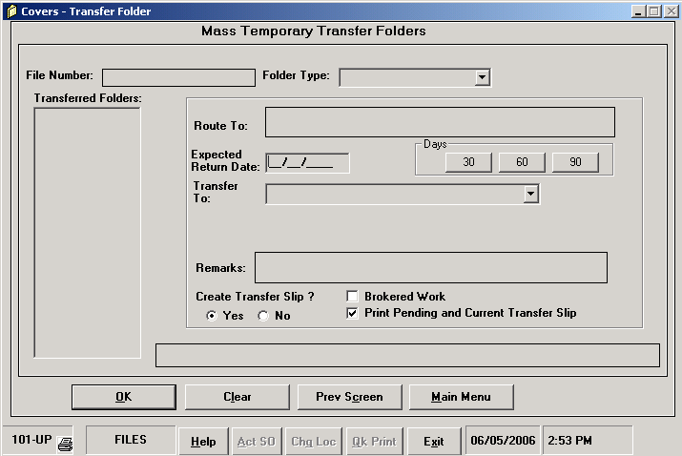

### Delete Transfer screen

The Delete Transfer screen will allow the user to delete a folder transfer.  The user will be allowed to select the transfer request to be deleted.

All fields on the Search screen are protected from user entry.  **Delete Transfer** and **Transfer Selection** button .

The Delete Transfer screen contains the following fields:

* **Transfer From**
* **Transfer To**
* **Type of Transfer**
* **Transfer Date**
* **Remarks**
* **Route To**
* **Expected Back By**
* **Send Back Date**
* **Adjudication Pending**
* **Type**
* **Vol**
* **Station**
* **Location**
* **Trans**
* **Spcl**
* **Code**
* **Restricted Data**
* **Org**
* **Received Date**
* **Confirm Date**
* **Created by User ID**
* **Last Updated by User ID**

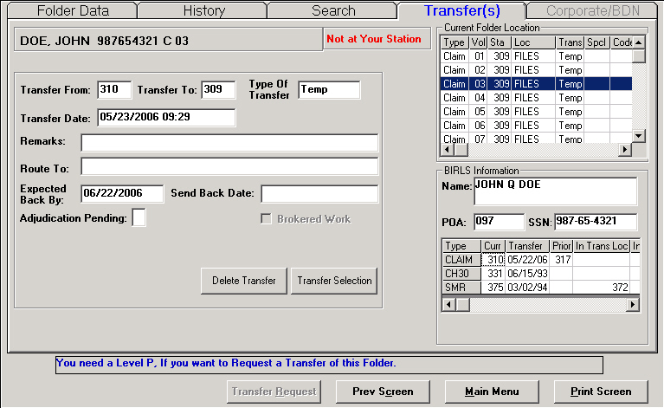

### Delete Temp Folder screen

**Screen Shot**

The Transfer Folder screen is used to transfer a folder from one station to another.  There are four types of transfers: Permanent, Temporary, Send TTO Back, and Mass Temporary Transfer.

The Transfer Folder screen contains the following fields:

* **File Number**
* **Folder Type**
* **Volume**
* **Last**
* **First**
* **Suffix**
* **Middle**
* **SSN**
* **POA**
* **Received At**
* **Confirmed At**
* **Special Code**
* **Restricted Data**
* **Type**
* **Vol**
* **Sta**
* **Loc**
* **Trans**
* **Spcl**
* **Code**
* **Restricted Data**
* **Org**
* **Received Date**
* **Confirm Date**
* **Created by User ID**
* **Last Updated by User ID**
* **Message Area**

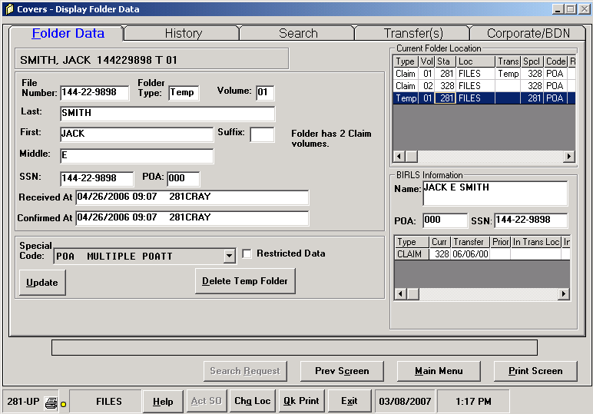

### Update Transfer screen

**Screen Shot**

The Update Transfer screen is used to update the transfer a folder from one station to another.

The Transfer Folder screen contains the following fields:

* **Transfer From**
* **Transfer To**
* **Type of Transfer**
* **Transfer Date**
* **Remarks**
* **Route To**
* **Expected Back By**
* **Send Back Date**
* **Adjudication Pending**
* **Brokered Work**
* **Type**
* **Vol**
* **Station**
* **Location**
* **Trans**
* **Spcl**
* **Code**
* **Restricted Data**
* **Org**
* **Received Date**
* **Confirm Date**
* **Created by User ID**
* **Last Updated by User ID**

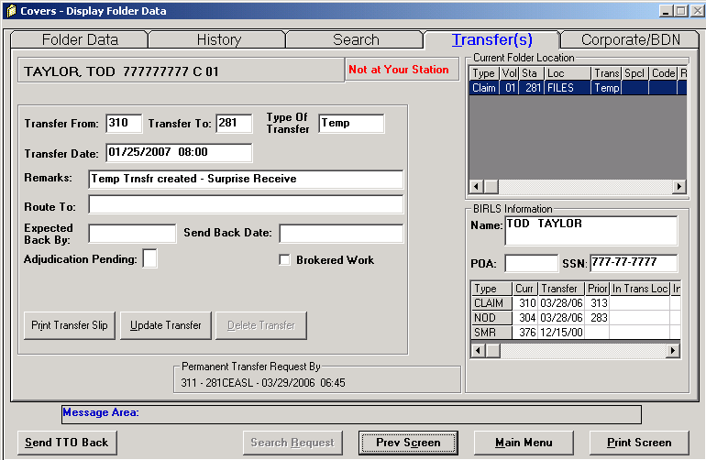

## BIRLS

### Location Inquiry screen

The Location Inquiry screen allows the user to view the BIRLS folder location information for a specified folder.

The Location Inquiry screen contains the following fields:

* **File Number**
* **SSN**
* **POA**
* **Last Name**
* **First Name**
* **Middle Name**
* **Name Suffix**
* **Folder Type**
* **Current Location**
* **Trans Date**
* **Prior Loc**
* **In Transit To Station**
* **In Transit To Date**
* **Des Ind**
* **Rblt Ind**

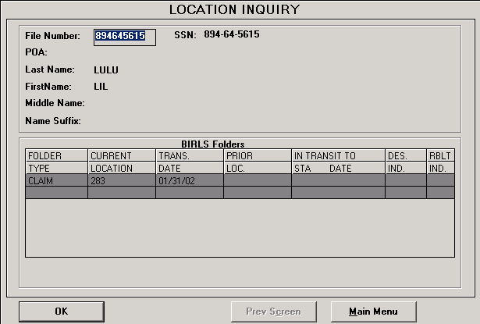

### Loc Correction screen

**Screen Shot**

The Loc Correction screen allows the user to make a correction to a folder location.  The **Update** button will be enabled.

The Loc Correction screen contain the following fields:

* **File Number**
* **Folder Type**
* **Volume**
* **Last**
* **First**
* **Suffix**
* **Middle**
* **SSN**
* **POA**
* **Received At**
* **Confirmed At**
* **Special Code**
* **Restricted Data**
* **Type**
* **Vol**
* **Sta**
* **Loc**
* **Trans**
* **Spcl**
* **Code**
* **Restricted Data**
* **Org**
* **Received Date**
* **Confirm Date**
* **Created by User ID**
* **Last Updated by User ID**
* **Message Area**

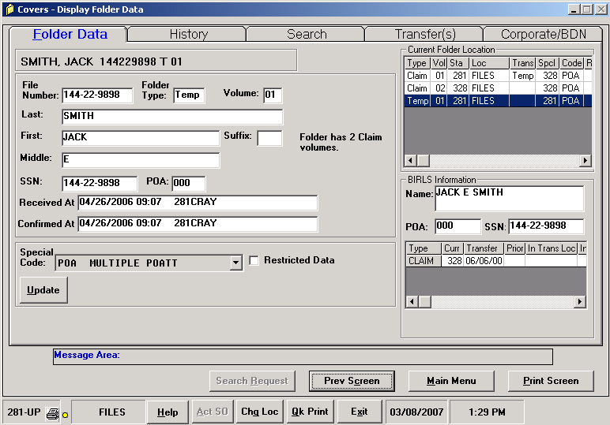

## Miscellaneous

### Reports screen

The Reports screen displays a selection of the available reports for printing.

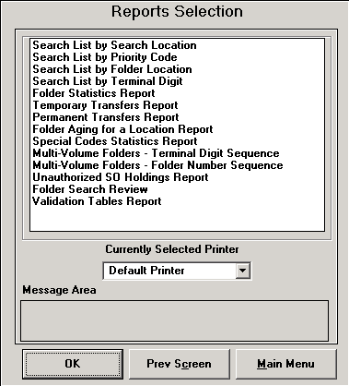









### Utilities screen

The Utilities screen contains command buttons to allows the user to access all utilities within COVERS.

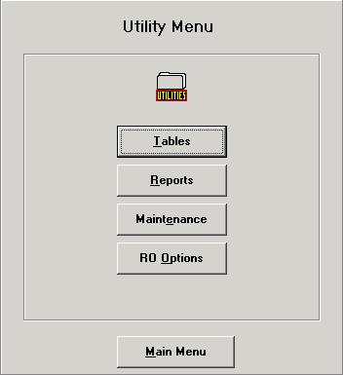

### CVR Extract screen

The CVR Extract screen will allow the user to move data between COVERS and an Excel spreadsheet.

* **File Number Order**
* **Ignore Temp Folders**
* **Message**
* **File Number**
* **Type**
* **Vol**
* **Sta**
* **Loc**
* **Trans**
* **Search**
* **Lock**
* **Last Name**

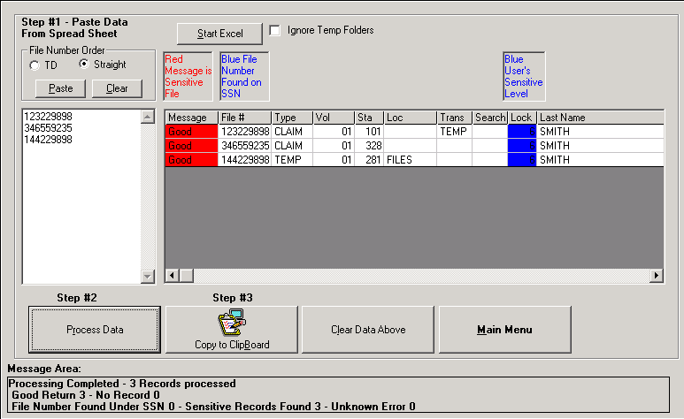

### Report Options-Folder Aging screen

The Report Options-Folder Aging screen allows the user to select and initiate a report using a set of aging durations for a specific folder.

The Report Options - Folder Aging screen contains the following fields:

* **Folder Location**
* **Select Aging Durations**
* **Message Area**

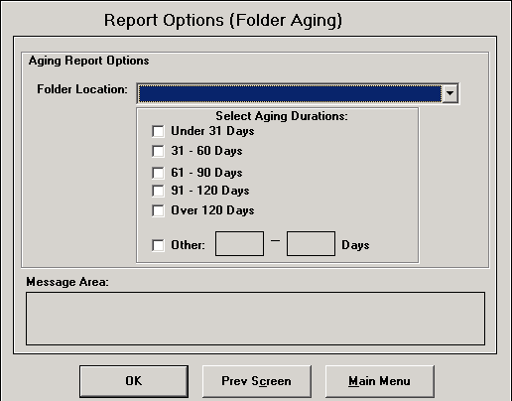

### Report Options-Special Codes screen

The Report Options-Special Codes screen allows the user to select a specific code report to print within a defined TD range.

The Report Options - Special Codes screen contains the following fields:

* **Code**
* **Description**
* **Specify TD Range**
* **Message Area**

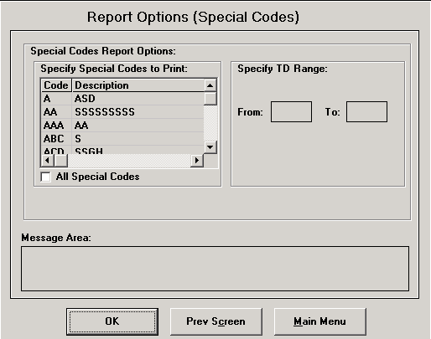

### Table Reports Selection screen

The Table Reports Selection screen allows the user to select a specific code report for printing.

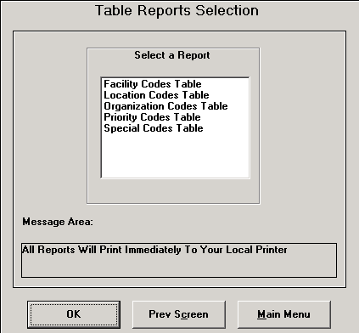

### Table Maintenance screen

The Table Maintenance screen allows the user to add, delete, edit, or consolidate locations to a selected tables.

**Special Codes Table**

**Location At 101Table**

**Location Table**

**Priority Codes Table**

**Organization Table**

**Facility Code Table**

### Consolidate Locations screen

The Consolidate Locations screen grid displays the locations that are available for consolidation.  The user may consolidate up to six locations into one specified location.  All requests and searches will be moved to the new location.

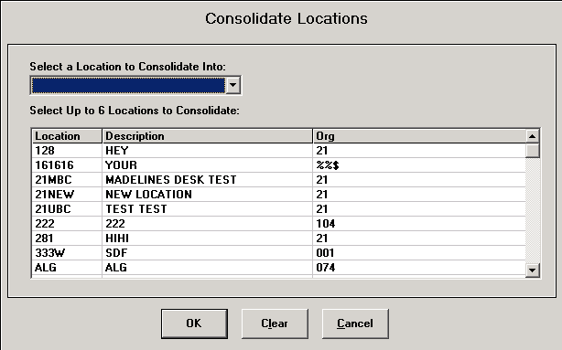

### Folder Retirement/Relocation screen

The Folder Retirement/Relocation screen displays the processing type that are available.

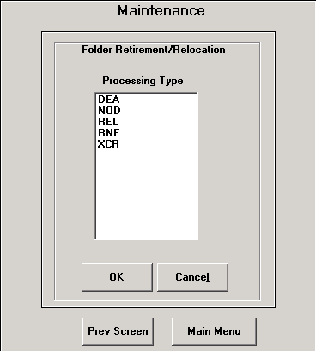

### Act As Service Organization screen

The Act As Service Organization screen allow designated users to change their location in order to serve as the Service Organization.

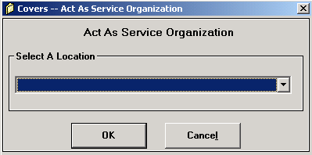

### Change User Location screen

The Change User Location screen allows the user to change their station location.



## Messages

### Info/Error Messages screen

The Info/Error Messages screen will be displayed when the yellow indicator light is visible in the Messages section of the Main Menu.  This will alert the user that they have messages regarding folders that may be requested or searched on by the User's ID.

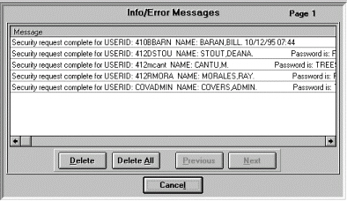

### Unauthorized Holdings screen

The Unauthorized Holding screen will display folders that are currently at unauthorized locations.

* **File Number**
* **Folder Type**
* **Volume**
* **Date**
* **Time**
* **Location**

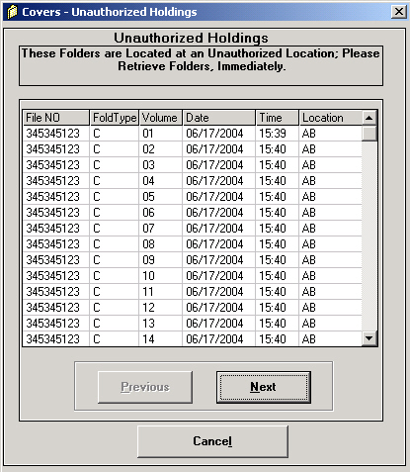

### Folder Request Your Sta screen

The Folder Request Your Station screen will display folders that are currently available for disposition at the users station.  Folders can be selected and charged out or forwarded to a specified location.

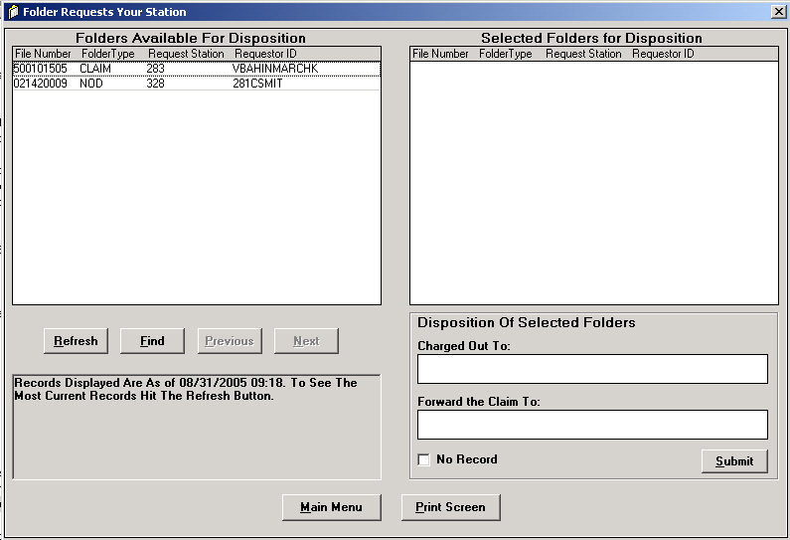

### Folder Request Responses screen

The Folder Request Responses screen will display folder requests for a specific folder and any messages associated with it.

The Folder Request Responses screen contains the following fields:

* **File Number**
* **Folder Type**
* **Requested From**
* **Requestor ID**
* **Folder Message**
* **Date/Time**

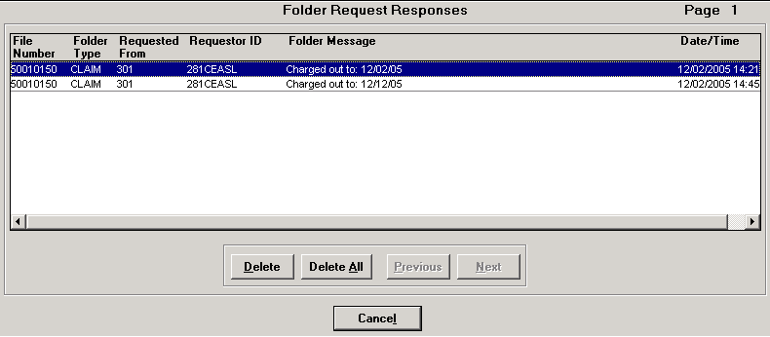

# Field Descriptions

## Field Descriptions

**Adj Pending** - Select if the folder has Adjudication Pending.

**Benefit Claim Type Code** - The alpha code designating the type of benefit claim.

**Benefit Type** - The business category for a benefit claim (CPL-Live or CPD-Death).

**BICO** - BIRLS to COVERS.

**Brokered Work** - This field indicated whether or not the folder being transferred for for brokered work.

**Cancel** - This button will cancel the current action.

**Change Date** - The date that the Corporate claim was changed.

**Claim Received Date** - The earliest date the claim was received by any VA facility.

**Claim Type** - The EPC code and description of the type of claim.

**Clear** - This button will clear all data entered on the screen and reset values, if applicable.

**Clear Dates** - This button will clear all entered dates.

**Clear Folder Location Count** - When selected, this indicator will clear the folder count for a specific location.

**Clear Rep By** - This button will clear the 'Represented by' field of an organization code.

**Code** - Enter priority code (single character, a-z) or special code (1 to 3 characters, a-z or 0-9).

**Code Description** - The code description field is 1 to 30 characters and is a required field.

**Comment** - This field allows comments to be entered regarding the folder.

**Confirm** - This button will confirm the action being performed.

**Confirm Date** - The date and time the folder was confirmed at the station.

**Confirmed At** - The date and time that the folder was confirmed at the current location, and the User ID that confirmed the received transaction.

**Created by User ID** - The ID of the user that created the request.

**Create Transfer Slip** - Selecting this field will print the current and pending transfer slips.

**Date** - The date the search was issued for a folder.

**Date/Time In** - The date and time the folder was received in.

**Date/Time Out** - The date and time the folder was transferred out.

**Delete** - This button will delete the selected entries on the screen.

**Delete All** - This button will delete all selected entries/messages on the screen.

**Delete All Searches** - When selected, this indicator will delete all searches for a folder.

**Description** - This field describes the location code.

**Destroyed Indicator** - When selected, this will indicate if the folder has been destroyed.

**Do Not Display Search/Sensitive Message** - When selected, this field will suppress the Search/Sensitive Message from being displayed.

**Expected Return Date** - Available only when doing a Temporary Transfer.  This date is eight characters and is required.  It must be entered in the format mm/dd/ccyy and must be greater than the current date but less than two years.

**File Number** -The veterans file number or claim number.

**File Number Order** - This denotes the detail display of the file numbers requested, i.e. by terminal digit or straight.

**Find** - This button will search the database for the entered file number.

**First Name** - The first name of the veteran or beneficiary.

**Folder Location** - If folder location is selected, only searches for folders in the specified locations will be provided.

**Folder Message** - Messages regarding the selected folder.

**Folder Type** - Select the folder type.  COVERS currently only tracks CLAIM and NOD folder types.

**Ignore Temp Folders** - When selected, all Temp folders will not be returned in the search.

**In Transit To Date** - The date that the folder was in transit to the new station.

**In Transit To Sta** - The station that the folder is in transit to.

**Issued By** - The user ID denoting who issued the search for a folder.

**Label Source** - Determines the data source from where the labels are to be printed from.

**Last Name** - The last name of the veteran or beneficiary.

**Last Updated by User ID** - The ID of the user that updated the request.

**Location Codes** - Represents places where folders may be received.  The location code can be one to six characters.  Valid characters are a-z.

**Main Menu** - This button will return the user to the main menu screen.

**Message** - This indicated the condition of the file.

**Message Area** - Displays a variety of COVERS messages, including error and completion messages.

**Middle Name** - The middle name of the veteran or beneficiary.

**Name** - The last name, first name, middle name, and suffix of the veteran.

**Next** - This button will retrieve the next set of entries/messages.

**OK Print** - This function allows the user to print a label.  It is available after a user performs a 'Receive', 'Transfer-In' or 'Add a Volume' to a folder.

**Organization Code** - Organization codes are organizations within the VA.  Organization codes cannot be deleted.

**P/T** - Permanent or Temporary transfer.

**Participant Claimant Name** - The name for the claimant.

**Participant Vet Name** - The name for the veteran participant.

**Payee** - A series of two-digit codes designated to the veteran and beneficiaries.

**Payee Type Code** - The two-digit code designating the veteran or beneficiary.

**Permanent Transfer Request By** - Displays the date and time, and User ID of the individual that requested the permanent transfer of a folder.

**PGM Type Code** - The claim code for the claim type (Live or Death).

**Power Of Attorney** - Assigned to a National or State service organization possessing authority to represent the beneficiary before the VA.

**Prev Screen** - This button will return to the previous screen.

**Previous** - This button will retrieve the previous set of entries/messages.

**Print Date** - Indicates the date that the labels will be printed on.

**Print Options** - Allows the user to select a print process.

**Print Pending and Current Transfer Slip** - When selected, this will print any pending transfer slips and the current transfer slip.

**Print Screen** - This button will print the active screen.

**Prior Location** - The prior location of the folder.

**Priority** - An alphanumeric code that designates the priority of the folder request.

**Priority Code** - Used to enable a person making a request to say how urgent the need for a folder is.  The priority code is a single character (a-z) and is required.  Priority Codes must be deleted and then added back if any new changes are needed.

**Ranking** - Ranking code is a two-byte value from 01-99.  No duplicate rankings are permitted.

**Rebuilt Indicator** - When selected, this will indicate if the folder has been rebuilt.

**Received At** - The date and time that the folder was received into the current location, and the User ID that completed the Receive transaction.

**Received Date** - The date and time the folder was received at the station.

**Refresh** - This button will refresh the data on the screen.

**Remarks** - This field is optional.  Enter relevant information.

**Represented By** - Available only when editing an organization code.  This field shows a service organization that can represent the interests for another service organization for the RO.

**Requested From** - The station that is requesting the folder.

**Requestor ID** - The user ID of the individual requesting the folder.

**Restricted Data** - Indicates the folder has restricted data.

**Return Status Message**

**Route To** - This field is optional.  Enter relevant information.

**Search Dates** - This field is optional.  If used, the search date is entered to select searches that are issued for the specific date range.  Enter a valid date in the From and To field.  The date format is mm/dd/ccyy, including leading zeros.  Date entered in 'From' must be less than or equal to the date entered in 'To' and must be greater than or equal to 1985.  The date entered in 'To' must be less than or equal to today's date.

**Search Locations** - If a search location is used, only searches issued from the specified locations will be provided.

**Search Types** - Search types are as follows:

M = Mail search type

O = Folder search type

B = Both types of searched

**Send Back Date** - The date that the folder is sent back to the transferring station.

**Select Aging Durations** -This file allows the user to select the aging duration for a folder.  The durations are established in 30 day increments.

**Service Organization** - The organization performing the search.

**Short Name** - Short code names for the organization.

**Social Security Number** - Enter the veteran's social security number.  Field will be displayed as 999-99-9999.

**Special Code** - Used to indicate special handling for a folder.  The special code is one to three characters (a-z or 0-9) and are required.  The use of these codes is RO dependent.

**Station** - The station number where the folder is residing at or being transferred to.

**Status** - Indicates the current status of the folder.

**Status Type Code** - Event status type.

**Submit/Enter** - On the Delete Mail Search In Bulk screen, the Enter button will add the following folder to the deletion list.  The Submit button will trigger the task.

**Suffix** - The suffix name of the veteran or beneficiary.

**TD** - Terminal Digit.

**TD Range** - Enter the terminal digit range.  Values for 'From' and 'To' are 00-99, spaces not allowed.  The number entered in 'From' must be less than or equal to the number in 'To'.

**Trans** -

**Transaction Date** - The date that the transaction took place.

**Transfer Date** - The date and time the transfer transaction occurred.

**Transfer From** - The station that the folder is being transferred from.

**Transfer To** - The station that the folder is being transferred to.

**Transferred Folders** - This is the list of the currently transferred folders.

**TTO Option** - This field will allow the user to select the Temp Transfer Out option.

**Type** - The type of folder (CLAIM, NOD, TEMP).

**Type of Transfer** - This field indicated the type of transfer for the folder (Temp, Perm, Mass Temp Transfer, Send TTO Back).

**User ID** - The User ID for the individual that completed the transfer.

**Veterans Name** - Enter the veteran's name.  The name consists of:

Last Name=30 bytes

First Name=20 bytes

Middle Name=20 bytes

Initial=1 byte

**Volume** - Volume number of the folder.

# Definitions

## Definitions

**Aging Durations** - Specifies the number of days a folder has been in the specific location.  This option is available when printing Folder Aging Report.  The pre-specified or the "Other" duration must be selected and enter the day range between 000-999.

**Brokered Work** - Claims transferred to and processed by the Brokered Work Site.

**Brokered Work Site (BWS)** - The station that temporary authority to process claims established by the Station of Jurisdiction.

**Brokered Work Transfer** - Current function in COVERS used to perform a temporary transger of folders to a Brokered Work Site.

**Station of Jurisdiction (SOJ)** - The Regional Office of Jurisdiction that has the primary authority over work activity associated with a veteran's or beneficiary's award/claim and permanent jurisdiction of the veteran's claim folder.

# Glossary

B

BDN: Benefits Delivery Network

C

Claims Jurisdiction: The station that has authority over work activity associated with a benefit claim.

COVERS: Control of Veteran Records System

L

Location: A locally-defined place in your RO to which folders may be tracked. Within the RO, a file cabinet or desk may be defined as valid location.

M

MR: Master Record

P

PIF: Pending Issue File

R

RMC: Record Management Center

RO: Regional Office

S

SOJ: Station of Jurisdiction

Station of Jurisdiction: The station that has authority over work activity associated with veterans and their beneficiaries. The station may be temporary or permanent.

# Index

I

Issued By 270

P

Permanent Transfer Out (PTO) 1

Prior Loc 292