Intent to File (ITF)

Trainee Handout

**Table of Contents**

Objectives 2

References 2

Topic 1: Intent to File 3

Topic 2: ITFs and Development in VBMS 7

Topic 3: ITF and Effective Dates 11

Appendix 1: ITF and Effective Date Scenarios 14

Practical Exercise 16

Objectives

* Understand the history of the informal claim and ITF
* Identify to what kinds of claims ITFs can be applied
* Recognize the different ways ITFs can be communicated
* Know required elements of an ITF and development actions needed for an inadequate communication of an ITF
* Locate list of ITFs in VBMS and determine their status
* Comprehend how an ITF can effect possible effective dates

References

All M21-1 references are found in the [Live Manual Website](https://vaww.compensation.pension.km.va.gov/system/templates/selfservice/va_ka/portal.html?encodedHash=%23!agent%2Fportal%2F554400000001034%3FLANGUAGE%3Den%26COUNTRY%3DUS)

* §[38 CFR 3.155(b) - Intent to File a Claim](http://www.ecfr.gov/cgi-bin/text-idx?SID=ad275643432556b9dda942343fb89296&mc=true&node=pt38.1.3&rgn=div58)
* §[38 CFR 3.155(d) - Claims](http://www.ecfr.gov/cgi-bin/text-idx?SID=ad275643432556b9dda942343fb89296&mc=true&node=pt38.1.3&rgn=div58)
* [M21-1 III.ii.2.C. - Informal Claims Received prior to March 24, 2015, Intent to File (ITF) and Requests for Application](https://vaww.compensation.pension.km.va.gov/system/templates/selfservice/va_ka/portal.html?encodedHash=%23!agent%2Fportal%2F554400000001034%2Farticle%2F554400000014115%2FM21-1-Part-III-Subpart-ii-Chapter-2-Section-C-Informal-Claims-Received-Prior-to-March-24-2015-Communication-of-an-Intent-to-File-ITF-and-Requests-for-an-Application%3FfromQuery%3Ditf)
* [M21-1 III.iv.5.C.2. - Impact of ITF on Effective Date](https://vaww.vrm.km.va.gov/system/templates/selfservice/va_kanew/help/agent/locale/en-US/portal/554400000001034/content/554400000067390/M21-1,-Part-III,-Subpart-iv,-Chapter-5,-Section-C---Effective-Dates#2)

Topic 1: Intent to File

**Informal Claims**

An informal claim received prior to March 24, 2015 was identified by the following characteristics:

* Any communication or action that shows an intent to apply for benefits under laws administered by VA
* An original claim not filed on the prescribed form
* An unsigned application (except for those received via VA On-Line Application (VONAPP) or VONAP Direct Connect (VDC)
* evidence of examination or hospitalization in a VA or uniformed services health care facility for a service-connected (SC) disability under historical §[38 CFR 3.157 (b)(1)](http://www.ecfr.gov/cgi-bin/text-idx?SID=1b780b2c30613fbf044bcf8e86b6fc85&pitd=20150101&node=se38.1.3_1157&rgn=div8), or
* any communication regarding the death of the appellant in a legacy appeal
  + submitted to the United States Court of Appeals for Veterans Claims (CAVC), and
  + furnished to VA by CAVC.

Informal claims were important because VA could possibly grant entitlement to benefits as early as the date of receipt of an informal claim, as long as VA received a formal claim within one year of the date VA sent the claimant an application. VA stopped accepting informal claims on March 24, 2015 and began implementing a new process for communication of an intent to file a claim for VA benefits.

**Intent to File**

Claimants desiring an “effective date placeholder” must communicate to VA a formal “intent to file” a claim. What we mean by “effective date placeholder” is that VA may grant entitlement to benefits from an effective date prior to the formal date of claim (DOC) as long as the claimant submits a complete claim within one year of the date VA received the ITF.

**Ways to Communicate an ITF:**

There are only four ways to communicate to VA an acceptable Intent to File:

1. Submitting a completed [*VA Form 21-0966, Intent to File a Claim for Compensation and/or Pension, or Survivors Pension and/or DIC*](http://vbaw.vba.va.gov/bl/20/cio/20s5/forms/VBA-21-0966-ARE.pdf)
2. Contacting a National Call Center (NCC) employee at 1-800-827-1000 or the National Pension Call Center (NPCC) at 1-877-294-6380
3. Initiating an application for benefits via
   * eBenefits/VDC
   * Stakeholder Enterprise Portal (SEP), or
   * Digits-to-Digits (D2D), or
4. Contacting a Veterans Service Center (VSC)/Pension Management Center (PMC) employee by telephone or in person.

Any other attempt at submitting an Intent to File besides the four ways listed above will not be considered an ITF, but rather a Request for Application (RFA).

**Benefits ITF Does and Does Not Apply to:**

An Intent to File only serves as a place holder for certain types of claims and must specify the type of claim the claimant is intending to file.

ITF applies to claims for:

* Compensation
* Pension
* Survivors Pension, and
* DIC

An ITF is specific to the benefit sought. When the claim received is not for the same type of benefit identified on the ITF, the ITF may not be applied to the claim for purposes of effective date assignment. For example, an ITF identifying pension as the benefit sought cannot be applied to a subsequent claim for compensation.

Also, there are certain types of claims for which an Intent to File cannot serve as a placeholder for an earlier effective date. The following are examples of benefits or types of claims to which ITF does not apply:

* Dependency
* Ancillary benefits
* Requests higher-level review
* Supplemental claims
* Duplicate claims
* Requests for review based on clear and unmistakable error.

These types of claims have their own sets of rules to be followed when determining effective date of entitlement. Therefore, an ITF does not affect the potential entitlement date.

**Request for Application**

Consider a request for benefits which was ***not*** filed via one of the appropriate prescribed form on or after March 24, 2015, a Request for Application (RFA). An RFA letter should be sent to the claimant informing them what they need to do to submit an ITF and/or a formal claim. It should be generated in VBMS using the process described below.

Follow the steps in the table below to provide the claimant notice of receipt of a request for application and the need for submission of a claim on a proper form.

|  |  |
| --- | --- |
| **Step** | **Action** |
| 1 | Ensure the request for application is associated with the Veteran’s claims folder. |
| 2 | Establish EP 400 with the date of claim (DOC) as the date the request for application was received. Apply the appropriate claim label, including   * Request for Application (compensation), or * PMC Request for Application (pension/DIC). |
| 3 | The *RFA Letter Information* pop-up screen will appear, as shown below.  ***Example***:  RFA Letter Information pop-up screen.   * If the address information is incorrect, select BACK to edit address information. * If the address information is correct, select CONTINUE to proceed with generation of the notice letter. |
| 4 | Review the generated letter for accuracy. The EP 400 will be automatically cleared during this process. No additional user action is required to complete the process of notifying the claimant on receipt of a request for application and need to submit a claim on the proper form. |

**VA Form 21-0966 in VBMS**

Not all ITFs will have a corresponding VA Form 21-0966 since there are other means by which an ITF can be submitted. A VA Form 21-0966 will not appear in the documents list if the ITF was communicated by initiating an application online, by calling the NCC or NPCC, or by speaking to a VSC or PMC employee who has immediate access to VBMS (to enter the ITF). These three acceptable means of communicating an ITF do not require the completion of VA Form 21-0966 as long as the required information is provided by the claimant.

**Required Elements of an ITF:**

A claimant’s communication of an ITF is adequate for VA purposes if, in the communication, the claimant:

* Provides VA with enough information to identify the Veteran (***and*** the claimant, if the claimant is *not* the Veteran), and
* Specifies the general benefit he/she is seeking (compensation and/or pension, or Survivors Pension and/or Dependency and Indemnity Compensation (DIC)), and
* Signs VA Form 21-0966 (if that’s how ITF is communicated)

***Notes***:

* When an ITF is submitted in writing, it must be submitted on[*VA Form 21-0966*](http://vbaw.vba.va.gov/bl/20/cio/20s5/forms/VBA-21-0966-ARE.pdf)*.*  [*VA Form 21-0966*](http://vbaw.vba.va.gov/bl/20/cio/20s5/forms/VBA-21-0966-ARE.pdf) must be signed by
  + the claimant
  + the claimant’s Veterans service organization (VSO), or
  + a VA-recognized power of attorney (POA).
* As long as VA can identify the claimant via information included on [*VA Form 21-0966*](http://vbaw.vba.va.gov/bl/20/cio/20s5/forms/VBA-21-0966-ARE.pdf) or other information submitted with the form, the only sections of [*VA Form 21-0966*](http://vbaw.vba.va.gov/bl/20/cio/20s5/forms/VBA-21-0966-ARE.pdf) a claimant must complete are the sections titled *General Benefit Election* and *Declaration of Intent* (Sections II and III on the July 2015 version of the form). Assume the claimant is the Veteran if he/she leaves the *Claimant/Veteran Identification* (Section I) of the form blank.
* If a claimant communicates his/her ITF by contacting a VA call center, and the claimant does not have a corporate record, a call center employee must complete, sign, and submit [*VA Form 21-0966*](http://vbaw.vba.va.gov/bl/20/cio/20s5/forms/VBA-21-0966-ARE.pdf) on the claimant's behalf.

Topic 2: ITFs and Development in VBMS

**Accessing ITF Information in VBMS**

ITF information can be found on the “Intent to File” screen under the “Veteran” tab in VBMS. Once the Veteran drop-down has been selected, the Intent to File option will appear.

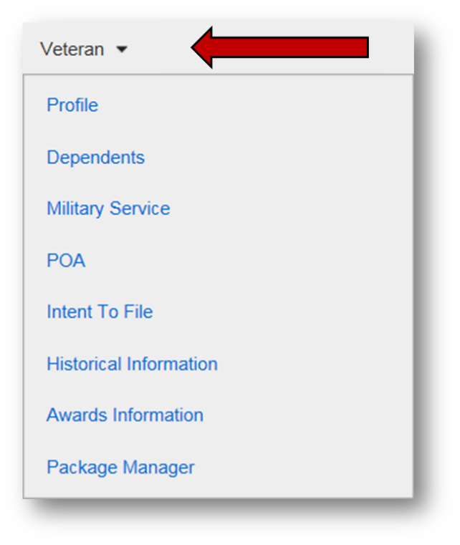

**Entering an ITF in VBMS**

ITFs can be manually entered on the “Intent to File” screen using the “Create New Intent to File” button.

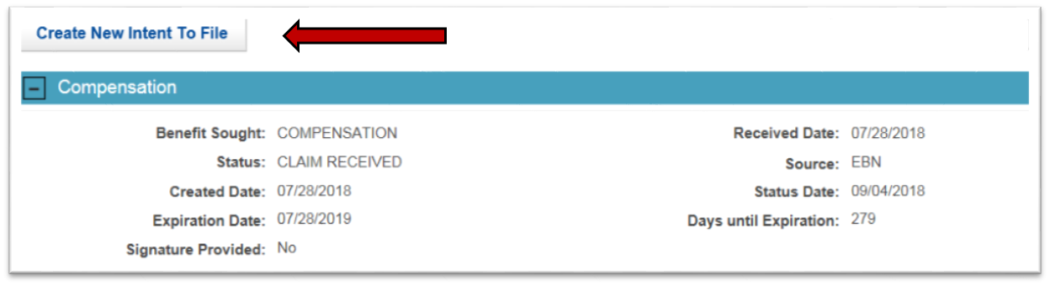

Please Note: This task is often completed by individuals other than VSRs (such as the National Call Center, Public Contact, and the Intake Processing Center) as they receive communications of an intent to file either in direct verbal communication with the veteran or through the receipt of VA Form 21-0966. However, there may be times when a VSR must input this information either as you receive it directly from a veteran or if it has been missed by other employees.

**ITF Acknowledgement Letter**

When a valid ITF is communicated online or entered in VBMS, and a substantially complete claim is NOT submitted online the same day, an automatically generated letter is sent to the claimant acknowledging receipt of the ITF. This letter informs the claimant when we received the ITF and what they need to do to submit a claim.

A copy of this letter should be automatically uploaded under the “Legacy Content Manager Documents” tab in VBMS.



**Incomplete VA Form 21-0966**

If VA Form 21-0966 is missing a required element, **and VA has not received a subsequent claim**, telephone development should be attempted to obtain the missing information. If telephone development is unsuccessful, an “Incomplete ITF” letter must be sent to the claimant. This letter is automatically generated by entering an “Incomplete” ITF in VBMS (selecting the benefit as unidentified and/or the signature is missing).

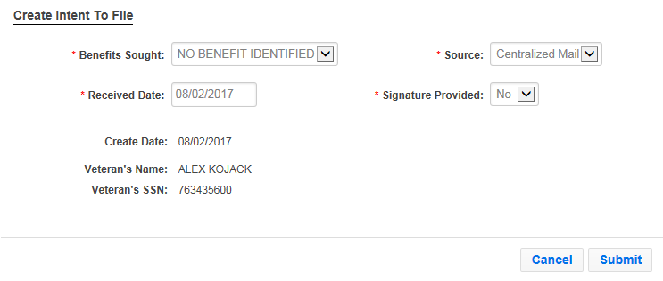

If a subsequent claim has been received an “Incomplete ITF – Claim Received” letter should be sent using the Letter Creator program.

Again, this task is most often completed by individuals other than VSRs (such as the National Call Center, Public Contact, and the Intake Processing Center) as they receive incomplete communications of an intent to file through the receipt of an incomplete VA Form 21-0966.

**Status of ITFs:**

The status of each communication of an ITF that VA receives is displayed in Share and VBMS. The table below provides the meaning behind each status the system may assign.

| **Status** | **Meaning** |
| --- | --- |
| *Active* | VA received a communication of an ITF that contains the required elements set forth in M21-1 III.ii.2.C.2.b. |
| *Duplicate* | While a communication of an intent to file a claim for a general benefit is in an active status, VA receives another communication of an intent to file a claim for the same benefit. |
| *Incomplete* | VA received a communication of an ITF that did ***not*** contain the required elements set forth in M21-1 III.ii.2.C.2.b. |
| *Expired* | The claimant failed to submit a substantially complete application within one year of the date VA received a communication of an ITF from the claimant. |
| *Claim Received* | VA received a substantially complete application for a benefit from a claimant within one year of the date VA received a communication of an intent to file a claim for the same general benefit from the claimant. |
| *Canceled* | An ITF was established erroneously and subsequently canceled by a VA employee with an associated cancellation reason, such as *Incorrect Received Date*. |

**Expiration of ITFs**

A communication of an ITF remains in “Active” status until the ***earlier*** of the following occur:

* VA receives a substantially complete application for benefits, or
* the one-year period following VA’s receipt of the communication ends.

***Note***:  No more than one communication of an intent to file a claim for a general benefit may be in an active status at any given period of time.

**Searching for the Status of ITFs**

To search for the status of any previous or current ITFs, use the “Select a Status” drop down.

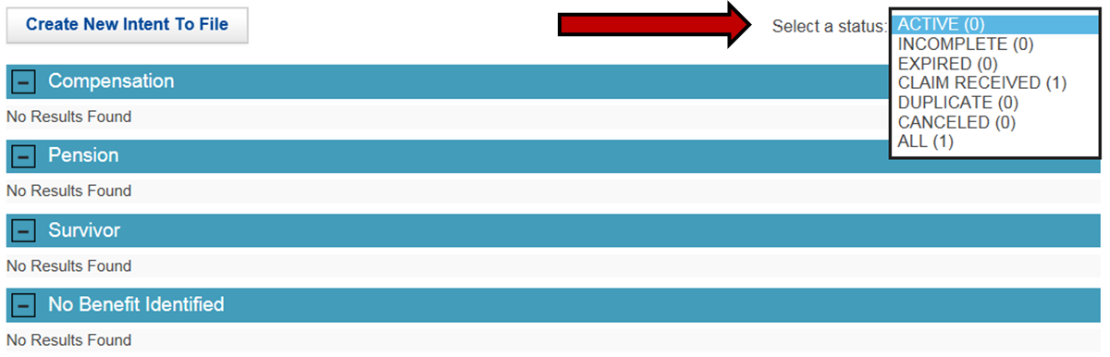

***Important Reminders:***

* Only one ITF can be active at a time. If another ITF is received while an active ITF exists, it is a “Duplicate” ITF.
* Once VA associates a specific application for benefits with a communication of an ITF, that communication is no longer active for the purpose of assigning an earlier effective date of entitlement to benefits for which the claimant might subsequently apply. This limitation applies even if VA receives the subsequent application(s) within one year of the date it received the communication of an ITF.
* Once VA associates a specific application for benefits with a claimant’s communication of an ITF, VA will then consider a subsequently submitted active ITF when assigning an effective date of entitlement to benefits for which the claimant might apply after that.
* An ITF may not be used to extend the period of non-finality for a recently decided claim. Accept an ITF submitted during the period of non-finality as an active ITF, if an active ITF is not already of record, and associate it with a claim if received within one year of the ITF.

Topic 3: ITF and Effective Dates

**ITF and Effective Dates**

The communication of an ITF is important because VA may grant entitlement to benefits from an effective date prior to the date of claim (DOC) as long as the claimant submits a complete claim within one year of the date VA received the ITF. The status of the ITF must be “Active” to qualify as an effective date placeholder.

Remember: A claimant’s communication of an ITF is “Active” for the purpose of assigning an earlier effective date of entitlement (as explained in [M21-1, Part III, Subpart ii, 2.C.2.c](https://vaww.compensation.pension.km.va.gov/system/templates/selfservice/va_ka/#1f)) until the ***earlier*** of the following occurs:

* VA receives a substantially complete application for the same benefit on a prescribed form, ***or***
* One year passes since VA received the ITF

Other factors can often play a role, in connection with the ITF, in determining an effective date (multiple ITFs, RAD date). These factors must be evaluated along with the ITF to ensure the correct effective date(s) is chosen.

Refer to the table in M21-1 III.iv.5.C.2.c for exceptional situations impacting assignment of effective dates when an ITF is of record.

**Multiple ITFs and/or Multiple Claims**

Per 38 CFR 3.155(d), Only one complete claim for a benefit (e.g., compensation, pension) may be associated with each intent to file a claim for that benefit, though multiple issues may be contained within a complete claim. In the event multiple complete claims for a benefit are filed within 1 year of an intent to file a claim for that benefit, only the first claim filed will be associated with the intent to file a claim.

Per M21-1 III.ii.2.C.2.d:

* Once VA associates a specific application for benefits with a communication of an ITF, that communication is no longer active for the purpose of assigning an earlier effective date of entitlement to the same specific benefit for which the claimant might subsequently apply. This limitation applies even if VA receives the subsequent application(s) within one year of the date it received the communication of an ITF.
* Once VA associates a specific application for benefits with a claimant’s communication of an ITF, the claimant may submit another communication of an ITF that VA will then consider when assigning an effective date of entitlement to benefits for which the claimant might subsequently apply.

In summary:

* Each ITF can only be associated with one substantially complete claim, though it applies to all issues within that claim
* Any subsequent claims submitted will not be associated with the ITF already connected to the original claim
* After an ITF and claim have been associated, a claimant may submit a subsequent ITF to serve as a new placeholder for a supplemental claim

**Potential Effective Dates Example 1**

* A Veteran communicates an ITF for compensation to a National Call Center (NCC) on June 1, 2017.
* On November 1, 2017, the Veteran begins an online application for SC for a back disorder through eBenefits.
* On January 1, 2018, VA receives a [*VA Form 21-526EZ*](http://www.vba.va.gov/pubs/forms/VBA-21-526EZ-ARE.pdf) from the Veteran with a non-original claim for SC for a knee disorder.
* On February 1, 2018, the Veteran completes and submits the online application for SC for a back disorder.

What is the status of the ITF received June 1, 2017?

**Active**

What claim is associated to the ITF received June 1, 2017?

**January 1, 2018**

What is the status of the ITF received November 1, 2017?

**Duplicate**

What would be the potential earliest effective date for back disorder?

**February 1, 2018, the date of claim (ITF was duplicate, not active at the time of receipt of subsequent claim)**

**ITFs Within One Year of Discharge**

According to M21-1 III.iv.5.C.2.b, the potential earliest effective date can be impacted based on:

* When the veteran was released from active duty
* When the veteran submits the Intent to File, and
* When the veteran submits the substantially complete claim

If VA receives communication of a Veteran’s ITF within one year of the date he/she separated from service, and VA subsequently receives a substantially complete application within one year of the date VA received the communication of an ITF, then the earliest potential effective date of entitlement to benefits is the day after the Veteran separated from service.

**Potential Effective Dates Example 2**

* A Veteran is honorably discharged from active duty on September 1, 2017.
* On December 1, 2017, VA receives the Veteran’s communication of an ITF.
* On November 1, 2018, VA receives VA Form 21-526EZ from the Veteran with a claim for SC for a knee disorder.

**The earliest potential effective date is September 2, 2017, because VA received the ITF within one year of the discharge date and received VA Form 21-526EZ within one year of the ITF.**

Appendix 1: ITF and Effective Date Scenarios

Below you will find additional scenarios for discussion of ITFs and effective dates:

**Scenario 1**

The Veteran has honorable Army service from June 2, 1996 until January 31, 2004. The Veteran submitted an ITF for compensation benefits on September 22, 2017, and filed his substantially complete claim for his bilateral knee condition on March 14, 2018. The Veteran also submitted an ITF on May 2, 2018, and a substantially complete claim for tinnitus and hearing loss on June 17, 2018. If all conditions are granted service connection, what would be the effective dates for the three claimed conditions?

**For the grant of service connection for the Veteran’s bilateral knee condition, the earliest potential effective date would be September 22, 2017, the date of receipt of the ITF, since the substantially complete claim was received within one year. The earliest potential effective date for the claim for tinnitus and hearing loss would be May 2, 2018, the date of the ITF, since the claim was also received within one year of the submission of the ITF.**

**Scenario 2**

The Veteran was discharged from the Army on December 3, 2017. We received a complete ITF for compensation on May 10, 2018. We received a complete VA Form 21-526EZ on May 16, 2018, claiming service connection for tinnitus. Rating decision dated July 21, 2018, granted service connection for tinnitus effective May 10, 2018. Is this effective date correct?

The grant of service connection should have been granted effective December 4, 2017, the day after the Veteran was discharged for service. Both the ITF and the substantially complete claim were received within one year of the release from active duty date. The ITF received on May 10, 2018, does not prevent us from granting an earlier effective in accordance with any other effective date regulation.

**Scenario 3**

A review of the file showed the Veteran was last discharged from service on April 16, 2017. She filed an ITF on April 8, 2018, and submitted her substantially complete application for lower back pain and right shoulder pain on April 22, 2018. The Veteran also submitted an ITF on April 30, 2018, and submitted her substantially complete application for a left ankle condition and bilateral pes planus on November 8, 2018. On the rating decision dated December 20, 2018, all conditions were granted service connection. What is the earliest potential effective dates for the four conditions claimed?

**For the lower back pain and right shoulder pain, the earliest potential effective date would be April 17, 2017, the day after release from active duty, because the ITF was received within one year of release and the substantially complete claim was received within one year of the ITF. However, the earliest potential effective date for the left ankle condition and bilateral pes planus would be April 30, 2018, the date of the second ITF, because the substantially complete claim was received within one year of the ITF, but the second ITF was not received within one year of the date of release from active duty.**

Practical Exercise

1. What is the date that determines if communication indicating a desire for benefits is considered an informal claim or Intent to File (ITF)?
2. What are the four ways a claimant may communicate an ITF?

1.

2.

3.

4.

1. What are the three possible required elements of an ITF?

1.

2.

3.

1. Does ITF apply to a claim for additional benefits for dependents?

1. Once an ITF is entered into the system it will contain a status that will be displayed in Share and VBMS. What are the six possible statuses?

1. 4.

2. 5.

3. 6.

1. VA receives an ITF on May 28, 2017. By what date does a substantially complete claim need to be received for the ITF to act as a possible effective date placeholder?