Effective Dates (Post Challenge RVSR)
Instructor Lesson Plan
Time Required: 3.25 Hours

Table of Contents

Lesson Description 2
Introduction to Effective Dates (Post Challenge RVSR) 4
Topic 1: Effective Date Rules 6
Topic 2: Special Considerations 14
Topic 3: Effective Date Tools 17
Practical Exercise 18
Lesson Review, Assessment, and Wrap-up 18

Lesson Description
The information below provides the instructor with an overview of the lesson and the materials that are required to effectively present this instruction.
TMS # | 3950443
Prerequisites | Prior to this lesson, the Rating Veteran Service Representatives (RVSRs), Decision Review Officers (DROs), and Rating Quality Review Specialists (RQRSs) should have completed Challenge training. Trainees should also have completed Standard Claims and Appeals Forms (Post Challenge RVSR).
target audience | The target audience for Effective Dates (Post Challenge RVSR) is for RVSRs who have completed Challenge training, DROs, and RQRSs.
Time Required | 3.25 hours
Materials/  TRAINING AIDS | Lesson materials:  - Effective Dates (Post Challenge RVSR) PowerPoint Presentation  - Effective Dates (Post Challenge RVSR) Trainee Handout  - RVSR Assistant: Effective Dates EPSS, Job Aid  - VBMS-R Effective Date Builder, Job Aid
Training Area/Tools | The following are required to ensure the trainees are able to meet the lesson objectives:  - Classroom or private area suitable for participatory discussions  - Seating, writing materials, and writing surfaces for trainee note taking and participation  - Handouts, which include a practical exercise  - Large writing surface (easel pad, chalkboard, dry erase board, overhead projector, etc.) with appropriate writing materials  - Computer with PowerPoint software to present the lesson material  Trainees require access to the following tools:  - VA TMS to complete the assessment  - Compensation Service Intranet: Rating Job Aids  - Internet access for Compensation Pension Knowledge Management (CPKM)  - Internet access for Electronic Code of Federal Regulations
Pre-Planning | - Become familiar with all training materials by reading the Instructor Lesson Plan while simultaneously reviewing the corresponding PowerPoint slides. This will provide you the opportunity to see the connection between the Lesson Plan and the slides, which will allow for a more structured presentation during the training session.  - Become familiar with the content of the trainee handouts and their association to the Lesson Plan.  - Practice is the best guarantee of providing a quality presentation. At a minimum, do a complete walkthrough of the presentation to practice coordination between this Lesson Plan, the trainee handouts, and the PowerPoint slides and ensure your timing is on track with the length of the lesson.  - Ensure that there are copies of all handouts before the training session.  - When required, reserve the training room.  - Arrange for equipment such as flip charts, an overhead projector, and any other equipment (as needed).  - Talk to people in your office who are most familiar with this topic to collect experiences that you can include as examples in the lesson.  - This lesson plan belongs to you. Feel free to highlight headings, key phrases, or other information to help the instruction flow smoothly. Feel free to add any notes or information that you need in the margins.
Training Day | - Arrive as early as possible to ensure access to the facility and computers.  - Become familiar with the location of restrooms and other facilities that the trainees will require.  - Test the computer and projector to ensure they are working properly.  - Before class begins, open the PowerPoint presentation to the first slide. This will help to ensure the presentation is functioning properly.  - Make sure that a whiteboard or flip chart and the associated markers are available.  - The instructor completes a roll call attendance sheet or provides a sign-in sheet to the students. The attendance records are forwarded to the Regional Office Training Managers.

Introduction to Effective Dates (Post Challenge RVSR)
INSTRUCTOR INTRODUCTION |  | Complete the following:  - Introduce yourself  - Orient learners to the facilities  - Ensure that all learners have the required handouts
time required |  | .25 hours
Purpose of Lesson |  | This lesson provides the RVSR, DRO, or RQRS with the requirements for assigning effective dates for the various types of claims. This lesson will contain discussions and exercises that allow you to review and gain a better understanding of:  - Effective date rules and regulations.  - Identifying the appropriate effective date.
Lesson Objectives  Slide 2  Handout 2 | In order to accomplish the purpose of this lesson, the RVSR, DRO, or RQRS will be required to accomplish the following lesson objectives.  The RVSR, DRO, or RQRS will be able to:  - Demonstrate a comprehensive understanding of effective date rules and regulations.  - Identify the appropriate effective date.
 | Each learning objective is covered in the associated topic. At the conclusion of the lesson, the learning objectives will be reviewed.
Motivation | One of the most common errors made in claims processing is incorrect effective dates. Gaining knowledge in this area will improve your quality, your office’s quality, and most importantly; ensure the accuracy of payments made to Veterans. The most damaging aspect of these errors is that they either deprive Veterans of benefits to which they are entitled to, or are harmful in other ways, such as creating overpayments.
STAR Error code(s) | D1- Failing to apply Public Law 112-154, Section 506.  D1- Incorrectly applying Public Law 112-154, Section 506. (Applying it to claims that are not original claims, or to claims that were (or should have been) excluded from FDC.)  D1-Failing to grant based on date of receipt of intent to file.  D1- Failing to correctly apply 38 CFR 3.400(q) when a Veteran fails to report for VAE, and expresses willingness to report within one year of notification of VA’s decision.  D1- Failing to correctly apply 38 CFR 3.400(o)(2) when a claim is received within a year that an increase occurred.  D1- Failing to correctly apply 38 CFR 3.114. (Missing the grant of one year prior to date of claim even though the Veteran had a diagnosis prior to the change of law, and adversely inappropriately granting the one year when the Veteran did not have a diagnosis prior to change in law.)

References  Slide 3  Handout 2 | All M21-1 references are found in the Live Manual Website.  - 38 CFR 3.400, Effective Dates; General  - 38 CFR 3.155, How to file a claim  - 38 CFR 3.1(r), Definitions, Date of receipt  - 38 CFR 3.114, Change of law or Department of Veterans Affairs issue  - 38 CFR 3.816, Awards under the Nehmer Court Orders for disability or death caused by a condition presumptively associated with herbicide exposure  - 38 CFR 3.105, Revision of decisions  - 38 CFR 3.156 New and material evidence  - 38 CFR 3.157 historical, Report of examination or hospitalization as claim for increase or to reopen  - 38 CFR 3.401(a), Effective Dates; Veterans, Aid and attendance and housebound benefits  - 38 CFR 4.29, Ratings for service-connected disabilities requiring hospital treatment or observation  - 38 CFR 4.30, Convalescent ratings  - M21-1 Part III, Subpart ii,2.B.1, Applications for Disability Compensation and/or Pension  - M21-1 Part III, Subpart ii,2.C.1, Identification of an Informal Original Claim Received Prior to March 24, 2015, an ITF, and a Request for Application  - M21-1 Part III, Subpart i,3.B.4.a, Determining the Appropriate Effective Date for a Grant of Benefits Under the FDC Program  - M21-1 Part IV, Subpart ii,2.C.3.i, Date Disabilities Became Subject to Presumptive SC Under 38 CFR 3.309(e)  - M21-1 Part IV, Subpart ii,2.F.1.a, Establishing Entitlement to TDIU

Topic 1: Effective Date Rules
Introduction | This topic will provide an overview on effective date rules and regulations, as well as discussion of identification of claims and other information to use when determining effective dates for claims.
Time Required | 1.5 hours (allow a break about an hour in)
OBJECTIVES/  Teaching Points | Topic objectives and teaching points to support the topic objectives:  - Questions to ask for effective date determination  - General rule for determining effective dates  - Effective date rules for direct, presumptive, increase, reconsideration, reopened, reduction, and competency.
Effective Date Determination  Slide 4 | The following questions should be asked when determining effective dates:  What is the issue?  - Service connection?  - Increased evaluation?  - Original/New/Reconsideration/Reopen?  What is the date of receipt of the claim?  - Was there an intent to file?  - Was the claim received before or after March 24, 2015?  What is the date basic entitlement arose?  Do any liberalizing laws or special considerations apply?  - 3.114? Section 506 PL 112-154?  Explain that in order to determine the correct effective date, all of these things must be taken into consideration, for every contention, of every claim. You might have one application you are working with, but still have multiple effective dates.  Ask who can tell me where you would look to determine if an intent to file has been received?  Answer Virtual VA, VBMS documents, VBMS- Veteran Tab- Intent to File (filter box can be set to Active, All, etc.), VBMS Notes, initiation date on electronically submitted applications, etc.
§3.400 The General Rule  Slide 5 | The effective date is the date of receipt of the claim or the date entitlement arose (whichever is later, unless otherwise provided)  CANNOT be prior to discharge.  CANNOT be prior to existence of the condition, or level of severity in the instance of an increase.  CANNOT be prior to service connection of primary condition.  Explain that the first part of 38 CFR 3.400 is noted to be the general rule for effective dates, but only applies when not otherwise provided, which it usually is. (This will be demonstrated by going through the specific rules based on claim types.)  Date of claim: date information or evidence was first received by the Department of Veterans Affairs  Ask the following questions:  - Does a POA date stamp count?  Response: No, the POA is not VA.  - Does a VAMC date stamp count?  Response: Yes, the VAMC is VA!  Date entitlement arose: earliest date from which the evidence shows that entitlement to VA benefits is warranted. As noted, there is no entitlement to compensation while the Veteran is still on active duty (double dipping, they are receiving active duty pay, and are not yet Veterans), there is no entitlement prior to existence of a condition, or prior to the legal requirements are met.
§3.400(b)(2)  Slide 6 | (i) Direct Service Connection  Day following separation from active service, if claimed within one year from separation  Otherwise: date of receipt of claim, or date entitlement arose, whichever is later.  (ii) Presumptive Service Connection  Date entitlement arose, if claimed within one year from separation  Otherwise: date of receipt of claim, or date entitlement arose, whichever is later.  Explain that as you can see, it is usually otherwise provided, so the general rule does not come into play that often.  Ask why do you think that it is date entitlement arose for presumptive, even if it is received within one year of discharge?  Response: Because as stated on the previous slide, service connection cannot be established prior to the existence of a condition. If you are granting on a presumptive basis, that indicates that it was not discharged (incurred) in service, but in fact manifested within the required time outlined by the CFR. Therefore, going back to RAD +1 would only be correct if the Veteran was in fact diagnosed with the condition on that date. Otherwise, it would be based on when the condition was diagnosed.
§3.400 (o)(2) – Claims for Increase  Slide 7 | Earliest date as of which it is factually ascertainable that an increase in disability had occurred if claim is received within one year from such date  otherwise, date of receipt of claim whichever is later.
Individual Unemployability  Slide 8 | §3.400 (o)(2) Earliest date as of which it is factually ascertainable based on all evidence of record that an increase in disability had occurred if a complete claim or intent to file a claim is received within 1 year from such date, otherwise, date of receipt of claim.  - date following date last worked  - the effective date of the grant of disability(ies) that first met the minimum schedular requirements  - the effective date of the grant of or (increase in) disability(ies) which result in or contribute to the Veteran’s unemployability  Explain that since IU is not a stand-alone claim, it is usually a claim for increase. (It is possible for a Veteran to file a claim for IU along with an original claim, at which time whatever effective date rules apply to the grant of SC would also apply to the IU. However, more often than not, IU is a claim for increase.)
§3.157 – Report of examination or hospitalization as claim for increase or to reopen  Slide 9 | PRIOR TO MARCH 24, 2015:  The date of outpatient or hospital examination or date of admission to a VA or uniformed services hospital for a service connection condition will be accepted as the date of receipt of a claim for increase.  **There is no time limit for application of §3.157, this should continue to be applied when admission or treatment took place prior to March 24, 2015.**  Explain that it does not matter what the date of receipt of your claim is, if you have evidence that you can grant an increase based on treatment or admission at a VA facility prior to March 24, 2015, you need to still apply 3.157 to do so.
§3.157 :Eliminated by  Standard Claims and Appeals Form Rule  Slide 10 | ON OR AFTER MARCH 24, 2015:  Hospitalization reports from VA or military treatment facilities will be accepted as a prescribed form for temporary total disability rating paragraph 29 and 30 benefits.  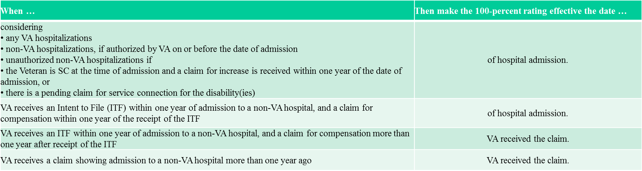  Explain that the above table is located in M21- 1 Part IV, Subpart ii,2.J.2.g. Effective Dates of Hospitalization Ratings  M21-1 Part III, Subpartii,2.B.1.b. Requirements for a Complete Claim Received on or After March 24, 2015  “If the benefit sought is ... temporary total disability rating (paragraph 29 and 30 benefits) Then the prescribed form is VA Form... 21-526, 21-526b, or 21-526EZ.  Note: Hospitalization reports from VA or military treatment facilities will be accepted as a prescribed form for paragraph 29 and 30 benefits.”
Effective Dates of Hospitalization Ratings  Slide 11 | §4.29 100% for hospitalization in excess of 21 days  The first day of continuous hospitalization and will be terminated effective the last day of the month of hospital discharge.  §4.30 Convalescent Ratings  This date of hospital admission or outpatient treatment and continuing for a period of 1, 2, or 3 months from the first day of the month following such hospital discharge or outpatient release.  Explain that even though the regulations state that the effective date of a reduction is the LAST DAY of the month following a 60 day period, from the date of the rating decision. It is important to note that this is for payment purposes only and VBMS does not take this into account. Therefore, RVSRs should be instructed to use the first day of the month following a 60 day period when entering effective dates into VBMS.
VBMS inputs  Slide 12 | 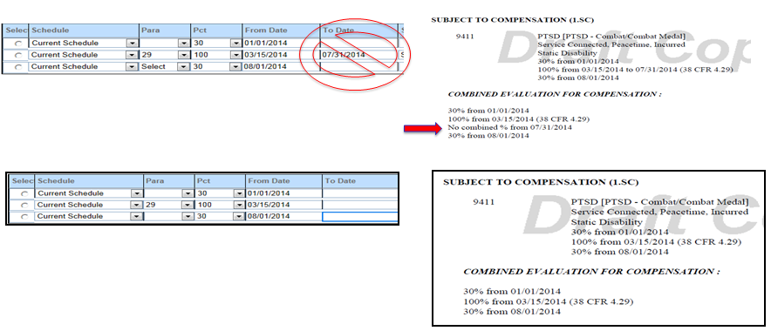  Explain that you do not enter a “To Date” when staging out an evaluation/reduction. This essentially results in ending service connection for that condition, which is not the desired outcome. If you see a “No Combined” line on your code sheet, that is an indication that you entered the dates incorrectly on your decision screen.
Secondary vs. Worsening  Slide 13 | Secondary: One condition is caused by another, not a disease process  - For effective date purposes, secondary service connection arises as a result of a specific claim  - §3.400 “general rule” is governing rule  Worsening: Part of a disease process, considered an “increased” manifestation of the primary disease  - For effective date purposes, treated as an increased manifestation  - §3.400(o) applies  - §3.157 potentially applies  Examples of Secondary:  Knee secondary to hip condition  Headaches secondary to neck condition  Examples of Worsening:  Diabetic complications  Radiculopathy due to lumbar or cervical condition  Explain that scars are considered secondary, not worsening. It is often an issue that should be raised by the RVSR, regardless of if it is explicitly claimed, as it is a reasonably raised issue within the scope of a claimed issue. M21-1, Part III, Subpart iv, 6.B.1.c – Example 3.  Example: The Veteran submits a claim for SC for right knee strain. The evidence of record, including the resulting examination, shows that SC for the knee strain is warranted. The examination also reveals a knee scar that resulted from a post-service arthroscopy procedure. The examination indicates the arthroscopy was associated with the SC right knee strain. The examination also shows that the scar is not painful or unstable and is less than 6 square inches.  Result: In the event that the examination is otherwise sufficient for rating purposes, the decision maker awards SC for the knee condition and separate SC for the noncompensable knee scar as within the scope of the claim for SC for right knee strain.
Reconsideration vs. Reopen  Slide 14 | Reconsideration: received within the one-year appeal period, which begins on the date the claimant was notified of the decision at issue.  - A prescribed form is not required for a request for reconsideration.  - §3.400(q) The effective date will be as though the former decision had not been rendered.  Reopened Claim: an application for a benefit received after final denial.  - the claim must be submitted on a prescribed form.  - §3.400(r) Date of receipt of claim or date entitlement arose, whichever is later.  *Both require the Veteran to submit or identify new evidence related to the previously denied/decided issue(s).  Explain When new and material evidence is submitted within the appeal period or prior to an appellate decision with regard to a claim for increased evaluation, the effective date for any increased evaluation is the later of the following dates  - the date on which the facts establish the increase in disability occurred, or  - the date of the original claim for increase.  Exception: If the facts establish that a Veteran’s disability increased within one year prior to VA’s receipt of the original claim for increased rating, the effective date of the increase is the date on which the increase in disability occurred.
§3.156 (c) Service department records  Slide 15 | At any time after VA issues a decision on a claim, if VA receives or associates with the claims file relevant official service department records that existed and had not been associated with the claims file when VA first decided the claim, VA will reconsider the claim. This includes:  (i) Service records that are related to a claimed in-service event, injury, or disease,  (ii) Additional service records forwarded by the Department of Defense or the service department to VA any time after VA's original request for service records; and  (iii) Declassified records that could not have been obtained because the records were classified when VA decided the claim.  An award made based all or in part on the records is effective on the date entitlement arose or the date VA received the previously decided claim, whichever is later.  Explain that this applies to ships that are added to the list: Navy and Coast Guard Ships Associated with Service in Vietnam and Exposure to Herbicide Agents  The effective date rules in 3.156(c) do NOT pertain to records that VA could not have obtained at the time it decided the claim because the records did not exist at the time. Additionally, records that VA could not obtain because the claimant failed to provide sufficient information for VA to obtain them, including records from the service department, the Joint Services Records Research Center (JSRRC), or from any other official source do not trigger the effective date rule in 3.156(c).  Example:  If the claim was received on January 3, 2000, SC was denied on April 2, 2000 and new STRs came in May 1, 2015, the January 3, 2000 date would be used to grant, assuming claimant had been discharged for more than one year.
Reductions  Slide 16 | After the notice of proposed adverse action has been sent and the 60-day period following that date has passed, prepare a final rating decision to reflect a lower evaluation.  The lower evaluation is effective the first day of the month following expiration of a 60-day period of time that commences the date the Veteran is notified of the final rating decision.  *When the net result is a higher or the same combined evaluation, promulgate the rating evaluation without proposal or due process.  Example:  If a rating decision dated February 15, 2015 is taking the final reduction for a left ankle, the effective date entered into VBMS would be May 1, 2015.
Competency  Slide 17 | Prepare a rating decision proposing a finding of incompetency  Provide the payee notice of the proposed incompetency rating, and the opportunity for a hearing  Issue a final decision based on all the evidence of record  §3.400 (x) Effective date of determination of incompetency  - Date of rating of incompetency.  §3.400 (y) Effective date of determination restoring competency  - Date shown by evidence of record that competency was regained.  Explain that when an initial competency determination is needed, and a court decree of incompetency or court appointment of a fiduciary by reason of incompetency has been received, a proposal of incompetency/due process is not required per 38 CFR 3.353(e). The claims folder may be referred directly to the fiduciary hub for appointment of a fiduciary. (M21-1 Part III, Subpart iv, 8.A.1.a. Jurisdiction for Competency Determinations)  Explain that final ratings of incompetency are now usually worked by the Fiduciary Hub, so this might not be something that comes up very often. But it is important to know, just in case.

Topic 2: Special Considerations
Introduction | This topic will provide a review of additional effective date rules and regulations that must be considered and applied in specific circumstances.
Time Required | .5 hours
OBJECTIVES/  Teaching Points | Topic objectives and teaching points to support the topic objectives:  - Effective date rules for liberalizing legislation, Nehmer and Public Law 112-154, Section 506.
§3.114 – Liberalizing Legislation  Slide 19  Handout 9-10 | If criteria for eligibility for the liberalized benefit were met from the date of the law change, and  - reviewed by VA or claimed by Veteran within one year of law change, effective date is date of law change.  - reviewed by VA or claimed by Veteran more than one year after law change, effective date is one year prior to date of VA review/date of claim.  Explain that liberalizing legislation will most often be encountered with Agent Orange related claims. But, it is important to remember it applies to changes made to the Rating Schedule as well. Medical EPSS has a “Historical” tab on the left column, which is organized by body system, and will show the old rating criteria, as well as the date of change. (Samples: Neurological, 8045- Brain disease due to trauma; Cardiovascular, 7005 - Arteriosclerotic heart disease)  Example: Amyotrophic lateral sclerosis (ALS), effective September 23, 2008, 38 CFR 3.318 established a presumption of SC for ALS. Effective January 19, 2012, the diagnostic criteria for ALS was amended in 38 CFR 4.124a to provide a 100 percent evaluation for any Veteran with SC ALS.  - Veteran is SC for ALS 30% effective September 23, 2008, files a claim for increase received June 20, 2012, what is the effective date of the increased evaluation of 100%?  Answer: January 19, 2012, date of change in law.  - What if the Veteran did not file a claim for increase until January 11, 2016?  Answer: January 11, 2015, 1 year prior to the date of receipt of claim.
Nehmer  Slide 20  Handout 10 | Nehmer class members are Vietnam Veterans who served in-country and have a covered herbicide disease, or the surviving spouse, child, or parent of a Vietnam Veteran who died from a covered herbicide disease.  The first claim of service connection for the condition at issue was received BEFORE the condition was added to the list of Agent Orange-related disabilities and the effective date for the grant of service connection will also be BEFORE the condition was added to the list of Agent Orange-related disabilities.  Effective dates  - the date the original claim was filed or date entitlement arose, whichever is later  - can go back as far as the date of claim that was pending on September 25, 1985  Explain that Nehmer claims must be reviewed and second signed by a Nehmer Subject Matter Expert (SME). It is important to know the criteria and be able to recognize Nehmer entitlement, even if you are not going to be the one to rate it!
Public Law 112-154, Section 506  Slide 21 | Allows up to one year retroactive effective date for fully developed original claims for compensation received between August 6, 2013 – August 5, 2015, for Veterans separated at least one year prior to filing claim  - Retroactive date is only calculated based on date VA receives formal claim or ITF received between March 24, 2015, through August 5, 2015  - The effective date may be up to one year prior to date of formalized claim depending on evidence of when the disability first manifested  - A staged rating may be appropriate when assigning the evaluation using the retroactive effective date  - If the claim is removed from the FDC program, then the one-year retroactive effective date cannot be granted (Always consider if the claim was correctly excluded, because if it was excluded, but should NOT have been, you must apply this law!)  Emphasize: Always consider if the claim was correctly excluded, because if it was excluded, but should NOT have been, you may still need to apply this law.  Explain that it says “up to one year” prior to date of formalized claim, because, just like any other effective date, it cannot be prior to the existence of entitlement.  Note: there must be conclusive and persuasive evidence that the claimed disability did not exist during the retroactive period. In all cases, reasonable doubt should be resolved in favor of the claimant.  Explain that before March 24, 2015, a Veteran could file a generic statement indicating an intention to file an FDC claim, and this was accepted as an “informal FDC.” The contentions listed on (or submitted with) the 526EZ are the only contentions that can potentially go back to the date of receipt of the informal claim.  Example: Veteran (RAD 2010) submits a 4138 on June 1, 2014 stating “I intend to file an FDC claim, please preserve my effective date.” and subsequently submits a substantially complete original 526EZ on March 2, 2015 for R knee condition and L hip condition. April 1, 2015, a substantially complete 526EZ is received for PTSD.  You are able to grant all three contentions, what are your effective dates?  R knee & L hip- March 2, 2014, 1 year prior to the date of receipt of original FDC claim. “Effective date assigned via Section 506 of PL 112-154.” Per M21-1 Part III, Subpart I,3.B.4.c. Explaining FDC Effective Dates.  PTSD- April 1, 2015, date of receipt of claim  Note: In cases where a Veteran filed an “informal FDC”, and meets the criteria for application of Section 506 of PL 112-154, you must determine which date would be the most advantageous to the Veteran. You cannot grant the 1 year retroactive from the date of the informal claim.  Note: In cases where §3.114 also applies, you must determine which date would be the most advantageous to the Veteran. You cannot grant 1 year based on §3.114 PLUS one year based on Section 506 of PL 112-154, as this is considered stacking of these benefits.  M21-1 Part III, Subpart I,3.B.4.a. Determining the Appropriate Effective Date for a Grant of Benefits Under the FDC Program

Topic 3: Effective Date Tools
Introduction | This topic will review the available effective date tools.
Time Required | .25 hours
OBJECTIVES/  Teaching Points | Topic objectives:  - Show the location of the RVSR Effective date assistant, and explain how to use it.
RVSR Assistant: Effective Dates EPSS  Slide 23 | 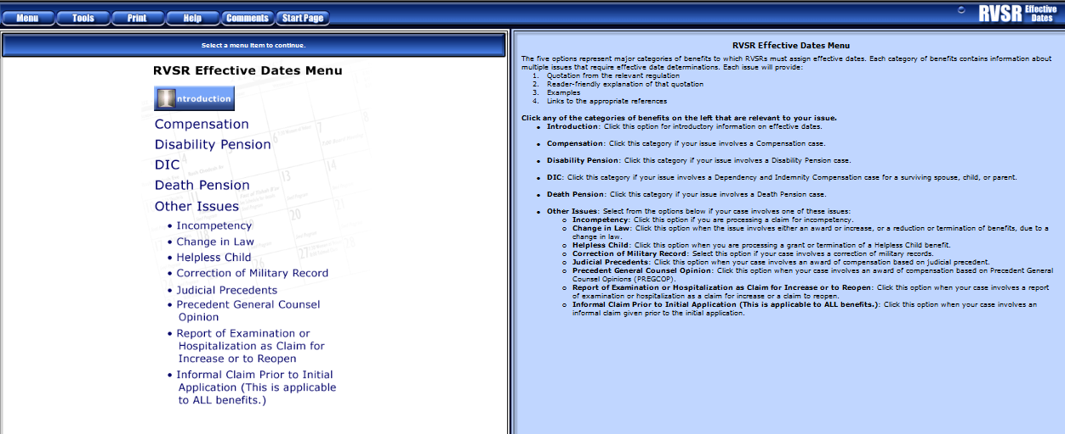
VBMS-R Effective Date Builder  Slide 24 | 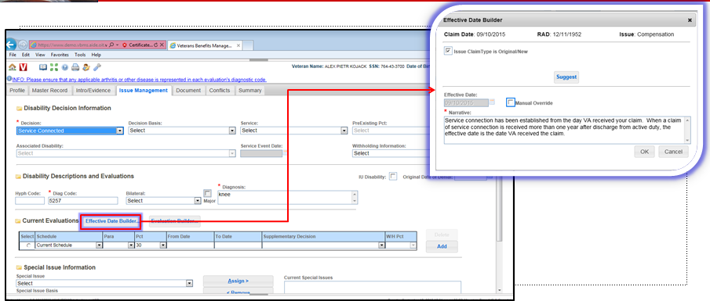

Practical Exercise
Time Required |  | .5 hours
EXERCISE  Handout 11-13 |  | Allow the trainees up to a half an hour to complete the ten scenarios included in the handout. Ensure that they have access to all lesson materials and tools outlined on page 2:  - Effective Dates (Post Challenge RVSR) PowerPoint Presentation  - Effective Dates (Post Challenge RVSR) Trainee Handout  - RVSR Assistant: Effective Dates EPSS, Job Aid  - VBMS-R Effective Date Builder, Job Aid  - Compensation Service Intranet: Rating Job Aids  - Internet access for Compensation Pension Knowledge Management (CPKM)  - Internet access for Electronic Code of Federal Regulations

Lesson Review, Assessment, and Wrap-up
Introduction  Discuss the following: | The Effective Dates (Post Challenge RVSR) lesson is complete.  Review each lesson objective and ask the trainees for any questions or comments.
Time Required | .25 hours
Lesson Objectives | You have completed the Effective Dates (Post Challenge RVSR) lesson.  The trainee should be able to:  - Effective date rules and regulations.  - Identifying the appropriate effective date.
Assessment | Remind the trainees to complete the on-line assessment in TMS to receive credit for completion of the course.  The assessment will allow the participants to demonstrate their understanding of the information presented in this lesson.

