***Table of Contents***

Objectives 2

References 2

Performing a “DUPC”-BIRLS Consolidation 3

Corporate Trouble Ticket 5

Performing a Corporate Record Merge 6

What to do if a DUPC has not been done 8

What to do if there is an error performing a DUPC 10

Reviewing the Corporate Record 11

Determining which PID is correct and incorrect 12

Updating the SSN on the Correct PID 17

Two Corporate Records and BOTH have Data 21

PID Deactivation 23

Two Corporate Records and BOTH have Pre-Converted Master Records 24

MAP-D Merge 25

# Objectives

|  |  |
| --- | --- |
| **PREREQUISITE TRAINING** | None |
| **PURPOSE OF LESSON** | This is essential to both VA Central Office and the Regional Offices. This guidance will help ensure all pertinent fields for this amendment are properly evaluated so Veterans who are entitled are properly identified and receiving the correct amount in award money and their records are accurately maintained. |
| **TIME REQUIRED** | 1.5 Hours |

# References

* M21-1 III.ii.4.E – Consolidation of Duplicate Beneficiary Identification and Records Locator Subsystem (BIRLS) Records and Corporate Records Preventing Duplicate Records Handout
* SHARE User Guide

# P e r f o r m i n g a “ D U P C ” -BIRLS Consolidation

The following steps describe the process for performing the DUPC-BIRLS Consolidation process.

This is essential to both VA Central Office and the Regional Offices. This guidance will help ensure all pertinent fields for this amendment are properly evaluated so Veterans who are entitled are properly identified and receiving the correct amount in award money and their records are accurately maintained.

The IPC Supervisor or designee is responsible for the consolidation process. DUPC action must be completed prior to submitting the corporate trouble ticket request.

##### Processing a DUPC Transaction BIRLS Consolidation

Only BIRLS data will be merged in the BIRLS consolidation process. Before the BIRLS records are consolidated using the DUPC process

* review the corporate record(s) to determine whether it will be necessary to terminate a corporate award, and
* do not complete the BIRLS record consolidation until the award action to terminate one of the corporate records has been authorized.

After you have determined if records must be merged you can use this information for BDN.

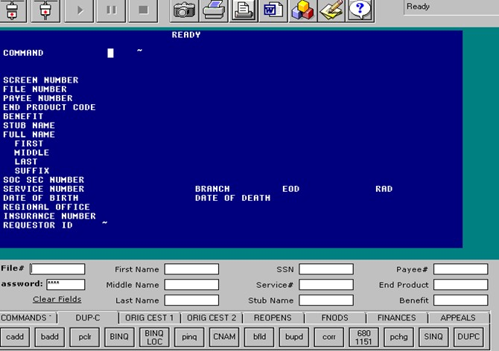

After you have determined records must be merged, you can use this information for processing in BDN.

1. On the BDN READY screen, enter “DUPC,” and
   * Your password
2. Press Enter
   * RESULT- The record consolidation screen (CON) is displayed
3. On the CON screen enter the
   * File number, and
   * Names of both records to be consolidated
4. Ensure information on the CON screen matches information in BIRLS

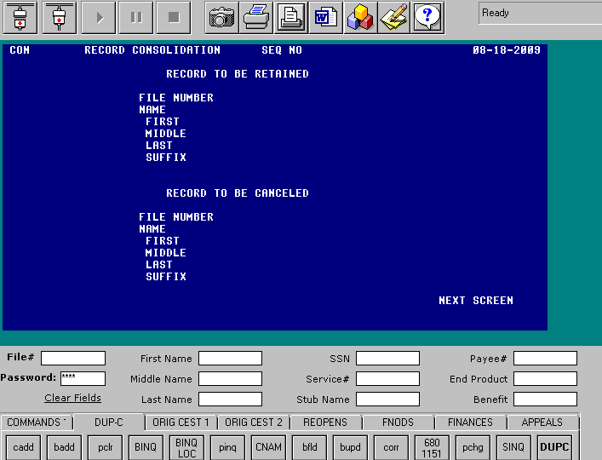

1. Display the retained record, make a print of the (VID) screen for your review
2. Press ENTER to display the cancelled record, make a print of the (VID) screen for your review
3. Press ENTER: Consolidation occurs
4. Compare the data in BIRLS and on the printed VID screens
5. Enter “UPD” to complete the transaction

##### Review file in VBMS for merger

# Corporate Trouble Ticket

Submit a corporate trouble ticket to the National Help Desk (NSD) for correction of errors that occur due to duplicate corporate records

The hyperlink to the trouble ticket form can be found within the CKMP at **III.ii.4.E.5.f. Corporate Trouble Ticket** or by clicking the link below:

[Corporate Trouble Ticket Request Form](http://vbaw.vba.va.gov/bl/21/systems/docs/Corporate%20Trouble%20Ticket%20Request.doc)

Before merging the duplicate corporate records and performing a corporate update, a ticket must be opened with the National Help Desk.

* 1. Complete the Corporate Trouble Ticket Request form.
  2. Email the National Service Desk the Corporate Trouble Ticket Request Form. Request receipt of the NSD ticket number to control the error. Request that it be assigned to your RO’s **SME Compensation Corporate Records** or the **SME Pension Corporate Records** group and to yourself as the assignee.

##### How do I transfer a ticket? (Assign to self or send to another group)

Go to **Activities** at the top of the ticket and choose **Transfer**:

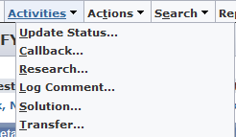

To assign it to yourself, type your last name in the New Assignee field and to transfer to another group: Change the group from your RO’s **SME Compensation Corporate Record** or **SME Pension Corporate Records** to the group you need to send it to. For example, Philadelphia SME Compensation Corporate Record:



Click **Save**

# Performing a Corporate Record Merge

*Systems you will need:*



**SHARE**

•Search All In List

•BIRLS Inquiry

•Corporate Inquiry

•Corporate Update



**MAPD**



**Virtual VA**



**VBMS**



**Participant Profile**

## Let’s get st arted

We have **2 Corporate Records** according to the Corporate Trouble Ticket Worksheet

There is either:

* *Claim Number vs SSN*
* *or*
* *Incorrect SSN vs Correct SSN*

First, determine if the DUPC has been performed prior to the ticket being submitted.

We will need to review BIRLS.

##### Enter the first number listed on the Corporate Trouble Ticket worksheet into BIRLS Inquiry.

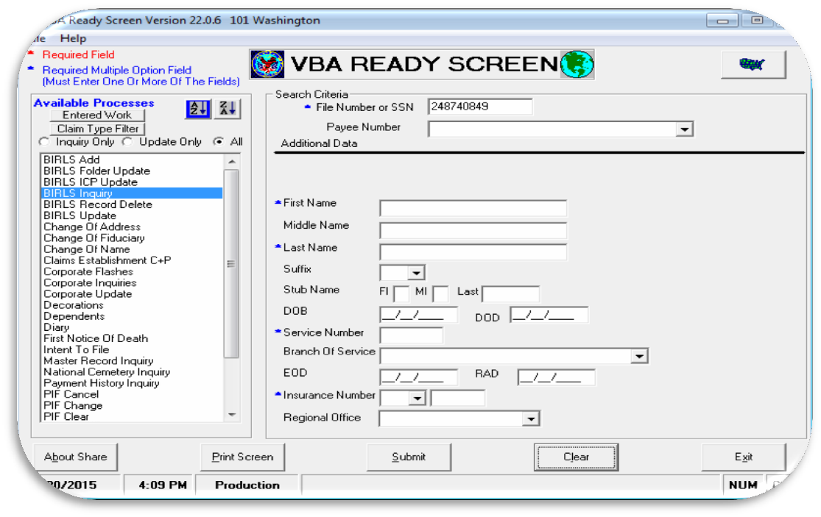

You want to check both numbers to ensure there is only one BIRLS record. The BIRLS record should look like the following:

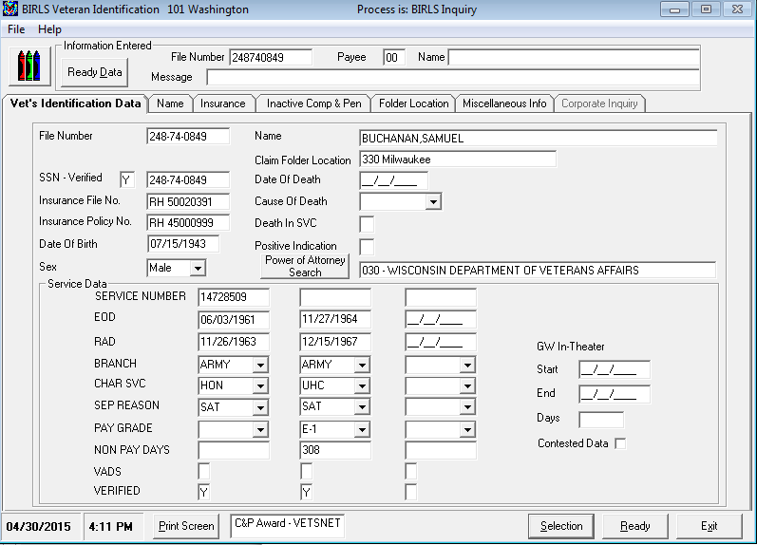

*TRN-45-678*

*TRN-45-6789*

# What to do if a DUPC has not been done

If the DUPC has not been performed and it has not been reported in the ticket attachment that a DUPC error occurred…



##### We need to have the RO end user (i.e. CA or Intake Analyst) perform the DUPC.

If the DUPC has not been performed and it has been reported in the ticket attachment that a DUPC error occurred, we **need to transfer the ticket to BPS BIRLS Support group**.

Here are the steps for transferring tickets to the BIRLS Support Group:

To transfer a ticket, select “**ACT I VI T IES”** and then “**TRANSFER**.”

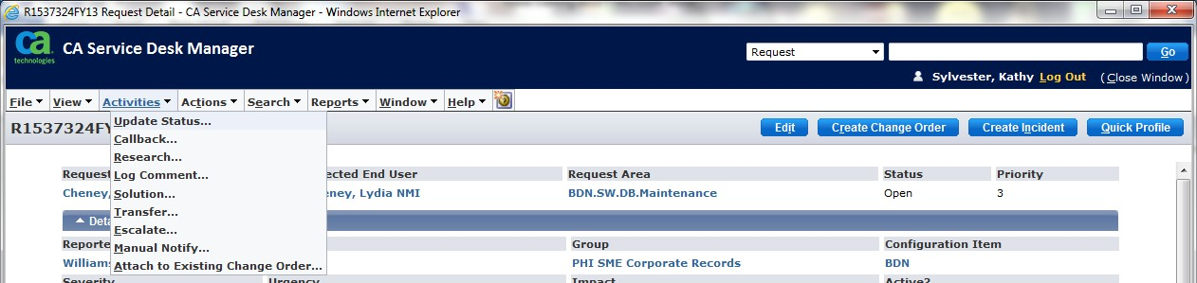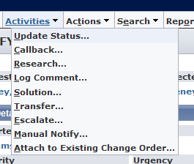

*What to do if there is an error performing a DUPC*

*une 2015 10*

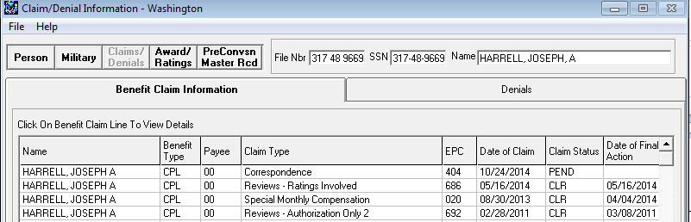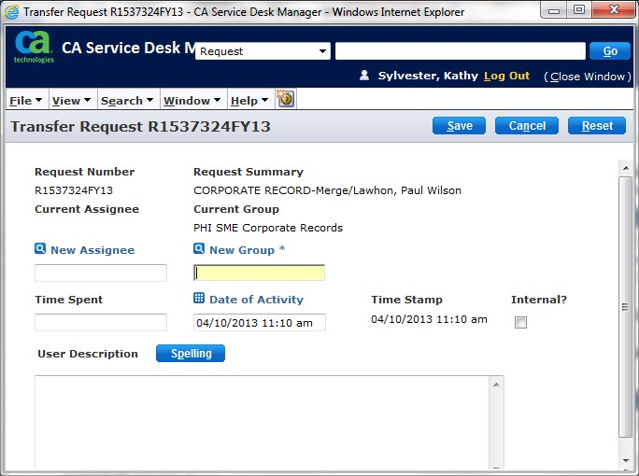

Under “**New Group**”

Insert **BPS BIRLS Support**

Under “**User Description**” you can input that a DUPC was not done and even insert the comment that is noted on the ticket attachment regarding why the DUPC was not done.

You have now just completed a transfer to the BIRLS Support group.

Check your work queue in the Service Desk occasionally because the ticket will be returned back to you once it is completed. You will know once you look at the “LOGS”

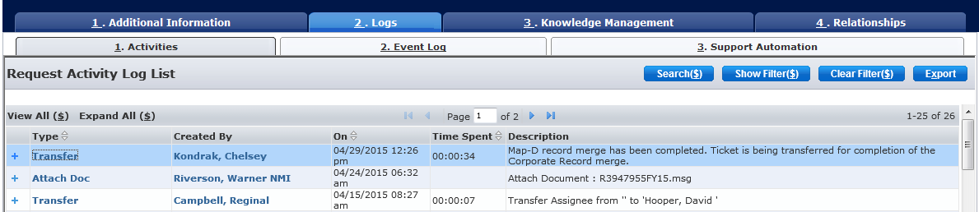

# Reviewing the Corporate Record

Go to Corporate Inquiry in SHARE and enter the first number listed on the Corporate Trouble Ticket Worksheet.

Next, review all the **TABS** located in the **Corporate Inquiry** also known as the Corporate Record. You are looking for **DATA** under each **TAB**.

Data means any information you see on any field(s) on a Corporate Inquiry. If there is data under any field and it is the incorrect PID, we will need to have screenshots uploaded into Virtual VA. This is because we will need a PID Deactivation performed by Data Architecture.

Any pertinent information you see on the screen is considered data. You are simply preserving this data when you take screenshots and upload them into Virtual VA.

When you are reviewing a Corporate Record in SHARE, you want to keep in mind that we are trying to determine which PID (Participant ID) is correct and which one is incorrect.

Next, go to Corporate Inquiry in SHARE and enter the second number listed on the Corporate Trouble Ticket Worksheet.

Next, review all the **TABS** located in the **Corporate Inquiry**. You are looking for **DATA** under each **TAB**.

Once again, you are looking for DATA, that pertinent information we will need to preserve.

*Determining which PID is correct and incorrect*

*Enter each PID (separately) listed under Corporate Inquiry to review the DATA associated with it.*



*trn-45-6789*

*11111111*

*22222222*

*trn-65-4321*

If there is data under both Corporate Inquiries, then look for the record with the most current and updated data - this will be the PID we will retain*.*

For example:

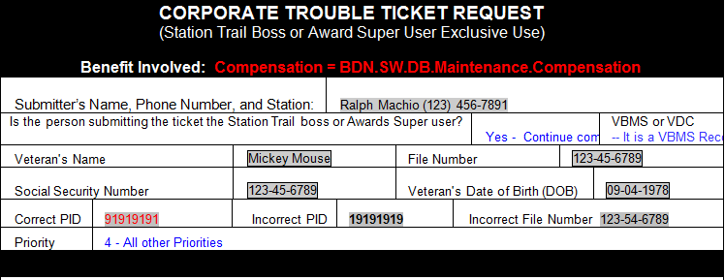

Sometimes the PID you assume is incorrect may actually be the correct PID.

Determine whether a merge or deactivation is needed. We cannot merge corporate records if there is a rating and/or payment/award history on both records. One of the records must be deactivated.

*June 12*

*2015*

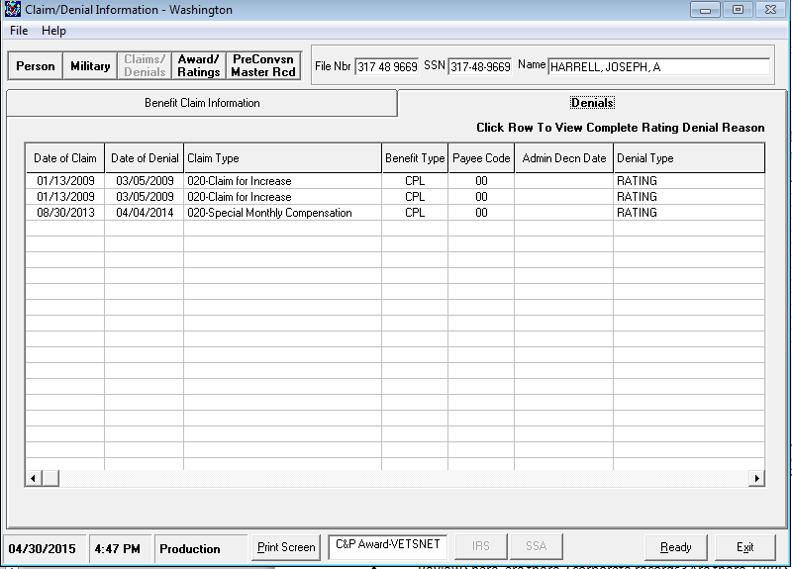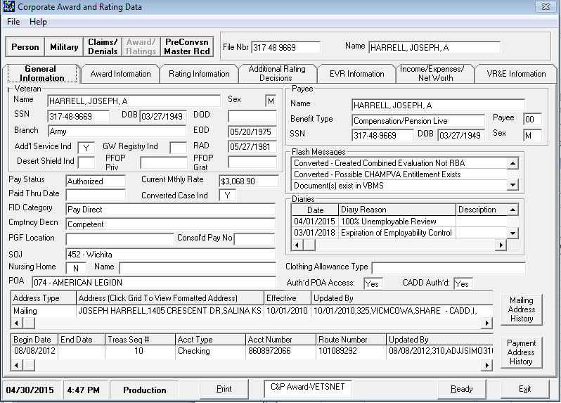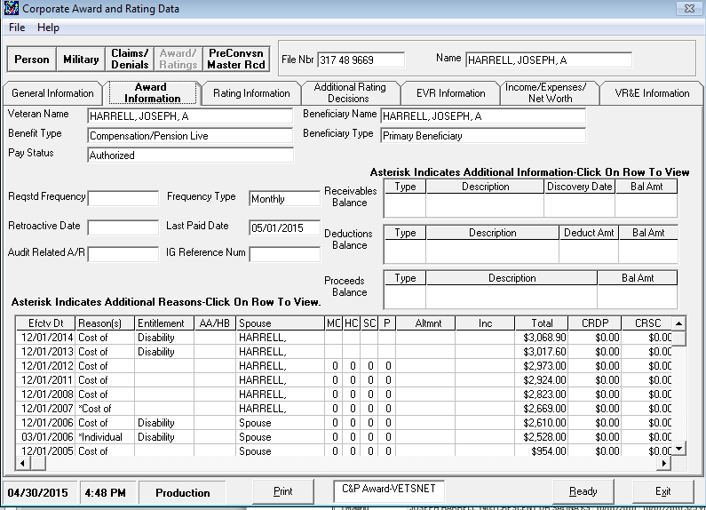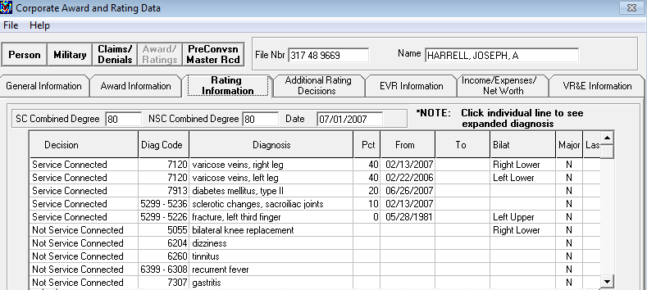

The PID we want to keep should have the **less pertinent information** that we want to keep.

If the PID that was listed as incorrect has **all the pertinent information,** we need to **keep that PID**.

*Remember, the PID that has the* ***valid or pertinent information*** *is the PID we need to keep.*

* Review Share: Are there 2 corporate records? Are there 2 BIRLS records? Collect PIDs
* While reviewing Share, look at the Claims tab and Awards/Rating tab for data.
* Determine the PID to be kept. Remember the hierarchy of data:

1. Running Award 1st
2. Historical Data 2nd
3. Pending EP 3rd

###### If none exist, the PID for the claim number or the SSN is the incorrect PID

For example:



*Updating the Corporate Record*

* + To complete the merge, start with the incorrect PID
  + Change the Corporate Update radio button to Participant ID and input the number

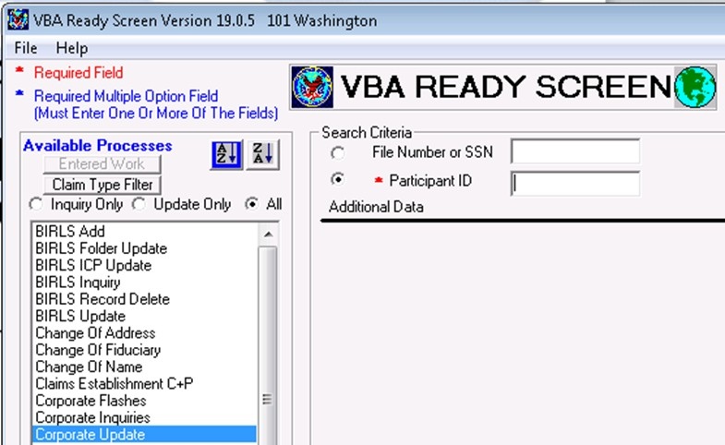

* + Remove the **File Number first**, then select “Update”
  + Remove the **SSN next**, then “Update”, and then “Ready”

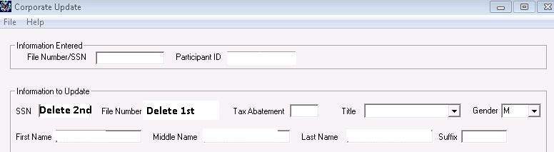

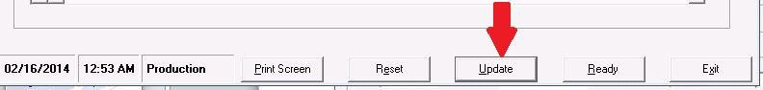

* + To correct the PID, enter the correct PID in Corporate Update search screen and click the submit button.
  + Add or correct either the File Number or SSN, then select “Update”
  + Click “Ready” and the update is now complete.

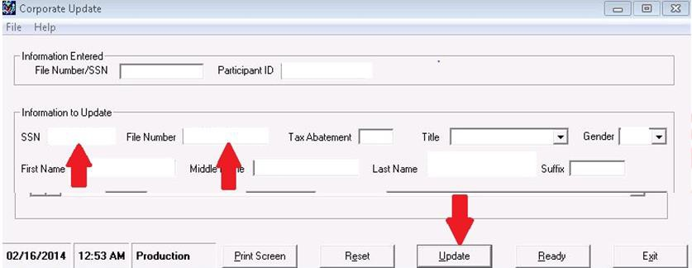

# Updating the SSN on the Correct PID

##### Editing the Correct PID with an Incorrect SSN

* You have an incorrect SSN trn-654321 while the correct SSN is trn-456789. Once the incorrect PID has been cleared of the correct SSN, enter into Corporate Update for the correct PID with the incorrect SSN.

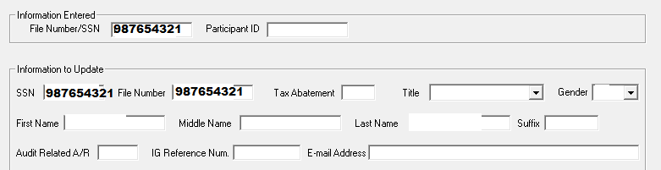

* Modify the file number

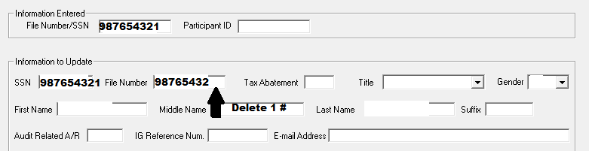

* + Click Update, then modify the SSN

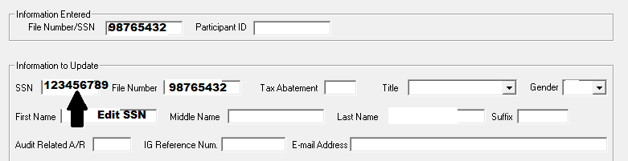

* Click Update
* Finally, you will modify the file number to the correct SSN.

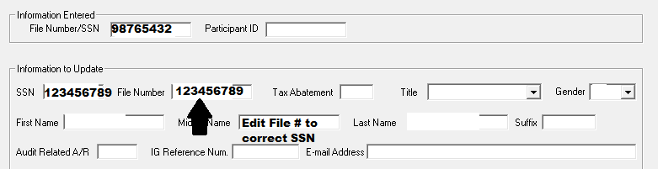

* Click Update

##### IF SSN Greyed Out

* + Sometimes the SSN is greyed out and not editable
  + Utilize Participant Profile to change SSN from verified to unverified.
  + Go back into corporate update

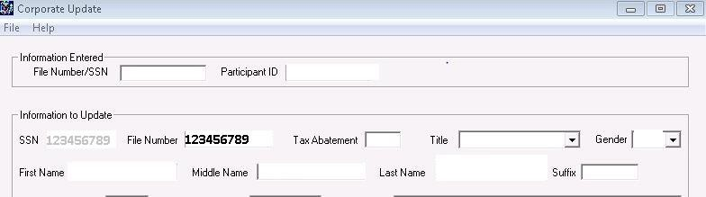

##### Participant Profile

* + Click Edit, change from Verified to Unverified, click Accept, reset when done

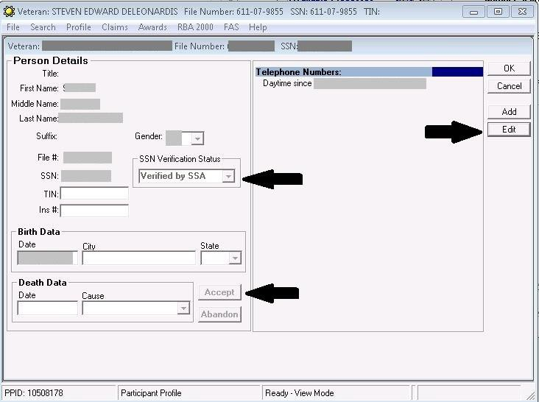

## Once you have completed the Corporate Record Merge, and the incorrect PID is no longer attached to a file number or SSN, the ticket can be closed.

**Update Status/Close Ticket**

Enter “**CLOSED**” into the New Status box and notes for the ticket, if necessary. Make sure you have assigned the ticket to yourself to ensure credit is received. Lastly, if specific tasks must be performed prior to closing the ticket, enter them in the User Description section as well as communicating it via email to the appropriate individual.

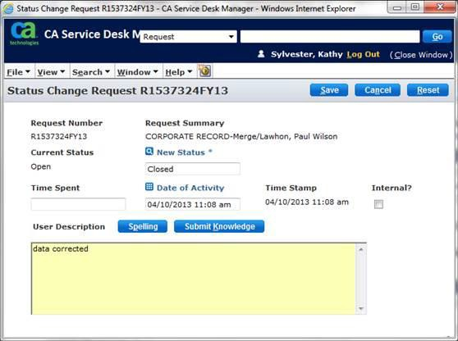

### Please follow the link to the Business Management Staff SharePoint page to request a Data Architecture Merge:

#### [Business Management SharePoint Page](https://vaww.vba.esp.va.gov/sites/SPTNCIO/215bm/Lists/DA%20Merge%20and%20Deactivation%20List/AllItems.aspx?ShowInGrid=True&amp;View=%7B825192ED%2D989A%2D464B%2D801C%2D65FE18392D98%7D&amp;InitialTabId=Ribbon%2EList&amp;VisibilityContext=WSSTabPersistence)

*Two Corporate Records and BOTH have Data*

Review both Corporate Records.

One Corporate Record has data, but is not up to date. You will need screenshots of every tab in Corporate Inquiry for the **INCORRECT PID** uploaded into Virtual VA for the file with the **CORRECT PID.**

###### Please note the difference between the data contained in the following screen shots:

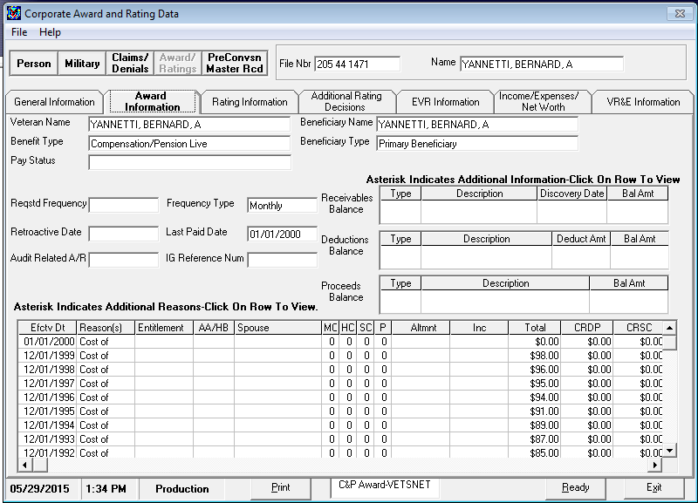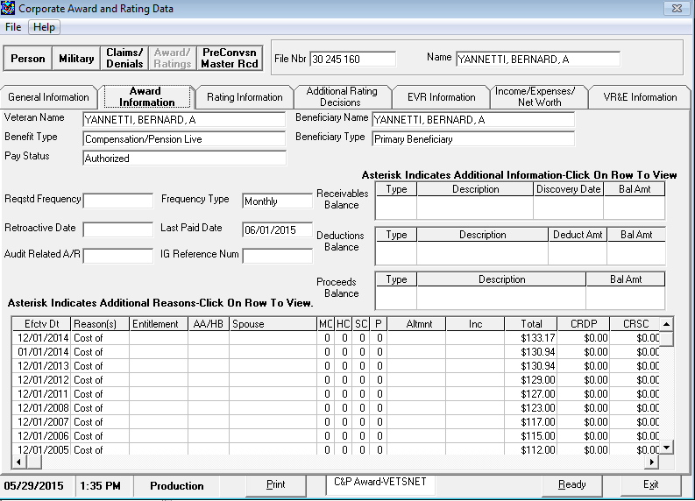

*You may receive the following error message when trying to perform a Corporate Update when both records contain data:*

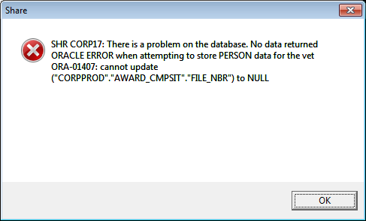

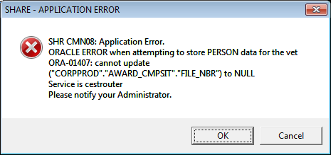



# PID Deactivation

### Please follow the link to the Business Management Staff SharePoint page to request a Data Architecture PID Deactivation:

#### [Business Management SharePoint Page](https://vaww.vba.esp.va.gov/sites/SPTNCIO/215bm/Lists/DA%20Merge%20and%20Deactivation%20List/AllItems.aspx?ShowInGrid=True&amp;View=%7B825192ED%2D989A%2D464B%2D801C%2D65FE18392D98%7D&amp;InitialTabId=Ribbon%2EList&amp;VisibilityContext=WSSTabPersistence)

*Two Corporate Records and BOTH have Pre- Converted Master Records*

*This will be the same process as the Incorrect PID Deactivation detailed above.*

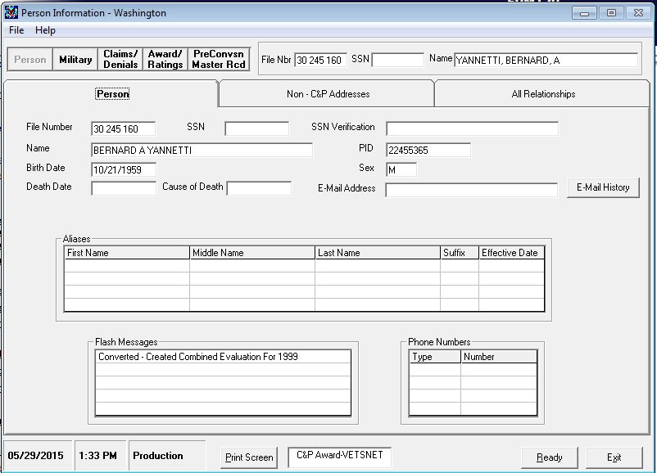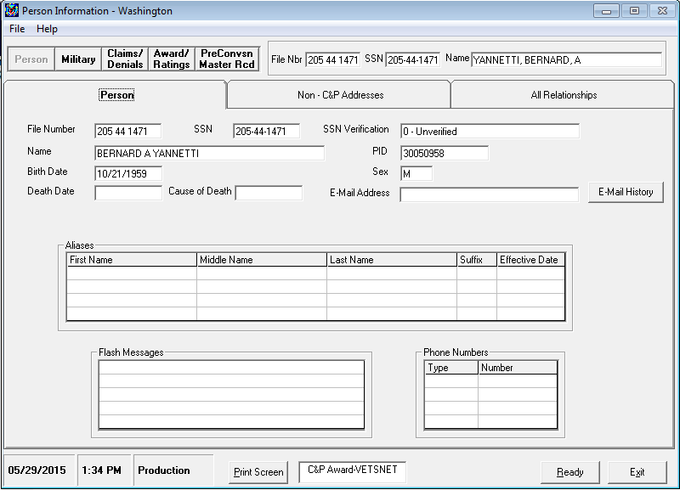

# MAP-D Merge

# Check for letters, notes, and closed claims.

#### Please review MAP-D records for the SSN/File Number indicated on the Corporate Record Trouble Ticket Request Form. Check for:

###### Letter Library for any MAP-D letters

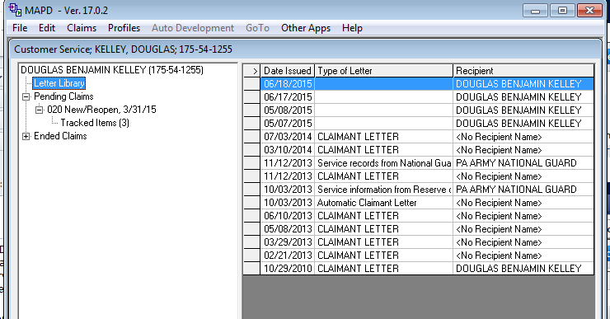

###### MAP-D Notes

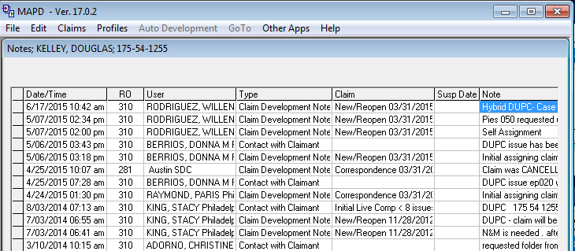

###### Ended Claims

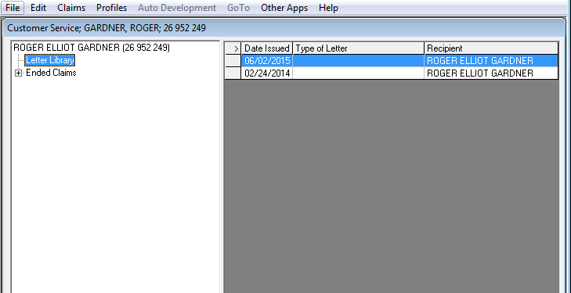

*Once you’ve checked both records, if the INCORRECT PID contains a MAP-D letter library and/or MAP-D Notes, then transfer the ticket to PHI SME MAP-D Group within NSD.*

To transfer a ticket, select “**TRANSFER**.” {**Note: for Incidents, a message must be entered in the**

**“Solution” section prior to closing a ticket.**}



**Transferring Tickets**

To transfer tickets, a new group must be assigned within the “New Group” category. Afterwards, select the Save button. The transfer action is complete.

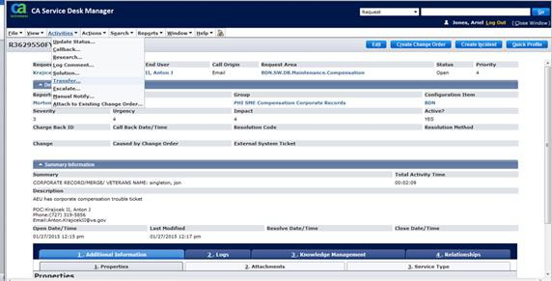

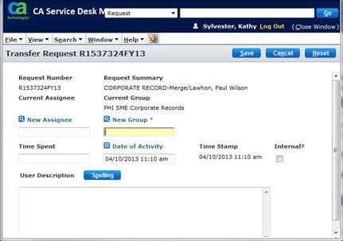

**Inputting a Solution**:

Within the Solution option, enter comments in the User Description box. For example, if this is a MAP-D Merge request, indicate that you would like a MAP-D Merge completed for the correct and incorrect PIDs.

* **Please note that you cannot include PII or PKI information at this step.**

Afterwards, select the Save button. The solution action is complete.