Drill Pay Waivers

Trainee Handout

**Table of Contents**

Objectives 2

References 3

Topic 1: Define and Explain 4

Topic 2: Drill Pay vs. Active Duty 6

Topic 3: Waiver Forms 7

Topic 4: Automated Processing for Drill Pay Adjustments 10

Topic 5: Withholding and Notification Procedures 12

Job Aid 1: VBMS-A Screenshots & Instructions 15

Job Aid 2: Sample VA Form 21-8951-2 17

Attachment A: Drill Pay Final Action Letter (PCGL – GP14 Post: Drill Pay) 19

Review Exercise: 23

Objectives

Upon completion of this lesson, you will be able to:

* Define drill pay and explain why VA must adjust Veteran’s benefits when in receipt of drill pay
* Differentiate between award adjustments necessitated by a Veteran’s receipt of drill pay and award adjustments necessitated by a Veteran’s return to active duty
* Summarize how the processing of drill pay cases has been automated
* Outline the steps in reviewing and manually processing drill pay cases that are rejected or removed from automated processing
* Explain the impact of drill pay adjustments on subsequent claims worked by all regional offices
* Demonstrate manual award adjustments in VBMS Awards (VBMS-A) based on receipt of drill pay
* Construct written notification to Veterans regarding drill pay-related award adjustments

References

All M21-1 references are available through the [Compensation Pension Knowledge Management (CPKM) Portal](https://vaww.vrm.km.va.gov/system/templates/selfservice/va_kanew/help/agent/locale/en-US/portal/554400000001034).

* [38 CFR 3.654](http://www.ecfr.gov/cgi-bin/text-idx?SID=75794814451aa554401c0867c0aeda13&mc=true&node=se38.1.3_1654&rgn=div8), Active service pay: Training duty
* [38 CFR 3.700(a)(1)(iii)](http://www.ecfr.gov/cgi-bin/text-idx?SID=75794814451aa554401c0867c0aeda13&mc=true&node=se38.1.3_1700&rgn=div8), General: Veterans: Active service pay: Reservists
* [M21-1, Part I, Subpart 2](https://vaww.vrm.km.va.gov/system/templates/selfservice/va_kanew/help/agent/locale/en-US/portal/554400000001034/topic/554400000003064/Chapter-02-Due-Process) Due Process
* [M21-1, Part III, Subpart v, 4.C](https://vaww.compensation.pension.km.va.gov/system/templates/selfservice/va_ka/portal.html?encodedHash=%23!agent%2Fportal%2F554400000001034%2Farticle%2F554400000014246%2FM21-1-Part-III-Subpart-v-Chapter-4-Section-C-Adjusting-Department-of-Veterans-Affairs-VA-Benefits-Based-on-a-Veterans-Receipt-of-Active-Service-Pay) Adjusting Department of Veterans Affairs (VA) Benefits Based on a Veteran’s Receipt of Active Service Pay
* [M21-1, Part III, Subpart v, 4.D](https://vaww.vrm.km.va.gov/system/templates/selfservice/va_kanew/help/agent/locale/en-US/portal/554400000001034/content/554400000014247/M21-1-Part-III-Subpart-v-Chapter-4-Section-D-Examples-of-Award-Adjustments-Necessitated-by-a-Veterans-Election-of-Drill-Pay) Examples of Award Adjustments Necessitated by a Veteran’s Election of Drill Pay
* [VA Compensation Rate Tables](https://www.va.gov/disability/compensation-rates/veteran-rates/)
* [Letter Creator Tool](http://vbaw.vba.va.gov/bl/21/rating/rat00.htm)
* [Date to Date Calculator](http://www.timeanddate.com/date/duration.html)

Topic 1: Define and Explain

**Definition of Drill Pay**

Drill pay refers to military pay a reservist or member of the National Guard receives for performing active or inactive duty training.

* Active duty training (ADT) generally consists of a two-week period of training, usually during the summer.
* Inactive duty training (IADT) is Reserves or National Guard duty that is other than full-time duty. IADT cannot be performed in connection with any correspondence courses, attendance at an educational facility while in inactive status or duty performed as a temporary member of the Coast Guard Reserves. IADT usually consists of “weekend drills and annual training” which are further broken down into four-hour drill sessions. One unit training assembly (UTA) is a 4-hour drill session. The normal weekend drill is considered four sessions of UTA, equal in pay to four days of active duty pay. Weekend drills are also called multiple unit training assemblies (MUTA).

Although two different categories of training exist, the Defense Manpower Data Center (DMDC) provides VA with one number that represents the total number of days for which the Veteran received drill pay in one fiscal year (FY).

**Other Names Used for Drill Pay**

* Training pay
* Military training pay and
* Military pay and allowances

**Prohibition against Duplication of Benefits**

10 U.S.C. 12316 and 38 U.S.C. 5304(c) prohibit the concurrent receipt of drill pay and Department of Veterans Affairs (VA) disability compensation or pension. Veterans who perform active or inactive duty training must choose the benefit they prefer and waive the other.

Most Veterans choose to receive drill pay instead of disability compensation or pension because drill pay is typically the greater benefit. These Veterans must waive their VA benefits for the same number of days they received drill pay.

**Fiscal Year (FY)**

The fiscal year (FY) goes from October 1st of the previous year to September 30th of the named FY.

* FY 2017: October 1, 2016 – September 30, 2017
* FY 2018: October 1, 2017 – September 30, 2018
* FY 2019: October 1, 2018 – September 30, 2019

It is very important that you understand what a FY is because:

* VA is notified of the number of drill pay days in a FY, NOT a calendar year.
* We withhold at the monthly rate of VA benefits to which the Veteran was entitled on the last day of the FY.
* If the Veteran served on active duty (AD) and received drill pay during the same fiscal year, the AD days need to be subtracted from the training days when adjusting benefits.

**How Drill Pay Waivers are Generated**

At the end of each FY, DMDC sends an electronic file to the Hines Information Technology Center (ITC) that identifies Veterans who received both military pay and VA benefits during that fiscal year.

***Note:*** If there has been an interruption in getting this data from DMDC, the file may include drill pay data for one or more prior years as well.

Before processing the file, the Hines ITC updates the corporate record of each Veteran to reflect the number of days for which he or she received drill pay during the prior fiscal year. This update is visible in the DRILL PAY PROFILE field of the DRILL PAY tab under the Award Adjustments screen in VBMS-A.

Hines ITC simultaneously uploads into the Veteran’s VBMS eFolder, and sends to the Veteran, VA Form 21-8951, *Notice of Waiver of VA Compensation or Pension to Receive Military Pay and Allowances*, to inform him/her that DMDC has identified him/her as having received active or inactive duty training pay. The form further advises the Veteran that training pay cannot legally be paid concurrently with VA compensation or pension benefits.

Due to drill pay automation, Hines ITC also sends a cover letter with the VA Form 21-8951 proposing to withhold the Veteran’s VA benefits based on the information contained on the form for that fiscal year. The notice of proposed adverse action advises the Veteran he/she has sixty days to respond to the notice. If the Veteran does not respond, the proposed adjustment will be made to his/her benefits.

Topic 2: Drill Pay vs. Active Duty

**Adjustments for Drill Pay vs. Adjustments for Active Duty (AD)**

* When a Veteran receives drill pay and elects to waive VA compensation, we withhold compensation at the monthly rate to which the Veteran was entitled on the last day of the FY under review.
* If a Veteran returns to AD, we stop his/her compensation for the entire period he/she is on AD.
* Both adjustments create an overpayment of benefits.

**Overlapping Active Duty and Drill Pay**

The number of drill pay days reported may also include AD days. Therefore, if the Veteran was on AD in the same FY, we must subtract the number of AD days in that FY from the number of drill pay days reported. In this situation, VA benefit payments must be stopped for the period of AD *and* withheld for the remaining days of drill pay, if any.

You can calculate AD days at <http://www.timeanddate.com/date/duration.html> (make sure to check the box that precedes the following text: *Include end date in calculation*).

*Examples:*

Veteran was on AD January 20, 2019 – August 21, 2019

Number of AD days in FY 2019: 214 days

Veteran was on AD December 5, 2018 – August 4, 2019

Number of AD days in FY 2015: 243 days

Veteran was on AD July 4, 2017 – December 5, 2018

Number of AD days in:

* FY 2017: 89 days (July 4, 2017 – September 30, 2017)
* FY 2018: 365 days (October 1, 2017 – September 30, 2018)
* FY 2019: 66 days (October 1, 2018 – December 5, 2018)

**Monthly Rate of Withholding for Drill Pay**

The rate of withholding is the same as the amount of compensation to which the Veteran is entitled each month on the last day of the FY in question. This includes increases effective in September that we pay on October 1st. Some exceptions may impact the amount of drill pay withholding, such as:

* No receipt of benefits at the end of the fiscal year
* Reduction due to incarceration
* A temporary grant of 100%
* An apportionment to a dependent

Specific instructions regarding the above circumstances are located in [M21-1 III.v.4.C.5 - Establishing a Withholding to Offset a Veteran’s Receipt of Drill Pay](https://vaww.vrm.km.va.gov/system/templates/selfservice/va_kanew/help/agent/locale/en-US/portal/554400000001034/content/554400000014246/M21-1-Part-III-Subpart-v-Chapter-4-Section-C-Adjusting-Department-of-Veterans-Affairs-VA-Benefits-Based-on-a-Veterans-Receipt-of-Active-Service-Pay#5).

**Review File to Determine if Withholding is Needed**

Review the following to make sure all FYs have been addressed:

* VBMS eFolder and Legacy Content Manager (LCM) for copies of
  + VA Form 21-8951/-2
  + Historical award documents and decision notices
  + emails to Central Office (CO) if Veteran waived drill pay
* Drill Pay tab under Award Adjustments in VBMS-A
* Award Information screen under Corporate Inquiries in Share

Topic 3: Waiver Forms

**VA Compensation or Pension Waiver Forms**

* VA Form 21-8951, *Notice of Waiver of VA Compensation or Pension to Receive Military Pay and Allowances* form is automatically generated and sent to the Veteran by the VA information technology center (ITC) in Hines, IL, which we call “Hines.”
* VA Form 21-8951-2, *Notice of Waiver of VA Compensation or Pension to Receive Military Pay and Allowances* is manually filled out by the Veteran

Refer to Job Aid 2 for an example of VA Form 21-8951-2.

**Previous Versions of VA Form 21-8951**

* VA Forms 21-8951 the Hines ITC issued for fiscal years ***prior to*** 2015
* Due process must be provided prior to withholding
* These forms notified the Veteran that VA would adjust from a future date, however, if that is not possible then it may make a retroactive adjustment.

**Newer Versions of VA Form 21-8951**

* VA Forms 21-8951 the Hines ITC issued for fiscal year 2015 and later
* Provides Veteran notice that an overpayment will occur if the drill pay withholding is processed
* Eliminates the need to provide due process

**Initial Review of VA Form 21-8951/-2**

Check the back of the form for Veteran’s acceptance of information on the front page and all required signatures. If the Veteran disagrees and reports *fewer* days than printed on the form, a signature from his/her unit commander is required, absent documentation confirming non-receipt or fewer number of days of training pay.

If a Veteran agrees with the number of days printed on the form or states there were ***more*** days than what is listed on the front of the form, the unit commander signature is not required. The unit commander’s signature is also not required if our systems can verify the Veteran was retired from the Reserve/National Guard or the Veteran elects to waive his/her drill pay and keep his/her VA compensation.

Note: The Veteran may correspond using means other than a VA Form 21-8951, as long as the written documentation clearly identifies the Veteran’s intent on which benefit (drill pay or VA benefits) he/she desires to waive, specifies the fiscal year training took place, provides the number of training days that took place that fiscal year, bears the Veteran’s signature and if claiming fewer training days than supplied on VA Form 21-8951, then commander’s signature is also needed.

**Over 179 Days of Drill Pay**

If DMDC reports over 179 days of drill pay, we must develop for AD

* Submit a Veterans Information Solution (VIS) inquiry and/or
* Defense Personnel Image Retrieval System (DPRIS) records request

*Important:* If evidence of AD is obtained via third party, propose to discontinue the Veteran’s benefits for the period of service. Refer to [M21-1 III.v.4.C.3.a](https://vaww.vrm.km.va.gov/system/templates/selfservice/va_kanew/help/agent/locale/en-US/portal/554400000001034/content/554400000014246/M21-1-Part-III-Subpart-v-Chapter-4-Section-C-Adjusting-Department-of-Veterans-Affairs-VA-Benefits-Based-on-a-Veterans-Receipt-of-Active-Service-Pay#3a) for further instructions.

If no AD periods are shown, generate the *Drill Pay – 179 Plus Days Letter* in Letter Creator. Set the suspense date of the pending EP to expire 30 days from the current date.

If the Veteran submits official separation documents for an AD period in response to the *Drill Pay – 179 Plus Days Letter*, stop his/her compensation for the period he/she was on AD. Resume benefits effective the day after discharge. Remember to calculate the days of AD service for that fiscal year and withhold drill pay for any *remaining* training days, if any.

If the Veteran fails to respond, assume the training days reported on the form do not include AD and process the adjustment for the total number of training days reported on VA Form 21-8951 for that fiscal year.

**Waiver Options on VA Form 21-8951/-2**

The Veteran may select any of the following options on the VA Form 21-8951/-2:

* *I elect to waive VA benefits for the days indicated in order to retain my training pay.*
  + If the Veteran alters the number of days on the front of the form to less than what was reported, then the form must also be signed by his/her unit commander.
* *I elect to waive military pay and allowances for the days indicated in order to retain my VA compensation or pension.*
* *I received no military pay and allowances during the fiscal year(s) indicated on the front of this form.*

**Incomplete Form**

Send the Veteran an *Incomplete 21-8951 Letter* (from the Letter Creator) advising that failure to return a completed and signed form may still result in a reduction of the Veteran’s benefits. Attach a copy of the incomplete VA Form 21-8951 and set the suspense date of the pending EP to expire 30 days from the current date.

**Veteran Indicates Waiver of Drill Pay**

Make one attempt to contact the Veteran via telephone to confirm his/her waiver of drill pay and explain he/she is likely waiving the greater benefit. You may need to calculate the total amount of the drill pay withholding in order to advise the Veteran (instructions to follow).

* Document call on VA Form 27-0820, *Report of General Information* and upload to the VBMS eFolder.
* If Veteran changes his/her waiver selection, determine whether further adjustment to VA benefits is needed.

If Veteran cannot be reached (enter note in VBMS) or still decides to waive drill pay, review the eFolder and systems to determine whether benefits were already withheld for that fiscal year of drill pay. If benefits have not yet been reduced, close the pending EP 600, if pending, or clear a one-time EP 290, and notify the Veteran that VA will *not* adjust his/her award.

If benefits were reduced and the waiver was received less than one year from the date of notification of the reduction, establish EP 290, reverse the drill pay adjustment for that fiscal year of drill pay, and notify the Veteran of the action taken.

After taking the actions described in the previous paragraphs, send an **encrypted** email to Compensation Service’s Pre-Discharge and Interagency Staff ([VAVBAWAS/CO/212A](mailto:212A.VBACO@va.gov?subject=VA%20Form%2021-8951-Waiver%20of%20Military%20Pay)).

* Refer to [M21-1 III.v.4.C.4.c](https://vaww.vrm.km.va.gov/system/templates/selfservice/va_kanew/help/agent/locale/en-US/portal/554400000001034/content/554400000014246/M21-1-Part-III-Subpart-v-Chapter-4-Section-C-Adjusting-Department-of-Veterans-Affairs-VA-Benefits-Based-on-a-Veterans-Receipt-of-Active-Service-Pay) for instructions on how to prepare the email
* Upload a copy of the sent email into the Veteran’s eFolder

**Important:** If benefits were already reduced and the waiver was received more than one year following notification of the reduction, notify the Veteran that the waiver request cannot be processed.

**How to Calculate Total Withholding Amount**

Divide the monthly withholding rate by 30 (all months have 30 days when calculating daily VA entitlements amounts) and multiply by the number of days we need to withhold.

Example:

* The monthly withholding rate is $455.75.
* The daily withholding is $15.19 ($455.75 ÷ 30)
* If we are withholding for 10 days, the total withholding amount is $151.19 ($15.19 x 10)

**Veteran Indicates They Did Not Receive Drill Pay**

Review the evidence of record to determine whether the Veteran was a reservist or member of the National Guard during the fiscal year in question.

If there is reason to question the accuracy of the Veteran’s assertion, initiate development, to include requesting a field examination, if necessary and appropriate.

If the evidence of record confirms the Veteran was **not** a reservist or member of the National Guard that fiscal year, clear the pending EP and notify the Veteran no adjustments will be made to his/her VA benefits.

Topic 4: Automated Processing for Drill Pay Adjustments

**Automated Processing of Drill Pay Cases**

In most cases, Hines ITC will generate and send a notice of proposed adverse action (a.k.a. “due process” letter) and VA Form 21-8951 to the Veteran to complete, sign, and return.

The system will also automatically:

* Establish EP 600 – *Drill Pay Adjustment,*
* Add a contention titled *Drill Pay Adjustment for FY XX – XX Days,*
* Add *Potential Under/Overpayment* and *Automated Drill Pay Adjustment* special issues,
* Add a tracked item titled *Drill Pay Proposal* with a 65-day suspense, and
* Select *Awaiting Response for VA Form 21-8951* as the suspense reason.

Note: If the automated process fails, an EP 290 is automatically established and distributed for manual processing.

**Automated Finalization of Award Adjustments**

If no response is received from the Veteran during the due process period, the system will automatically close the pending tracked item and make the necessary award adjustments for the number of drill pay days listed on the form and recorded in the system. Notification will also be sent to the Veteran and uploaded to the VBMS eFolder. A copy of the award print showing the adjustment will also be uploaded to the eFolder.

Note: The automated processing of drill pay cases involving pension awards ends at this point in the process. Such cases require manual processing from this point forward.

If the Veteran responds within the due process period, additional action will be needed. All responses received must be reviewed by claims processors to determine whether automated processing of the case should continue, or the case should be processed manually.

If the Veteran agrees with the proposed drill pay withholding, claims processors should update the tracked item under the pending EP as “received,” using the date VA received the VA Form 21-8951. Automated processing of the case will continue, since no changes or corrections need to be made to the proposed adjustment.

**Removal from Automated Processing**

However, if the Veteran *disagrees* with the number of days listed, wishes to waive the drill pay in order to avoid a reduction in his/her VA benefits, or submits an incomplete form, claims processors should remove the claim from the automated process by adding a *new* tracked item titled *Drill Pay – Manual Process* first, **then** updating the *Drill Pay Proposal* tracked item as “received,” using the date VA received the VA Form 21-8951.

Claims processors should proceed based on instructions discussed in the previous topic.

**Regional Office Processing of Drill Pay Adjustments**

All drill pay cases that are rejected from automated processing must be processed manually by the regional office to which the claim is assigned by National Work Queue (NWQ).

Drill Pay Cases Rejected from Automated Processing

In those instances when the Hines ITC is unable to send VA Form 21-8951 to the Veteran, the system will automatically establish EP 290. Claims processors must locate the file copy of the Hines-generated VA Form 21-8951 in the VBMS eFolder and review the form. The claims processor must ensure the file number and/or SSN printed on the VA Form 21-8951 belongs to the Veteran whose name, address and contact information are also printed on the form.

Claims processors must then review the systems to determine whether drill pay withholding for that fiscal year is necessary. If so, they must also determine the amount of benefits to be withheld and the length of time the withholding must remain in place – this will be explained later.

* Clear the pending EP 290 and establish EP 600
* Add the *Potential Under/Overpayment* special issue
* Add the tracked item titled *Drill Pay – Manual Process*

Draft a notice of proposed adverse action to withhold VA benefits – use VBMS (core) if available. If not, draft a Personal Computer Generated Letter (PCGL). Attach to the notice

* a copy of the VA Form 21-8951 the Hines ITC uploaded into the Veteran’s eFolder, and
* VA Form 21-0789, *Your Rights to Representation and a Hearing*.

**Veteran Fails to Return VA Form 21-8951**

If the Veteran does not respond to the notice of proposed adverse action within 65 days, assume the reported number of days of drill pay are accurate and make the proposed award adjustment. Notify the Veteran of the action taken and provide decision review rights. Remember to close any open tracked items prior to taking this action.

Topic 5: Withholding and Notification Procedures

**VA Benefits Withholding Procedures**

All withholdings will be made retroactively, creating an overpayment of benefits (effective February 25, 2016). This allows the Veteran to select repayment options or request waivers due to hardship. The Debt Management Center (DMC) will contact the Veteran regarding the debt and repayment/waiver options. (The Veteran will be notified in the decision notice that he or she will be contacted by DMC.) Under the old procedure, no overpayment was created, which left the Veteran with no option to mitigate the adverse effect of losing the withheld benefits.

Start withholding on the first day of the *current* fiscal year (October 1st). Start on a different date if the amount of VA benefits to which the Veteran is entitled on that date is less than the amount we need to withhold, or the withholding cannot be accomplished without affecting the *future* rate of payment. If you do not have enough days to retroactively adjust the award from the first day of the applicable FY, adjust the award from the date of the most recent award line that precedes October 1 of the applicable FY (this might be December 1 of the prior FY, which was the effective date for a COLA) or the first day of the fiscal year prior to the applicable FY.

**Adjusting Withholdings Based on Subsequent Claims**

Increased or Decreased Rating

If the drill pay adjustment has already been completed and a subsequent rating decision is made that increases the Veteran’s overall combined evaluation at the end of that same fiscal year (for which a drill pay adjustment was already made), the drill pay withholding amount must also be adjusted.

**Scenario**:

* A Veteran with a combined disability rating of 20 percent attended 65 days of training during fiscal year 2014.
* In February 2016, VA
  + established a withholding of $258.83 per month, effective October 1, 2015, to offset the Veteran’s receipt of drill pay, and
  + resumed the full payment of benefits ($263.23 per month), effective December 6, 2015.
* A June 2016 rating decision retroactively assigns the Veteran a combined disability rating of 30 percent, effective March 1, 2014.

**Result**:  When VA promulgates the rating decision it must increase the amount of the withholding for the period October 1, 2015, through December 5, 2015, to $400.93.

We must provide due process prior to making the adjustment to the drill pay withholding amount. We cannot reduce or terminate the Veteran’s payment without giving the Veteran due process.

**Less Common Drill Pay Related Adjustments**

Review Compensation Pension Knowledge Management (CPKM) for special instructions on these adjustments:

* Advance notice of receipt of drill pay
* Incarceration
* Apportionment
* Recoupment for separation benefits
* Paragraph 29 or 30 benefits

[Refer to M21-1, Part III, Subpart v, Chapter 4, Section D - Examples of Award Adjustments Necessitated by a Veteran’s Election of Drill Pay](https://vaww.vrm.km.va.gov/system/templates/selfservice/va_kanew/help/agent/locale/en-US/portal/554400000001034/content/554400000014247/M21-1-Part-III-Subpart-v-Chapter-4-Section-D-Examples-of-Award-Adjustments-Necessitated-by-a-Veterans-Election-of-Drill-Pay) for some specific examples of different types of VA Compensation adjustments.

**Manually Adjusting Drill Pay Related Withholding in VBMS-A**

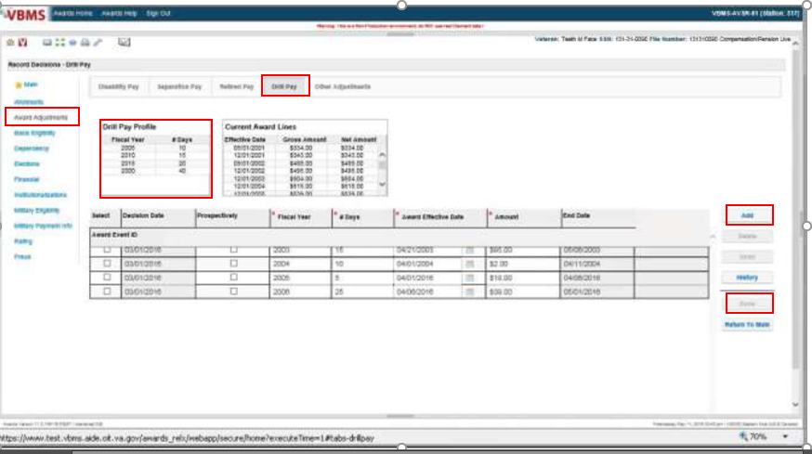

Refer to the attached Job Aid 1 for step-by-step award-generation instructions.

After all information is input, click Done, then Generate the award.

**Notify the Veteran**

Notify the Veteran of our decision using RADL, if available, or PCGL (GP14 Post: Drill Pay).

Be sure to add the evidence used to make our decision, as this will not automatically be input into either letter.

Refer to Attachment A for an example of a PCGL decision notice.

Job Aid 1: VBMS-A Screenshots & Instructions

To process the award to adjust benefits, you must first access the Award Adjustment screen in VBMS-A.

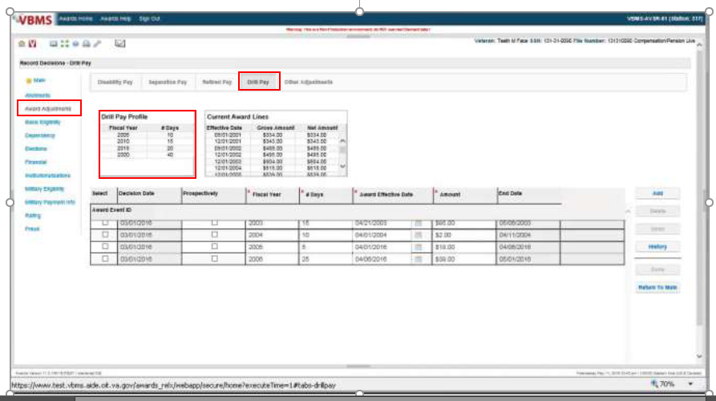

1. Note the **Drill Pay Profile** grid above the **Decision** grid. This grid will be updated when information is received electronically (via Hines) regarding the Veteran’s drill days.

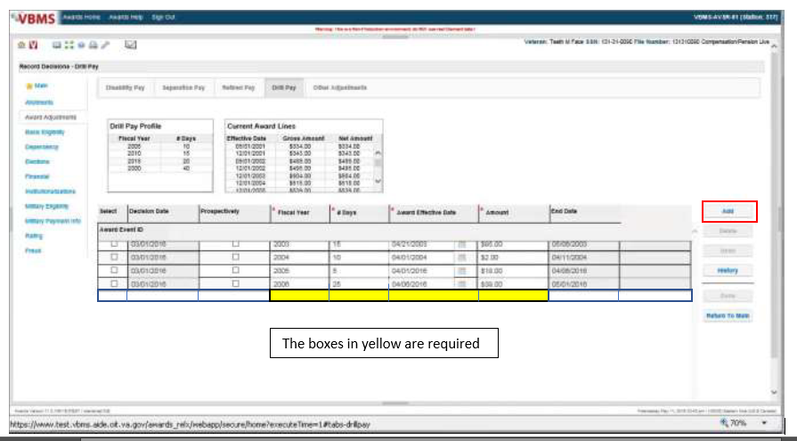

1. Click **Add**;enter the **Fiscal Year** that the drill pay was received; record the number of **Days** of drill pay; enter the **Award Effective Date (**the date that is entered to start the withholding).
2. The **Award End Date** will be system-generated from the **Award Effective Date** and number of days that were entered.
3. Calculate the benefit amount to be withheld and enter into the **Amount** field (Rate on September 30, FY = withheld amount).
4. Select **Done** to update the grid.
5. If drill pay for another fiscal year needs to be added, select the **Add** button and record the information for that year. Manually enter the next fiscal year’s **Award Effective Dat**e as the ***same date*** as the prior fiscal year’s **End Date**.
6. Select **Done** to save the decision(s) and close the screen.
7. **Generate** the award.
8. Notify the Veteran of our decision using RADL if available (making sure to cite the evidence considered), or PCGL if RADL is not available (GP 14 letter).

Job Aid 2: Sample VA Form 21-8951-2

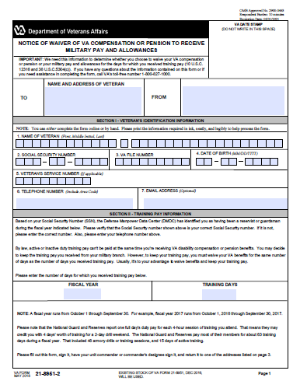

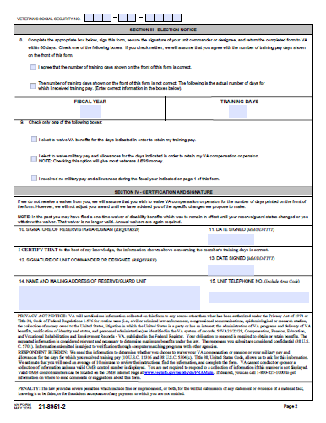

Attachment A: Drill Pay Final Action Letter (PCGL – GP14 Post: Drill Pay)

In Reply Refer To:

386/MJ/Challenge

CSS XXX XX XXXX

Veteran, Joe

JOHN Q VETERAN  
1234 VETERAN DR

VETERAN CITY US 12345

Dear Mr. Veteran:

In our letter of (Enter date notice of proposed adverse action was previously sent, ex. July 9, 2014), we informed you we would reduce your benefits because you received Military Drill Pay for fiscal year (FY) XXXX. We have adjusted your benefits accordingly.

This letter explains your new monthly payments. We have also included information about what to do if you disagree with our decision, and who to contact if you have questions or need assistance.

**Your Award Amount and Payment Start Date**

Your monthly payment amount is shown below:

|  |  |  |  |  |
| --- | --- | --- | --- | --- |
| **Total VA Benefit** | **Amount Withheld** | **Amount Paid** | **Payment Start Date** | **Reason For Change** |
| $1,041.39 | $797.00 | $244.39 | Oct 1, 2015 | Drill Pay Adjustment FY XXXX (XX days) |
| 1,041.39 | 0.00 | 1,041.39 | Nov 17, 2015 | Drill Pay Adjustment Ends |

**Why Have We Withheld Benefits?**

You received drill pay for XX days during fiscal year XXXX from the military. We must hold back part of your VA compensation until this has been paid back. After this amount is paid back, you'll start receiving your full VA compensation.

**This action will create an overpayment.**

**What You Owe**

We have created an overpayment in your account because the information we received showed that we paid you too much. You will receive a separate letter, which will explain how much we overpaid you, and how you can repay this debt.

**Evidence Used to Make Our Decision**

Evidence section must be entered manually.

In making our decision, we considered the following evidence:

* Report from Defense Manpower Data Center that you received drill pay for XX days in FY XX
* Our letter to you dated (enter date of notice of proposed adverse action)

**What You Should Do If You Disagree With Our Decision**

If you do not agree with our decision, you have one year from the date of this letter to select a review option in order to protect your initial filing date for effective date purposes. You must file your request on the required application form for the review option desired. The table below represents the review options and their respective required application form.

|  |  |
| --- | --- |
| **Review Option** | **Required Application Form** |
| **Supplemental Claim** | VA Form 20-0995, Decision Review Request: Supplemental Claim |
| **Higher-Level Review** | VA Form 20-0996, Decision Review Request: Higher-Level Review |
| **Appeal to the Board of Veterans’ Appeals** | VA Form 10182, Decision Review Request: Board Appeal (Notice of Disagreement) |

Please note: You may not request a higher-level review of a higher-level review decision issued by VA.

The enclosed VA Form 20-0998, *Your Rights to Seek Further Review of Our Decision*, explains your options in greater detail and provides instructions on how to request further review. You may download a copy of any of the required application forms noted above by visiting www.va.gov/vaforms/ or you may contact us by telephone at 1-800-827-1000 and we will mail you any form you need.

You can visit va.gov/decision-reviews to learn more about how the decision review process works.

If you would like to obtain or access evidence used in making this decision, please contact us by telephone, email, or letter as noted below letting us know what you would like to obtain. Some evidence may be obtained online by visiting VA.gov.

**What Is eBenefits?**

eBenefits provides electronic resources in a self-service environment to Service members, Veterans, and their families. Use of these resources often helps us serve you faster! Through the eBenefits website you can:

* Submit claims for benefits and/or upload documents directly to the VA
* Request to add or change your dependents
* Update your contact and direct deposit information and view payment history
* Request a Veterans Service Officer to represent you
* Track the status of your claim or appeal
* Obtain verification of your military service, civil service preference, or VA benefits
* And much more!

Enrolling in eBenefits is easy. Just visit www.eBenefits.va.gov for more information. If you submit a claim in the future, consider filing through eBenefits. Filing electronically, especially if you participate in our fully developed claim program, may result in a faster decision than if you submit your claim through the mail.

**If You Have Questions or Need Assistance**

If you have any questions, you may contact us by telephone, e-mail, or letter.

|  |  |
| --- | --- |
| **If you** | **Here is what to do.** |
| Telephone | Call us at 1‑800‑827‑1000. If you use a Telecommunications Device for the Deaf (TDD), the Federal number is 711. |
| Use the Internet | Send electronic inquiries through the Internet at <https://iris.custhelp.va.gov>. |
| Write | VA now uses a centralized mail system.  For all written communications, put your full name and VA file number on the letter.  Please mail or fax all written correspondence to the appropriate address listed on the attached *Where to Send Your Written Correspondence*. |

In all cases, be sure to refer to your VA file number XXX XX XXXX.

If you are looking for general information about benefits and eligibility, you should visit our website at https://www.va.gov, or search the Frequently Asked Questions (FAQs) at https://iris.va.gov.

We sent a copy of this letter to your representative, {Insert Name of Service Organization}, whom you can also contact if you have questions or need assistance.

Or

We have no record of you appointing a service organization or representative to assist you with your claim. You can contact us for a listing of the recognized veterans' service organizations and/or representatives. Veterans' service organizations, which are recognized or approved to provide services to the Veteran community, can also help you with any questions.

Sincerely yours,

RO Director

VA Regional Office

E-mail us at <https://iris.custhelp.va.gov>

Enclosure(s): Where to Send Your Written Correspondence

VA Form 20-0998

cc: {Insert Name of Service Organization} or remove line if none appointed

Review Exercise:

1. How is a Drill Pay Day (DPD) calculated?
2. One day during a two-week annual training equals one DPD.
3. One four-hour training assembly on a drill weekend equals one DPD.
4. One day always equals one DPD.
5. A & B
6. What should you check to make sure all fiscal years (FYs) during which a Veteran received drill pay have been/are being addressed?
7. The claims file (for VA Forms 21-8951/-2).
8. The Award Information screen under Corporate Inquires in Share.
9. The Drill Pay tab under Award Adjustments in VBMS-A.
10. All the above.
11. If we add a spouse to a Veteran’s award effective September 15, 2019; raising his/her monthly compensation rate from $428.83 to $479.83, starting October 1, 2019, how much would we withhold for FY 2019 drill pay?
12. $428.83
13. $479.83
14. We previously withheld for FY 2019 drill pay in 2020. If we retroactively increase benefits today, effective September 1, 2018, and the amount will be more than what was previously paid, do we need to give due process to also simultaneously increase the amount we withhold for FY 2019? Yes or No?
15. How many days do we withhold for FY 2018 drill pay if a Veteran, who was on active duty from January 15, 2016 – October 31, 2017 and August 1, 2018 – July 31, 2019, agrees with and signs a VAF 21-8951 for FY 2018 that indicates 120 days of drill pay?
16. 28
17. 30
18. 92
19. 120