Veterans Information Solution (VIS)

VIS User Guide



March 2014
Version 1.5

INTENTIONALLY BLANK

Revision History

Date | Version | Description | Author
12/16/2011 | 1.0 | VIS User Guide | VETS Inc.
04/09/2012 | 1.1 | Changes made to reflect initial enhancements to VIS-R | VETS Inc.
08/06/2012 | 1.2 | Changes made to include most recent enhancements to VIS-R | VETS Inc.
11/14/2012 | 1.3 | Revisions made in Overview, VADIR Military History, Disabilities and Log Out messages paragraphs; deleted reference to VIS-R | VETS Inc.
05/20/2013 | 1.4 | Revisions made to certain Compensation Services, and Pension and Fiduciary Services information and to Log Out instructions | VETS Inc.
03/5/2014 | 1.5 | DFAS payments screen, report added to the guide | A.Deshpande, L.Boina, SRA International, Inc.
Table of Contents
1. VIS Overview 6
1.1 System Requirements 6
1.2 Help Desk Contact 6
1.3 About Security 6
1.4 Creating a User Profile 7
1.5 Access to VIS 7
1.6 VIS Log in Screen 8
1.7 Password and Password Change 8
1.8 Other VIS Log in Screen Options 11
1.9 Footer 11
2. VIS Home Screen 12
2.1 Search 12
2.2 Help 12
2.3 Log Out 12
3. VIS Search Screen 13
3.1 Search by SSN or File Number 13
3.2 Search by Service Number 13
3.3 Name 14
3.4 Wild Card Search 14
4. Search Results and Refining the Search 14
4.1 No Records Found 14
4.2 Viewing Records 15
4.3 New Search 15
5. Reviewing Records 15
5.1 Veteran or Servicemember Profile 15
5.1.1 Profile Data from VADIR 16
5.1.2 Profile Data from BIRLS 16
5.2 Military History 17
5.2.1 Military History from VADIR 17
5.2.2 Active Duty Service Periods 18
5.2.3 National Guard and Reserve Activation/Mobilization Service Periods 19
5.2.4 National Guard and Reserve Service Periods 19
5.2.5 Deployment Periods 19
5.2.6 Combat Pay & Combat Tax Exclusion Periods 19
5.2.7 Hazardous Duty Incentive Pay Periods 19
5.2.8 Military History from BIRLS 19
5.3 Compensation and Pension (C&P) Rating and Award Information 20
5.3.1 C&P Summary Screen 21
5.3.2 C&P Disabilities Screen 22
5.3.3 C&P Dependents Screen 26
5.3.4 C&P Awards Screen 27
5.3.5 C&P Records Not Found Messages 28
5.4 Education 28
5.5 DFAS Payments 31
5.6 Reports 32
5.7 New Search 33
5.8 System Time Out 33
Appendix 35
Profile Report in HTML Format 35
Military History Report in PDF Format 36
Education Report in PDF Format 38
C&P Summary Report in HTML Format 40
C&P Disabilities & Awards Report (Example of Combined Reports) in HTML Format 40

Table of Figures

Figure 1- Landing Page 7
Figure 2- VIS Warning Page 8
Figure 3- Log in with Credentials 8
Figure 4- Changing Password 9
Figure 5- Creating an Acceptable Password 10
Figure 6- Other Screen Options 11
Figure 7- VIS Login Screen Footer 11
Figure 8- VIS Home Screen 12
Figure 9- Successful Log out 12
Figure 10- VIS Search Screen 13
Figure 11- Refining the Search 14
Figure 12- No Records Found 14
Figure 13- Multiple Records Returned 15
Figure 14- Understanding VIS Profile Fields 16
Figure 15- VADIR Screen- Profile Segment 17
Figure 16- VADIR Screen- Military History Segment 18
Figure 17- BIRLS Screen- Profile and Military History Segments 20
Figure 18- C&P Summary Screen 21
Figure 19- Diagnostics/ Combined Tab 23
Figure 20- Additional Rating Information Tab 25
Figure 21- C&P in BIRLS Screen 26
Figure 22- C&P Dependents Screen 27
Figure 23- C&P Awards Screen 28
Figure 24- Education Screen 30
Figure 25- DFAS Payments Screen 32
Figure 26- Reports Screen 33
Figure 27 - System Log out Pending due to Inactivity Indicator 33
Figure 28- System Log out due to Inactivity Indicator 34
Figure 29 - System Log out Indicator 34

VIS Overview
The Veterans Information Solution (VIS) is a web-based query application that provides a consolidated view of comprehensive eligibility and benefits data from the Veterans Benefits Administration (VBA) and the Department of Defense (DoD). VIS enables authorized users to search records and retrieve information on the Veteran’s or Servicemember’s profile or military history; on certain education benefits; and information on compensation and disability pension ratings and awards and on dependents included in those awards.
VIS has been developed and released in phases over a span of approximately eleven years. As it has grown in time and scope, VIS has provided an increased range of functionality and information, including access to additional sources of data on Veterans and Servicemembers.
VIS provides access to rating and award information from VBA’s corporate Rating Board Automation (RBA) 2000, Veterans Benefits Management System–Rating (VBMS-R) and Veterans Network (VETSNET) payment systems for Veterans and certain dependents. VIS also provides access to profile, service, and miscellaneous information from VBA’s Beneficiary Identification and Locator System (BIRLS) for Veterans and Servicemembers and profile, service, education and miscellaneous information from the Defense Manpower Data Center (DMDC) for Veterans and Servicemembers and certain dependents via Department of Veterans Affairs (VA)/Department of Defense Identity Repository (VADIR).

System Requirements
To access VIS, a user’s computer must be connected to the VBA intranet and have Microsoft Internet Explorer (Version 6.0 or later) installed. The user must also be authorized to access the data in the application. See Section Error: Reference source not found for information about creating a user profile.

Help Desk Contact
For a password reset or application issues, contact the IT National Service Desk at 855-NSD-HELP (855-673-4357) and select the options of Philadelphia and VBA Support. For a password reset, a user can also email itsc@va.gov indicating which system they are trying to access, user name, and applicable station number.
For application issues, a user can also email cdco-nsd@va.gov. Include the application name, a description of the problem, a screenshot if possible, the date and time of the problem, user name, and the applicable station number.

About Security
A user’s ability to access a specific Veteran’s or Servicemember’s record depends on the assigned account privileges. The sensitivity level of the user’s account (0-9) determines which records can be viewed. If a user attempts to view a record to which his or her account sensitivity level does not allow access, the system will display a Sensitive File – Access Violation notification. If a user requires a higher sensitivity level, he or she should contact the appropriate information security officer (ISO).
All VA information systems follow published security rules that users must follow. As a VA information system, VIS and its users must also follow these guidelines. The Common Security Services Rules of Behavior is a security point of reference that VIS users must read and abide by.

Creating a User Profile
To access VIS, a user must have a valid VIS user account ID and password. To obtain an account ID, the user should contact the VIS coordinator within their organization. The VIS coordinator will provide an access package containing a link to the VIS-R User Guide and the CSS Rules of Behavior and VA Form 20-8824e, which must be completed in order to be granted access. Once the VA Form 20-8824e is processed and access has been granted, the user will receive, via email, an account ID, password and a three-digit VBA station number code.

Access to VIS
To access VIS, type https://vaww.visr.aac.va.gov/vis into the web browser address bar and press the Enter key or click the web browser’s Go button. At this point, the user will be directed to a screen that is called a landing page, rather than the VIS application. This page, which is depicted in Figure 1, was added to the log-in process to provide the user with more reliable access to VIS. The user needs to simply click the Start button to proceed.
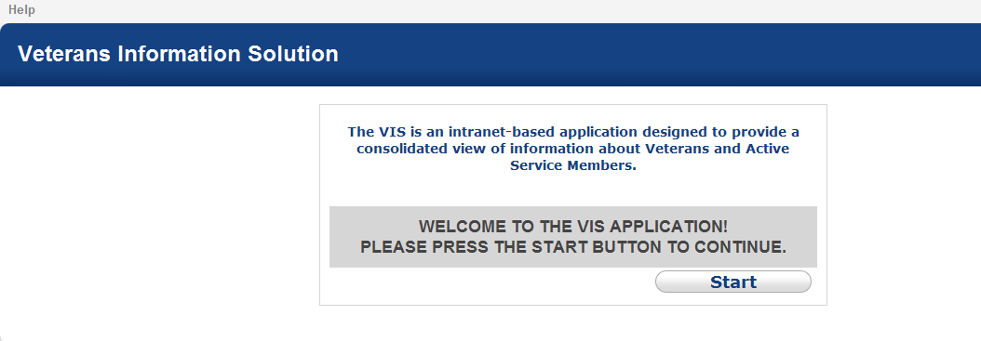
Figure 1- Landing Page
After selecting the Start button, the VIS application will load in the background with the warning page, depicted in Figure 2, in the foreground:
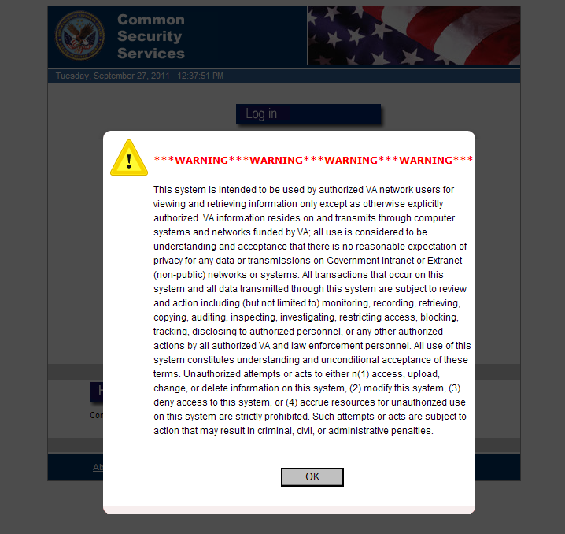
Figure 2- VIS Warning Page
The user must click the OK button to see the Log in Screen, as depicted in Figure 3.

VIS Log in Screen
To log in, the user must enter their Station ID (number code), User ID and Password, and then press the Submit button, as depicted in Figure 3.
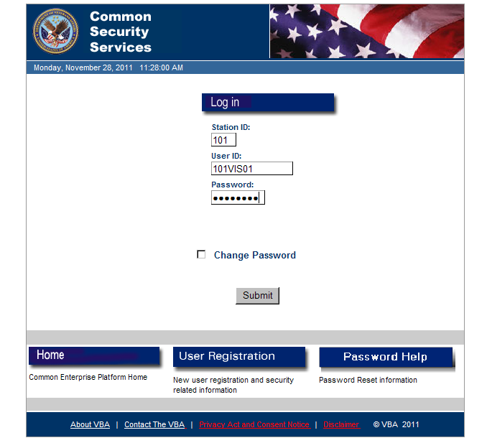
Figure 3- Log in with Credentials

Password and Password Change
The user will be prompted to change the password after the first log in session with the new account ID. To change a password, check the Change Password box. At that point, the New Password and Confirm New Password input fields will appear, as shown in Figure 4.
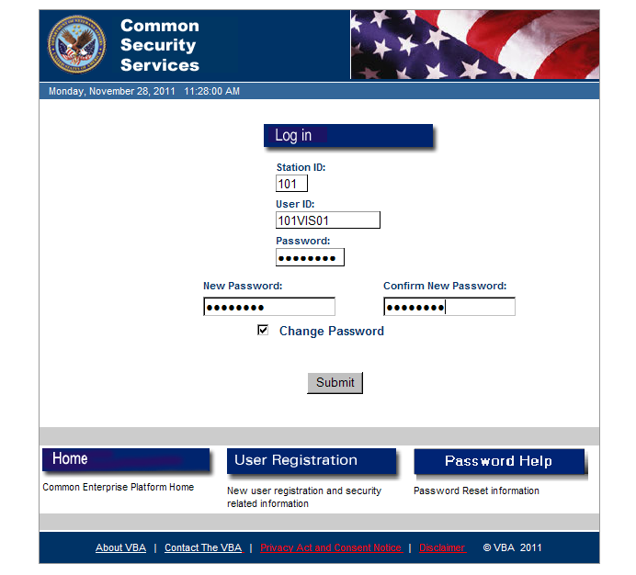
Figure 4- Changing Password
The user will need to input their new password information and click the Submit button.
Note: Passwords must be exactly eight characters in length and contain three of four types of characters. Types are alpha uppercase (A-Z); alpha lowercase (a-z); special characters (e.g., backslash or parenthesis mark); and numerals (0-9).
If the entered password does not meet the password requirements, the system will display the message shown in Figure 5, providing a comparison between an acceptable password and what was entered. For example, if the user enters 12345678, the screen will note that only eight numerals were entered and alpha and special characters are needed.
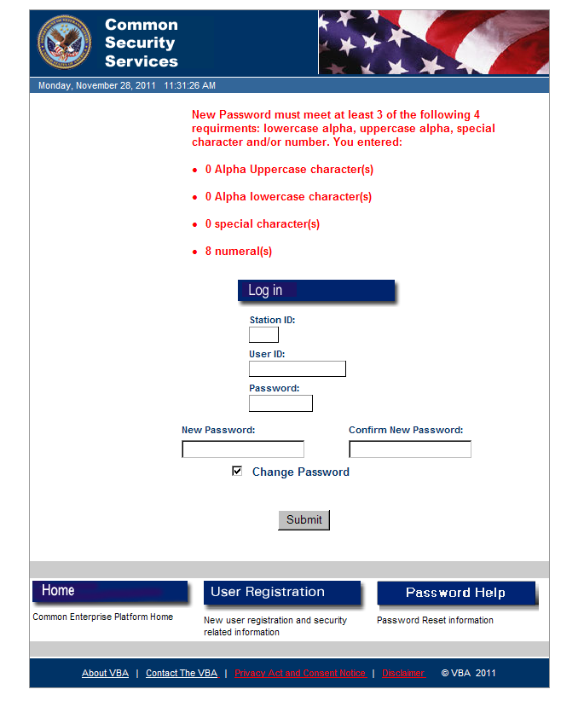
Figure 5- Creating an Acceptable Password

Other VIS Log in Screen Options
The Home, User Registration and Password Help buttons are located at the bottom of the Login screen, as depicted in Figure 6.
Figure 6- Other Screen Options
Individual descriptions of these buttons are listed below:
- Home – Common Enterprise Platform Home
- User Registration – Provides the following instructions for obtaining access to VBA Enterprise Applications.
For internal employees:
- A designated Requesting Official (supervisor) should complete and sign a VA Form 20-8824e Common Security Services (CSS) User Access Request form and submit it to the local ISO for processing.
- A designated Approving Official and/or ISO must sign the access request form to approve access to the application.
- The user must complete all the mandated security awareness and privacy training, and sign a Rules of Behavior (ROB) and a Statement of Commitment and Understanding prior to accessing the system.
For external users:
See your sponsor for specific instructions.
- Password Help – Provides instructions of this nature:
- For a password reset or application issues, contact the IT National Service Desk at 855-NSD-HELP (855-673-4357) and select the options of Philadelphia and VBA Support. For a password reset a user can also email itsc@va.gov, indicating which system he or she is trying to access, user name, and the applicable station number.
- For application issues a user can also email cdco-nsd@va.gov. Include the application name, a description of the problem, a screen shot if possible, the date and time of the problem, user name, and the applicable station number.

Footer
The VIS footer, located at the bottom of application window, is depicted in Figure 7.
Figure 7- VIS Login Screen Footer
The footer contains the following links:
About VBA - The Veterans Benefits Administration Web Site.
Contact The VBA – Inquiry Routing and Information System (IRIS) Web Site
Privacy Act and Consent Notice - The Veteran Affairs Privacy Policy and Privacy Rights Web Site.
Disclaimer - VA Network Intranet Warning Notice.

VIS Home Screen
Upon successful log in, the browser will load the following screen, as depicted in Figure 8. This screen also serves as the Search screen defined in Section 3.
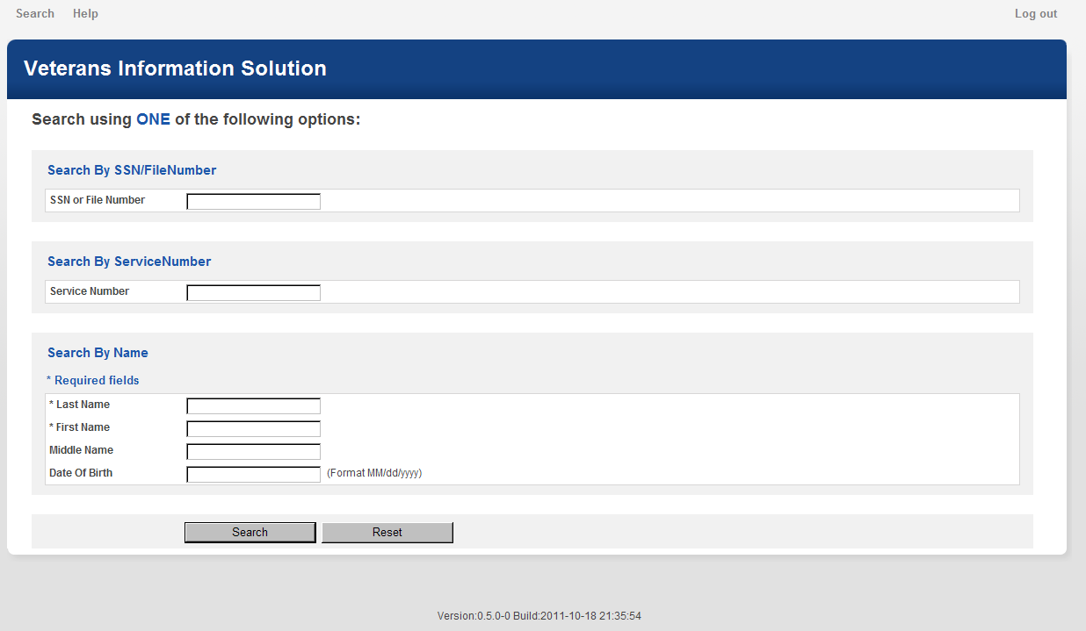
Figure 8- VIS Home Screen
The options Search, Help and Log Out at the top of the screen above the VIS banner are universal and will be accessible from all screens in the application.

Search
To conduct a new search at any time while viewing records, click the Search option. A new search screen will display.

Help
Clicking the Help option links the user to the VIS Training Home Page, which is part of VHA’s Employee Education System. This site provides the user with a variety of information, including access to the current VIS-R User Guide.

Log Out
When the user clicks the Log Out option, the system logs the user out and displays the screen depicted in Figure 9:

Figure 9- Successful Log out
The user can log back into the system by clicking the here link displayed on the Log Out screen.

VIS Search Screen
Upon successful log in, the browser loads search screen where the user can request a Veteran’s or a Servicemember’s record, as depicted in Figure 10. The search screen provides the user with three search criteria to process the information request: Social Security number (SSN) or claim file number, military service number, or the name of the individual.
Figure 10- VIS Search Screen

Search by SSN or File Number
To search for a record using a Veteran’s or Servicemember’s SSN or file number:
- Select SSN/File Number (this option is the default selection);
- Enter the SSN or file number into the text box excluding internal punctuation; and,
- Click the highlighted Search button at the bottom of the screen.
A VA file number for a Veteran will usually be a nine-digit SSN or an eight-digit claim number. However, Veterans from the beginning of WWII and earlier will generally have seven digit claim numbers.

Search by Service Number
The military started using an SSN to identify its members in the late 1960s; before then, a unique service number was assigned to a member by branch of service. To search for a record using a Veteran’s service number:
- Select Service Number;
- Enter the service number into the text box excluding any punctuation; and,
- Click the highlighted Search button at the bottom of the screen.
A service number for most Veterans will be seven or eight digits in length. Per the BIRLS section of the C&P manual, M21-1, a service number, entered as digits only, may not be unique to one individual.

Name
To search for a record using a Veteran’s or Servicemember’s name:
- Select Name;
- Enter the individual’s last name into the text box;
- Enter the first name or the first initial of the first name;
- Enter the middle name or the first initial of the middle name (an optional field);
- Enter the date of birth (DOB) (an optional field); and,
- Click the highlighted Search button at the bottom of the screen.
To optimize the results of the search, the user should enter data into the optional input fields when that data is available.

Wild Card Search
A user can use wildcard characters (% or _) in the search. For example, to find Patient One VA, the user could search on O% in the middle name field and thereby locate the record whether or not the database had the middle name as O or One. The single-character wildcard (underscore character) can also be used as part of the search. For example, to find the name One, search on O_ _ or On_.

Search Results and Refining the Search
When VIS finds more than 50 records for a search query, it automatically re-directs the user to the search screen allowing the user to refine the search or initiate a new one as depicted in Figure 11.
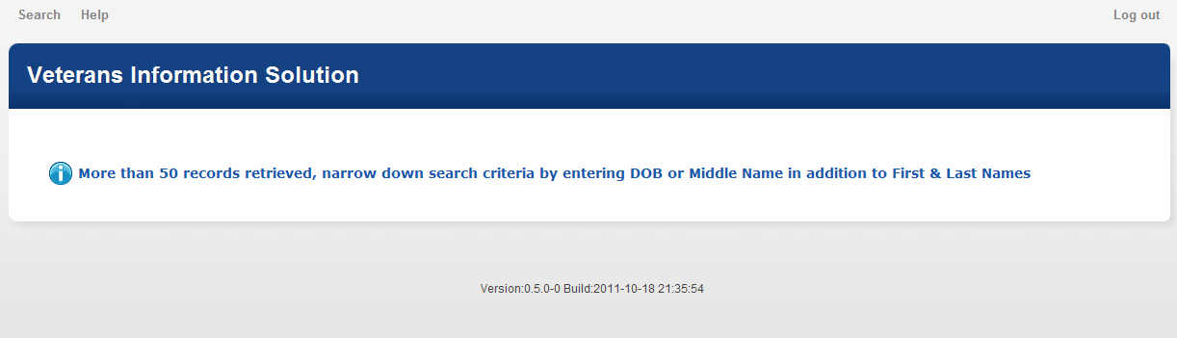
Figure 11- Refining the Search

No Records Found
If the user enters search criteria that cannot be located in the VIS application, they will receive the following message: No Records Found. Click On Search To View Another Record. This message is depicted in Figure 12.
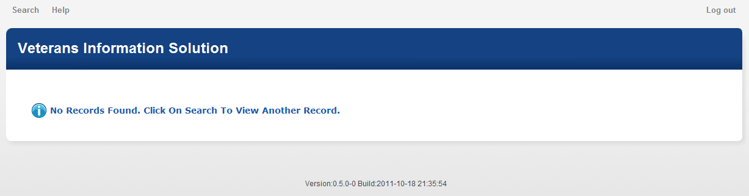
Figure 12- No Records Found

Viewing Records
A search request identifying a specific Veteran or Servicemember returns the profile immediately. If more than one possible individual is identified, the multiple records will be returned and displayed as noted below in Figure 13.
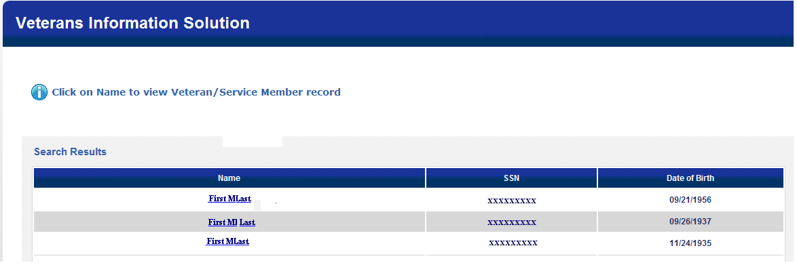
Figure 13- Multiple Records Returned
This is one of two screens in VIS where a complete SSN is displayed. The Education screen displays the complete SSN for dependents. In all other screens, only the last four digits are shown.
If an SSN, file number or service number identifies more than one individual, the multiple records sharing the number will be displayed. When more than one record is returned:
- Identify the required profile by matching name and DOB; and,
- Click on the identified record to view the individual’s profile.

New Search
To conduct a new search at any time while viewing records, click the Search tab in the left corner of the screen above the VIS banner and a new search screen will be displayed.

Reviewing Records
VIS provides Veteran or Servicemember profile and military service data from both VADIR and BIRLS databases. For Veterans who served prior to the mid-1980s, there will generally be no VADIR information – just BIRLS. The user can expect to see occasional differences in the content returned for the same data element (e.g., the surname of a female Veteran may be a maiden name in VADIR and a married name in BIRLS.)
The Profile screen is the default screen displayed after a successful record search is conducted. The user can move to different screens by clicking on any of the other tabs displayed on the top of the screen below the VIS banner ( i.e., Military History, C&P, Education and Reports).

Veteran or Servicemember Profile
The Profile screen, depicted in Figure 14 displays data from both VADIR and BIRLS on one page. As noted in the message below the screen tabs, a blank for any data field indicates nothing or nothing acceptable for VA use has been provided by VADIR and/or BIRLS.
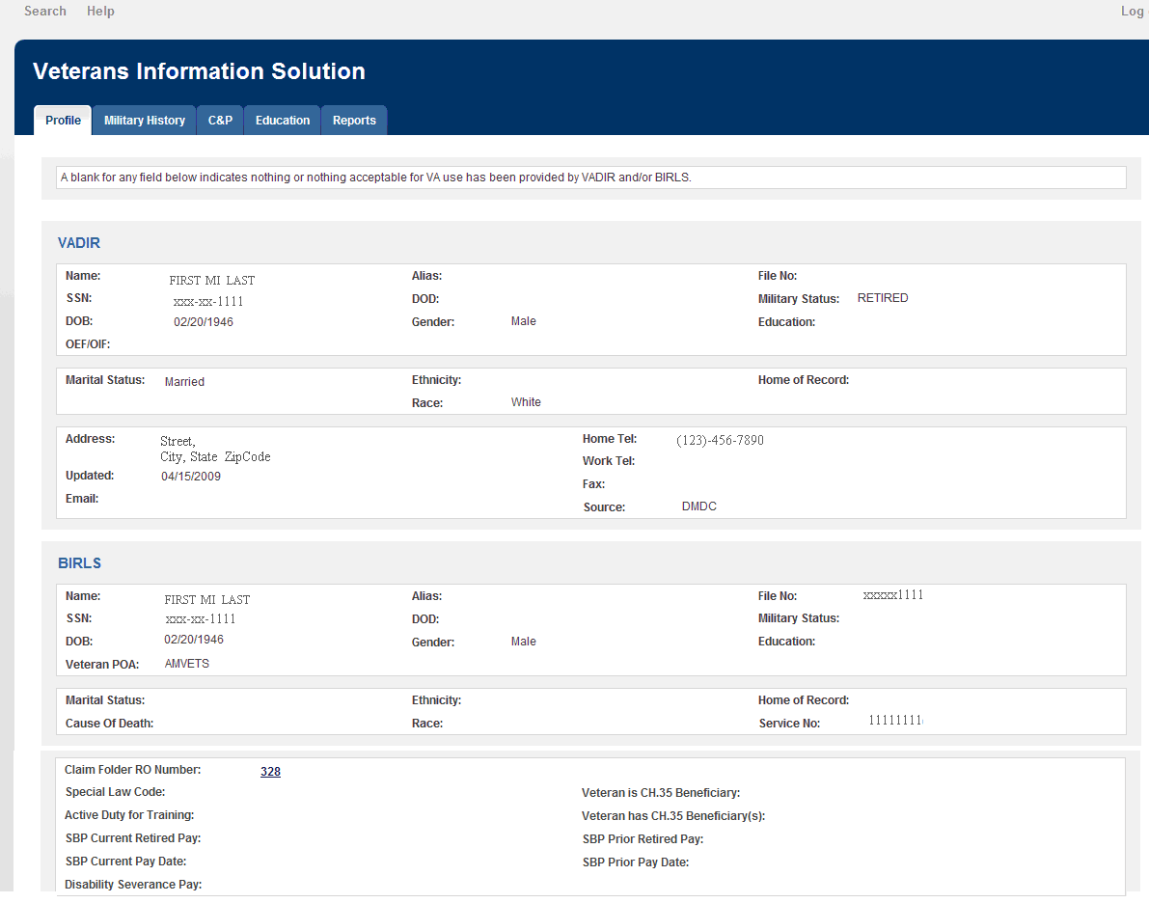
Figure 14- Understanding VIS Profile Fields

Profile Data from VADIR
The data elements in this information screen come directly through from DMDC through VADIR, with the exception of the Operation Enduring Freedom/Operation Iraqi Freedom (OEF/OIF) indicator. This data element draws its value from a single file obtained from VHA Environmental Epidemiology Service in February 2007, containing OEF/OIF information on discharged Servicemembers. This indicator displays ‘Yes’ if the Veteran was activated or deployed in support of Operation Iraqi Freedom or Operation Enduring Freedom; otherwise, it will be blank. The Home of Record is displayed if it is available from DMDC. The Effective Date refers to the address of record. Education refers to the highest education level attained by the individual.

Profile Data from BIRLS
The data elements in this information screen come directly from BIRLS. The miscellaneous data elements have values of text, dates, numbers, Yes, No or blank. SBP stands for the DoD Survivor Benefit Plan program. RO Number refers to the VBA regional office that has jurisdiction of the C&P claims folder. The office number displayed will be underlined, supplemented by hover text that will provide the office name (e. g., 319 will be defined as Columbia.)
For various data elements in many of its screens, VIS uses hover text, indicated by underlining, to provide supplemental explanation of the value displayed, as noted above for the RO Number. The hover text will display for up to five seconds. If the user wants the display for a longer period, he or she can left click the underlined data element and a dialogue box will pop up. The explanatory text, which can be copied and pasted into other documents, will display as long as the dialogue box is kept open. Only one dialogue box may be opened at one time. The dialogue box may be dragged to other positions on the screen being displayed.

Military History
To access the Military History screen, click the Military History tab on the top of the screen.
VIS provides military service information for a particular Veteran or Servicemember from both VADIR and BIRLS, if the information is available from each source. The VADIR screen will appear first, then the BIRLS screen. If there is data from both sources, there will be a prompt at the bottom of each screen instructing the user to click here to view the other military history screen.

Military History from VADIR
Figure 15 depicts the Profile segment of the VADIR screen. The data elements in the profile segment of this VADIR screen are generally self-explanatory and repeat a number of elements displayed in the Profile screen.
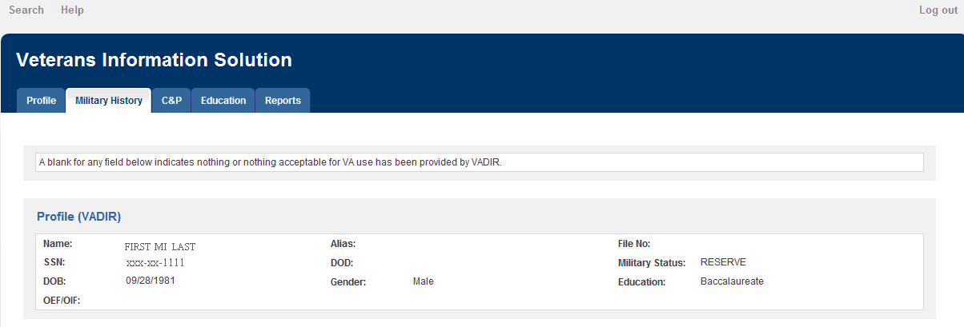
Figure 15- VADIR Screen- Profile Segment
The Military History segment, depicted in Figure 16, is divided into three categories: service periods, deployment periods and special pay periods. The category for service periods contains three types of service: 1) active duty periods; 2) National Guard and Reserve member activation/mobilization periods; and 3) National Guard and Reserve service periods. The category for special pay periods contains two types: 1) combat pay and combat tax exclusion periods, and 2) hazardous duty pay periods. For the most part, the category labels provide an explanation of the data elements.
It is in the military history segment where users will find information for Veterans and Servicemembers who were activated for duty and/or deployed in support of Operation Enduring Freedom, Operation Iraqi Freedom (OEF/OIF) and the Global War on Terrorism (GWOT). As of September 1, 2010, OIF has been renamed Operation New Dawn (OND).
When there are multiple occurrences of service or pay periods, they will display in reverse chronological order, with the most recent first. Codes from the pertinent DMDC tables will be defined with hover text. Retirement type B, for example, is defined as Voluntary.

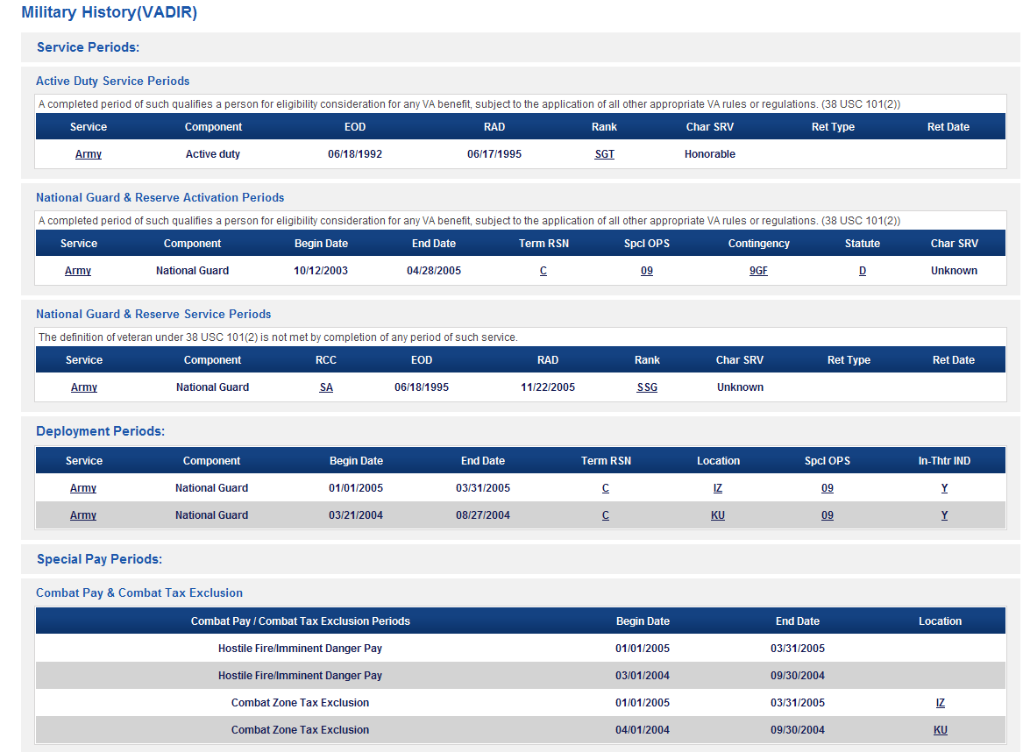
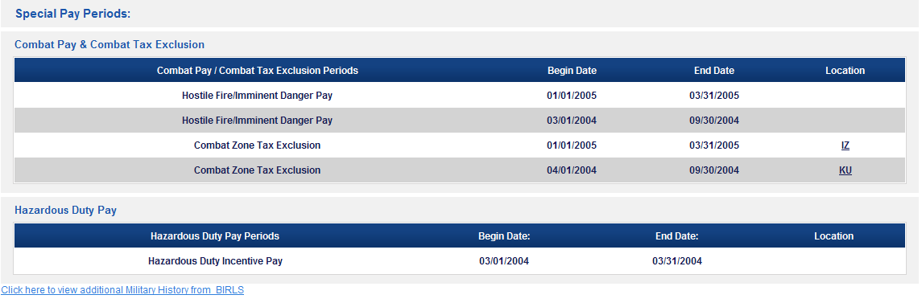
Figure 16- VADIR Screen- Military History Segment
A number of the elements will be underlined, indicating there is a supplemental explanation of the value displayed which can be accessed through hover text or a dialogue pop-up box. The Service will always be underlined, indicating that there may be details of that period of service or deployment (i.e., Tour of Duty). When left clicked, a dialogue box will pop up displaying consecutive lines of data if there is any for these four elements: Date, Event, Description and Code. For the Service alone, there is no hover functionality; just the dialogue pop up box Data elements in the VADIR screen will be blank if there is no data available from DMDC.

Active Duty Service Periods
This category of service includes a current period of active duty service and completed periods of such service under the provisions of 10 USC 101(d).

National Guard and Reserve Activation/Mobilization Service Periods
This category of service includes a current period of active duty service by reason of activation/ mobilization in support of a named contingency and completed periods of such service under the provisions of 10 USC 101(a)(13) & 101(d).

National Guard and Reserve Service Periods
This category of service includes a current period of National Guard or Reserve service and completed periods of such service under the provisions of 10 USC 101(c). The label RCC stands for Reserve Component Category and by example, one such category could be inactive National Guard.

Deployment Periods
This category of service includes a current period of deployment and completed periods of deployment during active duty service or active duty service due to activation in support of a named contingency.

Combat Pay & Combat Tax Exclusion Periods
This category of special pay includes a current period of hostile fire pay/ imminent danger pay and combat zone tax exclusion, and completed periods of such pay or tax exclusion. The data elements show dates and the country /location codes, which are explained by hovering text. For example, IZ stands for Iraq and KU stands for Kuwait. The country/ location code will often be blank or may be shown as ZZ, designating an unknown.
DMDC reports hostile fire pay and imminent danger pay as one entity. Since the dates come from monthly pay files, a beginning date will always be the first day of the cited month and an ending date will always be the last day of the cited month. If there is a starting date without an ending date, the period cited was still open when the record was last updated.

Hazardous Duty Incentive Pay Periods
This category of special pay includes a current period of hazardous duty incentive pay and completed periods of such pay. The data elements for this pay category show dates while country/location codes explanations are provided through hovering text.
Since the dates come from monthly pay files, a beginning date will always be the first day of the cited month and an ending date will always be the last day of the cited month. If there is a starting date without an ending date, the period cited was still open when the record was last updated.

Military History from BIRLS
The data elements in the Profile segment of the BIRLS screen, depicted in Figure 17 below, are generally self-explanatory and repeat a number of elements displayed in the Profile screen. As noted in the message below the screen tabs, a blank for any data field indicates BIRLS has not provided information or the information provided is not acceptable for VA use.
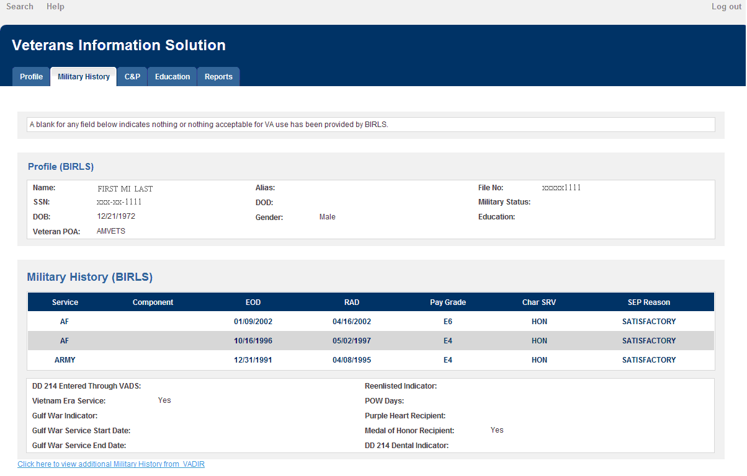
Figure 17- BIRLS Screen- Profile and Military History Segments
The Military History segment provides information about periods of active duty service as contained in BIRLS. The character of service (Char SRV) will display the expected values of HON, UHC, OTH and DIS; as well as HVA for honorable for VA purposes and DVA for dishonorable for DVA purposes. The separation (SEP) reason will display values such as DEV for development, SAT for satisfactory, ADM for administrative decision, and UNK for unknown; or may be blank.
The miscellaneous data elements following the service periods have values of text; dates; a number (POW days); or Yes, No or may be blank. For example, the Medal of Honor (MOH) indicator will note “Yes” if that indicator in BIRLS has been checked with a Y. If it has not been, this data element will be blank. This data element is also in VBA corporate and found on the C&P Awards screen in terms of receipt of the MOH pension. A user should check both sources if the Veteran in question may be a recipient of the MOH and the MOH pension.
The DD 214 Dental Indicator shows whether the Servicemember received a dental examination and all the appropriate dental services and treatment within 90 days of his or her discharge. The values are Yes, No or left blank.

Compensation and Pension (C&P) Rating and Award Information
C&P rating, awards and dependent information are displayed through four screens: Summary, Disabilities, divided into two sub screens; Dependents; and Awards. All four screens draw the data from VBA corporate, including that for the profile segment. There is limited synchronization between corporate and BIRLS and corporate and VADIR, so a user may see differences when viewing profile data from the different sources within VIS.
The Profile segment includes all open powers of attorney (POAs) found in corporate with the date the POA was authorized. Generally, there will only be one open POA, but in some cases, there may be multiple POAs when the Veteran has chosen representation by an organization and an individual or multiple individuals. There also may be no open POAs on file.

C&P Summary Screen
When a user selects the C&P tab, the Summary screen displays any compensation or disability pension being paid or any prior payments paid to a Veteran through VBA corporate, as depicted in Figure 18 below. It also displays the tabs for Disabilities, Dependents and Awards.
Under the General Record Information label, the Summary screen displays certain business information on claims for compensation and disability pension benefits: The date, description and status for the two most chronologically recent claims. If there is only one claim of record, e.g., a current open one, only that claim will display. If screen is blank, VIS found no claims.
Most of the other data elements of the screen are defined by the labels and reflect what is retrieved from VBA corporate. For example, the Entitlement field may display Disability Compensation – Vietnam Era. The SC Death field might display values such as Grant, SC Death, Primary, Denied, Not SC Death, or be blank. The Special Monthly Pension field might display values such as Veteran A&A – Not at Government Expense or Not Entitled to A&A, or be blank. The address of record displayed is the payment address or, if direct deposit is involved, the mailing address.
The monthly Check Amount is extracted from a table comparable to one used for VBA’s Treasury Inquiry (TINQ) query and represents the actual amount of the last monthly regular check issued to the Veteran. The Check Amount may be less than the monthly Total Award amount displayed to the right, if there is a deduction from the gross compensation or pension amount for items such as insurance premiums or overpayments. The Check Amount may be higher than the Total Award amount if the Veteran is receiving the Medal of Honor pension. The pension, $1,259 per month as of December 1, 2012, and the compensation check will likely be combined into one check. The Check Amount for terminated awards, e.g., because of the death of the Veteran, may sometimes show the amount of the last regular check paid for the last month of payment, even though the Total Award amount displays $0.00.
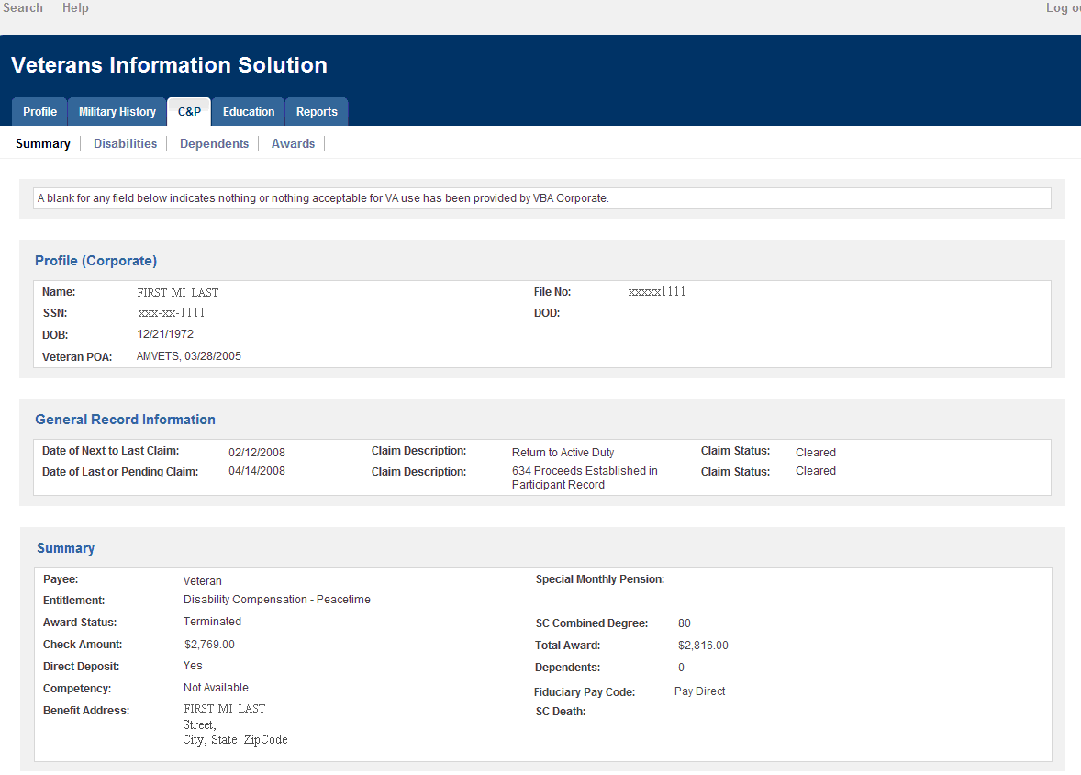
Figure 18- C&P Summary Screen
NOTE: The Competency and Fiduciary Pay Code data elements
The C&P business default values for these are Competent and Pay Direct. These default values, however, are not always coded in VBA corporate, and hence cannot be retrieved by VIS. When VIS finds no values for these two data elements, it will display Not Available or will be blank.

C&P Disabilities Screen

Diagnostics/ Combined Tab
When a user selects the C&P Disabilities tab, certain C&P rating data stored in VBA corporate displays under the default tab, Diagnostics/Combined. The rating data will display even when there is no concurrent corporate award of compensation or disability pension. Information on the two most chronologically recent C&P claims displays on this screen in case there is no Summary Screen for display. If the record has a history of conversion from C&P BDN to corporate, the date of the conversion will be shown. The Disabilities screen uses supplemental explanation displayed through hovering text when the user places the cursor over an item marked with underlining. The hovering text will display for up to five seconds. Left click the data element and a dialogue box will display with the same explanatory text.
For records with corporate rating data, the C&P rating diagnostic codes (DC) for all service-connected (SC) disability conditions and those conditions granted entitlement under 38 USC 1151 will display. Placing the cursor over the code number will display the complete narrative that was used in the actual C&P rating to describe the condition: e.g., DC 8521 might show this narrative in the hovering text or dialogue box: Left Foot Reflex Sympathetic Dystrophy, Residuals of Foot Injury, with Plantar Fasciitis (Claimed as Left Foot Disability). By way of contrast, the HINQ query system displays only fixed values from a table to explain the diagnostic codes. DC 8521, for example, is described in the table this way: Paralysis of the External Popliteal Nerve. This text value will display in HINQ every time DC 8521 is used, no matter what the actual C&P rating contains as the description.
When a specific DC has a special rating issue linked to it, the underlined abbreviated code will display under the column label Special Issue. The hover text and pop up features will define the code, plus any special issue basis if one was used in the C&P Rating. For DC 9411, for example, the special issue code might be PTSD/2, and the hover text might define it as PTSD – Non-Combat; Stressful Event, or simply as PTSD – Non-Combat.
For each SC and granted 38 USC 1151 diagnostic code, the screen will display the current evaluation percentage; the beginning/earliest effective date of SC or 38 USC 1151 in corporate; and, if different from the beginning date, the effective date that matches the current evaluation percentage. The screen will also display the following data for a particular DC if available in corporate: The extremity designation (left or right, bilateral, upper or lower); the special regulatory paragraph number under which a temporary and total (100 percent) evaluation has been granted (30 for 38 CFR 4.30, 29 for 4.29 and 28 for 4.28); and the future date a C&P examination has been scheduled to re-assess the disability condition. The special regulatory paragraph number, if displayed, will be supplemented with a brief hovering text explanation.
The SC Combined Information segment displays the history of the SC combined evaluation percentages. If there is at least one SC condition in the diagnostic code segment, there will be at least one SC combined evaluation percentage. For records with two or more SC conditions there will often be multiple SC combined evaluation percentages. In February 2007, VBA installed a table in the VBA corporate database to retain the actual, legal effective date of an SC combined evaluation percentage as displayed in the rating in the C&P claims’ folder, versus the SC combined award effective date: e.g., 03/21/2007 versus 04/01/2007.
For corporate ratings processed before February 2007, there will be no legal effective dates in the corporate database to be retrieved and displayed. From the point of the 2007 installation forward, the legal effective dates coded in any rating should be retained and displayed. The VIS will display both the SC combined legal effective date, when available, and the parallel SC combined award effective date. On occasion, the legal effective date may be the first day of the month. VBA has acknowledged a bug with the legal effective date, so it may not always be available even for ratings processed after February 2007.
For a record that has only rating data converted from the now discontinued C&P BDN system, only the actual rating data extracted from BDN at the time of conversion will display. Data generated for the system needs of corporate will not be displayed. The result will be that for each SC condition in such a converted record, the Disabilities screen will display only the diagnostic code and the evaluation percentage. There will be no effective dates, since none were stored in C&P BDN. The test narrative for each SC condition will come from a table with fixed values, since the actual narrative from the rating was not stored in C&P BDN.
There will be only one SC combined evaluation percentage, since only one was stored in C&P BDN, and it too will not have an effective date. The maximum number of SC conditions that will be displayed is nine, since that was the maximum number that could be stored in C&P BDN (in combination with a supplemental BDN storage database with the acronym VITAL). The descriptions outlined in this section can be cross-referenced against Figure 19 below.
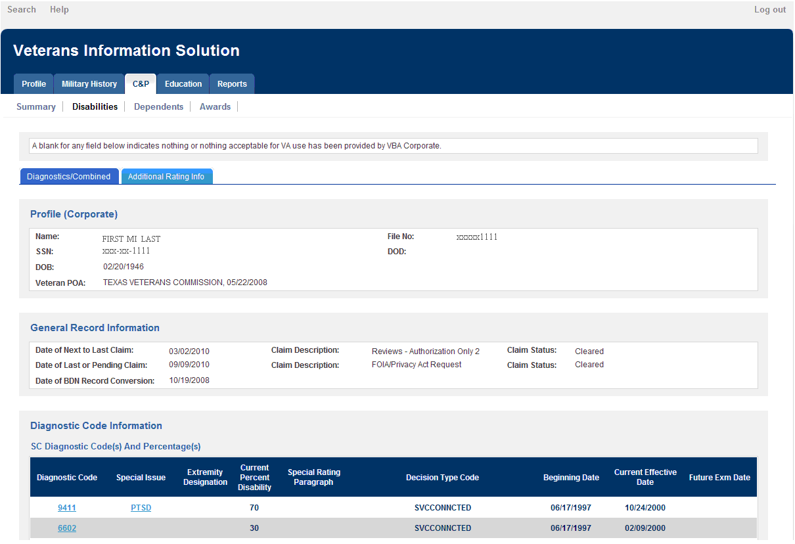
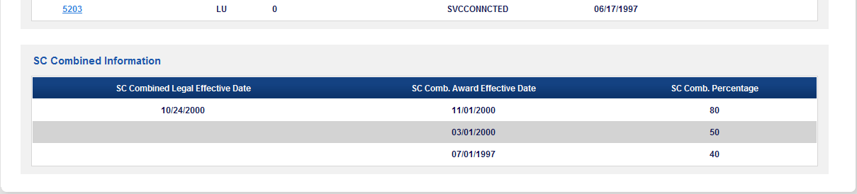
Figure 19- Diagnostics/ Combined Tab

Additional Rating Information Tab
When a user selects the Additional Rating Information tab, the second half of the C&P Disabilities screen is displayed. The PT SC (permanently and totally disabled by reasons SC conditions alone) field displays a Yes when a positive disability rating decision has been rendered under the provisions of 38 USC Chapter 35, along with the effective date of this grant. A “No” displays when a negative Chapter 35 rating decision has been rendered; there will be no effective date with a negative decision. This field will be blank if there is no Chapter 35 decision in the corporate rating.
Individual Unemployability (IU) is a level of total compensation disability granted to a Veteran when their SC conditions combine to a disability evaluation of at least 60 percent (in rare cases it may be lower) but less than 100 percent; and the Veteran is determined to be unemployable by reason of the SC conditions alone. The IU provision justifies paying a Veteran compensation at the 100 percent rate, even though their SC combined disability evaluation is less than 100 percent. If a Veteran’s SC combined evaluation is less than 60 percent or at 100 percent, then IU is not a compensation rating issue.
The IU Indicator will display the word Unemployable when the Veteran is determined, by C&P in a corporate rating, to be unemployable. The IU Indicator will display the text Employable or not an Issue when the Veteran is determined to be employable or when the rating determines that IU is not a compensation rating issue. A blank, the most common, means the issue of IU has not been addressed in a corporate rating.
The SC Death field will display what was rated for this issue in corporate. For example, it might show Grant, SC Death, Primary, Denied, Not SC Death, or be blank if this issue was not rated. The Special Monthly Pension field will display values if this issue was rated in corporate: e.g., Veteran A&A – Not at Government Expense or Not Entitled to A&A, or it will be blank. The Special Monthly Compensation (SMC) field will display the numeric value assigned by a corporate rating. The Hospital SMC field will display the same or a different numeric value; when different the SMC value assigned contains an allowance for Aid and Attendance (A&A) that must be reduced while the Veteran is hospitalized at VA expense. When displayed, the numeric SMC values are supplemented by a brief explanation that appears as hovering text or a dialogue pop up box. The fields for loss or loss of use and for housing benefits will display the values that have input via a corporate rating. The meanings of possible display values are self-explanatory.
Under the provision of 38 USC 1702, VA may provide medical treatment for an active psychosis not otherwise rated SC for compensation purposes; or for any active mental illness for a Gulf War Veteran if not otherwise service-connected and shown to be active within two years after discharge. Similarly, under the provisions of 38 CFR 3.360, VA may provide medical treatment for a condition that would have been rated SC for compensation purposes but for a character of discharge deemed by VA to be under conditions other than honorable. If the Veteran has been rated eligible for treatment under the above cited provisions for a condition via a corporate rating, the diagnostic code with complete rating narrative for the eligible condition will display, similar to a SC condition displayed in the Diagnostic Code Information segment. There is no evaluation percentage or effective date in such a C&P rating, however, and neither element will display on this screen for any condition noted. The descriptions outlined in this section can be cross-referenced against Figure 20 below.
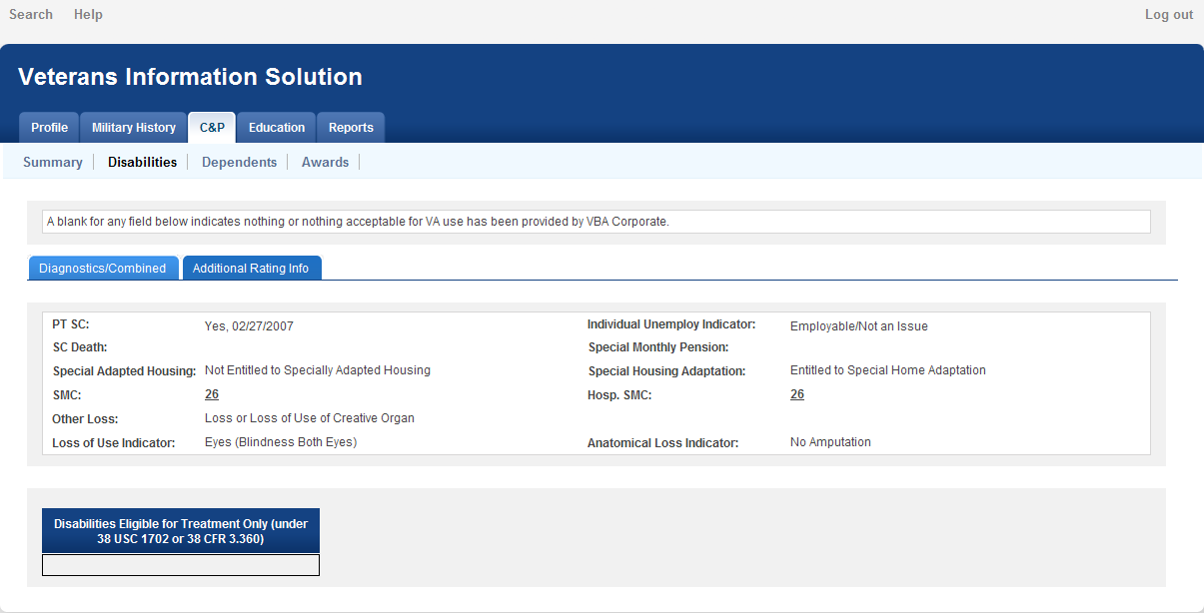
Figure 20- Additional Rating Information Tab

C&P in BIRLS
The BIRLS C&P disabilities screen, as depicted in Figure 21, will display as a default view when:
- There is no C&P corporate award;
- There is no C&P corporate rating data to populate the C&P Disabilities screen; and
- There is a BIRLS Inactive C&P (ICP) screen with at least one disability diagnostic code.
Prior to the introduction of VBA corporate rating and award processing, certain rating and award data from certain terminated C&P BDN awards was transferred to the ICP fields in BIRLS for retention. The rating data in the ICP is not always reliable in the information it displays, particularly when Diagnostic Codes Verified label does not say “Yes”. The ICP screen is retrieved and displayed by VIS as a last resort source of information.
The data displayed will be extracted one-for-one as shown in BIRLS, including the Veteran profile data. Where shown with an underline, the BIRLS codes are defined with hovering text or a dialogue pop up box. The explanatory banner, in gray shade right below the word Note, provides an important business disclaimer about the reliability and current state of the C&P data displayed in the ICP screen.
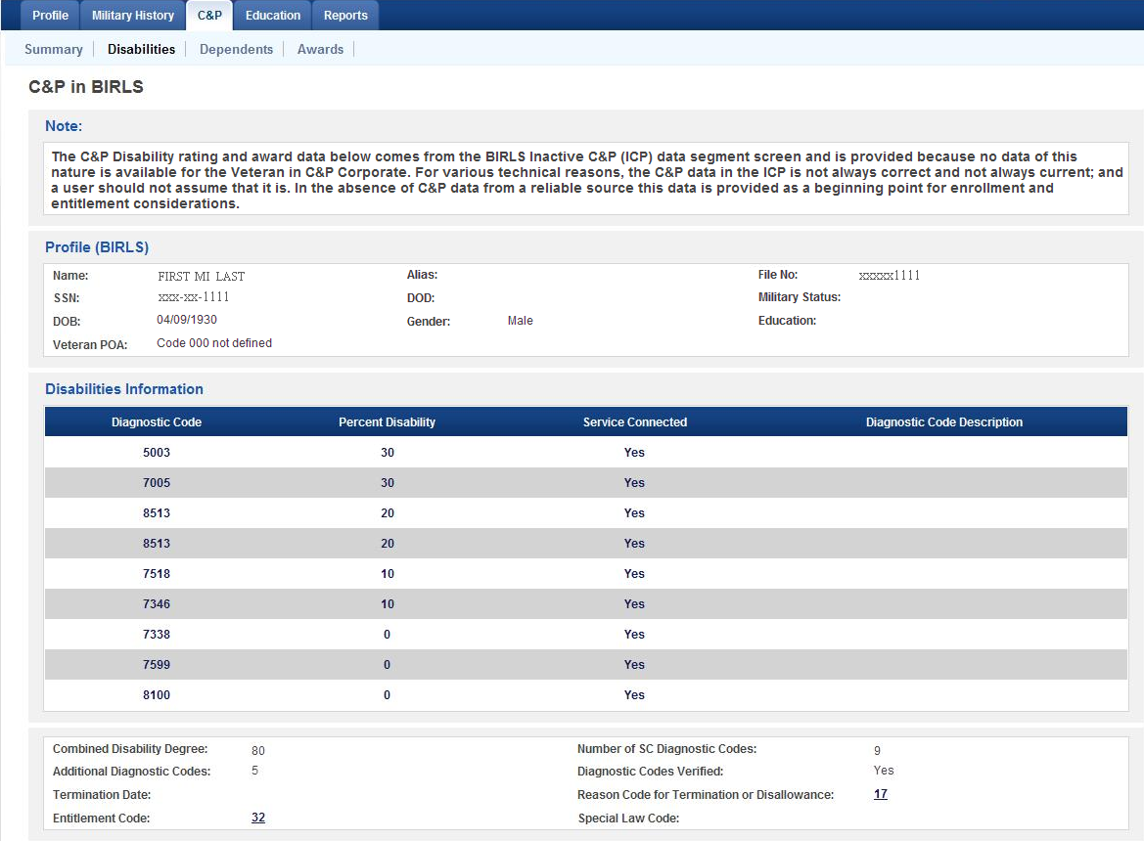
Figure 21- C&P in BIRLS Screen

C&P Dependents Screen
When a user selects the C&P Dependents tab, as seen in Figure 22, the specific C&P dependency data stored in corporate to support a Veteran’s award of compensation or disability pension displays. The labels explain the Dependents table data elements. Children are categorized as minor, school or helpless.
Benefits for children of certain Veterans under 38 USC Chapter 18 paid to, or for children with certain birth defects, are a part of the VBA corporate payment system. When there is an award of benefits for a child, the profile information noted is retrieved from corporate and displayed. The number of awards is low, so this data segment may be blank.
At the time of the 2011 revision of VIS, benefits for children of certain Veterans under 38 USC Chapter 18 paid to, or for, children with spina bifida, was still being paid through C&P BDN. Thus, information about such beneficiaries is not available in corporate to be retrieved and displayed.
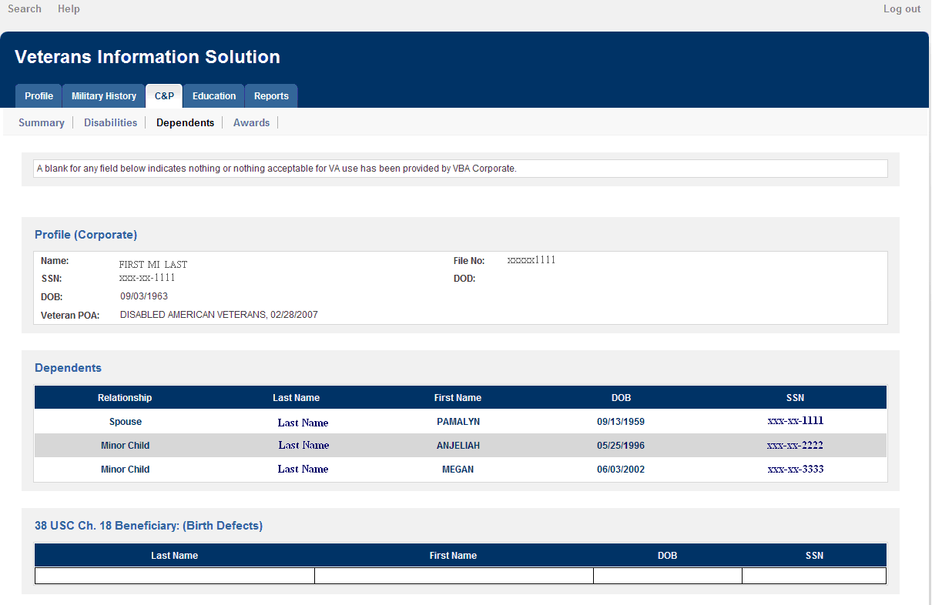
Figure 22- C&P Dependents Screen

C&P Awards Screen
When a user selects the C&P Awards tab, certain award data related to a specific C&P corporate award of compensation or disability pension displays, as seen in Figure 23.
The labels explain the Awards Information data elements. The reason for an award adjustment is explained in text rather than code. Income for VA purposes (IVAP) displays for disability pension records. The total or gross amount of an award of compensation or disability pension to which a Veteran may be entitled can be reduced by withholdings or deductions, and this will generally show in the net award amount displayed. For the vast majority of awards, however, the total award and net award amounts will be the same.
If a Veteran is receiving the Medal of Honor pension this data element will display Medal of Honor. The pension, $1,237 per month as of December 1, 2011, is usually a combined check with any compensation being paid.
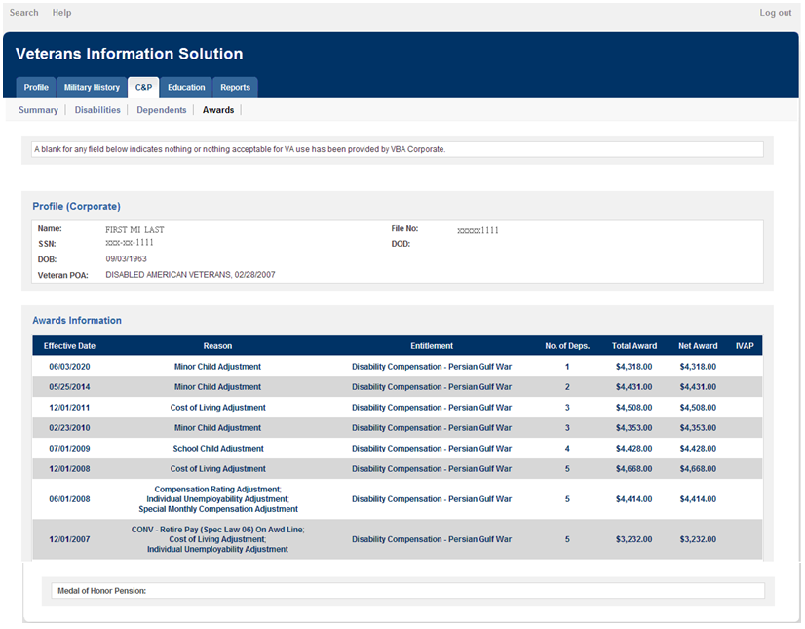
Figure 23- C&P Awards Screen

C&P Records Not Found Messages
If VIS does not locate corporate data to generate any one or all of the four C&P screens, it will return an information notice similar to those shown below for the respective screens.
- No C&P Corporate Summary Data Found for this Record, but Do Check the Disabilities Screen for Possible SC Conditions.
- No C&P Corporate Rating Data Found for this Record.
- No C&P Corporate Dependents Data Found for this Record.
- No C&P Corporate Awards Data Found for this Record.
Note: Even if there is no corporate compensation, disability pension or Medal of Honor award to generate the display of the C&P Summary screen, there may be rating data available in the Disabilities screen: SC conditions evaluated at the non-compensable 0 percent, or SC conditions through BIRLS ICP. Similarly, there may be data about a Chapter 18 beneficiary in the Dependents screen. The user should routinely check these other screens.

Education
The Education screen contains information from DMDC through VADIR relevant to the administration of primarily the Post 9/11 GI Bill, Chapter 33 of 38 USC. As depicted in Figure 24, the data elements in the Education screen are generally self-explanatory. Where definition is needed, VIS uses hover text, indicated by underlining, to provide supplemental explanation of the value displayed. As with the other screens in VIS, the hover text will display for up to five seconds. If the user wants the display for a longer period, he or she can left click the underlined data element and a dialogue box will pop up.
The Education screen is divided into segments that provide various types of information pertinent to the administration of the Education programs. The first segment is the Profile. The data elements in this segment repeat a number of elements displayed in the VADIR segment of the Profile screen and the VADIR Military History screen. The Date this record was last Updated refers to the date this Education record was last updated by DMDC. Updated below the Address refers to the date the address shown was last updated. Education refers to the highest education level attained by the individual.
The next segment is Transfer of Entitlement. Education benefits are transferable to the spouse and children of the Servicemember under certain conditions. Information about such transfer includes identification of the dependents. The full SSN of a dependent is displayed because of the needs of Education business processing.
The next two segments contain information about Active Duty Service Periods and Reserve & National Guard Active Duty [activation] Periods. The numeric Separation Reason codes are defined by loss code values from DMDC displayed via hover text. For example, code 02 is defined as Disability existed prior to Military Service; while code 06 is defined as Qualifying Active Duty Period.
Kicker Information is the next segment on the Education screen, and it displays information about any extra educational benefits to which the individual may be entitled.
The next two segments of the Education screen contain information about periods of service that must be excluded from education entitlement. As noted in the explanatory banner for Training Exclusion Periods, periods of basic or skills training must be deducted from otherwise qualifying service periods. As noted in the explanatory banner for Excluded Obligated Periods of Service, periods of service obligated by a loan repayment program, a commission as a result of a specific ROTC program, or graduation from a Service Academy are not countable as active duty.
The next segment is Military Service Academy Period and provides information about a period of active duty performed as a student in one of the Military Service Academies, whether or not the time as student culminated in graduation and a commission. This segment and the one immediately prior both deal with Service Academy time.
The final segment is $600 Additional Contribution, and it provides information about any personal funds the individual may have contributed to increase educational entitlement.
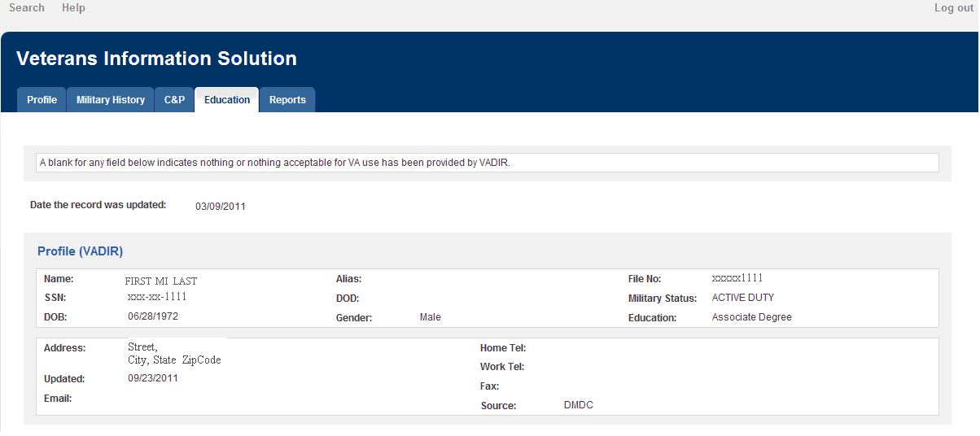
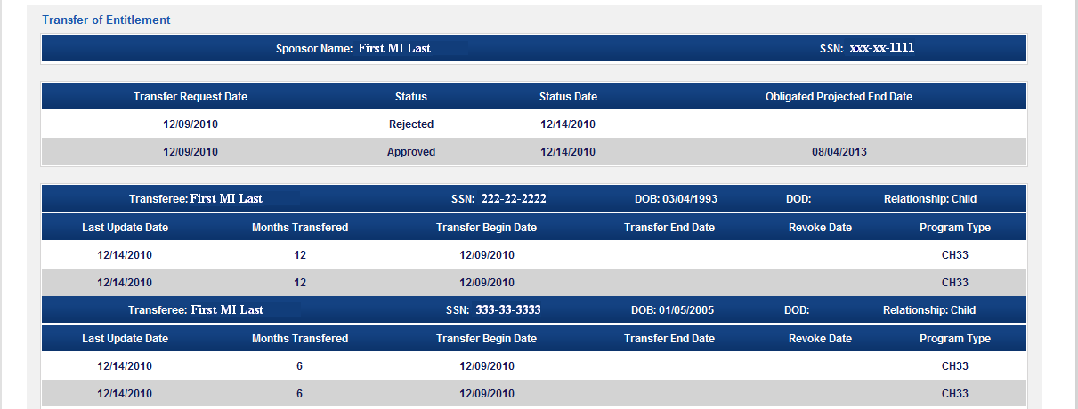
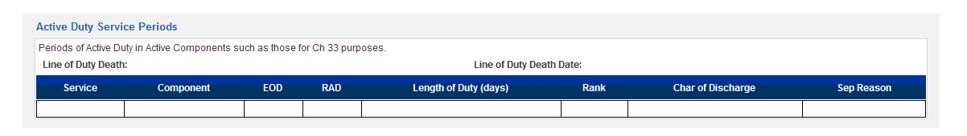
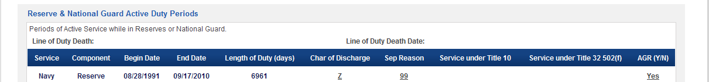
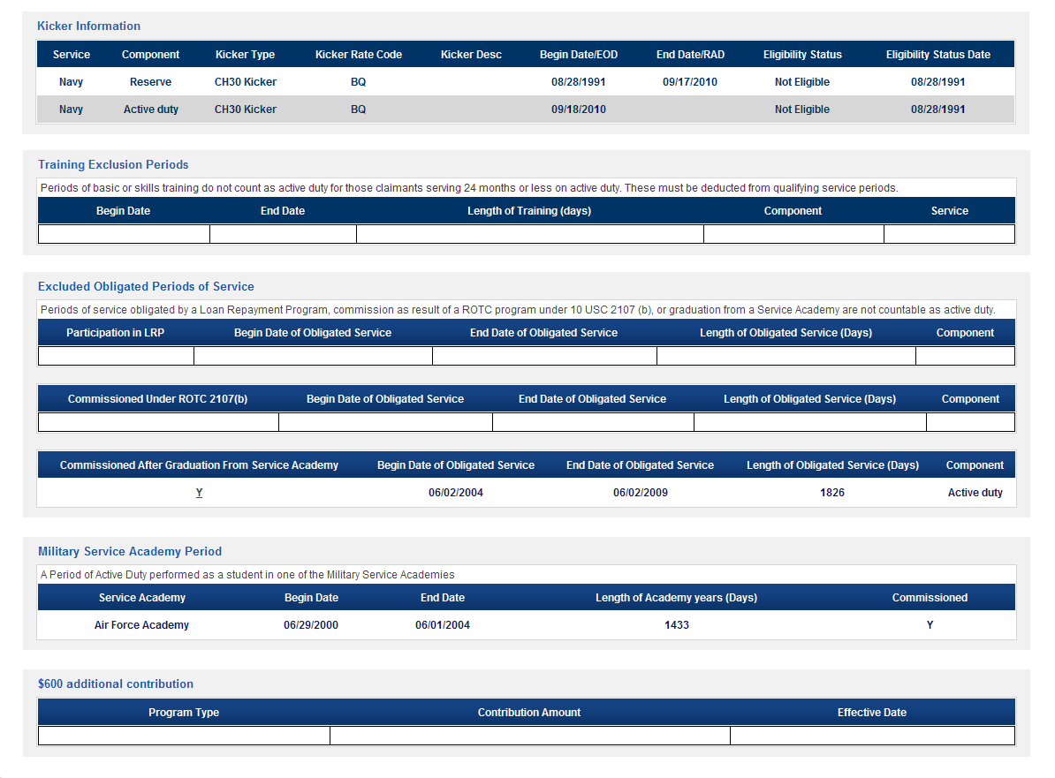
Figure 24- Education Screen

DFAS Payments
The DFAS Payments screen contains payments information such as Retired Pay, Non-Recurring Separation Pay, Survivor Pay & Survivor Benefit Plan Pay, pertaining to a particular Veteran or Service Member. As depicted in Figure 25, the data elements in the DFAS Payment screen are generally self-explanatory. Where definition is needed, VIS uses hover text, indicated by underlining, to provide supplemental explanation of the value displayed. As with the other screens in VIS, the hover text will display for up to five seconds. If the user wants the display for a longer period, he or she can left click the underlined data element and a dialogue box will appear displaying the text.
The DFAS Payments screen is divided into segments that primarily provide various types of pay information. The first segment is the Profile that is consistent with data displayed on the VADIR Profile screen, VADIR Military History screen and the Education screen.
The next segment is Retired Pay Information. The Retired Pay Information segment provides data that is primarily obtained from the Retired Pay table in VADIR. It provides information about the retirement pay that was paid to a service member by DoD. The data displayed in this segment indicate the branch of the service with which the service member is affiliated, the service member’s eligibility to receive retirement pay and the status of those payments (e.g., receiving, suspended, terminated), the type of retirement (e.g., mandatory, voluntary, Temporary Disability Retirement List (TDRL), Permanent Disability Retirement List (PDRL)), indication of whether or not the retiree is a Gray Area retiree eligible to retire with pay before his/her 60th birthday, the DoD-provided percentage disability rating for the service member, the original date on which the retiree began receiving retired pay, the gross retired pay amount and the date on which the gross retired pay amount displayed became effective, the gross monthly amount and effective date of Chapter 61 pay, which is the gross monthly amount of retirement pay that would have been received if the Veteran had not been on the TDRL or PDRL, and the termination date and reason for termination of retired pay.
The next segment is Separation Pay Information. This is displayed under the heading “Non-Recurring Pay at Separation”. It provides data that is primarily obtained from the Separation Pay Table in VADIR and represents one-time (lump sum) payments made to service members at separation. The data in this segment indicate the branch of the service with which the service member is affiliated, the type of the separation pay, the date on which the separation payment was made, the gross amount of the separation payment, the amount of federal income taxes withheld, the net amount of the separation pay, which is a calculated value equal to the gross amount of the separation pay minus the federal income tax withheld, and the disability severance pay combat code, which indicates whether or not a disability-related severance payment was for a combat-related disability.
The next segment is Survivor Pay Information. The Survivor Pay Information segment provides information about survivor benefits paid by DoD to the surviving spouse (current or former) of a deceased service member. The Name and Social Security Number (SSN) of the surviving spouse is shown above the names of the data fields in the Survivor Pay Information segment. The data displayed in this segment indicate the branch of the service with which the service member was affiliated, the type of the survivor pay (i.e., whether the plan under which payments are being made is the Retired Servicemembers Family Protection Plan (RSFPP) or the Survivor Benefit Plan (SBP)), the status of all of the survivor annuities elected by the member or authorized by law to be paid to a surviving spouse, the relationship of the annuitant to the service member, the type of annuity being paid (e.g., Spouse only, Spouse and Child, Former Spouse only, Insurable Interest), the date on which the beneficiary became eligible to receive survivor payments, the gross survivor payment amount and the date on which the gross survivor payment amount displayed became effective, and the termination date and reason for termination of survivor pay.
The next segment is Survivor Benefit Plan Information. The Survivor Benefits Plan Information segment contains information regarding the Sponsor’s current Survivor Benefits Plan (SBP) elections or the Survivor Benefits Plan payments that are being made to a beneficiary. Only information related to active SBPs is displayed. (Historic information for expired SBPs in not displayed.) The data displayed in this segment indicate the type of beneficiary(ies) elected as the SBP annuitant(s) (e.g., Spouse Only, Spouse and Children, Insurable Interest), the effective date for the SBP, the SBP monthly premium, the monthly SBP premium to be deducted from VA benefits for direct remitters and the date that direct remitter SBP payments began, and the projected amount of SBP payments to be made to the SBP annuitant.

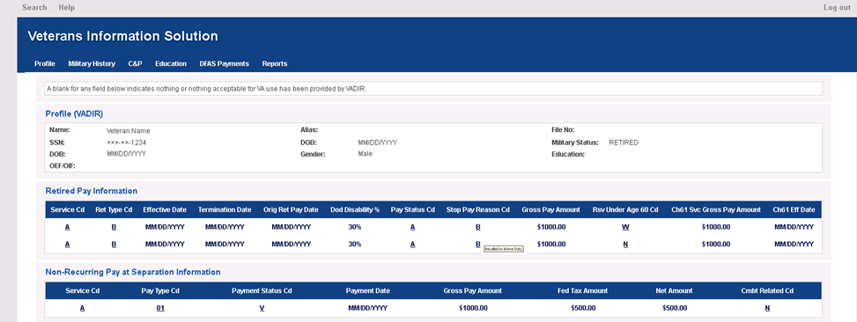
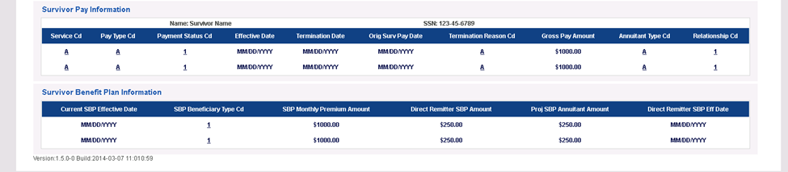
Figure 25- DFAS Payments Screen

Reports
The Reports screen provides the user the option of generating printed versions of the selected screens to serve as information reports for the Veteran or Servicemember, as depicted in Figure 25. The reports may also be saved as well as printed. The user may select a single screen to print or multiple screens combined into one report.
These printed reports display in either PDF or HTML format for some users and in HTML only for others. The restriction for the latter category relates to organizational permissions. When these users try to generate reports in PDF, they will see only a blank browser screen or a browser error message.
To access the reports in PDF, users will need the Adobe Reader. For this reason the Reports screen provides a link for downloading Adobe Reader for users who do not already have access to it. HTML reports require no special software to generate. Reports in the HTML format can be best viewed through the browser’s Print Preview option. HTML reports can also be copied to Microsoft Word for possible editing and saving.
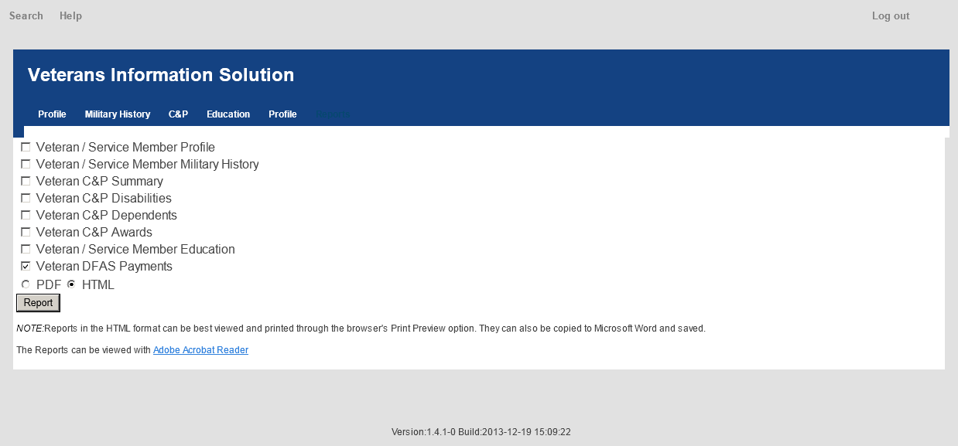

Figure 266- Reports Screen
To generate a report:
- Click the Reports tab;
- Place a check mark next to the screens to view/print;
- Select PDF or HTML format; and
- Click the Report button.
Note: Various examples of these respective reports are available in the Appendix of this Guide.

New Search
To conduct a new search at any time while viewing records, click the Search tab in the left corner above the VIS banner – a new Search screen displays.

System Time Out
When VIS is inactive for 14 minutes, a pop up message will appear on the VIS screen. As seen in Figure 26, the message indicates that the user will be signed out shortly and provides the option of staying logged in. At the same time, the following message appears on the web browser tab on the VIS screen:!!!VIS TIMEOUT HAS BEEN REACHED!!!

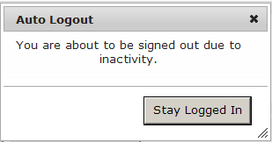
Figure 27 - System Log out Pending due to Inactivity Indicator

After 15 minutes of inactivity, the screen and message, as depicted in Figure 27, will be displayed.

Figure 28- System Log out due to Inactivity Indicator

When the user actively logs out, the screen and message, as depicted in Figure 28, will be displayed.

Figure 29 - System Log out Indicator

In either case, the user can log back into the system by clicking the here link.

Appendix

Profile Report in HTML Format
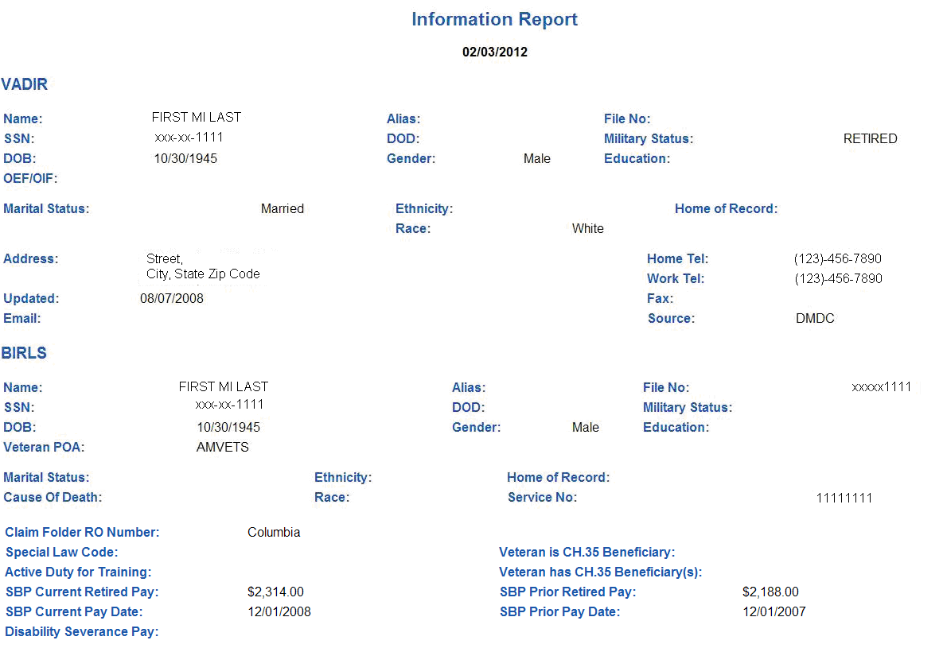

Military History Report in PDF Format
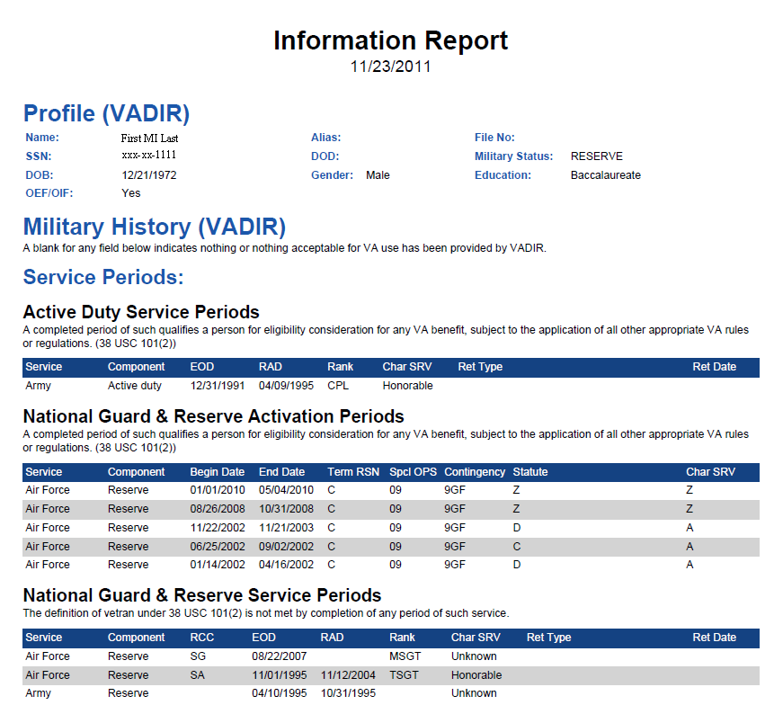
Note: The VADIR and BIRLS military history screens are separate in VIS, but the two are combined in Reports to simplify the printed report as noted below.
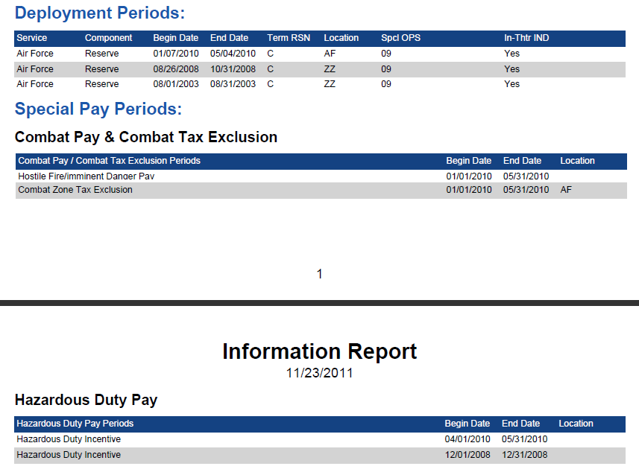
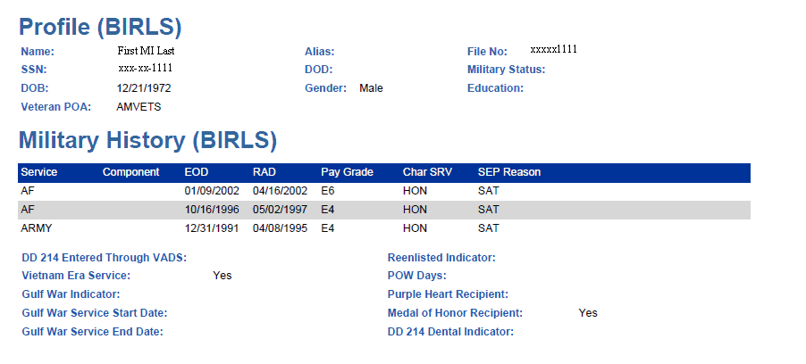

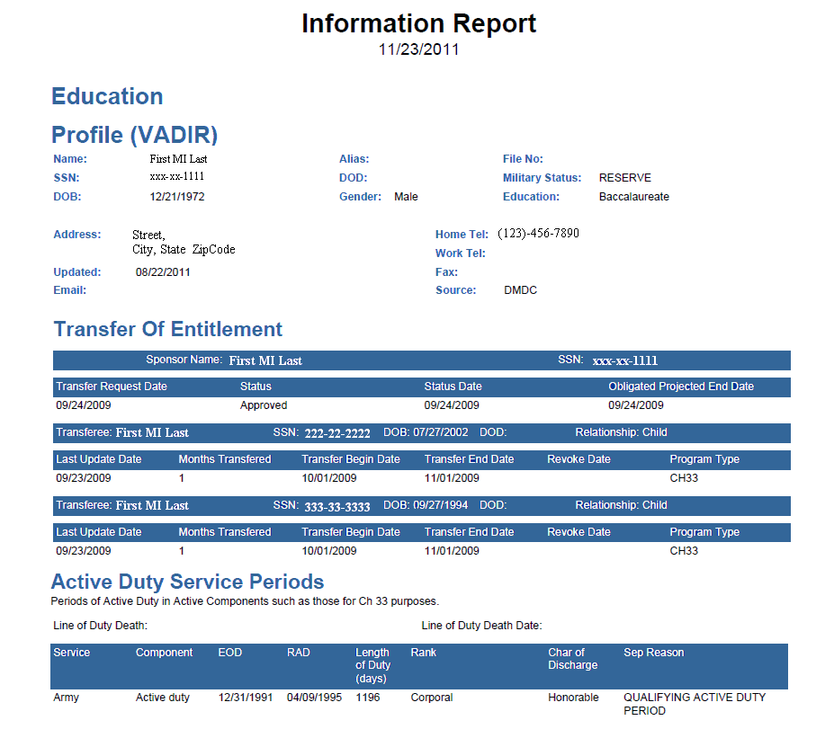
Education Report in PDF Format
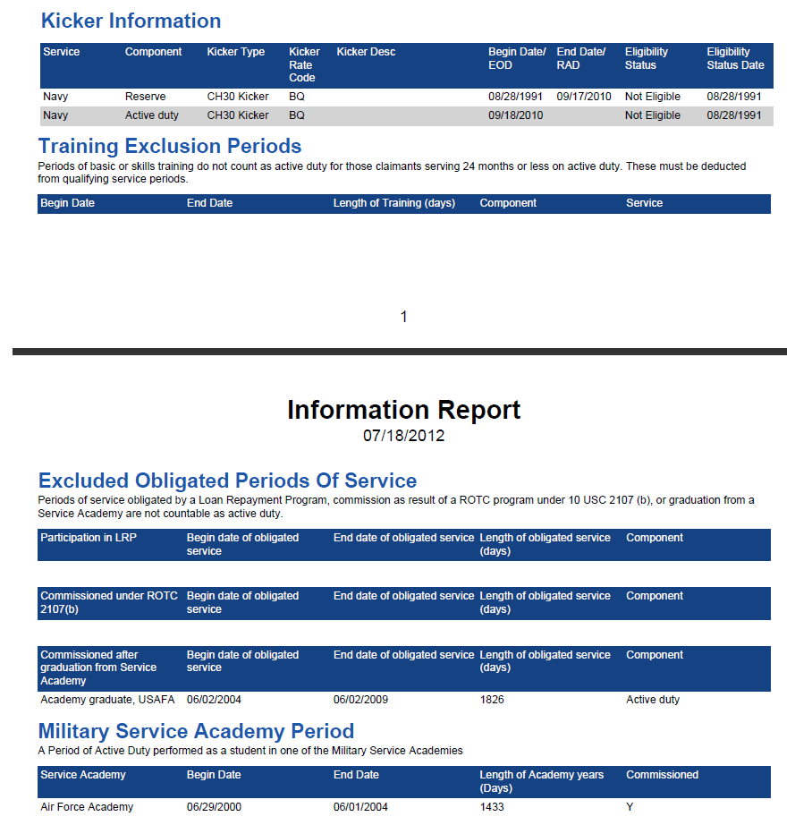

C&P Summary Report in HTML Format
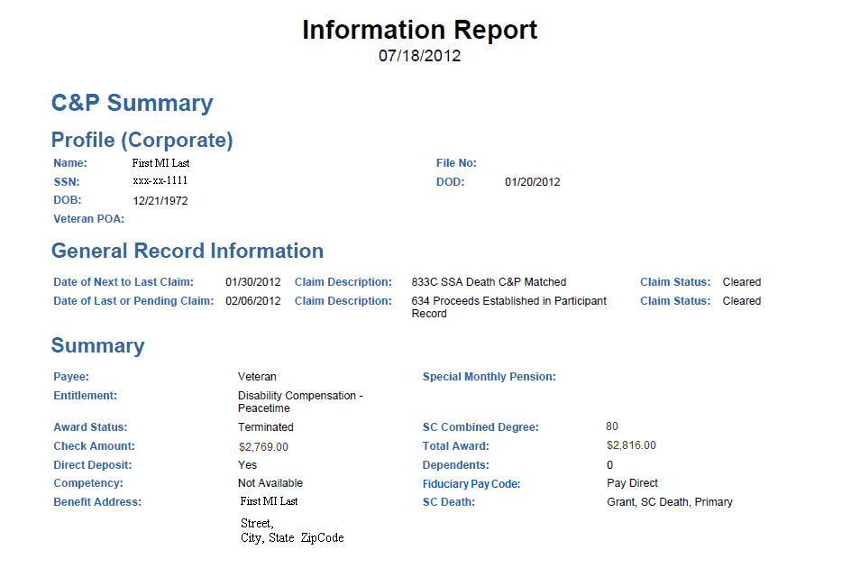

C&P Disabilities & Awards Report (Example of Combined Reports) in HTML Format
