VSOC CRM/UD User Guide

1. Access <https://vrm.xrm.va.gov>
2. Enter your VA LAN ID and password into the login fields. These are the same credentials you use to login to your computer.
3. 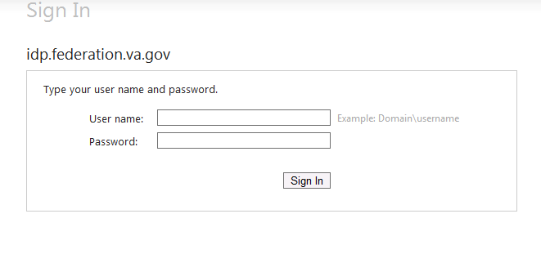After logging in, you will see the dashboard. You will only need to access the left hand menu.

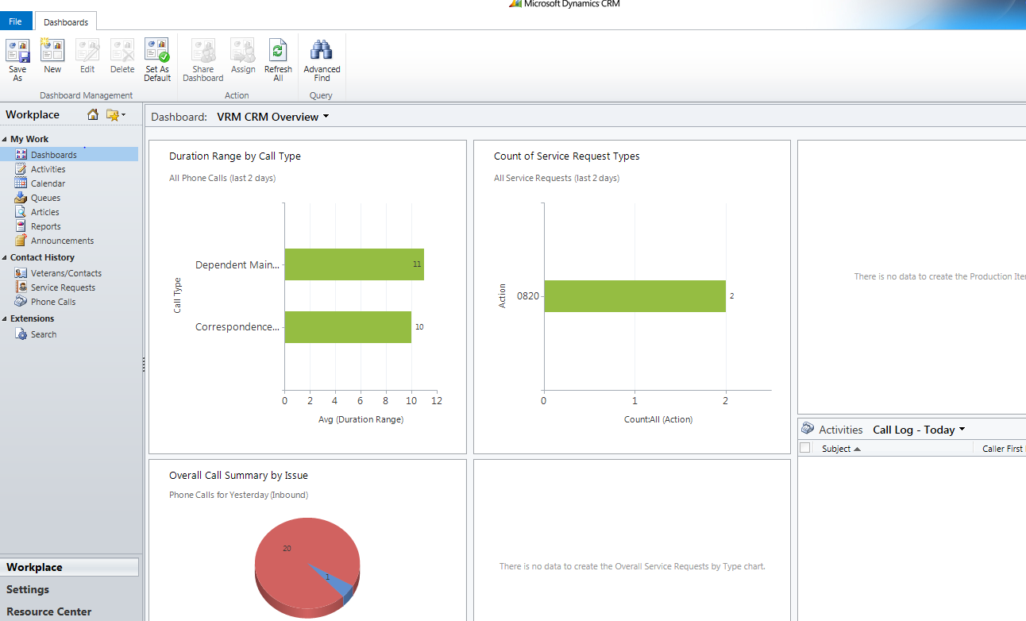

1. Select “Search” from the bottom of the left hand menu and then click “New.” This will open up a new window.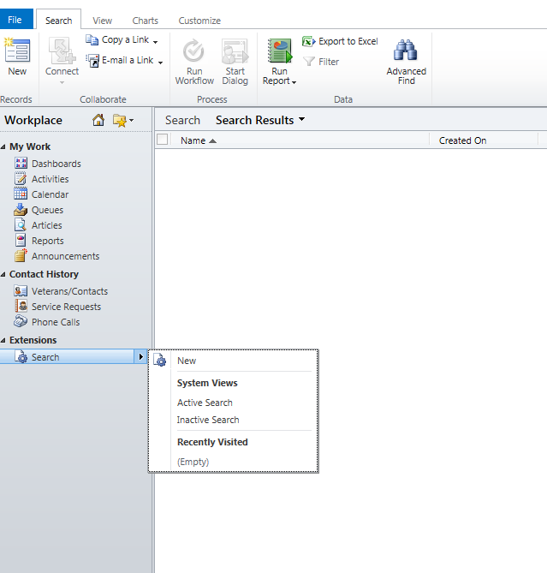
2. Enter the SSN or File Number of the Veteran you are searching for in the “SSN/File No./Claim No.” field.

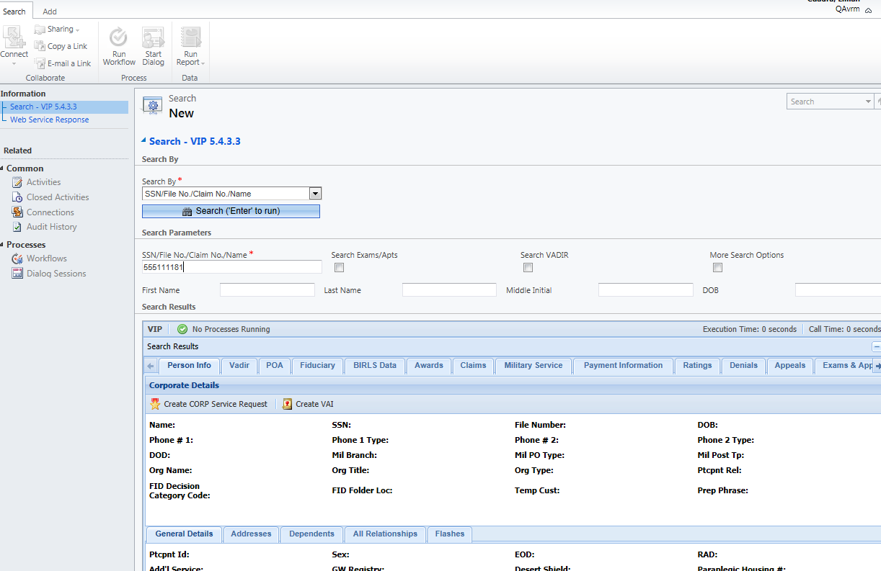

1. If you do not know the SSN of the Veteran, you can search by First and Last Name. If the name is common and yields too many results, you can click on the “More Search Options” box, which will expand the search criteria to include City, State, Zip and other service information.

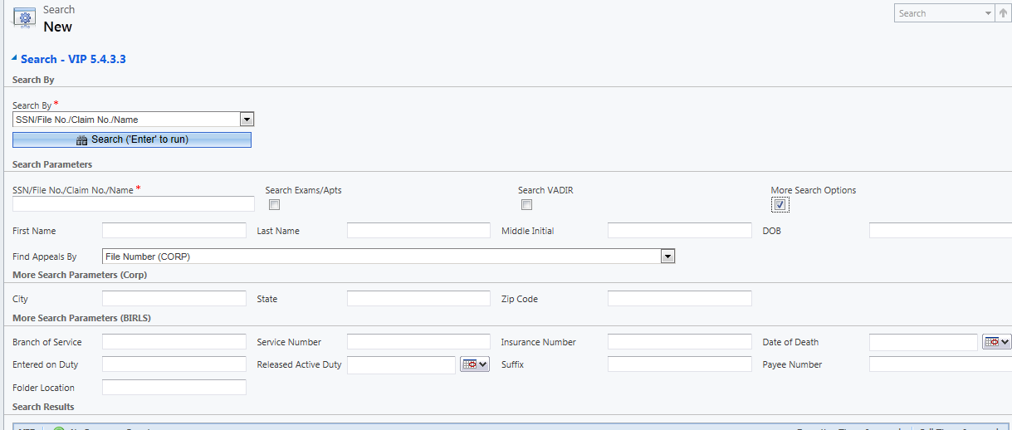

1. If you need to search for exam or appointment information, click on the “Search Exams/Apts” checkbox and set the dates you would like to search. The default is 6 months prior and 6 months forward. This search will only include information currently found in CAPRI. It will not search QTC.

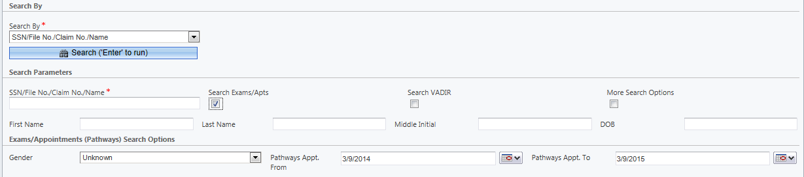

1. Once you have completed your search, information specific to that Veteran can be found in the Search Results tabs. Each tab contains information related to its label, and each will have corresponding subtabs.

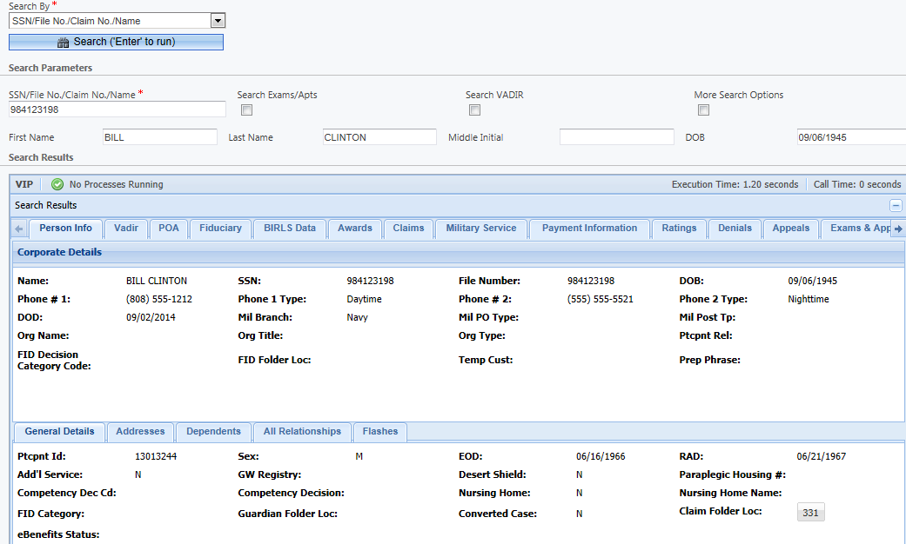

1. For information on a specific award, claim, payment or appeal, be sure to select the claim so that the information in the subtabs populates with the correct information.

