Centralized Mail (CM) Portal Training - CACI
Trainee Handout

Table of Contents

Objectives 2
References 2
Topic 1: Access and General features/functions of the CM Portal 3
Topic 2: Viewing and Uploading Mail in the CM Portal 10

Objectives

- Using the trainee handout packet and references, demonstrate how to access the CM Portal, with 85% accuracy.
- Using the trainee handout packet and references, identify the features and function of the CM Portal, with 85% accuracy.
- Using the trainee handout packet and references, discuss the process for viewing mail in the CM Portal, with 85% accuracy.
- Using the trainee handout packet and references, distinguish the difference in functions between those of the Super User and User, with 85% accuracy.
- Using the trainee handout packet and references, demonstrate the method for uploading the mail to VBMS, with 85% accuracy

References

- CM Portal User Guide
- CM Standard Operating Procedures

Topic 1: Access and General features/functions of the CM Portal

Defining Roles

The portal supports three user roles.

Basic User – Claims Assistants will be given the Basic User role. The Basic User will be able to view their assigned mail packages within their RO. The Basic User will also be able to clear exceptions in order to upload the mail package into VBMS and request for packages to be Rescanned or Split.

Super User – Supervisors and Intake Analysts will be given the Super User role. The Super User can view all mail packages within their RO and will be responsible for assigning packages to Basic Users at their RO and reassigning packages to other ROs. They are the final approver for Split requests and second approver for Rescan requests. Super Users also have the ability to perform all the actions of a Basic User.

National User – Personnel at Central Office will be given the National User role. The National User can view all mail packages across all ROs and will be responsible for the final approval of all Rescan requests. National Users also have the ability to perform all the actions of Basic Users and Super Users.

Access and Login

A user account and Entrust/CACI Token is required to access the CM Portal system. An email notification will be sent to users providing a Username and Personal Verification Number (PVN). That email will also provide a link/URL address for accessing the system. If the link does not work, copy the URL address provided in the email and paste the URL into web browser and hit enter. The Login page will be displayed.

User must enter the User Name provided and select Continue. User will then advance to the Username Token PVN Authentication page. This page will require the User to enter the Token Dynamic Password which will appear when you press the button on your assigned Token. User will also be required to enter the four digit PVN created. If successful, the User will advance to the confirmation screen. On the confirmation screen, user must select Continue.

Successful login will present the user with the Home Page.

Note: If you have issues logging in, clear your Internet Explorer cache. Additionally, be sure the browser is set to the most recent Internet Explorer version and not in Compatibility View. You can check browser settings by selecting F12 while in Internet Explorer.

If you forget your password, contact omegahelp@caci.com (found on the login page).

Home Page

The page is comprised of eleven identification items.

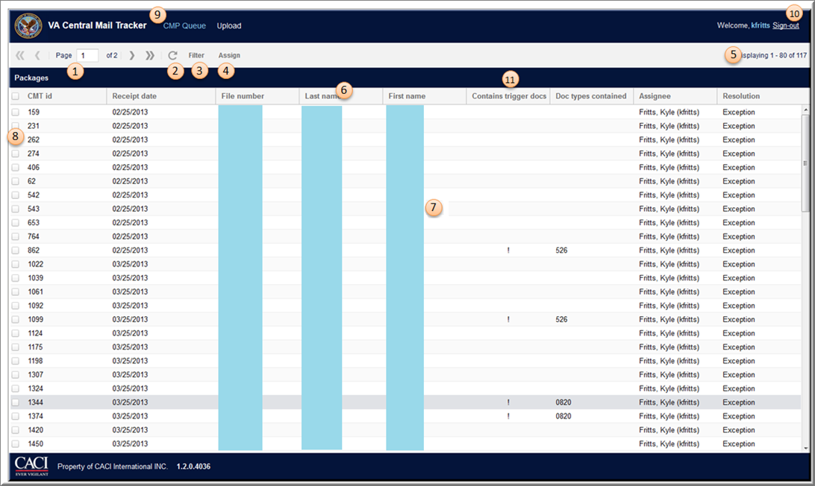

- Page Navigation – Allows the user to move to the first, previous, specific page, next, or last page of the Package Lists.

- Refresh Page - Resets the page back to the original view (will save any filters selected).

- Filter - Narrows package list by the selected field, e.g., Regional office, exception types, assignees, Veteran name/file number, and allows User to designate number of packages to list per page. Discussed in greater detail on following pages.

- Assign - Allows Super User to assign specific packages to a User. This is discussed in greater detail on the following pages.

- Page Display Count - Shows current range of packages and the total number of packages.

- Column Headers - Identifies package metadata (fields) and can be sorted or reconfigured to show desired fields.

Columns can be sorted and displayed depending on user preference. Each column can be sorted in ascending or descending order by selecting the column and choosing the sort preference.

Columns can also be hidden by selecting the dropdown on the column and removing the check mark next to the undesired column. To have access to the column again, simply place a check mark in the box.

To view the columns in a different order, select a column and drag and drop it to the desired location.

Column preferences will be saved for the duration of the login session.

- Document Rows - Reflects available packages in queue. The row is presented based on time in queue and whether they have been opened by you as follows:
- Bold red – older than one week that have not been opened by you
- Red – older than one week that have been opened by you
- Bold black – younger than one week that have not been opened by you
- Black – younger than one week that have been opened by you
- Green italic – work that has been completed in the last 90 days, with the exception of downloads which will appear indefinitely

- Selection Checkbox - Used to select all or specific packages to be assigned.

- CMP Queue View - Quick access to the CMP Queue/package list page (Home Page).

- Sign-Out - Sign-out link to logout of the application.

- Contains Trigger Docs – displays an indicator showing a trigger (action needed) document in the mail package. Trigger documents are defined as one of the following:

- VA Form 21-526 (526EZ, 526b, 526c, etc.)
- VA Form 21-4138
- Non-Rating CESTs (VA Form 21-686c, 674, 674b, etc.)
- VA Form 27-0820
- VA Form 21-4142

Home Page – Reports
Super Users with the reports permission have access to generate a report of work processed at their RO. The Reports button located on the Home Page will be available if the Super User has access.

Select the Repots button, then select User Work Processed RO. Enter the date or date range of the report you would like to generate, and select Get Report. The Report will open in Excel and will display daily work assigned, reassigned, and processed by each user at the RO.

Home Page Filtering

Users and Super Users have the ability to filter on the package lists page to quickly identify packages. The filter button located at the top of the Package List page contains several options which can be used together to quickly identify a package you may be searching for.

Select the filter button, fill out the filtering criteria and select the filter button to execute. If you would like to start your filter over, select the "Reset" button and the filter will reset. Filtering options and their descriptions are below:

- Regional Office (only National Users can access this)
- Solicited?
- Exception Type
- Assignee
- Resolution
- Find By
- Page Size

Filtering – Solicited?

Mail will be categorized as either solicited or unsolicited. Solicited mail will be mail VA specifically requested while unsolicited will be any other mail sent.

Solicited filtering options include:

- All
- Solicited
- Unsolicited

Filtering – Exception Type

All Exceptions need to be Cleared by the Basic User working the package before upload to VBMS can occur.

Exception Type filtering allows both the Basic User and Super User to filter by specific Exception Type. Exception Type selections include:

- Cannot Identify Veteran in VBA System
- Claims establishment document type, Missing Data- cannot submit document for automatic claims establishment
- Claims establishment document type, All required data available, failed to auto-establish
- Upload to CMS failed
- Missing Information, Veteran Name and/or File ID cannot be automatically captured
- Other

Filtering – Assignee (Super Users only)

Only the Super User may filter through the Assignee option. Filtering through this method will provide the Super User the list view for the following selections:

- Assigned – All mail packages assigned
- Unassigned – All mail packages not yet assigned
- All – Mail packages in any assignment status
- Specific Assignee – can select from list of assignees at the RO

Filtering – Resolution

This option will allow the Basic User and Super User to filter on specific resolution including:

- All
- Resolved (packages that have been completed – will display packages that are up to 90 days past the receipt date)
- Unresolved (Default selection – packages that have not been worked and require action)
- Auto CEST (mail package has been sent for upload to VBMS)
- Cleared (all Exceptions have been cleared but package has not been sent for upload to VBMS)
- Exception (exceptions exist which must be Cleared before upload to VBMS can occur)
- Download Confirmed (National User has approved the request to Download and will appear in the queue indefinitely in green italic font to indicate package is complete)
- Rescan Pending RO (Basic User has requested a Rescan to send an unreadable document through scanning again and still needs Super User and National User approval)
- Rescan Pending Final (Super User has approved the request for Rescan and still needs National User approval)
- Rescan Confirmed (National User has approved the request for Rescan and will appear in the queue in green italic font to indicate package is complete)
- Split Pending (Basic User has requested a Split of documents that should not be uploaded together (such as two Veterans co-mingled) and still needs Super User approval)
- Split Confirmed (Super User has approved the request for Split and the package is being sent back for re-upload as separate packages)

Filtering – Find By

This filter option contains several fields for searching Veteran information. They include:

- File Number
- Last Name
- First Name
- Middle Initial
- CMT ID

Filtering – Page Size

Filtering by page size allows the Basic User or Super User to adjust the number of packages displayed in the package list. Options include:

- 20
- 40
- 60
- 80
- 100

Assigning a Mail Package – Selecting Packages (Super Users only)

When a package enters the portal, it will automatically be assigned to the RO identified during processing. The Super User must assign each mail package manually.

There are two steps required when assigning a package.

First, on the package list grid, the Super User has the option to assign a single mail package, multiple packages, or all available mail packages at one time. To select one package at a time, mark a check in the specific box on the left. To select more than one package for assignment, check as many boxes as desired. To select all available packages in the grid, select the top checkbox and it will mark a check in all packages.

Assigning a Mail Package – Selecting Assignee (Super Users only)

Next, the Super User must selected the Assign button located on the top menu bar. A pop up screen will appear.

Next to “Assign to,” a drop down menu will be available. The Super User will be able to select an assignee from the list of all Basic Users at the RO.

The Super User may add a Comment. This is an optional field. Comments cannot be edited or deleted and will stay in the portal as long as the mail package is there. Comments do not upload to VBMS.

Finally, the Super User must select the Assign button at the bottom of the pop up screen to complete the process.

The Close button will take you out of the assign screen without saving comments and bring you back to the main page.

Note: The Super User has to option to Reassign a mail package from one Basic User’s queue to another if the workload or other circumstance require them to do so.

Topic 2: Viewing and Uploading Mail in the CM Portal

Reviewing a Mail Package

The Basic User is primarily responsible for reviewing the mail packages. The Basic User may only review mail packages specifically assigned to them. To view the mail package, the user will select (double-click) the desired row.

The screen that displays after selecting the mail package is identified as the Package Details. There are eight main parts to this screen.

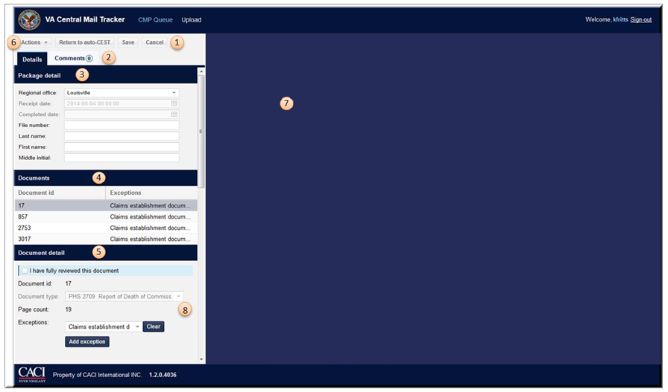
- Package Menu Bar – Users can access the Actions menu, Return to auto-CEST, Save updated details or Cancel changes for the current package.

- View Tabs – Toggle between Details (shown) or Comments (containing view-only notes about the package).

- Package Detail – Contains the Regional office drop down menu field to show the assigned RO and Receipt date field which tracks the date the package was received. Includes Completed Date after the package has been worked. Shows information about the selected Veteran; File number, Last name, First name, and Middle initial.

- Documents – Lists the documents contained in the package

- Document Detail – Shows information about the selected document; Document ID, Document type, Page count, Exceptions, and Contentions.
- Actions Menu – Request or Confirm Rescan or Split.
- Image View – Page view of the document (does not appear until a document is selected).
- Exceptions – Shows which exceptions exist for the current document.

Each section will be discussed in greater detail on the following pages.

Reviewing a Mail Package – Documents

The Documents Grid shows all the documents received in the mail package. Each row is a different type of document for the same Veteran.

The Document ID column is not relevant to VBA users, but is used by the scanning vendor.

The Exceptions column shows which Exceptions exist for each document. If the Exceptions have been cleared, this field will be blank.

The columns in the Documents Grid can be edited just like the columns on the Home Page, with the User determining which columns are viewable and using the drag and drop feature to rearrange the columns.

Users need to select each document row to view all documents in the mail package.

Reviewing a Mail Package – Image View

Upon selecting a document from the Documents grid, the user is now able to view the document.

The Document Detail fields will populate with information included by the scanning vendor. Document Details will be discussed further on the next page.

Portable Document Format (PDF) navigation tools will appear at the bottom of the document.

Reviewing a Mail Package – Details and Comments

The Details tab shows which RO the mail package is assigned to, and the date the mail package was received. The receipt date is entered by the scanning vendor and cannot be edited in the portal. The complete date is populated after the package has been worked and cannot be edited in the portal.

Super Users have the ability to update the Regional Office field to reassign work to another RO. When mail is received which belongs to another jurisdiction, Super Users can route the mail using the dropdown and selecting the correct RO. After the RO has been selected, a pop-up will appear in which the Super User can enter comments which are viewable by the receiving RO. The Super User will then select Reassign to complete the transfer, or Cancel to close out and keep the package at the current location.

The File Number will not be populated by the scanning vendor, but must be entered by the user. The File Number should not contain any spaces or dashes.
The Last Name and First Name may be populated by the scanning vendor, if it is not, it must be entered by the user.

The File Number, Last Name, and First Name are the data fields which VBMS pulls from when uploading. These fields must be correctly entered by the user and needs to match VBMS in order for upload to occur. If these fields are not completed, upload to VBMS will be unsuccessful, and the mail package will reenter the queue for rework.

The Comments tab shows all comments created by Super Users when assigning mail to Basic Users or to other ROs. There is an indicator to show how many comments exist for that package. Comments cannot be edited or deleted and will stay in the portal as long as the mail package is there. Comments do not upload to VBMS.

Reviewing a Mail Package – Document Details and Clearing Exceptions

The Document Details section provides information about the document. There is a checkbox stating “I have fully reviewed this document” on each document that must be checked before upload to VBMS can occur.

The Document ID is populated by the scanning vendor and cannot be edited.

The Document Type is populated by the scanning vendor and cannot be edited.

The Page Count provides how many pages exist for the selected document.

The Exceptions dropdown shows which exceptions exist for each document. After reviewing the document and completing the appropriate action in VA systems, the exception needs to be Cleared. All exceptions must be cleared from each document before attempting to upload to VBMS.

The Contentions fields may list contentions populated by the scanning vendor. These fields are not read by VBMS and do not take the place of the employee completing a full review of the mail package. Users can update these fields but are not required to do so. The Contentions fields should not contain any special characters, such as an ampersand (&).

Reviewing a Mail Package – Package Menu Bar

The Package Menu Bar allows the user to complete action for the current package. The following buttons are available:

- Actions
- Return to auto-CEST
- Save
- Cancel

Actions

If the mail package cannot or should not be worked in the portal as packaged, the Actions tab on the Package Menu bar allows the Basic User and Super User to request or confirm Rescan and Split mail packages.

The Basic User has the option to request Rescan or Split. They will select from the dropdown menu as appropriate.

The Super User has the option to confirm or deny requests for Rescan or Split. Super Users can also submit requests for these actions. They will select from the dropdown menu as appropriate. Rescan requests require approval from a National User.

Return to auto-CEST

The Return to auto-CEST tab on the Package Menu bar allows the User to upload to VBMS. This will be the final button selected before the package is removed from the queue and sent for upload. If package details have not been populated, or the package has not been checked as reviewed, or Exceptions still exist which have not been Cleared, a pop-up will appear which notifies the user that the action must be taken.

Save

The Save tab will save any changes the User has made on the screen, but will not send for upload to VBMS.

Cancel

The Cancel tab will close out of the mail package and will not save any changes or send for upload to VBMS.

Uploading Mail Package to VMBS

After the Veteran’s file number, first name, and last name have been entered in the Package Details section, the “fully reviewed” check box has been checked, and all Exceptions have been Cleared, the mail package is ready for upload to VBMS. Select Return to auto-CEST at the Package Menu Bar to send the mail package to VBMS.

Note: completed work will appear in the queue in green italic font for 90 days after it has been completed.

Additional Information

Establishing controls, updating evidence, and updating systems will be done the same way the user has always done it. The only change is that the mail is now being viewed in an electronic environment by way of the CM Portal.

Date of claim - User is responsible for ensuring that CEST is based on earliest date stamp.

All actions (CESTing, Updating Systems, Updating Evidence, etc.) must be completed prior to uploading mail to VBMS.

If a paper file exists at the RO, make sure that file is transferred to the scanning site.

Ensure that an eFolder exists prior to uploading materials to VBMS. If an eFolder does not exist, one must be created.

Misfiled and Misdirected Mail

Current process for dealing with misfiled or misdirected mail, which includes mail belonging to other business lines: PMC, Education, Voc Rehab, etc.

- Veterans sends paper claim
- Postal service redirects mail to the scan vender
- Claim arrives at scan vendor
- Claim scanned and data extracted
- IPC receives misfiled or misdirected mail
- IPC requests Download from OBPI-VCIP Issue Tracker (select Image Download Request Form)
- Approved download request documents are e-mailed to IPC requester, who in turn e-mails to the appropriate business line

