Suspicious Loan Modifications
Student Handout

Table of Contents

Objectives 2
References 3
Topic 1: Overview of The Suspicious Loan Modification Process 4
Topic 2: Review Suspicious Loan Modification 5
Topic 3: Communicate Mod Corrections 7
Practical Exercise 8
Job Aid: Example of Case Notes (SLM) 9
Attachment A: Screenshot Walkthrough 11

Objectives
- Following the class discussion of loan modifications and suspicious loan modification, the student will apply the definition of each term correctly at least 80% of the time.

- Given an open Suspicious Loan Modification process in VALERI, the student will be able to identify the specific business rule/VA regulation failures within the Loan Modification Complete event, correctly pinpointing why the Suspicious Loan Modification process opened at least 80% of the time.
- Given an open Suspicious Loan Modification process in VALERI, the student will be able to recognize if the mortgage servicer has uploaded the required modification documents, determining if a request needs to be made to the servicer for missing information at least 80% of the time.
- Given an open Suspicious Loan Modification process in VALERI and using the uploaded loan modification documents, the student will be able to determine if the business rule/VA regulation failures within the Completed Loan Modification event are valid at least 80% of the time.

- Given an open Suspicious Loan Modification process in VALERI, the student will be able to determine if the mortgage servicer needs to correct the loan modification at least 80% of the time.
References

- VA Technician Guide, (5.2.1.3) Loan Modification Pages 61 – 62. (5.2.2.1) Review of Suspicious Loan Modification, pages 63 – 66.
- Circular 26-11-11, Final Loan Modification Regulation Revision
- VALERI Intranet, Allowable Modification Rate http://vbaw.vba.va.gov/bl/26/valeri_intranet.htm
- VALERI Newsflash, September 14, 2009
- US Code of Federal Regulation 36.4315 – Loan modifications

Topic 1: Overview of The Suspicious Loan Modification Process
Definitions
To effectively review suspicious loan modifications, it is important to understand the definition of a loan modification and what makes it a suspicious.
Loan modification: a written agreement that permanently changes one or more of the terms of a loan, and includes re-amortization of the balance due.”
Suspicious loan modification: a loan modification becomes suspicious if certain business rules fail of which the data does not meet VA requirements.
Possible Business Rule Failures
- Less than twelve payments have been made on the loan since origination
- Loan was modified more than three times over the life of the loan
- Loan Modification Approved event was not reported
- Date the loan modification was completed is not on or after the modification approval date
- The first payment on the modified loan is due before the loan modification approval date.
- The modification’s fully executed date is after the date the Loan Mod Complete event was reported
- Modified loan amount is not greater than or equal to the most recently reported unpaid principal balance and is not greater than zero
- Term of the modified loan is greater than 30 years from the modified loan start date or 10 years from the original maturity date
- The first payment due date plus term of the modified loan must equal the maturity date
- Interest rate on a modified loan is greater than allowed under VA regulations
- Interest rate was increased by more than one percent
- Loan was modified more than once in a three year period
- First payment on the modified loan is before the modification was approved
- The new principal and interest (P&I) portion of the monthly payment must be greater than zero

Topic 2: Review Suspicious Loan Modification

The Suspicious Loan Modification is a five step process. Each step of the process has its own timeframe.
Step 1: Review Suspicious Loan Modification (2 Days)
Review the Modification Approved and Modification Complete events for all business rule failures that caused the Suspicious Loan Modification (SLM) process to generate. Document in your case notes a list of all the failed business rules.
Failed rules for which VA granted pre-approval typically will not cause the SLM to open, but should still be noted.
Step 2: Obtain Documents (14 Days)
After you complete step one, check step two and the document link in VALERI to determine if the servicer has already uploaded the necessary documents. If no documents were uploaded or some are missing place a task to follow-up in seven days to give the Servicer time to check their action report and provide the information. If the task comes due and documents have not been uploaded, then send a request to the servicer, giving them seven days. Documents needed for the SLM review are:

- Servicer case notes
- Loan modification approval letter
- Loan modification agreement signed by the borrower

Your case notes should document the email address of whom at the servicer you contacted, what documents you requested, and a timeframe for them to provide that information (usually the step two due date). Technicians can access the contact list by clicking on the servicers name within VALERI. When documents have been uploaded, complete step two by pressing continue and document your case notes accordingly.

Step 3: Perform Loss Mit Analysis (5 Days)

VALERI Newsflash dated September 14, 2009 states a full underwriting review should only be completed when there is an Early Payment Default (EPD). For the SLM it is only necessary to review the documentation uploaded by the servicer to determine if the business rule failures you noted in step one are valid. It’s fairly common for the servicer to report wrong information when submitting the Modification Complete event. If the correct information is contained in the modification documents and it adheres to all VA requirements, then no action is required by the servicer. Request your Servicing Officer (SO) to update the modification link in VALERI with the correct information and document case notes.

If the documentation provided by the servicer confirms that they did not follow VA guidelines when modifying the loan, the business rule or regulation failure is valid. VALERI places a regulatory infraction, so placing a manual infraction is not necessary. If the servicer received pre-approval from VA to waive one or more of our regulations, the failed regulation will reflect that VA granted approval, and the regulation failure is invalid.

Step 4: Make Recommendation on Suspicious Loan Modification (2 Days)

Based on your review of the failed business rules in step three, if it is necessary for the servicer to correct the loan modification you would select “Yes” from the drop down box. If a correction by the servicer is not needed, then select “No”. Also enter a case note that supports your decision, selecting Yes/No is not sufficient.

Interest rate non-compliance would be the only time we ask the servicer to correct the loan modification. This is the only circumstance where the best interest of the veteran is not being served by the modification. The exception to this rule is if the servicer can provide information that the investor would not allow the change in interest rate. Before recommending a correction to the interest rate, contact the servicer and inquire why the interest rate did not meet VA guidelines. If it was because the investor would not allow the change, we would not require a correction to the rate.

Per Circular 26-11-22 the max allowable interest rate is based on the approval date of the loan modification. VA uses the Freddie Mac Market Survey Rate which can be found on the VALERI Intranet site: http://vbaw.vba.va.gov/bl/26/valeri_intranet.htm in conjunction with the modification approval date to determine the max allowable interest rate.

Step 5: Approve or Deny Recommendation (2 Days)

This step is completed by a Servicing Officer (SO) or higher. They make the final decision if the servicer needs to fix the loan modification by selecting Yes/No. If no correction by the servicer is necessary, the process is complete. If a correction is needed, selecting “Yes” opens a new process: Communicate Mod Corrections.

Topic 3: Communicate Mod Corrections
The Communicate Mod Correction process contains three steps.

Step 1: Prepare Mod Correction Letter (1 Day)

Prepare a letter to the servicer, explaining VA’s recommendations for correcting the loan modification. The template for the letter can be found on the VALERI intranet site: http://vbaw.vba.va.gov/bl/26/valeri_intranet.htm

Step 2: Communicate Corrections to Servicer (1 Day)

Email or fax a copy of the correction letter to the servicer. Also upload a copy of the letter into VALERI.

Step 3: Confirm Corrections Agree (60 Days)

The servicer is given sixty days to correct the loan modification. Confirm that the corrections made to the loan modification agree with what was communicated to the servicer. When you click on step three, you would then select “Yes”. It may be necessary at this time to have the SO, correct the modification link in VALERI to show the new terms. The process is now complete.

If the servicer has not corrected the loan modification, and has not provided a justification as to why they are not making the change, there are two options to select from:
“No - Consider refund” or “No - No refund consideration.” In most situations it is not necessary to consider a refund. Since the servicer did not fix the loan modification, the failed VA regulation is still valid. If the account terminates and a claim is filed, it may be necessary to adjust the claim for the outstanding regulatory infraction, during the review regulatory infraction process.

Practical Exercise
Servicer Reported

Loan modification approved - 01/06/2013
Loan modification completed - 01/25/2013

Modification Details (Supported by uploaded documents)

Loan modification fully executed 01/25/2013
Modified loan amount $200,546.06
Term 360
Modified loan maturity date 12/01/2042
Interest rate 4%
Date of first payment 01/01/2013
New principal and interest payment 928.75

Failed Business Rules
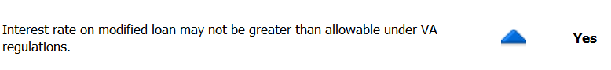
Allowable Interest Rate Table from VALERI Website

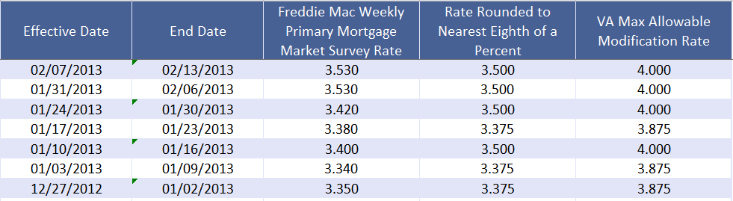

Questions

Using the above information:

1. Does the servicer need to correct the interest rate and why?

2. If so what interest rate should the servicer have used?

Job Aid: Example of Case Notes (SLM)

Step 1 Review Suspicious Loan Modification

SLM Step 1 – The SLM process occurred, due to the following business rule failures under the Loan Mod Complete event.
- Due date of the first payment on the modified loan plus the term of the modified loan (converted to days) must equal the maturity date.
- Interest rate on modified loan may not be greater than allowable under VA regulations.
- For a previously modified loan, date of the first payment on the new modification must be at least three years after the date the previous modification was fully executed.

Step 2 Obtain Documents

SLM Step 2 – The servicer has not uploaded documents for the SLM review. Emailed the servicer at JohnSmith@anylender.com requesting the following documents be uploaded by COB (due date of step 2): Servicing case notes, modification approval letter, and copy of the signed loan modification.

SLM Step 2 – The servicer has uploaded the required documents for the SLM review.

Step 3 Perform Loss Mit Analysis

SLM Step 3 – This loan modification had three failed business rules.
- Due date of the first payment on the modified loan plus the term of the modified loan (converted to days) must equal the maturity date. Servicer reported the maturity date of 12/01/2035, first payment due 02/01/2012, term 360 months. Mod docs support the maturity date and first payment due date. Term was entered incorrectly, should be 317 months.
- Interest rate on modified loan may not be greater than allowable under VA regulations. Servicer reported an interest rate of 6%. Modification was approved on 01/24/12; the maximum allowable rate at this time was 4.375. This is a valid infraction; the servicer needs to correct the interest rate.
- For a previously modified loan, date of the first payment on the new modification must be at least three years after the date the previous modification was fully executed. The servicer requested pre-approval to modify the loan a second time within a three year period, which VA granted. Not a valid infraction.

Step 4 Make Recommendation on Suspicious Loan Modification

SLM Step 4 – Interest rate of 6% does not meet VA requirements. The servicer was contacted at step three and did not provide a valid reason for not lowering the interest rate. Recommend the servicer correct the interest rate to 4.375%, which is the maximum allowed rate when this loan mod was approved.

Also request that the SO update the modification link in VALERI to show Terms of 317 months as the servicer incorrectly reported 360.

Step 5 Approve or Deny Recommendation (completed by SO or higher)

SLM Step 5 – Concur with the techs recommendation that the servicer needs to correct the interest rate.

Also agree with making the change to the modification link. (VALERI also automatically places a case note when a change is made to the link)

Attachment A: Screenshot Walkthrough
SLM Five Step Process
Step 1– Review the failed business rules in the Loan Mod Completed event.
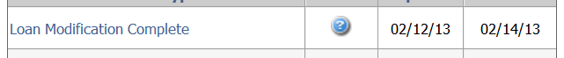
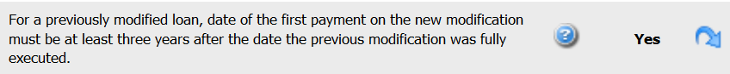
After documenting case notes, input today’s date in Step one and click update.
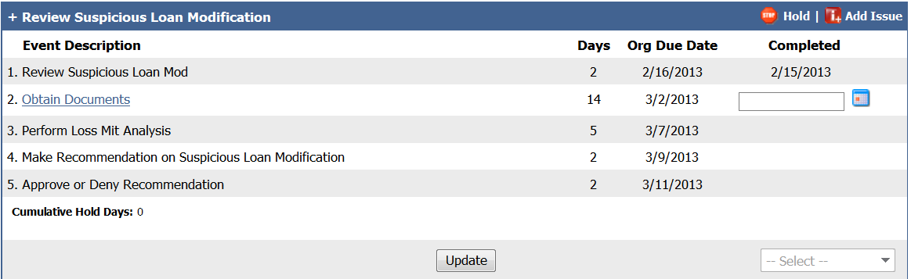
Step 2 – Click Obtain Documents. Verify documents have been uploaded, enter a case note then click Continue, this will complete step 2.

Step 3 – After documenting case notes, input today’s date in step three and click update.
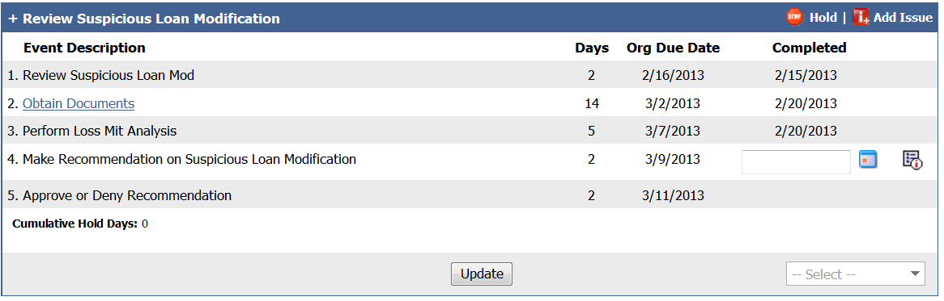
Step 4 – Document the case notes with your recommendation. Then click step 4, which will cause a new window to open. Enter a short justification, select the appropriate answer Yes/No from the drop down box and hit submit.
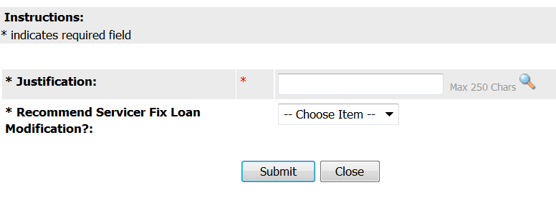
Step 5 – Approve or Deny Recommendation -When the SO clicks on step 5, VALERI opens a new window for them to select Yes/No that the loan modification needs to be corrected by the servicer.
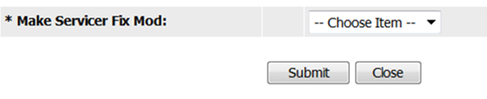
If the SO updates the modification link, VALERI automatically enters a case note.
