Modification Early Payment Defaults
Student Handout

Table of Contents

Objectives 2
References 3
Topic 1: Intro to Early Payment Defaults 4
Topic 2: Review Case File 5
Topic 3: Obtaining Information From Servicer 6
Topic 4: Contact Borrower 8
Topic 5: Make Recommendation 9
Topic 6: Approve or Deny Recommendation 12
Job Aid: Residual Guidelines Table (EPD) 14
Attachment A: Example Case Notes 14
Practical Exercise 18

Objectives

- Given information on an early payment default loan, the Loan Technician should be able to distinguish between a modification or origination early payment default with at least 80% accuracy.

- Given access to VALERI and an early payment default process, the Loan Technician should be able to complete each step within the process with at least 80% accuracy.

- Given access to VALERI and any necessary documentation, the Loan Technician should be able to determine if the loan met VA underwriting standards with at least 80% accuracy.
References

- VA Technicians Guide-Chapter 5 (5.2.2.2) page 66-67

- US Code of Federal Regulation 36.4206-Underwriting Standards, Occupancy and Non-Discrimination Requirements

- US Code of Federal Regulation 36.4340-Underwriting Standards, Processing Procedures, Lender Responsibility and Lender Certification

Topic 1: Intro To Early Payment Defaults

Definition
A situation where the borrower defaults on a loan within six months of loan origination or modification

Types of Early Payment Defaults:
- Origination EPD: A loan that becomes delinquent within six months from original due date or refinanced due date and is reviewed by Loan Production

- Modification EPD: A loan that becomes delinquent within six months from modified due date and is reviewed by Loan Administration

Why Early Payment Default Reviews?
EPD reviews are completed to determine if VA underwriting standards and regulations have been met. If failure to comply with VA underwriting standards and regulations has increased VA’s liability on the loan then claim payments may be adjusted to offset the loss to the government.
Steps of the EPD Process
5 steps to the EPD:
- Review Case File (3 days)
- Obtain Information from Servicer (8 days)
- Contact Borrower (3 days)
- Make Recommendation (4 days)
- Approve or Deny Recommendation (4 days) (Completed by SLT or higher)

Topic 2: Review Case File (Step 1)
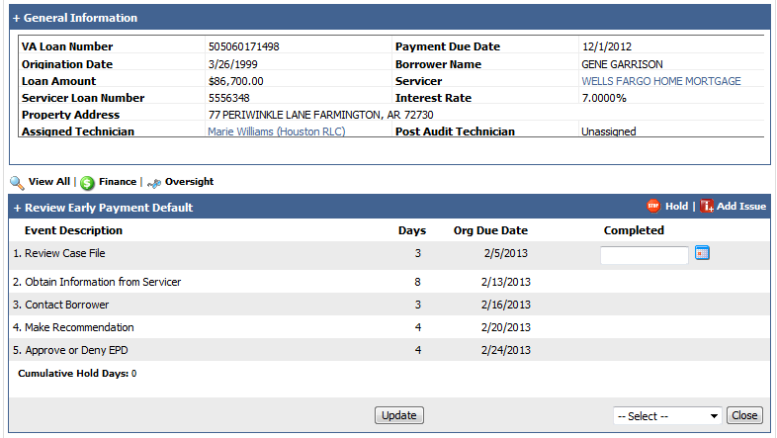
Case Review
Events
- Review events for an overview of the case
- Clear all business rule failures
Modifications
Review most recent modification for completion date to determine how many payments made on the loan
Case Notes
- Review prior VALERI case notes for RFD and activity prior to modification
- Review recent VALERI case notes for recent communication with the borrower regarding the current default to determine current RFD and any actions taken to resolve current delinquency
Information obtained during step 1 of the EPD process should be well documented in the VALERI case notes.

Topic 3: Obtain Information From Servicer (Step 2)

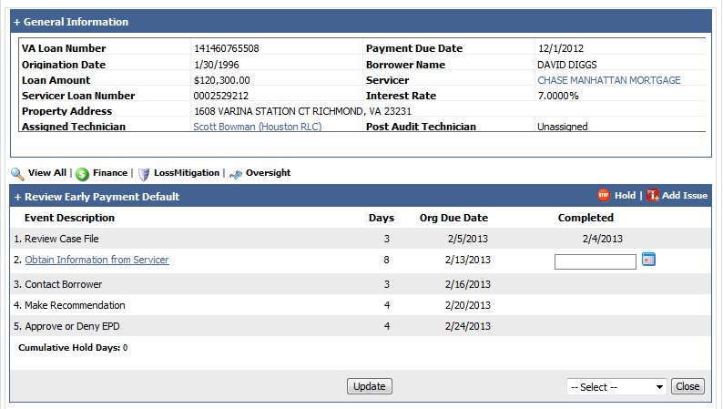
Documents Needed
The following documents are required to be uploaded by the servicer to complete step 2:
- Underwriting package (includes: credit report, homeowner’s financials, pay stubs and hardship letter)
- Signed Modification Agreement
- Modification Approval Letter
- Modification Worksheet
- Servicer Case Notes
Servicer Contact
The servicer is required to upload documents by the end of step 2. If documents are not uploaded when the EPD process opens in your workbasket, contact the servicer requesting the documents be uploaded in VALERI.
If the servicer fails to upload documents by the end of step 2, then the step can be processed and the Loan Technician can move to step 3 of the EPD process.
All efforts to contact the servicer must be well documented in the VALERI case notes

Uploading Documents
Documents must be uploaded under the correct Process Name and Document Type for step 2 to be available to process. When the documents are uploaded correctly the “submit” button will become available. Selecting the “submit” button will automatically complete step 2.
If the servicer did not upload documents during step 2, the Loan Technician should upload a copy of the email to the servicer under the correct Process Name and Document Type.
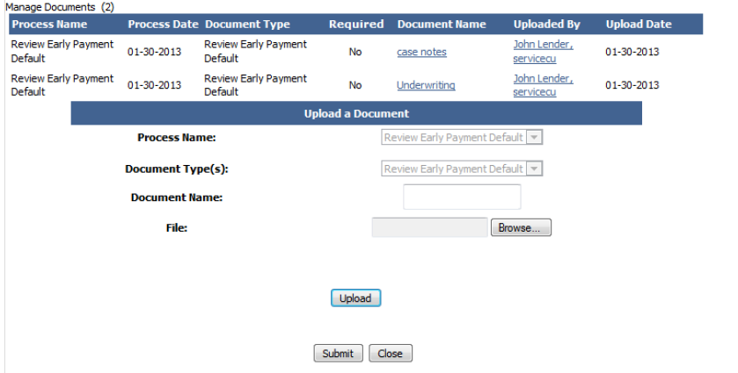

Topic 4: Contact Borrower (Step 3)

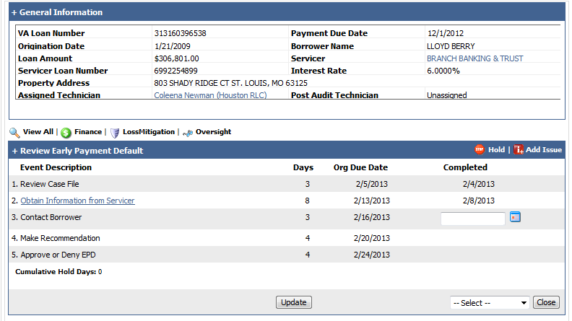
Contacting Borrower
The following information should be obtained when speaking with the borrower. This is the minimum information to obtain:
- Previous RFD
- Current RFD
- Modification requestor: to protect the borrower’s interest and ensure the borrower was aware of modification review
- Recent contact with the servicer
All efforts to contact the borrower must be well documented in the VALERI case notes
Note: Borrower contact can be completed consecutively with step 1 or step 2 of the EPD process.
When borrower contact has been made or 3 day timeframe has been met (whichever comes first) step 3 can be processed and the Loan Technician can proceed to step 4 of the EPD Process.

Topic 5: Make Recommendation (Step 4)

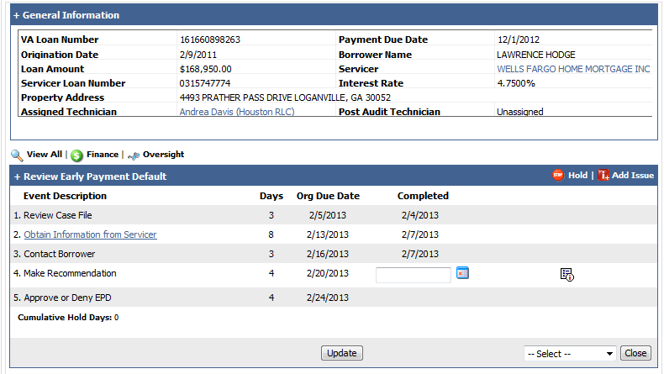

Loss Mitigation Tool
When filling out the loss mitigation tool in VALERI:
- Select “financial data is for an Early Payment Default review”
- Use Net income
- Only include: Shelter Expenses and Debts/Obligations (all other sections should be 0)
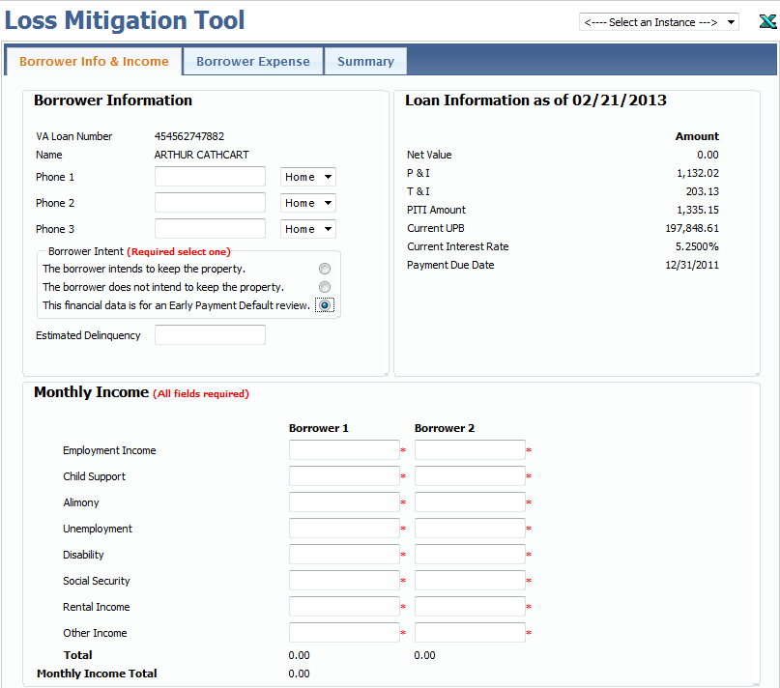

Borrower’s Income
Only verifiable income allowable during review:
- Employed Borrowers: Paystubs,
- Self Employed Borrowers: Profit & Loss Statement, Tax Returns
- Retired/Disabled Borrowers: Award Letters, Bank Statements
- Other Income: Rental Agreement, Child Support Decree

Net income Calculations:
- Weekly (net income x 52 /12= monthly income)
- Biweekly (net income x 26 /12 = monthly income)
- Bimonthly (net income x 24 / 12 = monthly income)

Note: If paystubs are inconsistent average the net income based on the paystubs provided.

Shelter Expenses
Shelter Expenses include:
- Primary Mortgage Payment
- Maintenance Costs
- Utilities (Electric, Gas and Water)
- HOA Fees
The cost of food, cable, phone, insurance etc… should not be included in shelter expenses or loss mitigation tool for EPD review.
Utilities can be calculated using the greater of:
- The borrower’s provided figure on financial statement
- Square feet x $.145 (Square feet found on appraisal)

Debts and Obligations
Items the borrower is obligated to pay on a monthly basis. Usually found on the credit report
Examples:
- Credit Cards
- Student Loans
- 2nd Mortgage
- Auto Loan
- Personal Loan
- Child Support (if not taken directly form pay check)

Use the greater of:
- The borrower reported debt
- Amount found on credit report

Note: Collection should not be used on financial analysis

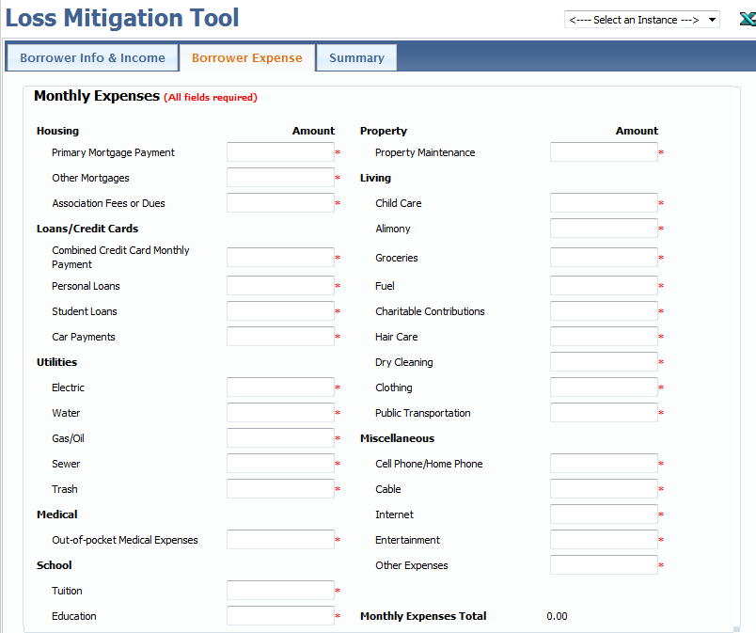

Making a Recommendation
The EPD recommendation is based on the financial analysis completed through the Loss Mitigation Tool and all information gathered on the loan.
Residual income should meet the family residual guidelines based on the region of the property, amount of original loan and how many residing in the household. (Refer to Job Aid: Residual Guideline Table)
Residual Income Calculation: Net Income – Shelter Expenses – Debts and Obligations
Note: If the borrower’s financials are close, but below the required residual income (per Residual Guideline Table), other compensating factors may be used to ensure proper underwriting.
Final recommendation step 4 of EPD process can be completed by answering “Yes” or “No” regarding if VA underwriting standards have been met.
A brief justification should be included with response regarding why underwriting standards have or have not been met.
Selecting “Submit” will complete step 4 of EPD process.
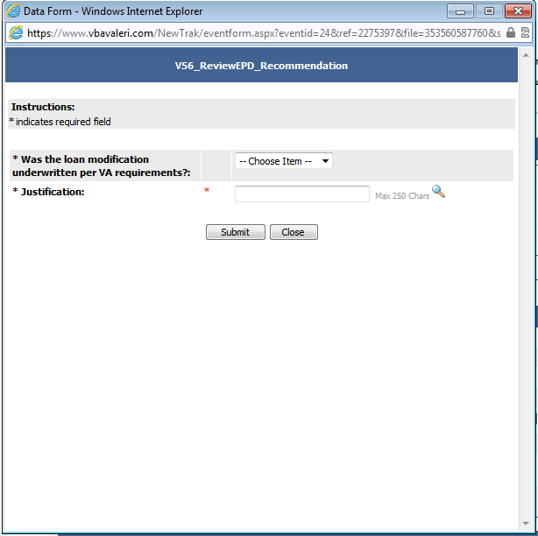
Note: If servicer fails to upload any documents for the EPD reivew, then underwriting standards cannot be determined and therefore are consdered not met. The response to the question should be “No”
Upon Completion of step 4 the EPD process moves from the Loan Technician’s workbasket to the approval basket for review and approval.
The final recommendation and financial analysis should be fully and completely documented in the VALERI case notes, including an explanation of income calculation. (Refer to Attachment A: EPD Case Note Example)

Topic 6: Approve or Deny EPD (Step 5)
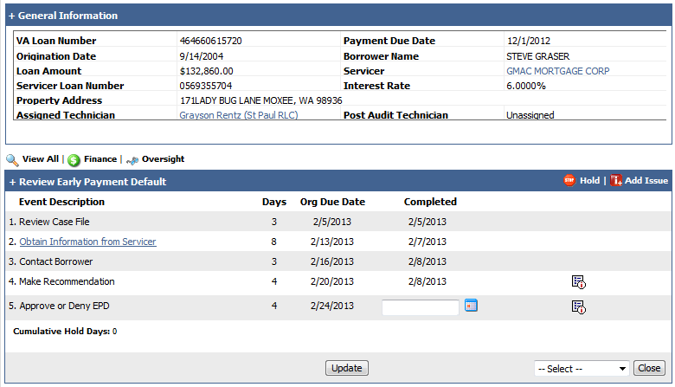
Recommendation Approved
When the reviewer approves the Loan Technician’s recommendation, the process is completed with no further action necessary on the loan.
Recommendation Denied
When the reviewer denies the Loan Technician’s recommendation, the process will be returned to the Loan Technician’s workbasket at step 4 of the EPD process. The reviewer will document case notes with their recommendation.
The Loan Technician will be required to re-review the borrower’s financials and adjust their recommendation based on the reviewer’s feedback.
Note: Additional case notes are required by the Loan Technician regarding their new recommendation when process is returned.
Underwriting Standards Not Met
When it is determined that VA underwriting standards have not been met, the reviewer will add an issue to the loan, after approval of step 5.

Select “Add Issue” on the VALERI process screen.
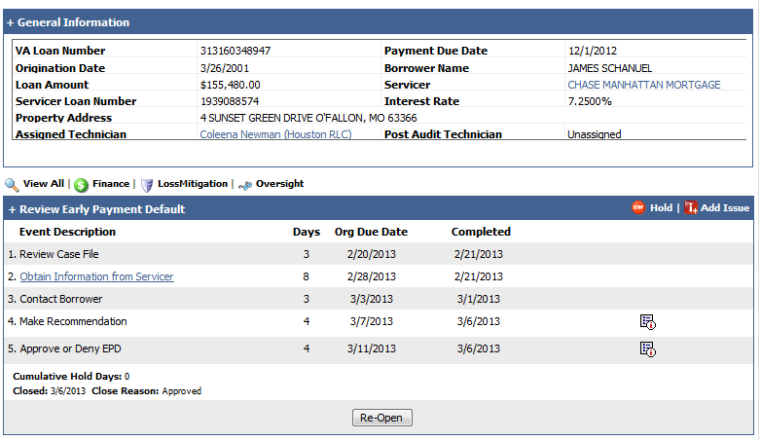
Select a reason for the type of issue from the drop down box: “Other”
Include a description for why the issuing is being added on the loan (maximum of 1000 characters). Select “Save” when complete.
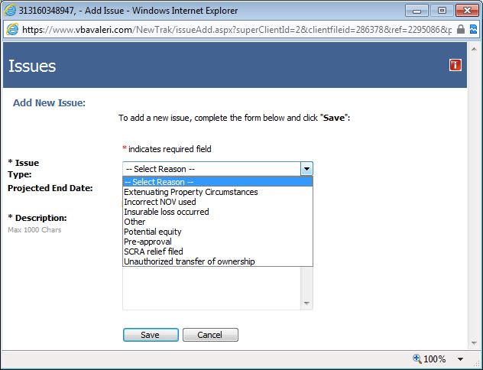
Job Aid: Residual Guidelines Table (EPD)
(1) Table of residual incomes by region (for loan amounts of $79,999 and below):
Table of Residual Incomes by Region
[For loan amounts of $79,999 and below]
Family size¹ | Northeast | Midwest | South | West
1 | 390 | 382 | 382 | 425
2 | 654 | 641 | 641 | 713
3 | 788 | 772 | 772 | 859
4 | 888 | 868 | 868 | 967
5 | 921 | 902 | 902 | 1,004
¹For families with more than five members, add $75 for each additional member up to a family of seven. “Family” includes all members of the household.
(2) Table of residual incomes by region (for loan amounts of $80,000 and above):
Table of Residual Incomes by Region
[For loan amounts of $80,000 and above]
Family size¹ | Northeast | Midwest | South | West
1 | 450 | 441 | 441 | 491
2 | 755 | 738 | 738 | 823
3 | 909 | 889 | 889 | 990
4 | 1,025 | 1,003 | 1,003 | 1,117
5 | 1,062 | 1,039 | 1,039 | 1,158
¹For families with more than five members, add $80 for each additional member up to a family of seven. “Family” includes all members of the household.
(3) Geographic regions for residual income guidelines: Northeast—Connecticut, Maine, Massachusetts, New Hampshire, New Jersey, New York, Pennsylvania, Rhode Island and Vermont; Midwest—Illinois, Indiana, Iowa, Kansas, Michigan, Minnesota, Missouri, Nebraska, North Dakota, Ohio, South Dakota and Wisconsin; South—Alabama, Arkansas, Delaware, District of Columbia, Florida, Georgia, Kentucky, Louisiana, Maryland, Mississippi, North Carolina, Oklahoma, Puerto Rico, South Carolina, Tennessee, Texas, Virginia, West Virginia; West—Alaska, Arizona, California, Colorado, Hawaii, Idaho, Montana, Nevada, New Mexico, Oregon, Utah, Washington and Wyoming.
Attachment A: Example EPD Case notes
Step 1 (REVIEW CASE FILE): Reviewed events reported on loan. Loan modification completed 07/01/11 with a new modified due date of 08/01/11. EDN reported 11/01/11 with a due date of 09/01/11. Only 1 payment made after modification was completed on loan.

Step 2 (OBTAIN INFORMATION FROM SERVICER): sent email to John.Smith@abcmortgage.com requesting the following information be uploaded in VALERI:
Signed modification agreement
Modification approval letter
Case notes
Modification Worksheet
Underwriting package

Step 3 (CONTACT BORROWER): Called Mr. Vet at 123-456-7891, He stated RFD prior to completion of modification was due to a reduction in hours at work/curtailment of income. However, he was able to find better paying job prior to completion of modification. During the previous loss review Mr. confirmed that he was told that he only qualified for a loan modification at the time. Mr. stated he fell behind on modification due to wife loosing employment/curtailment of income. He is currently in contact with servicer regarding delinquency and under review for a repayment plan.

Step 4 (MAKE RECOMMENDATION): Received and reviewed documents provided by servicer for underwriting review. Completed the loss mitigation tool in VALERI and financials indicated a total of 5 people in the household.
Financial Summary:
Total Income = $6,123.03
$1,166.91 VA retirement
$4,956.12 Borrower 1
Total Shelter Expenses = $1,999.73
$1,507.73 modified pmt
$400 utilities
$92 HOA Dues
Debts and Obligations = $1,689
$370 2nd lien
$269 Auto Loan
$492 Auto Loan
$33 Student Loans
$525 credit cards
Residual income = $2,434.30
Guideline for residual income in SC for 5 people = $1,039. The financials provided meet family support guidelines for completion of modification.

With the information provided it appears that underwriting standards were met when considering the homeowners financial qualification for completion of the modification on this loan. Completion of the modification was in the best interest of the homeowner and servicer could not predict homeowner’s new hardship and delinquency on loan.

Review of modification and worksheet indicates that modification meets VA requirements and does not reveal anything that would indicate fraud or mismanagement by the servicer when completing this modification.
Practical Exercise
Loan Background:
Original Loan Amount: $155,000
Modification Completed: 07/11/12
Modified Due date: 08/01/12
Current due date: 09/01/12
Modified Payment: $1,330.32
Location: Ohio
RFD:
Previous: RFD due to curtailment of income and excessive obligations. Borrower had loss of income due to birth of 2nd child. Co-borrower’s company did not offer maternity leave. Borrower’s hours at work were decreased due to weather (works construction). Upon co-borrower’s return to work childcare expenses increased
Current: Unemployment Notification (per EDN reported)
Income Verification:
Borrower’s paystubs provided:
04/23/12 - 04/29/12 in the amount of $651.40 (37 hours)
04/30/12 – 05/06/12 in the amount of $564.52 (32 hours)
05/07/12 – 05/13/12 in the amount of $555.48 (31.5 hours)
05/14/12 – 05/20/12 in the amount of $701.85 (40 hours)
Co Borrower’s pay stubs provided:
02/13/12 – 02/26/12 in the amount of $1,021.84 (64.75 hours)
02/27/12 – 03/11/12 in the amount of $996.64 (63 hours)
Borrower’s Financial Statement:
Food: $450
Transportation: $575
Child Care: $900
Medical: $250
Phone, cable, internet: $250
Clothing: $50
Discretionary income: $34.75
Credit Report:
Auto Loan: $430
Auto Loan: $220
2nd Mortgage: $450
Credit Cards: $700
Student Loans: $200

