Dependency Claims Processed by the Rules-Based Processing System (RBPS)

Trainee Handout

**Table of Contents**

Objectives 2

References 2

Topic 1: Rules Based Processing System (RBPS) 3

Objectives

* Define what is RBPS and its purpose
* Outline the claims process of RBPS
* Define a RBPS reject
* Describe how to locate claim documents
* Recall the appropriate action for processing RBPS rejects
* Identify possible earlier effective dates

References

* [M21-1 Part III, Subpart i, 4. D. – Dependency Claims Processed by the Rules-Based Processing System (RBPS)](https://vaww.vrm.km.va.gov/system/templates/selfservice/va_kanew/help/agent/locale/en-US/portal/554400000001034/content/554400000031795/M21-1-Part-III-Subpart-i-Chapter-4-Section-D-Dependency-Claims-Processed-by-the-Rules-Based-Processing-System-RBPS)

Topic 1: Rules Based Processing System (RBPS)

**Definitions**

* RBPS - Rules Based Processing System
* eBenefits - Online portal for Veterans to manage claims and apply for benefits
* CRM - Customer Relationship Management: program for national call center agents
* VDC - Veterans Direct Connect: Allows claimants to file disability compensation and dependency applications directly via eBenefits
* SEP - Stakeholder Enterprise Platform: A secure and seamless web-based entry portal for Veterans service organizations (VSOs), claim agents and private attorneys who provide services to claimants or conduct business with VBA
* D2D - Digits-to-Digits: A electronic claims data delivery service built to enable a Veteran’s representative to electronically submit claims and evidence

**What is RBPS**

RBPS is an automated system that executes business rules on eligible claims, records decisions, generates correspondence, and triggers payment for award decisions.

RBPS applies only to dependency adjustments for entitled Veterans receiving compensation. System adjustments include the addition of new dependents and the changing of the status of dependent children from minor to school child.

The rules engine is a preset grouping of rules:

* “if this, do that” parameters based on the regulations and
* policy regarding dependency benefits for Veterans on service-connected compensation.

Claims are established and either processed or rejected.

**Purpose of RBPS**

RBPS

* + - will reduce VA’s non-rating inventory and processing time
    - allows Regional Offices (ROs) to allocate more resources to the reduction of claims in their inventory to more difficult claims
    - ensures timely award adjustments for the addition or removal of dependents from a beneficiary’s award.

**How RBPS Receives Data**

Processes claims through the following methods:

* Veterans Online Application (VONAPP) Direct Connect (VDC)
  + eBenefits
  + SEP (Stakeholder Enterprise Portal)
  + D2D (Digits to Digits)
* Customer Relationship Management (CRM)

**VONAPP Direct Connect (VDC)**

The table below describes how RBPS receives the data necessary to process this category of claim via VDC.

|  |  |
| --- | --- |
| **Stage** | **Description** |
| 1 | A Veteran or appointed representative accesses VDC through eBenefits/D2D/SEP. |
| 2 | VDC utilizes a question-and-answer, interview-style interface to guide the Veteran in completing one of the following forms   * VA Form 21-686c, *Declaration of Status of Dependents*, or * VA Form 21-674, *Request for Approval of School Attendance*. |
| 3 | RBPS pulls data from the entries made on the forms listed in Step 2 and attempts to process the claim based on that data. These forms are then loaded into VBMS. |

**Customer Relationship Management (CRM)**

* Used by National Call Centers (NCC)
* Claim information is accepted over phone and entered into system
* Information is fed into an electronic VA Form 21-686c or 21-674
* Forms are uploaded to the electronic record
* Claim is established and either processed or rejected

**Note:** Review the flowchart “Process Overview of CRM Interface” located on slide 11 of the Power Point presentation.

**How RBPS Sorts and Processes Claims**

The table below describes the process that is triggered when a Veteran or appointed representative submits VA Forms 21-686c and/or 21-674.

|  |  |
| --- | --- |
| **If…** | **Then…** |
| The claim is eligible for automated processing | * RBPS   + Establishes an EP 130 with the appropriate claim label.   + uses rules-based programming to decide the claim, and   + processes the decision through the Veterans Service Network (VETSNET). * VETSNET clears the EP 130, and * The Hines Information Technology Center   + generates a decision notice, and   + uploads the corresponding award print and decision notice into the Veteran’s eFolder. |
| The claim is not eligible for automated processing | * RBPS establishes an EP 130 with a claim label designating it as an RBPS-rejected claim. * The National Work Queue (NWQ) will recall and distribute the EP for any additional development and/or adjudication. |

**Note:** Review the flowchart “Rules Engine (RBPS) Process Flow” located on slide 12 of the Power Point presentation.

**Common RBPS Reject Reasons**

* to add
  + an adopted child
  + a child over age 18 that is permanently incapable of self-support
  + a school child whose tuition is being paid by the Federal government, or
  + a dependent when
    - the payment of benefits may be subject to a withholding for attorney fees, or
    - the claimant or Veteran has a foreign address, or
  + to remove a spouse when there are additional dependent children on the award.

**Claim Labels**

|  |  |
| --- | --- |
| **Award** | |
| **eBenefits Dependency Adjustment** | **Dependency Claim Submitted through eBenefits** |
| **eBenefits School attendance** | **Dependency Claim Submitted through eBenefits** |
| **D2D-Dependency Adjustment** | **Dependency Claim Submitted through D2D** |
| **Phone Dependency Adjustment** | **Dependency Claim Submitted by NCC through CRM** |
|  |  |
| **Manual Processing** | |
| **eBenefits Dependency Adjustment/School Attendance Reject** | **Manual Processing Required, Dependency Claim Submitted through eBenefits** |
| **D2D-Dependency Adjustment** | **Manual Processing Required, Dependency Claim Submitted through D2D** |
| **Phone Dependency Adjustment Reject** | **Manual Processing Required, Dependency Claim Submitted by NCC through CRM** |

**Where are the Claim Documents?**

If submitted through eBenefits/SEP/D2D: documents are in the eFolder, but historical claim documents may be in Legacy Content Manager Documents tab.

**Document Failed to Upload**

If claim was submitted through eBenefits/CRM/D2D/SEP and claim document is missing:

Follow the guidance in [M21-1 Part III.ii.4.D.6 – Claims Materials Submitted Using a VA Electronic Application Process That Fail to Upload to the eFolder](https://vaww.vrm.km.va.gov/system/templates/selfservice/va_kanew/help/agent/locale/en-US/portal/554400000001034/content/554400000014129/M21-1-Part-III-Subpart-ii-Chapter-4-Section-D-Lost-Paper-Claims-Folders-Reconciliation-of-Duplicate-Records-in-the-Beneficiary-Identification-and-Records-Locator-Subsystem-BIRLS-and-Misplaced-Claims-Documents" \l "6) for obtaining the missing document(s)

**VDC Functionality**

VDC via eBenefits/SEP/D2D functionality includes:

* Add biological child
* Add stepchild
* Add school-age child
* Add spouse
* Remove spouse with no children
* Deny when Veteran is less than 30 percent-service connected

**CRM Functionality**

CRM Functionality includes:

* Add biological child
* Add spouse

**Ineligible Claims for RBPS**

The following types of claims are not eligible for automated processing through RBPS

* claims to add
  + an adopted child
  + a child over age 18 that is permanently incapable of self-support
  + a child over age 18 that is homeschooled, or
  + a school child whose tuition is being paid by the Federal government, or
* claims to add a dependent when
  + the payment of benefits may be subject to a withholding for attorney fees, or
  + the claimant or Veteran has a foreign address

**Earlier Effective Date Review**

**Scenario:** I have an EP 130 but a RBPS claim was cleared while the current claim was pending…Now what?

* Review all Claim Documents
  + eFolder documents
  + Documents in Legacy Tab
* Compare current claim document with last award print or award data: Were all dependents claimed established on the award?
  + Veteran could potentially claim other dependents
  + If not, take action to establish the unaddressed dependents
* Were all dependents added from the earliest effective date?

**Earlier Effective Date Flow Chart**

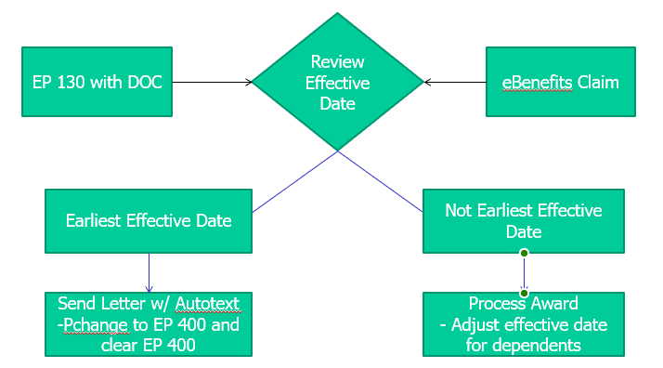

**Earlier Effective Date Example**

* You are reviewing the EP 130 dated January 20, 2014.
* Veteran sends a VA Form 21-686c to VA on January 20, 2014.
* Veteran’s EP 020 cleared on July 3, 2013 granting a combined evaluation of 30% evaluation effective June 1, 2013
* Through eBenefits, Veteran submitted a claim that clears on January 2, 2015 and RBPS auto establishes dependents effective January 2, 2015, with a payment date February 1, 2015.
* **Question:** What action should be taken?

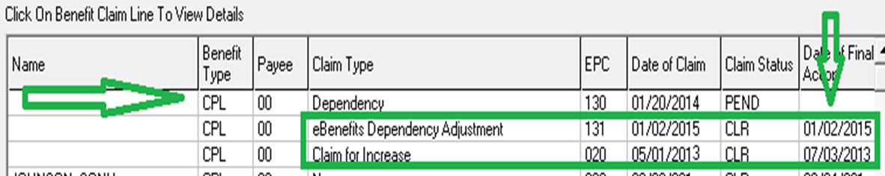

**Earlier Effective Date Example Answer:**

We should adjust the effective date of the dependents

* The eBenefits claim was based on the date of claim of January 2, 2015à February 1, 2015 payment date
* Veteran is eligible for an earlier effective date because of the EP 130 with a DOC of January 20, 2014.
* Process award to grant spouse and minor child from June 1, 2013

*Review 21-686c for event dates to ensure we are not granting dependents back to a period in which they are not eligible.

**Important:** EP 130 should be updated to an EP 930 with January 2, 2015 date of claim, since we are correcting an EP previously cleared.

**Earlier Effective Date Adjustment Not Needed Example**

**Scenario:** Spouse and minor child added from the earliest possible effective date of June 1, 2013. What action should be taken?

**Answer:** No corrective action is needed to Veteran’s dependency decisions

* We should send letter to the Veteran concerning claim. Update EP 130 to an EP 400.
* Clear EP 400 in Share.

**Earlier Effective Adjustment Not Needed Auto text**

“We are writing regarding your dependency claim that was received on (insert date). This letter is to inform you that the action has already been taken to add XXXXX on your award as a dependent (insert status, spouse, child, etc.) from XXXXXXX with the claim you submitted online through eBenefits. Our notification letter dated XXXXX informed you of this decision.

Your compensation payment will continue unchanged.”

*Suppress review rights if processing in RADL/VBMS-A. **Do not** enclose review rights if generating correspondence in PCGL.