General Information
Historical Information
Through the 1970’s and 1980’s, VBA used computer cards and letters to inquire about our claimants' benefits paid by SSA. In June 1996, VBA began using the Third Party Query (TPQY) system in which individual inquiries were bundled and sent to SSA. Response were recevied during the next 24 or 48 hours, On March 20, 2000, SSA signed a Memorandum of Understanding with VBA allowing direct access to SSA data nationwide.
SSA started giving direct access to State users through the State On-Line Query System, or SOLQ. This access was amended slightly creating the Federal On-Line Query (FOLQ) System. That is the system to which we have access.
To best present SSA Data and the many other ways VBA wants to present additional information, VA-SHARE is being developed. You will access SSA through a completed portion of SHARE designed for SSA inquiry.

What is the FOLQ
For a number of years, SSA used a process that bundled individual requests for information. This process was called the State Verification and Exchange System (SVES). With the increased computerized capability of both SSA and its partners, there was an increased need to process requests in real time. So SSA developed a way for states and other agencies to obtain certain data through a read-only-specific real-time query. The data presented through SVES is now shared through the State On Line Query (SOLQ), or with federal agencies through the Federal On-Line Query (FOLQ). This system provides the following information:
- Verification of SS numbers,
- Title II, Retirement, Survivors, and Disability Insurance data,
- Title XVI, Supplemental Security Income data, and
- A Payment history file.

Data for Use VBA Wide
This site was designed with all VBA divisions in mind. Therefore, you may see data that you would not normally use. Veterans Service Representatives will see fields more commonly used by the Insurance Service and visa versa. Also, by General Counsel requirement, the Insurance Service personnel are barred from access to the income information. Therefore, employees of the Insurance Service will not see financial data. Instead, it will be either grayed out or blank.

What is VA-SHARE?
VA-SHARE is a methodology presented in a Windows environment (not on the WEB) for inquiry against data bases. In the case of SSA, VBA is making inquiry against a data base designed to meet the needs of State and Federal agencies.

Purpose of FOLQ
VBA is obligated to verify Social Security numbers and income information submitted by applicants and beneficiaries. Access to FOLQ will enable VBA to assist veterans and dependents by providing instant verification of the information on applications and post entitlement reviews, such as EVR processing. This will also help reduce processing time and increase the accuracy of information.
Policy for Users
Who is Allowed Access?
The only employees that will be allowed access are Veterans Service Representatives (VSR’s) and their supervisors, and Insurance Specialists and Technicians and their supervisors.

Restrictions for Users
- SSA data is third party information. Use of information from SSA in this application does not change any previous instruction regarding the use of SSA data. Even though this information comes directly from Social Security, the veteran still has the right to due process for any adverse action that you consider taking.
Use of SSA data is under the restrictions of the Privacy Act. As third party information, any potential adverse action requires due process as given in current policy and procedures.
- Use of the data is for the specific purpose of verifying information and processing claims of veterans and their beneficiaries. Any other use is considered a violation of trust. All employees will treat the query information in a manor consistent with the requirements of the Privacy Act and all applicable regulations. Any other use will be considered a violation of trust.
Important: Before you begin using FOLQ, remember that the intentional inquiry into a file that is not required to perform your job is a violation of both state and federal law, and may result in felony prosecution.
As with TPQY information in the past, SSA data is confidential and may be used only for the purposes directly related to the administration of assistance to veterans and their beneficiaries. To monitor use of the system access, FOLQ is tracked by a fully automated audit trail on all inquiries.

Personal Statement of Agreement
Initially, and then annually, all users must sign a Certificate of Understanding. On this document, the user is certifying understanding of the requirements and penalties involved in misusing the SSA information received through FOLQ. This is intended as a way of emphasizing the importance of following Privacy Act requirements and ensuring at all users agree to those requirements. The absence of this signed form or lack of agreement by an employee will prevent any access to FOLQ.

Security System
VBA has a audit system which runs behind the transactions being processed. This system is designed to identify improper use of the system. While misuse of the system is not anticipated, VBA must be able to demonstrate to SSA and agency overseers that SSA data is appropriately used. Local managers and Central Office staff will monitor this system.
The VA IRM Directive 5.10.03 Common Security Services (draft) updates current VBA security policies to require Station Information Security Officers to have procedures for monitoring and controlling employee access. The Common Security Service Violation Reports (which include sensitive record violations to SSA inquiries) are to be reviewed monthly (or more often) for indications of security problems. They are to investigate and take appropriate measures to ensure future violations do not occur.
After a thorough investigation by the Station Information Security Offices and appropriate station managers, if it is shown that a violation of trust has occurred, disciplinary or adverse action, could result based on the Range of Penalties for Stated Offenses (MP 5, Part 1, Chapter 752, Appendix D, dated December 31, 1998).

SSA Advertised Hours
The latest update from SSA shows advertised hours for FOLQ as follows:
- Monday through Friday 6:30 am EST to 1:00 am EST (next day)
- Saturday 6:15 am EST to 8:00 pm EST
- Sunday 7:30 am EST to 4:00 pm EST (3 out of 4 Sundays)
There is no schedule to show which Sunday they are down.

Access to FOLQ
Getting VA-SHARE
Those employees authorized to have access to FOLQ will be given the addition link through VA-SHARE. If needed, VA-SHARE will be installed on your computer by the local IRM Administrator.

Entry into VA-SHARE, and FOLQ
Double click on the Share icon. From the main menu, enter your LAN user ID and password. Press enter. In the drop down list of available links, choose the SSA option. Press enter.
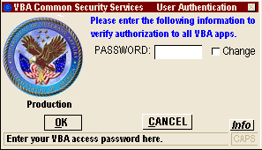

Required Data for FOLQ
VBA data required
- VA File number or Insurance File Number with prefix.
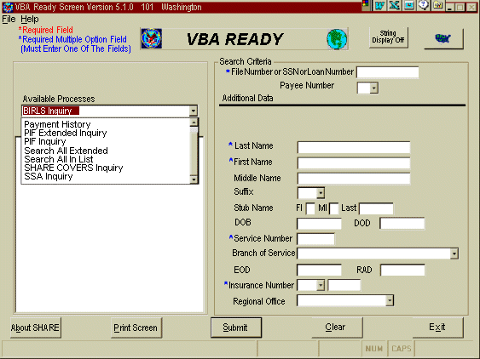

SSA requires the following data for all inquires:
- Full Name (middle initial is not required)
- Social Security Number - The SSN can be a digit off, or two digits can be transposed. The record will come back with the SSN as unverified, but will also give you the verified SSN. Of course you must have the correct name and date of birth for this to work.
- Date of Birth - A full date is required, but you only need the exact month and year to get the SSA record
The required items are identified by a red asterisk in front of the item.
The requirement of a VBA cross-reference is so a continuous record is maintained that may be used at any time to verify proper use of this system. Any attempt at browsing SSA data will be identified through the security system, which runs continuously behind all the transactions.
Input the data required and press ENTER

