IDES Initial Interview- (MSC)
Trainee Handout

Table of Contents

Objectives 2
References 3
Topic 1: Initial Interview Preparation 4
Topic 2: Initial Interview Requirements 7
Attachment A: Initial Interview Preparation Review Exercise 10
Attachment B: Initial Interview Requirements Review Exercise 12
Practical Exercise 14

Objectives
- Given the trainee handout packet and references, identify VA’s roles in IDES, with 85% accuracy.
- Given the trainee handout packet and references, identify pre-interview procedures, with 85% accuracy.
- Given the trainee handout packet and references, differentiate initial interview requirements, with 85% accuracy.
References
- Under Secretary of Defense Memorandum: Policy and Procedural Directive-Type Memorandum (DTM) for the Disability Evaluation System (DES) Pilot Program, dated November 21, 2007

- Under Secretary of Defense - Policy and Procedural Update for the Disability Evaluation System (DES) Pilot Program dated December 11, 2008

- Integrated Disability Evaluation System (IDES) Implementation Guide of July 2011

Topic 1: Initial Interview Preparation
IDES Integration
The Integrated Disability Evaluation System (IDES) integrates the Department of Defense (DoD) and Veterans Affairs (VA) disability evaluation systems into a single process. Each entity plays a very specific role in the process:
- IDES implements an efficient process that meets the needs of the Service member and the two Departments.
- The DoD retains the determination of a Service member’s fitness for continued military service.
- VA assigns disability evaluations that are binding on both Departments in accordance with the VA Schedule of Rating Disabilities (VASRD).
VA’s Roles
During an initial interview, the Military Service Coordinator (MSC) must explain VA’s role in the IDES rating process.
VA will provide:
- Single comprehensive physical examinations developed to meet the requirements of both DoD and VA, conducted according to VA protocols.
- Single disability ratings prepared by VA that are binding upon both departments.
- Rapid delivery of VA benefits on the first day allowed by law.
If the Service member is found unfit and separated from service, VA will:
- Make a decision on both the claimed and referred conditions
- Begin VA benefits (if entitled) shortly after VA receives verification of the Service member’s discharge
If the Service member is found fit and retained on active duty, VA will:
- Close the claim
- Take no further action until the Service member initiates a new claim upon his/her separation from service
Service Member Characteristics
The IDES process can be overwhelming for the Service member.
As the Service member’s direct link to VA benefits and services, the MSC should keep in mind:
- The initial interview may be the first interaction a Service member has with VA.
- The Service member is going through a very stressful time in his/her military career and personal life. The Service member’s potential military career and life-changing decisions are pending until a determination of fitness for duty is determined by the military.
MSC Support Role
The MSC can help relieve the stress levels of Service members by informing them of choices available, whether they remain on active duty or are discharged from the military. Those choices may include:
- Education assistance while on active duty
- Employment training and education benefits if discharged from the military
- VA benefits available during active duty and after they are discharged
MSCs need to let Service members know that they are available to answer questions and assist in any way possible.
Pre-Interview Requirements
Prior to the initial interview, the MSC should have:
- Received a complete referral from the Physical Evaluation Board Liaison Officer (PEBLO)
- Reviewed the referral and Service Treatment Records (STRs) for referred and claimed conditions
- Scheduled an appointment with the Service member
Notes: When preparing for the initial interview:
- If the referral is not complete, refer to the VA Form 21-0819 lesson for the procedures to follow.
- The initial interview appointment may be scheduled by the PEBLO or the MSC depending on the agreement at the facility.
Appointments
To prevent any delays in the IDES process, the initial interview appointment should be scheduled as soon as possible. The appointment MUST be scheduled within:
- 10 days of the referral for active duty Service members
- 30 days of the referral for Reserve component members
The initial interview generally takes 45 minutes to one hour to conduct. Schedule at least 30 minutes between appointments in case some interviews require extra time.
Remote Interviews
Whenever possible, the initial interview should be conducted in a face-to-face setting. However, in some cases meeting face-to-face is not possible. For example, the Service member may:
- Be located in a remote area
- Be a patient at a VA Hospital in another city
- Experience undue hardship if required to travel to the interview location
In such cases, the interview may be conducted via videoconference or telephone. Telephone interviews should be considered a last resort.
VSO Officer
When conducting a remote interview, the MSC may use a Veterans Service Organization (VSO) Officer to assist. The VSO can:
- Provide all appropriate documents
- Advise the Service member of any other benefits he/she may be entitled to receive
- Provide a copy of VA Form 21-22, Appointment of Veterans Service Organization as Claimant's Representative (http://www.vba.va.gov/pubs/forms/VBA-21-22-ARE.pdf)
- Ensure VA Form 21-22 is signed
- Follow all appropriate guidelines for PII information
- Utilize fax and mail for original documents
Note: VA Form 21-22 must be completed and of record before the MSC can discuss or release information to a VSO.
Topic 2: Initial Interview Requirements
Initial Interview Requirements
For Service members considered unfit for military service due to physical or mental impairment or condition, the IDES initial interview is an opportunity for the MSC and Service member to meet and exchange information.
VA Form 21-0819
VA Form 21-0819, VA/DoD Joint Physical Disability the Evaluation Board Claim is used to collect information to help determine the allowance of compensation benefits.
Section I of VA Form 21-0819 is completed by the PEBLO as part of the referral packet. During the initial interview, the MSC needs to complete Sections II – VII.
Note: Make sure VA Form 21-0819 and all other documents are date stamped. The date of the date stamp is the day the Service member signs the VA Form 21-0819.
Head to Toe Check
The MSC should ask the Service member to do a “head to toe check.” This check requires:
- The Service member to ask: “Do I have conditions to claim other than the referred or MSC recommended claimed conditions?”
- If yes, the MSC will ask for the dates the disabilities occurred if medical evidence is not available.
Ancillary Benefits Claims
A Service member who is rated service-connected for one or more conditions may also be entitled to additional ancillary benefits, including:
- Clothing allowance
- Vocational Rehabilitation and Employment (VR&E)
- Dependents’ Educational Assistance (DEA), AKA Chapter 35
- Restored Entitlement Program for Survivors (REPS)
- Civilian Health and Medical Program of the Department of Veterans Affairs (CHAMPVA)
- Loan Guaranty
- Automobile or other conveyance allowance
- Specially Adapted Housing (SAH) and Special Housing Adaptation (SHA) grants
During the initial interview, the MSC should explain additional benefit entitlements and initiate any claims for ancillary benefits.
Note: The Service member needs to know that a memorandum rating may need to be completed to establish benefits while on active duty.
IS-1 Handbook
Provide the Service member with a copy of the IS-1 Federal Benefits for Veterans, Dependents, and Survivors Handbook. This handbook provides a brief summary of all VA Benefits and may be used during the initial interview as a guide to discuss all VA Benefits available to Service members and Veterans.
Additional Requirements
During the initial interview, the MSC needs to address the following requirements:
- Inform the Service member that other conditions can be claimed after the initial interview, but there may be a chance that those condition(s) will not be examined or included on the final rating. An additional rating may be completed at a later time after the Service member is discharged from the military.
- Obtain a permanent address or a next of kin address and document the information on VA Form 27-0820. This ensures that VA will have an alternate address if the Service member does not attend the exit interview or if mail is returned from the address given on the 21-0819 form.
- Provide the Service member with a list of all future actions he/she may need to take. This includes providing information about:
  - Dependency
  - Direct deposit
  - Forwarding address(es)
  - DD-214, Certificate of Release or Discharge from Active Duty
  - Any additional forms needed for ancillary benefits
VA Medical Examinations
The primary purpose of the VA medical examination(s) is to assess the Service member’s referred and claimed medical condition(s).
- Examination results are used by the Medical Evaluation Board (MEB) to complete the Narrative Summary to determine referral to the Physical Evaluation Board (PEB).
- Once the PEB makes a determination that the Service member is unfit for duty, they ask VA to complete the proposed rating.
- The Rating Veterans Service Representative (RVSR) utilizes all the evidence of record and the VA Compensation Exam to provide the PEB with the proposed rating and a final rating after the Service member separates from active duty.
The MSC needs to explain to the Service member the following guidelines related to the examination(s):
- Do not miss appointments. Arrive to appointments on time.
- Leave should not be taken during the period of the examination appointments. The PEBLO reviews all leave requests during the IDES process.
- Transportation is determined by site policy.
- Meals on examination appointment days are determined by site policy.
- Any other special circumstances the site may have in place.
Close the Interview
As the initial interview comes to an end, the MSC needs to cover the following items:
- Provide the Service member with:
  - MSC contact information
  - An opportunity to ask additional questions or comments
  - VA medical facility address, phone number, location, and point of contact
  - Copies of all signed and date-stamped documents
- Inform the Service member that:
  - The PEBLO will contact him/her with the date and time of scheduled VA examination appointment(s).
  - Any needed changes to scheduled VA examination appointments must be done through the PEBLO. Changes to the appointments should be discouraged, as this will delay the IDES process.
  - If additional disabilities are identified during the VA medical examination, the examiner will add those disabilities.
  - VA will conduct an exit interview regardless of the outcome from the Medical Evaluation Board (MEB) or Physical Evaluation Board (PEB) to provide more information.
- Provide encouragement to the Service member by telling him/her that no matter the outcome of the IDES process, whether he/she is found fit or unfit for duty, there are positive paths to follow, and if he/she remains on or is discharged from active duty VA will assist with employment or educational opportunities.
In addition, the MSC must supply the PEBLO with:
- A completed copy of VA Form 21-0819
- The list of requested C&P examinations for each referred and Service member-claimed condition
Checklists
Use of a checklist is at the MSC discretion. However, checklists are an acceptable tool to prevent errors of omission.

Attachment A: Initial Interview Preparation Review Exercise
Use all available references to answer the following questions.

- The Integrated Disability Evaluation System (IDES) integrates what two legacy disability evaluation systems into a single process?
________________________________________________________________________________________________________________________________________________________________________________________________________________________

- Describe VA’s role in the IDES rating process if a Service member is found unfit and is separated from service.
________________________________________________________________________________________________________________________________________________________________________________________________________________________

- List two reasons why the IDES initial interview might be overwhelming for the Service member.
________________________________________________________________________________________________________________________________________________________________________________________________________________________

- Prior to the initial interview, what three things should the MSC have completed?
________________________________________________________________________________________________________________________________________________________________________________________________________________________

- Generally, how long does an initial interview take? How many minutes should be scheduled between appointments in case an interview needs extra time?
________________________________________________________________________________________________________________________________________________________________________________________________________________________

- List three situations that qualify a Service member to have an initial interview conducted remotely.
________________________________________________________________________________________________________________________________________________________________________________________________________________________

- How can a Veterans Service Organization (VSO) Officer assist the Service member when an initial interview is being conducted remotely?
________________________________________________________________________________________________________________________________________________________________________________________________________________________
Attachment B: Initial Interview Requirements Review Exercise
Use all available references to answer the following questions:

- What VA form needs to be completed during the initial interview?
________________________________________________________________________________________________________________________________________________________________________________________________________________________

- When asking the Service member to do a “head to toe check,” what information is being requested?
________________________________________________________________________________________________________________________________________________________________________________________________________________________

- If the Service member has other conditions to claim, what additional information should be collected?
________________________________________________________________________________________________________________________________________________________________________________________________________________________

- A Service member with a service-connected rating may be entitled to what types of ancillary benefits?
________________________________________________________________________________________________________________________________________________________________________________________________________________________

- Why does the MSC provide the Service member with a copy of the IS-1 Federal Benefits for Veterans, Dependents, and Survivors Handbook?
________________________________________________________________________________________________________________________________________________________________________________________________________________________

- List additional requirements the MSC needs to address during the initial interview.
________________________________________________________________________________________________________________________________________________________________________________________________________________________

- List the VA C&P Examination guidelines that need to be explained to the Service member.
________________________________________________________________________________________________________________________________________________________________________________________________________________________

- When closing the initial interview, what should the MSC provide the Service member?
________________________________________________________________________________________________________________________________________________________________________________________________________________________

- When closing the initial interview, what should the MSC supply to the PEBLO?
________________________________________________________________________________________________________________________________________________________________________________________________________________________

- When closing the initial interview, what should the MSC inform the Service member of?
________________________________________________________________________________________________________________________________________________________________________________________________________________________

Practical Exercise
This practical exercise will give you an opportunity to practice conducting an initial interview. Complete the following:
- Select a partner.
- Decide who will be the MSC/interviewer and who will be the Service member/interviewee.
- Based on your role, review the appropriate set of Scenario I instructions.
- Act out the Scenario I interview and answer the related questions.
- Come back to the group to discuss the experience.
- Change roles.
- Act out the Scenario II interview and answer the related questions.
- Come back to the group to discuss the experience.

Scenario 1 – Service member/Interviewee
Use the following data to answer the interview questions. Be sure to respond to both verbal and non-verbal cues from the interviewer.

Data/Question | Your Response
Address | Barracks  Bethesda, MD
Telephone Number | 999-999-9991
Have you ever filed a claim? | No
Point of contact name and address | Mommy Sailor  333 Lucky Lane  Alexandria, VA 22304
Did you serve under another name? | No
When did you enter this current period of active service? | 08/20/2002
Place of entry | Alexandria, VA
Are you currently assigned to an active reserve unit or national guard unit? | No
Additional conditions | - Hearing loss  - Bilateral knee degenerative joint disease  - Lumbar surgical scars
Do you have dependents? | Yes
Sections IV – VII – Select appropriate questions related to this section. | Responses that are appropriate for the questions that are asked.

Scenario 1 – MSC/Interviewer
Before beginning the interview, review all available initial interview references. Remember, the purpose of the initial interview is twofold – to provide information about VA benefits and the IDES process AND to collect the necessary data.
- Review the information provided in Section I, shown below:
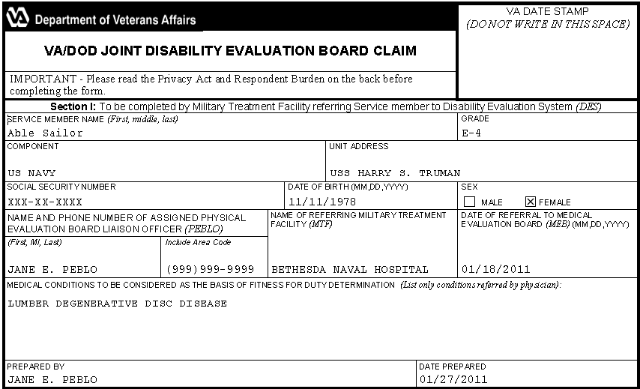

- Ask the Service member questions to complete Section II, shown below:
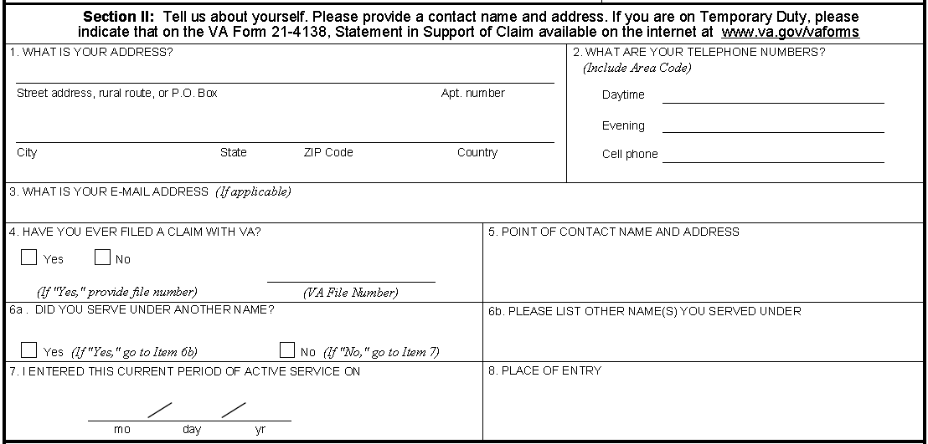

- Ask the Service member questions to complete Section III, shown below:
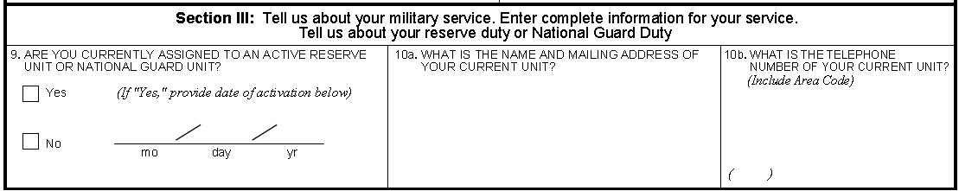
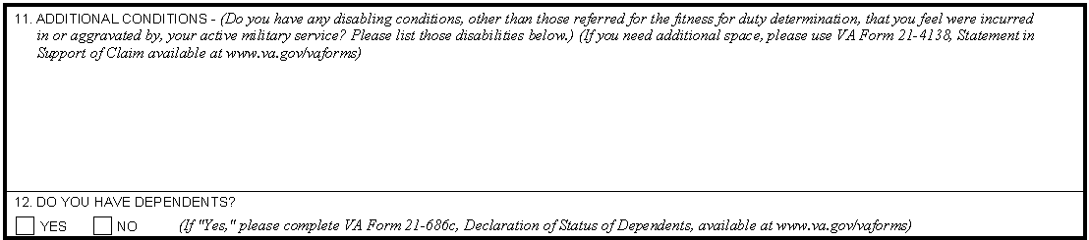

- Ask the Service member questions to complete Sections IV – VI, shown below:
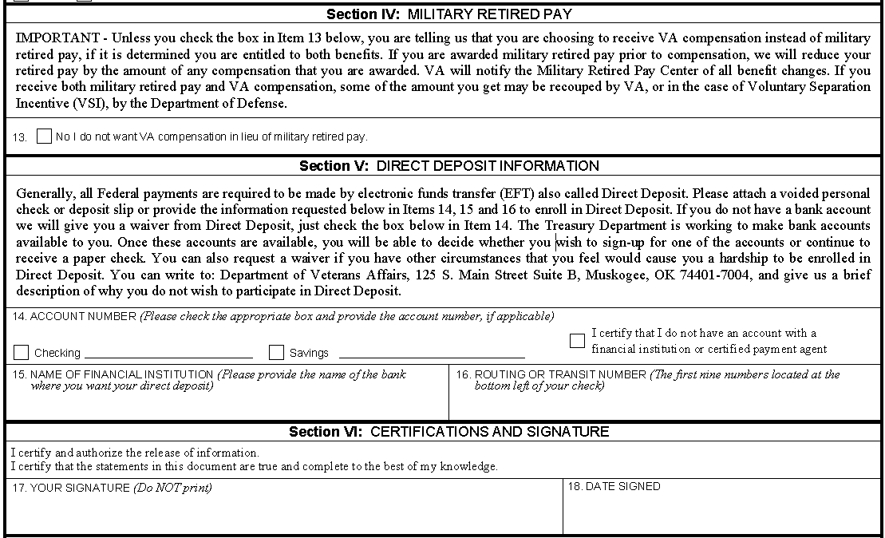

- Ask the Service member questions to complete Section VII, shown below:
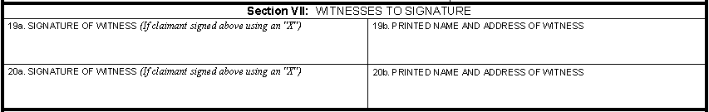
Scenario 1 – Feedback/Questions
- Select “Yes” or “No” for the following questions:

Did the interviewer: | Yes | No
Describe IDES and the MSC’s role in the process?
Ask questions to complete VA Form 21-0819?
Ask the Service member to do a “head to toe check”?
Mention initiating any ancillary benefits?
Provide a copy of IS-1 handbook?
Discuss what happens if additional conditions are claimed at the exit interview?
Obtain a permanent address or next of kin address?
Provide a list of actions that may need to be taken?
Discuss the guidelines for the medical examination(s)?
Provide his/her contact information?
Allow time for any additional questions or comments?
Provide copies of all signed and date-stamped documents?
Provide information about medical examinations - who will schedule and who to contact with questions?

For questions 2 - 4, use the back of this page for additional space, if necessary.
- List examples of positive verbal and non-verbal cues used during the interview. Be ready to discuss your answer.
________________________________________________________________________________________________________________________________________________

- List examples of negative verbal and non-verbal cues used during the interview (if any). Be ready to discuss your answer.
________________________________________________________________________________________________________________________________________________

- What would you change about the interview and why? Be ready to discuss your answer.
________________________________________________________________________________________________________________________________________________
Scenario 2 – Service member/Interviewee
Use the following data to answer the interview questions. Be sure to respond to both verbal and non-verbal cues from the interviewer.

Data/Question | Your Response
Address | Barracks  BAMC, TX
Telephone Number | 999-999-9991
Have you ever filed a claim? | No
Point of contact name and address | Mommy Soldier  333 Lucky Lane  Alexandria, VA 22304
Did you serve under another name? | No
When did you enter this current period of active service? | 09/27/2007
Place of entry | Alexandria, VA
Are you currently assigned to an active reserve unit or national guard unit? | No
Additional conditions | - Tinnitus  - Right knee surgical scar  - Post Traumatic Stress Disorder (PTSD)  - Flat feet
Do you have dependents? | Yes
Sections IV – VII – Select appropriate questions related to this section. | Responses that are appropriate for the questions that are asked.

Scenario 2 – MSC/Interviewer
Before beginning the interview, review all available initial interview references. Remember, the purpose of the initial interview is twofold – to provide information about VA benefits and the IDES process AND to collect the necessary data.
- Review the information provided in Section I, shown below:
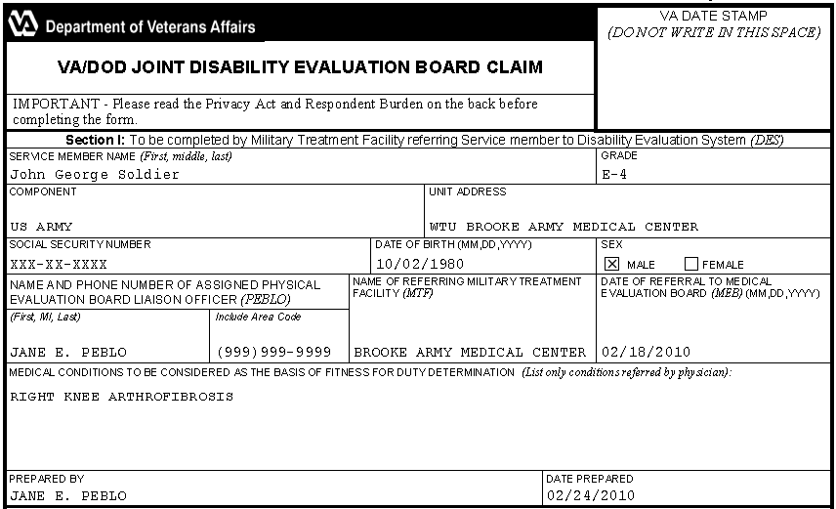

- Ask the Service member questions to complete Section II, shown below:

- Ask the Service member questions to complete Section III, shown below:

- Ask the Service member questions to complete Sections IV – VI, shown below:

- Ask the Service member questions to complete Section VII, shown below:
Scenario 2 – Feedback/Questions
- Select “Yes” or “No” for the following questions.

Did the interviewer: | Yes | No
Describe IDES and the MSC’s role in the process?
Ask questions to complete VA Form 21-0819?
Ask the Service member to do a “head to toe check”?
Mention initiating any ancillary benefits?
Provide a copy of IS-1 handbook?
Discuss what happens if additional conditions are claimed at the exit interview?
Obtain a permanent address or next of kin address?
Provide a list of actions that may need to be taken?
Discuss the guidelines for the medical examination(s)?
Provide his/her contact information?
Allow time for any additional questions or comments?
Provide copies of all signed and date-stamped documents?
Provide information about medical examinations - who will schedule and who to contact with questions?

For questions 2 - 4, use the back of this page for additional space, if necessary.
- List examples of positive verbal and non-verbal cues used during the interview. Be ready to discuss your answer.
________________________________________________________________________________________________________________________________________________

- List examples of negative verbal and non-verbal cues used during the interview (if any). Be ready to discuss your answer.
________________________________________________________________________________________________________________________________________________

- What would you change about the interview and why? Be ready to discuss your answer.
____________________________________________________________________________________________________________________________________________

