**INTRODUCTION TO**

**First NOTICE OF DEATH (FNOD)**

Trainee Handout

**Table of Contents**

Objectives 2

References 2

Topic 1: General Information About Veteran FNOD Processing 3

Topic 2: FNOD Notification Requirements 4

Topic 3: Processing a FNOD 6

Objectives

* Identify an acceptable Veteran Notice of Death (NOD)
* Describe the appropriate FNOD notification
* Explain the steps to process a FNOD

References

* [M21-1, Part III, Subpart ii, 8 First Notice of Death (FNOD) Processing](https://vaww.vrm.km.va.gov/system/templates/selfservice/va_kanew/help/agent/locale/en-US/portal/554400000001034/topic/554400000003083/Chapter-08-First-Notice-of-Death-FNOD-Processing)

Topic 1: General Information About Veteran FNOD Processing

**Purpose of Veteran FNOD Processing**

FNOD processing establishes or updates a Veteran’s Beneficiary Identification and Records Locator Subsystem (BIRLS) record with the date of the Veteran’s death.

It also automatically:

* clears and takes end product (EP) credit on any pending issues for compensation and pension benefits for live Veterans and apportionees that the Department of Veterans Affairs (VA) has not already authorized,
* discontinues any benefits being paid, and
* terminates the power of attorney (POA) of record.

***Note***: The FNOD process will discontinue an award as of the first day of the month of death (MOD).

**Criteria for an Acceptable Veteran NOD**

A NOD is acceptable if it:

* furnishes sufficient information about the Veteran to allow a definite identification of the Veteran’s record, and
* identifies the source of the report of the death.

**There is *no*requirement that a NOD be in writing or originate with the next of kin.**

Examples:

* Notice of a Veteran’s death from the Compensation and Pension Record Interchange (CAPRI) is considered an acceptable NOD.
* A NOD may originate with a funeral home or other third party.
* A report of contact based on a telephone call is an acceptable NOD if the report clearly identifies the Veteran and the caller.
* Any claim for burial and/or death benefits.

You can also use a search engine to locate an obituary or do an SSA Inquiry and upload the evidence to VBMS.

Topic 2: FNOD Notification Requirements

**Notice Requirements Associated With Veteran FNOD Processing**

In most cases, VA must issue notice of proposed adverse action (due process) to a beneficiary before reducing or discontinuing his/her benefits.

[38 CFR 3.103(b)(3)(iii),](http://www.ecfr.gov/cgi-bin/text-idx?SID=e782af30738e30146d8bf621b085fe28&amp;mc=true&amp;node=se38.1.3_1103&amp;rgn=div8) provides an exception to issuing a notice of proposed adverse action for a FNOD:

“In lieu of advance notice and opportunity for a hearing, VA will send a written notice to the beneficiary or his or her fiduciary at the same time it takes an adverse action under the following circumstances:

Evidence reasonably indicates that a beneficiary is deceased. However, in the event that VA has received a death certificate, a terminal hospital report verifying the death of a beneficiary or a claim for VA burial benefits, no notice of termination (contemporaneous or otherwise) will be required.”

Although notice of proposed adverse action is not required, contemporaneous notice of the action taken is required if the NOD was obtained:

* + by way of telephone or personal interview
  + from an Insurance Service Public Contact Representative, or
  + through computer matching with another Federal agency, such as the Social Security Administration (SSA).

An automatic generation and mailing of a contemporaneous notice is sent to the Veteran’s last known address (as it exists in the corporate record), when

* there was a running award of Veteran's benefits, and
* a spouse is of record on the Veteran's award at the time of the FNOD entry, and
* a user selects a *Next of Kin* letter on the MONTH OF DEATH screen.

If the award has been suspended by the SSA Death Master File notification, a user-generated letter must be sent by the claims processor.

**Notifying a Deceased Veteran’s Estate of Benefits to Which Survivors and Others May Be Entitled When There Was a Running Award**

When a VA employee processes the NOD and the Veteran has a running award, the employee is presented with the default option of sending a Next of Kin letter on the MONTH OF DEATH screen. If the employee proceeds with this selection, the Hines Information Technology Center (ITC) generates and mails a letter to the Veteran’s estate containing information about survivor benefits to which the Veteran’s survivors and others may be entitled. These benefits include

* burial benefits
* Survivors Pension
* Dependency and Indemnity Compensation (DIC)
* accrued, and
* educational benefits under 38 U.S.C. Chapter 35.

**Benefits Paid to Surviving Spouses Through the FNOD Process**

After FNOD processing, the following automated benefits can be awarded to eligible surviving spouses based on information contained in the corporate record:

* burial allowance, and
* DIC.

The month of death (MOD) payment is also awarded to eligible surviving spouses after a VA employee completes the MONTH OF DEATH screen that automatically appears after FNOD processing is completed.

Note: An automatically generated letter informs the surviving spouse if the burial allowance, DIC, and/or MOD payment are awarded.

**Issuing a Presidential Memorial Certificate (PMC) During a FNOD**

The Department of Veterans Affairs (VA) may issue a Presidential Memorial Certificate (PMC) to eligible persons to honor the memory and service of

* Veterans who received an honorable or general under honorable conditions discharge, and
* service members who died while on active military service.

The screen to process a PMC will automatically appear during the FNOD process after the Date of Death and Cause of Death have been entered and updated in SHARE.

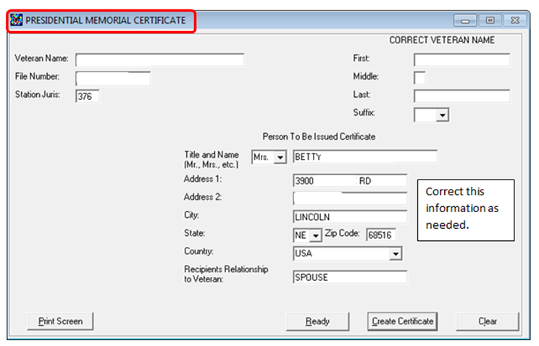

Topic 3: Processing a FNOD

**Step 1: Reviewing the Veteran’s File**

When notice of death is received, the user shall review the source of information and utilize Share to determine what action, if any, is needed.

The user should first identify the proper Veteran’s record via the Search All In List, Corporate Inquiries and BIRLS Inquiry screens via Share. Use extreme care not to add a new BIRLS record until all searches to include name variations have been exhausted.

**Step 2: Verifying Information**

If the Veteran’s record has no date of death, then the user should process a FNOD via Share.

User should also verify the dependency and award information via Share.

* Does the Veteran have a running award?
* Is a dependent spouse listed?
* Is the information in our records conflicting with information provided by informant/claimant?

**Step 3: Veteran FNOD Processing Steps to Include Working With the MOD and Presidential Memorial Certificate Screens**

From the READY screen, select the FNOD command and enter the Veteran’s

* file number
* name, and
* service information if sufficient evidence accompanies the NOD.

If you do not know the Veteran’s file number, enter

* the Veteran’s Social Security number (SSN) or service number, and
* as much additional identifying information as possible to avoid creating duplicate Beneficiary Identification and Records Locator Subsystem (BIRLS) records.

When the system locates an existing BIRLS record for a Veteran, follow the steps in the table below to process a Veteran FNOD.

| **Step** | **Action** |
| --- | --- |
| 1 | Review the system to determine if the Veteran has a running award.   * If *yes*, proceed to the next step. * If *no*, proceed to Step 6. |
| 2 | Review the system to see if there is a *living* spouse of record.   * If *yes*, proceed to the next step. * If *no*, proceed to Step 6. |
| 3 | Perform an SSA INQUIRY to confirm whether the spouse is still living.   * If *yes*, proceed to Step 6. * If *no*, proceed to the next step. |
| 4 | Insert the SSA INQUIRY showing the spouse’s date of death in the electronic claims folder (eFolder). |
| 5 | Enter the spouse’s date of death into VBMS under the Dependents tab, Participant Profile or using the DEPENDENTS command in Share. |
| 6 | Select the FIRST NOTICE OF DEATH process and enter the Veteran's file number or SSN, first name and last name, and click SUBMIT.    Verify that the information on the VETERAN IDENTIFICATION DATA (VID) screen for the Veteran is complete and accurate (if not, modify), and enter the following:     * the date of death for the Veteran * the applicable cause of death in the CAUSE OF DEATH field:   + *UNKNOWN*   + *NATURAL*   + *COMBAT*, or   + *OTHER*, and * a *Y* in the Death in Service field *if* the evidence shows the Veteran died in service.   ***Note***:The Philadelphia Veterans Service Center (VSC) has jurisdiction over all initial in-service death claims per [M21-1, Part III, Subpart ii, 5.B](https://vaww.vrm.km.va.gov/system/templates/selfservice/va_kanew/help/agent/locale/en-US/portal/554400000001034/content/554400000014137/M21-1,-Part-III,-Subpart-ii,-Chapter-5,-Section-B---Jurisdiction-Over-Deceased-Veterans’-Claims-Folders).  The PMC of jurisdiction processes all reopened and supplemental in-service death claims. |
| 7 | Select the UPDATE button on the VID screen. The MONTH OF DEATH (MOD) screen will automatically appear. |
| 8 | Verify that the Veteran’s and spouse’s information on the MOD screen is complete and accurate. If not accurate, modify the information.    Verify whether the Veteran was buried in a State or National cemetery. If so, leave the VET BURIED IN STATE OR NATIONAL CEMETERY box checked.  If the Veteran was not buried in a State or National cemetery, uncheck the VET BURIED IN STATE OR NATIONAL CEMETERY box.    ***Note***:  If you discover you are processing an FNOD under the incorrect Veteran’s record, then do the following:     * select the ABORT MOD ONLY button (this will stop any payment and letters being issued), and * refer the case to adjudication. |
| 9 | Select the applicable notice in the drop-down TYPE OF NOTICE field.   * The following notices will *not* send contemporaneous notice to the Veteran: * *DEATH CERTIFICATE/DEATH NOTICE* * *DEATH BENEFIT CLAIM* * *BURIAL BENEFIT/HEADSTONE/MARKER CLAIM* * *FLAG APPLICATION* * *INTERMENT RECORD* * *NOTICE OF DEATH MESSAGE*, or * *VA INSURANCE CLAIM*. * The following notices *will* send contemporaneous notice to the Veteran: * *TELEPHONE FNOD* * *PERSONAL INTERVIEW FNOD* * *INSURANCE PCR FNOD*, or * *DEATH MATCH*. |
| 10 | If the Veteran had *no* spouse or the spouse’s information is discrepant or incomplete, then check the SEND NEXT OF KIN LETTER box.    ***Note***: If a dependent spouse is not on the Veteran's award, the MOD screen will default to SEND NEXT OF KIN LETTER to the Veteran's last known mailing address.  If the evidence shows that a surviving spouse exists, and it is determined that he or she is entitled to the MOD payment, add the surviving spouse on the MOD screen by selecting ADD NEW SPOUSE check box.  Then complete the surviving spouse's information, including his or her date of birth and SSN. Once complete, select UPDATE. |
| 11 | Select the UPDATE button on the MOD screen.  Confirmation that the MOD has been successfully submitted will appear and select OK.  The PRESIDENTIAL MEMORIAL CERTIFICATE screen will automatically appear.  If the requirements for the Presidential Memorial Certificate have not been met, do not create the Presidential Memorial Certificate.    ***Note***:  In order to release the MOD payment from the MOD screen, it is required that the SSN is available at the time the FNOD is processed.  If the spouse has no SSN, or the SSN is not available while performing the FNOD, the MOD payment cannot be processed and the SEND NEXT OF KIN LETTER is the only option the user can select. |
| 12 | If there is a spouse of record in the system, this information will be pre-populated on the PRESIDENTIAL MEMORIAL CERTIFICATE screen. Verify that the information is complete and accurate. If not, modify the information. |
| 13 | Select the CREATE CERTIFICATE button on the PRESIDENTIAL MEMORIAL CERTIFICATE screen. |
| 14 | Scan the NOD mail into the Veteran’s eFolder.    ***Note***:  If a survivor claim was submitted with the NOD mail, then forward the survivor claim to the appropriate Pension Management Center. |

Note: When entering the veteran’s information on the FNOD screen in SHARE it must match EXACTLY as it is listed in SHARE. First name, middle name, last name. If it doesn’t match exactly, the “Update” button on the next screen will be greyed out and will not let you proceed with processing the FNOD.

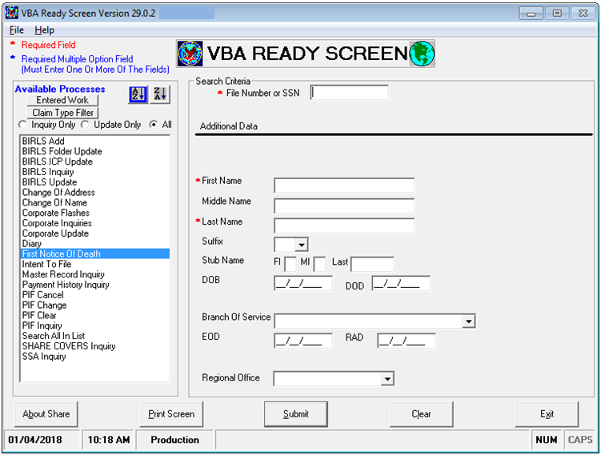

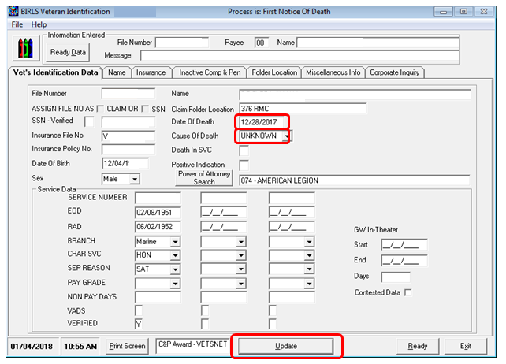

**Issuing a Presidential Memorial Certificate**

