DPRIS WEB
(DEFENSE PERSONNEL RECORDS INFORMATION RETRIEVAL SYSTEM)
Trainee Handout

Table of Contents

Objectives 2
References 3
DPRIS Web and Its Advantages 4
Using DPRIS Web 14
Account Management 24
DPRIS Web Help 27
Practical Exercise 30

Objectives
- Given the instructor’s lecture, class discussions, and practical exercises, you will:
- Become familiar with DPRIS Website,
- Understand your role and responsibilities as a DPRIS Web User,
- Become a registered user of DPRIS Web,
- Become familiar with how you can submit requests and review responses using DPRIS Web,
- Know how to request assistance if needed.

References

DPRIS Website User Guide

DPRIS Web and Its Advantages

The Defense Personnel Records Information Retrieval System (DPRIS) Website provides authorized users with access to digital electronic images to Official Military Personnel Files (OMPF). DPRIS Web is now the primary Internet portal supporting external electronic access by authorized government agencies to any of the military services’ digital OMPF repositories. In the past, information from these records was typically provided via hardcopy, with requests for information and responses to such requests mailed through the U.S. Postal Service. Regardless of the form in which the information is obtained, all users are required by law to safeguard the information contained in the OMPF, as directed by the Privacy Act of 1974 and HIPPA. Some advantages of DPRIS Web over other systems include:

- Through a single secure internet sign-on, allows access to OMPF images contained in the military services’ repositories,

- On average, images are received in less than 48 hours,

- Many images are received within minutes,

- Provides a standard index of all images contained in each of the Services’ OMPF systems,

- Includes a Follow-up Message capability. This enables the user to gain additional information directly from the Services’ action officer (except Army).

VA-SERVICES INTERFACE
Without DPRIS Web, submitting a request to a service’s image repository would be much more cumbersome. If you needed images from the Army’s image repository, for example, you would have to log into the repository, submit the request, and then log out. At some point later on, you would have to go back to see if the request for images has been processed, and then download the images. You would have to do this for each military service’s repository (Army, Navy, Air Force, or Marines). Therefore, you would have to maintain several separate log-ons.
In addition, if one of the Services needed to change some of the programming for their record system, VA would possibly need to change their programming to ensure users would have continued access. VA would have to do this every time a military service changed the programming to their personnel records system. This would result in delays in retrieving images from these repositories, which is not an efficient way to conduct business. This is why the Office of the Under Secretary of Defense, Personnel and Readiness Information Management, sponsored the creation of DPRIS Web.
By having DPRIS Web, you will only need to maintain one login in order to submit requests. When you submit the request, DPRIS Web will route the request to the correct image repository. When the image is available for viewing, DPRIS Web will advise you via email.
dpris WEB standard indexing scheme

Each of the military services manages their OMPF digital records systems differently. Rather than requiring users to learn each indexing system, DPRIS Web has developed a standard index. Each document within the four military services’ OMPF systems has been mapped to the DPRIS Web standard indexing scheme. The complete DPRIS Web Standard OMPF Document Indexing Scheme is depicted below. It shows the four major functional document groupings.
DPRIS Web Standard OMPF Document Indexing Scheme

DPRIS Web Groups and Subgroups
All documents in the digital OMPF inventory can intuitively be assigned to one of the following four major functional groupings:
- Service Computation: Documents that record service entry and exit, length of service, service agreements, appointments, commissions, statements of cumulative service, and other similar time specific data.
- Performance: Documents that record a service member’s performance including evaluations, fitness reports, effectiveness reports, commendatory or derogatory items, and other performance-specific data.
- Professional History: Documents that record promotions, education, training, chronological listings of assignments, qualifications, and similar historical data.
- Administrative: Documents that record administrative actions or personal information regarding dependents, tuition assistance, medical and dental reports, insurance, and other miscellaneous administrative data.
The Consolidated OMPF Document Mapping Report published July 24, 1998 assigned each of the individual document types contained in the Services’ digital OMPF systems (accessible by DPRIS) to one or more of the DPRIS Standard Index subgroups. Building on this, DPRIS can support standard requests and retrieval of OMPF document images from any of the four OMPF systems using a single functional methodology.

Personnel Records Available Through DPRIS
Not every Veteran’s OMPF is available through DPRIS. There are specific dates associated with each branch of service as to when each branch of service began retaining Veterans’ OMPFS into their imaging system.
The Veteran’s OMPF should be available through DPRIS Web if his/her service obligation ended on or after the following dates (M21-1 III.iii.2.I.4.a):
Army: October 1, 2002 (Note*: Army Discharge and Retirement date shown in the DPRIS User Guide under DPRIS Help tab is, October 1, 2002.)
Navy: January 1, 1995
Marine Corp: January 1, 1999
Air Force: October 01, 2004
There are no Coast Guard records currently available in DPRIS.
*Note: For Army service obligations that ended between October 1, 1994, and September 30, 2002, user should make the DPRIS request as indicated per M21-1 III.iii.2.I.4.a. If a negative response is given, user should make a request through NPRC, per M21-1 III.iii.2.B.5.b.
National Guard and Reserves Service
When determining if the OMPF records are available through DPRIS, you must take Reserves and National Guard duty into consideration as well. The easiest way to think about this is the word obligation. It does not matter if the person served on Active Duty, Reserves, National Guard, or in all three. It is when there is no further obligation that matters.
Two Periods of Active Duty Service (before and after DPRIS dates)
Example: The Veteran served in the Marine Corp from 1980 to 1988. The Veteran had no other obligated service after 1988. However, the Veteran reenlisted in 2001 and served on active duty until 2005. Would the Veteran’s OMPF be available through DPRIS Web?
Answer: You would begin your search for the OMPF records by first going to DPRIS. The 2001 through 2005 records will be available through DPRIS. Also, there may be OMPF images from the 1980 through 1988 period because the Veteran served after December 31, 1997. However, if the records from the first period of service were not part of the imaged OMPF (in this case, the 1980 to 1988 period), then you need to try alternate sources for those particular records.
Note: If the OMPF records for this Veteran’s first period of service were not available through DPRIS, than a request for OMPF records should be sent to the National Personnel Records Center (NPRC) through the Personnel Information Exchange System (PIES) application. If the Veteran only served from 1980 to1988, and had no service obligation to, or after, December 31, 1997, then a request for OMPF records should be submitted to NPRC, through the PIES application, and not through DPRIS.

ROLES & RESPONSIBILITIES
As a DPRIS User, there are several roles and responsibilities associated with this assigned duty:
- Initiate secure DPRIS Web follow-up messages.
- Initiate DPRIS Web requests for military personnel records.
- Manage own personal DPRIS Web user account information.
- Access DPRIS Web Information, Help Website Modules, and submit automated User Requests for assistance using the Assistance Form.

THE REGISTRATION PROCESS

The normal means of entry to the Website is through its home page at www.dpris.dod.mil, which includes a public area open to all Internet users. Type in the website address in your browser and hit enter. The DPRIS homepage will be displayed. It is recommended that this website address be added to your Favorites list.
New User Registration Home Page
In order to register as a DPRIS user, click on the “Register Now” button in the New User Registration section of the DPRIS login page.



Privacy and Security Statement
The Privacy and Security Statement page is then displayed. After reading the information presented, select the “Accept” button.
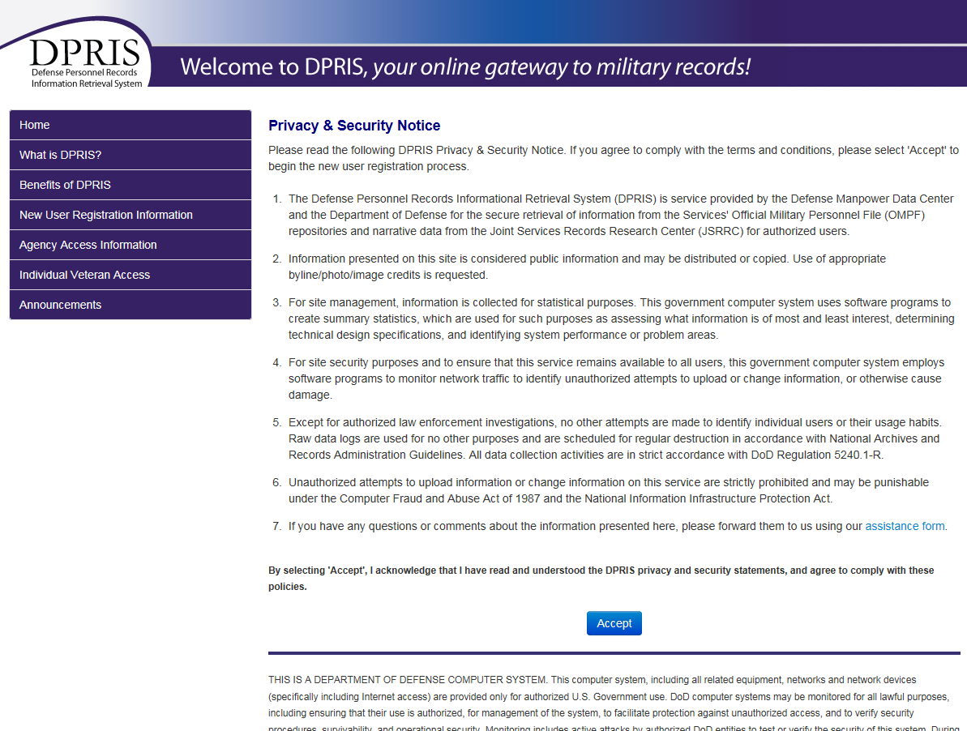

New User Registration Form
The New User Registration Form is displayed after entering the above Agency ID Code provided to you by your Manager or DPRIS point of contact. To insure security, create a password that adheres to the specific DPRIS Password Rules. The Password Rules ensure integrity of the system.
User ID
The Veterans Benefits Administration has determined that all VA regional office users must use their VA email address as their web-based DPRIS User ID. Your VA email address should look similar to this: John.Doe@va.gov. (Your first name, a period, your last name, followed by “@va.gov”.) However, if there are more than one person working for VA with the same first name and last name, your email address may look similar to this: John.Doe1@va.gov (Notice the “1”).
Your VA email address should not begin with items such as ADJ, VSC, or VSD, for example. Your email address after the “@” symbol should not end in “vba.va.gov” or with “.mil,” “.net,” or “.com” for example.
A handout should have been provided to you with details on how to locate your VA email address. It is strongly suggested that you follow the procedures in this handout, and have a printout of your VA email address prior to completing the DPRIS registration form. Once the User ID has been approved, it cannot be changed.
It should be noted that changing RO’s means that the original User ID will be unavailable for use. An easy workaround would be to change capitalization of the first letters of your first and last name. Example: original User ID joe.veteran@va.gov, the new User ID would be Joe.Veteran@va.gov.

Strong Passwords
DPRIS uses an industry standard process for establishing passwords. These rules
are called Strong Passwords. The following rules must be followed:
• Each password must contain:
1. a minimum of fifteen (15) characters
2. at least one uppercase alphabetical character
Example: A B C D E F G
3. at least one (1) lower case alphabetical character
Example: a b c d e f g
4. at least one (1) numeric character
Example: 1 2 3 4 5 6 7 8 9 0
5. at least one (1) of the following special characters:
! @ # $ % & * ( ) - _ = , . : ; ? ‘ “

• Each password must NOT:
1. Contain a space.
Example: US Gov
• The password may not be changed more than once within a 24 hour period.
• The password must be different than the last ten (10) created by the user.
Your password should be something you can easily remember; however, they should not be something associated with you. Do not use a relative’s or your birthday; names of your spouse, children or pets; house numbers or office codes. A common practice is to use passwords similar to the ones found on vanity plates. The following are incomplete passwords and provided only for information. Each DPRIS password must be fifteen characters in length.
DPRIS now allows for VA PIV access. You will still have to register with a user ID and password, but you will now be able to access DPRIS through the VA PIV login
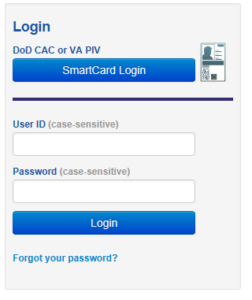
The system will prompt you to change your password every 90 days.
- A new password must be different from the last 10 that you created.
- You will be locked out of the system after three consecutive incorrect password entries.
- Passwords are case sensitive. (Tip: Do not create your password with the “CAPS LOCK” on.)
- Do not record your password in writing.
- Do not share your password or accept another user’s password.
- Do not use something anyone can guess such as names of your spouse, pets, children or words found in a dictionary.
If you forget your password
- You will get a message when you have unsuccessfully entered a password and are about to get locked out. If you get locked out of DPRIS Web, you must go to your User’s Manager. Suggestion: Before you get locked out, click on FORGOT PASSWORD on the DPRIS Web Home Page.
- You will be prompted to enter your User ID and email address.
- If both are entered correctly, you will be asked your secret question. (You selected your secret question when you initially registered.)
- You will be sent an email with your password.
The first time you log-in you must change your password to a new password. You must create a new password following the password rules.

COMPLETING THE REGISTRATION FORM
In order to complete the registration form, the first thing is to input personal information. Input your first name and last name (your middle name is optional). Then, input the User ID from the printout of your VA email address. Input a strong password. Confirm the password by inputting it a second time. Then select a secret question using the drop-down menu. Input the answer to the secret question. The answer to the secret question is case sensitive. Remember how you typed in the answer. Input your VA email address. Again, this can be taken directly from the printout of your VA email address. Finally, input your phone number.

Agency Information
For selecting a manager, select your direct supervisor or coach. When the correct DPRIS manager has been selected, DPRIS automatically populates the fields for name, phone number, email address, the full agency name, and the office code or symbol, if one was entered. These fields are read-only, and cannot be changed by the user when entering information on the registration form. Once the form has been completed, you just need to click on submit.
Note: The manager that was selected will receive an email stating that there is a pending request for access to the DPRIS website. The request will be reviewed. If the request is approved, you will receive an email stating that the account has been approved, and you can simply begin requesting DPRIS OMPF records. If the request is disapproved, you will receive an email stating that the request was disapproved, and an explanation will be provided to you as to why. You will need to complete the entire registration form again if you receive an email that the registration form was rejected because you selected either the incorrect User ID or the wrong manager.
If the reason for the form being rejected was for any other reason, you can go back to the DPRIS Web homepage (below) and click on New User Registration.
Using DPRIS
Log-in using your User ID and Password, or PIV Card. This is the first screen you see once you have successfully logged into DPRIS Web. (DPRIS system warns users of potential issues with the respective branches as shown below.)

DPRIS Response Page
- Responses: Link to the Responses via a list of your requests for which responses have been received from one or more of the military service OMPF systems or from JSRRC. This is the default page that opens after a successful user login. It is often useful to return to this screen from other pages within the secure area of the Website via this link.
- Create Request: Link to the Create Request Form, where you can create a new query for information from a digital OMPF record maintained by one of the military services or submit a request to JSRRC.
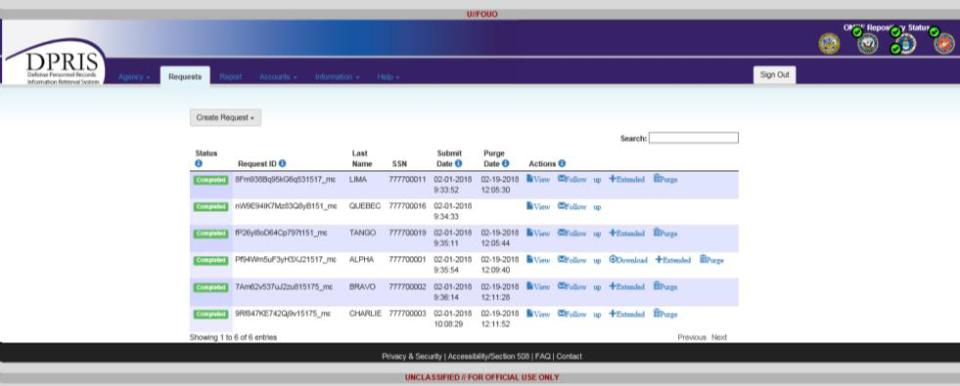

- Reports: Link to a page where a variety of DPRIS reports can be requested. The reports available to you are determined by your access level within DPRIS Web.

- Accounts: Link to a page that allows you to modify your profile or change your password.

- Information: Link to a page with background information about the DPRIS Web initiative and the DPRIS Web Standard Indexing Scheme.
- Help: Link to the DPRIS Web Assistance Form, which allows you to submit suggestions or feedback, or request assistance for using DPRIS Web.
- Request ID: (Request columns): This column lists Request IDs that have received a response from an OMPF repository or JSRRC. If multiple requests are displayed, they are initially sorted by the Request ID. However, multiple requests can be sorted in a different order by clicking on the arrow in either the Social Security Number (SSN) or Date column headings.

- SSN (Request columns): Lists the SSNs associated with each of your active requests.

- Date Received (Request columns): This column lists the date and time each set of images was received by DPRIS Web from the OMPF repository, or information was received from JSRRC.
- Purge Days Left (Request columns): This column displays the date the response will be purged from the DPRIS Web system. After a response is purged, non-image data pertaining to the request remains available via the Reports option, but the response is no longer displayed on the Responses page.
- Extend Purge Date: This link allows you to extend the purge date for a request.
- Purge Requests: This column and link allows you to purge requests prior to the purge date. You check one or more checkboxes associated with the requests to be purged, and then click the Purge Selected Requests link. A popup message will be displayed, requiring you to confirm the purge process. If you click the OK button on the confirmation message, all selected requests will be permanently removed from your list of active requests. If you click the Cancel button on the confirmation message, the selected requests will not be purged and will remain in the users list until the purge date has expired

Viewing Responses

At the DPRIS Requests page click on View for a completed request.

A list of available images received from the Services’ OMPF repository system based on the request will be shown. During prime business hours (0600 to 1400 hours), attempting to display more than 30 files at one time could cause a long wait time and a slowing of the system.

DPRIS system will automatically create a Full PDF of all the files returned for you. To view one file at a time, select the View Image option next to the file name. To generate a PDF of specific files, select the check-boxes next to the desired files and select the Generate PDF button. The system should generate and return this PDF in less than an hour, depending on how many files were selected. An email notification will be sent to the requestor when the self-generated PDF request is completed.

NOTE: Adobe Reader must be installed on the User’s computer in order to display selected files.

Creating Requests in DPRIS

The DPRIS Request page below is displayed once you are logged into DPRIS. From this page, you can create new requests for images from a Service’s OMPF repository or for information from the Joint Services Records Research Center (JSRRC). Click the “Create Request” drop-down button to begin the request process.

Creating an OMPF Request

Clicking on the “New OMPF Request” link from the DPRIS Request Screen will bring you to the OMPF Request Form (Figure 4-5). Fill in the personal information (Full Name and Social Security Number) of the individual you are requesting records for, and select the appropriate OMPF systems(s) to be queried. Make your selections from the document index and click “Submit”. Note: Depending upon your Agency and/or access granted by your DPRIS Manager, all options displayed here may or may not be available to you as a User within DPRIS.
OMPF Request Form

Creating a JSRRC Request
If authorized to make JSRRC requests, click the “New JSRRC Request” link. The JSRRC Request Form below will be displayed. Fill in the personal information (full name and Social Security Number) of the individual you are requesting records for, and select the appropriate Military Branch, Reason Code, and Station Code. A JSRRC request must contain the information for at least one of the Post-Traumatic Stress Disorder (PTSD) Stressor codes or the Agent Orange code. It can contain up to four codes if needed. To enter the request code information, select one of the request code radio buttons and then click the “Continue” link.

JSRRC Request Form
If one of the PTSD Stressor codes was selected, the PTSD Stressor form below will be displayed. Enter the mandatory information on this form and click the “Continue” button to return to the main JSRRC Request Form.

If the Agent Orange code was selected, the Agent Orange Claim form will be displayed. Once all of the information is entered, click the “Continue” link to return to the main JSRRC Request Form.

WEB-BASED DPRIS REPORTS

To navigate to the Reports page, click on the “Report” tab. Access to different types of Web-based reports will be found on this page. NOTE: Report availability is based on user roles and access permissions determined at the manager level. Typically, only Super Users and Managers will have access to these reports.

Reports Page

Types of Reports
The collection and organization of data into reports, tailored toward different users and administrators, represents an important DPRIS Web capability. Examples of the type of management information that should be available are: the total number of OMPF queries made by the external customer base; the types of information requested; and a listing of the documents or exception status returned in response to these queries. DPRIS Web has been designed to routinely collect such data and facilitate on-demand generation of detailed reports about DPRIS Web OMPF records management system usage.

Account Management

Managers have the responsibility of managing DPRIS accounts for their subordinate Users through the DPRIS Web site. The roles associated with this activity are assigned as part of the User approval process and are recognized by the DPRIS system when a User logs in. Managers are authorized to approve new User registration requests, change the document assignment and authority role of their active subordinate Users, and temporarily and permanently deactivate subordinate Users. The ability to manage other User accounts is available only to Users in a managerial role.
From the DPRIS View Responses/Default Screen, click on the “Accounts” tab for options to navigate for Accounts Management.

Account Management

Changing Your Account Profile

As a User, you can make changes to your account profile, such as modifying your e-mail address. Click on the “My Account” link and make the appropriate changes on the “My Account” page. Click “Submit” once you have made your changes. NOTE: Your User ID cannot be altered for any reason. If a new User ID is required, your old account needs to be deactivated by your Manager. You must then go through the registration process again with the new User ID.

My Account Profile

Changing Your Password
From the “Accounts” tab select Password to change your password. Be sure to adhere to the aforementioned strong password rules when making this change. Enter and confirm a new password then click “Submit”.

Changing Your Password

Information Page

The Information page (shown below) provides historical and background information on DPRIS Web and the OMPF environment.
Information Page

DPRIS Help

Click on the “Help” link to display the Help page.
DPRIS Assistance Form

Assistance Form

A Manager is the best resource to assist in helping a User with any questions. If the Manager is unable to fix the issue, navigate to the DPRIS Assistance Form. All Assistance Form comments are reviewed by a DPRIS functional analyst or a technical analyst. An acknowledgement of receipt and initial disposition action for suggestions, complaints, or problems/questions that do not require immediate assistance will be provided by e-mail within five working days. If your problem / question is more severe, you will receive a response by e-mail within one business day.

Frequently Asked Questions Page
Answers to common questions can be found on the Frequently Asked Questions page.

Practical Exercise
1. List two advantages of DPRIS Web over other systems.

2. What are the four major functional document groupings in the DPRIS Web Standard Indexing Scheme?

3. If a Veteran served in the Navy from August 16, 1992 to September 23, 1993, will his Official Military Personnel File (OMPF) be available through DPRIS Web?

4. Name at least two roles or responsibilities of a DPRIS Web user.

5. The Veterans Benefits Administration has determined that all VA Regional Office users shall use their _______________ as their web-based DPRIS Web User ID.

6. A strong password must contain a minimum of one numeric character, but the password is not case-sensitive. True or False.

7. When completing the registration form as a user, which person do you select to be your DPRIS Web manager?

8. When submitting a JSRRC request, what information is mandatory for a proper request to be sent?

9. What level determines a user’s role and access permissions to DPRIS Reports?
- VSR level
- RVSR level
- DRO level
- Manager level

10. What should the DPRIS Web Help Desk Assistance Form be used for?

- To submit suggestions to improve the DPRIS Web user interface and functional design.
- To report deficiencies and problems encountered with the performance of DPRIS Web.
- To request technical or operational assistance.
- All of the above.

