Date of Claim (DOC)

Instructor Lesson Plan

Time Required: 1.25 Hours

**Table of Contents**

Lesson Description 2

Introduction to Date of Claim 4

Overview of Date of Claim 6

Practical Exercise 9

|  |  |
| --- | --- |
| Lesson Description | |
| The information below provides the instructor with an overview of the lesson and the materials that are required to effectively present this instruction. | |
| TMS # | 1279927 |
| Prerequisites | Prior to this lesson, the Claims Assistant (CA) should have completed TMS 61975. |
| target audience | The target audience for this lesson are CAs.  Although this lesson is targeted to teach the CAit may be taught to other VA personnel as mandatory or refresher type training. |
| Time Required | 1.25 hours |
| Materials/ TRAINING AIDS | Lesson materials:   * Date of Claim PowerPoint Presentation * Date of Claim Trainee Handout * Date of Claim Answer Key |
| Training Area/Tools | The following are required to ensure the trainees are able to meet the lesson objectives:   * Classroom or private area suitable for participatory discussions * Seating, writing materials, and writing surfaces for trainee note taking and participation * Handouts, which include a practical exercise * Large writing surface (easel pad, chalkboard, dry erase board, overhead projector, etc.) with appropriate writing materials * Computer with PowerPoint software to present the lesson material   Trainees require access to the following tools:   * VA TMS to complete the assessment * VBA Learning Catalog to access training materials |
| Pre-Planning | * Become familiar with all training materials by reading the Instructor Lesson Plan while simultaneously reviewing the corresponding PowerPoint slides. This will provide you the opportunity to see the connection between the Lesson Plan and the slides, which will allow for a more structured presentation during the training session. * Become familiar with the content of the trainee handouts and their association to the Lesson Plan. * Practice is the best guarantee of providing a quality presentation. At a minimum, do a complete walkthrough of the presentation to practice coordination between this Lesson Plan, the trainee handouts, and the PowerPoint slides and ensure your timing is on track with the length of the lesson. * Ensure that there are copies of all handouts before the training session. * When required, reserve the training room. * Arrange for equipment such as flip charts, an overhead projector, and any other equipment (as needed). * Talk to people in your office who are most familiar with this topic to collect experiences that you can include as examples in the lesson. * This lesson plan belongs to you. Feel free to highlight headings, key phrases, or other information to help the instruction flow smoothly. Feel free to add any notes or information that you need in the margins. |
| Training Day | * Arrive as early as possible to ensure access to the facility and computers. * Become familiar with the location of restrooms and other facilities that the trainees will require. * Test the computer and projector to ensure they are working properly. * Before class begins, open the PowerPoint presentation to the first slide. This will help to ensure the presentation is functioning properly. * Make sure that a whiteboard or flip chart and the associated markers are available. * The instructor completes a roll call attendance sheet or provides a sign-in sheet to the students. The attendance records are forwarded to the Regional Office Training Managers. |

|  |  |  |
| --- | --- | --- |
| Introduction to Date of Claim | | |
| INSTRUCTOR INTRODUCTION | | Complete the following:   * Introduce yourself * Orient learners to the facilities * Ensure that all learners have the required handouts |
| time required | | 0.25 hours |
| Purpose of Lesson  Explain the following: | | This lesson is intended to provide the Claims Assistant (CA) or other employee with training to determine the date of claim. This lesson will contain discussions and exercises that will allow you to gain a better understanding of:   * Determine the correct VA date of claim |
| Lesson Objectives  **Discuss the following:**  Slide 2  Handout 2 | In order to accomplish the purpose of this lesson, the CA will be required to accomplish the following lesson objectives.  The CA will be able to:   * Identify and understand how to properly determine the date of claim | |
| Explain the following: | Each learning objective is covered in the associated topic. At the conclusion of the lesson, the learning objectives will be reviewed. | |
| Motivation | Inform trainees of the enormous impact that proper date of claim has on the timeliness of Veteran’s claims. Inform trainees that properly identifying the earliest DOC, ensures that the Veteran receives the proper entitlement. Stress to trainees that assigning proper EP codes are crucial to workload management for the Regional Office. | |
|  |  | |
| References  Slides 3  Handout 3 | Explain where these references are located in the workplace.   * 38 CFR 3.1(r), Definitions, Date of Receipt * 38 CFR 3.155, How to File a Clam * M21-1Part III, Subpart ii, Chapter 2, Section B, Claims for Disability Compensation * M21-1Part III, Subpart i, Chapter 2, Section A, Introduction to Pre-Discharged claims * M21-1Part III, Subpart i, Chapter 4, Section C, Date of Stamp for Claims Submitted Electronically * M21-1 Part III, Subpart ii, Chapter 1, Section C, Handling Documents Processed without a Date Stamp * M21- 4 Appendix B, Section I.C, General Principles * M21- 4 Appendix B, Section II, End Products | |

|  |  |  |
| --- | --- | --- |
| Overview of Date of Claim | | |
| Introduction | This topic will allow the trainee to understand the process of identifying a claim and understand what is the date of claim. In addition, the trainee will be able to determine the differences in the origins and properly establish the date of claim. | |
| Time Required | 0.25 hours | |
| OBJECTIVES/ Teaching Points | Topic objectives:   * Given 38 CFR, Compensation Pension Knowledgement Management (CPKM) and the trainee handout packet as references, establish a date of claim with 85% accuracy.   The following topic teaching points support the topic objectives:   * Date of Receipt Stamp * eBenefits * BDD & Quick Start | |
| Date of Receipt Stamp  Slides 4 - 5  Handout 4 | Stress to trainees the importance of establishing the earliest date of claim for Veteran’s claims  The Department of Veterans Affairs (VA) requires a date-of-receipt stamp on *all* of the following information received by the regional office (RO) mailroom:   * Claims * Applications, and * Associated evidence.   Inform trainees that Veterans applications, and associated evidence may be received with several date stamps on it.  Stress to trainees that the DOC will be the earliest date a VA facility actually received the claim.  Screen and place incoming mail under electronic control within seven  calendar days of receipt in the division  ***Important:***  This date should be identified from the earliest VA date  stamp. Date stamps can be from any VA entity, including but not  limited to, Regional Office (RO), Pension Management Center (PMC),  Veterans Affairs Medical Center (VAMC) or Records Management  Center (RMC), VA Claims Intake Centers or VDC forms received  through eBenefits.  ***Note:*** Date stamps from Veterans Service Organizations are not  considered official date stamps for DOC purposes. | |
| Examples of VA Date of Receipt stamps  Slide 6  Handling Documents Processed without a Date Stamp  Slide 7  eBenefits  Slide 8  Handout 5  BDD  Slide 9  Handout 5 | The power point slide displays different examples of VA Date of Receipt stamps that can be used to determine the VA Date of Claim.  A claim can be received through VDC in eBenefits. The online electronic system will time stamp the application and display the claim was submitted electronically.  Use the guidance in the table below when attempting to determine the date the VA received a document processed without a date stamp.   | **If receipt of the document by VA is determined to be ...** | **Then ...** | | --- | --- | | the current date | stamp the document with an official date stamp. | | prior to the current date | hand-write the date of receipt on the document. | | unknown | * hand-write the best estimate for the date of receipt, and * identify it as an estimate on the document. |   ***Important***:   * All hand-written annotations ***must*** include the   + RO number   + RO name   + employees signature, and   + current date.   It is important to review the form to determine the correct VA Date of Claim. If the VA Date Stamp field reads: “Application Submitted” and the date displays, you should use that date for the VA Date of Claim.  If the form reads, “ Application Initiated” and a date is displayed in the VA Date Stamp field, review the date in the top left corner to determine the date the form was submitted electronically. Use the top left hand corner date to establish the VA Date of Claim.  The 2 examples in the powerpoint display the differences between Application Submitted and Application Iniated in the VA Date Stamp field. The Claims Assistants should pay attention to the top left corner to determine if a date displays.  Inform trainees Benefits Delivery at Discharge (BDD) claims are exceptions to the rule. Although service members can file their claim for disability prior to their discharge date, their claim cannot be promulgated and the service member cannot start receiving compensation payments until after their discharge from service.  The date of claim for a Pre-Discharge Claim is the first day following the anticipated date of release from Active Duty (RAD), regardless of the date VA received the claim.  Therefore, the DOC for all BDD Claims will be the first day after the service member is discharged. | |
| EP 930  *Slide 10*  *Handout 6* | EP 930 applies to reviews and issues where no other EP is applicable and the appropriate EP credit has already been taken.  EP 930 is applicable to the following:   * Missed issues or prematurely cleared End Products, or * Correction of previous erroneous actions identified during a quality review.   Most commonly, EP 930 is used for missed issues not addressed by adjudication or rating or prematurely cleared end products.  The date of claim for EP 930 used in correcting an error is the date of the underlying EP was called for the error.  Note: Additional course regarding EP 930 is available. | |
|  |  | |
| Practical Exercise | |  | |
| Time Required | 0.5 hours  Have the trainees complete the exercise independently or in small groups.  Ask if there are any questions about the information presented in the exercise, and then proceed to the Review. |
| EXERCISE | The purpose of this exercise is to assist students in recognizing authorized date of claim stamps (DOC), and aid them in determining the correct DOC. For this exercise, the instructor display the examples provided in the Hand Out and request the students provide the VA Date of Claim.  VA Form 21-526EZ, Application for Disability Compensation and Related Compensation Benefits  VA Form 21-526c, Pre-Discharge Compensation Claim (BDD or Quick Start Claims) |

In all examples, there are no other date stamps on the document other than those displayed.

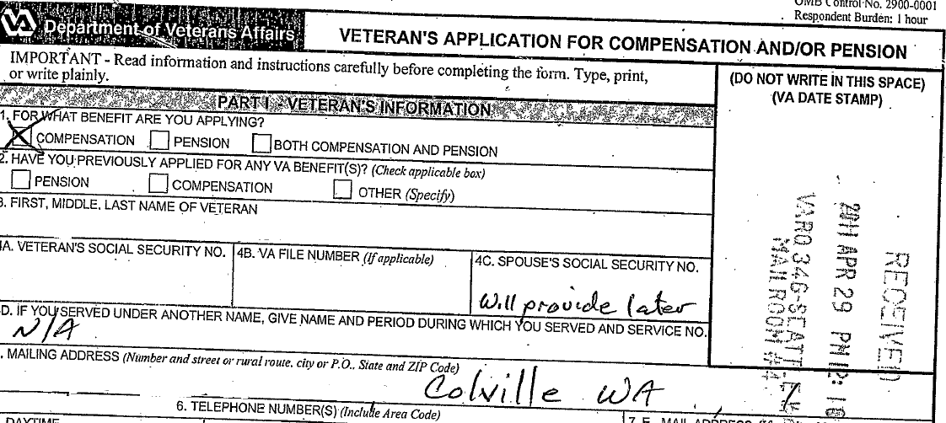

Example #1

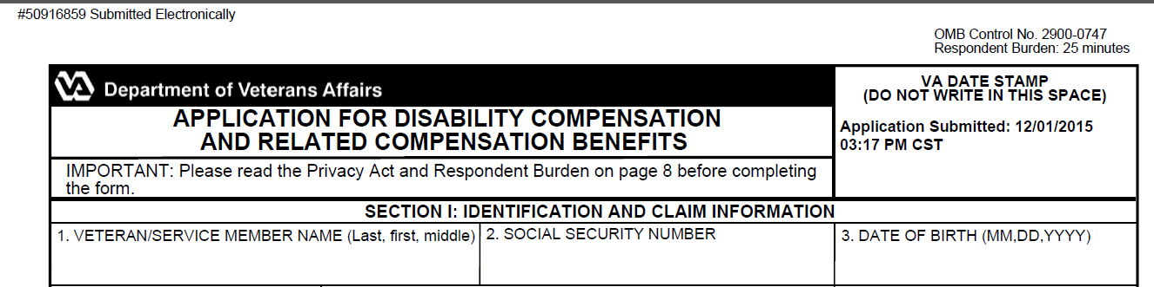

Example #2

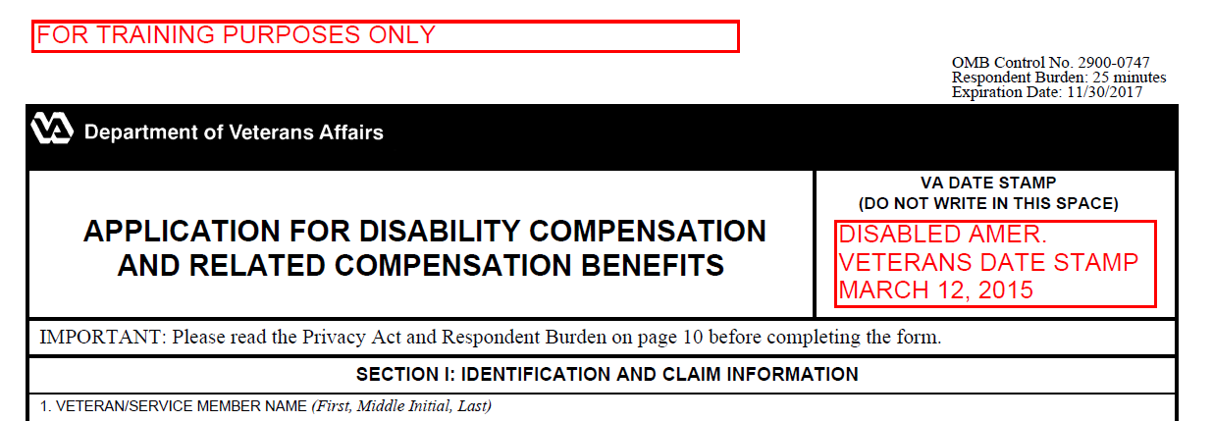

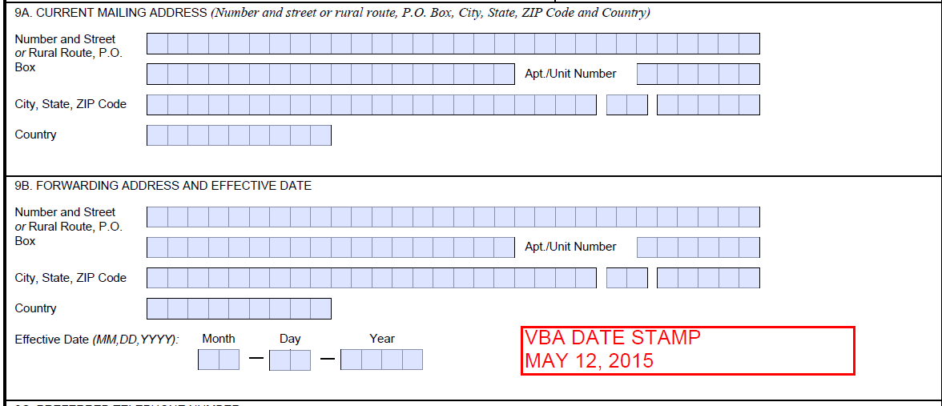

Example #3

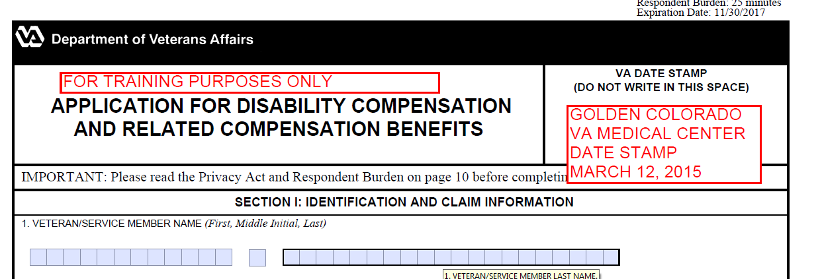

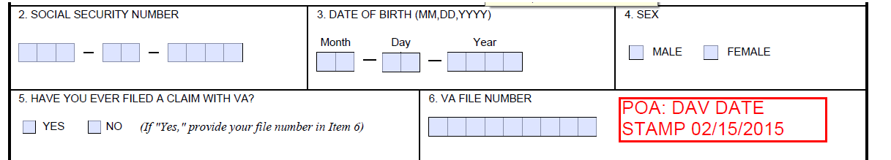

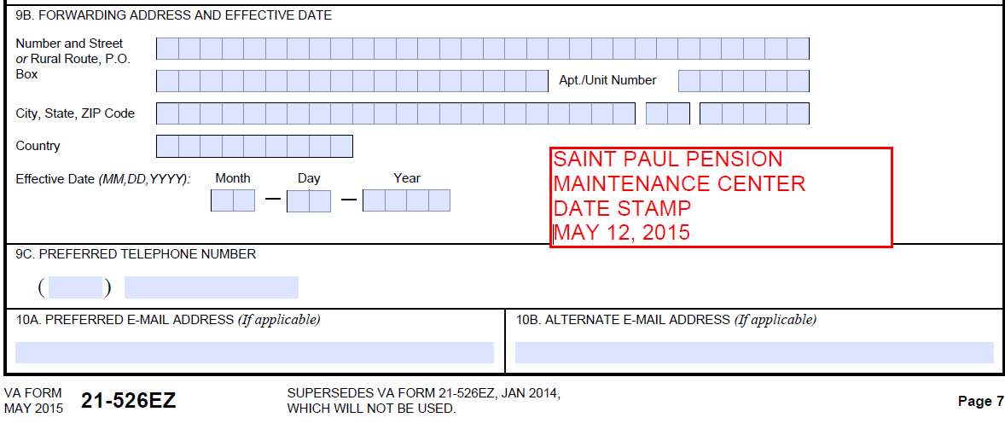

Example #4

Mail received by VA Claims Intake Center

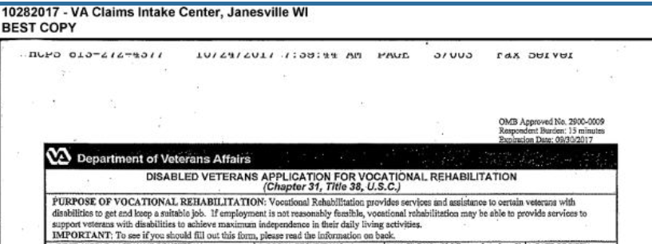

Example 5

|  |  |
| --- | --- |
| Lesson Review, Assessment, and Wrap-up | |
| Introduction  Discuss the following: | The Date of Claim lesson is complete.  Review each lesson objective and ask the trainees for any questions or comments. |
| Time Required | 0.25 hours |
| Lesson Objectives | You have completed the Date of Claim lesson.  The trainee should be able to:   * Discuss how to properly determine the date of claim for a variety of claims. |
| Assessment | Remind the trainees to complete the online assessment in TMS to receive credit for completion of the course.  The assessment will allow the participants to demonstrate their understanding of the information presented in this lesson. |