Date of Claim
Trainee Handout
Table of Contents

Objectives 2
References 3
Overview of Date of Claim 4
Practical Exercise 6

Objectives
In order to accomplish the purpose of this lesson, the CA will be required to accomplish the following lesson objectives.

The CA will be able to:
- Discuss how to properly determine the date of claim

References
Explain where these references are located in the workplace.
- 38 CFR 3.1(r), Definitions, Date of Receipt
- 38 CFR 3.155, How to File a Clam
- M21-1Part III, Subpart ii, Chapter 2, Section B, Claims for Disability Compensation
- M21-1Part III, Subpart i, Chapter 2, Section A, Introduction to Pre-Discharged claims
- M21-1Part III, Subpart i, Chapter 4, Section C, Date of Stamp for Claims Submitted Electronically
- M21-1 Part III, Subpart ii, Chapter 1, Section C, Handling Documents Processed without a Date Stamp
- M21- 4 Appendix B, Section I.C, General Principles
- M21- 4 Appendix B, Section II, End Products

Overview of Date of Claim
This topic will teach you how to determine the proper date of claim. In addition, you will be able to determine the differences in the origins and properly establish the date of claim.

Date of Receipt Stamp  Slides 4 - 5 | The Department of Veterans Affairs (VA) requires a date-of-receipt stamp on all of the following information received by the regional office (RO) mailroom:  - Claims  - Applications, and  - Associated evidence.  Special note: please review your forms because applications, and associated evidence may be received with several date stamps through the documents.  The DOC will be the earliest date a VA facility actually received the claim.  Important: For first or third party information, the earliest date the  information is received in any Department of Veterans Affairs facility.  This date should be identified from the earliest VA date stamp. Date  stamps can be from any VA entity, including but not limited to,  Regional Office (RO), Pension Management Center (PMC), Veterans  Affairs Medical Center (VAMC), Records Management Center  (RMC), or a contracted scanning vendor.  Note: Date stamps from Veterans Service Organizations are not  considered official date stamps for DOC purposes.
Examples of VA Date of Receipt  Slide 6  Handling Documents Processed without a Date Stamp  Slide 7  eBenefits  VDC  Slide 8  BDD  Slide 9  End Product 930  Slide 10 | A VA Date of Receipt stamp can be electronically generated by the Veterans Claims Intake Center or applied through the Vonapp Direct Connect application within eBenefits. These are accepted as VA Dates of Receipt for the VA Date of Claim.  Faxed documents incoming to the VA, may show a VA Date of Receipt at the top of the document. These documents should be reviewed to determine the earliest VA Date of Claim.  Prior to the electronic date stamps, a date stamp was manually stamped on the incoming paper documents. In some instances a manual date stamp is still applied. It is important to be able to recognize both the electronic date stamps and the manual date stamps.  Use the guidance in the table below when attempting to determine the date the VA received a document processed without a date stamp.  Important:  - All hand-written annotations must include the  - RO number  - RO name  - employees signature, and  - current date.  A claim can be received through VDC in eBenefits. The online electronic system will time stamp the application and display the claim was submitted electronically.  It is important to review the form to determine the correct VA Date of Claim. If the VA Date Stamp field reads: “Application Submitted” and the date displays, you should use that date for the VA Date of Claim.  If the form reads, “ Application Initiated” and a date is displayed in the VA Date Stamp field, review the date in the top left corner to determine the date the form was submitted electronically. Use the top left hand corner date to establish the VA Date of Claim.  Benefits Delivery at Discharge (BDD) claims are exceptions to the rule. Although service members can file their claim for disability prior to their discharge date, their claim cannot be promulgated and the service member cannot start receiving compensation payments until after their discharge from service.  The date of claim for a Pre-Discharge Claim is the first day following the anticipated date of release from Active Duty (RAD), regardless of the date VA received the claim.  Therefore, the DOC for all BDD Claims will be the first day after the service member is discharged.  EP 930 applies to reviews and issues where no other EP is applicable and the appropriate EP credit has already been taken.  EP 930 is applicable to the following:  - Missed issues or prematurely cleared End Products, or  - Correction of previous erroneous actions identified during a quality review.  Most commonly, EP 930 is used for missed issues not addressed by adjudication or rating or prematurely cleared end products.  The date of claim for EP 930 used in correcting an error is the date of the underlying EP that was called for the error.  Note: Additional course regarding EP 930 is available.
  If receipt of the document by VA is determined to be ... | Then ...
  the current date | stamp the document with an official date stamp.
  prior to the current date | hand-write the date of receipt on the document.
  unknown | - hand-write the best estimate for the date of receipt, and  - identify it as an estimate on the document.
Practical Exercise

Time Required | 0.5 hours  Coomplete the exercise independently or in small groups.
EXERCISE | The purpose of this exercise is to review the enclosed forms and determine the correct date of claim (DOC). You will be provided with five examples, and you will review and determine the correct DOC.

In all examples, there are no other date stamps on the document other than those displayed.

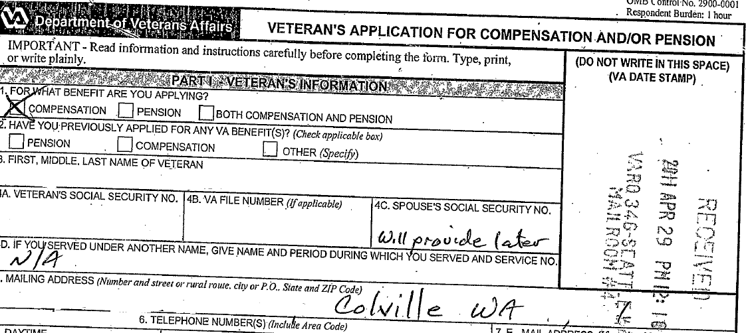

Example #1

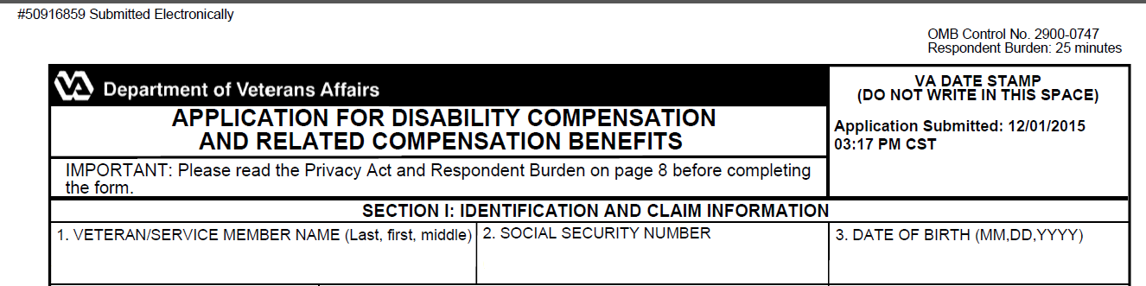

Example #2

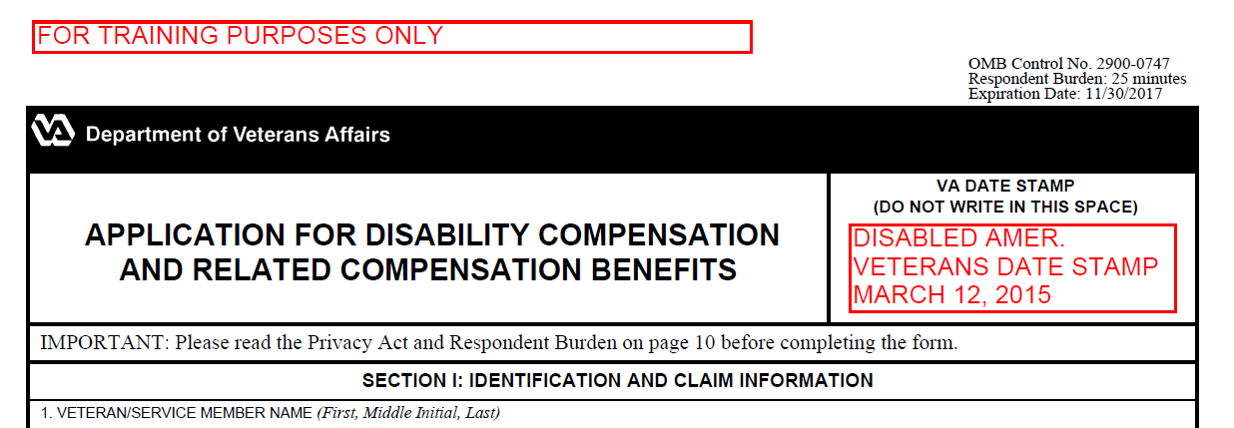
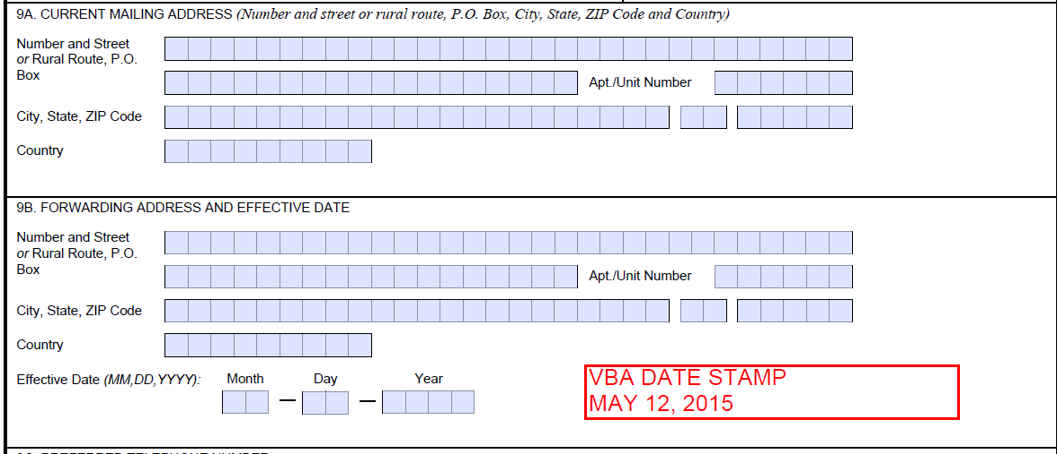

Example #3

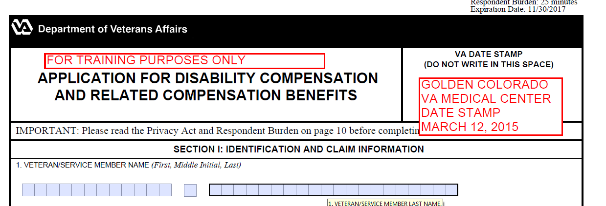
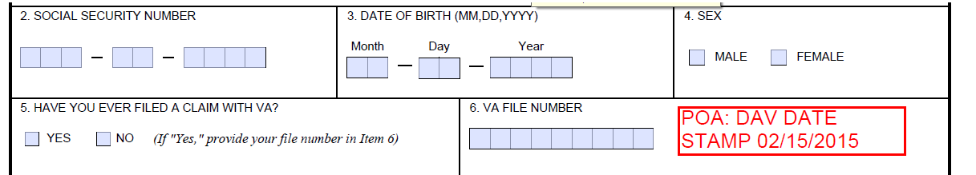
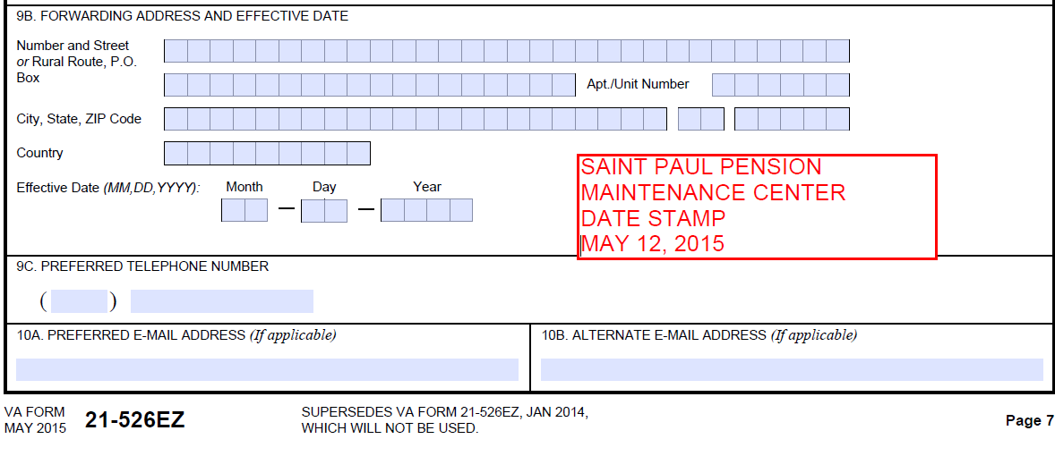

Example #4

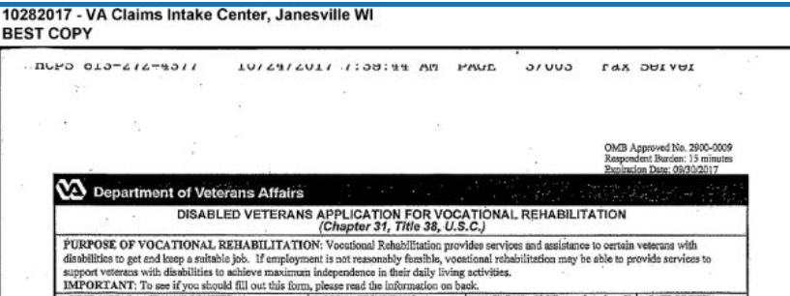

Example #5

