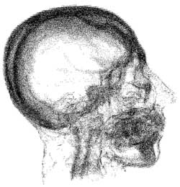
Making a Determination of Insanity
mental defect - mental retardation, brain damage or other biological dysfunction that is associated with distress or disability causing symptoms or impairment in at least one important area of an individual's functioning

psychopathic – an antisocial personality disorder occurring after age 18, characterized by a pervasive pattern of disregard for, and violation of, the rights of others

basic condition – a normal mode or operation

psychosis - a severe mental disorder, with or without organic damage, characterized by derangement of personality and loss of contact with reality and causing deterioration of normal social functioning.

Was the Veteran diagnosed with a mental defect or found constitutionally psychopathic prior to committing the offense?

Yes

No
The Veteran’s mental state at the time of the offense does not meet the conditions for a determination of insanity.
Prepare a determination that the veteran was not insane at the time of the offense.
Is there evidence that a psychosis was engrafted on the basic condition at the time of the offense?

The Veteran’s pre-existing mental state does not meet the conditions for a determination of insanity.
Prepare a determination that the Veteran was not insane at the time of the offense.

Yes

No

Yes

No
Prepare a determination that the Veteran was insane at the time of the offense.

Prepare a determination that the Veteran was not insane at the time of the offense.

Did the psychosis cause a (more or less) prolonged deviation from the Veteran’s “normal” behavior, or

has it interfered with “the peace of society,” or

has the Veteran so departed (become antisocial) from the accepted standards of the community to which, by birth and education, he or she belongs as to lack the adaptability to make further adjustment to the social customs of the community in which he or she resides?

