COMPLICATIONS OF DIABETES

Trainee Handout

**Table of Contents**

Objectives 3

References 3

Topic 1: General Rating Considerations 4

Topic 2: Microvascular Complications 5

Topic 3: Macrovascular Complications 9

Topic 4: Diabetes complications, nos 12

Practical Exercise 16

Objectives

* review considerations for rating diabetic complications under diagnostic code 7913
* define the term “microvascular”
* list the three microvascular disabilities that are associated with diabetes mellitus
* define the term “macrovascular”
* list the four macrovascular disabilities that are associated with diabetes mellitus
* list five complications of diabetes mellitus that are not specifically associated with the microvascular or macrovascular disease process
* describe the symptoms of each disability, tests that are performed to diagnose/evaluate them, and
* state types of Special Monthly Compensation considerations with complication of diabetes

References

* [38 CFR 3.307 Presumptive service connection for chronic, tropical or prisoner-of-war related disease, or disease associated with exposure to certain herbicide agents; wartime and service on or after January 1, 1947](https://vaww.compensation.pension.km.va.gov/system/templates/selfservice/va_ka/portal.html?portalid=554400000001034)
* [38 CFR 3.309 Disease subject to presumptive service connection](https://vaww.compensation.pension.km.va.gov/system/templates/selfservice/va_ka/portal.html?portalid=554400000001034)
* [38 CFR 4.26 Bilateral factor](http://vbaw.vba.va.gov/bl/21/publicat/Regs/Part4/4_26.htm)
* [38 CFR 4.71a Schedule of Ratings-Musculoskeletal System](http://vbaw.vba.va.gov/bl/21/publicat/Regs/Part4/4_71a.htmhttp:/vbaw.vba.va.gov/bl/21/publicat/Regs/Part4/4_71a.htm)
* [39 CFR 4.79 Schedule of Ratings—Eye](http://vbaw.vba.va.gov/bl/21/publicat/Regs/Part4/4_79.htm)
* [38 CFR 4.87 Schedule of Ratings - Ear](http://vbaw.vba.va.gov/bl/21/publicat/Regs/Part4/4_87.htm)
* [4.104 Schedule of Ratings—Cardiovascular system](http://vbaw.vba.va.gov/bl/21/publicat/Regs/Part4/4_104.htm)
* [38 CFR 4.114 Schedule of Ratings—Digestive System](http://vbaw.vba.va.gov/bl/21/publicat/Regs/Part4/4_114.htm)
* [38 CFR 4.115a Ratings of the genitourinary system-dysfunctions](http://vbaw.vba.va.gov/bl/21/publicat/Regs/Part4/4_115a.htm)
* [38 CFR 4.115b Ratings of the genitourinary system-diagnoses](http://vbaw.vba.va.gov/bl/21/publicat/Regs/Part4/4_115b.htm)
* [38 CFR 4.116 Schedule of ratings-gynecological conditions and disorders of the breast](http://vbaw.vba.va.gov/bl/21/publicat/Regs/Part4/4_116.htm)
* [38 CFR 4.118 Schedule of ratings-skin](http://vbaw.vba.va.gov/bl/21/publicat/Regs/Part4/4_118.htm)
* [38 CFR 4.119 Schedule of ratings-endocrine system](http://vbaw.vba.va.gov/bl/21/publicat/Regs/Part4/4_119.htm)
* [38 CFR 4.124a Schedule of ratings-neurological conditions and convulsive disorders](http://vbaw.vba.va.gov/bl/21/publicat/Regs/Part4/4_124a.htm)
* [38 CFR 4.130 Schedule of ratings-mental disorders](http://vbaw.vba.va.gov/bl/21/publicat/Regs/Part4/4_130.htm)
* [M21-1, Part III. Subpart iv.4.B - Conditions of the Organs of Special Sense](https://vaww.compensation.pension.km.va.gov/system/templates/selfservice/va_ka/)
* [M21-1, Part III. Subpart iv.4.E - Cardiovascular System Conditions](https://vaww.compensation.pension.km.va.gov/system/templates/selfservice/va_ka/portal.html?portalid=554400000001034)
* [M21-1, Part III. Subpart iv.4.F - Endocrine Conditions](https://vaww.compensation.pension.km.va.gov/system/templates/selfservice/va_ka/portal.html?portalid=554400000001034)
* [M21-1, Part III.Subpart iv.4.G.4.b – Guidance on Evaluating Completely Sensory Peripheral Nerve Impairment](https://vaww.compensation.pension.km.va.gov/system/templates/selfservice/va_ka/#!agent/portal/554400000001034/article/554400000014200/M21-1-Part-III-Subpart-iv-Chapter-4)
* [III.iv.4.I.3.s.  Limits on Separate Evaluation of Nephropathy and Hypertension](https://vaww.compensation.pension.km.va.gov/system/templates/selfservice/va_ka/)
* [M21-1, Part III. Subpart iv.6.B.3 - Qualifying Disabilities Under 38 CFR 3.383](https://vaww.compensation.pension.km.va.gov/system/templates/selfservice/va_ka/portal.html?portalid=554400000001034)
* [M21-1, Part IV. Subpart ii.2.H - Special Monthly Compensation (SMC)](https://vaww.compensation.pension.km.va.gov/system/templates/selfservice/va_ka/portal.html?portalid=554400000001034)

Topic 1: General Rating Considerations

The chronic complications of diabetes can affect many different parts of the body, most commonly the eyes, heart, feet, nervous system, and kidneys. On average, complications become evident about 15-20 years after the diagnosis of diabetes mellitus. However, some people never develop complications, and others develop them much earlier, and even have them at the time of diagnosis. About 40% will develop complications at some time.

Complications of diabetes can be divided into several categories:

**Microvascular complications** (small blood vessel damage)

* retinopathy - eye
* neuropathy - nerves
* nephropathy – kidney

**Macrovascular Complications** (large blood vessel damage)

* heart problems
* hypertension
* stroke
* peripheral vascular disease

**Other complications**

* infections
* sexual dysfunction
* pregnancy complications
* foot problems
* skin problems

Rating Criteris for Diabetes Mellitus:

|  |  |  |
| --- | --- | --- |
| **7913** | **Diabetes mellitus** | **Rating** |
| Requiring more than one daily injection of insulin, restricted diet, and regulation of activities (avoidance of strenuous occupational and recreational activities) with episodes of ketoacidosis or hypoglycemic reactions requiring at least three hospitalizations per year or weekly visits to a diabetic care provider, plus either progressive loss of weight and strength or complications that would be compensable if separately evaluated | **100** |
| Requiring insulin, restricted diet, and regulation of activities with episodes of ketoacidosis or hypoglycemic reactions requiring one or two hospitalizations per year or twice a month visits to a diabetic care provider, plus complications that would not be compensable if separately evaluated | **60** |
| Requiring insulin, restricted diet, and regulation of activities | **40** |
| Requiring insulin and restricted diet, or; oral hypoglycemic agent and restricted diet | **20** |
| Manageable by restricted diet only | **10** |
| **Note (1):** Evaluate compensable complications of diabetes separately unless they are part of the criteria used to support a 100 percent evaluation. Noncompensable complications are considered part of the diabetic process under diagnostic code [7913](http://vbaw.vba.va.gov/bl/21/publicat/Regs/Part4/4_119.htm#7913). | | |
| **Note (2):** When diabetes mellitus has been conclusively diagnosed, do not request a glucose tolerance test solely for rating purposes. | | |

Topic 2: Microvascular Complications

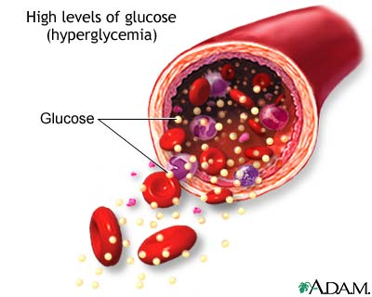Microvascular disease is a process through which the very small branches of arteries throughout the body become damaged. It is a common component of diabetes mellitus.

The very small branches of the arteries are delicate but very important structures. Damage to these vessels results in occlusion of the vessels and impairment of blood flow. In many situations the small arteries can re-grow and overcome the blockage, a process called angiogenesis.  This is part of the normal healing process. In microvascular disease the most common cause is chemicals within the blood that damage the very delicate lining of the small arteries and causes the blood to clot in the artery and block it.

**EYE COMPLICATIONS**

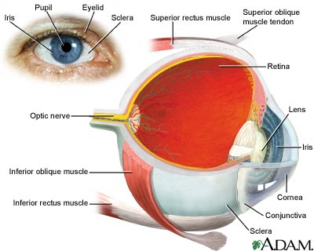

Diabetic eye disease is commonly associated with poor control of blood glucose and/or blood pressure. Most eye complications are due to blood vessel damage from high blood sugars. They may result in leakage (hemorrhage) from damage to capillaries or partial to total blood vessel blockage, due to decreased blood supply.

Diabetes is the leading cause of adult blindness. About 2% of people with Type 2 diabetes mellitus will suffer total loss of vision. The likelihood of developing eye complications increases the longer a person is diabetic.

1. **Retinopathy** - damage or growth problems in the small blood vessels of the retina

About 80% of people who have had diabetes for over 20 years have some background diabetic retinopathy (BDR), but 75-80% of those never develop serious vision problems. However, BDR can progress to macular edema or proliferative retinopathy.

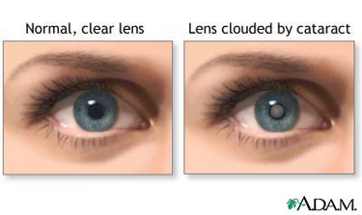

1. **Cataracts** – thickening and clouding of lens of eye

There are a variety of types of cataracts, but the most common type, called a senile cataract, occurs almost exclusively in those over the age of 60, although the underlying damage begins decades earlier. Senile cataracts often start as a discoloration of the lens, with loss of vision occurring as this localized structural damage enlarges to form a distinct opacity. Due to high blood sugar, diabetes raises the risk for senile cataract by about 40 percent.

Another type of cataract, called a sugar cataract, is found only in diabetics. This type can occur at any age, but often strikes young adults who are in very poor control of Type I diabetes. Sugar cataracts can grow rapidly and cause complete loss of vision in the affected eye in as little as 3 days.

1. 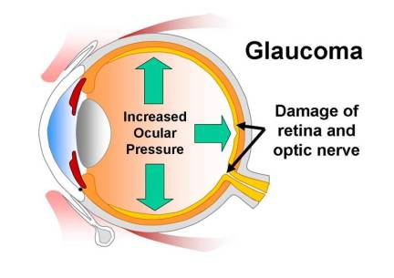**Glaucoma** – pressure build-up inside the eye

Open-angle glaucoma is 1.4 to 2 times more common in the diabetic population. The older a person is and the longer a person has had diabetes, the greater the risk of glaucoma. It results from high fluid pressure within the eye. As the pressure increases, it can compress the optic nerve and the blood vessels that nourish the retina and cause a slow loss of peripheral vision and eventual blindness.

**DIAGNOSING EYE COMPLICATIONS**

Tests conducted to evaluate eye complications include:

pupillary dilation test – expands pupil to examine retina for signs of disease

refraction test – measures ability to see objects at specific distances

tonometry – measures intraocular pressure

slit-lamp exam – looks at the front of the eye by shining a beam of light shaped like a small slit on the eye

**RATING CONSIDERATIONS FOR EYE COMPLICATIONS**

Diabetic eye diseases are rated as glaucoma, cataract, retinopathy or other manifestation (such as intra-ocular hemorrhage) based on visual acuity, visual field loss, or diplopia, depending on the specific findings. Visual impairment is the result of an eye disorder, rather than being the eye disorder or condition itself. Therefore, when rating eye complications, be sure to list the actual diagnosis, rather than merely citing impaired visual acuity, field of vision, or motor efficiency on the rating codesheet. Remember to identify the disability as being secondary to diabetes.

Keep in mind that examination reports must provide an established diagnosis when there are abnormal findings. If a diagnosis is either not given, or is not supported by the findings, the exam is not adequate for rating purposes. Only licensed optometrists and ophthalmologists may conduct compensation and pension (C&P) eye examinations. A fundoscopic examination after dilation of the pupils is routine, unless medically contraindicated.

Eye diseases are rated either by a level of activity or upon chronic residuals, as reflected by impairment of vision, and some eye disabilities result in more than one type of impairment:

Impairment of central visual acuity – how well one sees objects with each eye, whether near or far

Impairment of field of vision – how large a visual area one can see with each eye

Impairment of muscle function – how well the eye muscles function to permit binocular vision

Examinations of visual fields or muscle function are needed only when medically indicated, but if there is disease or injury to the optic nerve, such as with glaucoma, be sure that field of vision measurements are included in the exam report. Goldmann kinetic perimeter or equivalent kinetic method remains an accepted method of measuring visual fields, but it is no longer the only accepted method. Automated perimetry (using Humphrey Model 750, Octopus Model 101, or later versions) is also an accepted method of measuring visual fields, but results must be recorded on a standard Goldmann chart, which must be included with the examination report.

**Note:** Infer the issue of service connection for diabetic retinopathy when the veteran is already service connected for diabetes and the medical evidence of record provides a diagnosis. Further examination may be needed to ascertain the extent of involvement, but a 0% evaluation should be assigned pending the outcome of a VA examination

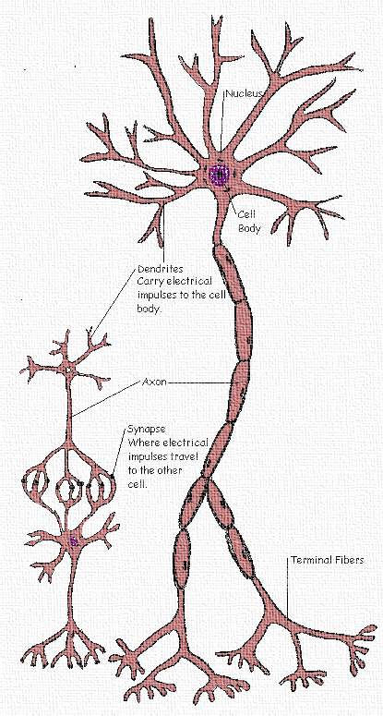

**NERVE DAMAGE**

Diabetic neuropathy is a group of disturbances that occur frequently in diabetics that can affect many parts of the nervous system. The peripheral nerves go out from the brain and spinal cord to muscles, skin, and internal organs.

The cause of diabetic neuropathy is not known, but may be due to a disturbance of nerve metabolism or ischemia (inadequate blood supply) of the nerves. Contributing factors are: increasing age, male sex, increasing height, long duration of diabetes, poor glucose control, hypertension, alcohol consumption, and smoking.

Diabetic neuropathy causes painful tingling or burning sensations in the hands and feet. It is primarily sensory and is usually bilateral and symmetrical. Peripheral neuropathy may be asymptomatic until a serious complication, such as foot ulcer or cardiac arrhythmia, develops. Peripheral neuropathy usually begins in the toes and then progresses up the legs. Then, it affects the fingertips and later the chest and abdomen. It always starts distally and moves proximally and is most commonly found in a **stocking-glove distribution**.

**DIAGNOSING NERVE DAMAGE**

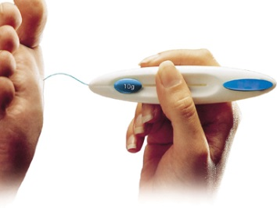Typically, physicians assess neurological function by evaluating deep tendon reflexes, muscle strength, and sensation (temperature, light touch, sharp and dull pressure, and vibration). Temperature sensation in the feet and legs are normally assessed by touching a cool metal object, such as a tuning fork, to the skin and asking the patient to describe the temperature. Light touch can be assessed by touching the skin with a wisp of cotton or a monofilament device (shown at right) and asking the patient to describe the location of the sensation. Sharp and dull sensation can be assessed by asking the patient to close his/her eyes and then alternately touching the feet with the dull and sharp ends of an object, such as a paper clip, and asking him/her to describe the sensation. Vibration sensation is assessed by placing a vibrating tuning fork on the distal first metatarsal head or the malleolus of the patient’s ankles and asking him/her to tell you when the vibration stops.

**KIDNEY DISEASE**

Diabetic nephropathy is deterioration of the kidneys due to diabetes. It occurs in 30-50% of insulin-dependent diabetics and 10-15% of non insulin-dependent diabetics. There is often a clinical syndrome of albuminuria, hypertension, background retinopathy, and a history of diabetes for more than 10 years.

**DIAGNOSING KIDNEY DISEASE**

The following tests are commonly used to detect kidney (renal) disease:

* **creatinine** – a waste product, from the normal breakdown of muscle. Normal levels vary, but a common normal range is 0.6 to 1.2 mg/dl.
* **creatinine clearance test** – indicates how fast creatinine is removed from the blood.
* **blood urea nitrogen (BUN)** – a waste product of protein that builds up in the blood when the kidneys are damaged. Normal is 7 to 20 mg./dL. of blood.
* **proteinuria** – protein in urine occurs when kidneys fail to separate protein from waste
* **renal imaging** – ultrasound, computed tomography (CAT scan), and magnetic resonance imaging (MRI), mainly to find tumors or urinary tract obstruction
* **renal biopsy** – a surgical procedure in which a sample of kidney tissue is obtained for miscroscopic examination
* **renal angiogram** – an x-ray study of blood vessels that lead to the kidney

Hemodialysis or kidney transplant may be needed in late stages of renal dysfunction. Patients with diabetes tend to start dialysis earlier (at a lower creatinine level) than others because they develop symptoms sooner than non-diabetics.

**RATING CONSIDERATIONS FOR KIDNEY DISEASE**

Diabetic nephropathy may be rated as renal dysfunction or as voiding dysfunction if there is incontinence. Creatinine levels above normal but less than 4 are abnormal and indicate decreased renal function that would warrant a 60% evaluation. If chronic pyelonephritis is the problem, rating as urinary tract infection may be appropriate. Eventually, some claims for advanced kidney disease will need to be rated as hemodialysis, nephrectomy or kidney transplant.

Topic 3: Macrovascular Complications

Diabetic macrovasular complications are conditions or diseases that affect the large blood vessels in the body. Macrovascular disease causes a narrowing in the vessels, resulting in reduced blood flow, and eventually damage to the area(s) affected. This can occur in blood vessels that are in any part of the body, but the most common complications include: heart disease (including hypertension), stroke, and peripheral vascular disease.

**HEART DISEASE**

Most cardiovascular complications related to diabetes have to do with the way the heart pumps blood through the body. Arteriosclerotic heart disease, also known as coronary artery disease (CAD), is a build-up of plaque on the walls of the arteries. It is a major cause of death among diabetics. When arteries narrow, or clog up completely, blood flow to the heart can slow down or stop, causing chest pain (stable angina) or heart attack. Angina and myocardial infarction (MI) may be silent until they result in unexpected heart failure.

**DIAGNOSING HEART DISEASE**

Tests performed to diagnose heart disease are:

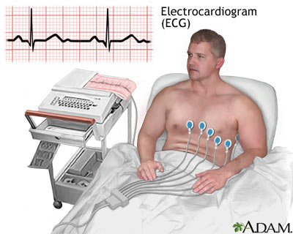

**Metabolic Equivalent of Task (METS)** determines if there are abnormalities in the heart’s electrical activity by measuring the metabolic rate on cardiac stress test

**Ejection Fraction** measures the fraction of blood pumped out of the left ventricle with each heart beat

**Electrocardiogram (ECG)** checks for problems with the electrical activity of the heart

**Computed Tomography (CT scan) of the heart**

visualizes the heart’s anatomy; Calcium-score heart scan and coronary CT angiography are just a few types used to diagnose heart disease

**Cardiac catheterization** (also called a coronary angiogram)

insertion of a catheter into the heart muscle to evaluate functioning

**HYPERTENSION**

More than half of all people with diabetes also suffer from hypertension, or high blood pressure. While most hypertension that develops in diabetics is essential, primary hypertension that is not due to diabetes, hypertension may be a complication of diabetes under certain circumstances. Diabetic nephropathy, even in its incipient stage, may be associated with renal hypertension and is the most common cause of hypertension that results from diabetes. Renovascular hypertension results from stenosis**,** or narrowing, of one or both renal arteries and isresponsible for less than two percent of all cases of hypertension.

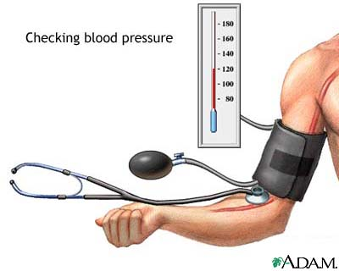**DIAGNOSING HYPERTENSION**

Blood pressure is measured with a cuff device called a sphygmomanometer. Results reported (i.e.; 130 over 80) are the systolic and diastolic pressure readings, respectively. A diagnosis of hypertension requires multiple high readings because blood pressure varies throughout the day. After the initial high reading, one or more measurements should be done outside the doctor's office to distinguish between sustained and white-coat hypertension (high blood pressure due to nervousness or anxiety in a clinical setting).

**RATING CONSIDERATIONS FOR HYPERTENSION**

Infer the issue of service connection for hypertension as secondary to diabetes mellitus whenever service connection is established for diabetes mellitus and diabetic nephropathy, and the Veteran has a diagnosis of hypertension. **Note**: do not infer hypertension to deny.

In the absence of record evidence specifically addressing the question of whether hypertension is related to diabetes mellitus

* consider hypertension to be a complication of diabetes mellitus when onset of hypertension occurred after a diagnosis of diabetes mellitus with diabetic nephropathy (The onset of hypertension after diabetes mellitus without diabetic nephropathy is not sufficient.), ***and***
* do not consider hypertension to be a complication of diabetes mellitus when
  + onset of hypertension was before diabetes mellitus (with or without diabetic nephropathy), ***and*** there has been no change in the treatment of hypertension or increase in blood pressure readings.

**STROKE**

Brain tissue requires a steady supply of oxygen and nutrients to keep nerve cells and other parts of the tissue alive and functioning. The brain depends on a network of blood vessels to supply it with blood that is rich in oxygen.

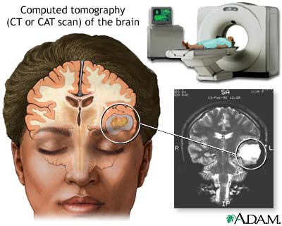

A stroke, also known as **cerebrovascular accident (CVA)**, is an acute event that occurs when one of these blood vessels becomes damaged or blocked, preventing blood from reaching an area of the brain. When that part of the brain is cut off from its supply of oxygen for more than three to four minutes, it begins to die. People with diabetes tend have strokes at an earlier age than other people and, when they do, they often fare worse than individuals without diabetes. Symptoms of stroke frequently begin with little warning, and may include: mental confusion and disorientation, sudden dizziness and/or loss of balance, difficulty talking or walking, visual disturbance, severe headache; and, weakness or numbness in the face, arm, or leg (typically on one side of the body). Prompt treatment is crucial, as early treatment can minimize damage.

**DIAGNOSING STROKE**

Diagnosing stroke usually begins with a healthcare professional asking questions concerning what happened and when the possible stroke symptoms began. A doctor making a stroke diagnosis will also typically review the patient's medical history and conduct a physical exam (including a short neurological exam). Tests used for diagnosing stroke may include**:** blood tests, CT scan, MRI, carotid Doppler ultrasound, and cerebral angiography.

**RATING CONSIDERATIONS FOR STROKE**

Strokes require rating in the neurological system, but sometimes present with symptoms in the genitourinary, digestive, and respiratory systems. Therefore, it is important to review all service connected disabilities and their associated symptoms before rating residuals of stroke to avoid pyramiding.

**PERIPHERAL VASCULAR DISEASE**

Peripheral vascular disease (PVD) refers to diseases of the blood vessels (arteries and veins) located outside the heart and brain. Doctors commonly use the term synonymously with peripheral arterial disease (PAD), a condition that develops when the arteries that supply blood to the internal organs, arms, and legs become completely or partially blocked as a result of atherosclerosis. Atherosclerosis occurs when a waxy substance, called plaque, forms inside of the arteries. Clogged peripheral arteries most often cause pain and cramping in the legs, called claudication.

Another symptom of peripheral vascular disease is when sores, wounds or ulcers heal slowly, or not at all; or have diminished hair and nail growth on the affected limb(s). In serious cases, the toes may turn a bluish color, the feet may be cold, and the pulse may be weak in the legs. In the most severe cases, the tissue dies (this is called gangrene) and amputation may be required.

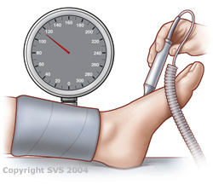

**DIAGNOSING PERIPHERAL VASCULAR DISEASE**

Typically, doctors test for peripheral vascular disease by conducting an ankle-brachial index (ABI) test, comparing the blood pressure at the ankle with blood pressure in the arm while a person is at rest. A normal resting ankle-brachial index is 1 or 1.1 Blood pressure at the ankle is the same or greater than the pressure at the arm; no significant narrowing or blockage of blood flow.

A resting ankle-brachial index < 1 is abnormal. If the ABI is less than 0.95, significant narrowing of one or more blood vessels in the legs is indicated and if it is less than 0.8, pain in the foot, leg, or buttock may occur during exercise. When the ABI is less than 0.4, symptoms may occur when at rest and at 0.25 or below, severe limb-threatening PVD is likely.

**RATING CONSIDERATIONS FOR PERIPHERAL VASCULAR DISEASE**

Evaluations listed in the Rating Schedule, under diagnostic code (DC) 7114, arteriosclerosis obliterans, are for involvement of a single extremity. If more than one extremity is affected, evaluate each separately and combine (§ 4.25), using the bilateral factor (§4.26).

Topic 4: Diabetes complications, nos

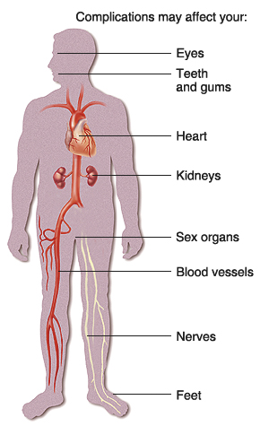Many people with diabetes mellitus eventually develop complications, especially if it is not well controlled. In addition to microvascular and macrovascular complications, other frequent complications are: foot problems, infections, skin problems, sexual dysfunction and pregnancy complications.

**FOOT PROBLEMS**

Diabetes can lead to many different types of foot complications including: calluses, bunions and other foot deformities, or ulcers that can range from a surface wound to a deep infection. Foot complications are the most frequent reason for hospitalization in patients with diabetes accounting for up to 25 percent of all diabetic admissions in the United States.

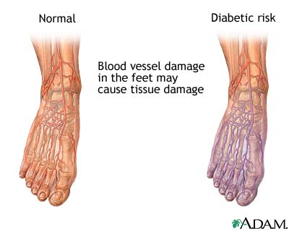Changes in sensation alter the way people with diabetes carry weight on their feet, concentrating weight in certain areas so that calluses form. Calluses (and dry skin) increase the risk of skin breakdown. When an abnormal focus of pressure is coupled with lack of sensation, foot ulcers can also develop. Diabetes causes poor circulation in the feet, making ulcers more likely to form when the skin is damaged and making the ulcers slower to heal. Because diabetes can affect the body's ability to fight infections, a foot ulcer, once it forms, easily becomes infected. Because of neuropathy, people may not feel discomfort from the infection until it becomes serious and difficult to treat, leading to gangrene. People with diabetes are more than 15 times more likely to require amputation of a foot or leg than are people without diabetes.

**RATING CONSIDERATIONS FOR FOOT PROBLEMS**

When an unhealed injury or foot infection is a complication of service-connected diabetes, and it results in amputation, remember to grant special monthly compensation (SMC) K for anatomical loss of a foot. If one amputation occurs above the knee, or both feet must be amputated above the ankles, be sure to consider service connection for any subsequent ischemic heart disease or hypertension on a secondary basis as well as higher levels of SMC.

**INFECTIONS**

Diabetics frequently develop bacterial skin infections, including: styes, boils, carbuncles, and cellulitis. Another type of bacterial infection that afflicts diabetics is a urinary tract infection (UTI) .

High glucose levels in the blood can enhance the growth of fungi, and skin is the flourishing site for it. Common types of dermatophytosis include: tinea pedis (athlete’s foot), tinea cruris (jock itch), tinea corporis (ringworm) and tinea capitis (ringworm on the scalp). Tinea infections of the skin may cause temporary hair loss at the site of infection, ring-like raised itchy patches, blisters or scabs. Diabetic women are prone to develop vaginal yeast infections and, in fact, the frequency of infection may be the first sign that a woman is diabetic. Diabetic men can develop penile Candidiasis, but it is quite rare and usually occurs as a result of contact with a female sexual partner who has a yeast infection.

**SKIN PROBLEMS**

Poor circulation to the skin can lead to ulcers and infections and causes wounds to heal slowly. People with diabetes are particularly likely to have ulcers and infections of the feet and legs.

**DIAGNOSING SKIN INFECTIONS**

Skin tests may be performed to diagnose bacterial or fungal skin infections. The most common tests are: **patch testing, skin biopsy, culture, or nail clipping/skin scraping test.**

**DIAGNOSING BACTERIAL INFECTIONS**

Diagnostic tests for urinary tract infection include: **clean catch urine sample** and **intravenous pyelogram** (for frequent/recurrent infections).

**RATING CONSIDERATIONS FOR INFECTIONS/SKIN PROBLEMS**

Residuals of infections are another source of potentially great variation in rating. They range from osteomyelitis to destruction of sinuses, foot ulcers, or gangrenous gall bladder.

**SEXUAL DYSFUNCTION**

Both men and women with diabetes can develop sexual problems due to damaged nerves and small blood vessels. The body’s response to sexual stimuli is involuntary, governed by autonomic nerve signals that increase blood flow to the genitals and cause smooth muscle tissue to relax. Damage to the autonomic nerves can hinder normal functioning and is often referred to as sexual neuropathy. Reduced blood flow, resulting from damaged blood vessels, may also contribute to sexual dysfunction.

Erectile dysfunction is a consistent inability to have an erection firm enough for sexual intercourse. The condition includes the total inability to have an erection and the inability to sustain an erection. Men who have diabetes are two to three times more likely to have erectile dysfunction than men who do not have diabetes. Among men with erectile dysfunction, those with diabetes may experience the problem as much as 10 to 15 years earlier than men without diabetes. Research suggests that erectile dysfunction may be an early marker of diabetes, particularly in men ages 45 and younger.

Retrograde ejaculation is a condition in which part or all of a man’s semen goes into the bladder instead of out the tip of the penis during ejaculation. Retrograde ejaculation occurs when internal muscles, called sphincters, do not function normally. A sphincter automatically opens or closes a passage in the body. With retrograde ejaculation, semen enters the bladder, mixes with urine, and leaves the body during urination without harming the bladder.

Women may also experience sexual problems due to diabetes. Symptoms of sexual problems may include: decreased vaginal lubrication resulting in vaginal dryness, uncomfortable or painful sexual intercourse (dyspareunia), decreased or no desire for sexual activity (loss of libido), and decreased or absent sexual response (anorgasmy), that may include the inability to become or remain aroused, reduced or no sensation in the genital area, and the constant or occasional inability to reach climax. Causes of sexual problems in women with diabetes include nerve damage, reduced blood flow to genital and vaginal tissues, and hormonal changes.

Regardless of gender, some additional reasons for sexual dysfunction are the side effects of medications taken to control diabetes and psychological factors (depression/anxiety) from coping with the effects of chronic disease.

**DIAGNOSING SEXUAL DYSFUNCTION**

A physical exam and laboratory tests may help pinpoint causes of sexual problems. The health care provider may order urinalysis, check blood glucose control, conduct a thyroid profile and consider serum hormone levels (testosterone/estrogen). Additional tests for males include penile blood pressure and a nocturnal tumescent study that checks for erections occurring during sleep. The health care provider may also ask whether the patient has recently experienced upsetting changes in his or her life to screen for psychological symptoms.

**RATING CONSIDERATIONS FOR SEXUAL DYSFUNCTION**

Award SMC K to a diabetic male veteran when medical evidence of record shows a condition of the reproductive tract resulting in loss of use of a creative organ, such as retrograde ejaculation, or spermatozoa dumping into the bladder in a male veteran, or the loss of erectile power. Successful use of medication to treat this condition does not preclude a grant of SMC K.

**PREGNANCY COMPLICATIONS**

Pre-eclampsia is pregnancy-induced hypertension (PIH), plus proteinuria. It occurs in otherwise healthy women after the twentieth week of pregnancy, although is more likely found in diabetic women and those who are overweight. PIH disappears within a few weeks after birth, but when complications occur, any resulting permanent damage may be attributed to the woman’s diabetic condition.

**DIAGNOSING PREGNANCY COMPLICATIONS**

No one test will diagnose pre-eclampsia, but normally, the following factors are considered:

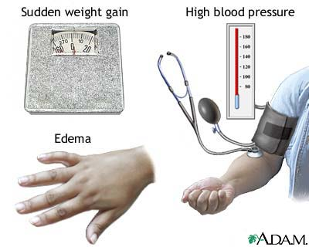

* elevated blood pressure (greater than 140/90 on
* more than 2 occasions, at least six hours apart)
* higher than normal liver enzymes
* platelet count < 100,000 (thrombocytopenia)
* protein in the urine (proteinuria)
* weight gain of more than 2 lbs per week, or sudden weight gain over 1-2 days

Babies of diabetic mothers have a tendency to be large (macrosomia) because fetal hyperglycemia stimulates production of insulin, growth hormones and the deposition of fat and glycogen. Other pregnancy-related complications for the mother include birth injuries and Cesarean birth. Diabetic women are three to four times more likely to require Cesarean sections than non-diabetics.

**RATING CONSIDERATIONS FOR PREGNANCY COMPLICATIONS**

Most pregnancy complications are self-limiting and will resolve without residuals after delivery. However, maternal birth injuries and all *permanent* complications of pregnancy will be rated on residuals.

**Special Monthly Compensation & Ancillary Benefits**

* Loss of use
* Anatomical loss
* Need for aid and attendance
* Housebound (In-fact/Statutory)
* Automobile Allowance
* Specially Adapted Housing/Special Home Adaptation
* Chapter 35

**Reminder: GENERAL RATING CONSIDERATIONS**

Evaluate compensable complications of diabetes separately, unless they are a part of the criteria used to support a 100 evaluation. Non-compensable complications are considered part of the diabetic process under diagnostic code (DC) 7913. If the Veteran has noncompensable complications of diabetes mellitus but does not have ketoacidosis or hypoglycemic reactions, do not evaluate the diabetes mellitus at 60 percent simply because noncompensable complications are present. Instead, assign an evaluation based on the evidence of record. If there is a requirement for insulin, restricted diet, and regulation of activities and include the non-compensable complications under DC 7913, assign a 40 percent evaluation.

**Note:** The preceding information is provided to make RVSRs aware of some common complications that may be related to diabetes, but does not provide authority to automatically grant them. Some complications, like diabetic retinopathy or diabetic nephropathy, won’t need a medical opinion because their association to diabetes is already established by the diagnosis, but others (like glaucoma, PVD, stroke, skin infections, etc) are not exclusive to diabetics, and therefore, will require an opinion to determine if there is a causal relationship. It is important to note the course of diabetes (the date it was first diagnosed, treatment and control) and the date complications first arose when requesting a medical opinion.

Practical Exercise

**Directions: please answer the questions.**

1. What does the term *microvascular* mean?

a. Pertaining to the small intestines

b. Pertaining to the plural sacs

c. Pertaining to small blood vessels, including capillaries

d. None of the above

1. Non-compensable complications are considered part if the diabetic process under diagnostic code (DC) 7913.

a. Yes

b. No

1. Which eye condition is frequently related to diabetes?

a. Diplopia

b. Astigmatism

c. Glaucoma

d. Macular degeneration

1. Which condition is not part of the stages of diabetic nephropathy?

a. Renal insufficiency

b. Microalbuminaria

c. End Stage renal disease

d. Nephritis

1. Which of the following is a common macrovascular complications of diabetes mellitus?

a. Hyprtension

b. Cataracts

c. Subconjunctival hemorrhage

d. Epistaxis

6. Foot problems, skin pronblems, sexual dysfunction, infections and _____________ are diabetic complications not otherwise specified.

a. Claudication

b. Vestibular disorder

c. Splenomegaly

d. Pregnancy complications

**LESSON REVIEW**

PPT Review available at instructors discretion.