Incarceration-Related Award Adjustments

Trainee Handout

**Table of Contents**

Objectives 2

References 3

Topic 1: Definition of Terms Associated with Incarceration-Related Award Adjustments 4

Topic 2: Regulatory Requirements 5

Topic 3: Notices of Proposed Adverse Action and Incarceration-Related Award Adjustments 14

Topic 3 Exercise –Notices of Proposed Adverse Action and Incarceration-Related Award Adjustments 17

Topic 4: Apportionment of Benefits 18

Topic 4 Exercise – Apportionment/Payment of an Incarcerated Beneficiary’s Benefits to Eligible Dependents 22

Topic 5: Award Adjustments Necessitated by a Dependent’s Incarceration 23

Topic 5 Exercise – Award Adjustments Necessitated by a Dependent’s Incarceration 25

Attachment A: Sample Prison Match 26

Attachment B: Sample Notice of Proposed Adverse Action 27

Attachment C: Making Adjustments in VBMS-A 31

Attachment D: Sample Decision Notice 36

Attachment E: Incarceration-Related Apportionment Checklists 40

Objectives

Upon completion of this lesson, the trainee will be able to:

* Define terms associated with award adjustments necessitated by an individual’s incarceration
* Understand the regulatory requirements for adjusting benefits because of a beneficiary’s or dependent’s incarceration
* Understand and take the necessary steps for sending notices of proposed adverse action and completing reductions of compensation and discontinuance of pension during incarceration
* Identify and apply the methods used to properly apportion/pay the benefits of an incarcerated beneficiary to his/her dependent(s)
* Identify and apply the methods used to properly adjust awards for incarcerated dependents

References

* [38 U.S.C. § 5313](https://www.law.cornell.edu/uscode/text/38/5313), Limitation on payment of compensation and DIC to persons incarcerated for conviction of a felony
* [38 U.S.C. § 1505](https://www.law.cornell.edu/uscode/text/38/1505), Payment of pension during confinement in penal institutions
* [38 CFR 3.665](http://www.ecfr.gov/cgi-bin/text-idx?SID=ad275643432556b9dda942343fb89296&mc=true&node=pt38.1.3&rgn=div58#se38.1.3_1665), Incarcerated beneficiaries and fugitive felons-compensation[M21-1, Part III, Subpart v, 8](https://vaww.vrm.km.va.gov/system/templates/selfservice/va_kanew/help/agent/locale/en-US/portal/554400000001034/topic/554400000003109/Chapter-08-Incarceration), Incarceration
* [M21-1, Part X, 7](https://vaww.vrm.km.va.gov/system/templates/selfservice/va_kanew/help/agent/locale/en-US/portal/554400000001034/content/554400000015004/M21-1-Part-X-Chapter-12-Bureau-of-Prisons-BOP-Matchhttps:/vaww.vrm.km.va.gov/system/templates/selfservice/va_kanew/help/agent/locale/en-US/portal/554400000001034/content/554400000015004/M21-1-Part-X-Chapter-12-Bureau-of-Prisons-BOP-Match), Bureau of Prisons (BOP) Match
* [M21-1, Part X, 2.D](https://vaww.vrm.km.va.gov/system/templates/selfservice/va_kanew/help/agent/locale/en-US/portal/554400000001034/topic/554400000018457/Chapter-02-Matches-With-Social-Security-Administration-SSA-Records), SSA Prison Match
* VBMS-A User Guide (Log in to VBMS-A & click “Awards Help”)
* [VETSNET Awards User Guide](http://vbaw.vba.va.gov/VetsNet/Awards_Docs/Awards%20User%20Guide.pdf)
* [VSR Assistant – Resources](http://epss.vba.va.gov/vsr_assistant/resource_index.html), 61-Day Rule Incarceration Calculator

All M21-1 references are found in the [Compensation Pension Knowledge Management Website](https://vaww.compensation.pension.km.va.gov/).

Topic 1: Definition of Terms Associated with Incarceration-Related Award Adjustments

An individual is not “incarcerated” for the purpose of this course if he/she is residing in a halfway house or participating in a work-release program

**Felony**is any offense punishable by death or imprisonment for a term exceeding one year, unless specifically categorized as a misdemeanor under the law of the prosecuting jurisdiction.

**Misdemeanor**is any offense lower than a felony and generally punishable by fine, penalty, forfeiture, or imprisonment other than in a penitentiary.

**Release from incarceration** includes participation in a work release or halfway house program, residential re-entry center, parole, and/or completion of sentence.

Topic 2: Regulatory Requirements

**Incarcerated Beneficiaries -Compensation (38 CFR 3.665)**

Any person specified below **(1)**, who is incarcerated in a Federal, State or local penal institution in excess of 60 days for conviction of a felony will not be paid compensation or Dependency and Indemnity Compensation (DIC) in excess of the amount specified below **(2)**, beginning on the 61st day of incarceration. A person whose benefits are subject to this reduction shall be informed by VA of the rights of the person's dependents to an apportionment while the person is incarcerated, and the conditions under which payments to the person may be resumed upon release from incarceration. In addition, VA will also notify the person's dependents of their right to an apportionment if VA is aware of their existence and can obtain their addresses.

**(1)**

1. A person serving a period of incarceration for conviction of a felony committed after October 7, 1980
2. A person serving a period of incarceration after September 30, 1980 (regardless of when the felony was committed) when the following conditions are met:
   1. The person was incarcerated on October 1, 1980; and
   2. An award of compensation or DIC is approved after September 30, 1980
3. A Veteran who, on October 7, 1980, was incarcerated in a Federal, State, or local penal institution for a felony committed before that date, and who remains so incarcerated for a conviction of that felony as of December 27, 2001

**(2)**

1. *Veteran rated 20 percent or more.* A Veteran, to whom the above provisions apply, with a service-connected disability evaluation of 20 percent or more shall receive compensation at the rate payable for a service-connected disability evaluated 10% disabling.
2. *Veteran rated less than 20 percent*. A Veteran, to whom the above provisions apply, with a service-connected disability evaluation of less than 20 percent shall receive one-half the rate of compensation payable for a service-connected disability evaluated 10% disabling (round down if the amount results in a half-cent).
3. *Surviving spouse, parent or child.* A surviving spouse, parent, or child beneficiary, to whom the above provisions apply, shall receive one-half of the rate of compensation payable to a Veteran for a service-connected disability evaluated 10% disabling.

**NOTE**: the reduction/termination begins on the 61st day of incarceration (start counting from the first FULL day of incarceration) following conviction

***VA Benefits Affected by 38 CFR 3.665***

The following benefits are affected by 38 CFR 3.665:

* Compensation, including disability compensation under 38 U.S.C. 1151
* Dependency and Indemnity Compensation (DIC) and death compensationDIC and death compensation payable under 38 U.S.C. **Incarcerated Beneficiaries (38 CFR 3.666)**

If any individual to or for whom pension is being paid under a public or private law administered by the Department of Veterans Affairs is imprisoned in a Federal, State or local penal institution as the result of conviction of a felony or misdemeanor, such pension payments will be discontinued effective on the 61st day of imprisonment following conviction. The payee will be informed of his or her rights and the rights of dependents to payments while he or she is imprisoned as well as the conditions under which payments to him or to her may be resumed on his or her release from imprisonment. However, no apportionment will be made if the Veteran or the dependent is a fugitive felon as defined in paragraph (e) of 38 CFR 3.666. Payments of pension authorized an apportionment will continue until the Department of Veterans Affairs receives notice that the imprisonment has terminated.

**NOTE**: If the incarcerated individual is a Veteran entitled to compensation, we may be able to pay at least some benefits (compensation at one of the rates described on Page 6 of this handout) to the Veteran during his/her incarceration.

***VA Benefits Affected by 38 CFR 3.666***

The following benefits are affected by 38 CFR 3.666:

* Veterans Pension
* Survivors Pension

**Authority to Adjust Compensation and DIC and Discontinue Pension**

VA is responsible for adjusting payments of incarcerated beneficiaries.

* **38 U.S.C. 5313** - Authority to reduce compensation and dependency and indemnity compensation to persons incarcerated following conviction of a felony
* **38 U.S.C. 1505** - Authority to discontinue pension during confinement in a penal institution following conviction of a felony or misdemeanor

**Periods during Which VA May Not Reduce or Discontinue Benefits**

Benefits may not be reduced or discontinued for any period in which a beneficiary is:

* Participating in a work-release program
* Under community control (per VAOPGCPREC 59-91)
* Incarcerated in a foreign penal institution, or
* Residing in:
  + A halfway house
  + Residential re-entry center, or
  + Civil commitment center

**Important** “Residential re-entry center” is a term used by the Bureau of Prisons (BOP) in lieu of the traditional term “halfway house.”

**Effect of Incarceration on Payments of VA Benefits**

***Overview – Reduction of Compensation and Discontinuance of Pension Payments***

Reduce compensation (felony) or discontinue pension (felony or misdemeanor) effective the 61st day of incarceration following conviction or *re-incarceration* due to parole or probation violation as follows:

|  |  |
| --- | --- |
| **If the beneficiary is:** | **Then:** |
| a Veteran with a combined disability evaluation of at least 20% for service-connected disabilities | reduce the monthly rate to that payable to a Veteran with a disability evaluation of 10% for service-connected disabilities |
| a Veteran with a combined disability evaluation that is less than 20% for service-connected disabilities | reduce the monthly rate to half of that payable to a Veteran with a disability evaluation of 10% for service-connected disabilities  NOTE: Do not adjust a parent’s DIC award if it is currently less than half of the rate payable to a Veteran with a disability evaluation of 10% for service-connected disabilities. |
| a Veteran with   * a combined disability evaluation of 0% for service-connected disabilities, and * entitlement to SMC |
| a surviving spouse, parent or child entitled to DIC |
| * a Veteran in receipt of Veterans Pension, or   surviving spouse or child in receipt of Survivors Pension | discontinue payments. |

For a surviving spouse, child, or dependent parent receiving DIC, or a Veteran whose disability rating is 10 %, the payment is reduced to

* of the rate payable to a Veteran evaluated as 10 % disabled due to service-connected disabilities or
* the current rate payable if it is less than ½ of the rate described in the previous bullet.

Do not adjust a parent’s DIC award if it is less than ½ the rate of compensation payable to a Veteran evaluated as 10% disabled due to service-connected disabilities.

***Compensation***

Effective October 7, 1980, Public Law 96-385, added 38 U.S.C. 5313, which prohibits VA from paying full compensation benefits to beneficiaries who are incarcerated in a Federal, State or local penal institution in excess of 60 days for conviction of a felony. Beginning on the 61st full day of incarceration, compensation is not to be paid at a rate higher than 10 % for those ***convicted*** of a felony.  
  
What does this mean? Any individual who is incarcerated in a Federal, State, or local penal institution as the result of conviction of a felony and is receiving compensation or DIC benefits will have his or her benefits reduced to the amounts stated in the table above on the 61st day of confinement following conviction. (See the section titled ***Overview –*** ***Reduction of Compensation and Discontinuance of Pension Payments*** above.)

**Increased Compensation Evaluations During Incarceration**

Sometimes, VA increases a Veteran’s disability evaluation (for service-connected disabilities) while he/she is incarcerated. Here’s how to handle those cases:

|  |  |
| --- | --- |
| **If…** | **Then…** |
| VA increased the combined disability evaluation from a level of 10 percent to a level of 20 percent or higher | Increase the Veteran’s benefits to the rate payable for a combined disability evaluation of 10 percent during his/her period of incarceration. |
| The Veteran’s combined disability evaluation was 20 percent or higher ***before*** VA granted entitlement to an increased evaluation | Process the corresponding rating decision but do not increase the Veteran’s benefits to reflect the increased evaluation until incarceration ends. |

***Important*** 38 CFR 3.341(b) prohibits the *initial assignment* or *reinstatement* of a total disability evaluation based on individual unemployability during a period of incarceration.

**Re-Incarceration for the Same Conviction Following a Period of Release**

The rules that apply to the adjustment of compensation due to incarceration also apply to instances of *re-incarceration* for the same conviction following a period of release. For example, a beneficiary may be released on parole, probation, work-release, etc. If the beneficiary violates the conditions of that release and is subsequently re-incarcerated, benefits must be adjusted on the 61st day of re-incarceration.

Note: If the beneficiary is in receipt of DIC, responsibility for adjusting his/her award falls under the jurisdiction of the pension management centers (PMCs) and the case should be forwarded to the appropriate PMC for processing.

***Disability Pension and Survivors Pension***

When a beneficiary is in receipt of pension and is incarcerated following the conviction of a felony or misdemeanor, VA must discontinue his/her benefits on the 61st day of confinement following conviction.

Prior to discontinuing the payment of pension to a Veteran, a review must be completed to determine if the he/she has compensable service-connected disabilities.

* If yes, follow instructions under [M21-1 Part III, Subpart v, 8.B.3.a](https://vaww.compensation.pension.km.va.gov/system/templates/selfservice/va_ka/portal.html?portalid=5544000000010343), Paying Compensation in Lieu of Pension During Incarceration
* If no, discontinue pension

Note: As with DIC cases, if the beneficiary is a Veteran with no compensable service-connected disabilities, the responsibility for adjusting the Veteran’s pension rests with the PMCs. The case should be forwarded to the appropriate PMC for processing.

***Other Benefits Affected***

The following benefits may also be affected by a beneficiary’s incarceration:

* Clothing Allowance (handled by VAMC)
* Education Benefits

**Notice of a Beneficiary’s Incarceration**

*For Action to Take upon Receipt of Notice of Incarceration, see* [*M21-1 III.v.8.A.3.a*](https://vaww.compensation.pension.km.va.gov/system/templates/selfservice/va_ka/portal.html?portalid=5544000000010343)*. (Both official and unofficial notice)*

***Official Notice of Incarceration***

The Department of Veterans Affairs has agreements in place with the Bureau of Prisons (BOP) and the Social Security Administration (SSA). Periodically, computer matches are run to compare VA beneficiaries’ identifying data with BOP and SSA records information about incarcerated Veterans.

Beneficiaries who have been incarcerated in Federal or State penal institutions may be identified through the Bureau of Prisons (BOP) and Social Security Administration (SSA) matching programs. VA has a computer matching agreement with the BOP under which the BOP provides VA with information on Federal prisoners whose VA benefits may be subject to reduction or discontinuance.

When the Social Security numbers (SSNs) of a VA beneficiary or dependent match BOP’s or SSA’s record of incarcerated individuals, the system generates a "VA AND BUREAU OF PRISONS MATCH" worksheet or an "SSA PRISONER MATCH"worksheet. To obtain the name and address of a BOP facility go to <http://www.bop.gov/>.

Establish EP 290 when BOP/SSA worksheet is received and/or EP 840 work item is identified

* + Claim label for EP 290:
    - *Social Security Prison Match* if notice was received from SSA match,
    - *Bureau of Prisons* if notice came from BOP match, or
    - *Incarceration Adjustment* in all other instances
  + Date of claim (DOC) for EP 290 use:
    - Run date of the BOP/SSA match, or
    - Same DOC as the EP 840, if one was established

Upon establishment of EP 290, clear EP 840 (if one exists) and add the *Potential Over/Underpayment* special issue to the contention under the EP 290.

Before taking any action on the match, compare the information on the worksheet with information maintained in Share.

Compare the name in the "prisoner's name" field on the worksheet with the beneficiary's or dependent's name in Share. If the names are not close, check the date in the "date of birth" field on the worksheet with the date of birth (DOB) in Share and, if applicable, the Beneficiary Identification and Records Locator Subsystem (BIRLS).

If the BOP/SSA worksheet is lost, the listing can be utilized.

The listing contains:

* Information identifying the incarcerated individual, and
* Information on the place and date of incarceration, and sometimes the release date and the prisoner's ID number

***Unofficial Notice of Incarceration***

Unofficial notice is information received from an individual or non-government third party.

Attempt to confirm the unofficial notice through Federal, State or other inmate information resources, such as:

* contacting (by telephone) the correctional facility where the beneficiary is/was incarcerated
* accessing BOP’s web site ([http://www.bop.gov](http://www.bop.gov/))
* using Vine (<http://www.vinelink.com/index.jsp>), a privately operated, online, inmate locator service, and/or
* asking the correctional facility where the beneficiary is/was incarcerated to complete and return VA Form 21-4193, Notice to Department of Veterans Affairs of Veteran or Beneficiary Incarcerated in Penal Institution

***Verifying Incarceration from an Official Source***

An official source, for the purpose of verifying incarceration, includes:

* Federal, State, and local government authorities, such as
  + - * + law enforcement officials
        + officials at correctional facilities
        + prosecutors, and
        + parole officers
* BOP’s website (<http://www.bop.gov/>)
* official websites of individual correctional facilities, and
* Vine (<http://www.vinelink.com/>), a privately operated, online inmate locator service.

Information to obtain from an official source:

* Type of conviction (felony, misdemeanor, or other)
* Date (month, day, year) of conviction
* Date (month, day, year) of incarceration following conviction
* Indication the beneficiary was incarcerated for more than 60 days following conviction

Claims processors may request information via telephone, e-mail, fax, or letter. If information is obtained via telephone, document on VA Form 27-0820e.

***Incarceration Verified?***

Use the table below to help you determine how to proceed:

|  |  |
| --- | --- |
| **If information from official source shows…** | **Then…** |
| Beneficiary/dependent was incarcerated:   * For reasons other than a felony (for compensation/DIC) or felony or misdemeanor (for pension) * Less than 60 days, or * Not yet convicted | Clear the EP 290 and take no further action. If notice of incarceration was received from the beneficiary, then notify him/her that no adjustment is needed. |
| Beneficiary/dependent was incarcerated at least 60 days after conviction for a:   * Felony (for compensation/DIC), or * Felony or misdemeanor (for pension) | * Clear the EP 290 * Establish EP 600, using current date as DOC * Add *Potential Over/Underpayment* special issue * Add *Incarceration* corporate flash * Initiate due process |

Topic 1 Exercise –Definition of Terms Associated with Incarceration-Related Award Adjustments

**Instructions:** Fill in the blank.

____________________ means any beneficiary receiving compensation and imprisoned in a penal institution in excess of 60 days for conviction of a felony or receiving pension and imprisoned for a felony or misdemeanor. It does **not** include Veterans pursuing a rehabilitation program under the Vocational Rehabilitation and Employment Program (Chapter 31) while residing in a halfway house or participating in a work-release program in connection with conviction of a felony.

____________________ is any offense lower than a felony and generally punishable by fine, penalty, forfeiture, or imprisonment other than in a penitentiary.

____________________ includes participation in a work-release or halfway house program, parole, or completion of sentence.

____________________ is an order from a magistrate or other official authorized to issue such warrants directing that a named individual be arrested and brought before the issuing official.

____________________ is any offense punishable by death or imprisonment for a term exceeding one year, unless specifically categorized as a misdemeanor under the law.

Topic 2 Exercise – Regulatory Requirements

**Instructions:** Please locate the appropriate statutory authorities from title 38 United States Code (U.S.C.) and fill in the blanks.

1. 38 U.S.C. 5313 **–** Authority to **______________________________________________** ______________________________________ to persons incarcerated for a conviction of a felony.
2. 38 U.S.C. 1505 – Authority to **___________________________________** during confinement in a penal institution as a result of a felony or misdemeanor.

**Instructions:**Please provide a short answer to the following question.

1. Should VA reduce or discontinue benefits while the beneficiary is awaiting trial? Why or why not? **______________________________________________________________________ _______________________________________________________________________**

**Instructions:** Please read the following scenarios and determine the effective dates utilizing the 61-day Rule Calculator found in VSR Assistant Resources, as well as the knowledge you have obtained from this class to complete the scenarios.

1. John Smith is in receipt of disability compensation based on a combined disability rating of 20%. His first full day of incarceration following conviction of a felony was July 20, 2019 (convicted July 19, 2019). What is the effective date of the award adjustment? What is his new payment rate?
2. Bonnie Rib is in receipt of Veterans Pension. Her first full day of incarceration following conviction of a misdemeanor was March 21, 2019 (convicted March 20, 2019). What is the effective date of the award adjustment? What is her new payment amount?
3. Jimmy Walker is in receipt of disability compensation based on a combined disability rating of 30%. His first day of incarceration following conviction of a misdemeanor was June 6, 2019 (convicted June 5, 2019). What is the effective date of the award adjustment?

Topic 3: Due Process Notices and Incarceration Adjustments

**Due Process for Discontinuance or Reduction**

*To calculate the 61st full day of confinement following conviction, see [VSR Assistant – Resources](http://epss.vba.va.gov/vsr_assistant/resource_index.html), 61-Day Rule Incarceration Calculator, click on Calculators on the bottom left side, then click on 61-Day Rule Incarceration Calculator (see Attachment C).

Beneficiaries have due process rights that VA must satisfy before reducing or discontinuing their award. Each notice of proposed adverse action must:

* Cite the statutory authority for the proposed action:
  + 38 U.S.C. 5313 – Compensation or DIC
  + 38 U.S.C. 1505 – Pension
* Inform the beneficiary that the proposed reduction or discontinuance will take place effective the 61st full day of incarceration following conviction of a felony (compensation/DIC) or felony or misdemeanor (pension) – **specify the date**
* Provide the proposed rate of payment
* Include information about the potential entitlement of eligible family members to:
  + An apportionment of the beneficiary’s compensation or DIC, or
  + An allotment of the pension to which the beneficiary is otherwise entitled
* Include VA Form 21-0788, Information Regarding Apportionment of Beneficiary’s Award, when sending the notice *(If the address of dependents who may be entitled to an apportionment is known,* Attach the form to the notice of proposed adverse action ***in all cases***. Send ***another*** copy of the form directly to family members if their address is known*.)*
* Inform the beneficiary that VA may resume benefits effective the date incarceration ends if it receives notice within one year of that date; otherwise, VA may resume benefits no earlier than the date it receives notice. If incarceration period has already ended, specify the date the benefits will be resumed.

***Important:*** A beneficiary is entitled to due process and the notice described above *each time* he or she is incarcerated. This includes *re-incarceration* (following a resumption of benefits after incarceration ends) because of

* a parole violation, or
* dismissal from a halfway house or work-release program

**Adjusting a Beneficiary’s Award in the Claims-Processing System**

Adjusting a beneficiary’s award is the same in both VBMS-A and VETSNET Awards. First, access the INSTITUTIONALIZATIONS screen. Click on the ADD buttons, and then enter:

* *Incarceration Period* in the INSTITUTION TYPE/EVENT field
* The name of the facility where the beneficiary is incarcerated in the INSTITUTION field
* The date of the first full day of incarceration in the FROM field, and
* The date incarceration ended (if applicable) in the TO field

After making the above entries, click on the ACCEPT button, **then the ADJUST button**. When the next screen appears:

* Enter Incarceration Adjustment, in the ADJUSTMENT TYPE field,
* Verify the information is correct, and
* Click on the ACCEPT button

*See Attachment C for screenshots showing how to enter the adjustment in VBMS-A

*See Attachment D for a decision notice for an incarceration adjustment (Redesigned Automated Decision Letter should generate letter, but make sure all requirements in 38 CFR 3.103(f) and M21-1.III.v.2.B.1.b are met.

**Resuming Payments Upon Release from Incarceration**

***Compensation and Pension (live)***

If notification of release from incarceration is received within one year of the date of release, and VA receives official notice or confirmation of that release, reinstate full benefits on the date the beneficiary is:

* Released from incarceration,
* Placed under community care,
* Begins participation in a work-release program, or
* Moves to a halfway house; civil commitment center; or a residential re-entry center (as defined in M21-1 III.v.8.A.1.d).

If notification is received more than one year following the date of the release, we can only resume benefits from the date VA first receives notice that incarceration has ended. For notices of release from incarceration no standard form is needed, and the information may be received in writing, by telephone, or through eBenefits (*Reminder: must still verify with an official source*).

Control using EP 290 with DOC as date the notice of release from incarceration was received:

* Add *Potential Over/Underpayment* special issue
* If release from incarceration is verified, remove the *Incarceration* corporate flash

Absent evidence to the contrary,

assume a Veteran and the dependent(s) to whom VA apportioned benefits are reunited when incarceration ends, and

discontinue the apportionment, accordingly, effective the date in the LAST PAID DATE field on the AWARD INFORMATION tab in Share.

Follow the instructions in M21-1III.v.8.B.2.k if the Veteran is ***not*** reunited with the dependent(s) to whom VA apportioned benefits when incarceration ends.

***DIC and Survivors Pension - Surviving Spouse, Child, or Parent***

Upon official notification of release from incarceration of a surviving spouse, child, or parent, benefits are to be restored either:

* The date of release, if notification is received within one year, or
* The date of receipt of the notice, if notification is not received within one year of release

In Survivors Pension cases, VA must request information regarding current income, expenses, and net worth, as well as confirmation that any child/children remain in his/her custody (if applicable) prior to reinstating benefits.

*If the Veteran’s award was subject to a withholding to recoup separation benefits, or another withholding existed prior to the incarceration adjustment, review to determine if that withholding needs to be adjusted/reinstated following release from incarceration.*

For additional information on resumption of benefits following release from incarceration, see [M21-1 III.v.8.A.5](https://vaww.compensation.pension.km.va.gov/system/templates/selfservice/va_ka/portal.html?portalid=5544000000010343), [M21-1 III.v.8.C.7](https://vaww.compensation.pension.km.va.gov/system/templates/selfservice/va_ka/portal.html?portalid=5544000000010343) and [M21-1 III.v.8.C.8](https://vaww.compensation.pension.km.va.gov/system/templates/selfservice/va_ka/portal.html?portalid=5544000000010343).

Topic 3 Exercise – Due Process Notices and Incarceration Adjustments

**Instructions:** Determine from the scenarios:

* 1. if due process is required for the discontinuation or reduction of benefits.
  2. the correct effective date of reduction or discontinuance of the VA benefit
  3. the correct proposed rate.

**Scenario 1:** Single Veteran in receipt of compensation for PTSD, evaluated as 70% disabling, is convicted of a felony and incarcerated in a Federal penal institution for 5 years. He is convicted on January 5, 2019 and remained in custody following conviction. An official notice was received from the prison facility on January 15, 2019, confirming that the veteran is convicted of a felony.

1. Is due process required?
2. If so, what would be the effective date of the reduction or discontinuance?
3. What is the proposed rate?

**Scenario 2:** A Veteran with a spouse and dependent child is in receipt of VA non-service-connected pension benefits. On December 24, 2019, the veteran was convicted and incarcerated for a misdemeanor. His spouse was also convicted and incarcerated on December 24, 2019. Their dependent child, aged 17 years old, is allowed to live at home. The daughter had sent in the notification of the incarcerations.

1. Is due process required?
2. If so, what would be the effective date of the reduction or discontinuance?
3. What is the proposed rate?

**Scenario 3:** A single Veteran with no dependents is in receipt of 10% for tinnitus was incarcerated following a felony conviction on November 15, 2018 for 20 years. Official notification is received from the correctional facility on December 15, 2018.

1. Is due process required?
2. If so, what would be the effective date of the reduction or discontinuance?
3. What is the proposed rate?

Topic 4: Apportionment Benefits

**Apportionments in Cases Involving Incarceration**

***General***

Effective March 24, 2015, in order to claim an apportionment (compensation and DIC) or request payment of an incarcerated beneficiary’s pension, the claimant or beneficiary must submit VA Form 21-0788, Information Regarding Apportionment of Beneficiary’s Award. *Note that VA will accept VA Form 21-0788 from a beneficiary only when an apportionment or the payment of pension to dependents may be in order because of the beneficiary’s incarceration. In all other instances, the claim must originate with the claimant.*

VA is responsible for notifying a Veteran of the rights of his or her dependents to an apportionment of the Veteran’s compensation at the same time it provides the Veteran with notice of the proposal to reduce his or her benefits due to incarceration. VA must concurrently notify the Veteran’s dependent(s) of his or her right to an apportionment if

* + the evidence of record indicates the existence of eligible dependents, and
  + VA is able to obtain contact information for the dependents.

Attach VA Form 21-0788 to the Veteran’s notice and to the notice to the Veteran’s dependents. After March 24, 2015, if an apportionment claim is received on something other than VA Form 21-0788, follow the request for application procedures found in M21-1.III.v.3.A.1.h.

**DO NOT** pay an apportionment/an incarcerated beneficiary’s pension *to or on behalf of any dependent who is incarcerated* in a Federal, State, or local penal institution for conviction of a felony (compensation & DIC) or felony or misdemeanor (Veterans Pension & Survivors Pension).

Consider **individual need** when processing a claim for an apportionment of service-connected compensation benefits. If need is not shown by the claimant, do not pay an apportionment to that claimant. In determining individual need, consider such factors as:

* The claimant’s income and living expenses
* Amount of benefits available to be apportioned
* The needs and any expenses of other apportionment claimants
* The special needs of any apportionment claimants

***Compensation Benefits***

All or part of the compensation not paid to an incarcerated Veteran *may* be apportioned to the following dependents of a Veteran, **based on individual need**:

* Spouse
* Child or children
* Dependent parents

***Veterans Pension***

Pension payments may be made to the spouse, child or children of an incarcerated Veteran if:

* The Veteran continues to be eligible except for his or her incarceration, and
* The annual income of the spouse or child is such that **Survivors Pension** would be payable.
* Payment may be made at the rate of Survivors Pension payable based on current income or the Veteran’s rate of payment at the time of imprisonment, whichever is less.

***Survivors Pension***

Survivors Pension may be paid to a child or children where a surviving spouse or child is incarcerated if:

* The surviving spouse is incarcerated: to a child or children at the rate of death pension payable if there was no such surviving spouse; or
* A child is incarcerated: to a surviving spouse or other child or children at the rate of Survivors Pension payable if there was no such child

***DIC***

All or part of the DIC not paid to an incarcerated **surviving spouse** or other children not in the surviving spouse’s custody may be apportioned to another child or children.

All or part of the DIC not paid to an **incarcerated child** may be apportioned to the surviving spouse or other children.

Review M21-1, III.v.8.B.2.d regarding the effective date of the apportionment award and withholding from the incarcerated beneficiary’s award.

**Effective Dates for Apportionments Due to Incarceration**

When determining the effective date of a claimant’s entitlement to an apportionment/payment of an incarcerated beneficiary’s pension, claims processors must consider the date of incarceration and the date the claim.

***Potential Effective Dates:***

* *61st day of incarceration* – if claim was received within one year of the date VA notified the Veteran or his or her dependents of the dependents’ potential entitlement to an apportionment

There is almost always a delay between the 61st day of incarceration and the date VA adjusts the Veteran’s award. This may result in a greater overpayment of benefits to the Veteran. Although VA may grant ***entitlement*** to the apportionment effective the 61st day of incarceration, the effective date of ***payment*** can be no earlier than the first of the month following the date VA last paid the Veteran his or her full rate of benefits. The monies that would be due for that time period will be applied towards the Veteran’s overpayment (unless the overpayment was already collected or waived).

* *Date claim is received by VA* - if the claim was not received within one year of the date VA notified the Veteran or his or her dependents of the dependents’ potential entitlement to an apportionment

If VA does not receive notice of the Veteran’s incarceration until after the incarceration has ended and a reduction is warranted during that period, no apportionment of the Veterans award is payable to his or her dependents.

VA *may* still grant entitlement to the apportionment, but only to lessen the overpayment to the Veteran. No actual monies will be paid to the Veteran’s dependents, as the Veteran’s “household” has, technically, already received those monies.

***Notification to the claimant***

When notifying a claimant of VA’s decision to grant an apportionment, inform the claimant:

* The apportionment is temporary and is subject to immediate discontinuance (without due process) when incarceration ends, and
* The apportionee may submit a new claim if he or she does not reside with the beneficiary after incarceration ends

**Adjusting Awards Upon Release from Incarceration**

Since apportionees should have been notified of the temporary nature of the apportionment/payment of pension at the time of the grant, there is no need to provide due process prior to reducing or terminating the apportionment when incarceration ends.

When the primary beneficiary’s incarceration ends, we need to consider the date of release, the date VA last paid benefits (from Award Information tab in Share), and whether the Veteran was reunited with the dependent(s) when determining the effective date to discontinue the apportionment/payment of pension.

***Pension***

When the primary beneficiary is released from prison, VA will:

* Discontinue the payment of pension effective the date VA last paid it
* For the period between the date incarceration ended and the date VA last paid pension to the beneficiary’s dependent(s), pay the primary beneficiary the difference between the full amount of pension to which he or she is entitled, and the amount of pension VA paid to the beneficiary’s dependent(s)
* Resume payment of the full amount of pension to which the primary beneficiary is entitled effective the date VA last paid pension to the beneficiary’s dependent(s), and
* Notify both the primary beneficiary and his or her dependents of the adjustments made to their individual awards

**Note**: need to obtain current income and net worth information to determine pension entitlement following release from prison.

***Compensation***

When a Veteran is released from prison and reunited with his/her dependents, VA will:

* Discontinue the apportionment effective the date VA last paid it
* For the period between the date incarceration ended and the date VA last paid the apportionment, pay the Veteran the difference between the full amount of compensation to which he or she is entitled, and the amount of the apportionment
* Resume payment of the full amount of compensation to which the Veteran is entitled effective the date VA last paid the apportionment, and
* Notify both the Veteran and his or her dependents of the adjustments made to their individual awards

When a Veteran is released from incarceration, and is NOT reunited with *all* his/her dependents, VA will:

* Reduce the apportionment to the dependent(s) with whom the veteran is **not** reunited to the additional amount payable for the dependent(s) effective the date VA last paid the apportionment
* For the period between the date incarceration ended and the date VA last paid the apportionment, pay the Veteran the difference between the full amount of compensation to which he or she is entitled, and the amount of the apportionment
* Resume payment of the full amount of compensation to which the Veteran is entitled, **minus** the additional benefits for the dependent(s) with whom he/she is not reunited effective the date VA last paid the apportionment, and
* Notify both the Veteran and his or her dependents of the adjustments made to their individual awards
* Follow the instructions in M21-1.III.v.8.B.2.l-m.

*Special instructions exist for handling an apportionment claim that VA receives after incarceration ends, if the Veteran’s award was subject to a withholding (ex. to recoup separation pay) prior to the adjustment necessitated by his/her incarceration.*

Topic 4 Exercise – Apportionment of Benefits

Review the following scenarios and answer the questions.

**Scenario 1:** Veteran was receiving disability compensation for anxiety, evaluated as 70% disabling. He is married with one minor child. We have official information showing he was convicted of a felony on March 1, 2019, and sentenced to eight years in prison from that date. The veteran’s award of $1,609.71 was reduced to $140.05, the rate payable for a service-connected disability evaluated as 10% disabling. The spouse filed a claim for an apportionment. Her VA Form 21-0788 showed no income and monthly expenses of $2,000.00.

1. Is the spouse an eligible claimant? Why or why not?
2. Is the spouse entitled to an apportionment? If yes, what amount would we grant?

**Scenario 2:** Veteran was receiving disability compensation for COPD, evaluated as 70% disabling. He is married with one minor child. We have official information showing he was convicted of a felony on June 15, 2019, and sentenced to eight years in prison from that date. The veteran’s award of $1,609.71 was reduced to $140.05, the rate payable for a service-connected disability evaluated as 10% disabling. The spouse, who is a doctor, filed a claim for an apportionment. Her VA Form 21-0788 showed monthly income of $25,000 and monthly expenses of $2,000.00.

1. Is the spouse an eligible claimant? Why or why not?
2. Is the spouse entitled to an apportionment? If yes, what amount would we grant?

**Scenario 3:** A married Veteran was receiving disability compensation for PTSD, evaluated as 70% disabling. He was convicted of a misdemeanor on November 1, 2018, and sentenced to eight months in jail. An official notice was received from the prison facility on December 1, 2018, confirming that the Veteran was convicted of a misdemeanor. The veteran’s award of $1,609.71 was reduced to $140.05, the rate payable for a service-connected disability evaluated as 10% disabling. The spouse filed a claim for an apportionment. Her VA Form 21-0788 showed no income and monthly expenses of $2,500.00.

1. Is the spouse an eligible claimant? Why or why not?
2. Is the spouse entitled to an apportionment? If yes, what amount would we grant?

Topic 5: Incarcerated Dependent Adjustments

Disability Compensation

If there is no apportionment to the incarcerated dependent, the compensation payment will continue to the Veteran unchanged. If an apportionee is incarcerated, the apportionment must be terminated effective the 61st full day of incarceration following conviction of a felony.  
  
Because the dependent no longer resides with the beneficiary, and the beneficiary no longer contributes to the dependent’s support (the state is providing the care for the dependent), the dependent cannot be counted for pension purposes; however, these standards to establish a dependent **do not apply if the beneficiary is a Veteran in receipt of disability compensation**.

Veterans Pension and Survivors Pension

No pension shall be paid for an individual incarcerated for a felony or misdemeanor, beginning the 61st day of confinement following conviction.

If payments are made to a Veteran or surviving spouse with one or more dependents, and a dependent is incarcerated for a period in excess of 60 full days following conviction, amend the Veteran’s or surviving spouse's award to reflect the rate payable as if the incarcerated dependent did not exist. Ignore any income of the incarcerated dependent and recalculate the countable income.

If the Veteran’s or surviving spouse’s entitlement to pension under the applicable income limitation is contingent on a sole dependent that is imprisoned in excess of 60 full days following conviction, discontinue benefits. The effective date is the date on which the 61st day of confinement occurs.

***Exception***: In some instances, a Veteran’s or surviving spouse’s pension rate could increase if the incarcerated dependent had income. In such cases, the delayed payment provision of 38 CFR 3.31 applies to the Veteran’s or surviving spouse’s increased pension rate.

In Survivors Pension cases, if the surviving spouse’s award will be subject to adjustment, advise the beneficiary to provide the following information when sending the notice of proposed adverse action:

* , and
* The name and address of the person or persons responsible for their care during the incarceration
* Include VA Form 21-0788

Concurrently notify the child(ren) of their potential right to receive pension if:

* The evidence of record indicates the existence of an eligible child(ren), and
* VA is able to obtain contact information for the child(ren)

DIC

*Surviving Spouse*

If a surviving spouse, in receipt of DIC benefits, becomes incarcerated for conviction of a felony, VA must reduce the payment to one-half of the 10% service-connected disability rate, effective the 61st full day of confinement following conviction.

In the notice of proposed adverse action sent to the incarcerated surviving spouse who has eligible children:

* Notify him or her that an apportionment may be made to the children
* Include VA Form 21-0788, and
* Request that he or she furnish the name and address of the person responsible for the children’s care during the incarceration

If a child in receipt of DIC is incarcerated following conviction of a felony, reduce his/her award to **one half of the rate of disability compensation payable for a service-connected disability evaluated as 10% disabling,** effective the 61st day of incarceration. If there is an eligible surviving spouse or any other children, we may be able to apportion the amount not paid to the incarcerated child to the surviving spouse or other children. Determine entitlement to the apportionment based on the needs of the surviving spouse or remaining child(ren).

If the apportionment is authorized, award payment effective the 61st full day of confinement following conviction of a felony if VA received the apportionment claim within one year of the date VA notified the dependents of potential entitlement to an apportionment; otherwise, the effective date would be the date VA received the claim.

Topic 5 Exercise – Incarcerated Dependent Adjustments

**Instructions:** Review the following scenarios and answer the questions.

**Scenario 1:** Brody is the surviving child of a Veteran. Brody is in receipt of DIC and was incarcerated following conviction of a felony.

1. Is VA required to adjust Brody’s DIC award?
2. If so, what is the rate payable to Brody?
3. If so, may VA apportion the withheld benefits to anyone?

**Scenario 2:** The Veteran is in receipt of compensation and is receiving additional benefits for his biological child, Michael. Michael becomes incarcerated following conviction of a felony.

1. Is VA required to adjust the Veteran’s benefits upon the 61st full day of incarceration following conviction of a felony for Michael?
2. Why or why not?

**Scenario 3:** The Veteran is receiving Veterans Pension with an additional allowance for his spouse, Rita. Rita is incarcerated following the conviction of a misdemeanor on July 7, 2019. Rita has an annual income of $6,000. The veteran reports annual income of $9,000 with no net worth. No expenses are reported.

1. Would the Veteran still be entitled to Veterans Pension?
2. Why or why not?

Attachment A: Sample Prison Match

VETSNET C&P VA AND SSA STATE PRISONER DOC: 000

COMPUTER MATCH RUN DATE: 02/06/16

DATE OF MATCH: 02/06/2016

VA CLAIM NUMBER: XXXXXXXXX

VA REGIONAL OFFICE NUMBER: 00

STATUS CODE: 02 - Prisoner Data Present, disclosed

FACILITY TYPE: 02 - County Prison

NAME OF PENAL INSTITUTION: ANYWHERE COUNTY JAIL

ADDRESS: 100 E ANYWHERE ST

ANYWHERE, US 76543-0000

TELEPHONE NUMBER OF PENAL INSTITUTION: (555) 555-5555

FAX NUMBER OF PENAL INSTITUTION: (555) 555-5555

PRISONER’S NAME (FIRST, MI, LAST): JOHN Q VETERAN

VETERAN’S/PAYEE’S NAME: VETERAN, JOHN Q

PRISONER’S SOCIAL SECURITY NUMBER: XXX-XX-XXXX

VETERAN’S/PAYEE’S SOCIAL SECURITY NUMBER: XXX-XX-XXXX

PRISONER’S DATE OF BIRTH: XX/XX/XXXX

PRISONER’S ID NUMBER:

DATE OF CONFINEMENT: 05/27/2015

DATE OF ACTUAL RELEASE: 00/00/0000

DATE REPORTED TO SSA: 08/06/2015

Attachment B: Sample Notice of Proposed Adverse Action

NOTE: This notice depicts the verbiage for a beneficiary receiving compensation. Verbiage pertaining to the regulations will change based on the benefit entitlement (pension, Survivors Pension, DIC, etc.). Complete the letter in Letter Creator and upload to VBMS.

**Department Of Veterans Affairs**



|  |  |  |
| --- | --- | --- |
| VETERAN ADDRESS 1 ADDRESS 2 |  | In reply, refer to:  335/Your Initials File Number: XXXXXXX VETERAN NAME |

Dear Mr. VETERAN NAME:

We have received evidence which indicates that you were incarcerated following conviction of a felony at PRISON NAME on DATE**.**

The law, specifically 38 U.S.C. 5313, requires that the payment of Department of Veterans Affairs (VA) Compensation benefits be reduced to the lesser of the two following amounts after the 61st day of incarceration following conviction of a felony:

a. the amount payable for a disability evaluated as 10% disabling if the combined disability evaluation is 20% or more, or;

b. the amount equal to one-half of the rate payable for a disability evaluated as 10% disabling if the combined evaluation is 10%.

**What We Propose to Do**

We propose to reduce your Compensation benefits as shown below:

| Total VA Benefit | Withholding | Amount Paid | Payment Start Date | Reason for Change |
| --- | --- | --- | --- | --- |
| FILL IN TABLE |  |  |  |  |

NOTE: If incarceration has already ended, inform veteran of date benefits will be resumed.

Please note that if you are also in receipt of a clothing allowance, the law states these benefits must be reduced by 1/365th for each day of incarceration after the initial 60 days.

Benefits may be resumed upon your release from incarceration. You should notify us when this occurs. VA may resume benefits effective the date incarceration ends if it receives notice within one year of that date.  Otherwise, VA may resume benefits no earlier than the date it receives notice. If you have dependents, they may be entitled to an apportioned share of your compensation benefits while you are incarcerated. We are enclosing VA Form 21-0788, Information Regarding Apportionment of a Beneficiary's Award, for your convenience. They should contact this office, using your name and file number, if they wish to file a claim for an apportionment.

Before we make this adjustment, we are giving you 60 days in which to submit additional evidence to show that this reduction should not be made. Evidence might consist of official documentation from PRISON NAME.

It is important to note that this reduction is required by law if you are incarcerated as stated in this letter. By delaying your response or by failing to respond to this predetermination notice of your due process rights, you are creating an additional overpayment in your account for which you will be responsible for repayment.

**How Submitting Evidence May Affect Payments**

Your payments will continue at the present rate for 60 days following the date of this notice so that you may, if you wish, submit evidence to show that the proposed action should not be taken. You may submit evidence in person, through the mail or through your accredited representative.

If you wait more than 60 days to submit evidence, we will carefully consider whatever you submit, but the adjustment of benefits described above will already have gone into effect and your adjusted benefits will continue while we review the additional evidence.

Be sure to send your evidence, with your full name and VA file number, to the address at the top of this letter.

**How to Minimize a Potential Overpayment**

You should be aware that if you continue to accept payments at the present rate for the next 60 days and we then determine to make the proposed adjustment, you will have to repay all or a part of the benefits you have received during the 60 days. You may minimize this potential overpayment by sending us a written statement asking that, beginning with your next check, we reduce your payments while we review your case. If you make this request and, at the end of 60 days, our review shows that you should have received the higher rate, we will restore the full rate from the date on which it was reduced.

**How to Obtain a Personal Hearing**

If you desire a personal hearing to present evidence or argument on any point in your claim,   
notify this office and we will arrange a time and place for the hearing. You may use the enclosed VA Form 21-4138, *Statement in Support of Claim*, for this purpose.  If you want, you may bring witnesses and their testimony will be entered in the record.  VA will furnish the hearing room and provide hearing officials.  VA cannot pay for any other expenses of the hearing since a personal hearing is held only on your request. Please see the enclosed VA Form 21-0790, *Your Rights to Representation and a Hearing (Potential Overpayment)*, for more information.

If, within 30 days from the date of this notice, VA receives your hearing request, we will continue payments at the present rate until we have held the hearing and reviewed the testimony. Continuing to receive the current rate of payment until a hearing is conducted could result in the creation of an overpayment, which you must repay. If you request a hearing but wish to minimize any overpayment which could result, you should submit a statement asking that we reduce or suspend your benefits beginning with your next check.

You may request a hearing after 30 days; however, we may continue with our proposed action.

**How to Obtain Representation**

An accredited representative of a veterans' organization or other service organization recognized by the Secretary of Veterans Affairs may represent you, without charge. An accredited agent or attorney may also represent you. However, an accredited agent or attorney may only charge you for services performed after the date you file either a notice of disagreement or supplemental claim or request a higher-level review. If you desire representation, let us know and we will send you the necessary forms. If you have already designated a representative, no further action is required on your part.

**If You Have Questions or Need Assistance**

If you have any questions or need assistance with this claim, you may contact us by telephone, e-mail, or letter.

| **If you** | **Here is what to do.** |
| --- | --- |
| Telephone | Call us at 1-800-827-1000. If you use a Telecommunications Device for the Deaf (TDD), the Federal number is 711. |
| Use the Internet | Send electronic inquiries through the Internet at https://iris.custhelp.va.gov. |
| Write | VA now uses a centralized mail system. For all written communications, put your full name and VA file number on the letter. Please mail or fax all written correspondence to the appropriate address listed on the attached *Where to Send Written Correspondence.* |

In all cases, be sure to refer to your VA file number, XXXXXXXXXXXX.

If you are looking for general information about benefits and eligibility, you should visit our website at http://www.va.gov or search the Frequently Asked Questions (FAQs) at https://iris.custhelp.va.gov.

We sent a copy of this letter to your representative, POA (if any), whom you can also contact if you have questions or need assistance.

Sincerely yours,

**Regional Office Director**

Enclosures: VA Form 21-0790   
VA Form 21-0788  
VA Form 21-4138  
Where to Send Written Correspondence

cc: POA (if any)

Attachment C: Making Adjustments in VBMS-A

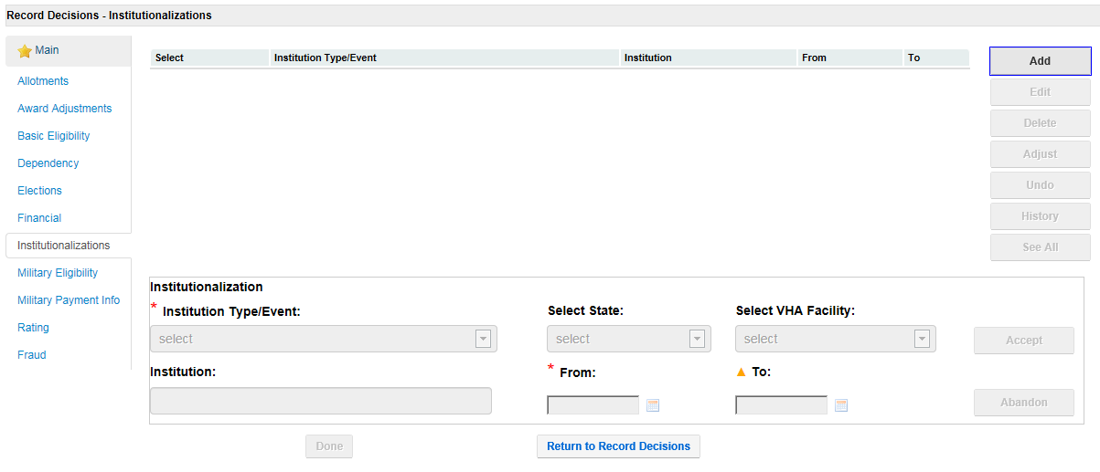

Click on the “Institutionalizations” tab, then click “Add.”

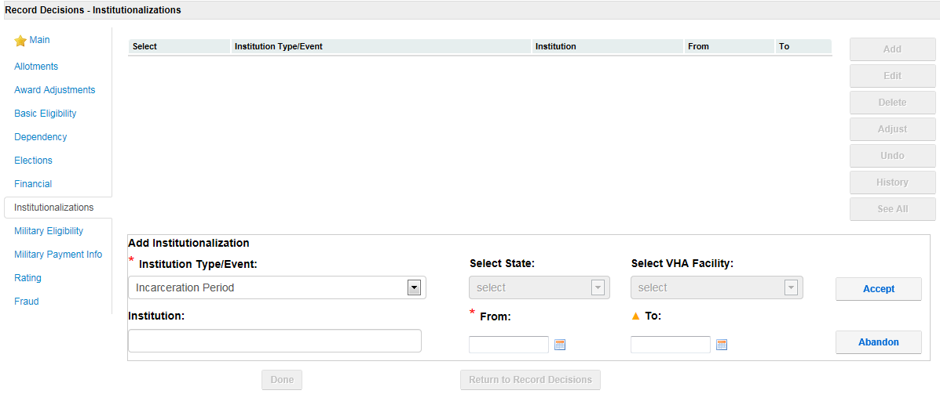

Change the “Institution Type/Event” to “Incarceration Period.” Enter the name of the “Institution,” as well as the “From” date and “To” date (if applicable – if there is no known release date, leave this field blank). Once all applicable information is entered, click “Accept.”

***Important:*** In the “From” field, be sure to enter the first ***full*** day of incarceration following conviction. This is *usually* the day after the date of conviction. This will allow the system to properly adjust the Veteran’s award. In this example, the date of conviction would be 05/05/2014. Therefore, we would enter 05/06/2014 as the first FULL day of confinement following conviction.

Use the VSR Assistant Resources 61-Day Rule Incarceration Calculator to compute the date of reduction. See below.

Go to the C&P Website then click on the Training Homepage. On the left side of the screen, hover over RVSR & VSR EPSS/Assistant then click on VSR & RVSR Assistants. At the top of the page, click on VSR Assistant. Once brought to the VSR Assistant, click on RESOURCES on the top right of the screen. When the resources page pops up, click on Calculators in the box on the bottom left of the page. Then click on 61-Day Rule Incarceration Calculator. This screen will pop up; enter the applicable date and hit Calculate.

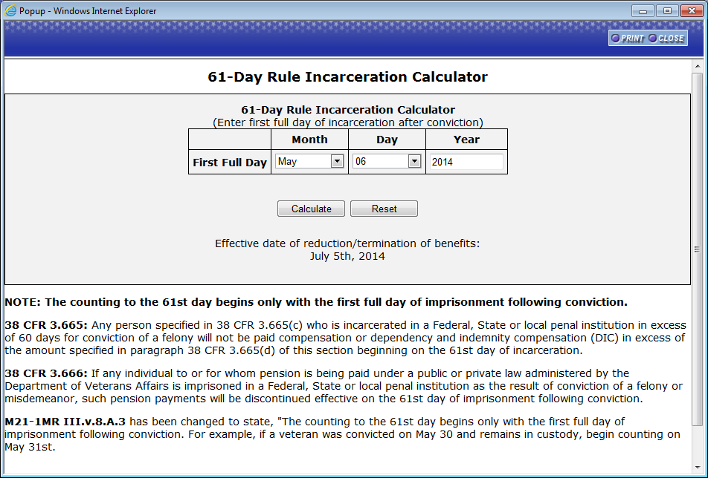

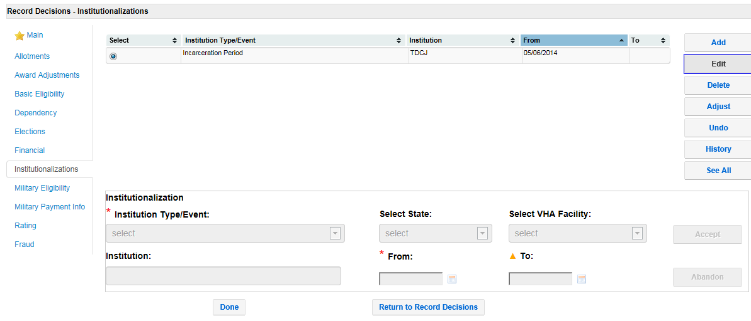

Once you click on “Accept” on the previous screen, you will be taken back to the main “Institutionalizations” screen. You will notice the period of incarceration showing at the top of this screen.

**NOT DONE YET!** There is one more entry to make. Click “Adjust.” This **must** be done in order for the actual withholding to be made.

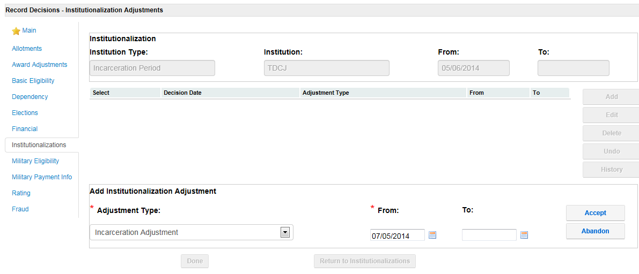

On the “Institutionalization Adjustments” screen, change the “Adjustment Type” to “Incarceration Adjustment.” The “From” and “To” fields should automatically populate the date of reduction based on the entries made on the “Add” tab. Double check to make sure this date is correct based on what the 61-Day Rule Incarceration Calculator shows. If the Veteran is still incarcerated the “To” field should remain blank. If all information is correct, click “Accept” and the withholding should be made once the award is generated.

Attachment D: Sample Decision Notice

NOTE: This letter depicts the verbiage for a Veteran receiving compensation. Verbiage pertaining to the regulations will change based on the benefit entitlement (pension, death pension, DIC, etc.).

Department of Veterans Affairs

335/21/Your Initials

CSS xxx xx xxxx

VETERAN, John Q.

In Reply Refer To:

JOHN Q VETERAN

ADDRESS 1

ADDRESS 2

Change highlighted items based on each individual case.

Dear Mr. Veteran:

We have been notified by the Anywhere Department of Criminal Justice that you have been sentenced to a 4 -year prison sentence. We have also been notified that your date of confinement, following conviction, was May 28, 2014. Effective October 7, 1980, the law (38 USC 5513) governing payment of benefits to veterans and other beneficiaries who are imprisoned in a Federal, State, or Local penal institution for the conviction of a felony has been changed. The law provides, in part, that disability compensation from the Department of Veterans Affairs (VA) be reduced to

A. one-half of the ten-percent (10%) rate for a veteran with a disability evaluation of less than 20 percent, or,

B. the ten percent (10%) rate for any veteran with an evaluation of twenty percent (20%) or greater.

This reduction will be effective the 61st day of confinement, following conviction.

Payment will be restored to the full rate as of the date of your release from prison if you notify us within one year from the date of your release. If the notice is not timely received, payment may only be resumed from the date of receipt of your claim.

We have reduced your VA disability compensation to the rate of $130.94 per month effective July 27, 2014, which is the 61st day of your confinement, following conviction. Your rate becomes $133.17 per month effective December 1, 2014, due to a cost of living adjustment.

Change highlighted items based on each individual case.

An apportionment of your disability compensation benefits which is not payable to you may be authorized for your dependents upon receipt of a claim from you or your dependents. The apportionment may become effective the date your benefits are reduced (the 61st day of your confinement after conviction) provided the claim is received within 1 year of the date of this letter. We will have to consider such factors as the total amount of compensation payable, the income and living expenses of the claimant(s), and any special needs of the claimant(s).

If you wish to file for an apportionment on their behalf, please be sure to respond on the enclosed *VA Form 21-0788, Information Regarding Apportionment of Beneficiary’s Award*, making sure to provide us with a current address for your dependent(s). This evidence must be submitted as soon as possible, preferably within 60 days. In any case, it must be received in the Department of Veterans Affairs (VA) within one year from the date of this letter; otherwise, benefits, if entitlement is established, may not be paid prior to the date the form is received. Please show your full name and VA file number on all correspondence or evidence submitted.

**Need to add evidence section (specific to case) and applicable laws/regulations.**

**Evidence Used to Make Our Decision**

In making our decision, we considered the following evidence:

* Bureau of Prisons computer match run February 6, 2015
* VA Form 27-0820e, Report of Incarceration, documenting our call to ADCJ on March 3, 2015, verifying your incarceration and conviction dates
* Our letter to ADCJ dated March 8, 2015, requesting complete information regarding your incarceration and conviction
* VA Form 21-4193, Notice to Department of Veterans Affairs of Veteran or Beneficiary Incarcerated in Penal Institution, received from ADCJ on March 20, 2015, verifying your incarceration and conviction dates

**Applicable Laws/Regulations**

38 CFR 3.31; 38 CFR 3.665; 38 CFR 3.666

**What Is eBenefits?**

eBenefits provides electronic resources in a self-service environment to Servicemembers, Veterans, and their families. Use of these resources often helps us serve you faster! Through the eBenefits website you can:

* Submit claims for benefits and/or upload documents directly to the VA
* Request to add or change your dependents
* Update your contract and direct deposit information and view payment history
* Request a Veterans Service Officer to represent you
* Track the status of your claim or appeal
* Obtain verification of your military service, civil service preference, or VA benefits
* And much more!

Enrolling in eBenefits is easy. Just visit www.eBenefits.va.gov for more information. If you submit a claim in the future, consider filing through eBenefits. Filing electronically, especially if you participate in our fully developed claim program, may result in faster decision than if you submit your claim through the mail.

**What You Should Do If You Disagree With Our Decision**

 If you do not agree with our decision, you have one year from the date of this letter to select a review option to preserve your earliest effective benefit date.  The review options and their proper applications are as follows for a(n):

* **Supplemental Claim,** complete **VA Form 20-0995,** Decision Review Request: Supplemental Claim
* **Higher-Level Review,** complete **VA Form 20-0996**, Decision Review Request: Higher-Level Review
* **Appeal to the Board of Veterans’ Appeals**, complete **VA Form 10182**, Decision Review Request: Board Appeal (Notice of Disagreement)

Please see the enclosed VA Form 20-0998, Your Rights To Seek Further Review Of Our Decision.  It explains your options for an additional review.  You may obtain any of the  required applications by downloading them from www.va.gov/vaforms/ or by contacting us.  You can also learn more about the disagreement process at [www.va.gov/decision-reviews/](http://www.va.gov/decision-reviews/).   If you would like to obtain or access evidence used in making this decision, please contact us as noted below.   Some evidence may be obtained by signing in at [www.va.gov](http://www.va.gov/).

**If You Have Questions or Need Assistance**

If you have any questions, you may contact us by telephone, e-mail, or letter.

|  |  |
| --- | --- |
| **If you** | **Here is what to do.** |
| Telephone | Call us at 1‑800‑827‑1000. If you use a Telecommunications Device for the Deaf (TDD), the Federal number is 711. |
| Use the Internet | Send electronic inquiries through the Internet at https://iris.custhelp.va.gov. |
| Write | VA now uses a centralized mail system. For all written communications, put your full name and VA file number on the letter. Please mail or fax all written correspondence to the appropriate address listed on the attached *Where to Send Your Written Correspondence*. |

Centralized Mail Changes

In all cases, be sure to refer to your VA file number xxx xx xxxx.

If you are looking for general information about benefits and eligibility, you should visit our website at https://www.va.gov, or search the Frequently Asked Questions (FAQs) at https://iris.va.gov.

We have no record of you appointing a service organization or representative to assist you with your claim. You can contact us for a listing of the recognized veterans' service organizations and/or representatives. Veterans' service organizations, which are recognized or approved to provide services to the veteran community, can also help you with any questions.

Choose one based on your case.

A copy of this letter was sent to the **applicable POA name** because you appointed them as your representative. If you have questions or need assistance, you can also contact them.

Sincerely yours,

Centralized Mail Changes

RO Director

VA Regional Office

Email us at: https://iris.va.gov

Will need to add manually (don’t forget to actually print & attach to the letter).

cc: applicable POA name

Enclosure(s): VA Form 20-0998

Where to Send Your Written Correspondence

Attachment E: Incarceration-Related Apportionment Checklists

Pension Checklist

|  |  |  |
| --- | --- | --- |
| **Yes** | **No** | **Question** |
| **Effective date** | | |
|  |  | Has the beneficiary been imprisoned for more than 60 days following conviction of a felony or a misdemeanor?  **Yes ⇒ Pension payments are subject to discontinuance.** |
|  |  | Was the claim for the apportionment received within 1 yr. from the date or within one year of notification of discontinuance of the Veterans pension payments?  **Yes⇒The apportioned award will be effective no earlier than the first day of the Veteran’s non-entitlement**  **No⇒The apportioned award will be effective the date VA received the claim. Use EP 130 is control for all apportionment claims.**  **Important: Offset the award by the amount of prior payments to the Veteran over the same period, if any, and pay the difference for that period.** |
| **Adjustment** | | |
|  |  | Does the income of the dependents exceed the income limits applicable to the payment of Survivors Pension?  The apportion award cannot exceed the lesser of   1. Survivors Pension payable, or 2. Amount the Veteran was receiving at the time of imprisonment. |
| **Notification** | | |
|  |  | Does the imprisoned Veteran have a spouse or child? (Does the imprisoned surviving spouse have a child in his or her custody?)  **Yes ⇒ Advise the beneficiary (or beneficiary’s fiduciary) in the notice of proposed adverse action that VA may apportion benefits to any of these dependents on receipt of a claim for apportionment from the eligible dependents. Notify the dependents of their right to an apportionment if there is evidence of their existence and their address is available**  **No ⇒ No action necessary** |
|  |  | Did we advise the dependent once the apportionment was/is granted that the apportionment is a special apportionment and granted for the period of the beneficiary’s incarceration and is subjected to immediate discontinuance when the incarcerated person is released, and the dependent must submit a new claim for apportionment once the Veteran is released? |
| **Claimants Need** | | |
|  |  | Did we consider the following “Individual Needs” of the apportionment claimant?  The claimant’s income and living expense  The amount of pension available for apportionment  The needs and any expenses of other claimants, and  Are there any special needs of any claimants? |
|  |  |
|  |  |
|  |  |
|  |  |
| **Resumption of benefits** | | |
|  |  | Did VA receive official notice dated no more than 30 days before the anticipated release from prison?  **Yes⇒ VA may resume benefits prospectively from the anticipated date of release based on evidence received from a parole board or other official source showing a Veteran’s scheduled release date.**  **No⇒ An adjustment should not be made.** |
|  |  | Did VA receive notice of release within one year of the date of release?  **Yes ⇒ Resume the payment of benefits effective the day of release**  **No ⇒ Resume the payment of benefits effective the day VA received the notification of release.** |
|  |  | If the incarcerated beneficiary was a Veteran, did benefits during incarceration because he/she was entitled to pension only?  **Yes ⇒ Resume pension if current entitlement exists.** |
| **Remember:** *We cannot create an overpayment on the Veteran and re-pay those same benefits to the apportionee* | | |

Compensation/DIC Apportionment Checklist

|  |  |  |
| --- | --- | --- |
| **Yes** | **No** | **Question** |
| **Adjustment** | | |
|  |  | Has the beneficiary been imprisoned for more than 60 days and was it for a felony?  **Yes ⇒ Compensation payments are subject to reduction.** |
|  |  | Was the claim for the apportionment received within one year of the date VA notified the Veteran (surviving spouse) of the rights of his/her dependent(s) to an apportionment during his/her incarceration?  **Yes⇒The effective date of the apportionment is the 61st day of incarceration**  **No⇒The effective date of the apportionment is the date VA received the claim. Use EP 130 to control apportionment claims.**  **Important: Offset the award by the amount of prior payments to the Veteran over the same period, if any, and pay the difference for that period.** |
|  |  | Does the withholding field of the Veteran’s (surviving spouse’s) award reflect the total amount of benefits reduced due to the incarceration, even if the total amount is not apportioned? |
| **Notification** | | |
|  |  | Does the imprisoned Veteran have a spouse or child? (Does the imprisoned surviving spouse have a child in his or her custody?)  **Yes ⇒ Advise the beneficiary (or beneficiary’s fiduciary) in the notice of proposed adverse action that VA may apportion benefits to any of these dependents on receipt of a claim for apportionment from eligible dependents. Notify the dependents of their right to an apportionment once there is evidence of their existence and their address is available**  **No ⇒ No action necessary** |
|  |  | Did we advise the dependent once the apportionment was/is granted that the apportionment is a special apportionment and granted for the period of the beneficiary’s incarceration and is subjected to immediate discontinuance when the incarcerated person is released, or begin participation on a work release, halfway house or residential re-entry enter program, and the dependent must submit a new claim for apportionment once the Veteran is released? |
| **Claimants Need** | | |
|  |  | Did we consider the following “individual needs” of the apportionment claimant?   * The claimant’s income and living expenses * the amount of compensation (DIC) available for the apportionment * the needs and living expenses of other claimants * special needs of any claimants |
|  |  |
|  |  |
|  |  |
|  |  |
| **Resumption of benefits** | | |
|  |  | Did VA receive notice of release from prison within one year of the date of release?  **Yes⇒Resume compensation (DIC) at the full rate effective the day of release.**  **No⇒Resume compensation (DIC) at the full rate effective the day that VA receives notification of release.** |
|  |  | If the incarcerated beneficiary was a Veteran, was he/she in receipt of compensation while incarcerated, and is he or she entitled ONLY to compensation?  **Yes⇒Resume compensation at the full rate.** |
|  |  | If the incarcerated beneficiary was a Veteran, was he/she receiving compensation while incarcerated and is he or she entitled to both compensation and pension?  **Yes⇒Upon release, authorize payment of the greater of either pension or compensation** |
|  |  | If the incarcerated beneficiary was a Veteran, did he/she request an increase or claim service connection for additional disabilities upon release from incarceration?  **Yes⇒ Undertake any necessary development concurrently with any other action to resume benefits following release from prison.** |
|  |  | If the incarcerated beneficiary was a Veteran, was he/she reunited with all apportionees upon release from prison?  **Yes⇒ He or she is entitled to restoration of the full monthly benefit, effective the day after discontinuance of any apportionment. (Example #1)**  **No⇒ Withhold from the Veteran’s award the additional amount for dependents not reunited with the Veteran. (Example #2)** |
| **Remember:** *We cannot create an overpayment on the Veteran and re-pay those same benefits to the apportionee* | | |