EFFECTIVE DATES
(Intermediate)
Trainee Handouts

PREREQUISITE TRAINING | Prior to this training, the VSRs must have completed the following lessons: Effective vs. Payment date; CRDP/CRSC; Advanced Dependency; and Incarceration.
PURPOSE OF LESSON  objectives | The purpose of this lesson is to provide continued training in determining effective dates and how this applies to a Veteran’s compensation benefits. This lesson will present the following material to the VSRs:  - Review the basics of determining effective dates.  - Recognize the factors to determine effective dates.
Time Required | 1.5 hours: Class presentation and demonstration
Instructional Method | Lecture, participatory discussion and practical application.
Materials/ Training Aids | Effective Date - Chart

Table of Contents
References 3
Review 4
Claim Types 5
Review Exercise 6
Prepared Practical Exercises with Forms and Scenarios 8

References

38 U.S.C. 5110: Effective dates of awards
38 CFR 3.1(r): Date of receipt
38 CFR 3.400: Effective dates: General
38 CFR 3.401: Effective dates: Veteran
38 CFR 3.654: Active Service Pay
38 CFR 3.665: Incarceration - Compensation
38 CFR 3.666: Incarceration - Pension
38 CFR 3.667: School Attendance
38 CFR 3.750: Military Retired Pay

M21-1MR, Part III.iii.5: Relationship and Dependency
M21-1MR, Part III.iii.6: School Attendance
M21-1MR, Part III.v.5: Military Retired Pay
M21-1MR, Part III.v.8: Incarceration

Electronic Performance Selective System Tool (EPSS): Effective Dates
Effective date
(Review)

38 CFR 3.400 (General)
Except as otherwise provided, the effective date of an evaluation and award of pension, compensation or dependency and indemnity compensation based on an original claim, a claim reopened after final disallowance, or a claim for increase will be the date of receipt of the claim or the date entitlement arose, whichever is the later. (Authority: 38 U.S.C. 5110(a).)
38 CFR 3.1(r)

"Date of receipt" means the date on which a claim, information or evidence was received in the Department of Veterans Affairs.

Date of Claim

The “date of claim” for claims establishment purposes is the earliest date the claim was actually received by any Department of Veterans Affairs facility. The term “VA facility” includes, but is not limited to

- Your regional office (RO) or pension management center (PMC)
- Another VARO or PMC if the claim was first received there before being forwarded to your office
- A VA medical center (VAMC) if the claim was first received there before being forwarded to your office

VA requires a date stamp, indicating this earliest date received, on all of the following information received by the RO mailroom: claims, applications, and associated evidence.
Date Entitlement Arose
Date entitlement arose is the earliest date as of which evidence shows that it is factually ascertainable that entitlement to VA benefits is warranted.

Refer to the review exercise on page 6.

TYPES OF CLAIMS
AND
CORRESPONDING EFFECTIVE DATES

(a) Dependency:
1. Spouse
2. Child: under 18, 18-23 and Helpless
3. Parent Note: This will be addressed during the Journey level lesson.

(b) Military Adjustments:

1. Returned to Active Duty
2. Release of Active Duty (RAD)
3. Drill Pay
4. Temporary Disability Retired List to Severance pay
5. Retired Pay

(c) Incarceration:

1. Compensation

2. Pension
Effective Date vs. Payment Date
(Compensation)

Fill in the Effective Date and Payment Date for each example below.

Release of Active  Duty (RAD) | Claim Type | Date of Claim | S/C Grant | Effective Date | Payment Date
04-15-06 | Original | 04-03-07 | 04-16-06
06-12-05 | Reopen | 07-12-06 | 09-15-06
12-13-72 | Presumptive | 09-12-07 | 04-09-07
07-05-06 | Informal date  12-05-06 | 08-19-07 | 07-06-06
04-15-98 | Increase | 01-05-08 | 09-22-07

Effective Date vs. Payment Date
(DEPENDENCY)

Effective  Date for a  grant of  30% or more | Date VA  Notified the Veteran | Event | Date Evidence Received | Effective Date
04-15-98 | 03-25-07 with  686c sent | Married 05-01-00  Child born 06-07-02 | 04-27-07 | Spouse  Child
06-12-05 | 06-30-05 with  686c sent | Married 11-15-35 | 07-12-06
12-13-06 | 12-30-06 with  686c sent | Married 04-09-07 | 09-12-07
07-05-06 | 07-15-06  with 686c sent | Married 08-15-03  Child born 08-25-06 | 08-19-07 | Spouse  Child
04-15-98 | 03-25-07  with 686c sent | Married 09-15-92  Child born 03-12-00  Child born 03-19-98  Child born 06-19-07 | 01-05-08 | Spouse  Child  Child  Child
Review Exercises

Note: This exercise will give the VSR a realistic view of processing claims and determining the proper effective date.

Use the enclosed VA Forms to prepare effective dates for dependency awards:

1. 21-686c Single spouse

2. 21-686c Spouse with prior marriages

3. 21-686c Spouse with priors and 1 biological child

4. 21-686c Spouse with priors, 2 under 18 and 1 step (lives with ex spouse)

5. 21-674 Student going to college with grad date

6. 21-674 Student turns 18 and goes to college after summer break

7. 21-674 Student going to college after turning 18 and graduates after 23rd birthday

8. 21-4138 Returned to Active Duty

9. 21-8951 Drill Pay

10. 21-4193 Incarceration (Comp)

1.
Today’s Date: October 13, 2009
Date claim received: September 1, 2009
Initial notification sent: March 11, 2009
Granted 30% SC effective July 5, 2008.

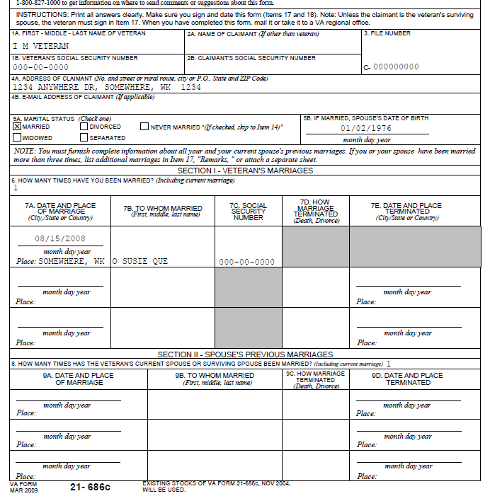

Can we award additional dependency benefits? Yes/No Why?

If so, provide the effective date and reference to support your decision.

2.
Today’s Date: October 13, 2009
Date claim received: September 1, 2009
Initial notification sent: November 6, 2008
Granted increased SC rating from 20% to 40% effective March 4, 2008

Can we award additional dependency benefits? Yes/No Why?

If so, provide the effective date and reference to support your decision.
3.
Today’s Date: October 13, 2009
Date claim received: September 1, 2009
Granted 40% SC effective February 15, 2008
Initial notification sent: July 15, 2008

Can we award additional dependency benefits? Yes/No Why?

If so, provide the effective date and reference to support your decision

4.
Today’s Date: September 13, 2009
Date claim received: March 15, 2009
Review of the file shows an original grant of 30% effective May 23, 2005, and paid benefits are based on single rate. Initial notification sent: August 7, 2006
New rating for an increase to 60% SC effective May 15, 2008, notified July 12, 2008.

Can we award additional dependency benefits? Yes/No Why?

If so, provide the effective date and reference to support your decision.

5.
Today’s Date: September 13, 2009
Date claim received: March 15, 2008
Original grant 30% SC effective May 23, 2005. Increase to 60% SC effective May 15, 2008

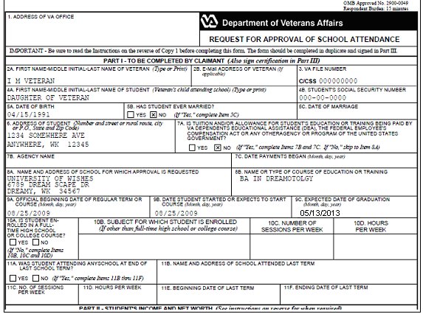

Can we award additional dependency benefits? Yes/No Why?

If so, provide the effective date and reference to support your decision.

6.
Today’s Date: June 20, 2009
Date claim received: May 1, 2009
Son of Veteran signed application dated April 20, 2009

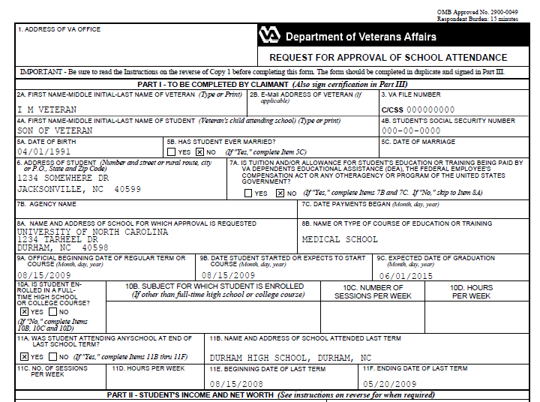

Can we award additional dependency benefits? Yes/No Why?

If so, provide the effective date and reference to support your decision.

7.
Today’s Date: September 13, 2009
Date claim received: March 15, 2008
Currently receiving 60% SC effective May 15, 2008.

Can we award additional dependency benefits and why?

If so, provide the effective date and reference to support your decision.
8.
Today’s Date: September 13, 2009
Date claim received: March 15, 2008
Refer to the below VA Form 21-4138, statement from the Veteran.

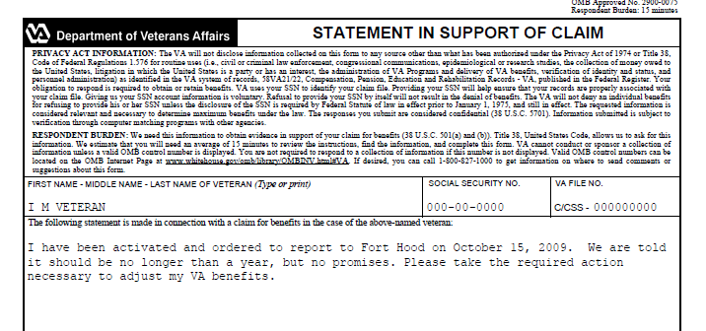

Provide the effective date and reference to support your decision.
9.
Today’s Date: September 13, 2009
Date claim received: March 15, 2009
Veteran was 20% SC effective May 23, 2005. Increase to 60% SC effective May 15, 2008
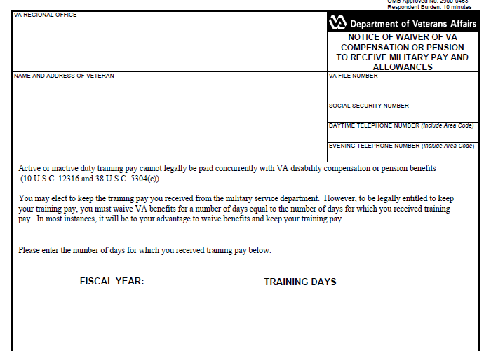

FY 07

123 DAYS

What will be the proposed withheld amounts and the “from and to” dates?

10.
Today’s Date: September 13, 2009
Date claim received: March 15, 2008
Currently receiving 30% SC effective May 23, 2005.
Due Process expired. No reply
07/04/2008
07/15/2008
5 YEARS

Provide the effective date and reference to support your decision.

