SHARE-SSA/FOLQ

Trainee Handout

**Table of Contents**

Objectives 2

References 3

Topic 1: Federal On-Line Query (FOLQ) 4

What is FOLQ? 4

Accessing FOLQ 4

Topic 2: SSA Inquiry 6

Using the SSA Inquiry Command in SHARE 6

Combined SSA Payment to a Veteran and Spouse 6

Combined SSA Payment to a Surviving Spouse and Child(ren) 7

Topic 3: SHARE SSA Inquiry Screens 7

SSA Inquiry Command 7

Response Screen – Profile 9

Response Screen – SSA Basic Info 10

Response Screen – Income History 11

Response Screen – SSI Basic Info 12

Practical Exercise 13

Objectives

Upon completion of this lesson, the trainee will be able to:

* recognize what the SHARE-SSA/Federal On-Line Query (FOLQ) program is and who has access to it,
* perform the inquiry function of the SHARE-SSA/FOLQ program,
* apply the information of each SHARE-SSA/FOLQ response screen to perform job-related tasks, and
* interpret SHARE-SSA/FOLQ messages.

References

* M21-1 Part III, Subpart iii, 3.A.3 – Obtaining Information Through Federal On-Line Query (FOLQ)
* M21-1 Part III, Subpart iii, 3.A.4 – VA Requests for Verification of SSA Monthly Payments
* SHARE User Guide
* SSA Federal On-Line Query (FOLQ) System User Guide

Topic 1: Federal On-Line Query (FOLQ)

What is FOLQ?

For a number of years, SSA used a process that bundled individual requests for information. This process was called the State Verification and Exchange System (SVES). With the increased computerized capability of both SSA and its partners, there was an increased need to process requests in real time. So SSA developed a way for states and other agencies to obtain certain data through a read-only, real-time query. The data presented through SVES is now shared through the State On Line Query (SOLQ), or with federal agencies through the Federal On-Line Query (FOLQ). This system provides the following information:

* verification of SS numbers,
* Title II, Retirement, Survivors, and Disability Insurance data,
* Title XVI, Supplemental Security Income data, and
* a Payment history file.

VBA is obligated to verify Social Security numbers and income information submitted by applicants and beneficiaries. Access to FOLQ enables VBA to assist Veterans and dependents by providing instant verification of the information on applications and post-entitlement reviews, such as EVR processing. This also helps reduce processing time and increases the accuracy of information.

FOLQ was designed with all VBA divisions in mind. Therefore, you may see data that you would not normally use. Veterans Service Representatives (VSRs) will see fields more commonly used by the Insurance Service and visa versa. Also, by General Counsel requirement, the Insurance Service personnel are barred from access to the income information. Therefore, employees of the Insurance Service will not see financial data. Instead, it will be either grayed out or blank.

Accessing FOLQ

**Access FOLQ Through Share using the SSA Inquiry Command**

SHARE is presented in a Windows environment (not web-based) for inquiry against databases. In the case of SSA, VBA is making inquiry against a database designed to meet the needs of State and Federal agencies.

For more information on

* FOLQ, see the [FOLQ User Guide](http://vbaw.vba.va.gov/bl/21/publicat/Users/SSA/index.htm)*,* and
* SHARE, see the [SHARE User Guide](http://css.vba.va.gov/SHARE/) and updated information via the application’s HELP menu.

FOLQ is used to obtain or verify a Veteran/claimant’s:

* Vital information – SSN, address, and/or dates of birth and death
* Social Security benefit information
* Unearned income history
* SSI information

**Who is Allowed Access?**

The only employees that will be allowed access are Veterans Service Representatives (VSRs) and their supervisors, and Insurance Specialists and Technicians and their supervisors.

Restrictions for Users:

1. SSA data is third party information. Use of information from SSA in this application does not change any previous instruction regarding the use of SSA data. Even though this information comes directly from Social Security, the Veteran still has the right to due process for any adverse action that you consider taking based on this data. Use of SSA data is under the restrictions of the Privacy Act. As third party information, any potential adverse action requires due process as given in current policy and procedures.
2. Use of the data is for the specific purpose of verifying information and processing claims of Veterans and their beneficiaries. Any other use is considered a violation of trust. All employees will treat the query information in a manor consistent with the requirements of the Privacy Act and all applicable regulations. Any other use will be considered a violation of trust.

***Important*:** Before you begin using FOLQ, remember that the intentional inquiry into a file that is not required to perform your job is a violation of both state and federal law, and may result in felony prosecution.

**Personal Statement of Agreement**

Initially, and then annually, all users must sign a **Certificate of Understanding**. On this document, the user certifies understanding of the requirements and penalties involved in misusing SSA information. This emphasizes the importance of following Privacy Act requirements and ensures all users agree to those requirements. The absence of this signed form, or lack of agreement by an employee, will prevent any access to FOLQ.

**Security System**

VBA has a audit system which runs behind the transactions being processed. This system is designed to identify improper use. While misuse of the system is not anticipated, VBA must be able to demonstrate to SSA and agency overseers that SSA data is appropriately used. Local managers and Central Office staff will monitor this system.

Topic 2: SSA Inquiry

Using the SSA Inquiry Command in SHARE

Use the SSA Inquiry command in Share to verify the monthly amount of benefits SSA paid to a:

* Veteran,
* Veteran’s spouse or surviving spouse,
* Veteran’s surviving child(ren), and/or
* Veteran’s parent(s).

The SSA Inquiry command requires the user to provide, for each individual for whom information is needed, the Veteran/claimant’s:

* name,
* SSN,
* date of birth,
* VA file number, and
* the reason for inquiry.

Combined SSA Payment to a Veteran and Spouse

SSA may issue a combined payment to a beneficiary and his/her spouse, although the benefit is based on the employment of only one spouse, if:

* both the wage earner and spouse reside at the same address,
* neither spouse
  + is incompetent, nor
  + voices any objection to combining of the payment, and
* no other reason exists that would make combining of the payment undesirable, such as entitlement by the dependent spouse to old-age insurance or Social Security benefits on his/her own account.

***Important***: Consider only the amount of the combined payment that represents the Veteran’s portion as his/her income.

Combined SSA Payment to a Surviving Spouse and Child(ren)

Under SSA procedures, a surviving spouse with a child, or children, may continue to receive Social Security benefits in his/her own name but, because of earnings, one or more of these checks must be for the benefit of the child or children in his/her custody.

Topic 3: Share SSA Inquiry Screens

SSA Inquiry Command

Social Security Inquiry allows the verification of social security numbers. It is a Federal policy to verify the Social Security Number (SSN) of all the recipients of federally-funded aid. Data obtained by Social Security Administration (SSA) may be used to establish eligibility. Social Security Inquiry may be submitted to verify a person's SSN, personal information, Veteran's death, or to verify benefits.

VBA Veteran Benefit Administration is obligated to verify SSNs and income information submitted by applicants and beneficiaries. Access to FOLQ Federal On Line Query will enable VBA to assist Veterans and dependents by providing instant verification of the information on applications and post-entitlement reviews, such as EVR processing. This will help reduce processing time and increase the accuracy of information.

SSA Inquiry will retrieve only those records for which a Beneficiary Identification and Records Locator Subsystem (BIRLS) record exists. If the user searches for a file number which does not exist in BIRLS, an error message is displayed.

**For inquiries for *dependents* related to the Veteran:**

* The relationship must already be established in the Veteran’s profile (SHARE and/or VBMS) prior to attempting to do the SSA Inquiry.

1. Select SSA Social Security Administration Inquiry from the Available Processes list on the Ready Screen.
2. In Search Criteria, type the Veteran's File Number or SSN.
3. Under SSA Inquiry Data, enter the SSN Social Security Number, First Name and Last Name of the established dependent and the DOB Date of Birth, and Inquiry Reason.
4. Enter the Submit button.

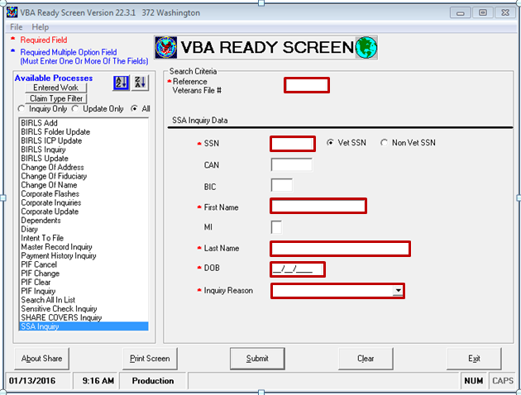

Response Screen – Profile

This screen displays the Veteran/claimants’s vital information – verified SSN, address, dates of birth and death. This is the first screen displayed after a ***successful*** SSA inquiry. Unsuccessful inquiries will result in an SSA message. Descriptions of each message can be found in the FOLQ User Guide.

**SSA Messages**

Upon an ***unsuccessful*** SSA inquiry, one of several messages may appear.

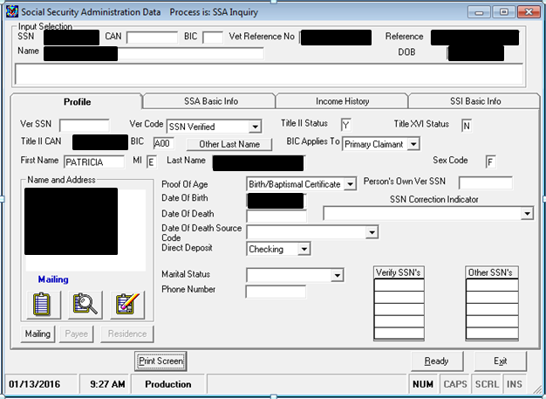

Response Screen – SSA Basic Info

The SSA Social Security Administration Basic Info screen displays Veteran/claimant payment amounts, dates and account numbers, and related information. The Basic Info screen is the second screen displayed after a successful SSA inquiry.

The SMI fields reflect Supplemental Medical Insurance – part B (SMIB), deducted from monthly SSA benefits. The beneficiary is not paying “out of pocket” for SMIB if the SMI Buy-In Option Code is any of the following:

* Pd by Private Party
* Pd by 3rd Party
* Pd by State
* Pd by Civil Service

If this is the case, when processing NSC Penstion, the SMIB should ***not*** be counted as a recurring medical expense.

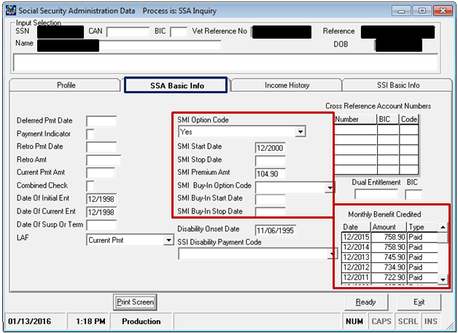

Response Screen – Income History

The Income History screen displays the Veteran/claimant’s unearned income. It provides information about the Veteran’s income type, amount, start and end dates, Federal Countable Income (FCI), and earned amount.

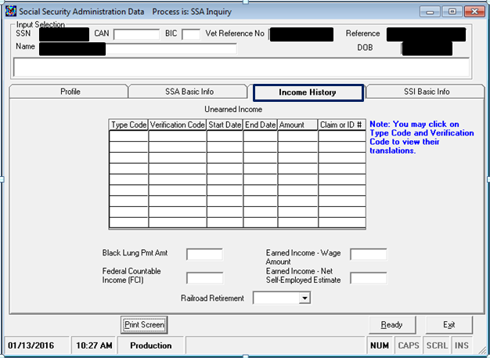

Other potential earned income entitlements

Current month’s amount of unearned income after all exclusions

Response Screen – SSI Basic Info

This screen will show if the beneficiary is receiving SSI benefits. SSI benefits do not affect NSC Pension, as this is benefit is public assistance. These are unearned incomes and gross payable amounts.

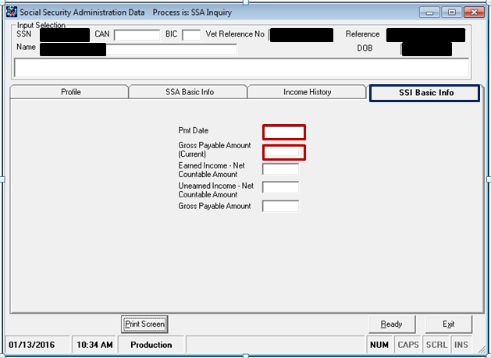

Practical Exercise

1. All users must sign a _________________________. On this document, the user is certifying understanding of the requirements and penalties involved in misusing the SSA information received through FOLQ.
2. Which screen is the first screen displayed after a ***successful*** SSA inquiry?
3. What 5 elements does the SSA Inquiry command require the user to provide?
   1. ______________________
   2. ______________________
   3. ______________________
   4. ______________________
   5. ______________________
4. What must be done prior to making an inquiry for dependents related to the Veteran?
5. Who is authorized to access FOLQ?
6. Which reference would you use to find the explanation of SSA messages received after an ***unsuccessful*** SSA inquiry?