Entitlement to Individual Unemployability Benefit
(Post Challenge VSR & RVSR)
Instructor Lesson Plan
Time Required: 4.5 Hours

Table of Contents

Lesson Description 2
Introduction to Individual Unemployability 4
Topic 1: Eligibility Criteria for Individual Unemployability 5
Topic 2: Developing IU Claims 10
Topic 3: Promulgation Considerations for IU 18
Practical Exercise 23
Lesson Review, Assessment, and Wrap-up 24

Lesson Description
The information below provides the instructor with an overview of the lesson and the materials that are required to effectively present this instruction.
TMS # | 1197926
Prerequisites | Prior to this lesson, the Veteran Service Representatives (VSRs), Rating Veteran Service Representatives (RVSRs), Decision Review Officers (DROs), and Quality Review Specialists (QRSs) should have completed Challenge training.
target audience | The target audience for Entitlement to Individual Unemployability (Post Challenge VSR & RVSR) is for VSRs and RVSRs who have completed Challenge training, DROs, and QRSs. Although the VSR will be undertaking the necessary development actions, an RVSR/DRO must also know what information is required before they can appropriately decide a claim. The A/RQRSs must also know this information in order to properly review claims for quality.
Time Required | 4.5 hours
Materials/  TRAINING AIDS | Lesson materials:  - Claims Based on Entitlement to Individual Unemployability PowerPoint Presentation and Handout.
Training Area/Tools | The following are required to ensure the trainees are able to meet the lesson objectives:  - Classroom or private area suitable for participatory discussions  - Seating, writing materials, and writing surfaces for trainee note taking and participation  - Handouts, which include a practical exercise  - Large writing surface (easel pad, chalkboard, dry erase board, overhead projector, etc.) with appropriate writing materials  - Computer with PowerPoint software to present the lesson material  Trainees require access to the following tools:  - VA TMS to complete the assessment  - Compensation Service Publications webpage  - Internet access for Compensation Pension Knowledge Management (CPKM)  - Internet access for Electronic Code of Federal Regulations
Pre-Planning | - Become familiar with all training materials by reading the Instructor Lesson Plan while simultaneously reviewing the corresponding PowerPoint slides. This will provide you the opportunity to see the connection between the Lesson Plan and the slides, which will allow for a more structured presentation during the training session.  - Become familiar with the content of the trainee handouts and their association to the Lesson Plan.  - Practice is the best guarantee of providing a quality presentation. At a minimum, do a complete walkthrough of the presentation to practice coordination between this Lesson Plan, the trainee handouts, and the PowerPoint slides and ensures your timing is on track with the length of the lesson.  - Ensure that there are copies of all handouts before the training session.  - When required, reserve the training room.  - Arrange for equipment such as flip charts, an overhead projector, and any other equipment (as needed).  - Talk to people in your office who are most familiar with this topic to collect experiences that you can include as examples in the lesson.  - This lesson plan belongs to you. Feel free to highlight headings, key phrases, or other information to help the instruction flow smoothly. Feel free to add any notes or information that you need in the margins.
Training Day | - Arrive as early as possible to ensure access to the facility and computers.  - Become familiar with the location of restrooms and other facilities that the trainees will require.  - Test the computer and projector to ensure they are working properly.  - Before class begins, open the PowerPoint presentation to the first slide. This will help to ensure the presentation is functioning properly.  - Make sure that a whiteboard or flip chart and the associated markers are available.  - The instructor completes a roll call attendance sheet or provides a sign-in sheet to the students. The attendance records are forwarded to the Regional Office Training Managers.

 | Introduction to Individual Unemployability
 | INSTRUCTOR INTRODUCTION |  | Complete the following:  - Introduce yourself  - Orient learners to the facilities  - Ensure that all learners have the required handouts
 | time required |  | 0.25 hours
 | Purpose of Lesson |  | This lesson is intended to provide the trainees with the information required to develop a claim for entitlement to Individual Unemployability benefits, including any ancillary benefits. This lesson will contain discussions and exercises that will allow you to gain a better understanding of:  - Eligibility Criteria for Individual Unemployability  - Evidence Requirements for Individual Unemployability  - Claim Processing for Individual Unemployability
 | Lesson Objectives  Slide 2  Handout 2 | In order to accomplish the purpose of this lesson, the VSR, RVSR, DRO, or QRS will be required to accomplish the following lesson objectives:  Demonstrate a comprehensive understanding of  - eligibility criteria for individual unemployability (IU),  - development of claims for IU,  - promulgation of decisions for IU, and  - addressing continued entitlement to IU.
 |  | Each learning objective is covered in the associated topic. At the conclusion of the lesson, the learning objectives will be reviewed.
 | Motivation | Correct development of a claim for Individual Unemployability will prevent unnecessary development in the future and will ensure the Veteran receives the payments he/she is entitled to in a timely manner.
 | STAR Error code(s) | A1j- Failing to address claim for increase in condition(s) identified on 21-8940 as cause(s) of unemployability.  A1c- Failing to address claim for IU when the evidence shows that the Veteran is unemployable due to service connected conditions.  B2g- Failing to develop for 8940, or other employment history (if needed).  B2l-Failing to obtain SSA records which were identified by the Veteran.
 | References  Slide 3  Handout 2 | All M21-1 references are found in the Live Manual Website.  - 38 CFR 4.16, Total disability ratings for compensation based on unemployability of the individual  - M21-1, Part IV, Subpart ii.2.F, Compensation Based on Individual Unemployability (IU)  - M21-1, Part III, Subpart ii.2.B.1, Applications for Disability Compensation and/or Pension  - M21-1, Part I, Chapter 1.B.1, Notification Requirements for Claims Not Previously Denied
Topic 1: Eligibility Criteria for Individual Unemployability
Introduction |  |  |  | This topic will allow the trainee to gain a better understanding of what constitutes Individual Unemployability and the eligibility criteria for receipt of Individual Unemployability benefits.
Time Required |  |  |  | 0.5 hours
OBJECTIVES/  Teaching Points |  |  |  | The following topic teaching points support the overall objectives:  - Definition of Individual Unemployability  - Establishing Entitlement to Increased Compensation Based on Individual Unemployability  - Unemployed v. Unemployable  - Definition of Substantially Gainful Employment  - Definition of Marginal Employment  - Schedular Requirements  - 38 CFR 4.16(a) Requirements
What is IU?  Slide 4 |  |  |  | Ask Who can tell me what IU is?  Answers will vary, but should include information like:  The Individual Unemployability (IU) benefit is payable when a Veteran cannot secure or follow a substantially gainful occupation as a result of one or more service-connected disabilities.  Granting IU results in payment at the 100 percent (total) rate, although the Veteran does not have a schedular evaluation of 100 percent. It may also result in other benefits, such as Chapter 35, or possibly SMCs.  Note: IU is also referred to as total disability based on individual unemployability (TDIU).
Establishing Entitlement to Increased Compensation Based on IU  Slide 5 |  |  |  | To establish entitlement to a total disability rating for compensation based on individual unemployability (TDIU), the Veteran must be unemployable in fact by reason of SC disability and either  - meet the schedular requirements of 38 CFR 4.16, or  - have an extra-schedular evaluation approved by the Compensation Service (211B).  Explain IU can be either expressly raised by the Veteran (VA Form 21-8940 claiming IU, or other valid application including an indication of inability to work due to SC conditions), or reasonably raised by the record (the evidence shows that the Veteran meets schedular criteria and is unemployable due to SC conditions, so the RVSR infers and defers the issue). (M21-1IV.ii.2.F.2.a, m, n & o.)
Unemployed v. Unemployable  Slide 6 |  |  |  | The term unemployability is not synonymous with the terms unemployed and unemployable for the purpose of determining entitlement to increased compensation. A Veteran may be unemployed or unemployable for a variety of reasons, such as:  - economic factors  - work performance  Explain Not working is not that same as being unable to work. If a Veteran is simply unemployed because of a bad job market, that is not evidence that they are unemployable. If the Veteran has lost their job due to work performance, consideration will be given to whether their performance was impacted by their service connected disability(ies). (M21-1IV.ii.2.F.2.b.)  Example: A Veteran with PTSD is not performing well in a customer service oriented field because they are short tempered.
Definition:  Substantially Gainful Employment  Slide 7 |  |  |  | Substantially gainful employment is  - competitive (not protected) employment, and with  - earnings exceeding the amount established by the U.S. Department of Commerce, U.S. Census Bureau, as the poverty threshold for one person.  Explain A Veteran who is employed, but the employment does not meet the criteria of substantially gainful employment, is entitled to consideration of IU. (Protected environment is explained on the next slide.) (M21-1IV.ii.2.F.2.c.)  Emphasize The sole fact that a Veteran is employed does not automatically disqualify them from this benefit!
Definition:  Marginal Employment  Slide 8 |  |  |  | Marginal employment exists  - when a Veteran’s earned annual income does not exceed the amount established by the U.S. Department of Commerce, U.S. Census Bureau, as the poverty threshold for one person, or  - on a facts-found basis, and includes, but is not limited to, employment in a protected environment, such as a family business or sheltered workshop, when earned annual income exceeds the poverty threshold.  Examples of marginal employment include (but are not limited to) school bus drivers, ministers, crossing guard, etc. If the Veteran is working full time, but the reason they have been able to maintain such employment is because it is a family (or self) owned company, is considered protected employment and the Veteran is still entitled to consideration of IU. (M21-1IV.ii.2.F.2.d.)
Schedular Criteria under §4.16  Slide 9 |  |  |  | Veteran’s combined disability evaluation is not total (100%), but he/she has:  - One service-connected disability at 60% <OR>  - Two or more service-connected disabilities combined at 70% or more, with at least one rated at 40 % or more  Explain If the schedular criteria are not met, but the evidence of record supports a finding that the Veteran is unemployable by reason of SC disability, the case should be referred for extra-schedular consideration. (This would need to be prepared by the RVSR, as it is above the scope of a VSR to determine if the Veteran is unemployable.)  Prepare a memorandum to accompany (or for electronic upload and insertion into) the claims folder, providing a full statement of the issue(s) to be resolved and including the recommended evaluation. If the issue is consideration of extra-schedular entitlement under 38 CFR 4.16(b), also include a full statement of the following:  - Veteran’s SC disabilities  - employment history  - education and vocational attainment, and  - all other pertinent factors.  Attach a copy of the memorandum to an encrypted e-mail, and direct it to the following mailbox for review and consideration: VAVBAWAS/CO/211 Policy Staff.  (M21-1 III.iv.6.B.4.a.)
38 CFR 4.16(a)  Slide 10 |  |  |  | For the purpose of consideration as one 60 percent or one 40 percent disability, the following will be considered as one disability:  - disabilities of one or both upper extremities, or of one or both lower extremities, including the bilateral factor, if applicable  - disabilities resulting from common etiology or a single accident  - disabilities affecting a single body system  - multiple disabilities incurred in combat, or  - multiple disabilities incurred as a former prisoner of war (FPOW).  Explain Make sure to consider if the Veteran’s conditions fall into any of these categories! It is not always obvious that a Veteran does in fact meet schedular criteria just by a quick glance at the codesheet.  (M21-1IV.ii.2.F.2.e.)
38 CFR 4.16(a) Examples  Slide 11 |  |  |  | - Consider the following as one disability  - multiple disabilities granted as a result of herbicide exposure (common etiology)  - multiple disabilities of the musculoskeletal system (single body system)  - multiple gunshot wounds as the result of combat service (incurred in combat)  Emphasize missing consideration of these combinations can result in an incorrect denial of IU!
38 CFR 4.16(a) Continued  Slide 12 |  |  |  | - Important: In determining whether the Veteran's SC disabilities meet the schedular requirement as stated in 38 CFR 4.16(a), all SC disabilities will be considered. This determination is not restricted to only those SC disabilities that cause or contribute to unemployability.  - Example: A Veteran is SC for diabetes mellitus at 40%, right shoulder arthritis at 30%, ulcerative colitis at 30%, posttraumatic stress disorder (PTSD) at 30%, and low back strain at 20%. The combined disability evaluation is 80%. The evidence demonstrates that all SC disabilities, except for diabetes mellitus, cause or contribute to rendering the Veteran unable to secure or follow substantially gainful employment. TDIU would be awarded under 38 CFR 4.16(a) as the Veteran meets the schedular requirements of the regulation (combined disability evaluation of at least 70% and one disability, diabetes mellitus, rated at least 40%).  Emphasize determining whether the Veteran meets the schedular criteria is NOT limited to the conditions that the Veteran identifies cause unemployability, or those that the evidence shows contribute to unemployability. ALL service connected conditions should be considered.

Topic 2: Developing IU Claims
Introduction | This topic describes the evidence required to develop an Individual Unemployability claim.
Time Required | 1.5 hours
OBJECTIVES/  Teaching Points | The following topic teaching points support the overall objectives:  - Form and notice requirements  - Medical evidence requirements (to include VA examinations)  - Employment evidence requirements (to include self-employment)  - SSA Reports, Vocational Rehabilitation records, National Guard and Reservists requirements
Evaluating Evidence  to Establish Entitlement to IU  Slide 14 | A decision concerning entitlement to an IU evaluation is based on a review of all available evidence, which should be sufficient to evaluate the  - current severity of the SC disability(ies) that the Veteran states and/or the evidence indicates prevent(s) substantially gainful employment  - the impact of SC disability(ies) upon employability, and  - employment status.  Explain The following factors have no bearing on a determination of whether SC disability renders a Veteran unemployable  - age  - NSC disabilities  - injuries occurring after military service  - availability of work, or  - voluntary withdrawal from the labor market.  Emphasize it does not matter how old or young the Veteran is. We do NOT consider age in IU determinations. (We do not deny because they are over retirement age, or because they are young and you think they could possibly be able to return to work someday.) It does not matter if they stopped working due to a NSC condition, we still must consider if their SC condition(s) preclude employment.
Section 5103 Notice  Slide 15 | In rare instances, ROs may still need to send claimants the traditional Section 5103 notice letter but only when one of the following methods was not utilized in the filing of the claim:  - on a standard EZ application form when filing  - a claim through the Fully Developed Claim (FDC) program, or  - a claim through the standard claims process,  - through online claims submission via  - eBenefits, or  - the Stakeholder Enterprise Portal (SEP), or  - when an automated Section 5103 notice is generated during the establishment of the end product (EP), via the  - Veterans Benefits Management System (VBMS), or  - Letter Creator.  Explain More often than not a 5103 notice will not be needed since the Veterans are usually provided “What the Evidence Must Show” upfront.
VA Form 21-8940  Slide 16 | Forward a VA Form 21-8940, Veteran’s Application for Increased Compensation based on Unemployability, to the Veteran if a request for IU is  - expressly raised by the Veteran, or  - reasonably raised by the evidence of record. (RVSR determination)  Note: TDIU can be claimed on any of the following VA Forms 21-526, 526b, 526c, & 526EZ. A substantially complete VA Form 21-8940 is required to establish entitlement to IU, and meets the requirement for a claim submitted on a prescribed form.  Example of expressly raised: Sometimes a Veteran will simply state he or she is no longer able to work due to service-connected disabilities. Although not submitted on VA Form 21-8940, it should still be interpreted as a claim for IU.
Veteran’s Responsibility to Specify a Disability or Disabilities  Slide 17 | As part of a substantially complete application for IU, VA will require that the claimant with multiple SC disabilities specify at least one disability that he or she believes causes the unemployability.  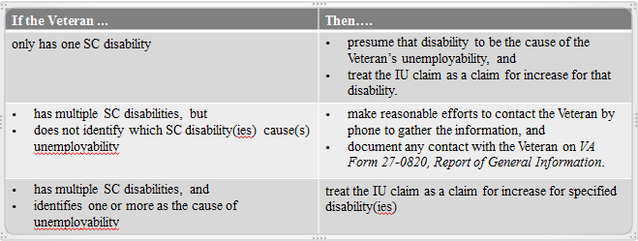  Explain A claim for IU is a claim for increase in the service-connected disability(ies) that the Veteran has identified as causing/contributing to unemployability.  Consider if they have been examined within the last year before you order examinations. In claims for increased evaluations, an examination is necessary if an examination or other adequate medical evidence within the last year is not part of the record. (M21-1 I.1.C.3.i. Increase Claims: Reviewing for Examination)
Employment History Requirements  in IU Claims  Slide 18 | The last five years that he or she worked  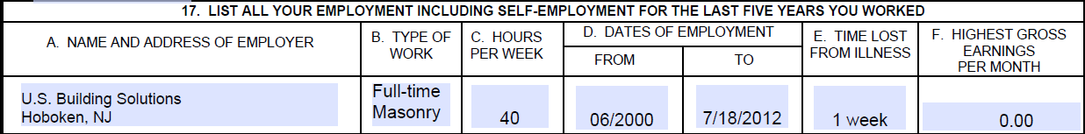  - Request VA Form(s) 21-4192, Request for Employment Information in Connection with Claim for Disability Benefit, for the Veteran’s last year of employment even if the Veteran has not worked for five years or more.  Exception: Do not send the VA Form 21-4192 to the Veteran’s last employer if the evidence of record is sufficient to award increased compensation based on IU and the Veteran has returned a substantially complete VA Form 21-8940 indicating he/she is unemployed.  Important: VA Form 21-8940 must contain the last five years of Veteran’s work history, no matter how long ago it was.
Requesting Employment Information  From Employers  Slide 19 | - Send a VA Form 21-4192 to the former employer(s) for which the Veteran worked during his/her last year of employment.  - At the same time, send a copy of VA Form 21-4192 to the Veteran and request that their previous employer complete and return the form.  - If VA Form 21-4192 is not received from the Veteran’s employer(s) within 15 days  - send a follow-up request to the employer(s) for VA Form 21-4192, allowing an additional 15 days for response, and  - notify the Veteran that it is ultimately the Veteran’s responsibility to obtain this information.  Explain VA Form 21-4192 is not a required form: (IU cannot be denied solely because an employer failed to return a completed VA Form 21-4192.)  Note Do not send the VA Form 21-4192 to the Veteran’s last employer if the evidence of record is sufficient to award increased compensation based on IU and the Veteran has returned a substantially complete VA Form 21-8940 indicating he/she is unemployed.  Do not send the VA Form 21-4192 to a previous employer if the Veteran states that the employer is no longer in business or other evidence indicates the business is closed.  If the Veteran worked for a federal agency, we would treat the VA Form 21-4192 development as a request for federal records and follow the guidelines prescribed under M21-1, Part III, Subpart iii, 1.C.2.b.
Medical Evidence Requirements  in IU Claims  Slide 20 | The evidence should reflect the Veteran’s condition within the past 12 months and include, but need not be limited to  - the results of VA examination(s)  - hospital reports, and/or  - outpatient treatment records.  Important: A medical examination is not automatically required in every IU claim. An examination is required if the information and evidence of record does not contain sufficient competent medical evidence to decide the claim.  Note Do not order unnecessary examinations! When TDIU is inferred and deferred on a decision by the RVSR/DRO, the evidence in most cases is sufficient to award the grant of TDIU pending receipt of the 8940. This is also often true when a claim for IU is received within a year of a rating decision.
Exam Request Builder Language  Slide 21 | 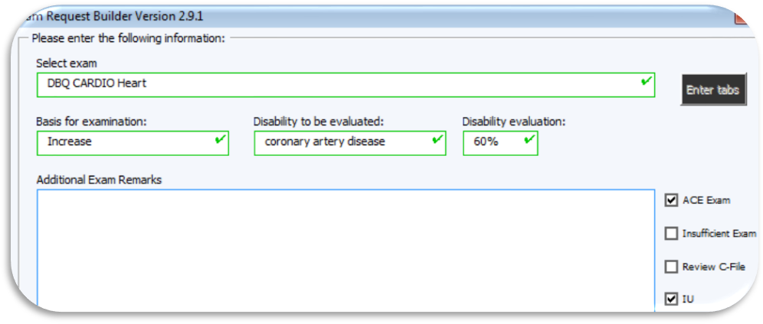  ***Please comment on the effect of the Veteran's service connected disabilities on his or her ability to function in an occupational environment and describe any identified functional limitations. Please refrain from opining on if the veteran is unemployable or employable; instead focus and reflect on the functional impairments and how these impairments impacts occupational and employment activities.  Note: Do not ask the medical authority to provide an opinion as to whether a Veteran is unemployable or entitled to individual unemployability. (M21-1 III.iv.3.A.7.i) Instead, in the Remarks section of the examination request, ask the examiner to comment on the Veteran’s ability to function in an occupational environment and to describe functional limitations. (Use language shown on slide, provided by ERB.)
When to Obtain SSA Reports  in IU Claims  Slide 22 | Obtain and consider complete copies of the Social Security Administration (SSA) decision (grants and denials) and any supporting medical records when  - evidence of record is insufficient to award increased compensation based on IU, and  - the Veteran’s claims folder shows that the Veteran has been examined or awarded disability benefits by SSA.  Note: Regional offices (ROs) are not required to request SSA records when a Veteran fails to return the VA Form 21-8940.  Explain decisions by SSA regarding a Veteran’s unemployability are not controlling for VA determinations, however SSA’s record may indicate the level of impairment of the Veteran’s SC disability.
How to Obtain SSA Reports  Slide 23 | Regional Offices (ROs) are required to  - request records through the SSA-GSO website, and  - follow the format for the requests as outlined in the SSA-GSO User Guide.  Note: SSA allows only a limited number of employees at each RO to have access to SSA-GSO.  Provide contact information for the designated employee(s) at your RO.
When and How to Obtain Vocational Rehabilitation Records in IU Claims  Slide 24 | When the evidence of record indicates that the Veteran was seen by the Vocational Rehabilitation and Employment Service (VR&E) and evidence of record is insufficient to award IU, obtain and evaluate any records related to this contact.  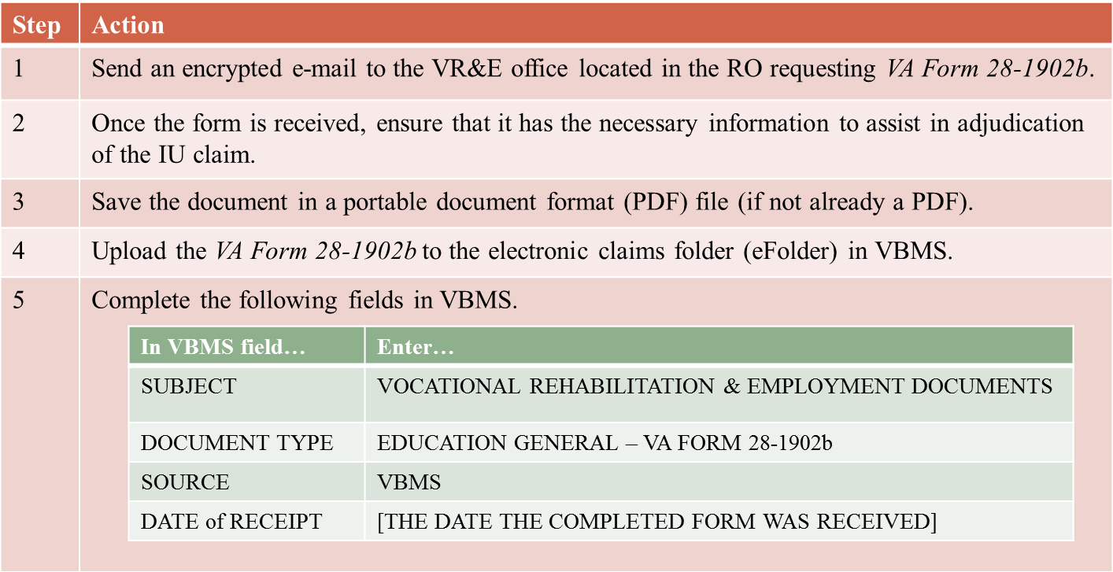  Explain The entire Counseling/Evaluation/Rehabilitation (CER) folder is not necessary. If the Veteran has an existing VR&E record, request that VR&E provide a completed VA Form 28-1902b, Counseling Record – Narrative Report, in lieu of the entire CER folder. VA Form 28-1902b contains the necessary information concerning the impact of the Veteran’s SC and NSC conditions on employability.
Considering IU Claims for  National Guard and Reservists  Slide 25 | If a Veteran is currently serving in the National Guard or Reserves, the reviewer should consider the following:  - Determine if a medical examiner has indicated that a Veteran is unable to perform his/her military duties due to SC disability.  - Make sure that the latest service treatment records (STRS) are of record. Such records may aid in determining if the disability is preventing the Veteran from performing his/her current Guard or Reserve duties.  If the evidence of record is not sufficient to award increased compensation based on IU, request that the unit commander complete and return VA Form 21-4192.  Note The VBMS Initial Private 3rd Party Employer Letter, 21-4192 does not allow the user to edit the salutation section of the letter. To ensure that the request is routed to the unit commander, include “ATTN Unit Commander” in the Employer Name section following the unit designation.  Example: 334th Brigade Engineer Battalion ATTN Unit Commander
Self-Employment Development  Slide 26 | Request that the Veteran furnish a statement regarding the  - types of work performed  - number of hours worked per week, and  - amount of time lost in the previous 12 months due to SC disabilities.  Explain the RVSR will need to consider the relationship between the frequency and the type of service performed by the Veteran for his/her business and the Veteran’s net and gross earnings for the past 12 months.

Topic 3: Promulgation Considerations for IU
Introduction | This topic discusses ancillary benefits and the requirements for continued entitlement to the IU award.
Time Required | 1 hour
OBJECTIVES/  Teaching Points | The following topic teaching points support the overall objectives:  - Handling reasonably raised claims  - Ancillary benefit considerations  - Considerations for incarcerated veterans  - Continuing requirements for the IU award  - Gainful employment  - Due process
Reasonably Raised Claims of IU Continued  Slide 28 | When a reasonably raised claim of IU is identified, and additional evidence is needed  - the RVSR will rate all other claimed issues that can be decided,  - show the issue of potential IU entitlement as deferred in the rating decision, and  - the reasonably raised IU issue is developed under the existing end product (EP), which will remain pending until a merits determination of IU entitlement is made  Explain send the Veteran the section 5103 notice, enclosing VA Form 21-8940 for completion.  Emphasize A subsequent formal rating decision will be required to dispose of the issue of entitlement to IU, even when the Veteran fails to return VA Form 21-8940.
Ancillary Considerations  Slide 29 | - If IU has been granted and there is no future examination established, Chapter 35 must also be granted.  - Special monthly compensation S (housebound rate) is payable where the Veteran has a single service-connected disability rated as 100 percent and has additional service-connected disability or disabilities independently ratable at 60 percent  Note Please return to the RVSR if you see these requirements are met but the rating conclusion does not include the statement, “Basic eligibility under 38 U.S.C. Chapter 35 is established from [date].”, or the required SMC paragraph(s) and coding.
Entitlement to SMC at  Housebound Rate  Slide 30 | A Veteran in receipt of IU benefits may be entitled to special monthly compensation (SMC) at the Housebound rate under 38 U.S.C. 1114(s) if the evidence shows that  - the unemployability is the result of one SC disability, and  - the Veteran has additional SC disability(ies) independently rated at least 60 percent disabling  Emphasize Please return to the RVSR if you see these requirements are met but the rating conclusion does not include the required SMC paragraph(s) and coding.
SMC Housebound Continued  Slide 31 | Example: A Veteran would be entitled to SMC at the Housebound rate if  - his/her total IU evaluation is based on a 70 percent SC rating for posttraumatic stress disorder, and  - the Veteran has additional SC evaluations for headaches and a back condition that combine to 60 percent.  Emphasize Entitlement to Housebound benefits under 38 U.S.C. 1114(s) cannot be established if the IU rating is based on multiple disabilities considered as one disability under 38 CFR 4.16(a). (Discussed slides 10 & 11)
Considering IU for  Incarcerated Veterans  Slide 32 | - If an IU evaluation is in effect prior to incarceration in excess of 60 days for conviction of a felony, the IU evaluation will be reduced to 10 percent in accordance with 38 CFR 3.665.  Note This is an administrative action handled by the VSR and does not require any rating activity.
Monitoring Changes in Employability Status  38 C.F.R. 3.343(c)(1) and (2)  Slide 33 | Changes in the employability of Veterans for whom IU is established is monitored through the  - annual release of VA Form 21-4140, Employment Questionnaire, via the Benefits Delivery Network (BDN)  Explain On a yearly basis, HINES will automatically send a VA Form 21-4140, Employment Questionnaire (Pull up and show them), to Veterans receiving IU benefits. The Veteran is required to report any employment for the past 12 months or certify that no employment has occurred during this period. The form must be returned with the Veteran’s signature certifying employment status within 60 days or the Veteran’s benefits may be reduced.  NOTE There are two places on this form that the Veteran can indicate that they have NOT returned to work. Box #3, and Section II. If Box #3 is blank, but the Veteran signed and dated Section II- this IS acceptable certification that they have NOT returned to work.  Explain If the form is returned in a timely manner and shows no employment, IU will continue uninterrupted :  - PCLR EP 692  - Delete future diary reason code 34  - Associate the questionnaire with the claims folder  If the VA Form 21-4140 is returned and shows the Veteran has engaged in substantially gainful employment, then refer to RVSR for consideration of discontinuation of IU.  Note 38 C.F.R 3.343(c)(1) and (2) provide that actual employability must be shown by clear and convincing evidence before the benefit is discontinued. Additionally, IU cannot be discontinued unless the Veteran maintains the gainful occupation for a period of 12 consecutive months. Per 38 C.F.R. 3.343(c).
When Monitoring Changes in Employability Status Is Not Required  Slide 34 | Monitoring changes in employability status is not required when the Veteran  - is 69 years of age or older,  - has been rated totally disabled due to unemployability for a period of 20 continuous years, which protects the evaluation from future reduction under 38 CFR 3.951(b), or  - is assigned a 100-percent schedular evaluation.  Note The system automatically stops sending the 4140 out to the Veteran upon turning 69 and/or after 20 continuous years. It does not automatically stop when a 100% shedular evaluation is assigned because consideration may still need to be made if the Veteran is in receipt of SMC S. (If they return to work and the IU discontinues, a proposal to take away the SMC S would need to be done.)
Action Taken if VA Form 21-4140  Is Not Returned  Slide 35 | - Rating Decision proposes to reduce,  - due process (65 days) is sent to the Veteran,  - if the Veteran does not return the completed 21-4140 within 65 days,  - reduce the first day of the month following the end of the 65 day due process period, or date last paid (whichever is later), then  - refer to the RVSR for rating decision reflecting reduction to the schedular evaluation.  Explain If the form is not returned:  - CEST EP 310  - Refer to rating board  - Notify of proposed reduction, including  - Effective date of proposed reduction, reduction rate and proposed loss of entitlement to Dependent’s Educational Assistance (DEA)  - PCLR EP 310  - CEST EP 600, to control claim during due process period  Before taking the action shown above, it may be useful to telephone the Veteran and ask him/her to return a signed form by mail or fax. If the telephone contact is successful, and the Veteran agrees to return the form:  - Document the fact in the folder  - Allow 10 day for receipt of form before taking the action shown above  NOTE: A telephone call to the Veteran is not acceptable to certify employment status for IU claims.  Per 38 C.F.R. 3.105(e) and 3.501(e)(2) – once this period of sustained employment has been maintained, the Veteran must be provided with due process before the IU benefit is actually discontinued.  This consists of providing Veteran with a rating that:  - Proposes to discontinue the IU benefit  - Explains the reason for the discontinuance  - States the effective date of the discontinuance  - States the Veteran has 60 days to respond with evidence showing why the discontinuance should not take place.  Veteran must also be notified that if the form is returned within one year of notification and shows continued unemployability, then the IU evaluation may be restored from the date of discontinuance.

Practical Exercise
Time Required | 0.50 hours
EXERCISE  Handout 2 & 3 | This exercise can be conducted individually or as a group. Allow time for the trainees to review the scenario. After review the scenario, the trainees should describe the development needed for the Veteran’s claim using the space provided in the trainee handout packet. Review the development actions selected and ensure the trainees understand the material that has been presented.

Lesson Review, Assessment, and Wrap-up
Introduction  Discuss the following: | The Eligibility for Individual Unemployability lesson is complete.  Review each lesson objective and ask the trainees for any questions.
Time Required | 0.75 hours
Lesson Objectives | You have completed the Entitlement to Individual Unemployability lesson.  The trainee should be able to:  Demonstrate a comprehensive understanding of  - development of claims for individual unemployability (IU),  - promulgation of decisions for IU, and  - addressing continued entitlement to IU.
Assessment | The assessment will allow the participants to demonstrate their understanding of the information presented in this lesson.  Allow the trainees 30 minutes to complete the online assessment.

